Test Plan for LogiGear POC  
by Tanya Jenkins for Suitable Technologies  
Copyright 2016 Tanya Jenkins and Suitable Technologies

# Summary

This document outlines the test scenarios and deliverables for the LogiGear Proof of Concept (POC) period of two weeks. The POC period commences with the approval and delivery of this Test Plan to LogiGear, a Feedback period where LogiGear has time to review this document, and a test environment on Staging to which they have access. LogiGear will then deliver standalone tests that can run against our Admin Website and can be integrated in a continuous integration environment like TeamCity.

# Technical Details

We have agreed that the following Tools will be used for the Test Environment.

## **Test Development and Execution Tools (**LogiGear**)**

|  |  |  |  |
| --- | --- | --- | --- |
| **Item** | **Description** | **Detail** | **Deliverable for POC?** |
| Test Code Environment | Environment used to create tests | Selenium | Yes |
| Test Code | The code in which the tests are written | Python | Yes |
| Test Execution Script | The script which launches the Suite of Tests that are developed | Python | Yes |
| Test Execution Operating Systems | The Operating Systems under which the tests can be executed | MacOS, Windows | Yes |
| Test Browsers | The browsers in which the Admin Site will be launched and against which the tests will be executed | Internet Explorer and Firefox | Yes |
| Test Results | The results that are produced by running the tests. | Human readable (text, HTML, etc.) | Yes |

## **Test Environment Setup (SuitableTech)**

|  |  |  |  |
| --- | --- | --- | --- |
| **Item** | **Description** | **Detail** | **Resp?** |
| LogiGear Test Organization creation | Create an organization that has Beams for LogiGear to access. They will be able to add/remove users and perform other test related tasks as needed. | * Access will be sandboxed. * They will be the Admins so that they can create users, etc. * Beams will be added so that Reservations can be made | Hans |
| Default Device Group Setup | Create default device group for allocated Beams | * Beams (real and virtual) will be added to this device group | Hans/  Tanya |
| Beam Setup | Set up Beams so that LogiGear has access for Test Development. | These will be physically located in the QA Lab and will be logically sandboxed by being in the LogiGear Org. | Tanya |
| TestRail Access | Create accounts and grant access to TestRail | * Create account(s) for LogiGear | Fred |
| Organization Configuration | Configure organization such that LogiGear gets Admin emails | * Set Email Notifications to someone at LogiGear | Hans |
| TestRail Admin Test Cases | LogiGear can use this as a guide to see what we test manually | https://suitabletech.testrail.com/index.php?/runs/view/403&group_by=cases:section_id&group_order=asc | Tanya |

# Deliverables

Upon the conclusion of the POC period, LogiGear will deliver a suite of tests that can be run in a standalone environment at SuitableTech. Some test cases in the suite will be for the ‘Reserve A Beam’ functionality, and will be written by LogiGear as part of this POC. This run will produce a report that summarizes test Passes and Failures for that run. We will use this deliverable to determine in what way, if at all, we would like to move forward with using LogiGear for test automation.

LogiGear will not use any proprietary software in development of this suite. See the section “Technical Details” for more information about tools used for this deliverable.

## Deliverable Expectations

|  |  |  |
| --- | --- | --- |
| **Item** | **Summary** | **Detail** |
| Site Admin– Reservations Suite and Supporting infrastructure | Delivery of standalone code that can be run at SuitableTech | The suite is for our Site Admin web tool. In order to make reservations, LogiGear will need to create test structures to add Users, etc. |
| Test Data Handling | Test Data Store. Delivery of test data so that same scenario can be run with various data. | The test data should be able to be isolated for easy updates, especially when it is reused in various places. |
| Test Case Creation | For our ‘Reservations’ functionality, LogiGear should deliver written Automation test cases for the Section on ‘Reserve a Beam’. See the section in this document **Reservations->Reserve a Beam** | Delivered in TestRail. This will allow us to see the quality of written test cases that LogiGear produces. Some simple test cases are currently in this document and will be transferred to TestRail. |
| Verification of Site Feedback | Verify the feedback that appears after an action is completed on the browser page (Page Feedback) or in a pop-up | 1. At least one pop-up handled 2. Several Page Feedback scenarios handled |
| Verification of Error Cases | Verify feedback that is the result of an error scenario | 1. Check for possible errors in execution (inline code) 2. Several explicit Error Cases should be created by seeding bad data to produce Expected Errors 3. Several explicit Error Cases should be created by doing actions to produce Expected Errors |
| Verification of Email | Verify email content and structure | 1. Scrape User Activation Email for correctness. 2. If time allows, automate User Activation (Add User) through Email |
| Pass/Fail Report | At the end of the test suite run, there will be a report of Pass and Fail status |  |

# Setting Up Your Org

## Email Notifications and Default Invite Message

We have set up an Organization for LogiGear. In order to change the email settings, go to ***Home->Settings*** (the gear in the upper-right corner) and you will see the page below. You can set the email address for ***Email Notifications*** and you can set the ***Default Invite Message.*** Modifying this is not required for the POC.

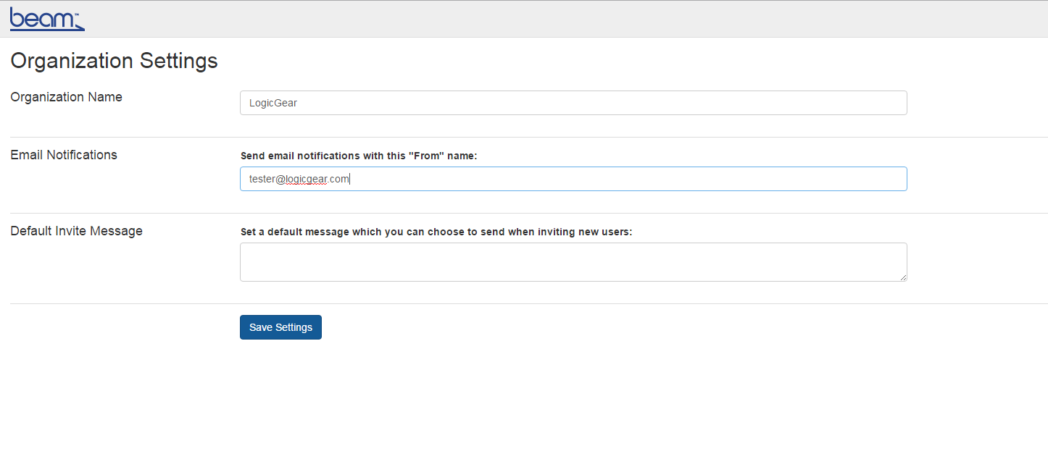

## Notifications

You can turn on and off Notifications, located at ***Your Account->Notifications***. Mostly, you will use this to adjust test settings so that you will receive the required email notifications, but it is also useful when you want to cut down the “noise” of unnecessary emails (like charging emails). Modification is not required for this POC.

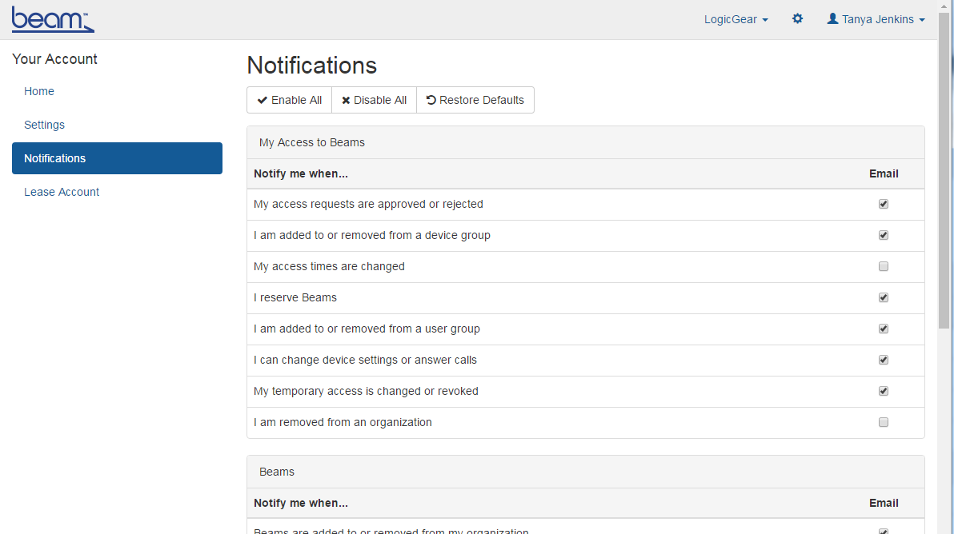

# Test Cases

The following test cases are expected for this POC. Each test case is predicated on the LogiGear Organization existing and being accessible. Creation of a default Device Group is not required, but Test User creation, Reservation creation, etc.

## Invite/Add User

Inviting or Adding a User requires that you have a device available, as the LogiGear Organization does. Below is a screenshot of where you can add a user. Once the user is invited, an email is generated and sent to the email that was set in ***Your Account->Notifications***.

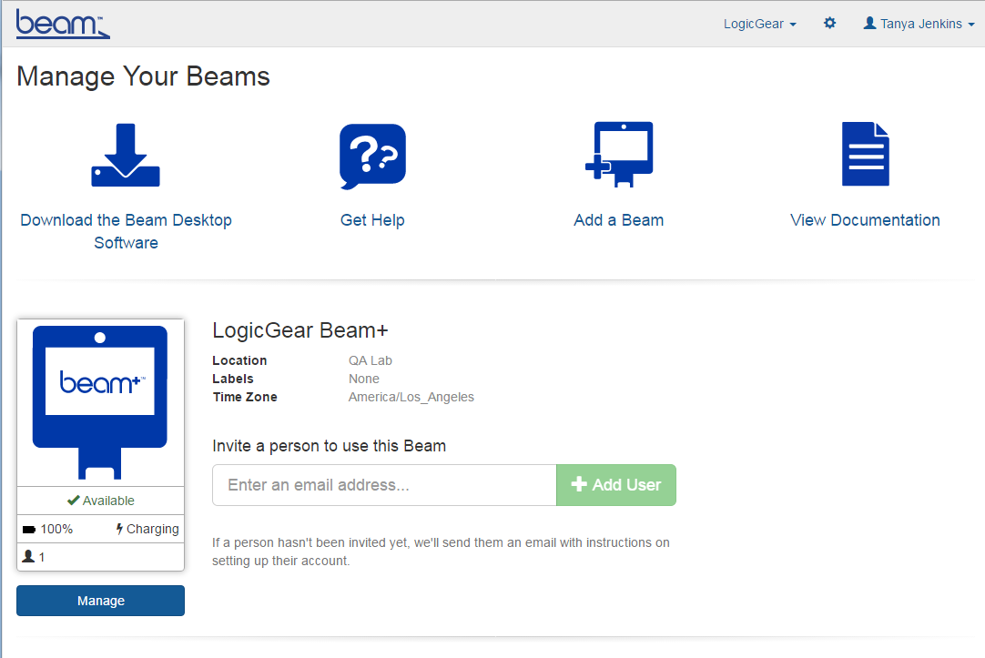

### Invite/Add User

|  |  |  |  |
| --- | --- | --- | --- |
| **Test Case** | **Description** | **TestRail Link and Notes** | **Priority** |
| Add New User - Errors | Attempt to Add a User with a malformed email address | User will not be added and you will see an error generated in the UI. | P1 |
| Add New User | Add a User that does not have an existing account | Example: Ignore preconditions – Use LogiGear Organization.  [**https://suitabletech.testrail.com/index.php?/cases/view/10938**](https://suitabletech.testrail.com/index.php?/cases/view/10938) | P1 |

### Invitation Email

The invited user will be sent an email similar to the one below. You should verify that it was sent and that all relevant information is included. The picture below is for a viewer that allows for HTML.

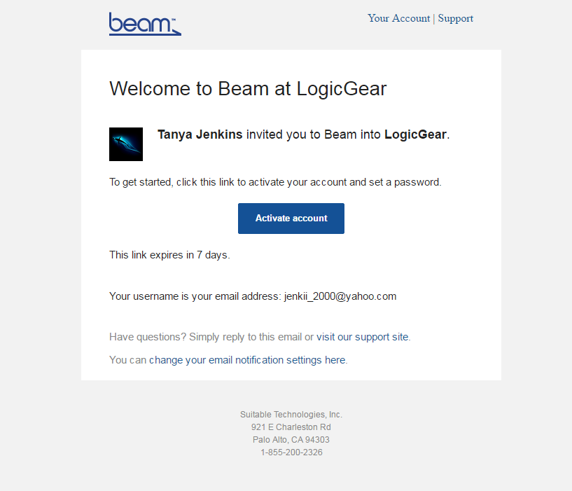

|  |  |  |  |
| --- | --- | --- | --- |
| **Test Case** | **Description** | **TestRail Link and Notes** | **Priority** |
| Verify Add/Invite User Email | Scrape the email **received** to ensure all information is correct: Name, Org, Group, TO: From: etc. | TBD | P1 |
| Verify Add/Invite User Email – Text Only | Ensure that the email can be viewed in a text client | TBD. Create this test if time allows only | P2 |
| Verify Add/Invite User Email – Activation Link | Verify the activation link   1. is active in HTML 2. or if text only, can be pasted into a browser and followed | Only create 2. If time allows | P2 |

## Activate a New User

Activating a New User happens when a user clicks on the ‘Activate Account’ button or link in the email sent to the user that was invited. After the user clicks the ‘Activate Account’ link, they will be taken to a screen that will allow them to create a password. This will activate the user’s account.

### Password Setup

The screenshot below shows where the user will set up their password. Note that there are several scenarios under which a password should fail the password requirements listed on the right of the page.

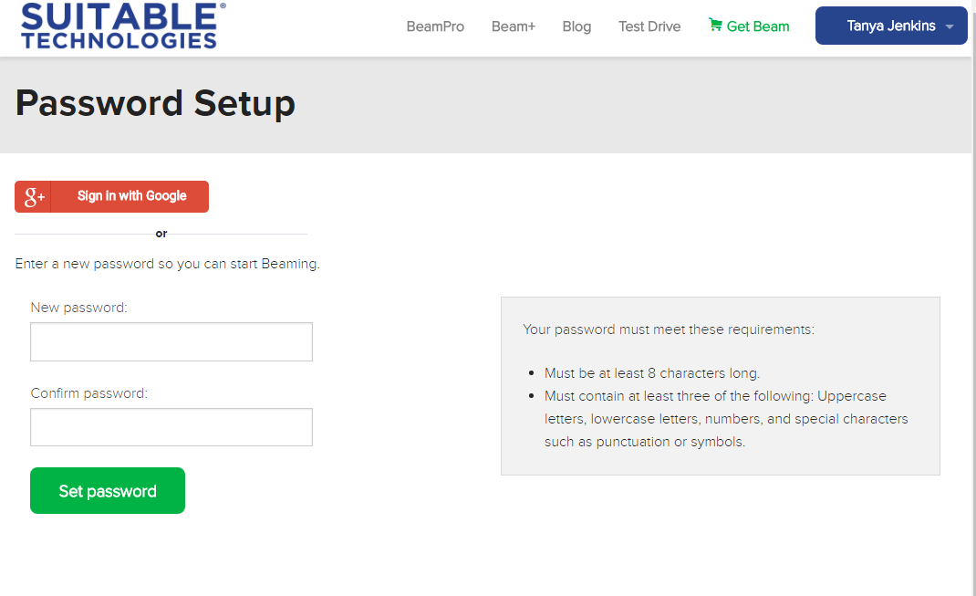

|  |  |  |  |
| --- | --- | --- | --- |
| **Test Case** | **Description** | **TestRail Link and Notes** | **Priority** |
| Password Setup - Errors | Set up password that is 7 chars | You should not see the user added in UI | P1 |
| Password Setup - Errors | Set up password that is a combo of only **two** of the following   1. Uppercase 2. Lowercase 3. Numbers 4. Special chars | You should not see the user added in UI | P1 |
| Password Setup - Errors | Set up password that does not have any   1. Uppercase 2. Lowercase 3. Numbers 4. Special chars | You should not see the user added in UI  **Note**: You can have variations on these, but you do not need to be exhaustive for the POC. | P1 |
| Password Setup - Success | Set up password that is valid per the requirements | You should see a Password Set successfully banner | P1 |

## Verify ‘User Added’ Notifications

Verify that the User added above has been added in all of the relevant places in Site Admin, and that the proper responses and notifications have been received.

### UI Verification of User Added (Activation successful)

## Verify Remove User

Removing an active user takes them out of a group or an organization and revokes their access for that entity. It does not remove their account and they should receive a notification via email.

### Remove User from Group

|  |  |  |  |
| --- | --- | --- | --- |
| **Test Case** |  | **TestRail Link and Notes** | **Priority** |
| Remove User (Group or Org) | Remove an existing user | https://suitabletech.testrail.com/index.php?/cases/view/11635&group_by=cases:section_id&group_id=1805&group_order=asc | P2 |

### Verify Remove User Notification

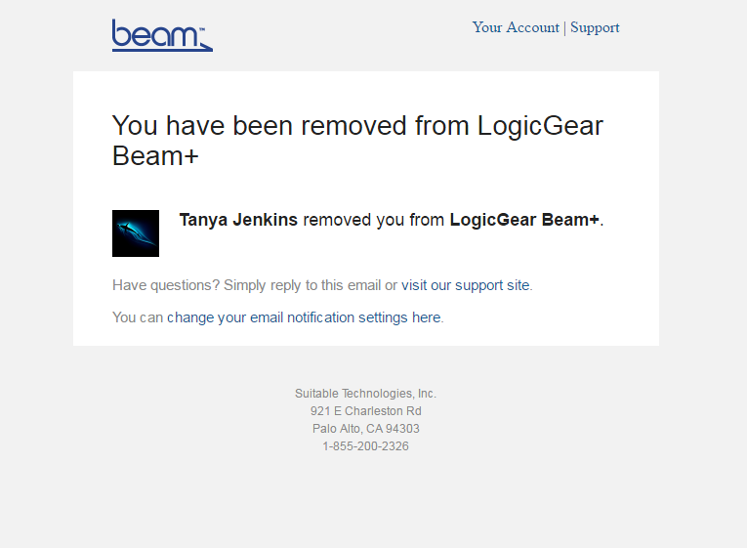

|  |  |  |  |  |  |
| --- | --- | --- | --- | --- | --- |
| **Test Case** | | **Description** | | **TestRail Link and Notes** | **Priority** |
| Verify Remove User - Email | | Scrape the email **received** to ensure all information is correct: Name, Org, Group, TO: From: etc. | | TBD | P1 |
| Verify Remove User - UI | | Check that the User is removed in the UI | | TBD | P1 |
| Verify Remove User Email – Text Only | | Ensure that the email can be viewed in a text client | | TBD. Create this test if time allows only | P2 |

## Reservations

Reserving a Beam allows a User to be ensured of getting control of the Beam during a certain period of time. A user can make several reservations and all reservations for a Device Group can be found in   
***Beams->Reservations*** as can be seen below.

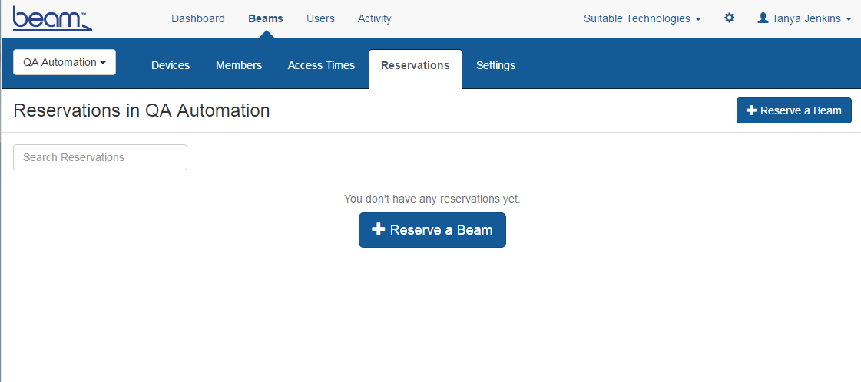

### Reserve a Beam ***

After reserving a Beam, the new Reservation should show in the Site Admin UI. Any conflicts will show up as banners in the UI. **LogiGear will be expected to add additional test cases in this section only.**

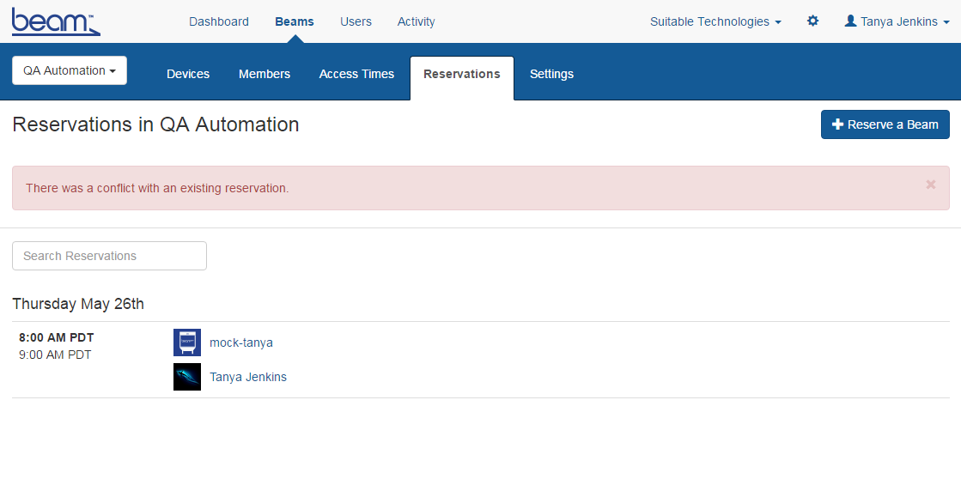

|  |  |  |  |
| --- | --- | --- | --- |
| **Test Case** | **Description** | **TestRail Link and Notes** | **Priority** |
| Reserve a Beam - Successful | Create a reservation for an existing User on a Beam that is free during that time period | TBD | P1 |
| Reserve a Beam - Immediate | Create a reservation for an existing User on a Beam that is free. The reservation should commence ASAP after adding the reservation. | TBD | P1 |
| Reserve a Beam - Conflict | Create a reservation for an existing User on a Beam that is **not** free during that time period | TBD | P1 |

### Search Reservations

Search Reservations filters the current reservations based on the text string entered.  
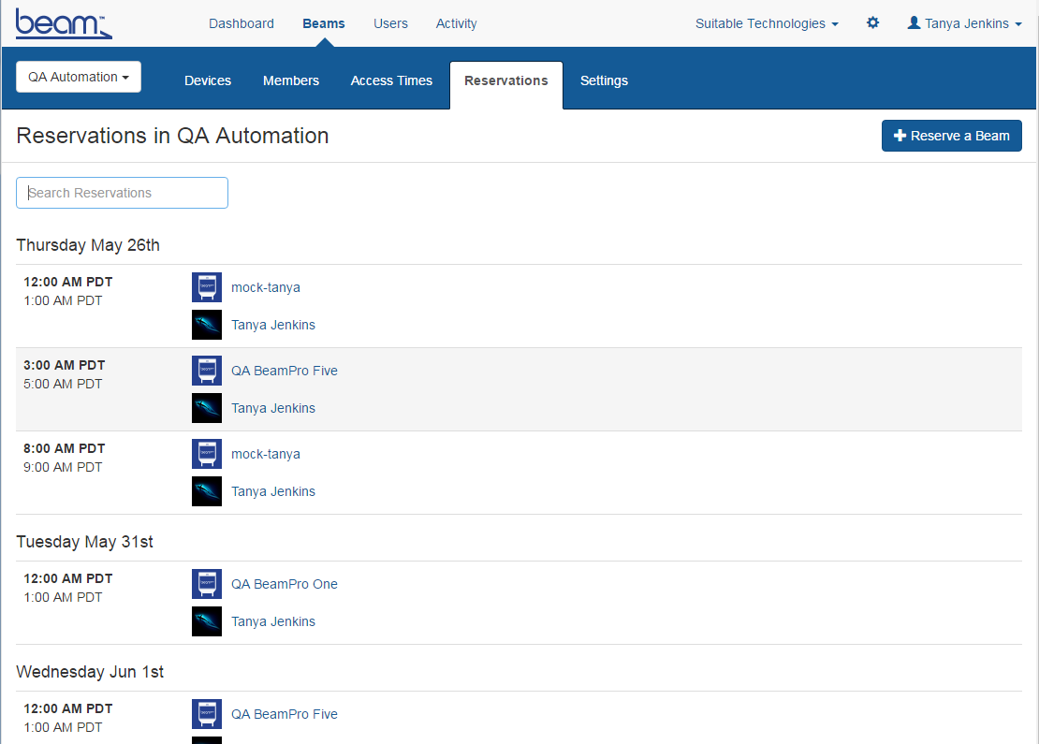

#### Search Reservations UI

|  |  |  |  |
| --- | --- | --- | --- |
| **Test Case** | **Description** | **TestRail Link and Notes** | **Priority** |
| User Name Link | For an existing reservation, click on User Name and ensure you are taken to the correct page. | TBD | P2 |
| Beam Name Link | For an existing reservation, click on User Name and ensure you are taken to the correct page. | TBD | P2 |

#### Search Reservations Results

|  |  |  |  |
| --- | --- | --- | --- |
| **Test Case** | **Description** | **TestRail Link and Notes** | **Priority** |
| Search Reservation – By Beam name, Exists | Search for an existing reservation on a Beam that exists | TBD   1. Full name 2. Partial name | P1 |
| Search Reservation – By User name, Exists | Search for an existing reservation for an existing user | TBD   1. Only one reservation exists on that Beam, and it is for that user 2. Multiple reservations exist, one for that user 3. Partial User name | P1 |
| Search Reservation – By Beam name, Does not exist | Search for an existing reservation on a Beam that does not exist | TBD | P1 |
| Search Reservation – By User name, Does not exist | Search for an existing reservation for an non-existent user | TBD   1. Only one reservation exists on that Beam, and it is not for that user 2. Multiple reservations exist, none for that user | P1 |
| Search Reservation – chars exist | Conduct searches using characters that exist in usernames or beam names. | TBD | P1 |
| Search Reservation – utf-8 chars (exist or not) | Conduct searches using characters that exist in usernames or beam names. | TBD | P1 |
| Search Reservation – Chars do not exist | Conduct searches using characters that do not exist in usernames or beam names. | TBD | P2 |
| Search Reservation – Day of Week | Conduct searches using Day of the Week | TBD. Currently not implemented | P2 |
| Search Reservation – Date | Conduct searches using characters that do not exist in usernames or beam names. | TBD. Currently not implemented | P2 |