ALLIANCE BANKING CHAT BOT USING AGENT AI
- Use cases:
- General behaviors:
- The AI will respond politely “Sorry, I’m just a banking virtual assistant and I can just answer questions within the banking field” if user asks questions outside of banking’s business logic
- If user asks too general questions like technical issues, need to ask a question, need to see an agent,… then the AI will try to clarify their issue. If it can’t get the detail issue, it will provide the phone number of live agent corresponding to “Other” category to solve. If it can get the detail issue but it can’t support that issue then it will provide the phone number of live agent corresponding to issue’s category to solve
Category | PhoneNum
bank_account | 205-123-5678
transaction | 205-732-5679
general_issues | 205-345-5680
technical_support | 205-789-5681

- Answer the queries about banking policies such as working hours, headquarter address,, technical issue such as forgot login detail, lost or stolen card, OTP issues,... based on content in PDF files.
- Support handling actions like updating bank account information, retrieving account balance, dispute transaction, get list of transactions
- The agent can memorize the conversation and respond correctly to user
- Specialized functions:
- Update contact details of bank account
  - Input param:
    - Account number
    - Email
    - Phone number
    - Address
  - Output param:
    - InforMsg
  - Sample screenshot:
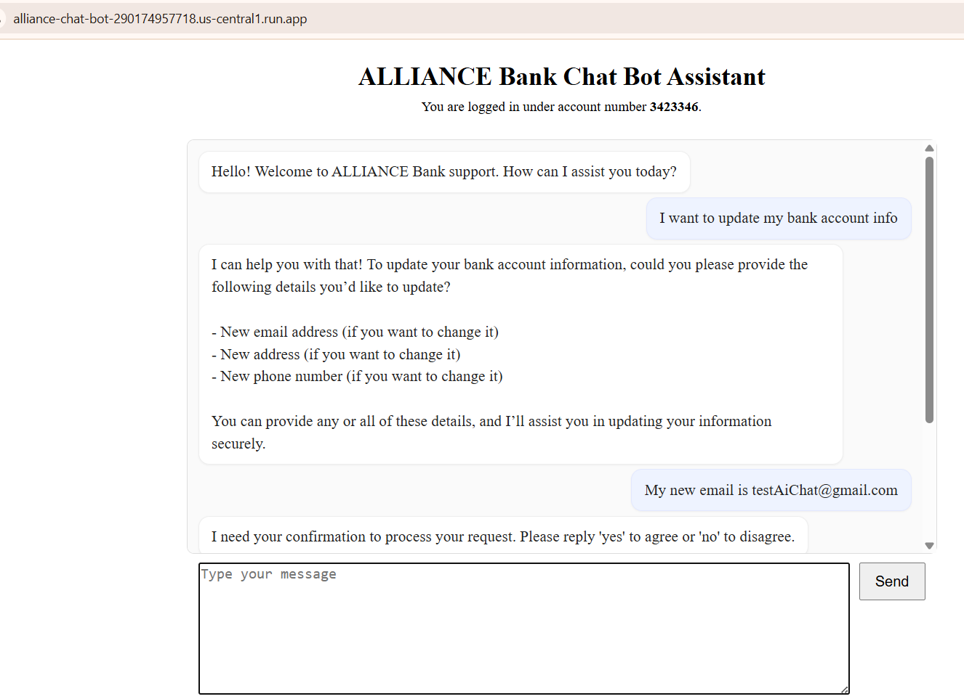

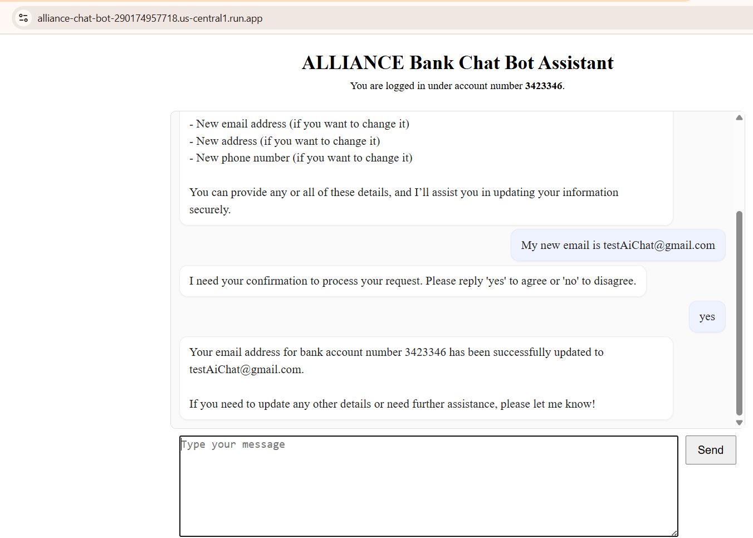
- Query the current account balance
  - Input param:
    - Account number
  - Output param:
    - Current balance
  - Sample screenshot:
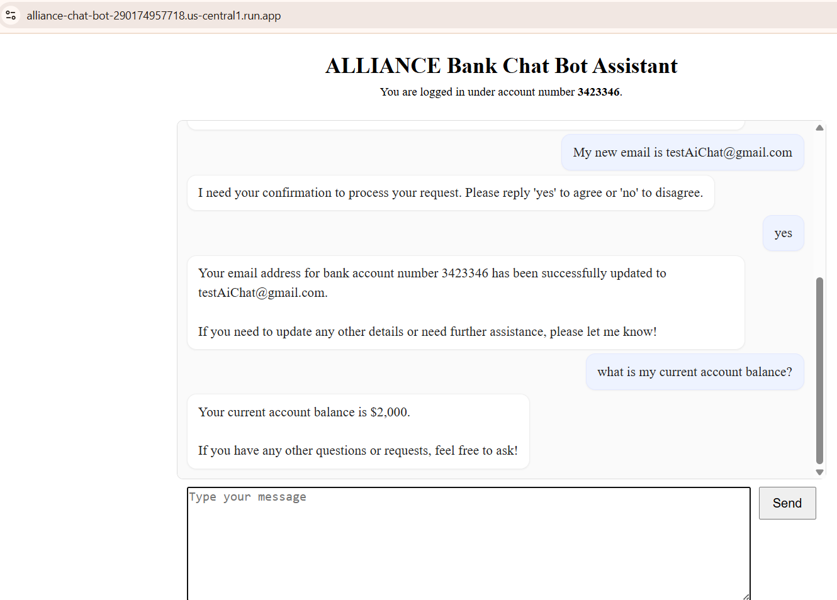
- Show at most X transactions in a date range on account
  - Input param:
    - Account number
    - Date range
  - Output param:
    - A list of transactions including:
      - Transaction Identifier
      - Date time of transaction
      - Receiver’s first and last name
      - Transfer content
      - Status of transaction (SENT, DISPUTED,PENDING)
      - Transfer amount
  - Sample screenshot:
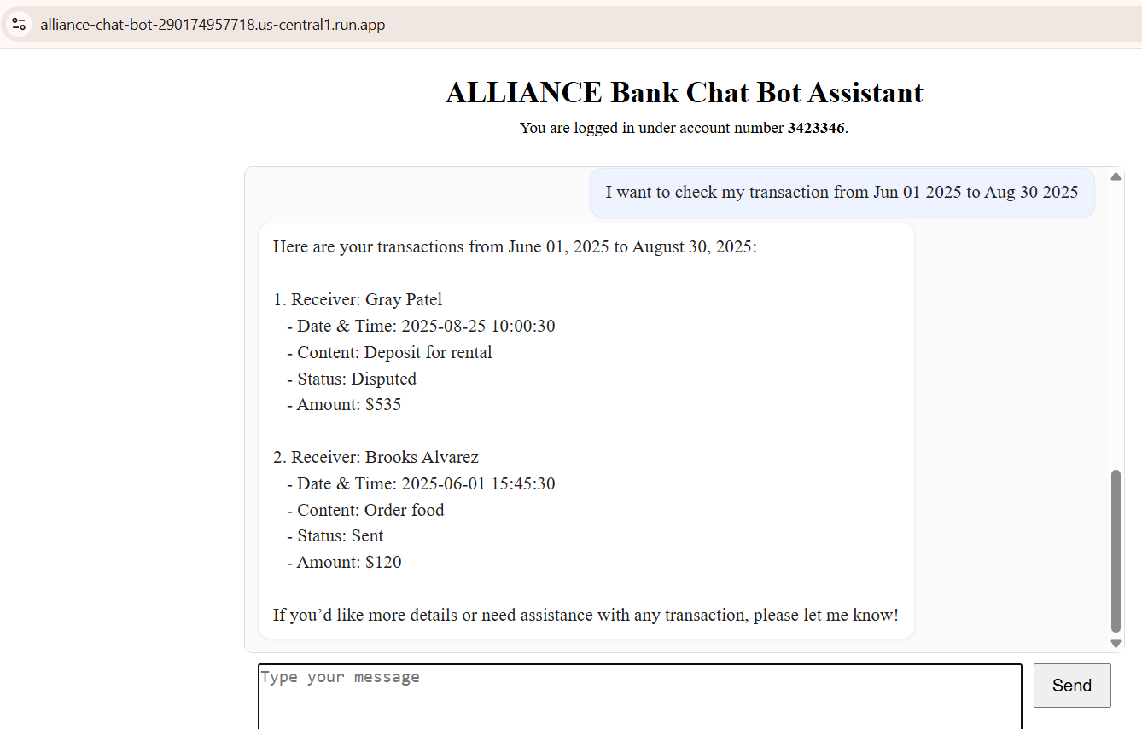
- Dispute a transaction
  - Input param:
    - Account number
    - Date time of transaction
    - Receiver’s first and last name
    - Transfer amount
  - Output param:
    - InforMsg
  - Sample screenshot:

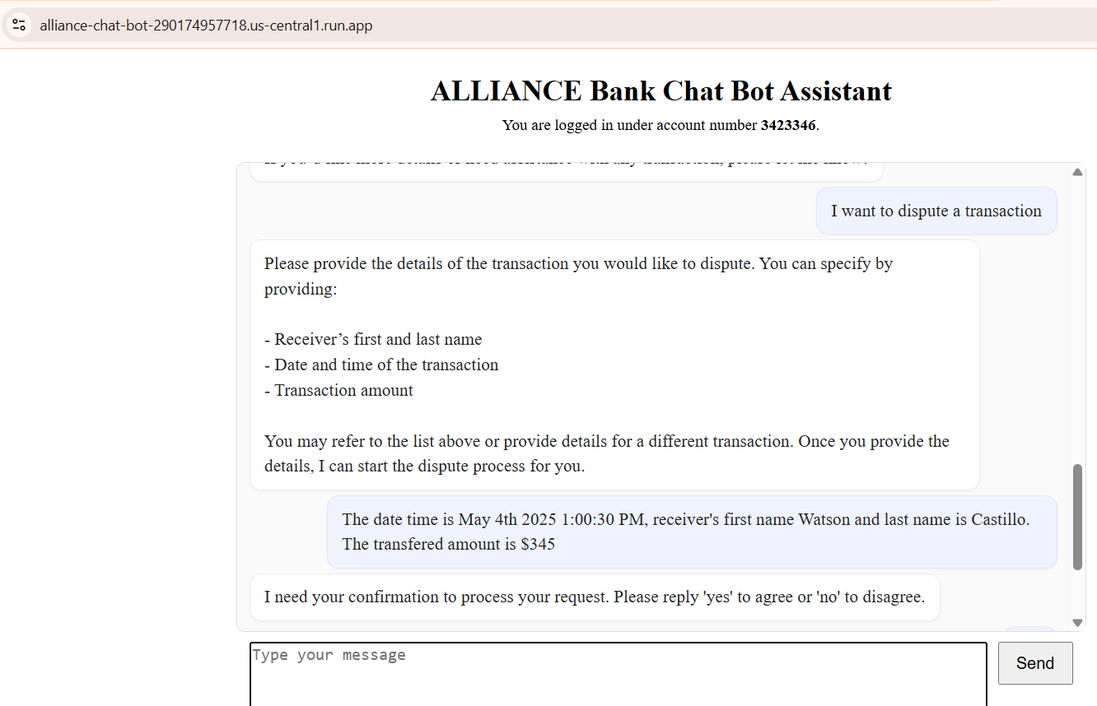

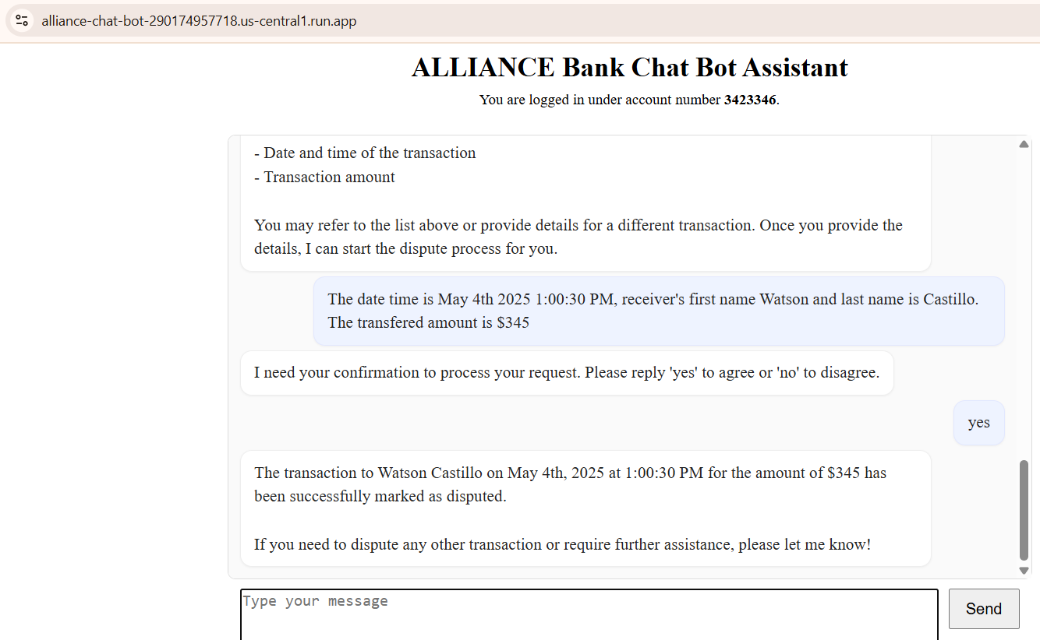

- Support solving technical issues
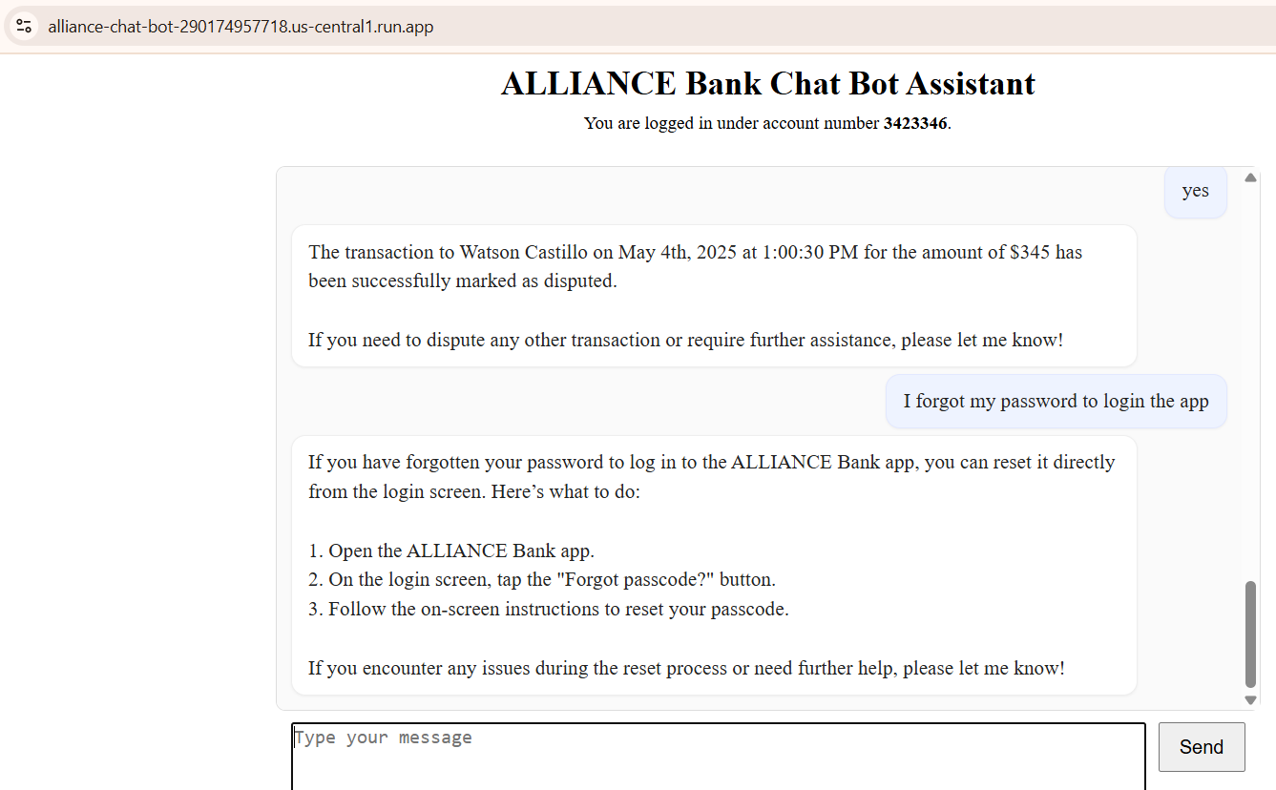
- Refer to a phone number corresponding to issue’s category if agent can’t solve the problem: In this case, it refers user to the bank account’s support phone number.
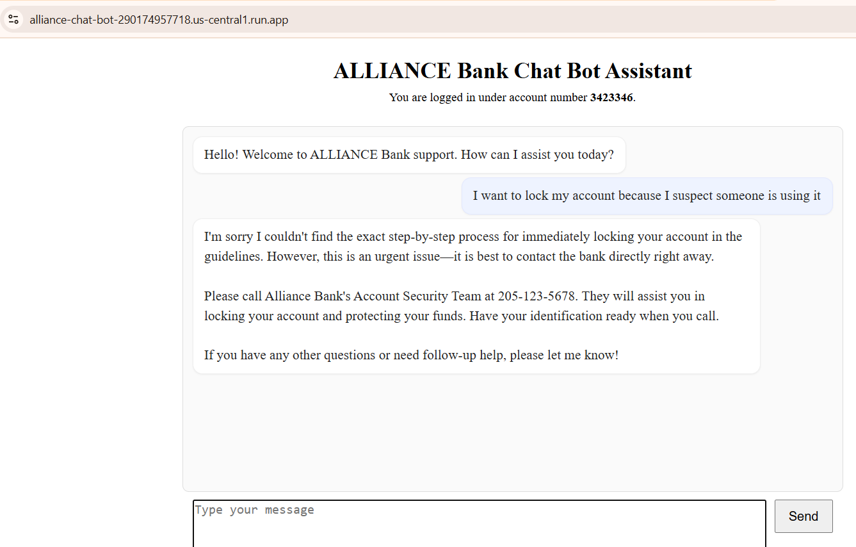
- Try to clarify the problem if user’s question is too vague
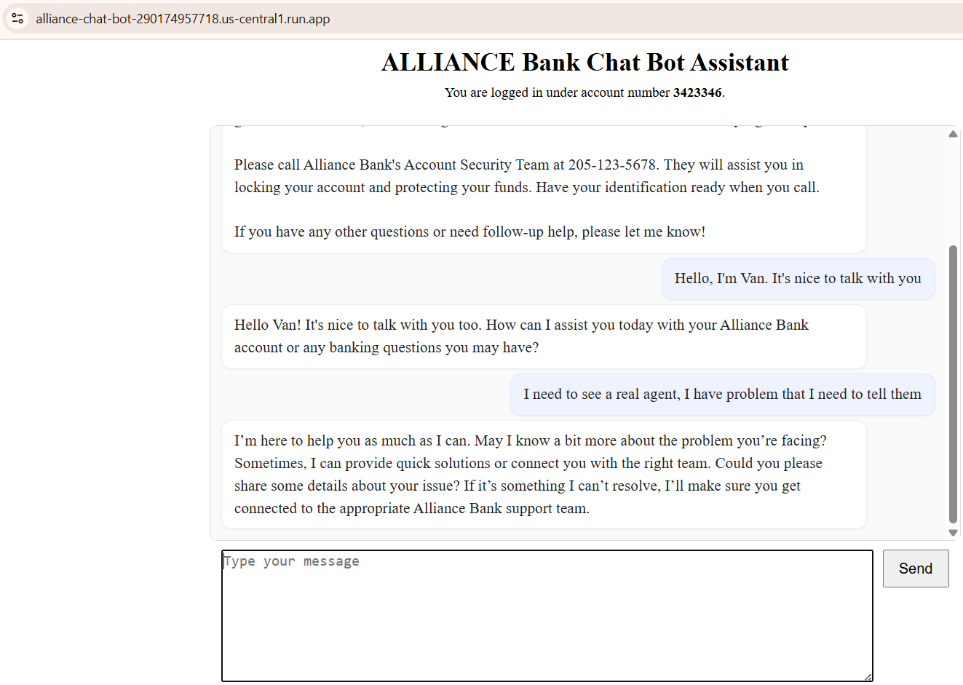
- Memorize the conversation to serve user better
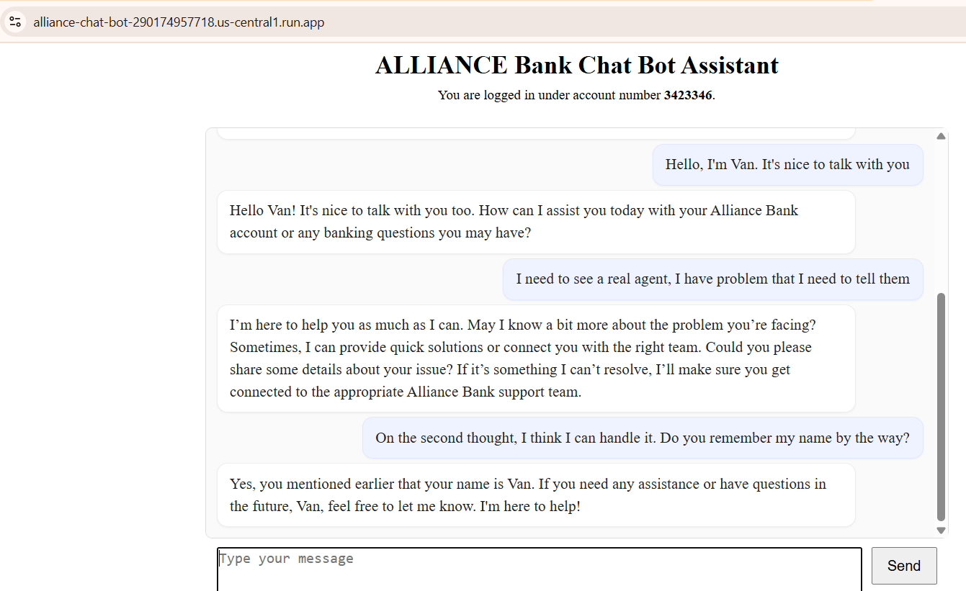
- Answer any business or general questions based on data stored in PDF files
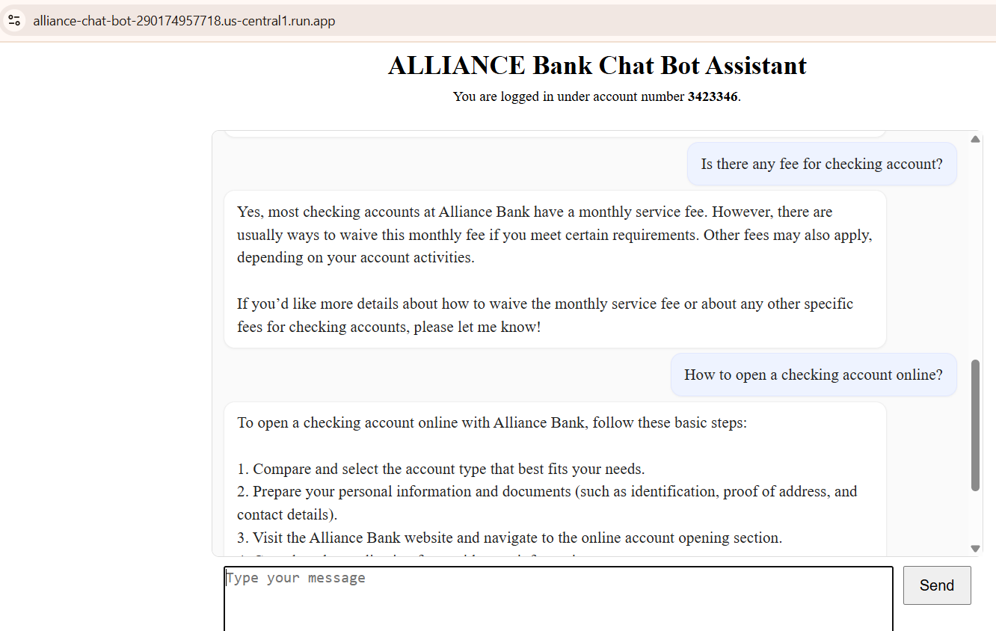
- Specification:
- Primary assistant:
  - We will have 1 primary assistant to answer any general questions relating to the bank like headquarters’ office, working time, how to create account, how to dispute transaction…
  - This agent will read information from a pdf document and summarize the information to answer customers’ queries.
  - If primary agent can’t find information that is relevant to user’s query, it will return the support phone number corresponding to question’s category so that user can contact the real agent directly.
- Account agent:
  - A secondary assistant to specialize in bank accounts
  - It will help update bank accounts
- Transaction agent:
  - A secondary assistant to be responsible for the transactions’ queries
  - It will support functions such as list transactions, dispute transactions
- All these agents will work together to answer user’s questions.
- For requests that need to update or insert data into DB, AI agent will confirm with user before proceeding with the update.
- Graph to show the interaction between agents
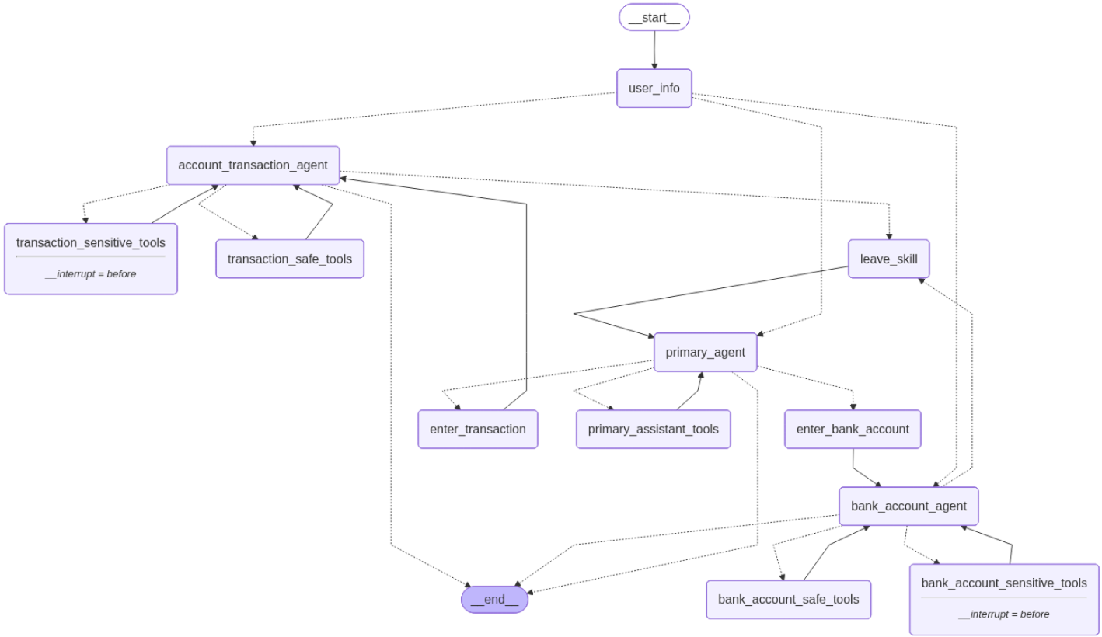
- Log the detail conversation to serve debugging and reporting
- Using LangSmith
- The conversation will be recorded on LangSmith website https://smith.langchain.com with detail information like sessionid, date time, the flow of conversation, which tool has been called with which input parameters, the trace to LLM calls,..
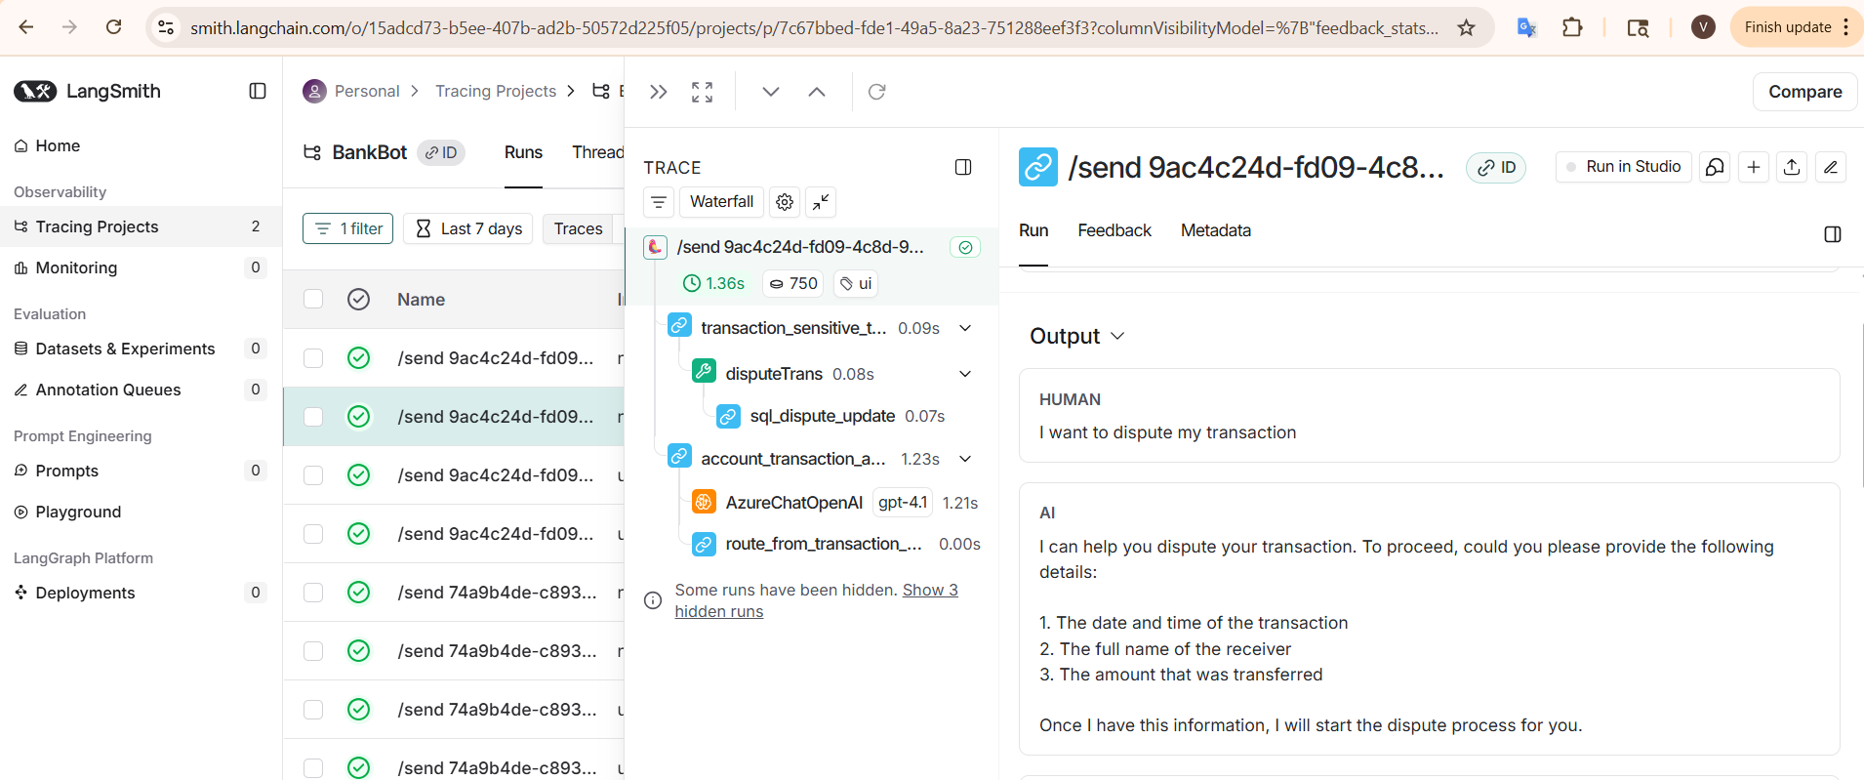
- Using package logging:
- The API keys, configurable parameters will be put in a .env file
- Using logging package to log detail information into the terminal or a doc file
10:09:34 INFO [bankbot.tools.transaction_tool] account_number=3423346
10:09:34 DEBUG [bankbot.tools.transaction_tool] Executing search SQL:
Select TransactionId from banktransaction where AccountNumber = %s and TransDateTime = %s and ReceiverFirstName = %s and
ReceiverLastName = %s and TransferAmount = %s
| params=('3423346', datetime.datetime(2025, 5, 4, 13, 0, 30), 'Watson', 'Castillo', 345)
10:09:34 DEBUG [bankbot.tools.transaction_tool] Executing update SQL:
Update banktransaction set TransferStatus = %s where TransactionId = %s
| params=('Disputed', '2368')
10:09:34 DEBUG [bankbot.tools.transaction_tool] Executed. rowcount=1

- The application is written under *.py file to be published on a cloud. So we need to build an interface to interact with end users.
- Technology information:
- DB to use: MySQL
- LLM Model name: AzureChatOpenAI
- Agentic framework: LangChain and LangGraph
- Embedding model: MistralAIEmbeddings
- RAG (Retrieval-Augmented Generation)
- Points should be improved:
- 3 PDF files should be read into 3 different objects to be called when needed, currently, they are all called at the same time.
- Implement the solution to solve the security problem about prompt injection.
- Asynchronous working model should be used to improve performance and response speed.
- How to run
- On local:
Build a docker image and run it locally
- On cloud:
Access this link: https://alliance-chat-bot-290174957718.us-central1.run.app/

