Name: NOM Vannkinh

ID: e20160439

IP of Dynamic Routing 1

1. Questions
2. Interior Gateway Protocol (IGP) is a protocol that using the technique of routing information exchange between gateways.
3. The difference between Distance vector and Path vector:

* Distance vector: routers running distance vector algorithms the vector and distance for each destination reachable within the network to adjacent peer.
* Path vector protocol does not rely on the cost of reaching a given destination to determine whether each path available is loop free or not.

1. The difference between RIP mechanism and IGRP mechanism in routing:

* RIP mechanism:
* RIP is a distance vector protocol
* The metrics used is hop.
* RIP uses Distance vector algorithm to calculate the best path.
* IGRP mechanism:
* IGRP is a link state protocol
* The metrics used are bandwidth and delay
* IGRP used the distance vector algorithm to calculate the best path and the variance mechanism to support unequal-cost load balancing.

1. Exercise

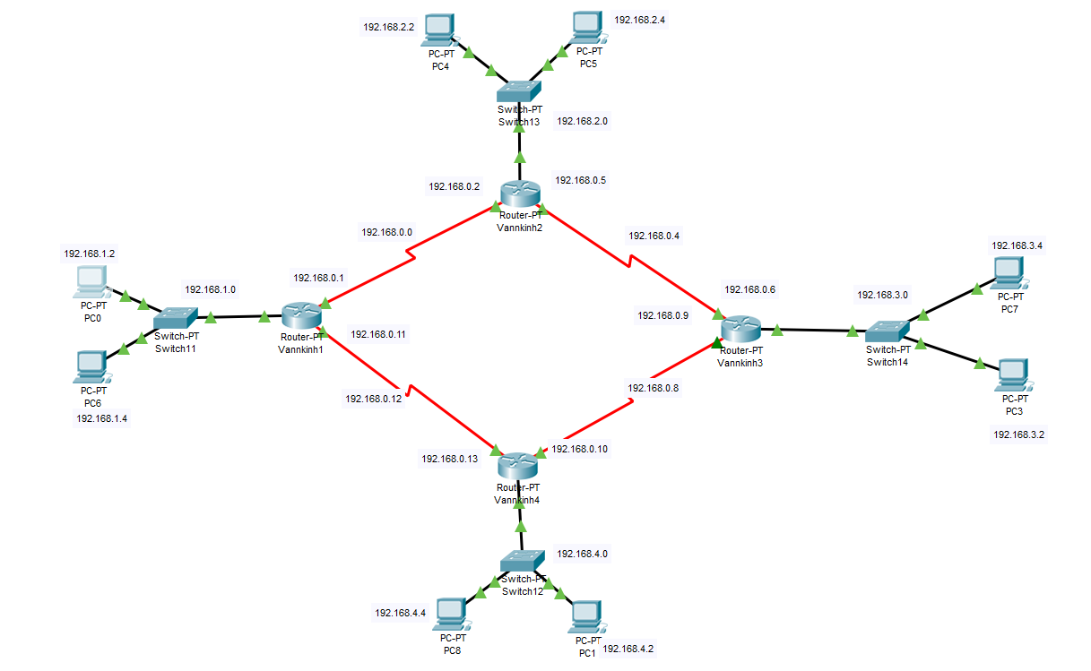This design infrastructure need to be deploy OSPF because this infrastructure can be share router between router and it doesn’t make any sense to use CPU cycles for the routing protocol, since routers inherently know about directly connected networks.