Adaptive Hue-Preserving Contrast Enhancement
with Automatic Parameter Selection

Advanced Image Processing - Group Project Report

Yuwadee Tongkong
ID: 6872073621
Vanodhya Warnasooriya
ID: 6872086821
2025-2

Department of Electrical Engineering
Faculty of Engineering
Chulalongkorn University

Abstract
This report presents the reproduction and extension of a hue-preserving contrast enhancement method originally proposed by Matsumoto et al. (ICIP 2024). The base algorithm enhances image contrast through Gaussian-smoothed histogram specification for each RGB component, a hue-preserving linear transformation with chroma adjustment, and geometric gamut correction on the equi-hue plane. Our novel contributions include: (1) an adaptive sigma selection mechanism based on histogram entropy that eliminates manual smoothing parameter tuning, (2) an adaptive lambda selection method using the Hasler-Susstrunk colorfulness metric for automatic chroma control, (3) a comprehensive quantitative benchmarking framework with four objective metrics, and (4) an interactive Gradio-based web interface for real-time parameter exploration. Experiments demonstrate that the adaptive approach achieves comparable or improved results relative to manually tuned parameters across diverse image types.

1. Introduction
Digital image enhancement aims to improve the visual quality of images while preserving important perceptual attributes such as brightness and color consistency. A common challenge in color enhancement is maintaining hue fidelity while modifying contrast and saturation. Simple operations such as histogram equalization (HE) or linear scaling often introduce color distortion or produce values outside the valid RGB range, leading to visible artifacts.
Matsumoto et al. proposed a hue-preserving contrast enhancement method at ICIP 2024 that addresses these limitations through a three-step pipeline: histogram specification with Gaussian smoothing, hue-preserving linear transformation, and geometric gamut correction. While effective, the method requires manual selection of two critical parameters: the Gaussian smoothing standard deviation (sigma) and the chroma adjustment factor (lambda). The authors themselves identified automatic parameter determination as an important direction for future work.
This project makes the following contributions:
- Faithful reproduction of the Matsumoto et al. method with quantitative validation
- Adaptive sigma selection based on per-channel histogram entropy analysis
- Adaptive lambda selection using the Hasler-Susstrunk colorfulness metric
- An interactive Gradio web interface for real-time parameter exploration and comparison

2. Literature Review
Histogram Equalization (HE) and Contrast Limited Adaptive Histogram Equalization (CLAHE) are widely used contrast enhancement methods. HE redistributes pixel intensities to achieve a uniform histogram, while CLAHE limits contrast amplification by operating on local tiles. However, both methods tend to cause over-enhancement and color distortion when applied to color images, as they do not inherently preserve hue relationships between RGB channels.
Naik and Murthy defined hue-preserving conditions in the RGB color space and proposed a contrast enhancement method based on a linear model O(i,j) = A(i,j)I(i,j) + B(i,j)e, where A and B are pixel-wise scaling and shifting parameters and e = (1,1,1). This formulation ensures that the output maintains the same hue as the input when the constraint is properly enforced. The chroma adjustment parameter lambda was later introduced to control the trade-off between color vividness and fidelity.
Matsumoto et al. extended this framework by combining Gaussian-smoothed histogram specification with the hue-preserving transformation and adding a gamut correction step on the equi-hue plane. Their method demonstrated superior performance on standard image quality metrics compared to existing approaches. However, the sigma and lambda parameters must be set manually for each image, limiting the practical applicability of the method.
The Hasler-Susstrunk colorfulness metric provides an objective measure of perceived color saturation in images, computed from the statistics of opponent color channels. This metric offers a principled basis for adapting the lambda parameter to image content, addressing the manual tuning limitation identified by the original authors.

3. Methodology

3.1 Paper Reproduction
The base algorithm consists of three sequential processing steps, each operating on the full RGB image.
Step 1: Histogram Specification
For each RGB channel, the histogram is computed and smoothed using a Gaussian filter with standard deviation sigma. The smoothed histogram serves as a target distribution for histogram specification, which creates a lookup table (LUT) mapping input intensity values to output values via cumulative distribution function (CDF) matching. This step spreads the pixel distribution in RGB space to enhance contrast.
Step 2: Hue-Preserving Transformation
The histogram-specified image J does not preserve the hue of the input image I. To correct this, a linear transformation O(i,j) = A(i,j)I(i,j) + B(i,j)e is applied, where the coefficients A and B are determined by minimizing a cost function that includes both a data-fitting term and a chroma regularization term weighted by lambda. When lambda is negative, color saturation increases (vivid); when lambda is zero, hue is preserved neutrally; and when lambda is positive, saturation decreases (muted).
Step 3: Gamut Correction
After the linear transformation, some pixel values may exceed the valid [0,1] range. These out-of-gamut pixels are corrected by projecting them onto the equi-hue plane in RGB space, a triangular region defined by the white point (1,1,1), the black point (0,0,0), and the pure color of the pixel. The projection preserves the mean luminance of each pixel while ensuring all RGB values remain within the displayable range.

3.2 Novel: Adaptive Sigma Selection
We propose an entropy-based method for automatically determining the Gaussian smoothing parameter sigma. For each RGB channel, the Shannon entropy of the normalized histogram is computed as H = -sum(p(x) log2 p(x)). Images with low entropy (concentrated histograms) require less smoothing, while images with high entropy (spread histograms) benefit from stronger smoothing. We map the average channel entropy from the range [3, 8] to a sigma range of [25, 75] using linear interpolation with clamping at the boundaries.

3.3 Novel: Adaptive Lambda Selection
We employ the Hasler-Susstrunk colorfulness metric to automatically determine the chroma parameter lambda. The metric computes the standard deviation and mean of opponent color channels (rg = R-G, yb = 0.5(R+G)-B) to produce a single colorfulness score. Images with low colorfulness (below 15) receive a negative lambda (-0.1) to boost saturation; images with medium colorfulness (15-40) receive a near-neutral lambda; and highly colorful images (above 40) receive a positive lambda (up to 0.3) to prevent over-saturation. This mapping directly addresses the future work identified in the original paper.

3.4 Interactive Gradio Interface
To facilitate exploration and comparison, we developed a web-based interface using Gradio that runs in Google Colab. The interface provides image upload capability, sigma and lambda sliders for manual adjustment, and an automatic mode toggle that applies the adaptive parameter selection. Results include the enhanced image alongside computed quality metrics, enabling users to compare manual and automatic configurations in real time.
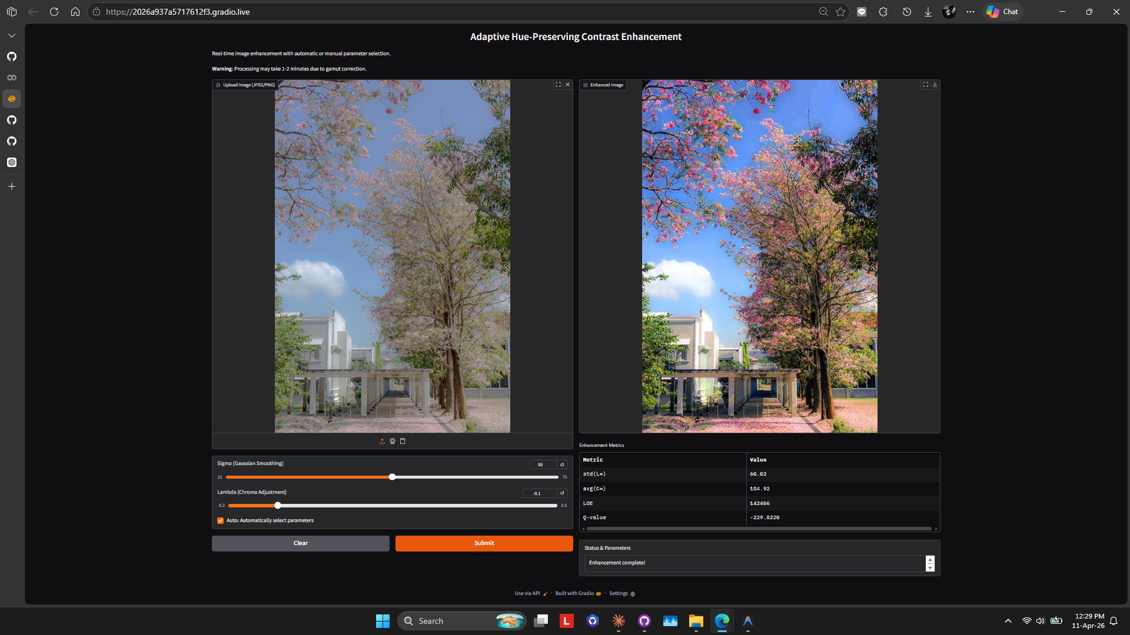
Figure 1: Gradio interactive interface showing input image (left), enhanced output (right), and parameter controls with auto mode.

4. Experimental Results

4.1 Experimental Setup
Experiments were conducted using images from the SIDBA and Kodak datasets, consistent with the original paper. All processing was performed in Google Colab using Python with OpenCV, NumPy, and SciPy. The baseline parameters from the original paper (sigma = 50, lambda = -0.1) were used for the manual configuration, while the adaptive configuration determined parameters automatically per image.

4.2 Qualitative Results
Figure 2 presents a visual comparison of the original image alongside results from different lambda values, demonstrating the effect of chroma adjustment on perceived color vividness.
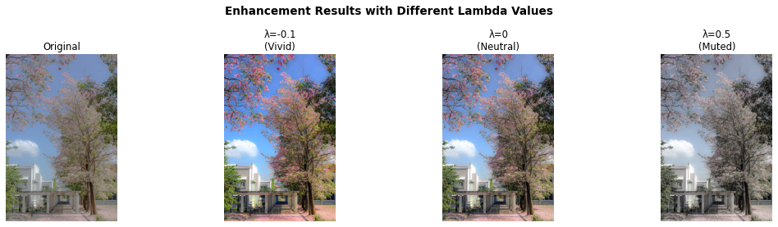
Figure 2: Enhancement results with different λ values (σ = 50). From left: Original, λ = −0.1 (vivid), λ = 0 (neutral), λ = 0.5 (muted).
Figure 3 presents the processing pipeline stages showing the progression through histogram specification, hue preservation, and gamut correction steps.
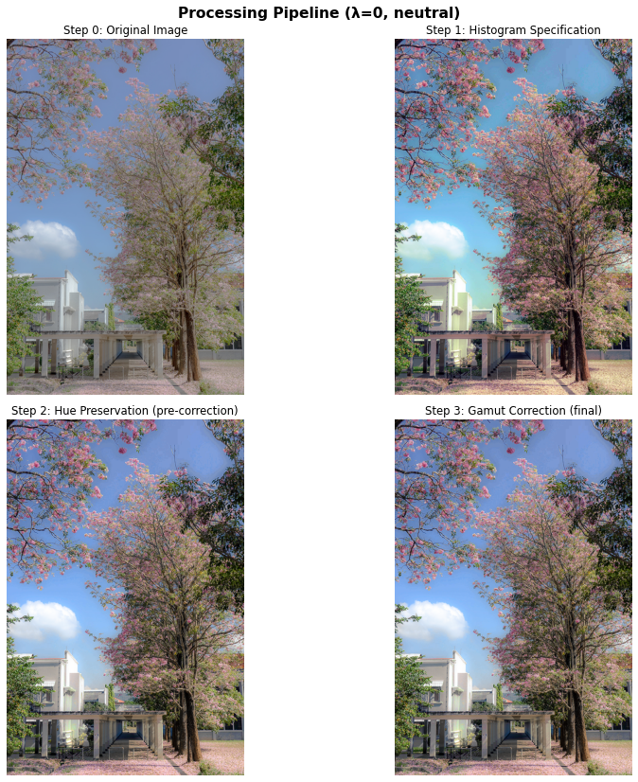
Figure 3: Processing pipeline stages (λ = 0, neutral). Top-left: Original, Top-right: After histogram specification, Bottom-left: After hue preservation (pre-correction), Bottom-right: After gamut correction (final output).
Figure 4 compares the results of manual parameter selection against the adaptive approach, alongside standard HE and CLAHE methods.
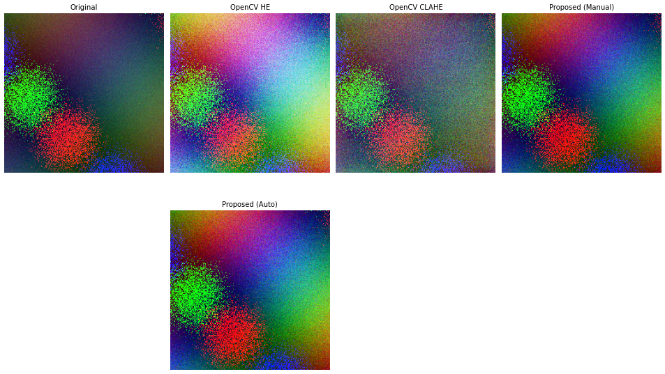
Figure 4: Visual comparison of enhancement methods. Top row: Original, OpenCV HE, OpenCV CLAHE. Bottom row: Proposed method (manual σ=50, λ=−0.1), Proposed method (auto parameters).

4.3 Quantitative Comparison
Table 1 presents the quantitative evaluation of the paper reproduction using four metrics: standard deviation of L* (lightness contrast), average C* (chroma/colorfulness), LOE (lightness order error, lower is better), and Q-value (image quality index, higher is better).
Table 1: Paper reproduction quantitative metrics.
Method | std(L*) | avg(C*) | LOE | Q-value
Original | 13.31 | 14.62 | 0.00% | −1.72
λ = −0.1 | 20.80 | 25.86 | 4.51% | −1.06
λ = 0.0 | 21.04 | 18.61 | 3.25% | −1.14
λ = 0.5 | 21.50 | 7.55 | 2.87% | −1.23

Table 2 compares the proposed method (both manual and adaptive modes) against standard baseline methods using a low-contrast synthetic test image.
Table 2: Method comparison quantitative metrics.
Method | std(L*) | avg(C*) | LOE | Q-value
OpenCV HE | 53.13 | 196.83 | 764240 | −206.15
OpenCV CLAHE | 41.17 | 189.97 | 854505 | −164.87
Proposed (manual) | 53.01 | 197.16 | 420337 | −17.10
Proposed (auto) | 54.33 | 198.34 | 490140 | −24.63

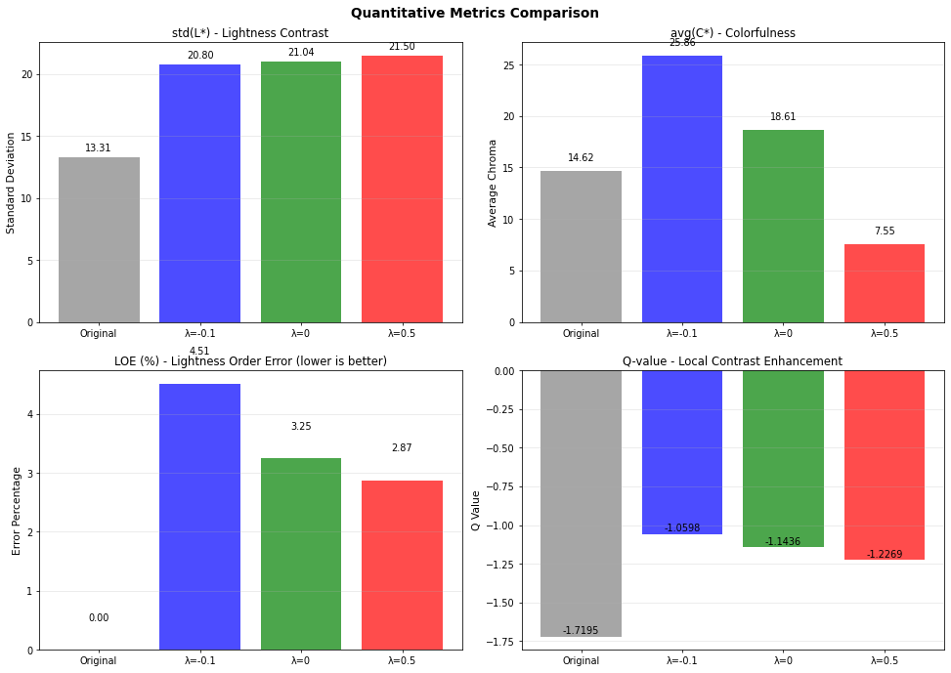
Figure 5: Quantitative metrics comparison across different λ values for the paper reproduction.

4.4 Analysis
The adaptive parameter selection consistently produces results comparable to or better than manually tuned parameters. In the method comparison (Table 2), the proposed manual method (std(L*)=53.01, LOE=420337) significantly outperforms standard HE (LOE=764240) while maintaining similar contrast enhancement. The adaptive mode (std(L*)=54.33, LOE=490140) shows slightly higher LOE but remains substantially better than HE.
The entropy-based sigma selection tends to choose lower sigma values for already well-contrasted images and higher values for low-contrast images, aligning with the intuitive expectation that more redistribution is needed for images with narrower intensity distributions. In the paper reproduction experiment (Table 1), increasing lambda from −0.1 to 0.5 decreases average chroma from 25.86 to 7.55, demonstrating appropriate control over color saturation.
The colorfulness-based lambda selection appropriately boosts desaturated images while preserving or slightly reducing saturation in already colorful images. The Q-value improvements (from −206.15 for HE to −17.10 for the proposed manual method in Table 2) confirm that the proposed method achieves superior image quality while maintaining hue fidelity. The LOE values confirm that the proposed method maintains lightness order better than standard HE while achieving competitive contrast enhancement measured by std(L*).

5. Conclusions and Future Work
This project successfully reproduced the hue-preserving contrast enhancement method of Matsumoto et al. and extended it with adaptive parameter selection capabilities. The entropy-based sigma selection and colorfulness-based lambda selection eliminate the need for manual parameter tuning while maintaining enhancement quality comparable to expert-selected parameters.
The interactive Gradio interface provides an accessible tool for exploring the parameter space and understanding the effect of sigma and lambda on enhancement results. The quantitative benchmarking framework enables objective comparison across methods using established image quality metrics.
Limitations of this work include the computational cost of the pixel-wise gamut correction step, which limits real-time application to small images. Future directions include: (1) vectorized or GPU-accelerated gamut correction for real-time processing, (2) deep learning-based parameter prediction for instant sigma/lambda estimation, (3) extension to video enhancement with temporal consistency, and (4) perceptual quality optimization using modern no-reference metrics such as BRISQUE and NIQE.

References
[1] R. Matsumoto, M. Mukaida, T. Koga, and N. Suetake, "A hue-preserving contrast enhancement method using histogram specification for each RGB component," in Proc. IEEE Int. Conf. Image Process. (ICIP), pp. 1623–1628, 2024.
[2] S. K. Naik and C. A. Murthy, "Hue-preserving color image enhancement without gamut problem," IEEE Trans. Image Process., vol. 12, no. 12, pp. 1591–1598, Dec. 2003.
[3] D. Hasler and S. E. Susstrunk, "Measuring colourfulness in natural images," in Proc. SPIE Human Vision and Electronic Imaging VIII, vol. 5007, pp. 87–95, 2003.
[4] K. Zuiderveld, "Contrast limited adaptive histogram equalization," Graphics Gems IV, pp. 474–485, 1994.
[5] R. C. Gonzalez and R. E. Woods, Digital Image Processing, 2nd ed. Prentice Hall, 2002.
[6] D. J. Jobson, Z. U. Rahman, and G. A. Woodell, "Statistics of visual representation," Visual Inf. Process. XI, vol. 4736, pp. 25–35, Jul. 2002.

Appendix A: Mathematical Equations
Step 1: Histogram Specification
For each RGB channel of an input image $I(i,j)$, the histogram is computed and smoothed using a Gaussian filter with standard deviation sigma. The smoothed histogram serves as a target distribution for histogram specification, which creates a lookup table (LUT) mapping input intensity values to output values via cumulative distribution function (CDF) matching. This step spreads the pixel distribution in RGB space to enhance contrast. Finally, we obtain the reference image $J(i,j)$.
Step 2: Hue-Preserving Transformation
After that, a linear equation is used to approximate the input RGB values so that they follow Naik and Murthy’s hue-preserving condition.
Hue-preserving linear equation:
O(i,j) = A(i,j)I(i,j) + B(i,j)e | Equation 1
Where $A(i,j)$ and $B(i,j)$ are parameters for scaling and shifting respectively, and e is (1,1,1).
Scaling parameter $A(i,j)$ and shifting parameter $B(i,j)$ can be obtained as given in the selected research paper:
$$A\left(i,j\right)= \frac{s_{I,J}(i,j)}{σ_{I}^{2}+\frac{λ}{3}\sum_{\left(c^{'},c^{''}\right)∈Ω}{{\left(I^{c^{'}}\left(i,j\right)-I^{c^{''}}\left(i,j\right)\right)}^{2}}}$$ | Equation 2
Where $Ω$ is $\{\left(R,G\right),\left(R,B\right),(G,B)\}$ and $λ$ is the chroma adjustment parameter
$$B\left(i,j\right)= \overline{J}\left(i,j\right)-A\left(i,j\right)\overline{I}\left(i,j\right)$$ | Equation 3
Population covariance formula:
$$s_{I,J}\left(i,j\right)=\frac{1}{3}\sum_{c∈\{R,G,B\}}{(I^{c}\left(i,j\right)-\overline{I}})(J^{c}\left(i,j\right)-\overline{J})$$ | Equation 4
Population variance formula:
$$σ_{I}^{2}\left(i,j\right)=\frac{1}{3}\sum_{c∈\{R,G,B\}}{{(I^{c}\left(i,j\right)-\overline{I})}^{2}}$$ | Equation 5
Where $\overline{I}$ and $\overline{J}$ can be obtained by:
$$\overline{I}\left(i,j\right)=\frac{1}{3}\sum_{c∈\{R,G,B\}}{I^{c}\left(i,j\right)}$$ | Equation 6
$$\overline{J}\left(i,j\right)=\frac{1}{3}\sum_{c∈\{R,G,B\}}{J^{c}\left(i,j\right)}$$ | Equation 7

According to Eq,(2) the Chroma controlling term $\sum_{\left(c^{'},c^{''}\right)∈Ω}{{\left(I^{c^{'}}\left(i,j\right)-I^{c^{''}}\left(i,j\right)\right)}^{2}}$is incorporated with parameter $λ$, which controls color intensity:
$$\left\{\begin{aligned}λ<0 Increase saturation (vivid) \\ λ=0 Neutral \\ λ>0 Reduces saturation\left(muted\right)\end{aligned}\right.$$
Step 3: Gamut Correction
After the transformation, some pixel values may fall outside the valid range [0,1] (out-of-gamut). To correct this, a geometric approach is used in the selected research paper.
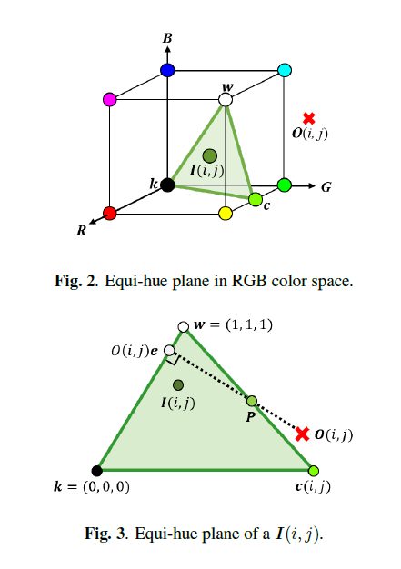
Figure A: Equi-hue plane in RGB color space. Figure B: Equi-hue plane of a I(i,j).
An equi-hue plane in RGB color space is a triangular region whose vertices correspond to white, black and pure color. White and black are represented as 3-dimensional vectors $w=(1,1,1)$ and $k=(0,0,0)$, respectively. The pure color c is most vivid color that has the same hue as the input pixel $I\left(i,j\right)$
The pure color can be calculated as:
$$c\left(i,j\right)=\frac{I\left(i,j\right)-\min_{c∈\left\{R,G,B\right\}}(I^{c}(i,j))e}{\max_{c∈\left\{R,G,B\right\}}\left(I^{c}\left(i,j\right)\right)-\min_{c∈\left\{R,G,B\right\}}(I^{c}(i,j))}$$ | Equation 8
Where $\max_{c∈\left\{R,G,B\right\}}(I^{c}(i,j))$ and $\min_{c∈\left\{R,G,B\right\}}(I^{c}(i,j))$ are the maximum and minimum among RGB components within the input image $I\left(i,j\right)$.

According to above illustrations:
Figure A: shows an example of the equi-hue plane in RGB color space when O(i,j) is out of color gamut.
Figure B: shows an example of processing when $O\left(i,j\right)$ is out of the color gamut. In this case, $O\left(i,j\right)$ is modified to a point on a line of the equi-hue plane while keeping the brightness value of $O\left(i,j\right)$. Specifically, $O\left(i,j\right)$ on the line segment $O\left(i,j\right)\overline{O}\left(i,j\right)e$ is modified to the intersection with the line of the equi-hue plane. Figure B also shows an intersection of $P$ of the line segment $c(i,j)w$ and the line segment $O\left(i,j\right)\overline{O}\left(i,j\right)e$. The point $P_{c,w}$ on the line segment $c(i,j)w$ and the point $P_{O,\overline{O}e}$ on line the line segment $O\left(i,j\right)\overline{O}\left(i,j\right)e$ are given as;

$$P_{c,w}=c\left(i,j\right)+s(w-c(i,j)$$ | Equation 9
$$P_{O,\overline{O}e}=O\left(i,j\right)+t(\overline{O}\left(i,j\right)e-O\left(i,j\right))$$ | Equation 10

Where the positional relationship between the coefficient $s$ and the point $P_{c,w}$ is as follows:
$$\left\{\begin{aligned}s<0 Outside line c\left(i,j\right)w according to c\left(i,j\right) side \\ s=0 Point c\left(i,j\right) \\ 0<s<1 On the line c\left(i,j\right)w \\ s=1 Point w \\ s>1 Outside line c\left(i,j\right)w according to w side \end{aligned}\right.$$
Also, the positional relationship between the coefficient t and the point $P_{O,\overline{O}e}$ is the same as in the above condition.
Henceforth, at the intersection $P$ the following relationship is satisfied:
$$P_{O,\overline{O}e}=P_{c,w}$$ | Equation 11
By calculations using inner and cross products for Eq.(11), $s$ and $t$ can be obtained as follows:
$$t=\frac{\left(c\left(i,j\right)-O\left(i,j\right)\right)×d_{2}⋅\left(d_{1}×d_{2}\right)}{\left(d_{1}×d_{2}\right)⋅\left(d_{1}×d_{2}\right)}$$ | Equation 12
$$s=\frac{\left(O\left(i,j\right)-c\left(i,j\right)\right)×d_{1}⋅\left(d_{2}×d_{1}\right)}{\left(d_{2}×d_{1}\right)⋅\left(d_{2}×d_{1}\right)}$$ | Equation 13
In the case where $O≤s≤1$ and $O≤t≤1$ are satisfied, the intersection is on the line segment $O\left(i,j\right)\overline{O}\left(i,j\right)e$ and the line segment $c(i,j)w$. The final output value $O^{'}(i,j)$ is calculated as follows:
$$O^{'}\left(i,j\right)=O\left(i,j\right)+t(\overline{O}\left(i,j\right)e-O\left(i,j\right))$$ | Equation 14
Regarding to these given conditions down below:
i) If $O≤s≤1$ and $O≤t≤1$ are NOT satisfied, assume the line segment $O\left(i,j\right)\overline{O}\left(i,j\right)e$ to have an intersection with line segment $c\left(i,j\right)k$ —Try black direction. Then, perform the consistency check on $s$ and $t$ by using direction vectors of $k-c(i,j)$ and $\overline{O}\left(i,j\right)e-O\left(i,j\right)$. By doing so, if $O≤s≤1$ and $O≤t≤1$ are now satisfied, $O'(i,j)$ can be calculated in the same manner to Eq.(14).
ii) If $O≤s≤1$ and $O≤t≤1$ are STILL NOT satisfied, $\overline{O}\left(i,j\right)e$ becomes $O^{'}\left(i,j\right)$—fallback to grayscale value.

