**GitHub**

**What is GitHub?**

GitHub is a code hosting platform for version control and collaboration. It lets you and others work together on projects from anywhere.

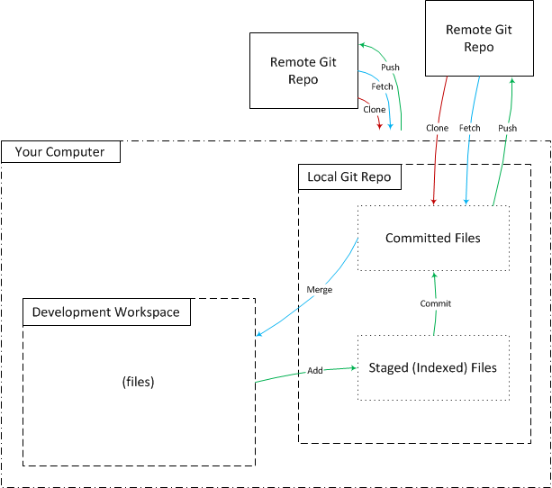

**Concept 1: Repositories**

Git has two repository types: local and remote.  The local repo is on your computer for only your direct use.  The remote repo is typically elsewhere and for your indirect use.  Git supports multiple remote repositories.

## **Remote Repo**

Typically, we work in teams and need to work on a codebase together.  The codebase is on a “central” server and people retrieve files from it and commit to it.

Git refers to the centralized server as a “remote repository”.  The remote repo is usually not on your machine and is the one shared by the team. The team “pushes” commits to it when ready to share with the team.

## **Local Repo**

The local repo is on your computer and has all the files and their commit history, enabling full diffs, history review, and committing when offline.  This is one of the key features of a “distributed” version control system (DVCS), locally having the full repository history.

### **Creation**

You have two options to get a local repository onto your machine: you can either create a new, empty one or clone it from an existing remote repository.

## **Creating a Local Repo from a Remote Repo**

Use the Git clone command to create a local repo with all of the remote repo’s history.  Only use this command once to create the local repo from a remote.

### **Example**

$ git clone <http://username@hostname.com/giturl/gitreponame.git>

# Concept 2: Committing is a Multi-Step Process

1. Add. This copies new or updated files to the “stage” or “index”
2. Commit. This copies your staged files to the local repo.
3. Push. This copies your files from the local repo to the remote repo (only the changes the remote repos does not have

### **Examples**

$ git add .

$ git commit -m "This is a basic commit message."

$ git push

**Git BASH**

Git for Windows provides a BASH emulation used to run Git from the command line

**Installation of Gitbash**

<https://gitforwindows.org/>