1# Main URL.
https://www.techiedelight.com/data-structures-and-algorithms-problems/

Total 687 links.

2# Need to arrange as per category filter.
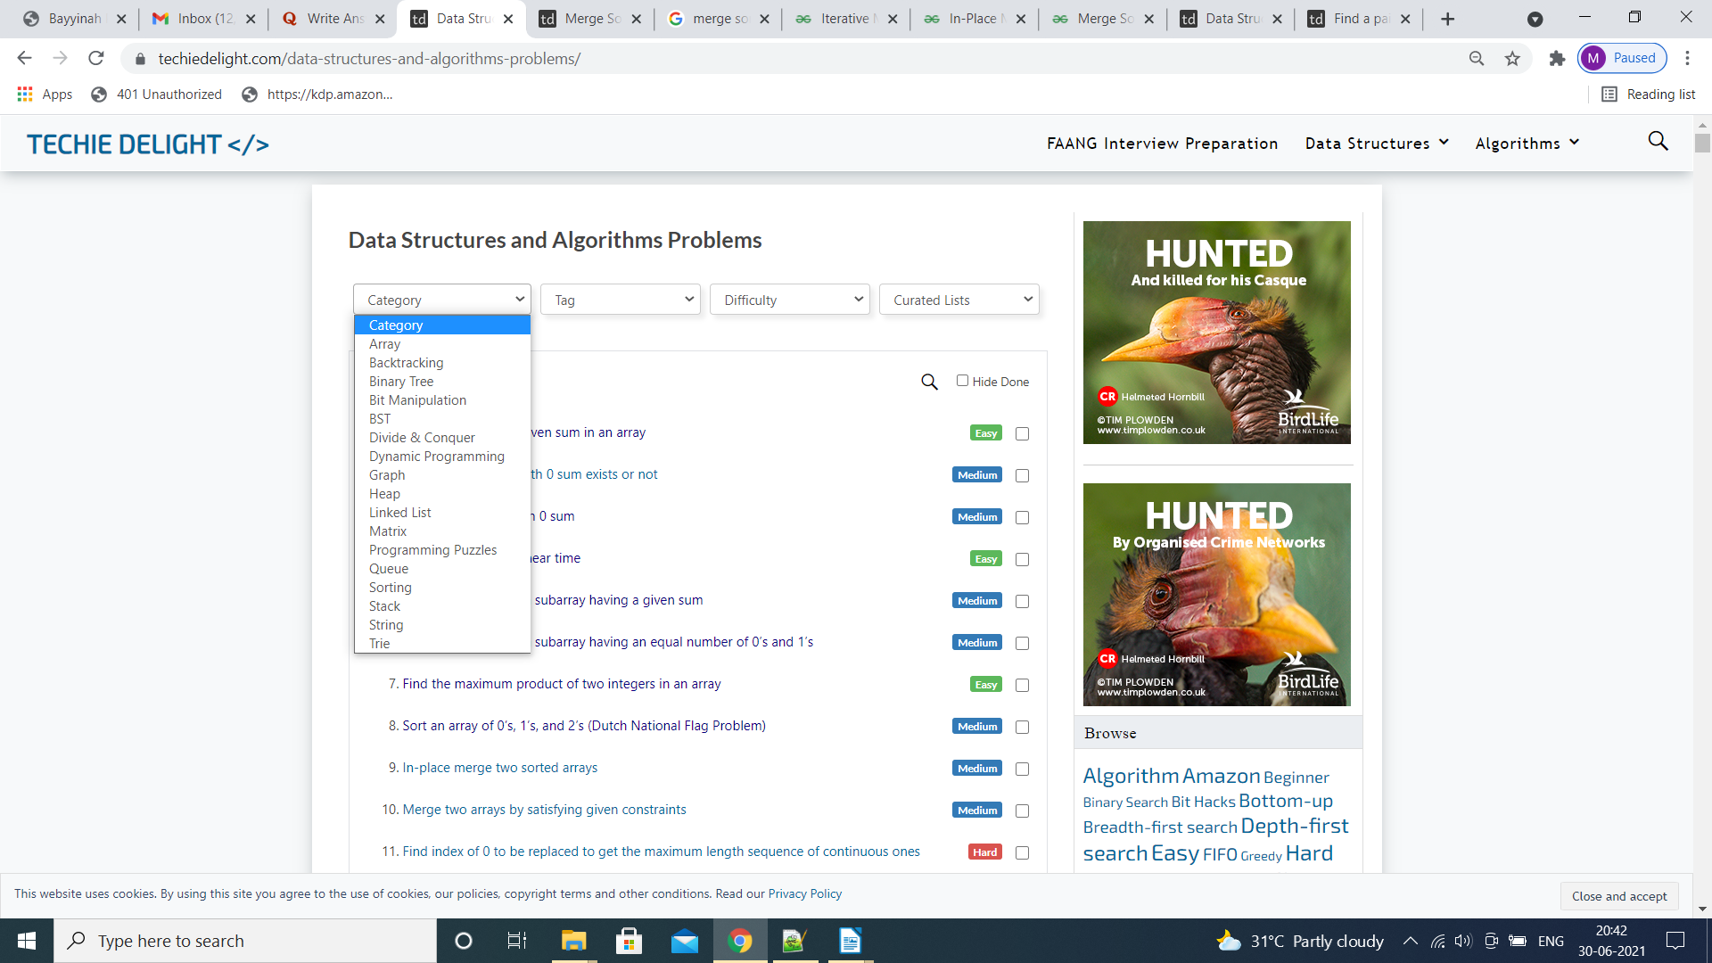
3# For arrays – it shows 210 links.
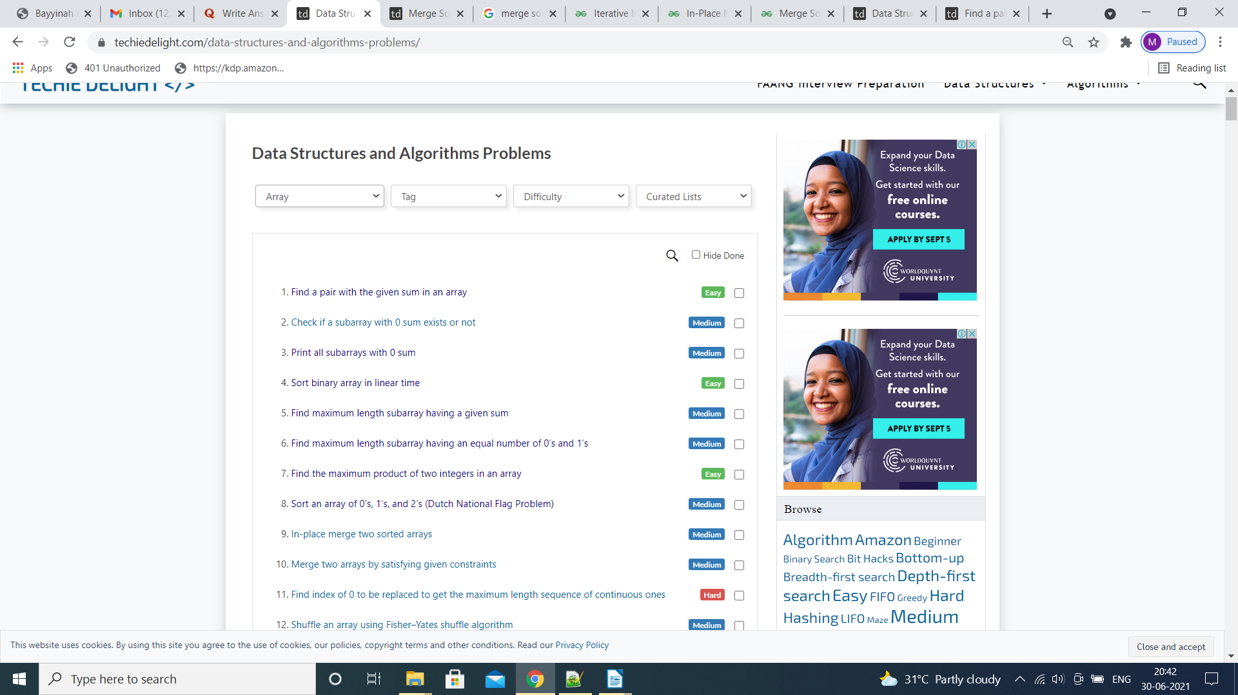
Likewise, for each category need to sort the 687 links

4# To get the required Data records.
For arrays.

1st
For the 1st record.
https://www.techiedelight.com/find-pair-with-given-sum-array/

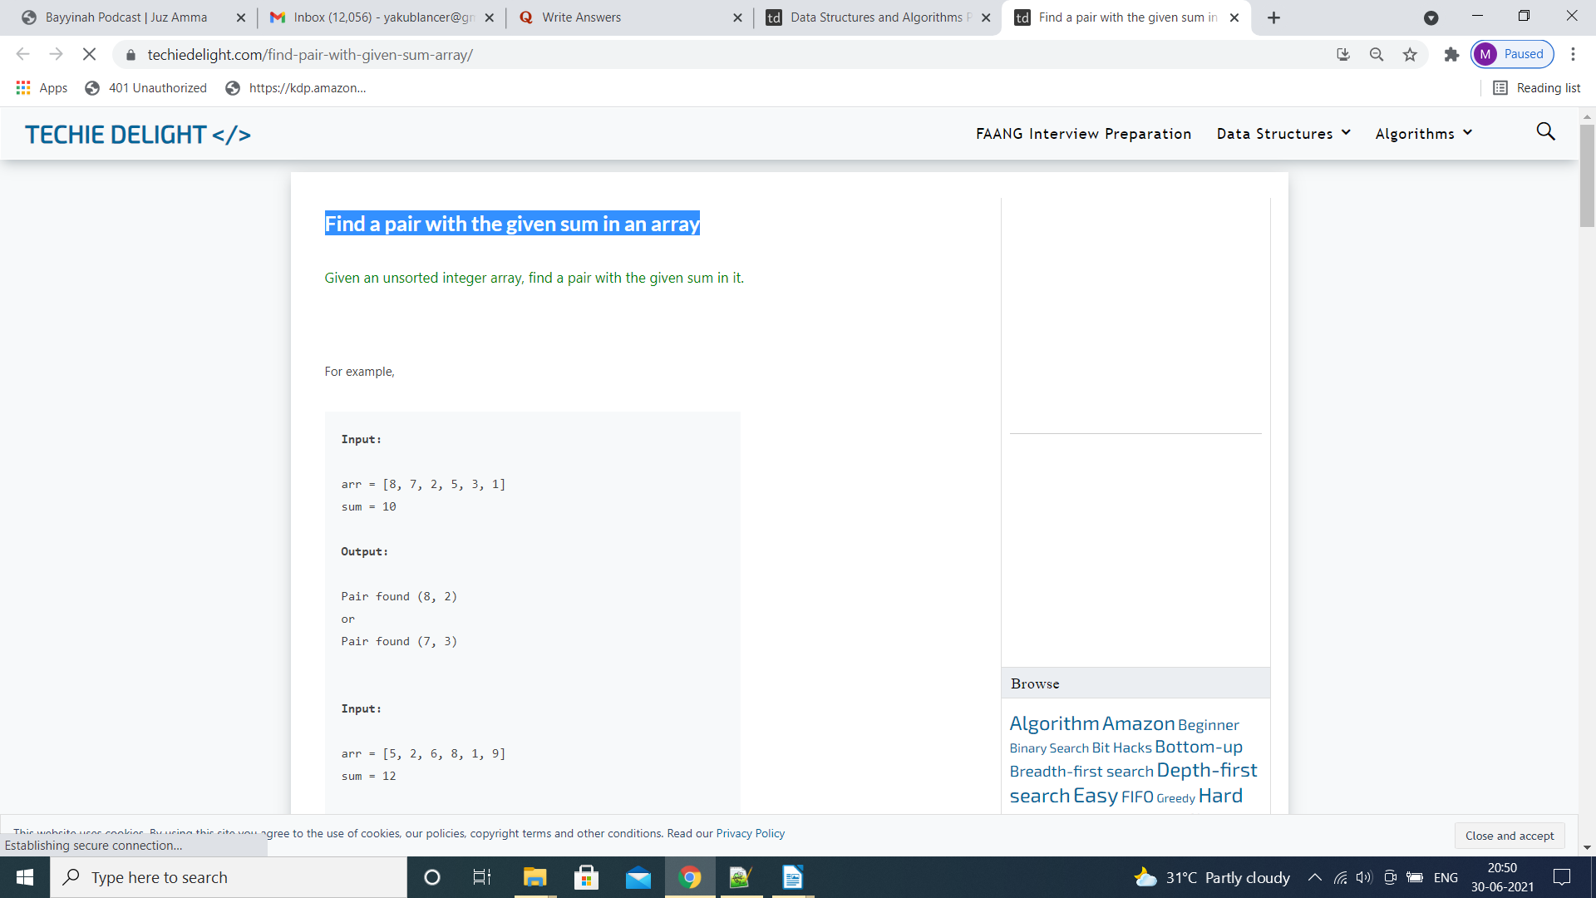
Select the title : Find a pair with the given sum in an array

Select the title and put in search box of google.com with geeksforgeeks suffix as given below.

Find a pair with the given sum in an array geeksforgeeks

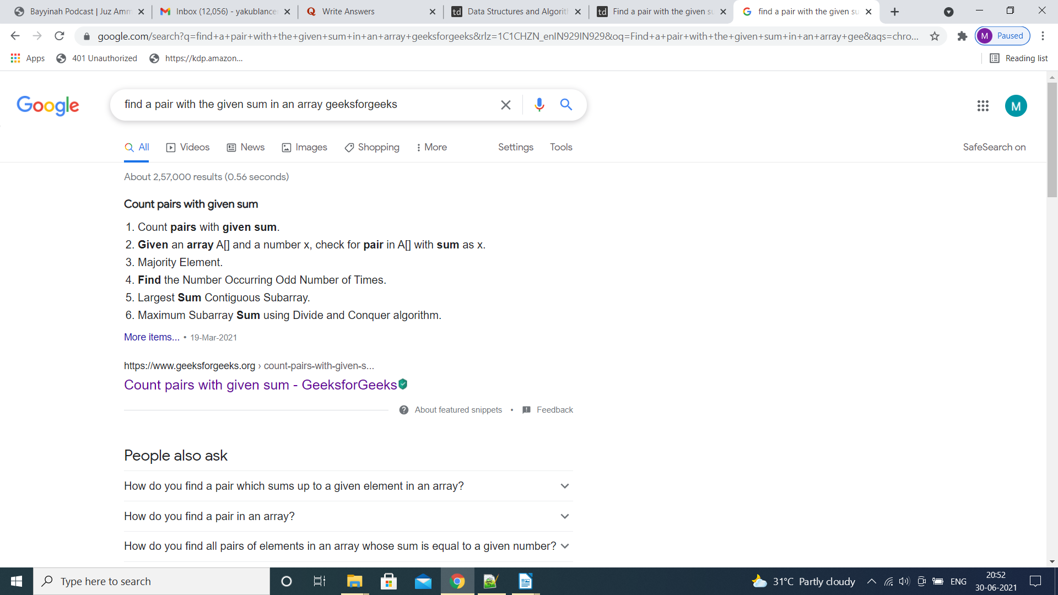
Need to copy the hyperlinks related to geeksforgeeks only on the 1st page of google search results.

We will get the following links.
https://www.geeksforgeeks.org/count-pairs-with-given-sum/
https://www.geeksforgeeks.org/given-an-array-a-and-a-number-x-check-for-pair-in-a-with-sum-as-x/
https://www.geeksforgeeks.org/print-all-pairs-with-given-sum/
https://www.geeksforgeeks.org/count-pairs-with-given-sum-set-2/
https://www.geeksforgeeks.org/given-a-sorted-and-rotated-array-find-if-there-is-a-pair-with-a-given-sum/
https://www.geeksforgeeks.org/find-pairs-in-array-whose-sums-already-exist-in-array/

In many cases, the link of counts related to geeksforgeeks could be less like 2/3/
We need to repeat this exercise for the title of 687 page links which are from the main url and strictly maintaining the Category & Difficulty

5# The CSV format file attached showing the sample record.

