**Workflow:** Slack Notification upon receiving Gmail email

**Purpose:** To automate notification of received Gmail emails to Slack

**Sequence:**

1. **Gmail Trigger:** This is the starting point of the workflow. It acts as a listener for specific events within your Gmail account. When a predefined event occurs (e.g., a new email arrives, an email is starred, or an email matches certain criteria), this node "triggers" the workflow to begin.
2. **Gmail (Get: Message):** Following the trigger, this node performs an action within Gmail. Specifically, it's configured to "get: message," meaning it retrieves the details of the email that triggered the workflow. This typically includes the sender, subject, body content, and any attachments.
3. **Slack (Post: Message):** This is the final action node in the workflow. It takes the information retrieved from the Gmail message and "posts: message" to a designated Slack channel or direct message. This effectively relays the content or a summary of the email into Slack.

**In essence, this workflow automates the process of forwarding or notifying a Slack channel about specific emails received in Gmail.**

**Possible Use Cases of This Workflow**

This simple yet powerful workflow can be adapted for numerous practical scenarios, acting as a virtual assistant for various notification and communication tasks:

1. **Urgent Email Alerts:** Receive instant Slack notifications for emails from specific senders (e.g., "CEO," "Critical Alerts") or with urgent keywords in the subject line (e.g., "URGENT," "ERROR," "Downtime").
2. **Customer Support Monitoring:** Forward emails from a support inbox (e.g., support@yourcompany.com) directly to a dedicated Slack support channel, ensuring the team is immediately aware of new inquiries.
3. **Sales Lead Notifications:** Get real-time alerts in a sales Slack channel when new lead inquiries come in via email, including key details like the sender's email and subject.
4. **Newsletter/Subscription Digest:** Consolidate specific newsletters or daily reports received in Gmail into a dedicated Slack channel for easy team review without needing to open email.
5. **Application Monitoring & Error Reporting:** If an application sends error reports or status updates via email, this workflow can push those alerts to a development or operations Slack channel for quick action.
6. **Project Update Notifications:** When project-related emails arrive (e.g., from clients or external collaborators), automatically post them to the relevant project channel in Slack to keep the team informed.
7. **Personal Assistant for Important Communications:** For a busy individual, forward emails from VIP contacts or about specific topics (e.g., "meeting changes," "travel updates") to a personal Slack channel or direct message.
8. **Feedback Channel Integration:** If customer feedback is sent via email, push it to a product feedback Slack channel for discussion and prioritization.
9. **Invoice/Payment Receipt Notifications:** Get Slack alerts when payment confirmations or invoices are received via email, helping track financial transactions.
10. **Security Alerts:** Forward security-related emails (e.g., "login attempt from new device," "password change confirmation") to a security monitoring Slack channel for immediate review.

This workflow serves as a foundational example of how n8n can automate cross-application communication, saving time and ensuring timely information flow.

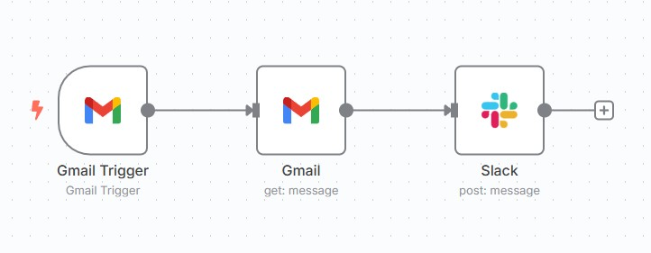*N8n workflow:

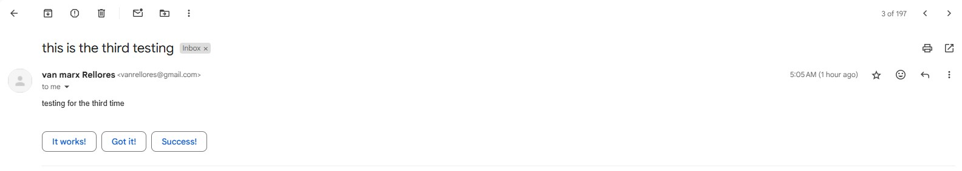*Gmail Email received:

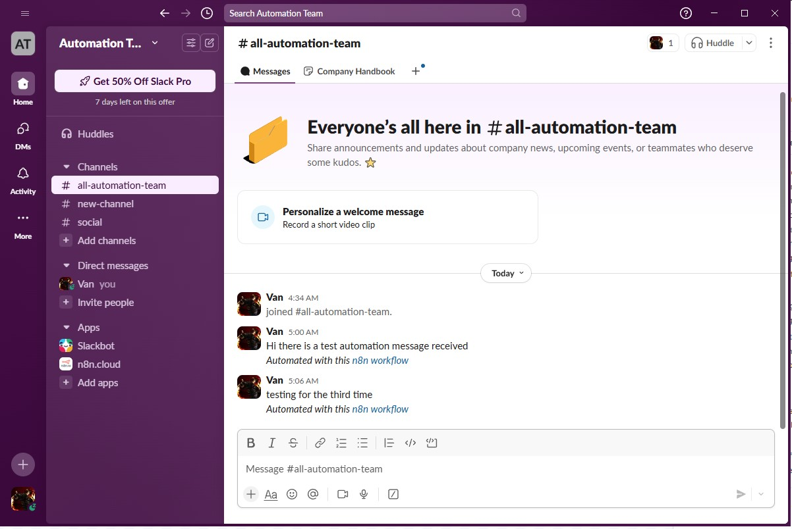*Slack Notification: