**Workflow:** Slack Notification upon receiving Gmail email (with data extraction and interpretation)

**Purpose:** To automate notification of received Gmail emails having specific labels, data extraction, content interpretation and notification to Slack

**Sequence:**

1. **Gmail Trigger:** The workflow initiates upon a specific event occurring in your Gmail account (e.g., a new email arrives, an email matching certain criteria is received). This node captures the context of that email event.
2. **AI Agent (Tools Agent):** This is the core intelligence hub of the workflow. The AI Agent node in n8n is designed to understand natural language instructions, reason, and potentially utilize various "tools" (other n8n nodes or custom functions, though no specific tools are visibly connected in this image's "Tool" input, its capability is inherent) to achieve a goal. It receives the email's content as its input.
3. **Google Gemini Chat Model:** This node powers the AI Agent. It provides the underlying Large Language Model (LLM) capabilities (like understanding, generation, summarization) that the AI Agent uses for its reasoning and processing tasks. The AI Agent sends prompts and context to the Gemini model and receives its responses.
4. **Slack (Post: Message):** After the AI Agent has processed the email, its output (which could be a summary, a generated response, extracted data, or an action recommendation) is then posted as a message to a designated Slack channel or direct message.

**In essence, this workflow automatically monitors your Gmail, uses a sophisticated AI model (Google Gemini) to understand and interpret email content, and then posts the AI's intelligent output to Slack. This is a significant step beyond simple forwarding, as the AI can perform complex analysis and decision-making.**

**Possible Use Cases of This Workflow**

This AI-powered workflow opens up possibilities for automating tasks that require understanding, summarization, and intelligent action based on text content:

1. **Intelligent Email Summarization & Action Item Extraction:**
   * **Use Case:** Automatically summarize long email threads or complex reports received via email.
   * **Automation:** Gmail Trigger -> AI Agent (Gemini summarizes, extracts key decisions, action items, and deadlines) -> Slack (posts a concise summary and a list of action items to a project channel).
2. **Automated Customer Support Triage & Response Drafting:**
   * **Use Case:** Analyze incoming customer support emails, categorize them (e.g., "billing," "technical issue"), identify urgency, and draft preliminary responses.
   * **Automation:** Gmail Trigger (new support email) -> AI Agent (Gemini analyzes email, classifies issue, extracts customer details, drafts a response/internal note) -> Slack (posts the issue category, urgency, and AI-drafted response/summary to the relevant support team's channel).
3. **Meeting Request Parsing & Calendar Suggestions:**
   * **Use Case:** Intelligently parse natural language meeting requests from emails and suggest a structured calendar event.
   * **Automation:** Gmail Trigger (new meeting request email) -> AI Agent (Gemini extracts proposed time, attendees, topic, and even suggests alternative times based on a prompt) -> Slack (posts the extracted details and suggestions to a personal assistant channel for approval).
4. **Lead Qualification from Email Inquiries:**
   * **Use Case:** Automatically qualify potential sales leads based on their email inquiries and send structured lead notifications.
   * **Automation:** Gmail Trigger (new sales inquiry email) -> AI Agent (Gemini analyzes the email, extracts company name, contact person, expressed needs, and scores the lead based on predefined criteria) -> Slack (posts a structured lead notification with qualification score to the sales team channel).
5. **Competitor Monitoring & News Digest:**
   * **Use Case:** Monitor emails from specific news feeds or competitor alerts, summarize the most relevant information, and share it with the team.
   * **Automation:** Gmail Trigger (new alert email) -> AI Agent (Gemini reads the alert, extracts key news, identifies relevant competitor mentions) -> Slack (posts a daily digest of competitor activities or news headlines to a strategy channel).
6. **Complaint & Feedback Analysis:**
   * **Use Case:** Process customer complaints or feedback emails, extract sentiment, identify common themes, and route to appropriate teams.
   * **Automation:** Gmail Trigger (new feedback email) -> AI Agent (Gemini performs sentiment analysis, identifies keywords, categorizes feedback type) -> Slack (posts categorized feedback and sentiment to a product or customer success channel).
7. **Content Idea Generation from Incoming Topics:**
   * **Use Case:** Receive general topic emails or content briefs and have an AI brainstorm related content ideas, headlines, or outlines.
   * **Automation:** Gmail Trigger (email with content topic) -> AI Agent (Gemini generates multiple content ideas, headlines, or a basic outline based on the topic) -> Slack (posts the brainstormed ideas to a content team channel).

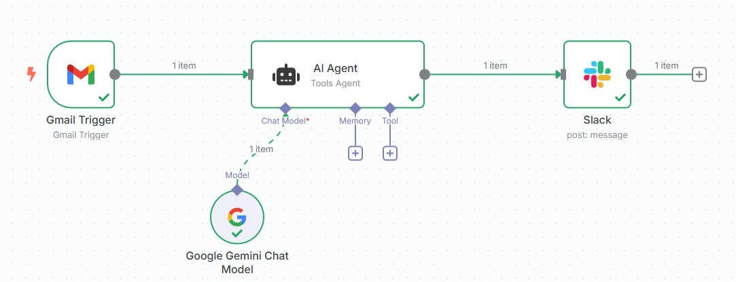*N8n workflow:

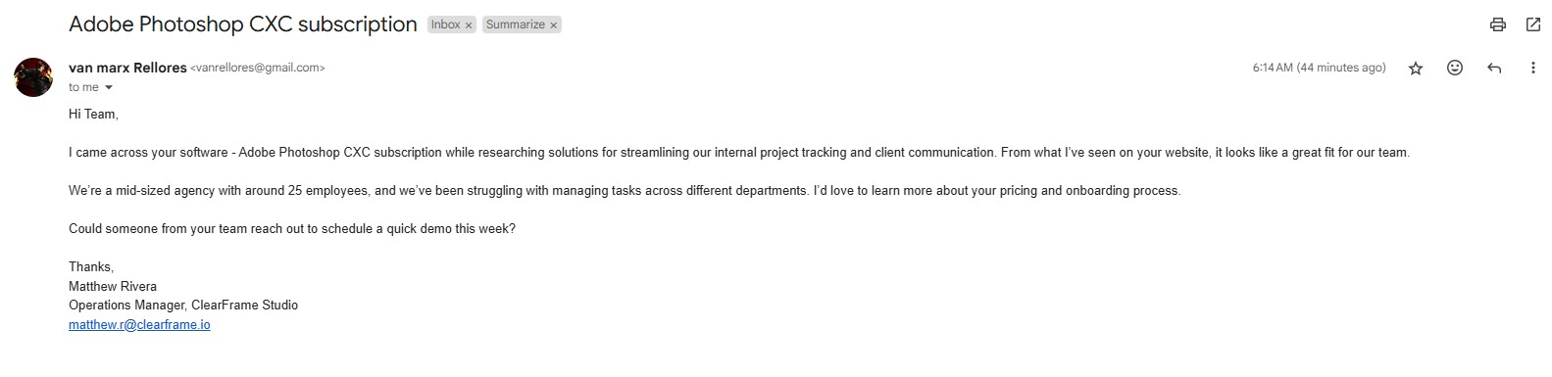*Gmail email received:

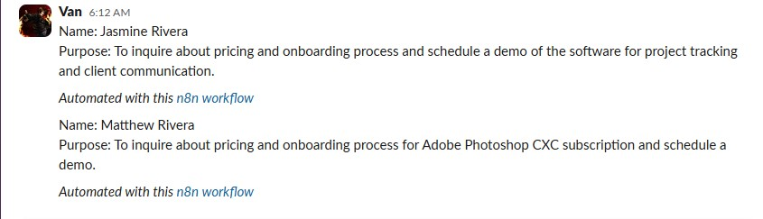*Slack notification: