**Workflow:** File replication from Github push to Google Drive then SNS notification to subscribers

**Purpose:** To automate replication of pushed/uploaded file to Github repository to Google Drive then inform subscribers via email using AWS SNS

**Sequence:**

1. **GitHub Trigger:** This is the starting point of the workflow. It listens for specific events within a designated GitHub repository (e.g., a push to a branch, a new commit, a file upload, or a release event, as suggested by the partial "n8n_fileuploads: p..."). When such an event occurs, it triggers the workflow.
2. **Google Drive (Download: File):** After being triggered by GitHub, this node performs an action in Google Drive. It's configured to "download: file," meaning it retrieves a specific file from a Google Drive location. This file might be a configuration file, a script, a document, or an asset related to the GitHub event.
3. **Google Drive1 (Upload: File):** This node immediately follows the download operation and performs an "upload: file" action to Google Drive. This suggests a file transfer, mirroring, or potentially a processing step in between (even if not explicitly shown). It could be uploading the same downloaded file to a different folder, a modified version of it, or a related file that was created during the process.
4. **AWS SNS (Publish: Message):** This is the final action node. It publishes a message to a specific AWS SNS (Simple Notification Service) topic. This is typically used for sending out notifications, alerts, or initiating further downstream processes (e.g., triggering AWS Lambda functions, sending SMS/emails to subscribers of the SNS topic) to indicate the successful completion of the workflow or details about the GitHub event and file transfer.

**In summary, this workflow automates a synchronization or backup process: a GitHub event kicks off the download of a file from Google Drive, followed by an upload to another Google Drive location, and finally, a notification via AWS SNS about the operation.**

**Possible Use Cases of This Workflow**

This workflow is highly useful for automating tasks in development, DevOps, and content management workflows that involve GitHub, cloud storage, and notifications:

1. **Automated Configuration File Deployment/Sync:**
   * **Use Case:** When a specific configuration file is pushed to a GitHub repository, automatically download an old version from Google Drive, update it, and upload the new version to a deployment-ready Google Drive folder, notifying a deployment team via SNS.
   * **Example:** A settings.json file on GitHub is updated. The workflow downloads a template, merges changes, uploads to /production_configs, and SNS notifies ops.
2. **GitHub Repository Backup to Google Drive:**
   * **Use Case:** Automatically create backups of critical repository files or even the entire repository content (if fetched by a previous node) to a specific Google Drive folder every time there's a push to the main branch.
   * **Example:** A push to main branch -> download source_code.zip from previous backup location (or generate it) -> upload to Google Drive/GitHub Backups/RepoName_Timestamp.zip -> SNS confirms backup.
3. **Versioned Documentation Management with Code Releases:**
   * **Use Case:** When a new release or tag is created on GitHub, download specific documentation files from a "staging" Google Drive folder, move them to a "production" documentation folder (or create a versioned copy), and notify relevant stakeholders.
   * **Example:** GitHub release event -> download UserManual_vX.pdf -> upload to Google Drive/Published Docs/ -> SNS notifies marketing team.
4. **CI/CD Pipeline Stage Notification:**
   * **Use Case:** A GitHub push triggers a build process. This workflow could be a sub-part that downloads build artifacts or test reports from one Drive, uploads them to another for review/archiving, and then SNS notifies about the build status or availability of reports.
   * **Example:** GitHub push -> *[External CI/CD runs]* -> N8n workflow triggered by CI/CD hook -> download test_report.pdf from CI/CD-generated Drive folder -> upload to Google Drive/Test Reports/ -> SNS notifies QA lead.
5. **Asset Syncing for Web Projects:**
   * **Use Case:** If a web project's assets (images, fonts, videos) are managed in Google Drive and referenced in a GitHub repository, this workflow could ensure specific assets are always synced or copied to a "live" folder upon a code update.
   * **Example:** GitHub push to frontend-assets branch -> download updated images -> upload to Google Drive/LiveAssets/ -> SNS notifies frontend team.
6. **Cross-Project Data Transfer & Notification:**
   * **Use Case:** A specific event in a GitHub repository (e.g., closing an issue related to data transfer) triggers the download of data from one Google Drive project folder and uploads it to another, notifying a separate team via SNS.
   * **Example:** GitHub issue closed: "Data Transfer Request" -> download projectX_data.csv -> upload to projectY_intake/ -> SNS notifies Project Y team.

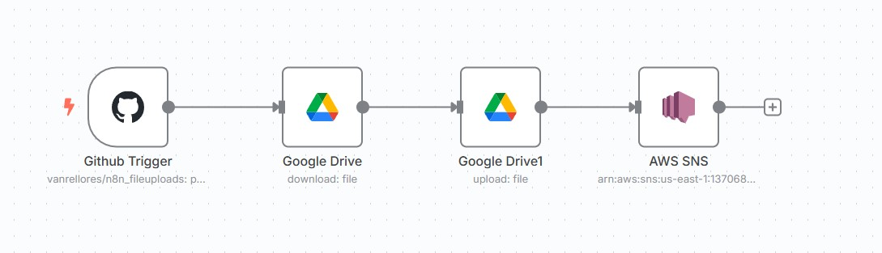*N8n workflow:

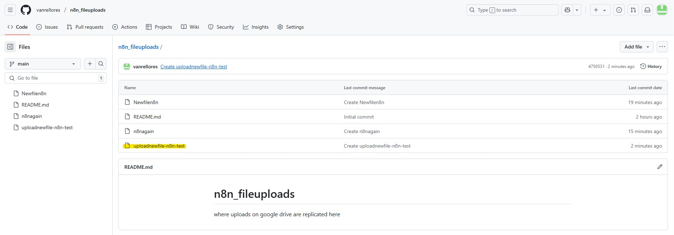*Github Push/Upload to Repo:

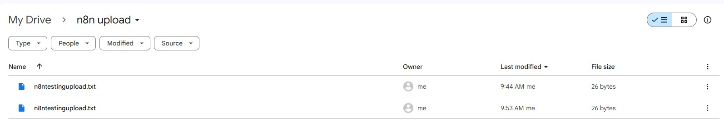*Download file and upload to Google Drive:

*SNS email notification to subscribers:

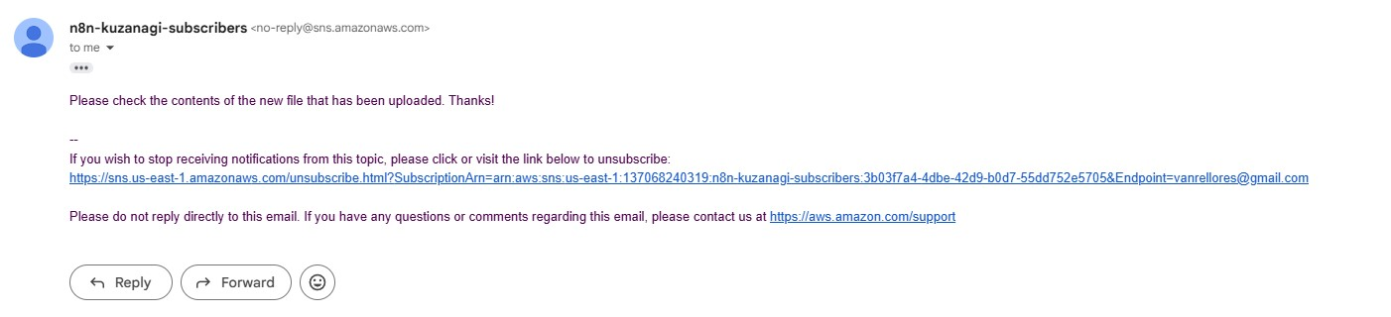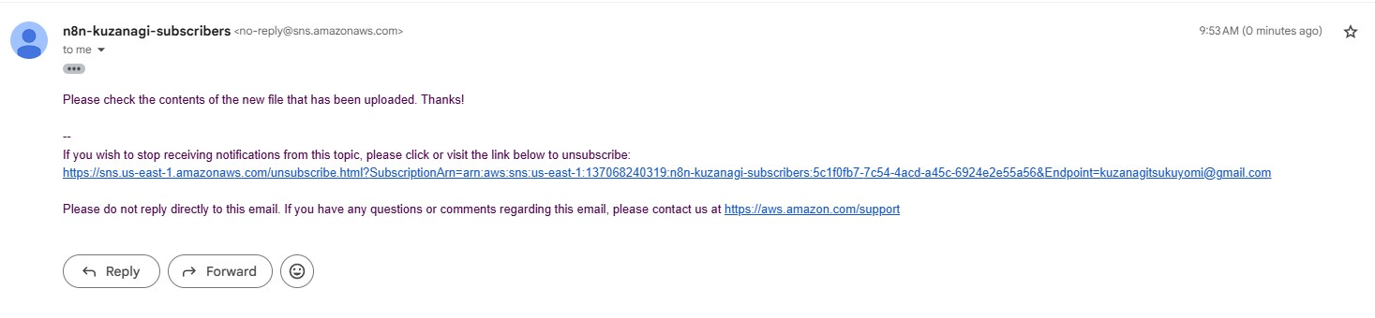(email #1)

(email #2)