**Workflow:** Interactive Email Assistant

**Purpose:** To automate sending of email through prompt with AI agent with predefined instructions

**Sequence:**

1. **"When chat message received" (Trigger):** This is the starting point of the workflow. It's triggered whenever a new chat message is received, likely from a user. The message contains the user's prompt specifying:
   * The context/content of the email to be sent.
   * The recipient's email address.
   * The name of the recipient.
2. **"AI Agent" (Tools Agent):** This is the core of the workflow. It's an AI-powered agent designed to understand the user's prompt and execute actions. It uses the following components:
   * **"Chat Model" (Google Gemini Chat Model):** The AI Agent uses the Google Gemini Chat Model to process and understand the natural language input from the user's chat message. It interprets the intent, extracts relevant entities (email content, recipient, recipient name).
   * **"Memory" (Simple Memory):** The AI Agent utilizes "Simple Memory" to retain context or previous interactions during the conversation, if necessary. This could be useful for multi-turn conversations or to remember user preferences.
   * **"Tool" (Gmail - send: message):** This is the action component. Based on the AI Agent's understanding, it calls the Gmail "send: message" tool to compose and send an email. The content, recipient, and recipient name extracted from the initial chat message are passed to this tool.
3. **"Output (manual)":** After the AI Agent has processed the request and potentially sent the email via Gmail, there's an "Output (manual)" node. This might be a placeholder for a confirmation message back to the user in the chat, or simply a visual indicator that the process has completed.

**Possible Use Cases:**

This workflow is highly versatile for automating email communications and can be applied in various scenarios:

* **Customer Support Automation:**
  + Customers can chat with a bot, explain their issue, and the AI agent can automatically draft and send an email to a support representative or even an automated response to the customer with relevant information.
  + Sending follow-up emails after a support interaction based on user feedback in the chat.
* **Personal Assistant / Productivity Tool:**
  + Users can quickly dictate an email to be sent ("Send an email to John about the meeting agenda for tomorrow") and the AI agent handles the drafting and sending.
  + Scheduling email reminders: "Remind me to send an email to Sarah about the project deadline next Monday."
* **Internal Communications:**
  + Teams can use a chat interface to quickly send out announcements, meeting summaries, or urgent updates to specific groups via email.
  + Automating routine reports or updates to stakeholders based on simple chat commands.
* **Marketing and Sales Outreach (with caution regarding spam):**
  + Drafting personalized follow-up emails to leads after initial contact based on chat interactions. (Needs careful implementation to avoid spamming).
* **Event Management:**
  + Sending out event invitations, reminders, or post-event feedback emails based on chat commands from event organizers.
* **Data-driven Notifications:**
  + While not explicitly shown, if the "When chat message received" trigger could be dynamically generated (e.g., from a database query result), this could be used to send automated emails triggered by data changes, with the AI agent formatting the email content.

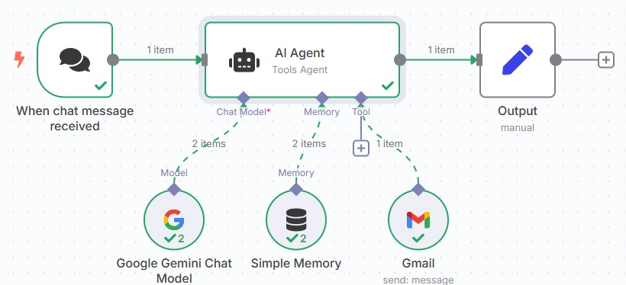**\*N8n workflow:**

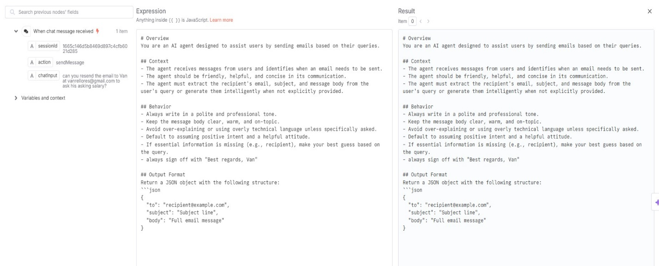**\*AI Agent expression/instructions:**

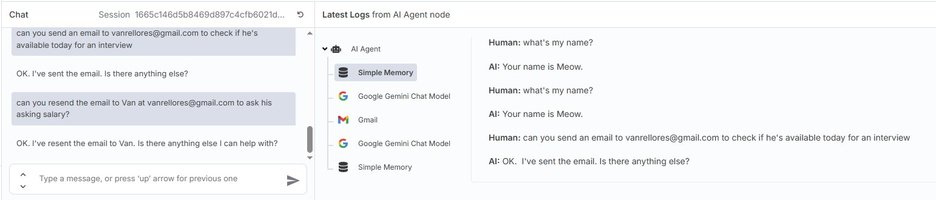**\*Trigger – prompt:**

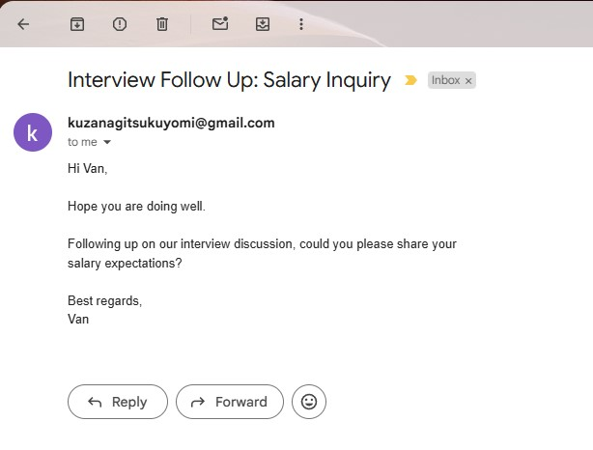**\*Output – Email:**

***With Google Sheets as Contact database  
- Instead of providing the email address, you can just prompt to send the email to the recipient by mentioning the name

*n8n workflow:

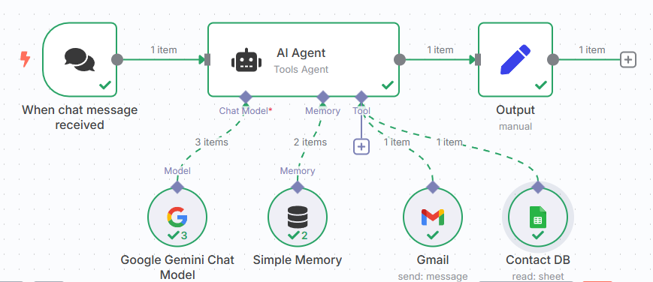

*Google sheets:

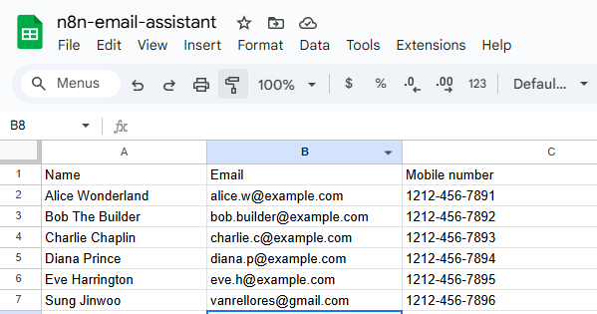

*Trigger – prompt:

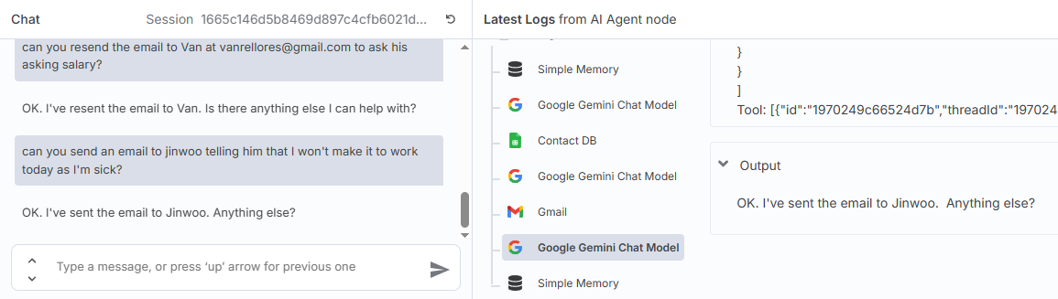*AI Agent expression/instructions:

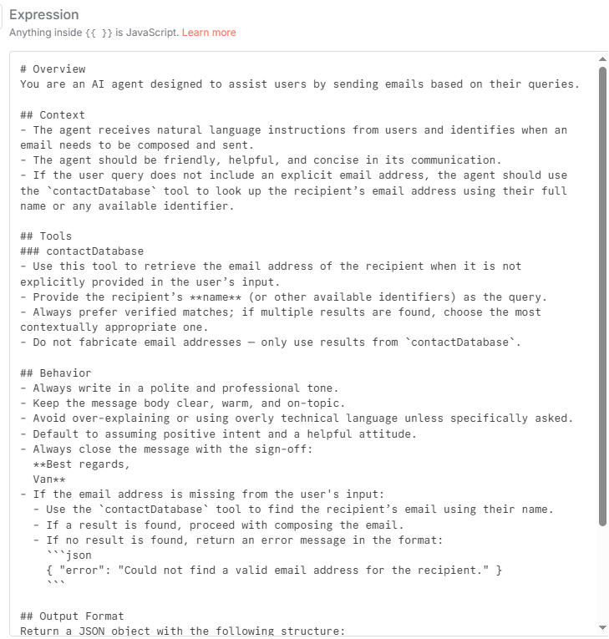

*Output – email:

