Task 1: Nth Fibonacci Number

Description: Write a recursive function that calculates the nth Fibonacci number, where n is a positive integer. The Fibonacci sequence is a series of numbers in which each number is the sum of the two preceding ones, starting with 0 and 1.

Solution:

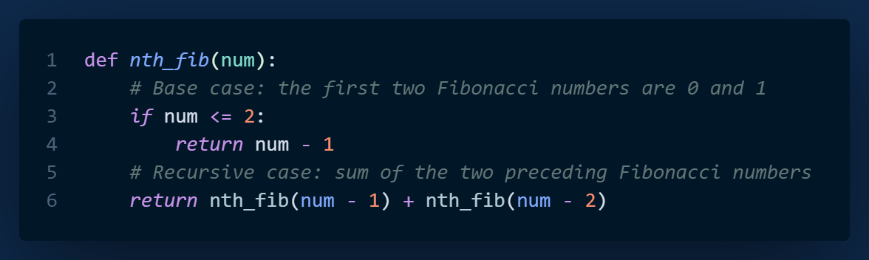

Test Cases:

Output:

Task 2: Reverse String

Description: Write a recursive function that reverses a string. The function should take a string as input and return the reversed string as output.

Solution: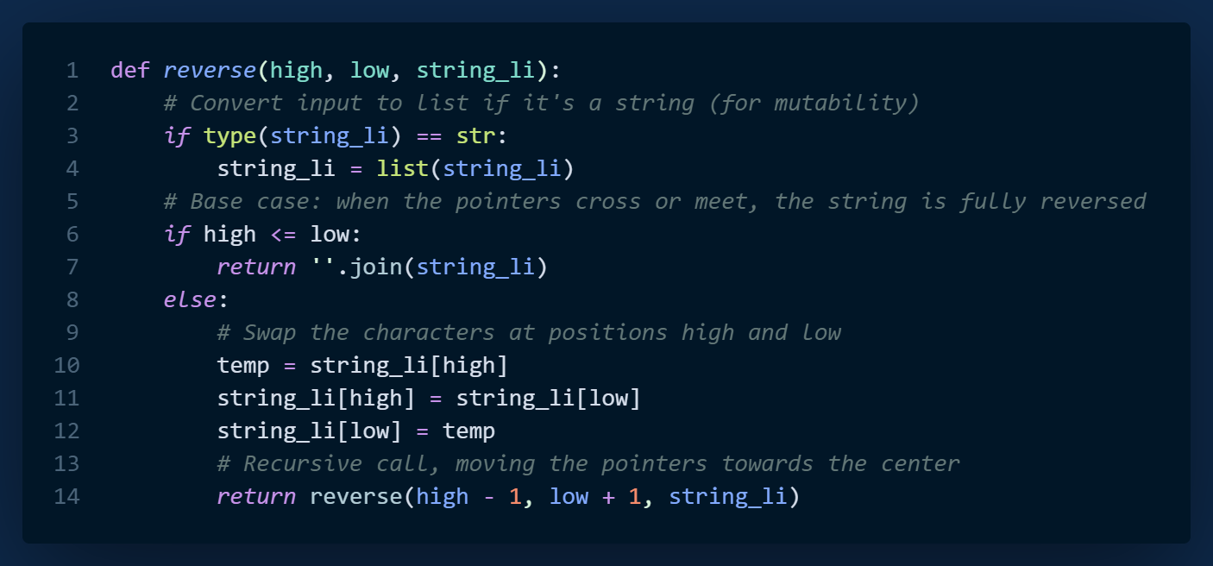

Output:

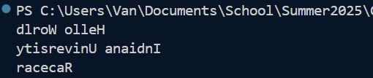

Task 3: Binary Search

Description: Write a recursive function binary_search(arr, target) that performs a binary search on a sorted array arr to find the index of the given target value. If the target is found, return its index; otherwise, return -1.

Solution:

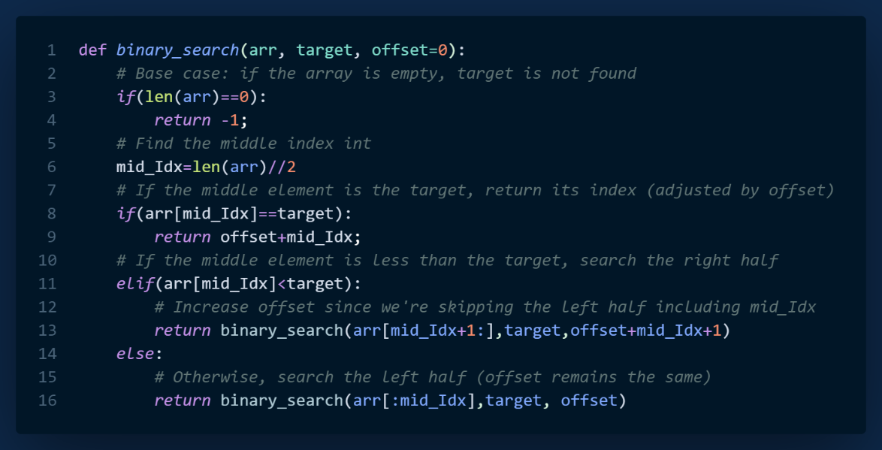

Test Cases:

Output:

