Kill It With Fire design
This will be a platform game where the level is defined by a set color palette and a 16 bit BMP picture which holds all the level data.

We have a bald man (a.k.a. hero man) who has a jetpack and a flamethrower which shoots firey fireballs of death and destruction. He lands in a world full of zombies and other things that want to kill him. He has a very strong desire to eat cake. Fortunately he sees one, but he has to fight through hordes of zombies and obstacles to get there.
The flamethrower and jetpack require fuel and he needs health stay alive.

Entities

We have the following level tiles:
- Ground
- Floor
- Spikes (floor, roof and wall)
- Lava (animated surface and regular lava)

We have the following objects in the game:
- Mushroom: upgrades your flamethrower.. or zombies.
- Fuel barrel: refuels
- Hamburger: heals you
- Savepoint: if you pass it you will respawn there if you die
- Signs: show tutorial info which may or may not be useful
- Cake: finishes the level (or does it?)
- Burnable crate: destroyable block
- Falling block: drops when you stand on it too long

Enemies
- Wooden tombstone: spawns zombies and can be burned
- Stone tombstone: spawns zombies and cannot be burned
- Golden tombstone: spawns super zombies and cannot be burned
- Zombie: they will eat your brain
- Super zombies: you run from these

Class diagram
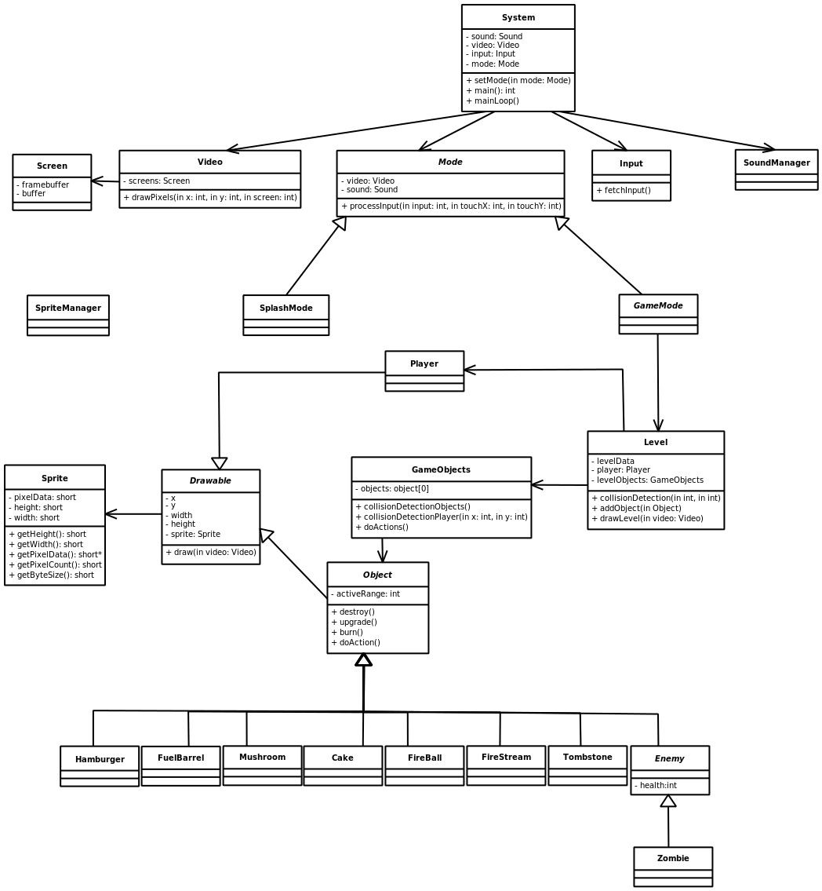

Mockups
