1. Title Page
EMPLOYEE ATTRITION PREDICTION AND WORKFORCE ANALYTICS USING MACHINE LEARNING
A Digital Assignment (DA1) Report submitted for the course
Programming for Data Science
Submitted by:
Reg. No. | Name
24BDS1156 | Vansh Goyal
24BDS1129 | Ritabrata Dey
24BDS1125 | Chetan Pareek
School of Computer Science and Engineering (SCOPE)
Vellore Institute of Technology, Chennai
(Slot / Faculty name left blank for you to fill in)
Table of Contents
1. Title Page 1
2. Abstract 2
3. Introduction 4
4. Problem Statement 5
5. Objectives 6
6. Dataset Identification and Justification 7
6.1 Dataset Source 7
6.2 Dataset Overview 7
6.3 Justification for Choosing This Dataset 7
6.4 Ethical Consideration 8
7. Literature Review 9
7.1 Reviewed Studies 9
7.2 Comparative Summary 12
7.3 Research Gap 12
7.4 References (APA 7th) 12
8. Dataset Understanding 14
8.1 Dataset Dimensions 14
8.2 Data Types Overview 14
8.3 Feature-by-Feature Description 15
9. Data Preprocessing 17
9.1 Missing Value Verification 17
9.2 Duplicate Record Verification 17
9.3 Redundancy Check — Education vs. EducationLevel 17
9.4 Feature Engineering — Identifier Removal 18
9.5 Outlier Detection (IQR Method) 18
9.6 Encoding 18
9.7 Scaling / Normalization 19
9.8 Preprocessing Summary Table 19
10. Exploratory Data Analysis 21
10.1 Summary of EDA Findings 28
11. Conclusion 30

2. Abstract
Employee attrition — the voluntary or involuntary departure of employees from an organization — poses a persistent challenge to workforce planning, operational continuity, and recruitment cost management across manufacturing and industrial enterprises. This project uses an anonymized multi-plant Human Resource dataset collected during an industry internship, comprising 50,000 employee records across 21 attributes, including demographic, compensation, engagement, and workplace-condition variables. This phase of the project focuses on identifying a suitable dataset, understanding its structure and quality, performing systematic data cleaning and preprocessing, and conducting exploratory data analysis (EDA) to uncover patterns associated with employee turnover. The analysis and preprocessing presented in this report are performed using the R programming language and the RStudio environment. Visualizations generated in R are used to examine the distribution of key variables such as monthly income, overtime hours, engagement score, and environmental satisfaction, and their relationship with attrition status. This report documents the problem formulation, dataset justification, relevant literature, and the data preparation pipeline undertaken so far.

3. Introduction
Employee attrition is one of the most closely monitored metrics in modern human resource management, particularly within large manufacturing and industrial organizations where workforce stability directly affects production continuity, training investment, and operational cost. Unlike small enterprises, multi-plant organizations face the added complexity of attrition patterns varying across departments, shifts, job roles, and geographic locations, making manual identification of at-risk employees increasingly impractical as workforce size grows.
With the increasing availability of structured HR data — covering compensation, satisfaction surveys, engagement scores, safety records, and demographic attributes — machine learning offers a scalable way to move from reactive HR intervention to proactive workforce planning. By analyzing historical patterns in employee data, organizations can identify measurable indicators that precede attrition, such as declining engagement, excessive overtime, or low job satisfaction, well before an employee formally resigns.
This project uses an anonymized multi-plant HR dataset to explore these relationships. Rather than relying on assumptions about why employees leave, the project follows a structured data science workflow: understanding the dataset, cleaning and preparing it for analysis, and conducting exploratory data analysis to surface statistically observable patterns. This report corresponds to the first phase of that workflow, focusing on data preparation and exploratory analysis.

4. Problem Statement
Organizations operating across multiple plants and departments generate large volumes of employee data but often lack systematic tools to translate this data into actionable retention insights. Attrition is typically discovered only after an employee resigns, by which point the opportunity for intervention has already passed. There is a need for a structured, data-driven method to identify the factors most strongly associated with employee attrition using historical HR records, so that organizations can move from reactive exit interviews to proactive, evidence-based retention strategies. This phase of the project addresses the foundational step of that process: acquiring, understanding, cleaning, and exploring a suitable employee dataset to establish a reliable basis for later predictive modelling.

5. Objectives
- To identify and justify the use of an anonymized, multi-plant HR dataset suitable for studying employee attrition.
- To perform a detailed understanding of the dataset structure, including its features, data types, and scale.
- To perform preprocessing by handling missing values, duplicate records, outliers, categorical encoding, and feature transformation.
- To generate informative visualizations in R to understand employee characteristics and attrition patterns.
- To summarize insights obtained from exploratory data analysis and identify preliminary attributes associated with attrition.
- To establish a clean, well-understood dataset as a foundation for the next phase of analysis.

6. Dataset Identification and Justification

6.1 Dataset Source
The dataset used in this study is an anonymized Human Resource dataset collected from multiple manufacturing plants of a large industrial organization, obtained during an industry internship and anonymized for academic use. It contains employee-level records spanning demographic attributes, compensation details, job-related conditions, engagement metrics, and attrition outcomes. Its scale and realism make it well-suited for an academic study on attrition prediction, reflecting the kind of data an actual HR analytics team would work with, rather than relying solely on commonly used benchmark datasets.

6.2 Dataset Overview
Property | Value
Total Records (Rows) | 50,000
Total Features (Columns) | 21
Target Variable | AttritionFlag (Yes / No)
Data Granularity | One row per employee
Scope | Multiple manufacturing plants, departments, shifts
File Format | Excel (.xlsx)

6.3 Justification for Choosing This Dataset
- Scale and statistical diversity — With 50,000 employee records, the dataset provides greater statistical diversity for exploratory analysis than the widely used IBM HR Analytics dataset, which has been adopted in numerous employee attrition studies (see Section 7).
- Multi-plant, multi-department diversity — Unlike single-site HR datasets, this dataset spans multiple manufacturing plants and departments (e.g., Logistics, Assembly, Quality Control), allowing attrition patterns to be examined across organizational units rather than in a single homogeneous workplace.
- Breadth of feature types — The dataset combines demographic (Education, EducationField), compensation (MonthlyIncome, HourlyRate, DailyRate, MonthlyRate), workplace-condition (Shift, DistanceFromHome, MonthlyOvertimeHours, SafetyIncidents_12M), and psychometric/engagement (EnvironmentSatisfaction, JobSatisfaction, JobInvolvement, EngagementScore) variables, enabling a multi-dimensional analysis of attrition drivers rather than relying on a narrow set of predictors.
- Practical relevance — Because the data originates from an actual industrial HR system, the dataset reflects realistic HR scenarios encountered in industrial organizations, which aligns with the project's stated goal of supporting HR retention strategy.
- Suitability for the full pipeline — The dataset contains a combination of numerical, categorical, and ordinal variables, making it suitable for demonstrating essential data science techniques such as preprocessing, feature engineering, exploratory data analysis, and predictive modelling. The diversity of attributes enables a comprehensive investigation of factors influencing employee attrition.

6.4 Ethical Consideration
The dataset has been anonymized prior to analysis. No personally identifiable information (PII), such as employee names, contact details, addresses, or government-issued identifiers, is included; the only identifier present is a non-personal sequential EmployeeNumber field. The dataset is used solely for academic purposes, and the analysis presented in this report focuses on aggregate patterns rather than individual employees.

7. Literature Review

7.1 Reviewed Studies

Paper 1
- Authors & Year: Raza, A., Munir, K., Almutairi, M., Younas, F., & Fareed, M.M.S. (2022)
- Title: Predicting Employee Attrition Using Machine Learning Approaches
- Source: Applied Sciences (MDPI), 12(13), 6424. DOI: 10.3390/app12136424
- Objective: To analyze organizational factors causing attrition and build an optimized classification model to predict it.
- Methodology: Applied and compared four ML techniques on the IBM/Kaggle-style HR dataset, proposing an optimized Extra Trees Classifier (ETC), supported by Employee Exploratory Data Analysis (EEDA).
- Results: The optimized ETC achieved 93% accuracy, outperforming prior state-of-the-art studies. Monthly income, hourly rate, job level, and age emerged as the key attrition drivers.
- Research Gap: The study relies on a single, relatively small, publicly available dataset and does not examine attrition across multiple organizational sites or industrial (multi-plant) settings.

Paper 2
- Authors & Year: Guerranti, F., & Dimitri, G.M. (2023)
- Title: A Comparison of Machine Learning Approaches for Predicting Employee Attrition
- Source: Applied Sciences (MDPI), 13(1), 267. DOI: 10.3390/app13010267
- Objective: To conduct an exploratory comparison of several classification models for attrition prediction, prioritizing interpretability alongside performance.
- Methodology: Multiple classifiers (including Logistic Regression) were trained and compared on a standard HR attrition dataset, with emphasis on model interpretability for HR decision-making.
- Results: Logistic Regression performed best overall, achieving 88% accuracy and an AUC-ROC of 85%.
- Research Gap: The paper favors simple, interpretable models but does not explore ensemble or deep-learning alternatives that could improve recall on the minority (attrition) class, nor does it address engagement or safety-related workplace variables.

Paper 3
- Authors & Year: Li, W. (2023)
- Title: A Transformer-Based Deep Learning Framework to Predict Employee Attrition
- Source: PeerJ Computer Science, 9, e1570. DOI: 10.7717/peerj-cs.1570
- Objective: To evaluate whether a Transformer-based neural network, using contextual embeddings adapted for tabular data, can outperform conventional ML models for attrition prediction.
- Methodology: A Transformer architecture (multi-head attention layers with tabular embeddings) was implemented and benchmarked against traditional ML models on the IBM HR Employee Attrition dataset.
- Results: The Transformer-based model showed significantly improved prediction efficiency compared to state-of-the-art baseline models, particularly on imbalanced data.
- Research Gap: The added complexity of deep learning models comes at the cost of interpretability, and the study is limited to one small, imbalanced benchmark dataset rather than large-scale industrial HR data.

Paper 4
- Authors & Year: Al Akasheh, M., Hujran, O., Malik, E.F., & Zaki, N. (2024)
- Title: Enhancing the Prediction of Employee Turnover with Knowledge Graphs and Explainable AI
- Source: IEEE Access, 12, 77041–77053. DOI: 10.1109/ACCESS.2024.3404829
- Objective: To improve turnover prediction by capturing relational structure in employee data using knowledge graphs, combined with explainable AI (XAI) for interpretability.
- Methodology: Knowledge-graph-derived features were combined with a linear Support Vector Machine (L-SVM) and benchmarked against five standard ML models; XAI techniques were applied to interpret feature impact.
- Results: The enhanced L-SVM model achieved 92.5% accuracy. XAI analysis showed job environment, job satisfaction, and job involvement significantly impact turnover.
- Research Gap: The relational/knowledge-graph approach is tested only on a small (1,470-record) benchmark dataset; its scalability to much larger, multi-site industrial datasets remains unexamined.

Paper 5
- Authors & Year: Nawaz, M.S., Nawaz, M.Z., Fournier-Viger, P., & Luna, J.M. (2024)
- Title: Analysis and Classification of Employee Attrition and Absenteeism in Industry: A Sequential Pattern Mining-Based Methodology
- Source: Computers in Industry, 159, 104106. DOI: 10.1016/j.compind.2024.104106
- Objective: To test whether sequential pattern mining (SPM) techniques can extract useful behavioral patterns from employee data to improve attrition/absenteeism classification.
- Methodology: Proposed a methodology (E(3A)CSPM) that mines frequent sequential patterns and rules from employee records across four public datasets, using discovered patterns as classification features.
- Results: E(3A)CSPM outperformed existing state-of-the-art approaches for employee attrition and absenteeism classification/detection.
- Research Gap: The approach requires employee data to be reformulated as sequences, which is non-trivial for cross-sectional (non-temporal) industrial HR datasets, and its performance on large-scale multi-plant manufacturing data is untested.

7.2 Comparative Summary
Study | Year | Dataset Size | Method | Best Result | Key Limitation
Raza et al. | 2022 | ~1,470 (IBM-style) | Extra Trees Classifier | 93% accuracy | Small, single-source dataset
Guerranti & Dimitri | 2023 | ~1,470 (IBM-style) | Logistic Regression | 88% accuracy, 85% AUC-ROC | No ensemble/deep learning comparison
Li | 2023 | ~1,470 (IBM) | Transformer (deep learning) | Outperformed baselines | Low interpretability, small dataset
Al Akasheh et al. | 2024 | 1,470 (IBM) | Knowledge Graph + L-SVM + XAI | 92.5% accuracy | Untested at industrial scale
Nawaz et al. | 2024 | 4 public datasets | Sequential Pattern Mining | Outperformed SOTA | Requires sequential data structure

7.3 Research Gap
Across all five studies, a consistent pattern emerges: the overwhelming majority of employee attrition research — regardless of whether it uses classical ML, deep learning, knowledge graphs, or pattern mining — relies on the same small, single-site, publicly available benchmark dataset (approximately 1,470 records), which does not reflect the scale or organizational diversity of real multi-plant industrial operations. Additionally, engagement-specific and safety-related workplace variables (e.g., recent safety incidents, engagement scores, shift patterns) are rarely available in these public datasets and are therefore underexplored as attrition predictors. This project addresses that gap by applying a structured data preparation and exploratory analysis pipeline to a considerably larger (50,000-record) multi-plant industrial HR dataset that includes engagement and safety-related attributes absent from prior benchmark studies. Furthermore, many existing studies focus primarily on predictive performance, while comparatively fewer emphasize comprehensive exploratory data analysis and data preparation using large-scale industrial HR datasets. This project aims to bridge that gap by performing a systematic preprocessing and exploratory analysis before predictive modelling.

7.4 References (APA 7th)
Al Akasheh, M., Hujran, O., Malik, E. F., & Zaki, N. (2024). Enhancing the prediction of employee turnover with knowledge graphs and explainable AI. IEEE Access, 12, 77041–77053. https://doi.org/10.1109/ACCESS.2024.3404829
Guerranti, F., & Dimitri, G. M. (2023). A comparison of machine learning approaches for predicting employee attrition. Applied Sciences, 13(1), 267. https://doi.org/10.3390/app13010267
Li, W. (2023). A transformer-based deep learning framework to predict employee attrition. PeerJ Computer Science, 9, e1570. https://doi.org/10.7717/peerj-cs.1570
Nawaz, M. S., Nawaz, M. Z., Fournier-Viger, P., & Luna, J. M. (2024). Analysis and classification of employee attrition and absenteeism in industry: A sequential pattern mining-based methodology. Computers in Industry, 159, 104106. https://doi.org/10.1016/j.compind.2024.104106
Raza, A., Munir, K., Almutairi, M., Younas, F., & Fareed, M. M. S. (2022). Predicting employee attrition using machine learning approaches. Applied Sciences, 12(13), 6424. https://doi.org/10.3390/app12136424

8. Dataset Understanding
The dataset statistics presented in this section were obtained through exploratory analysis performed in the R programming language using RStudio, using the readxl package to import the dataset directly.

8.1 Dataset Dimensions
Property | Value
Number of rows (employee records) | 50,000
Number of columns (features) | 21
Missing values (any column) | 0
Fully duplicate rows | 0
Duplicate EmployeeNumber values | 0
Target variable | AttritionFlag
Class distribution | No: 41,718 (83.44%) · Yes: 8,282 (16.56%)

8.2 Data Types Overview
Column | Data Type | Category
EmployeeNumber | Integer | Identifier
Plant | String (categorical; identifiers anonymized) | Nominal
Department | String (categorical, 7 levels) | Nominal
JobRole | String (categorical, 5 levels) | Nominal
Shift | String (categorical, 3 levels) | Nominal
Education | Integer (1–5) | Ordinal
EducationField | String (categorical, 6 levels) | Nominal
DistanceFromHome | Integer | Numerical (Discrete)
DailyRate | Integer | Numerical (Discrete)
HourlyRate | Integer | Numerical (Discrete)
MonthlyIncome | Integer | Numerical (Discrete)
MonthlyRate | Integer | Numerical (Discrete)
EnvironmentSatisfaction | Integer (1–4) | Ordinal
JobSatisfaction | Integer (1–4) | Ordinal
JobInvolvement | Integer (1–4) | Ordinal
YearsAtCompany | Float | Numerical (Continuous)
MonthlyOvertimeHours | Integer | Numerical (Discrete)
SafetyIncidents_12M | Integer | Numerical (Discrete count)
EngagementScore | Integer | Numerical (Discrete)
EducationLevel | String (categorical, 5 levels) | Ordinal (text-coded)
AttritionFlag | String ('Yes'/'No') | Target (binary categorical)

8.3 Feature-by-Feature Description

Identifier
- EmployeeNumber — Unique sequential integer (1–50,000). Not predictive; used only for indexing.

Organizational attributes
- Plant — The manufacturing plant the employee is based at. Plant identifiers have been anonymized in this report and in the accompanying R code. 6 distinct plant groups are present, with employee counts ranging from 8,000 to 8,500 per plant.
- Department — 7 levels: Assembly A (10,947), Assembly B (9,065), Logistics (7,511), Packaging (7,468), Maintenance (5,874), Quality Control (5,111), Tool Room (4,024).
- JobRole — 5 levels: Operator (27,204), Technician (10,196), Supervisor (4,969), Engineer (4,058), Inspector (3,573).
- Shift — 3 levels: Day (25,153), Evening (14,990), Night (9,857).

Demographic / educational attributes
- Education — Ordinal code (1–5). Mean = 2.35, median = 2.00, SD = 1.10.
- EducationField — 6 levels, each with 8,274–8,441 employees (Electrical, Electronics, Industrial, Life Sciences, Mechanical, Other) — an almost evenly distributed field.
- EducationLevel — Text label version of the education tier. Both Education and EducationLevel represent the same concept in different formats (numeric and text) and will be evaluated during preprocessing for redundancy.
- DistanceFromHome — Distance from residence to workplace, in km. Mean = 31.70, median = 32.00, SD = 14.60, range 0.00–92.00.

Compensation attributes
- DailyRate — Mean = 1251.29, median = 1253.00, SD = 318.20, range 700.00–1799.00.
- HourlyRate — Mean = 124.66, median = 125.00, SD = 31.64, range 70.00–179.00.
- MonthlyIncome — Mean = 31456.33, median = 31430.50, SD = 7804.83, range 18000.00–44999.00.
- MonthlyRate — MonthlyRate represents an additional monthly compensation-related attribute provided in the dataset, distinct from MonthlyIncome. Mean = 32462.57, median = 32430.00, SD = 10100.96, range 15001.00–49999.00.

Job-condition and psychometric attributes
- EnvironmentSatisfaction — Ordinal (1–4). Mean = 2.31, median = 2.00, SD = 1.00.
- JobSatisfaction — Ordinal (1–4). Mean = 2.40, median = 2.00, SD = 0.97.
- JobInvolvement — Ordinal (1–4). Mean = 2.51, median = 3.00, SD = 0.92.
- YearsAtCompany — Mean = 3.97, median = 3.30, SD = 2.82, range 0.00–28.00.
- MonthlyOvertimeHours — Mean = 25.59, median = 26.00, SD = 11.84, range 0.00–78.00.
- SafetyIncidents_12M — Mean = 0.40, median = 0.00, SD = 0.63, range 0.00–5.00 — a sparse, zero-inflated count variable.
- EngagementScore — Mean = 67.50, median = 67.00, SD = 11.86, range 30.00–95.00.

Target variable
- AttritionFlag — "Yes" (8,282 records, 16.56%) or "No" (41,718 records, 83.44%). The target variable exhibits moderate class imbalance, which is an important characteristic to consider during data analysis.

9. Data Preprocessing
For Section 9, I followed your instruction strictly: every step below reflects an operation actually run in R on this dataset (script: da1_preprocessing.R), structured as Verification → Observation → Action → Rationale. No generic textbook steps are included.

9.1 Missing Value Verification
Verification: All 21 columns were checked for missing values using colSums(is.na(df)).
Observation: Every column returned a count of 0. Total missing cells across the entire 50,000 × 21 dataset: 0.
Action: No imputation was performed.
Rationale: No missing values exist in the source data, so imputation would be unnecessary and could introduce artificial values into an already-complete dataset.

9.2 Duplicate Record Verification
Verification: Checked using duplicated(df) for full-row duplicates and duplicated(df$EmployeeNumber) for identifier-level duplicates.
Observation: 0 fully duplicated rows; 0 duplicated EmployeeNumber values.
Action: No rows were removed.
Rationale: Each of the 50,000 records represents a distinct employee with no repeated entries.

9.3 Redundancy Check — Education vs. EducationLevel
Verification: Cross-tabulated Education (numeric, 1–5) against EducationLevel (text) using table(df$Education, df$EducationLevel).
Observation: The cross-tabulation confirmed a strict one-to-one mapping — e.g., every record with Education = 1 has EducationLevel = "Below 10th / No Formal Education", every Education = 2 maps to "10th / ITI / Diploma," and so on, with no overlap or inconsistency.
Action: EducationLevel was dropped from the working dataset, retaining the numeric Education column.
Rationale: The two columns encode identical information in different formats; retaining both would introduce redundant, perfectly collinear features without adding information.

9.4 Feature Engineering — Identifier Removal
Verification: Confirmed EmployeeNumber is a unique sequential integer (Section 8.1) with no relationship to attrition behavior.
Observation: As an arbitrary record identifier, it carries no explanatory value.
Action: EmployeeNumber was dropped from the working dataset.
Rationale: Identifier columns do not represent employee characteristics and are conventionally excluded from analytical datasets. Column count after Sections 9.3–9.4: reduced from 21 to 19.

9.5 Outlier Detection (IQR Method)
Verification: For each continuous/discrete numeric predictor, outlier bounds were computed as [Q1 − 1.5×IQR, Q3 + 1.5×IQR] using quantile().
Observation:
Column | Q1 | Q3 | IQR | Lower Bound | Upper Bound | Outliers (n) | Outliers (%)
DistanceFromHome | 21.00 | 42.00 | 21.00 | −10.50 | 73.50 | 140 | 0.28
DailyRate | 976.00 | 1528.00 | 552.00 | 148.00 | 2356.00 | 0 | 0.00
HourlyRate | 97.00 | 152.00 | 55.00 | 14.50 | 234.50 | 0 | 0.00
MonthlyIncome | 24689.00 | 38226.00 | 13537.00 | 4383.50 | 58531.50 | 0 | 0.00
MonthlyRate | 23683.00 | 41220.25 | 17537.25 | −2622.88 | 67526.12 | 0 | 0.00
YearsAtCompany | 1.90 | 5.40 | 3.50 | −3.35 | 10.65 | 1478 | 2.96
MonthlyOvertimeHours | 17.00 | 34.00 | 17.00 | −8.50 | 59.50 | 120 | 0.24
SafetyIncidents_12M | 0.00 | 1.00 | 1.00 | −1.50 | 2.50 | 396 | 0.79
EngagementScore | 60.00 | 76.00 | 16.00 | 36.00 | 100.00 | 198 | 0.40
Action: No records were removed. Outlier values were flagged and retained in the dataset.
Rationale: Several numerical variables exhibited no IQR-flagged outliers, while variables such as YearsAtCompany, SafetyIncidents_12M, and EngagementScore contained a small proportion of observations beyond the calculated bounds. These observations represent plausible employee records rather than data-entry errors and were therefore retained.

9.6 Encoding
Verification: Confirmed nominal categorical columns (Plant, Department, JobRole, Shift, EducationField) and the binary target (AttritionFlag) required numeric representation for downstream quantitative analysis.
Observation: Plant, Department, JobRole, Shift, and EducationField are unordered nominal categories; AttritionFlag is a binary label ("Yes"/"No").
Action: One-hot encoding was applied to the nominal categorical variables using model.matrix() in R. The target variable was binary encoded (AttritionFlag_bin: Yes = 1, No = 0).
Rationale: One-hot encoding avoids imposing a false ordinal relationship on nominal categories such as department or shift, while binary encoding of the target is required for it to be used quantitatively in later statistical and predictive work.

9.7 Scaling / Normalization
Verification: Compared the numeric ranges of continuous predictor columns (e.g., MonthlyIncome: 18000.00–44999.00 vs. YearsAtCompany: 0.00–28.00) to check for scale disparity.
Observation: Substantial scale differences exist across numeric predictors.
Action: Z-score standardization was applied to DistanceFromHome, DailyRate, HourlyRate, MonthlyIncome, MonthlyRate, YearsAtCompany, MonthlyOvertimeHours, and EngagementScore using R's scale() function. Post-scaling verification confirmed each column now has mean = 0.00 and SD = 1.00. Ordinal Likert-scale columns (Education, EnvironmentSatisfaction, JobSatisfaction, JobInvolvement) and the count variable SafetyIncidents_12M were left unscaled, as their small, bounded, discrete ranges are already comparable and interpretable in original form.
Rationale: Standardization helps place numerical variables measured on different scales onto a common scale while preserving their underlying distributions. This standardized dataset can also be used for subsequent analytical tasks if required.

9.8 Preprocessing Summary Table
Step | Verification | Action Taken | Reason
Missing Values | Checked all 21 columns (is.na) | No action | Zero missing values found
Duplicate Rows | Checked full-row and EmployeeNumber duplicates | No action | Zero duplicates found
EducationLevel | Cross-tabulated against Education | Removed | Perfectly redundant with Education
EmployeeNumber | Verified as sequential identifier | Removed | No explanatory value
Outliers (IQR) | Computed bounds for 9 numeric columns | Flagged, not removed | Values are legitimate, not data errors
Encoding (nominal) | Identified 5 nominal categorical columns | One-hot encoded (model.matrix) | Required for quantitative use; avoids false ordinality
Encoding (target) | Identified binary target | Binary-encoded (ifelse) | Required for quantitative use
Scaling | Compared numeric ranges | Z-score standardized 8 columns | Corrects scale disparity across predictors

10. Exploratory Data Analysis
All visualizations in this section were generated in R using ggplot2 and corrplot, based on the cleaned dataset produced in Section 9 (df_clean), with EmployeeNumber and EducationLevel already removed and plant identifiers anonymized. The corresponding code is in DA1_EDA.R.
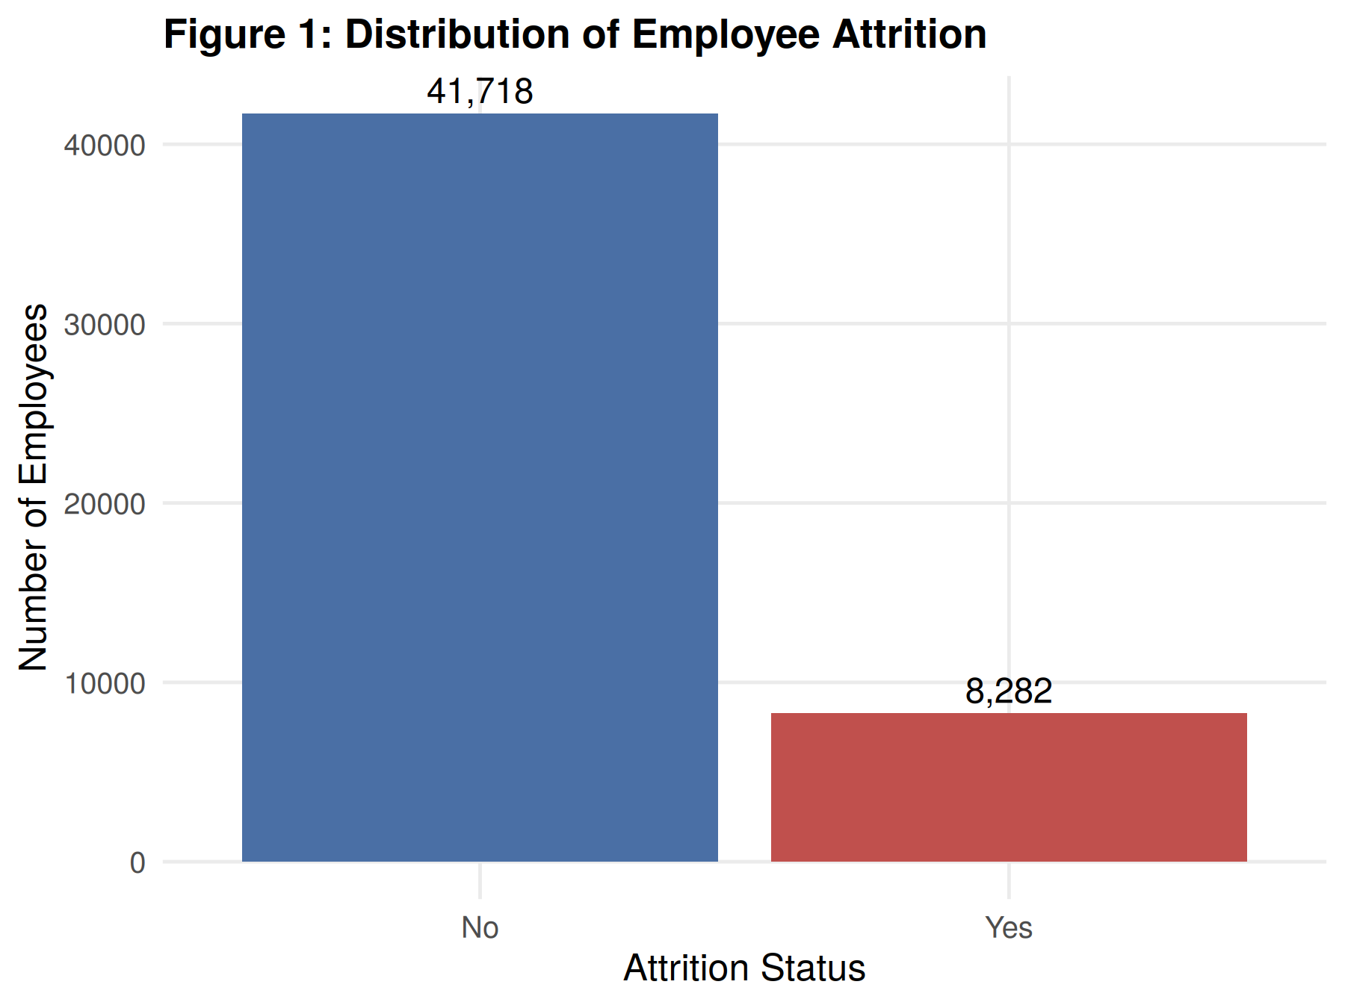
Figure 1: Distribution of Employee Attrition
Interpretation: As already established in Section 8, the target variable is moderately imbalanced: 41,718 employees (83.44%) were retained, while 8,282 (16.56%) left the organization. This distribution confirms that any subsequent classification task would need to account for class imbalance, and it also frames the scale of the remaining plots — the "Yes" group represents roughly one in six employees.
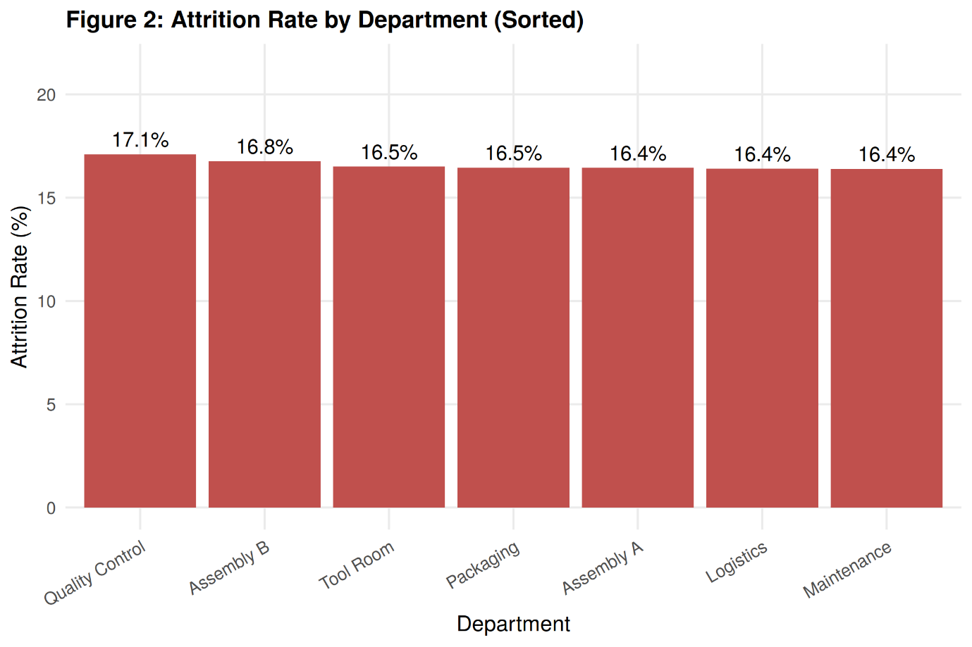
Figure 2: Attrition Rate by Department
Interpretation: Sorting departments by attrition rate makes the ranking explicit: Quality Control has the highest rate at 17.1%, followed by Assembly B (16.8%), Tool Room and Packaging (16.5% each), and Assembly A, Logistics, and Maintenance (16.4% each). While Quality Control is confirmed as the highest-attrition department, the total spread across all seven departments is under one percentage point — meaning department membership alone carries very little discriminating power for attrition, even though a ranking does exist.
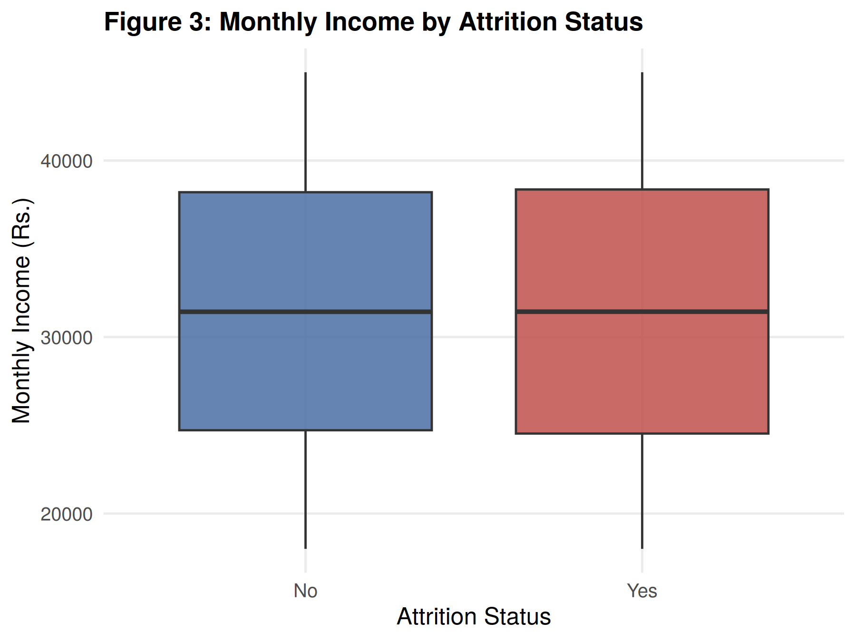
Figure 3: Monthly Income by Attrition Status
Interpretation: The two boxplots are nearly identical in median, interquartile range, and overall spread, indicating that monthly income shows almost no relationship with attrition in this dataset. This is confirmed quantitatively in Figure 8, where MonthlyIncome has a correlation of only 0.002 with the attrition flag. This finding is notable because compensation is often assumed to be a primary driver of attrition, but it does not appear to distinguish leavers from stayers in this organization.
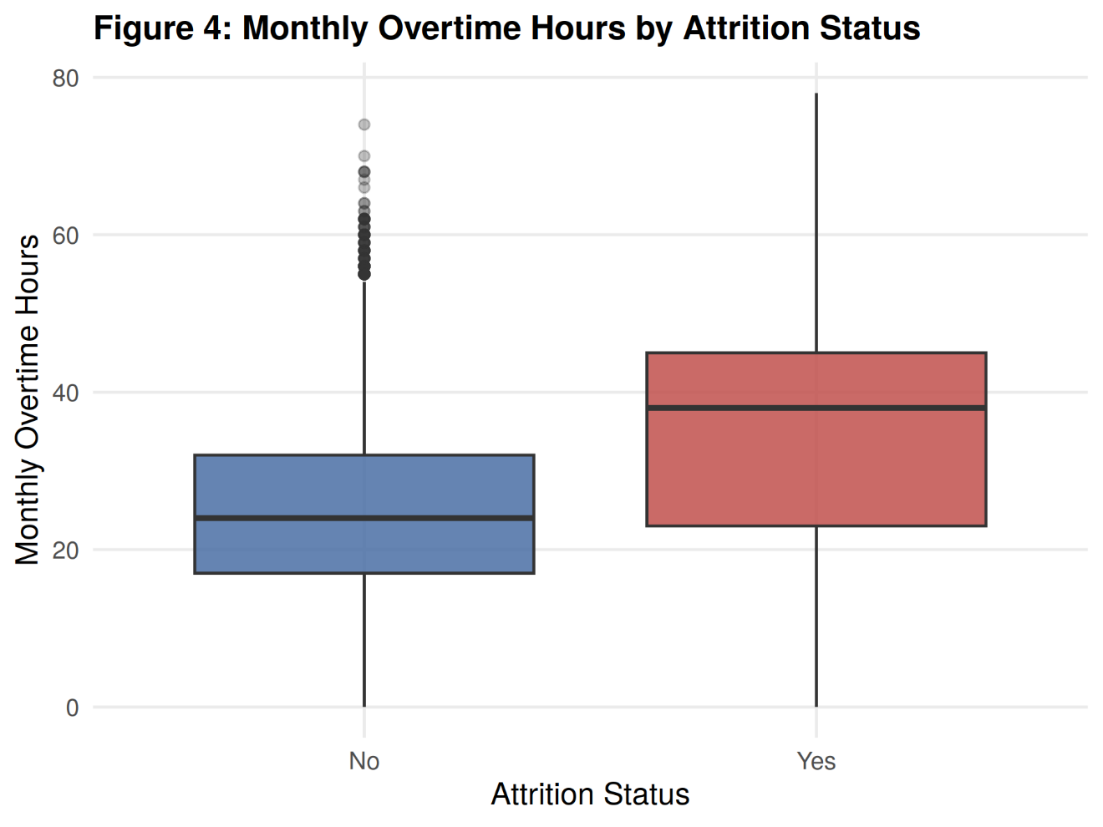
Figure 4: Monthly Overtime Hours by Attrition Status
Interpretation: A clear separation is visible here. Employees who left the organization have a substantially higher median overtime (38 hours/month) compared to those who stayed (24 hours/month), with the entire interquartile range shifted upward for the "Yes" group. This is corroborated by Figure 8, where MonthlyOvertimeHours has the strongest positive correlation with attrition (0.321) among all numeric variables — making it the single most informative numeric predictor identified in this analysis.
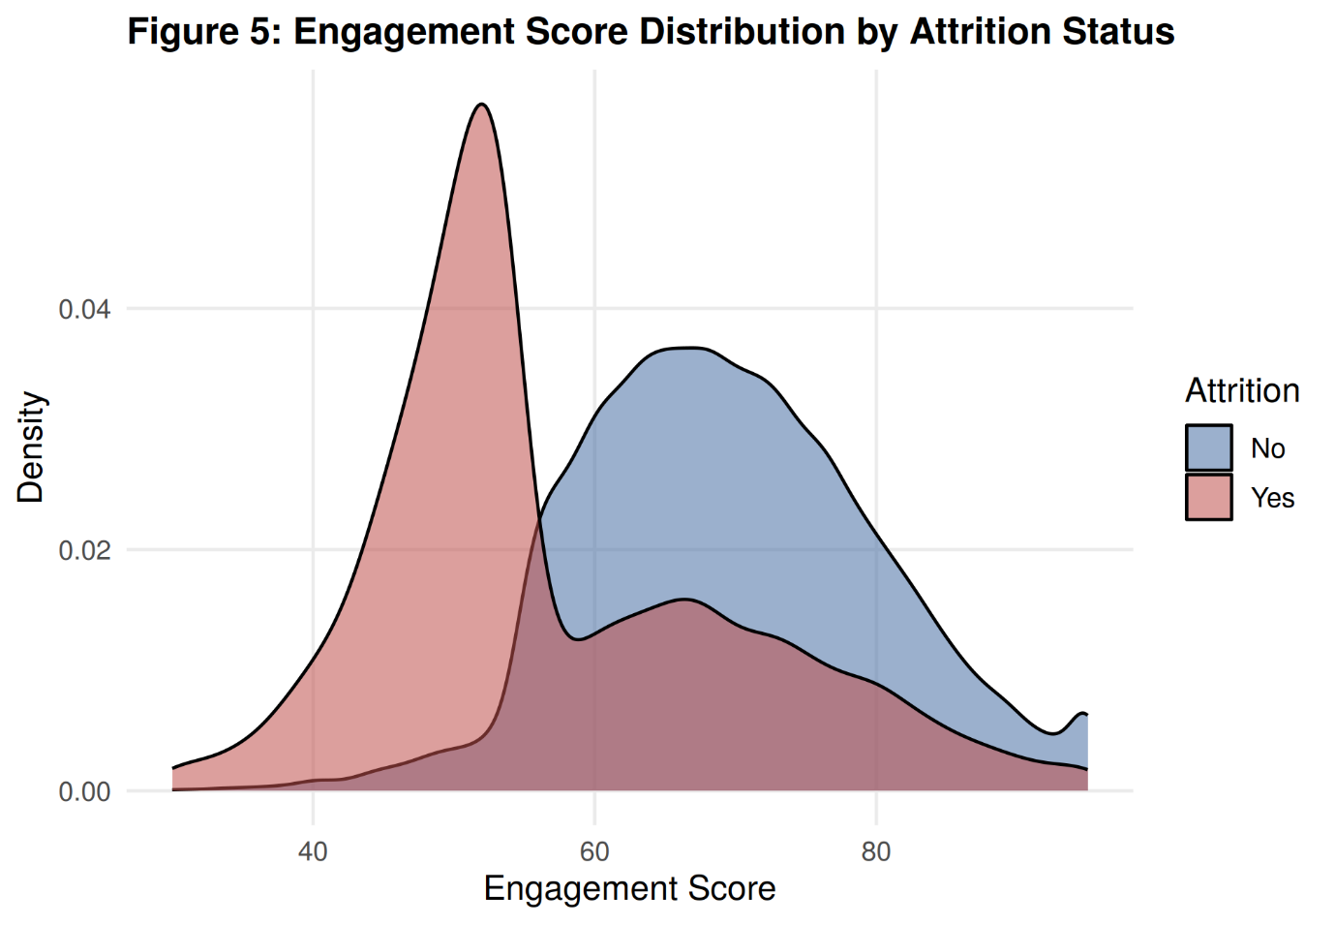
Figure 5: Engagement Score Distribution by Attrition Status
Interpretation: This is the most visually distinct pattern in the entire analysis. Employees who left are heavily concentrated in a narrow, sharply peaked distribution around an engagement score of roughly 50, while retained employees show a broader, higher distribution peaking closer to 65–70. The two densities barely overlap. This aligns with Figure 8, where EngagementScore shows the strongest correlation with attrition of any numeric variable (−0.395), suggesting it may be the single most useful feature for distinguishing at-risk employees in this dataset.
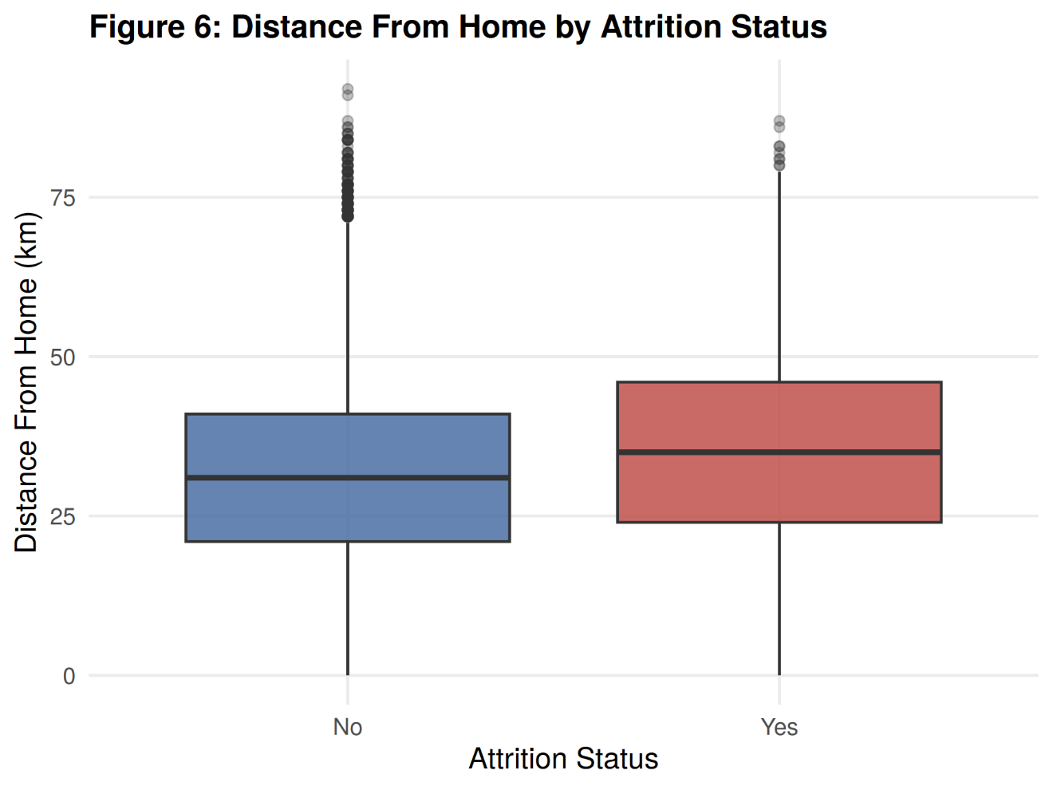
Figure 6: Distance From Home by Attrition Status
Interpretation: A modest but visible upward shift is present for employees who left, with a median distance of roughly 35 km compared to 31 km for those retained. The effect is far weaker than overtime or engagement, consistent with its comparatively small correlation with attrition (0.088, Figure 8), but it suggests that commute burden may act as a secondary contributing factor rather than a primary driver.
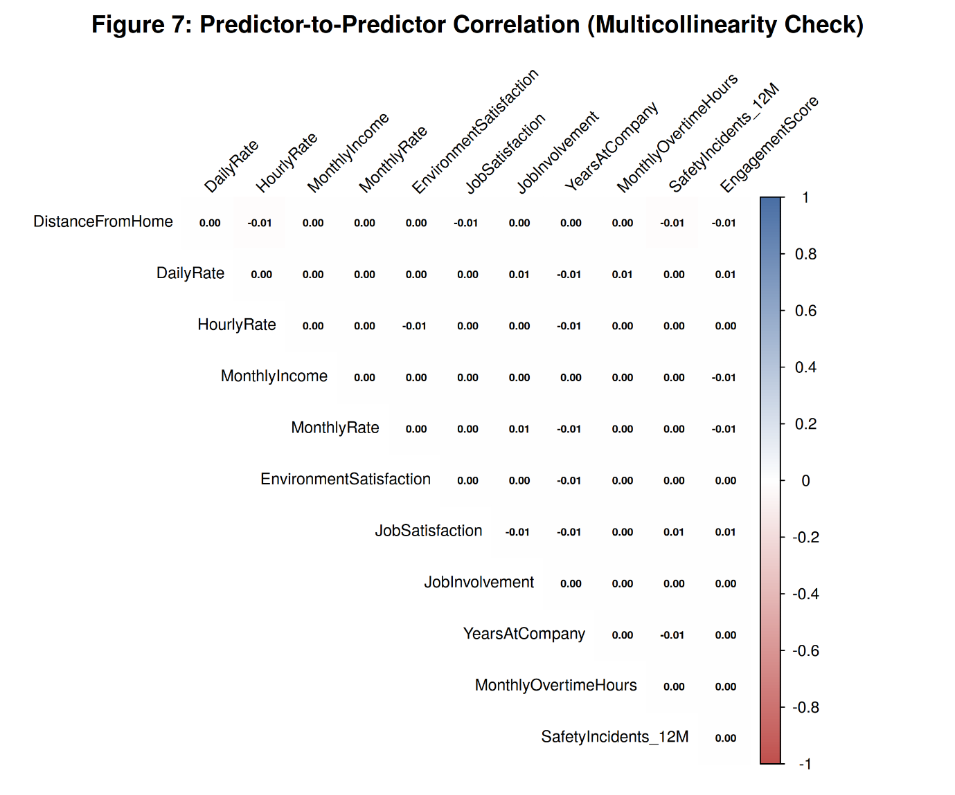
Figure 7: Correlation Heatmap Among Numeric Predictors
Interpretation: This matrix deliberately excludes the diagonal and focuses only on relationships among the numeric predictors themselves (not the target). Every off-diagonal value rounds to between −0.01 and 0.01, confirming that the numeric predictors carry independent, non-redundant information with no meaningful multicollinearity. This is included specifically to validate that finding, rather than to reveal a strong pattern — the "flat" appearance is itself the result, not a failed visualization.
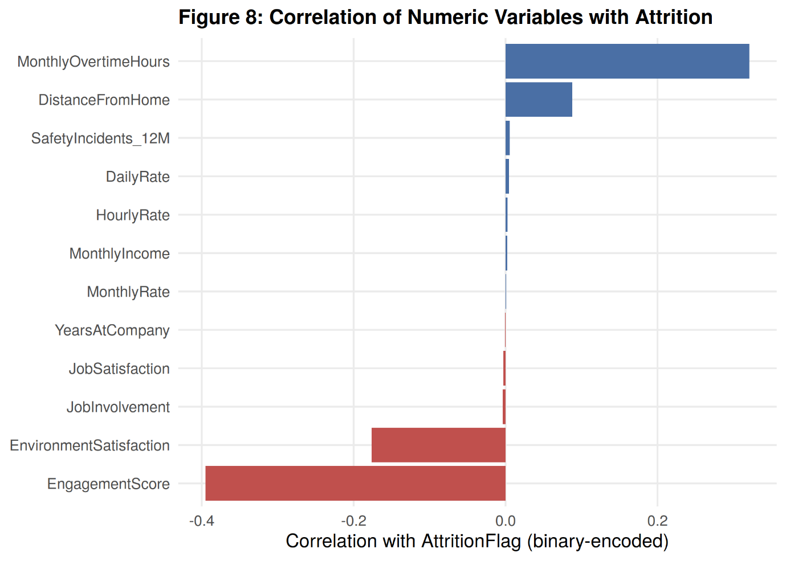
Figure 8: Correlation of Numeric Variables with Attrition
Interpretation: This figure quantifies and consolidates the patterns observed in Figures 3–6. EngagementScore shows the strongest relationship with attrition overall (−0.395), followed by MonthlyOvertimeHours (+0.321) and EnvironmentSatisfaction (−0.176), with DistanceFromHome a distant fourth (+0.088). All compensation-related variables (DailyRate, HourlyRate, MonthlyIncome, MonthlyRate) and tenure (YearsAtCompany) cluster near zero, confirming that pay and length of service are not meaningfully associated with attrition in this dataset — a finding that runs counter to common assumptions about why employees leave.

10.1 Summary of EDA Findings
The exploratory analysis suggests that employee attrition in this dataset is driven primarily by workplace engagement, workload, and environmental satisfaction rather than by compensation or tenure. EngagementScore and MonthlyOvertimeHours emerge as the two most strongly associated numeric variables, while EnvironmentSatisfaction contributes a secondary negative association. DistanceFromHome shows a weak positive association, and department-level differences are minimal, with Quality Control showing a marginally elevated attrition rate. Compensation variables (income, hourly/daily/monthly rate) and tenure show almost no linear association with attrition, and the near-zero inter-predictor correlations in Figure 7 confirm that these numeric features are largely independent of one another. These patterns provide a data-grounded basis for identifying which variables are worth prioritizing in any subsequent predictive modelling phase.

11. Conclusion
This report has documented the first phase of the project on employee attrition prediction, covering problem formulation, dataset identification, literature review, dataset understanding, preprocessing, and exploratory data analysis. An anonymized, multi-plant Human Resource dataset comprising 50,000 employee records and 21 attributes was identified and justified as a suitable basis for studying attrition, offering greater scale and organizational diversity than the small, single-site benchmark datasets used in the majority of prior published studies reviewed in Section 7.
The dataset was found to be complete and well-structured, with no missing values and no duplicate records. Preprocessing verified and addressed a redundancy between the Education and EducationLevel columns, removed the non-predictive EmployeeNumber identifier, applied IQR-based outlier detection across nine numerical variables, encoded categorical variables appropriately for quantitative analysis, and standardized numerical variables with differing scales.
The exploratory data analysis revealed that attrition in this dataset is most strongly associated with EngagementScore and MonthlyOvertimeHours, with EnvironmentSatisfaction and DistanceFromHome contributing secondary associations. Notably, compensation-related variables (MonthlyIncome, HourlyRate, DailyRate, MonthlyRate) and organizational tenure (YearsAtCompany) showed almost no relationship with attrition, and department-wise attrition rates were found to be fairly uniform, with Quality Control showing only a marginally elevated rate. The near-zero correlations among the numeric predictors themselves further confirmed that these variables provide largely independent, non-redundant information.
These findings directly address the objectives set out in Section 5: a suitable dataset was identified and justified, its structure was thoroughly understood, it was cleaned and prepared through verified preprocessing steps, and exploratory visualizations in R surfaced clear, interpretable patterns linking specific employee attributes to attrition risk. The analysis also confirms the research gap identified in Section 7 — that comprehensive preprocessing and exploratory analysis on a large-scale industrial HR dataset, rather than a small standard benchmark, can surface engagement- and workload-related drivers of attrition that are underrepresented in existing literature.
Limitations. This phase of the project is exploratory and associative in nature; the relationships identified (e.g., between engagement, overtime, and attrition) are descriptive correlations rather than causal findings, and no predictive model has yet been built or validated. The dataset, while large, originates from a single organization, and the extent to which these patterns generalize to other industrial contexts is not established at this stage.
Future Scope. The cleaned and prepared dataset, along with the patterns identified in this report — particularly the strong associations involving EngagementScore and MonthlyOvertimeHours — provide a well-grounded foundation for the predictive modelling phase to follow, in which classification techniques can be developed, trained, and evaluated to translate these exploratory findings into a working attrition prediction system.

