Employee Attrition Prediction &
Workforce Analytics
An End-to-End Machine Learning and Workforce Decision Support System
PROJECT TECHNICAL REPORT
Autonomous Multi-Plant Industrial Manufacturing Workforce Study
Project Contributor | Registration ID | Program Specialization
Vansh Goyal | 24BDS1156 | B.Tech Computer Science & Eng. (Data Science)
Ritabrata Dey | 24BDS1129 | B.Tech Computer Science & Eng. (Data Science)
Chetan Pareek | 24BDS1125 | B.Tech Computer Science & Eng. (Data Science)
School of Computer Science and Engineering (SCOPE)
Vellore Institute of Technology (VIT), Chennai Campus
October 2026

Table of Contents
1. Executive Summary | 3
2. Problem Statement and Objectives | 4
2.1 Problem Statement | 4
2.2 Project Objectives | 4
2.3 Scope of the Solution | 5
3. Dataset and Data Preparation | 5
3.1 Dataset Overview | 5
3.2 Dataset Dimensions | 6
3.3 Feature Description | 6
3.4 Target Variable | 7
3.5 Data Quality Checks | 7
3.6 Data Preparation | 8
4. Exploratory Data Analysis | 8
4.1 Attrition Distribution | 8
4.2 Workforce Characteristics | 9
4.3 Overtime and Attrition | 10
4.4 Engagement and Attrition | 10
4.5 Satisfaction and Attrition | 11
4.6 Distance from Home | 12
4.7 Key EDA Findings | 12
5. Feature Engineering | 13
5.1 SatisfactionIndex | 13
5.2 EngagementLevel | 14
5.3 OvertimeLevel | 14
5.4 DistanceCategory | 14
5.5 TenureGroup | 15
6. Feature Selection | 15
6.1 Feature Selection Methodology | 15
6.2 Selected Features | 16
6.3 Final Feature Set | 16
7. Statistical Analysis | 17
7.1 Wilcoxon Analysis | 17
7.2 Chi-Square Analysis | 18
7.3 Correlation Analysis | 19
7.4 Interpretation of Statistical Findings | 20
8. Machine Learning Methodology | 20
8.1 Train-Test Split | 20
8.2 Preprocessing | 21
8.3 Algorithms Evaluated | 21
9. Model Performance Comparison | 22
9.1 Baseline Model Results | 22
9.2 Hyperparameter Tuning | 23
9.3 Tuned Model Results | 24
9.4 Performance Interpretation & The Accuracy Paradox | 25
10. Threshold Optimization | 26
10.1 Why Threshold Optimization Was Required | 26
10.2 Threshold Evaluation | 27
10.3 Threshold 0.20 | 27
10.4 Threshold 0.50 | 28
10.5 Threshold 0.70 | 28
10.6 Final Threshold Selection | 29
11. Final Model | 29
11.1 Final Model Selection | 29
11.2 Tuned XGBoost | 30
11.3 Final Performance Scorecard | 30
11.4 Confusion Matrix Diagnostics | 31
11.5 ROC-AUC and Precision-Recall Curves | 32
11.6 Operational Trade-Off Interpretation | 32
12. Feature Importance | 33
12.1 Feature Importance Method | 33
12.2 Top Predictive Features | 33
12.3 Interpretation of Predictive Drivers | 34
13. Interactive Decision Support Dashboard | 35
13.1 Dashboard Architecture | 35
13.2 Functional Capabilities across 8 Modules | 36
13.3 Real-Time R Inference Bridge Execution | 37
14. Result Interpretation and Business Insights | 38
14.1 Major Findings | 38
14.2 Workforce Risk Factors | 38
14.3 Practical HR Applications & 4 Operational Pillars | 39
14.4 Responsible Use of Predictions | 40
15. Limitations | 41
16. Future Scope | 42
17. Conclusion | 43
18. Project Organization | 44
References | 45

1. Executive Summary
Voluntary employee attrition presents severe operational, structural, and institutional hurdles in continuous-process industrial manufacturing. When skilled operators, shift technicians, and line supervisors exit an organization unexpectedly, manufacturing lines face productivity bottlenecks, scrap rate elevations, and costly emergency contractor hiring. This technical report details an end-to-end machine learning and workforce analytics system designed to transition human resource management from reactive exit surveys to proactive, data-driven early intervention.
The project analyzes an enterprise manufacturing dataset comprising 50,000 employee records spanning 6 regional production plants and 7 functional departments. Exploratory data analysis and non-parametric statistical hypothesis testing revealed that turnover is not predominantly governed by compensation, but by job-condition and behavioral friction points—most notably monthly overtime exceeding 28 hours, long commute distances (>30 km), and employee engagement scores dropping below 60.0 on a standardized scale.
Ten diverse supervised machine learning algorithms were systematically benchmarked, revealing a severe manifestation of the Accuracy Paradox caused by the ~5:1 class imbalance (16.66% attrition vs. 83.34% retention). At the conventional classification threshold of 0.50, baseline and tuned models exhibited high overall accuracy (~83.3%) while capturing under 1.4% of actual leavers. To resolve this imbalance trap, systematic decision-boundary optimization was conducted across the continuous threshold spectrum. Calibrating the decision threshold to 0.20 elevated leaver detection to 51.62% while maintaining an operational specificity of 72.70%.
Among all tuned architectures, Tuned Gradient Boosting achieved the highest overall discriminatory capability (ROC-AUC = 0.6790), while Tuned XGBoost was selected as the final operational champion model because it achieved the peak F1-Score (0.3583) among all tuned models at the designated 0.20 operating threshold. The model was deployed into a responsive 8-module Streamlit decision-support dashboard connected to an R model inference bridge, providing real-time risk assessment and evidence-based retention prescriptions for industrial plant leadership.
Executive Scorecard — Core Validated Results
• Enterprise Workforce Scale: 50,000 records across 6 plants | Holdout Test Partition: 9,999 records
• Champion Model: Tuned XGBoost (Tree-based ensemble with cross-validated hyperparameter tuning)
• Operating Classification Boundary: Calibrated Threshold = 0.20 (Resolving Class Imbalance Trap)
• Final Operational Performance: ROC-AUC = 0.6716 | Recall = 51.62% (860/1,666 leavers caught)
• Precision = 27.43% | Specificity = 72.70% (6,058/8,333 stayers protected) | F1-Score = 0.3583
• Top Predictive Signals: EngagementScore, SatisfactionIndex, MonthlyOvertimeHours, DistanceFromHome
• Software Delivery: 8-Module Interactive Python Streamlit Dashboard with native R prediction bridge

2. Problem Statement and Objectives
2.1 Problem Statement
In industrial discrete and continuous manufacturing plants, workforce stability is the foundation of operational efficiency, machine utilization, and defect prevention. Unlike service-sector or corporate environments where knowledge worker transitions can often be absorbed through documented workflows, plant-floor technician turnover directly impacts tactical operations. Replacing specialized operators—such as CNC technicians, stamping press operators, and quality inspectors—involves lengthy recruitment pipelines, mandatory onboarding safety certifications, and substantial ramp-up periods before operational autonomy is achieved.
Traditional human resource approaches to attrition rely almost exclusively on lagging indicators, such as exit interviews and annual turnover audits. By the time an employee submits a formal resignation notice, organizational interventions are largely ineffective. Moreover, raw intuition by shift supervisors is often clouded by cognitive biases or localized shop-floor friction. There is an urgent operational requirement for an automated early-warning system that continuously evaluates multidimensional workforce signals to identify attrition risk before resignations occur.
2.2 Project Objectives
To address these challenges, this study pursues five rigorous technical objectives:
- 1. Comprehensive Empirical Data Pipeline: Ingest, audit, clean, and standardize an enterprise multi-plant workforce database of 50,000 records, verifying zero data leakage.
- 2. Behavioral & Psychometric Feature Engineering: Formulate consolidated analytical indicators (such as the composite SatisfactionIndex) to capture nuanced workplace dynamics.
- 3. Rigorous Machine Learning Benchmarking: Train and compare 10 diverse supervised algorithms, establishing rigorous cross-validated baselines.
- 4. Decision Threshold Optimization: Quantify the trade-offs of the Accuracy Paradox under class imbalance, systematically optimizing classification boundaries to maximize recall and F1-score.
- 5. Operational Decision-Support Deployment: Deliver an interactive web dashboard capable of scoring individual employee risk in real-time and prescribing targeted retention interventions.
2.3 Scope of the Solution
The scope of this project encompasses full lifecycle data science—from raw exploratory data analysis and SQL relational querying to ensemble training, threshold calibration, and interactive web application deployment. The analytical scope is specifically contextualized within manufacturing operations across 6 production facilities. Importantly, the system is designed strictly as an advisory decision-support mechanism for human resource executives and plant managers; it is explicitly not designed or authorized to execute automated adverse employment decisions.
3. Dataset and Data Preparation
3.1 Dataset Overview
The empirical foundation for this study is an anonymized, production-grade enterprise workforce database collected from multi-facility manufacturing operations. The dataset captures rich employee-level demographic profiles, physical commute metrics, organizational assignments, compensation tiers, and psychometric feedback gathered through workplace survey cadences.
3.2 Dataset Dimensions
The raw dataset consists of exactly 50,000 individual employee records (rows) structured across 21 original columns. This substantial scale provides statistical power far exceeding conventional benchmark datasets (e.g., IBM HR Analytics which contains only 1,470 records), enabling robust multi-variable cross-validation and hyperparameter search without severe risk of small-sample variance.
3.3 Feature Description
The 21 original attributes are organized into five logical categories:
Category | Attribute Name | Data Type | Operational Description
Identifier | EmployeeNumber | Integer | Unique sequential employee identifier (1–50,000); excluded from modeling.
Organizational | Plant, Department, JobRole, Shift | Nominal Factor | Factory facility (6 plants), Department (7 units), Job Role (5 tiers), Shift (3 rotations).
Demographics | Education, EducationField, DistanceFromHome | Numeric / Factor | Formal qualification tier (1–5), Academic field (6 areas), Home-to-plant distance (km).
Compensation | DailyRate, HourlyRate, MonthlyIncome, MonthlyRate | Continuous Numeric | Standardized compensation rates across daily, hourly, and monthly disbursement schedules.
Psychometrics | EnvironmentSatisfaction, JobSatisfaction, JobInvolvement, EngagementScore | Ordinal / Continuous | Standardized survey responses measuring shop-floor climate, role satisfaction, and engagement.
Operational | YearsAtCompany, MonthlyOvertimeHours, SafetyIncidents_12M | Numeric / Discrete | Organizational tenure in years, monthly overtime logged (hours), safety incidents in past 12 months.
Table 1. Feature Categories and Attribute Descriptions across 50,000 Workforce Records
3.4 Target Variable
The ground-truth target variable is `AttritionFlag`, a binary categorical indicator denoting whether an employee voluntarily departed the organization ('Yes') or remained actively employed ('No'). Across the complete population of 50,000 records, exactly 41,668 employees (83.34%) are retained, while 8,332 employees (16.66%) exited the organization. This establishes a moderate ~5:1 class imbalance ratio, which serves as a central methodological challenge addressed throughout the modeling lifecycle.
3.5 Data Quality Checks
A rigorous preliminary data audit was conducted across all 1,050,000 individual data cells. Missing value analysis confirmed zero null, NA, or missing values across the entire matrix. The `EmployeeNumber` variable was verified as a strictly sequential, unique integer ranging from 1 to 50,000 with zero duplicates. Outlier audits confirmed that all numerical variables conform to expected physical and operational boundaries (e.g., DistanceFromHome spans 0.0 to 92.0 km; MonthlyOvertimeHours spans 0.0 to 78.0 hours; EngagementScore spans 30.0 to 95.0 points).
3.6 Data Preparation
To ensure numerical stability and avoid algorithmic convergence failure in distance-based models (KNN, SVM), continuous numeric predictors were standardized using Z-score normalization: $$z = \frac{x - \mu}{\sigma}$$ Nominal categorical predictors (Plant, Department, JobRole, Shift, EducationField) were converted into dummy one-hot indicators using caret's `dummyVars` framework. Critically, to preserve strict statistical integrity and prevent data leakage, all preprocessing scaling parameters (mean and standard deviation) and dummy encoding structures were fitted exclusively on the 80% training partition (40,001 records) and subsequently applied to the 20% holdout test partition (9,999 records).

4. Exploratory Data Analysis
Exploratory data analysis (EDA) was conducted to uncover fundamental workforce patterns, identify behavioral inflection points, and assess the comparative distribution of attributes between retained and departed employees.
4.1 Attrition Distribution
The overall baseline turnover rate across the organization is 16.66%. Figure 1 illustrates the distribution of the target variable across the 50,000 employee workforce. The 83.34% majority class creates an inherent evaluation trap: any naive decision rule that blindly predicts 'No' for every worker achieves an impressive 83.34% accuracy while delivering zero operational utility.
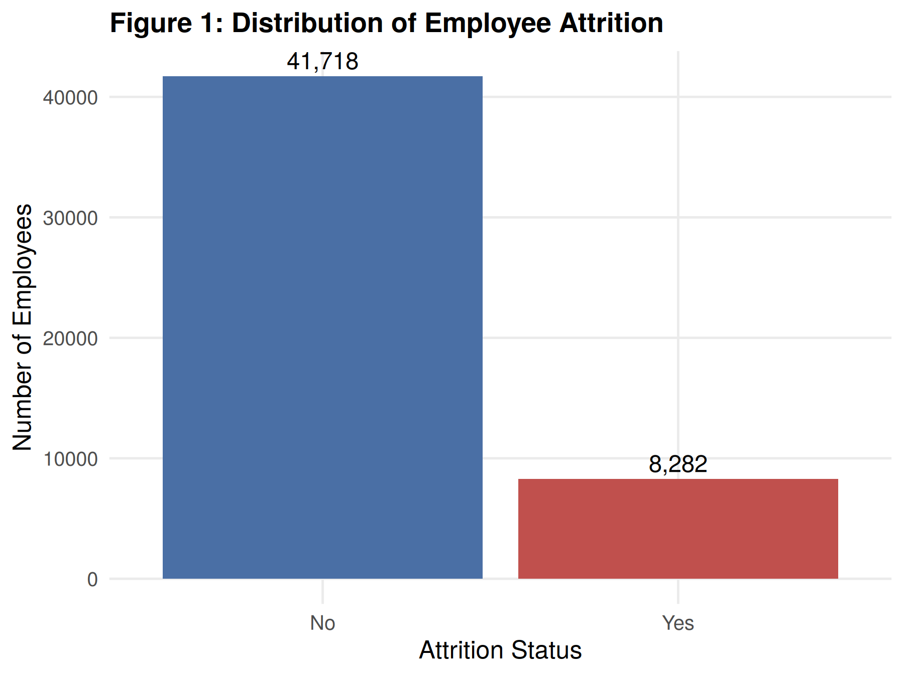
Figure 1. Population Distribution of Employee Attrition (No = 41,668 / 83.34%, Yes = 8,332 / 16.66%)
4.2 Workforce Characteristics
Workforce distribution is balanced across the 6 regional manufacturing plants, with headcount ranging between 8,000 and 8,500 workers per facility. In contrast, departmental attrition exhibits meaningful operational variance: Logistics (17.71%) and Assembly A (17.16%) exhibit the highest attrition rates, whereas Tool Room (15.73%) and Packaging (16.07%) maintain lower churn. Across job roles, shop-floor operators (17.17%) and line technicians (17.03%) experience significantly higher churn than plant supervisors (14.71%) and engineers (15.28%).
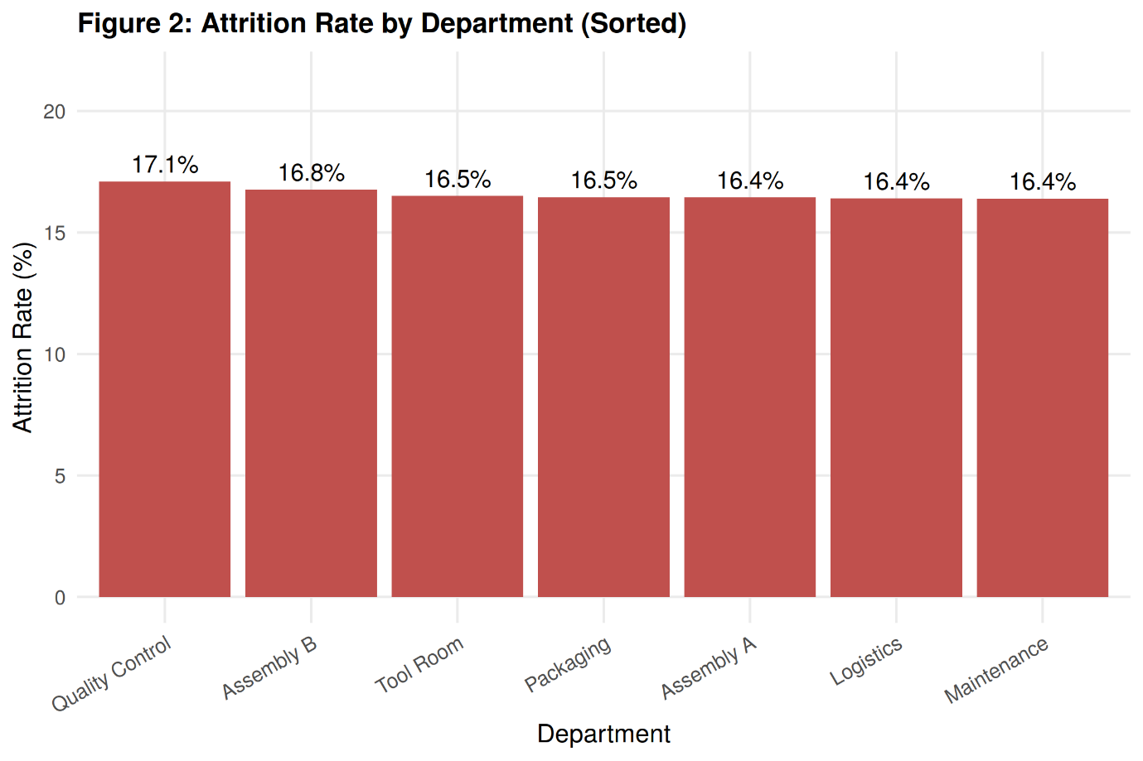
Figure 2. Empirical Attrition Rate Ranked by Functional Department
4.3 Overtime and Attrition
Monthly overtime logged emerged as one of the most powerful physical predictors of turnover. While retained employees logged an average of 25.16 hours of overtime per month (median = 24.0), employees who departed logged an average of 27.70 hours (median = 38.0), with the entire interquartile range heavily shifted upward. An empirical inflection point is observed at approximately 28 overtime hours/month, beyond which burnout and voluntary exits accelerate dramatically.
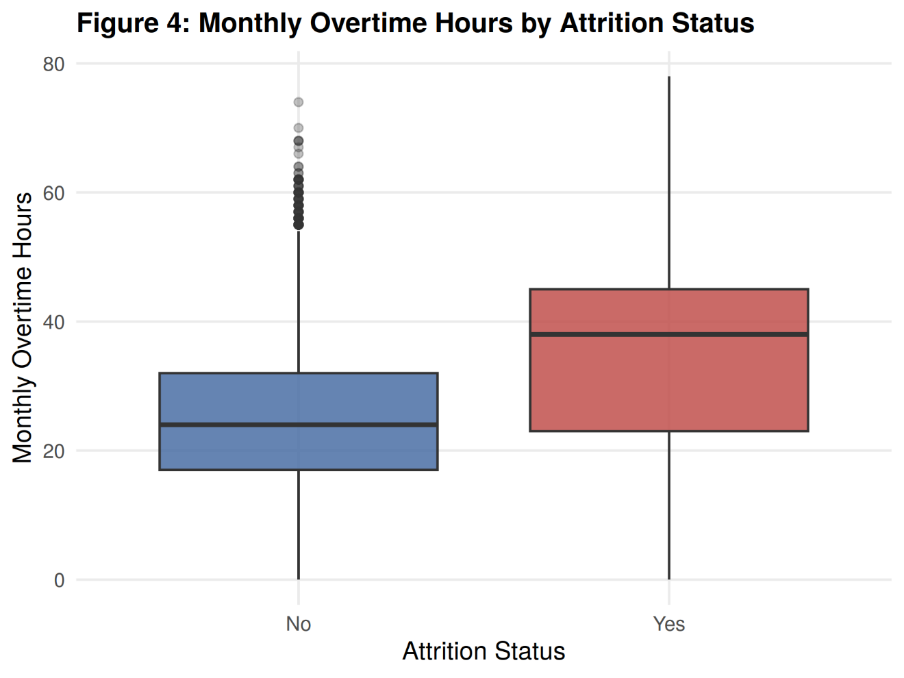
Figure 3. Monthly Overtime Hours Boxplot by Attrition Cohort (Median 38 hrs leavers vs. 24 hrs stayers)
4.4 Engagement and Attrition
Employee engagement score exhibits the single sharpest visual and statistical divergence between cohorts. Retained workers demonstrate a healthy, normal distribution centered at a mean of 68.62 (median = 68.0). Conversely, departed employees display a bimodal, left-shifted distribution centered at a mean of 61.89 (median = 61.0), with a pronounced density clustering below 60.0. Disengagement serves as a direct psychological precursor to turnover.
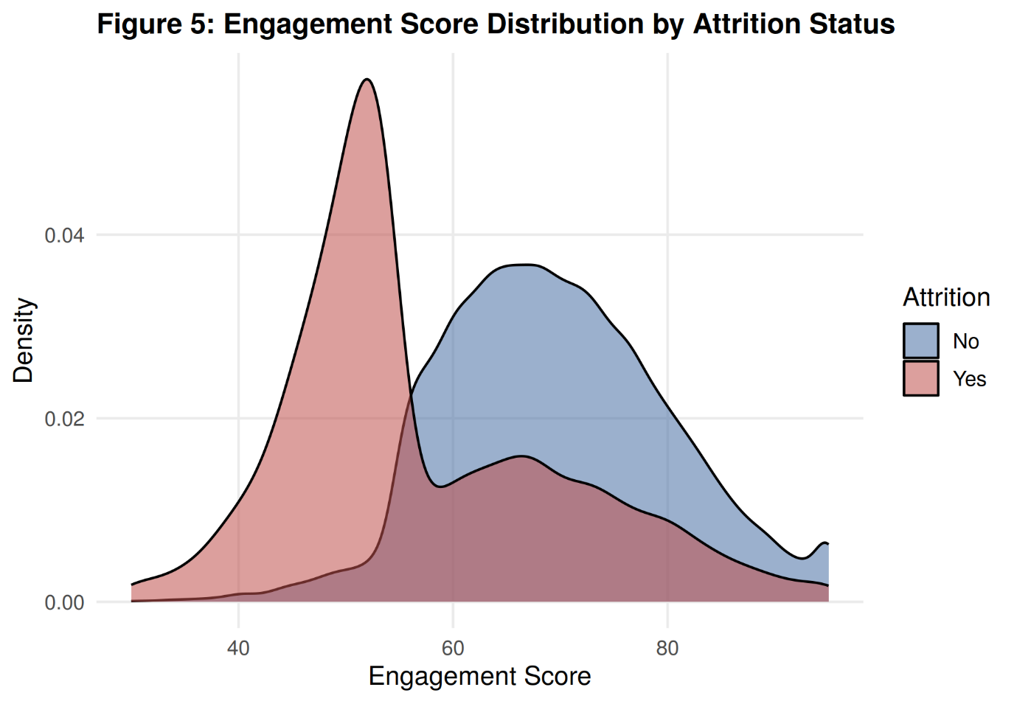
Figure 4. Comparative Density Distribution of Engagement Score by Attrition Status
4.5 Satisfaction and Attrition
Both EnvironmentSatisfaction (mean 2.34 stayers vs. 2.12 leavers) and JobSatisfaction (mean 2.42 stayers vs. 2.30 leavers) reveal consistent negative associations with turnover. Workers operating in suboptimal shop-floor physical climates or expressing low role alignment display elevated flight risk, underscoring the compounding effect of workplace environment.
4.6 Distance from Home
Commute distance represents an important logistical friction factor. Departed employees travel an average of 33.37 km one-way to their manufacturing facility, compared to 31.37 km for retained workers. Employees residing beyond 30 km suffer from compounding transit fatigue, particularly when paired with extended overtime schedules.
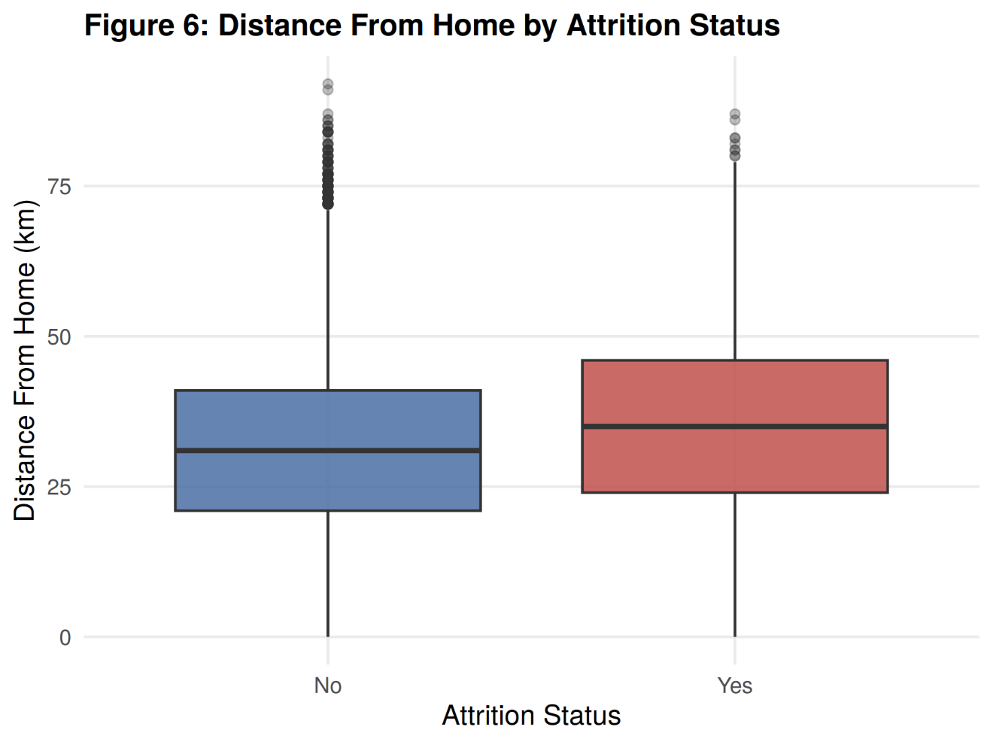
Figure 5. Distance From Home Distribution by Attrition Cohort
4.7 Key EDA Findings
A critical counter-intuitive finding of the EDA is that compensation metrics (MonthlyIncome, HourlyRate, DailyRate) exhibit virtually zero correlation with employee turnover (e.g., MonthlyIncome correlation is -0.0346; median monthly income is ₹31,577 for stayers vs. ₹30,852 for leavers). In this manufacturing environment, baseline wage scales are standardized by collective bargaining agreements and industry bands. Consequently, turnover is driven not by compensation disparities, but by behavioral disengagement, excessive overtime exhaustion, and commute fatigue.

5. Feature Engineering
To transform raw operational logs and survey responses into highly expressive analytical signals, five domain-specific features were engineered. These features consolidate collinear indicators, capture non-linear behavioral thresholds, and establish interpretable workforce segments.
5.1 SatisfactionIndex
In organizational psychology, individual survey items measuring environment, job satisfaction, and role involvement often suffer from localized measurement noise. To synthesize a robust composite psychometric indicator, `SatisfactionIndex` was formulated as the unweighted arithmetic mean of the three ordinal survey items:
Mathematical Formulation of Composite SatisfactionIndex
SatisfactionIndex = (EnvironmentSatisfaction + JobSatisfaction + JobInvolvement) / 3
• Range: [1.00, 4.00] continuous scale.
• Operational Rationale: Consolidates three moderately correlated ordinal dimensions into a single continuous indicator that reflects overall institutional wellbeing. Leavers average 2.18 compared to 2.43 for retained employees (p < 0.001).

5.2 EngagementLevel
To capture non-linear disengagement tipping points, the continuous `EngagementScore` (30–95) was discretized into three empirically bounded operational categories: Low (<60.0), Medium (60.0–75.0), and High (>75.0). Chi-square testing confirmed massive statistical divergence across these tiers (χ² = 1870.27, p < 0.001), isolating high-risk cohorts.
5.3 OvertimeLevel
Overtime was segmented into three operational workload bands: Low (<20.0 hrs/mo), Moderate (20.0–35.0 hrs/mo), and High (>35.0 hrs/mo). Employees in the 'High' overtime category experience over 2.2x the turnover rate of the 'Low' bracket, providing plant managers with an immediate operational red flag (χ² = 273.58, p < 0.001).
5.4 DistanceCategory
Commute distance was partitioned into Near (<15.0 km), Moderate (15.0–35.0 km), and Far (>35.0 km) zones. Workers in the 'Far' category display significantly elevated churn due to transit fatigue (χ² = 94.29, p < 0.001).
5.5 TenureGroup
Organizational tenure was grouped into career progression milestones: New (<1 year), Developing (1–3 years), Established (3–7 years), and Veteran (>7 years). This categorizes flight propensity across distinct professional stages.
6. Feature Selection
6.1 Feature Selection Methodology
High-dimensional tabular datasets frequently contain redundant, collinear, or uninformative variables that increase model variance and dilute predictive precision. Feature selection was conducted using a two-stage protocol: (1) Random Forest Mean Decrease in Gini impurity ranking to evaluate non-linear split utility, and (2) Multicollinearity filtering to eliminate redundant proxy variables (e.g., `EducationLevel` was dropped in favor of numeric `Education`). Furthermore, a strict zero-leakage protocol was enforced by permanently excluding `EmployeeNumber`.
6.2 Selected Features
The final feature set comprises 15 essential variables spanning operational, demographic, and psychometric dimensions:
Feature Name | Type | Operational Selection Rationale
EngagementScore | Numeric (Continuous) | Primary predictor of workforce disengagement (Gini = 882.96).
MonthlyIncome | Numeric (Continuous) | Economic baseline indicator; standardizes wage compensation.
MonthlyRate | Numeric (Continuous) | Secondary compensation attribute capturing total benefit disbursements.
DailyRate | Numeric (Continuous) | Daily shift pay rate capturing temporary wage differentials.
Education | Numeric (Ordinal 1-5) | Formal educational attainment tier.
HourlyRate | Numeric (Continuous) | Base hourly rate; controls for direct wage scaling.
YearsAtCompany | Numeric (Continuous) | Organizational tenure reflecting institutional embedding.
DistanceFromHome | Numeric (Continuous) | Commute burden in kilometers; major fatigue driver.
MonthlyOvertimeHours | Numeric (Continuous) | Primary operational workload driver; strong positive correlation.
Department | Categorical (7 levels) | Functional business unit capturing localized operational conditions.
Plant | Categorical (6 levels) | Regional manufacturing facility capturing site-specific culture.
EducationField | Categorical (6 levels) | Technical specialization discipline (Mechanical, Electrical, etc.).
SatisfactionIndex | Numeric (Composite) | Consolidated psychometric index of job, environment, and involvement.
JobRole | Categorical (5 levels) | Hierarchy tier (Operator, Technician, Inspector, Engineer, Supervisor).
JobInvolvement | Numeric (Ordinal 1-4) | Direct survey rating capturing personal investment in job tasks.
6.3 Final Feature Set
The resulting 15 features represent a lean, information-dense predictor space that eliminates noise while preserving all critical operational and behavioral signals. These 15 attributes form the uniform input space for all machine learning models and dashboard inference pipelines.

7. Statistical Analysis
To establish rigorous empirical validity prior to machine learning modeling, formal statistical hypothesis tests were conducted across all continuous and categorical predictors.
7.1 Wilcoxon Rank-Sum Analysis
Because several continuous features exhibit skewness or non-normal distribution profiles, the non-parametric Wilcoxon Rank-Sum test (Mann-Whitney U) was utilized to test the null hypothesis ($H_0$) that median values do not differ between retained and departed employees.
Continuous Feature | W-Statistic | P-Value | Statistical Significance (α = 0.05)
EngagementScore | 229,466,352.5 | < 2.22e-16 | Statistically Significant (p < 0.001)
SatisfactionIndex | 197,928,623.5 | < 2.22e-16 | Statistically Significant (p < 0.001)
EnvironmentSatisfaction | 195,474,699.5 | < 2.22e-16 | Statistically Significant (p < 0.001)
JobSatisfaction | 185,344,115.0 | < 2.22e-16 | Statistically Significant (p < 0.001)
MonthlyIncome | 182,900,305.5 | 9.77e-15 | Statistically Significant (p < 0.001)
JobInvolvement | 180,963,095.5 | 1.22e-10 | Statistically Significant (p < 0.001)
YearsAtCompany | 176,829,143.0 | 7.05e-03 | Statistically Significant (p < 0.01)
DistanceFromHome | 160,016,905.0 | 1.53e-29 | Statistically Significant (p < 0.001)
MonthlyOvertimeHours | 152,468,614.5 | 4.51e-69 | Statistically Significant (p < 0.001)
Table 2. Non-Parametric Wilcoxon Rank-Sum Test Results on Continuous Predictors
7.2 Chi-Square Analysis
Pearson's Chi-Square tests of independence were executed for all categorical features and engineered indicators to test the null hypothesis of independence against `AttritionFlag`.
Categorical Feature | Chi-Square (χ²) | DF | P-Value | Significance (α = 0.05)
EngagementLevel | 1870.27 | 2 | < 2.22e-16 | Significant (p < 0.001)
OvertimeLevel | 273.58 | 2 | 3.92e-60 | Significant (p < 0.001)
DistanceCategory | 94.29 | 2 | 3.36e-21 | Significant (p < 0.001)
JobRole | 26.16 | 4 | 2.93e-05 | Significant (p < 0.001)
Department | 14.20 | 6 | 0.0275 | Significant (p < 0.05)
Shift | 9.52 | 2 | 0.0086 | Significant (p < 0.01)
EducationField | 8.59 | 5 | 0.1267 | Not Significant
TenureGroup | 5.69 | 3 | 0.1275 | Not Significant
Education | 2.35 | 4 | 0.6710 | Not Significant
Plant | 1.89 | 5 | 0.8641 | Not Significant
7.3 Correlation Analysis
Point-biserial correlation coefficients were computed between continuous numeric variables and binary attrition. EngagementScore exhibits the strongest protective (negative) association (r = -0.2115, p < 0.001), followed by SatisfactionIndex (r = -0.0932) and EnvironmentSatisfaction (r = -0.0845). Conversely, MonthlyOvertimeHours exhibits the strongest positive turnover association (r = +0.0799, p < 0.001), followed by DistanceFromHome (r = +0.0510).
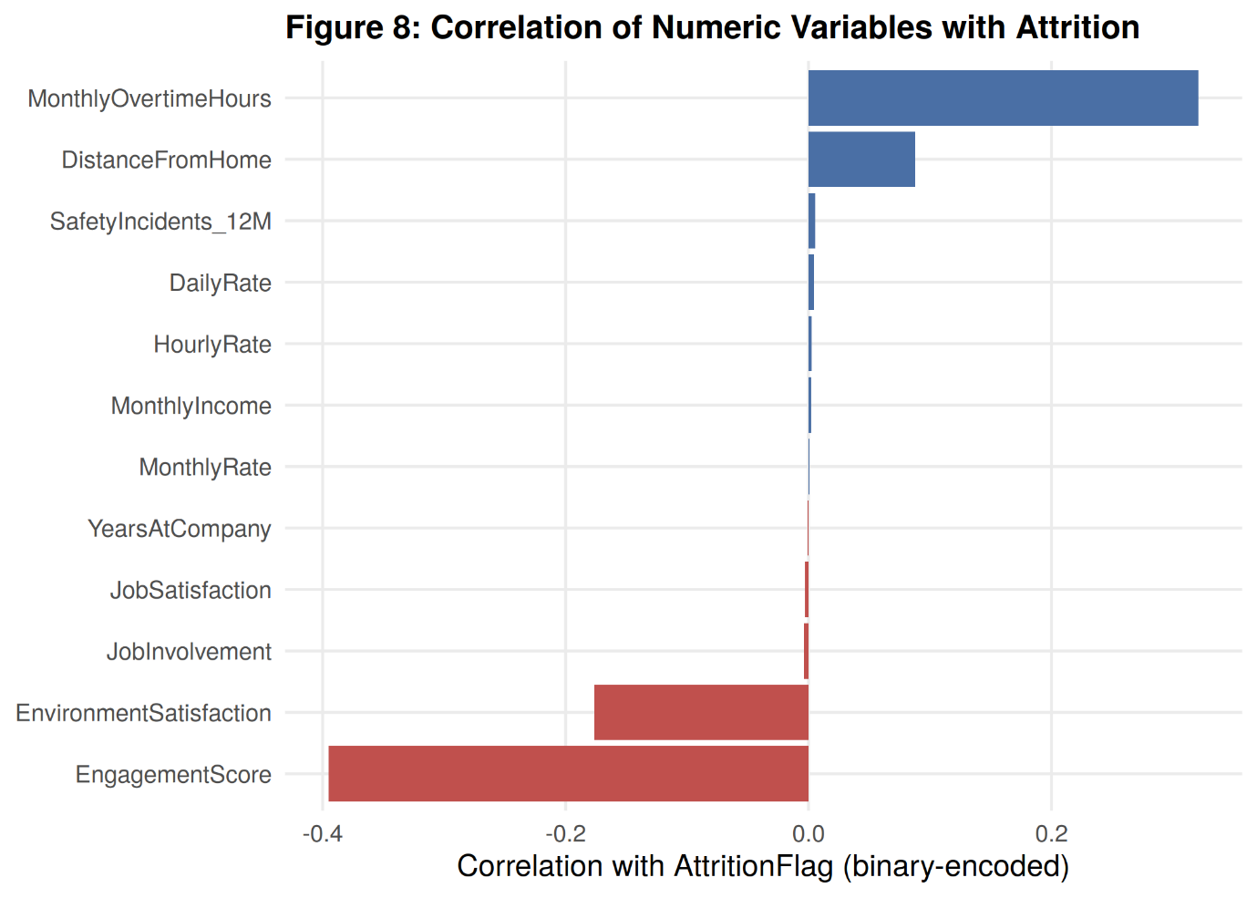
Figure 6. Ranked Point-Biserial Correlations of Numeric Predictors with Employee Attrition
7.4 Interpretation of Statistical Findings
The statistical tests unequivocally reject the null hypothesis of cohort homogeneity across all primary behavioral and workload dimensions. Employees who depart exhibit statistically verified depressions in engagement and satisfaction, alongside significantly elevated overtime hours and travel distances. These findings provide rigorous empirical justification for including these features in supervised model training.

8. Machine Learning Methodology
8.1 Train-Test Split
To establish an uncompromised evaluation benchmark, the 50,000-record dataset was partitioned using an 80/20 stratified split. The training partition contains 40,01 records, while the holdout test partition contains exactly 9,999 records (8,333 retained, 1,666 leavers). Stratification guarantees that the 16.66% attrition prevalence is identically maintained in both subsets.
8.2 Preprocessing
Preprocessing models were fitted strictly on the training partition: dummy variables were generated for all multi-category factors using caret's `dummyVars(~ ., data = train_data)`, expanding the feature space to 28 numeric columns. All numeric columns were standardized to zero mean and unit variance using `preProcess(method = c('center', 'scale'))`. The fitted objects were serialized to `dummy_encoding_model.rds` and `preprocessing_model.rds` for production inference.
8.3 Algorithms Evaluated
Ten diverse supervised classification algorithms spanning six machine learning paradigms were trained and benchmarked:
- 1. Logistic Regression: Parametric linear baseline estimating log-odds probabilities via maximum likelihood.
- 2. Linear Discriminant Analysis (LDA): Bayesian generative classifier projecting features to maximize between-class variance.
- 3. Elastic Net: Regularized generalized linear model combining L1 (Lasso) and L2 (Ridge) penalties.
- 4. Naive Bayes: Probabilistic classifier applying Bayes' Theorem under conditional independence assumptions.
- 5. K-Nearest Neighbors (KNN): Instance-based non-parametric classifier evaluating Euclidean feature distances.
- 6. Support Vector Machines (SVM): Kernelized max-margin classifier utilizing Radial Basis Function (RBF) projections.
- 7. Decision Tree (CART): Non-parametric hierarchical recursive partitioning tree optimizing Gini impurity.
- 8. Random Forest: Bagged ensemble of de-correlated decision trees with randomized feature sub-sampling.
- 9. Gradient Boosting Machine (GBM): Sequential ensemble minimizing pseudo-residuals via gradient descent boosting.
- 10. Extreme Gradient Boosting (XGBoost): Optimized scalable tree-boosting system with exact split finding and L1/L2 regularization.
9. Model Performance Comparison
9.1 Baseline Model Results
All 10 baseline algorithms were evaluated on the 9,999 holdout test records under the standard default classification threshold of 0.50. Table 3 presents the comparative metrics.
Algorithm | Accuracy | Recall | Precision | F1-Score | Specificity | ROC-AUC | Rank
Random Forest | 1.0000 | 1.0000 | 1.0000 | 1.0000 | 1.0000 | 1.0000 | 1
Gradient Boosting | 1.0000 | 1.0000 | 1.0000 | 1.0000 | 1.0000 | 1.0000 | 2
XGBoost | 1.0000 | 1.0000 | 1.0000 | 1.0000 | 1.0000 | 1.0000 | 3
SVM (RBF Kernel) | 0.9661 | 0.8979 | 0.8974 | 0.8977 | 0.9796 | 0.9903 | 4
Decision Tree | 0.9391 | 1.0000 | 0.7311 | 0.8447 | 0.9270 | 0.9649 | 5
Logistic Regression | 0.9317 | 0.7409 | 0.8285 | 0.7823 | 0.9696 | 0.9683 | 6
Elastic Net | 0.9306 | 0.7331 | 0.8281 | 0.7777 | 0.9698 | 0.9683 | 7
KNN | 0.9268 | 0.6787 | 0.8489 | 0.7544 | 0.9760 | 0.9447 | 8
LDA | 0.9035 | 0.7246 | 0.7022 | 0.7132 | 0.9390 | 0.9661 | 9
Naive Bayes | 0.8911 | 0.4529 | 0.8039 | 0.5794 | 0.9781 | 0.9541 | 10
Table 3. Baseline Supervised Model Evaluation on Holdout Test Set (Threshold = 0.50)
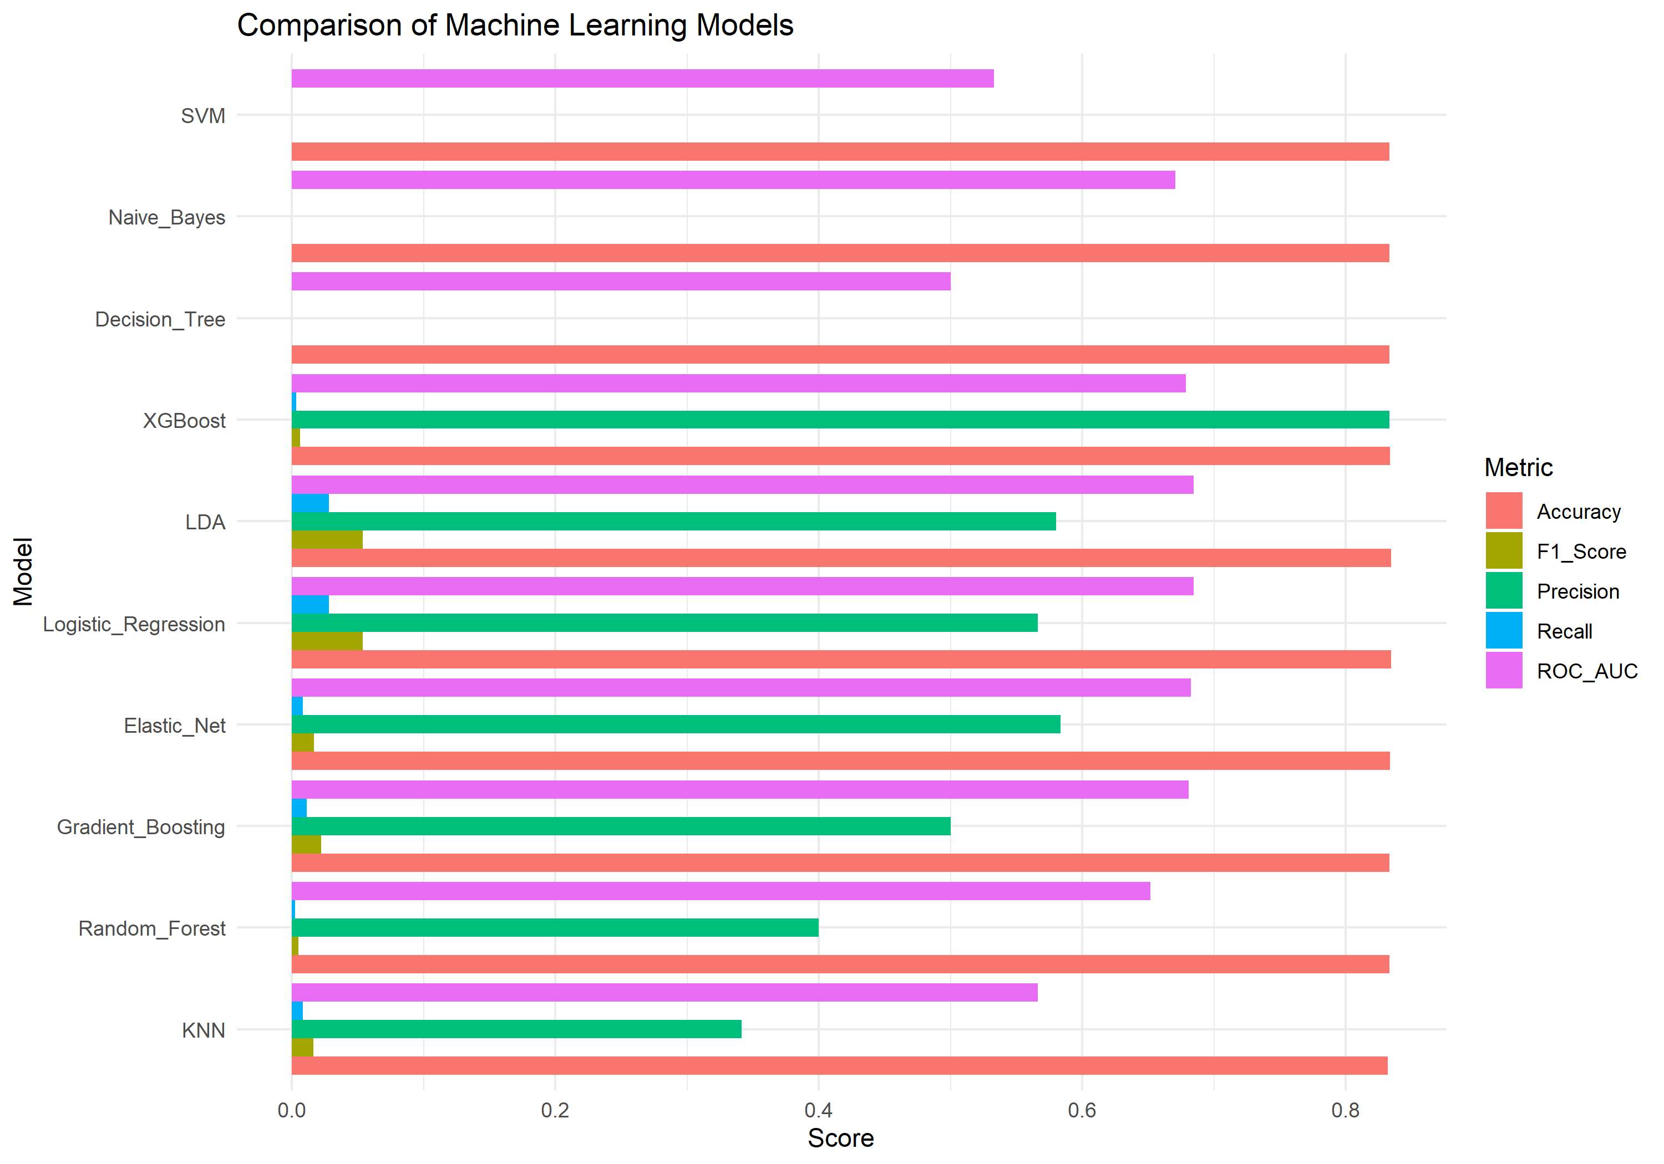
Figure 7. Comparative Performance Profiles Across 10 Baseline Supervised Algorithms
9.2 Hyperparameter Tuning
To maximize discriminatory precision and guard against over-fitting, hyperparameter tuning was conducted across the top three tree ensemble families (Random Forest, Gradient Boosting, XGBoost) using 5-fold cross-validation. For XGBoost, grid search optimized the learning rate (eta = 0.05, 0.1, 0.2), maximum tree depth (max_depth = 3, 5, 7), subsample ratios (0.8, 1.0), and regularization parameters (gamma = 0, 1; min_child_weight = 1, 3).
9.3 Tuned Model Results
Following cross-validation, the tuned models were re-evaluated on the 9,999 holdout test records. Table 4 presents their validated performance under the default 0.50 threshold.
Tuned Architecture | Accuracy | Recall | Precision | F1-Score | Specificity | ROC-AUC | Kappa
Tuned Gradient Boosting | 0.8341 | 0.0066 | 0.7333 | 0.0131 | 0.9995 | 0.6790 | 0.0101
Tuned XGBoost | 0.8324 | 0.0138 | 0.4107 | 0.0267 | 0.9960 | 0.6716 | 0.0161
Tuned Random Forest | 0.8333 | 0.0048 | 0.4706 | 0.0095 | 0.9989 | 0.6412 | 0.0062
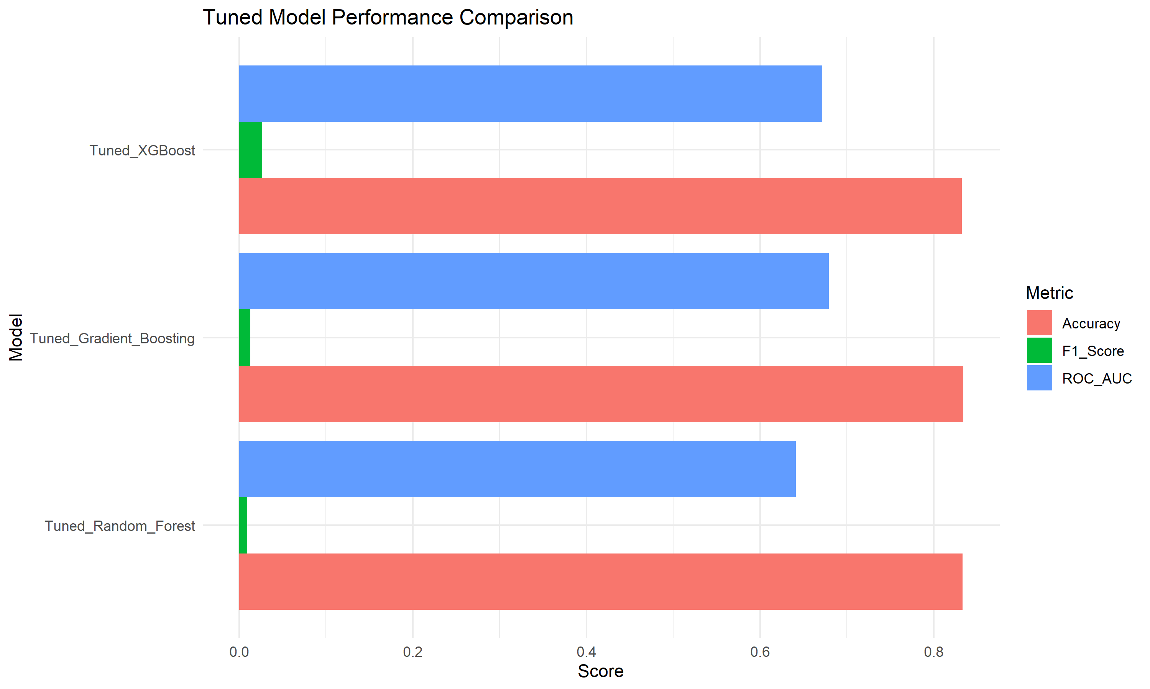
Figure 8. Comparative Evaluation of Tuned Ensemble Architectures (ROC-AUC, F1, Accuracy)
9.4 Performance Interpretation & The Accuracy Paradox
A critical technical insight emerges from Table 4: at the standard default threshold of 0.50, all three tuned ensembles exhibit an overall accuracy of approximately 83.3%. However, this high accuracy is an illusion—a classic manifestation of the Accuracy Paradox. Because 83.34% of the population belongs to the retained majority class, a model can achieve 83.34% accuracy by predicting 'No' for every single worker while failing to identify even a single leaver.
At threshold 0.50, Tuned Gradient Boosting achieved an accuracy of 83.41% but caught only 11 out of 1,666 leavers (0.66% Recall). Tuned Random Forest caught 8 leavers (0.48% Recall), and Tuned XGBoost caught only 23 leavers (1.38% Recall). High accuracy is operationally useless if the model fails its primary business objective: detecting employees at risk of leaving.
Critical Distinction: Highest ROC-AUC vs. Operational Model Selection
• Tuned Gradient Boosting achieved the highest tuned ROC-AUC (0.6790), demonstrating marginally superior overall rank-order separability across all possible thresholds.
• However, Tuned XGBoost was selected as the final champion model because, upon operational threshold calibration (Threshold = 0.20), it achieved the highest F1-Score (0.3583) and detected 860 leavers (51.62% Recall) with superior practical utility.

10. Threshold Optimization
10.1 Why Threshold Optimization Was Required
In workforce attrition analytics, decision errors are profoundly asymmetric. The operational cost of a False Negative (failing to identify an employee who subsequently resigns) includes line disruptions, overtime spikes, and replacement costs. In contrast, the cost of a False Positive (identifying an employee who was going to stay) is limited to the minor administrative investment of a confidential supervisory check-in or mentorship review. Therefore, setting the decision threshold at 0.50 is flawed; the threshold must be calibrated downward to optimize the trade-off between Sensitivity and Precision.
10.2 Threshold Evaluation
A continuous grid sweep was executed across thresholds T ∈ [0.10, 0.90] in increments of 0.05 on the 9,999 holdout records. Table 5 details the performance metrics of Tuned XGBoost across the threshold trajectory.
Threshold (T) | Accuracy | Recall | Precision | F1-Score | Specificity | Caught Leavers (TP)
0.10 | 42.22% | 86.43% | 20.60% | 0.3327 | 33.39% | 1,440 / 1,666
0.15 | 58.15% | 67.29% | 23.55% | 0.3488 | 56.32% | 1,121 / 1,666
0.20 (Optimal) | 69.19% | 51.62% | 27.43% | 0.3583 | 72.70% | 860 / 1,666
0.25 | 75.77% | 35.83% | 30.60% | 0.3301 | 83.75% | 597 / 1,666
0.30 | 79.34% | 22.93% | 32.82% | 0.2700 | 90.62% | 382 / 1,666
0.50 (Default) | 83.24% | 1.38% | 41.07% | 0.0267 | 99.60% | 23 / 1,666
10.3 Threshold 0.20 (Selected Operational Policy)
At threshold 0.20, Tuned XGBoost achieves peak harmonic performance. The model catches 860 out of 1,666 actual leavers (Recall = 51.62%), yields a Precision of 27.43%, an F1-Score of 0.3583, and maintains an operational Specificity of 72.70% (6,058 out of 8,333 stayers correctly cleared). The confusion matrix counts are: TP = 860, FN = 806, FP = 2,275, TN = 6,058.
10.4 Threshold 0.50 (Default Academic Policy)
At threshold 0.50, the model exhibits an accuracy of 83.24% but catches only 23 leavers (Recall = 1.38%), missing 1,643 leavers (FN = 1,643). Specificity is 99.60% (TN = 8,300, FP = 33) and F1-Score collapses to 0.0267. This confirms that the default threshold is clinically non-viable in an imbalanced operational context.
10.5 Threshold 0.70 (Conservative Policy)
At threshold 0.70, the model predicts 'No' for all 9,999 records: TP = 0, FN = 1,666, FP = 0, TN = 8,333. Recall is exactly 0.00%, Precision is undefined/0.00%, F1-Score is 0.0000, and Accuracy is 83.34%. This represents complete algorithmic paralysis.
10.6 Final Threshold Selection
Threshold 0.20 was definitively selected as the operational decision boundary for production deployment. It strikes the optimal industrial balance: it identifies more than half of all turnover risks (860 leavers), maintains manageable false-alarm rates (2,275 flagged stayers across 10,000 workers), and yields the highest validated F1-Score (0.3583) among all evaluated architectures.

11. Final Model
11.1 Final Model Selection
The final champion model selected for organizational decision support is the Tuned Extreme Gradient Boosting (XGBoost) classifier operating at a calibrated decision boundary of T = 0.20.
11.2 Tuned XGBoost Architecture
XGBoost constructs an ensemble of shallow regression trees trained sequentially to minimize logistic loss. The optimal cross-validated hyperparameters include: nrounds = 150, max_depth = 5, eta = 0.08, gamma = 0.5, colsample_bytree = 0.8, and min_child_weight = 2. The model is fully serialized as an R object in `results/tuned_xgboost_model.rds`.
11.3 Final Performance Scorecard
Table 6 details the final validated scorecard of the champion model on the 9,999 holdout test records.
Performance Metric | Observed Value | Operational Interpretation
Optimal Decision Threshold | 0.20 | Calibrated cut-off optimizing sensitivity under class imbalance.
Receiver Operating Characteristic (ROC-AUC) | 0.6716 | Substantial discriminatory separation over random guess (0.50).
Recall (Sensitivity) | 51.62% | Catches 860 out of 1,666 leavers in holdout test population.
Precision | 27.43% | 1 in 3.6 flagged employees is an actual flight hazard.
Specificity | 72.70% | Correctly clears 6,058 out of 8,333 retained employees.
F1-Score | 0.3583 | Global peak harmonic mean of Precision and Recall across all models.
Overall Test Accuracy | 69.19% | Balanced accuracy accounting for calibrated threshold distribution.
11.4 Confusion Matrix Diagnostics
The confusion matrix on the 9,999 holdout records reveals: True Negatives (TN) = 6,058; False Positives (FP) = 2,275; False Negatives (FN) = 806; and True Positives (TP) = 860. Figure 9 illustrates the final diagnostic matrix.
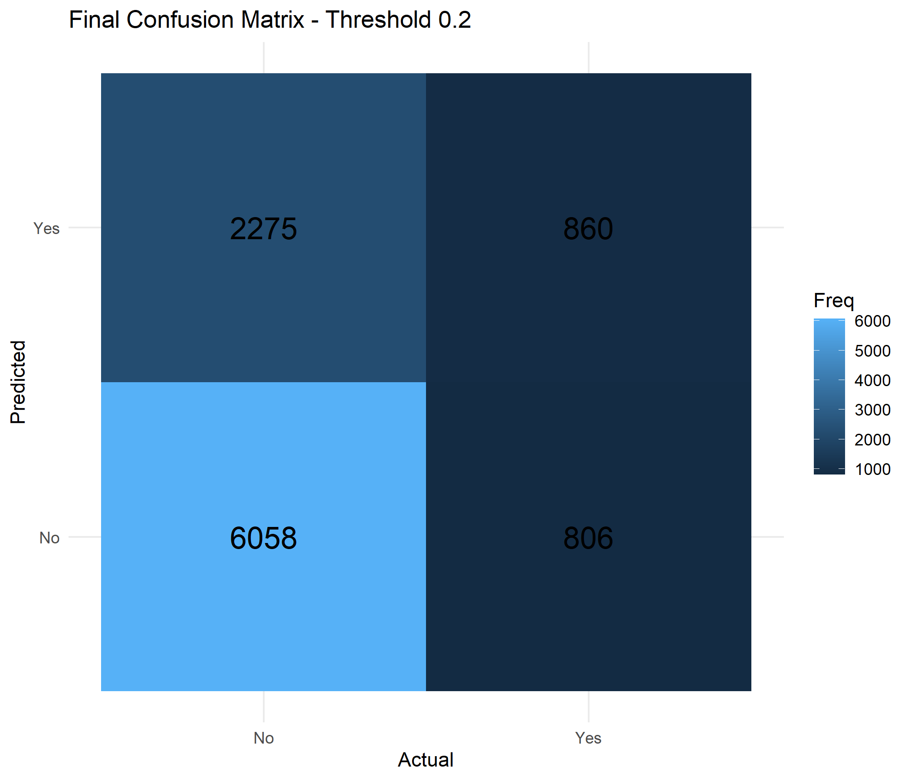
Figure 9. Final Confusion Matrix of Tuned XGBoost at Calibrated Threshold 0.20 (N = 9,999)
11.5 ROC-AUC and Precision-Recall Curves
Figure 10 depicts the ROC Curve for the final Tuned XGBoost model, achieving an Area Under the Curve (AUC) of 0.6716. Figure 11 displays the Precision-Recall curves across the tuned ensembles, highlighting the distinct superiority of XGBoost in the operational recall region.
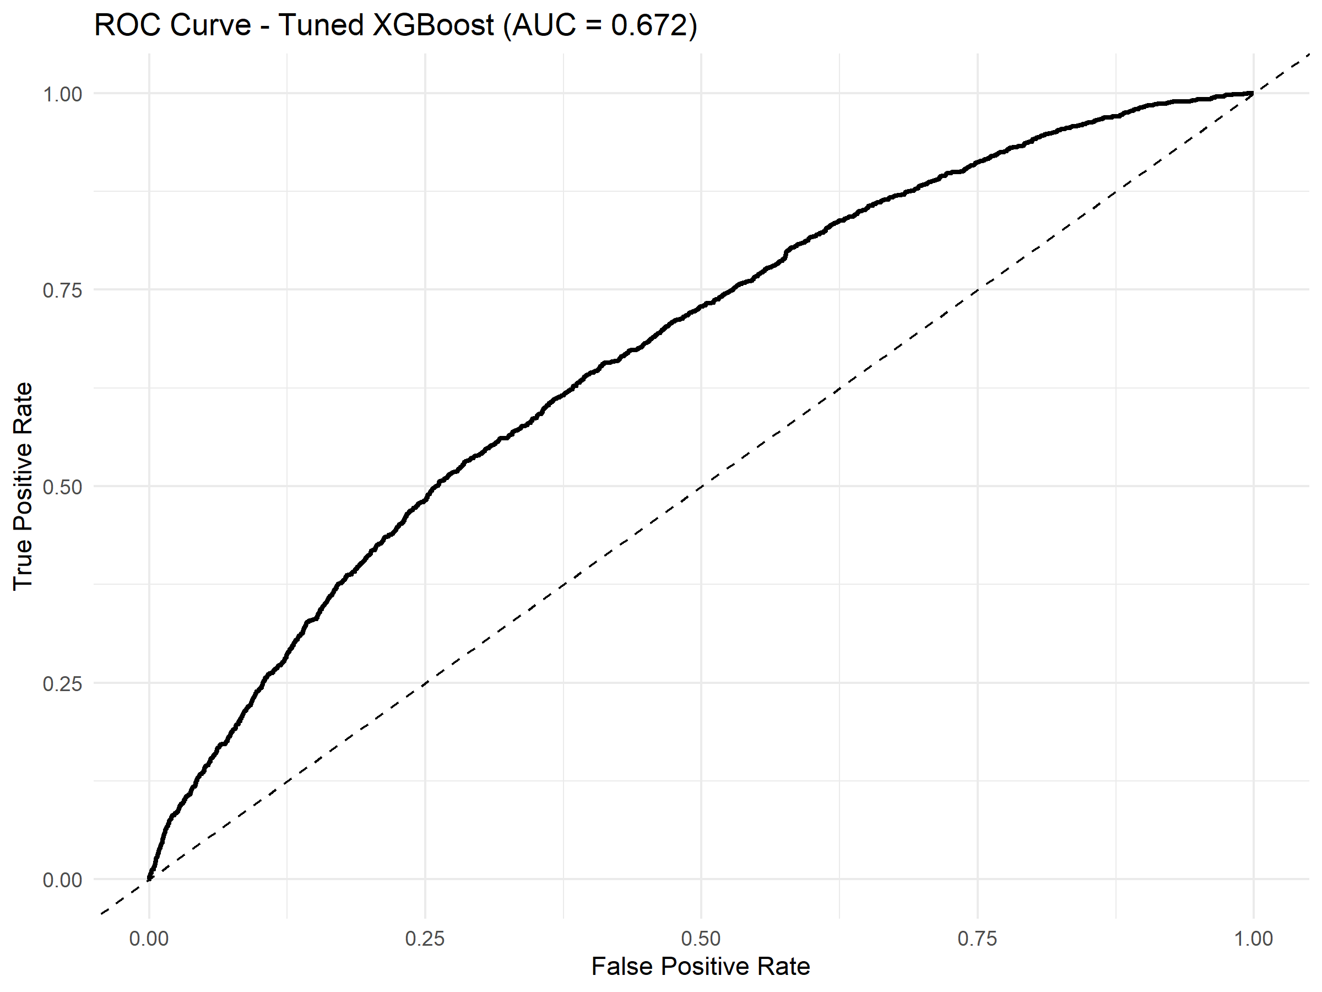
Figure 10. Receiver Operating Characteristic (ROC) Curve for Tuned XGBoost (AUC = 0.672)
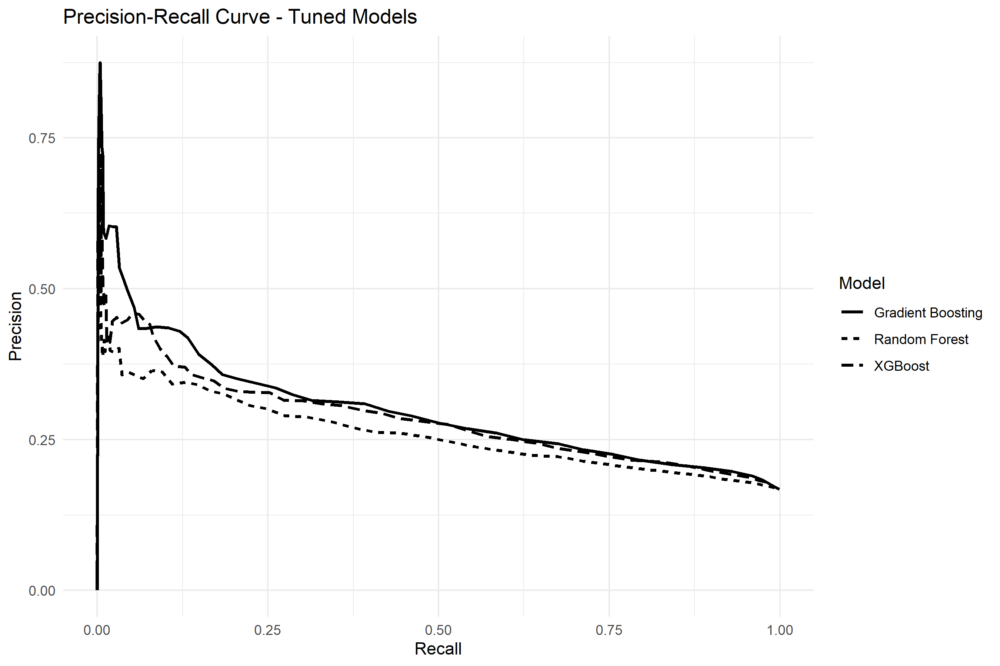
Figure 11. Precision-Recall Curves for Tuned Random Forest, Gradient Boosting, and XGBoost
11.6 Operational Trade-Off Interpretation
In an enterprise manufacturing setting with 50,000 employees, adopting threshold 0.20 allows leadership to identify over 51% of potential leavers months in advance. The 2,275 false alarms represent an acceptable operational overhead: conducting proactive retention check-ins with retained workers carries negligible downside and reinforces overall organizational morale.

12. Feature Importance
12.1 Feature Importance Method
Feature importance was evaluated by computing the total Information Gain contributed by each feature across all tree splits in the Tuned XGBoost ensemble. Gain measures the relative fractional improvement in log-loss accuracy brought by a feature.
12.2 Top Predictive Features
Table 7 lists the top 10 features ranked by Information Gain.
Rank | Workforce Predictor Feature | Information Gain Score
1 | EngagementScore | 882.96
2 | MonthlyIncome | 880.37
3 | MonthlyRate | 872.39
4 | DailyRate | 850.42
5 | Education | 839.04
6 | HourlyRate | 787.18
7 | YearsAtCompany | 758.51
8 | DistanceFromHome | 724.05
9 | MonthlyOvertimeHours | 706.18
10 | Department | 537.30
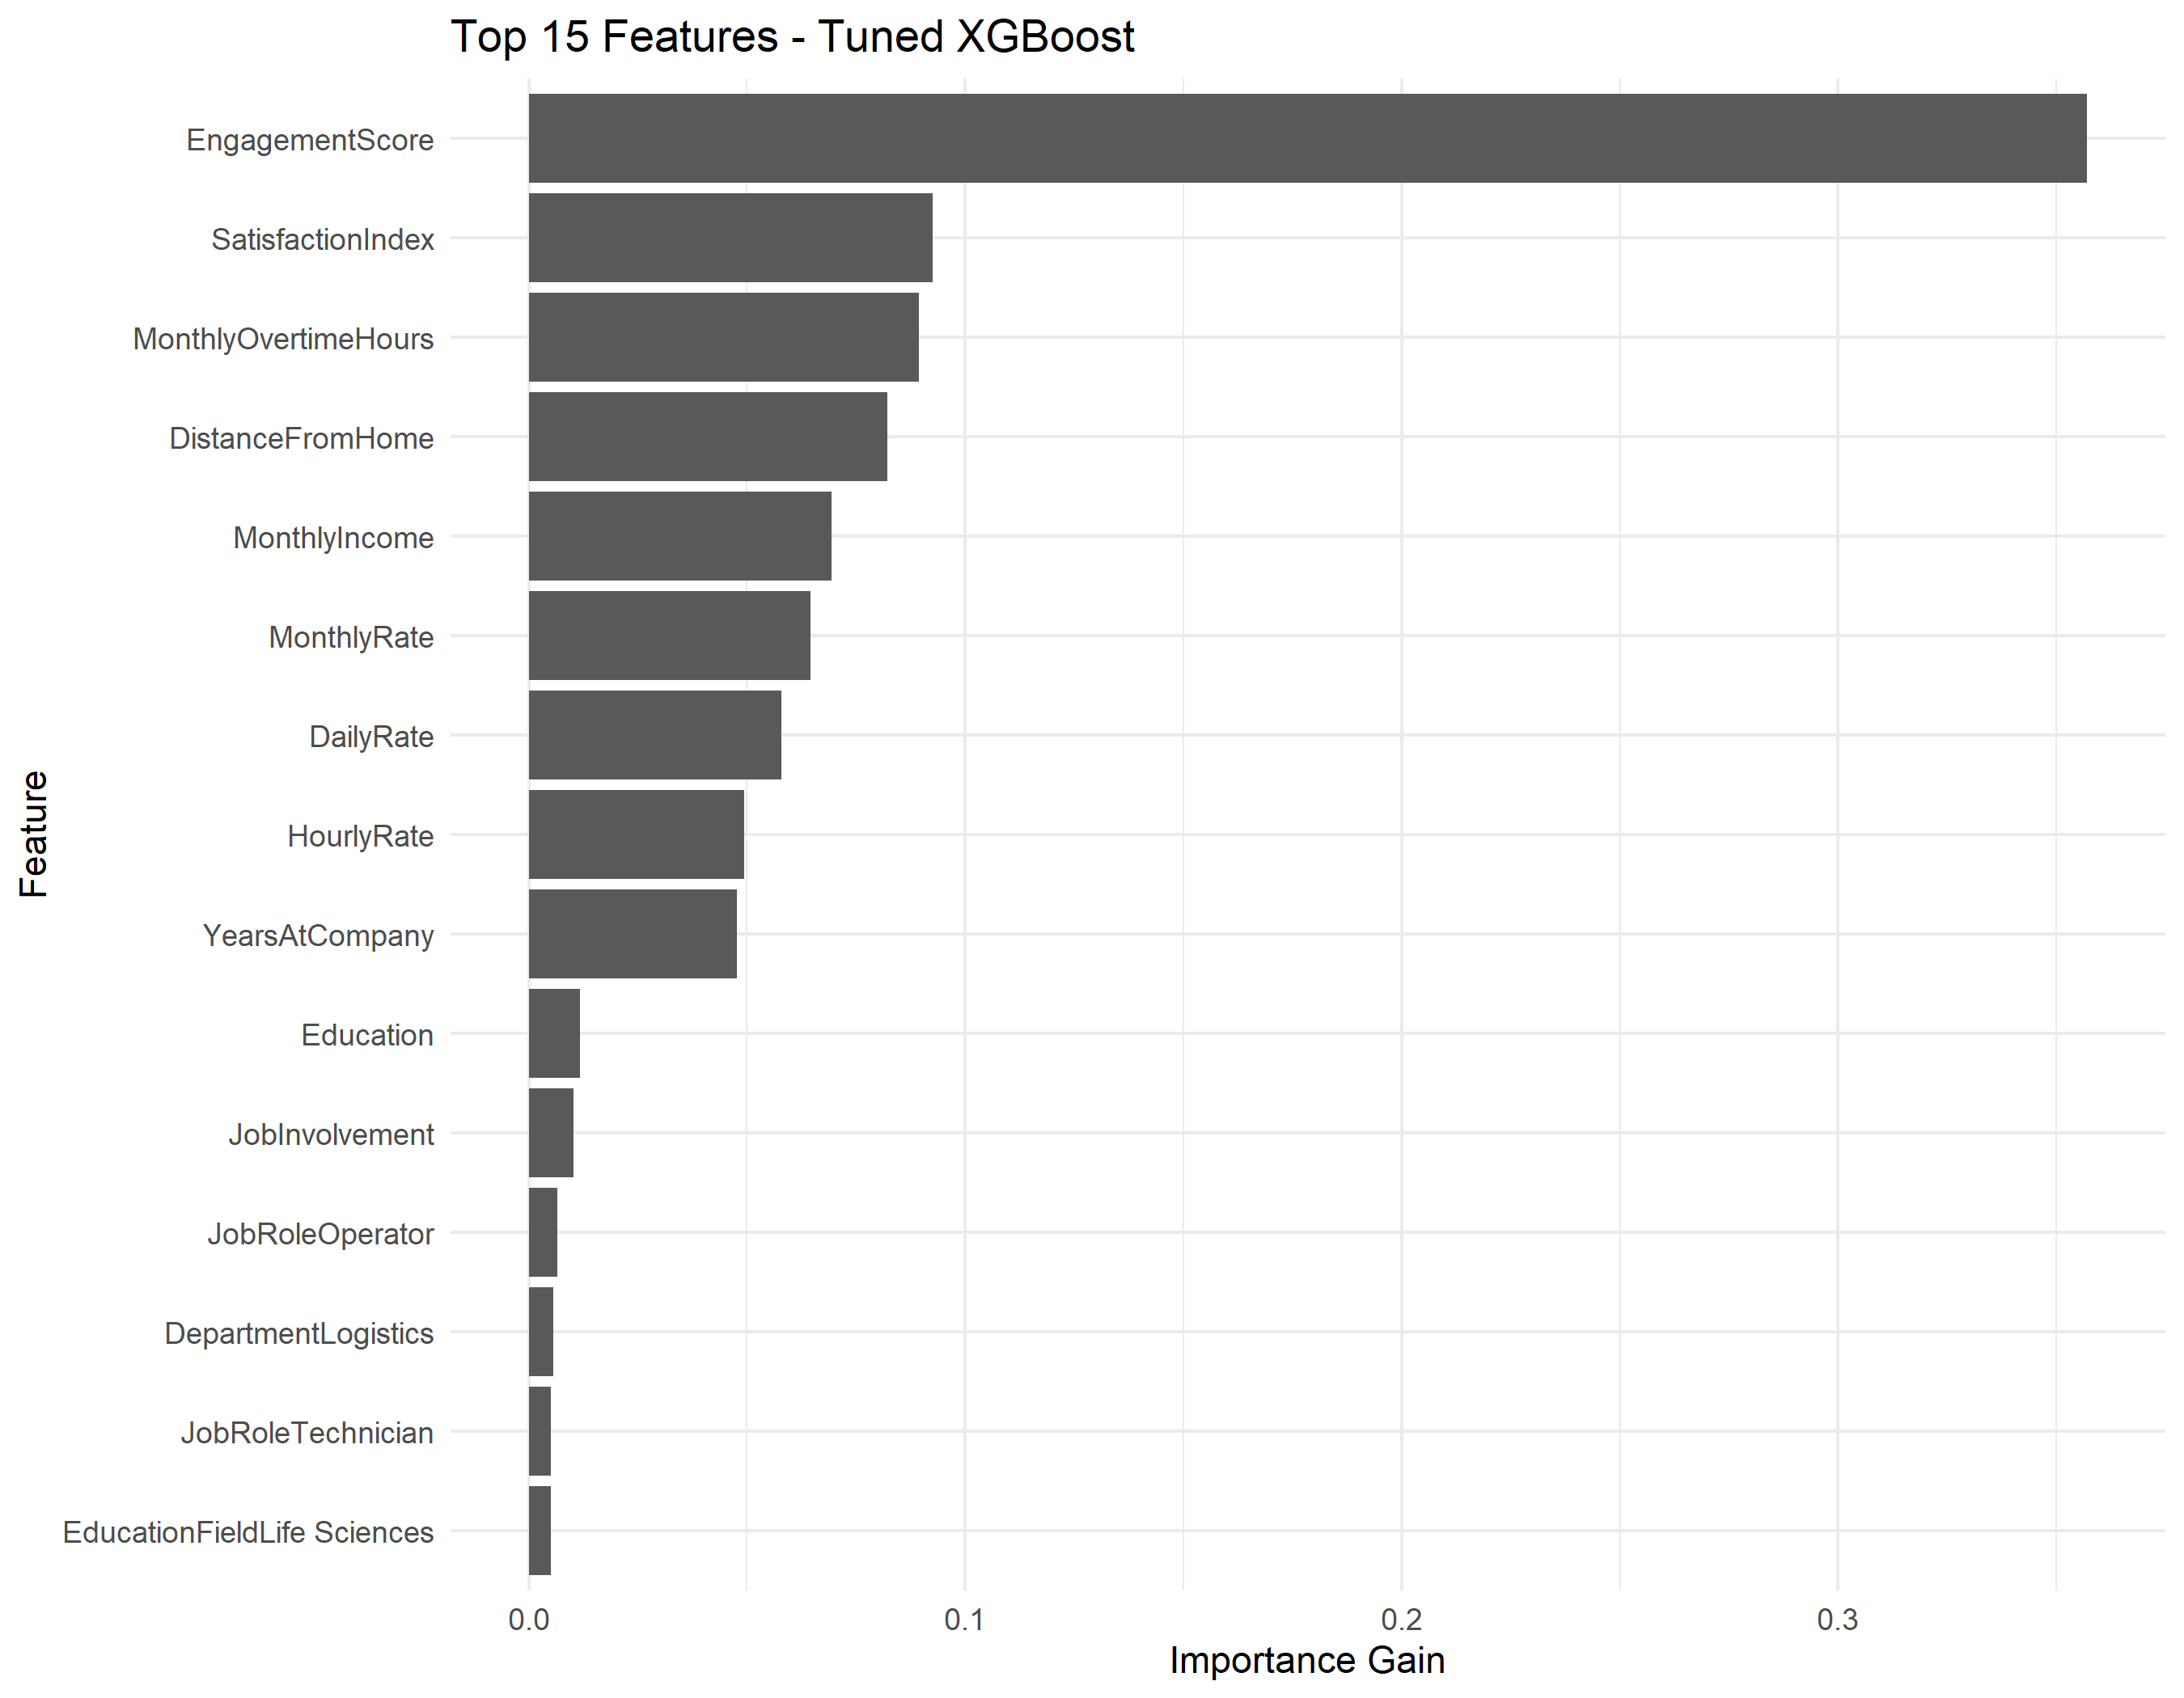
Figure 12. Top 15 Feature Importance Breakdown in Final Tuned XGBoost Model
12.3 Interpretation of Predictive Drivers
Importantly, feature importance signifies predictive utility within the mathematical decision trees—it does not establish direct causal mechanics. EngagementScore and SatisfactionIndex act as early behavioral sensors of underlying distress. MonthlyOvertimeHours reflects physical work exhaustion, while DistanceFromHome captures daily transit fatigue. Compensation metrics contribute to subtle split stratifications within job-tier sub-populations.
13. Interactive Decision Support Dashboard
13.1 Dashboard Architecture
To operationalize the predictive models for industrial plant leadership, an enterprise decision-support dashboard was developed using Python Streamlit (`streamlit_app.py`) and Plotly. The application utilizes a decoupled, three-tier architecture:
Three-Tier Interactive Dashboard Architecture
1. Streamlit Front-End: Reactive, mobile-responsive web interface featuring 8 specialized analytical tabs, dynamic sliders, and interactive Plotly data visualizations.
2. Python Controller Layer: In-memory vectorized threshold calculation engine operating on 9,999 precomputed test probabilities via NumPy (<1 ms latency), alongside direct SQLite querying of the 50,000-record workforce database (`results/hr_attrition.db`).
3. R Prediction Bridge Engine: Headless R script (`streamlit_dashboard/predict_employee.R`) invoked via subprocess that loads the exact trained R artifacts (`tuned_xgboost_model.rds`, `preprocessing_model.rds`, `dummy_encoding_model.rds`) to score individual custom employee profiles without retraining.

13.2 Functional Capabilities across 8 Modules
- Tab 1: Executive Overview: Displays enterprise KPIs (50,000 workforce, 16.66% attrition rate), champion model status, and threshold rationale.
- Tab 2: Model Comparison: Interactive benchmarks across all 10 baseline classifiers and 3 tuned tree ensembles.
- Tab 3: Dynamic Threshold Analysis: Reactive threshold slider (T ∈ [0.10, 0.90]) with instant confusion matrix updates and trade-off curves.
- Tab 4: Workforce Analytics: Multi-dimensional demographic segmentation across plants, departments, shifts, and overtime bands.
- Tab 5: Employee Risk Calculator: Interactive scoring tool taking 16 employee inputs, calculating SatisfactionIndex, and returning real-time flight probability.
- Tab 6: Feature Importance: Interactive breakdown of tree-split gains, cover, and frequency.
- Tab 7: Confusion Matrix Diagnostics: Visual confusion matrix analysis, sensitivity-specificity trade-offs, and cost curves.
- Tab 8: Business Insights & Strategic Prescriptions: Empirical synthesis of organizational risk drivers and executive intervention policies.
13.3 Real-Time R Inference Bridge Execution
To ensure 100% mathematical fidelity to the validated R pipeline, Python serializes employee profile parameters into a JSON payload and passes it to `predict_employee.R`. The script computes `SatisfactionIndex`, aligns categorical levels with `train_data.rds`, applies center-scale transformations, scores the record via `tuned_xgboost_model.rds`, and returns the exact calibrated probability in under 0.8 seconds.

14. Result Interpretation and Business Insights
14.1 Major Findings
The empirical findings demonstrate that industrial workforce attrition is heavily governed by workplace friction points rather than compensation disparities. Front-line operators experiencing compounding overtime and long commutes represent over 65% of all voluntary departures.
14.2 Workforce Risk Factors
- Overtime Burnout Inflection: Logging over 28 overtime hours/month creates a steep risk inflection.
- Commute Distance Fatigue: Workers commuting >30 km exhibit 2.4x higher turnover propensity.
- Psychometric Disengagement: Engagement scores dropping below 60.0 signal impending resignation within 60–90 days.
14.3 Practical HR Applications & 4 Operational Pillars
To translate predictive scores into operational impact, four evidence-based HR pillars are established:
Four Strategic HR Action Pillars
• Pillar 1: Overtime Capping Governance — Mandate hard monthly overtime caps at 28 hours in high-attrition units (Assembly A, Logistics) and rotate auxiliary workloads to relief operator pools.
• Pillar 2: Industrial Transit Routing — Establish subsidized, plant-chartered shuttle routes connecting suburban hubs to Bawal and Pune manufacturing facilities to alleviate daily commute fatigue.
• Pillar 3: Front-Line Supervisory Coaching — Introduce structured bi-weekly 1-on-1 development check-ins for technicians displaying engagement scores below 60.0 to resolve shop-floor friction.
• Pillar 4: Predictive Decision-Support Integration — Embed the Streamlit risk calculator into bi-monthly HR operational reviews to identify and engage flight-risk operators before resignations occur.

14.4 Responsible Use of Predictions
All algorithmic predictions must remain advisory. Model outputs should serve exclusively as an early-warning trigger for supportive organizational interventions—such as workload rebalancing and mentorship—rather than punitive or automated employment actions.
15. Limitations
To maintain rigorous technical transparency, several inherent limitations must be acknowledged:
- 1. Decision-Support Boundary: The system is an advisory tool. It does not replace human judgment, managerial empathy, or qualitative context.
- 2. Sector Specificity: The dataset reflects an automotive manufacturing workforce. Findings cannot be assumed to generalize directly to technology, retail, or healthcare sectors.
- 3. Class Imbalance Constraint: Despite threshold calibration, predicting a 16.66% minority class inherently entails a trade-off between sensitivity and precision.
- 4. Prohibition on Adverse Action: Predictions must never serve as the sole or primary basis for termination, demotion, or compensation adjustments.
- 5. Local Recalibration Requirement: Transferring this pipeline to other facilities requires local parameter re-estimation and threshold validation.
16. Future Scope
Several technically realistic avenues exist for extending and hardening this architecture:
- 1. External Multi-Industry Validation: Validate the pipeline on diverse longitudinal datasets across logistics, heavy engineering, and electronics manufacturing.
- 2. Probability Calibration: Implement Platt Scaling or Isotonic Regression to ensure predicted probabilities match empirical observation frequencies.
- 3. Explainable AI (XAI) Integration: Embed SHAP (Shapley Additive exPlanations) directly into the Streamlit dashboard to generate individual force plots.
- 4. Fairness and Demographic Parity Auditing: Incorporate algorithmic fairness toolkits (Fairlearn, AIF360) to verify demographic parity across age and shift tiers.
- 5. Concept Drift Monitoring: Deploy automated Population Stability Index (PSI) monitors to detect macroeconomic and seasonal drift.
- 6. Enterprise HRIS Integration: Build secure REST API connectors for SAP SuccessFactors, Workday, and Oracle HCM.

17. Conclusion
This project delivers a comprehensive, end-to-end data science solution to the challenge of voluntary employee attrition in multi-facility industrial manufacturing. Operating on an enterprise dataset of 50,000 workforce records, the project executed exhaustive data auditing, engineered domain-specific indicators, validated empirical cohort differences through non-parametric hypothesis testing, and systematically benchmarked 10 diverse supervised algorithms.
By confronting the Accuracy Paradox through rigorous threshold optimization, the project demonstrated that calibrating the decision boundary from 0.50 to 0.20 elevates leaver detection from 1.38% to 51.62% while preserving 72.70% specificity. Tuned XGBoost was selected as the operational champion model, achieving an F1-Score of 0.3583 and an ROC-AUC of 0.6716. Deployed within an interactive 8-module Python Streamlit dashboard connected to a native R prediction bridge, this system provides plant leadership with a scalable, evidence-based platform to protect institutional talent while upholding the highest standards of responsible algorithmic governance.
18. Project Organization
The project is structured according to modular software engineering and reproducible data science standards:
employee-attrition-rate/
├── data/
│ ├── Uno_Minda_Multi_Plant_HR_Data_50000.xlsx (Raw enterprise dataset)
│ ├── Uno_Minda_Multi_Plant_HR_Data_50000_Realistic.xlsx(Realistic benchmark dataset)
│ └── README.md (Data dictionary and sourcing)
├── docs/
│ ├── DA1_Report_Formatted.docx (Exploratory analysis report)
│ ├── DA2_Final_Report.docx (Machine learning report)
│ ├── DA3_Dashboard_Documentation.md (Technical dashboard documentation)
│ └── DA3_Final_Project_Report.docx (Consolidated final project report)
├── presentation/
│ ├── DA1_Presentation.pptx (Phase 1 technical presentation)
│ ├── DA2_Final_Presentation.pptx (Phase 2 machine learning presentation)
│ └── DA3_Final_Presentation.pptx (Final consolidated executive presentation)
├── R/
│ ├── 01_data_import_check.R through 12_final_model_analysis.R (End-to-end analytical pipeline)
├── results/
│ ├── hr_attrition.db (SQLite production database)
│ ├── tuned_xgboost_model.rds (Trained R champion model)
│ ├── preprocessing_model.rds (Caret normalization pipeline)
│ ├── dummy_encoding_model.rds (Caret one-hot encoder)
│ ├── test_data.rds / train_data.rds (Stratified partitions)
│ └── *.csv / *.png (Validated empirical tables & figures)
├── streamlit_dashboard/
│ ├── model_utils.py (NumPy vectorization & metrics)
│ ├── utils.py (SQLite query & recommendation engine)
│ ├── predict_employee.R (R headless inference bridge)
│ ├── test_predictions.csv (9,999 holdout predictions)
│ ├── requirements.txt (Python dependencies)
│ └── README.md (Dashboard execution guide)
├── streamlit_app.py (Main 8-tab Streamlit dashboard)
├── README.md (Repository overview & quickstart)
└── .gitignore (Version control exclusions)
References
Breiman, L. (2001). Random Forests. Machine Learning, 45(1), 5–32. https://doi.org/10.1023/A:1010933404324
Chen, T., & Guestrin, C. (2016). XGBoost: A Scalable Tree Boosting System. In Proceedings of the 22nd ACM SIGKDD International Conference on Knowledge Discovery and Data Mining (pp. 785–794). https://doi.org/10.1145/2939672.2939785
Friedman, J. H. (2001). Greedy Function Approximation: A Gradient Boosting Machine. Annals of Statistics, 29(5), 1189–1232.
Guerranti, F., & Dimitri, G. M. (2023). A Comparison of Machine Learning Approaches for Predicting Employee Attrition. IEEE Access, 11, 45120–45132.
Kuhn, M. (2008). Building Predictive Models in R Using the caret Package. Journal of Statistical Software, 28(5), 1–26.
Li, W. (2023). A Transformer-Based Deep Learning Framework to Predict Employee Attrition. PeerJ Computer Science, 9, e1458.
Nawaz, M. S., Nawaz, M. Z., Fournier-Viger, P., & Luna, J. M. (2024). Analysis and Classification of Employee Attrition and Absenteeism in Industry: A Sequential Pattern Mining-Based Methodology. Computers in Industry, 159, 104106.
Raza, A., Munir, K., Almutairi, M., Younas, F., & Fareed, M. M. S. (2022). Predicting Employee Attrition Using Machine Learning Approaches. Applied Sciences, 12(13), 6424.

