

VISVESVARAYA TECHNOLOGICAL UNIVERSITY

“Jnana Sangama”, Belagavi – 590018, Karnataka.

A Project Report
on

“PharmaCompare: A Real-Time Drug Price and Prescription Intelligence Platform”
Submitted in partial fulfillment for the award of degree of

BACHELOR OF ENGINEERING
in

Department of Information Science & Engineering

Project Associates
- Pramod S D 4GM23IS031
- Rajesh R G 4GM23IS036
- Vaibhav R Katagi 4GM23IS053
- Vanshika D Jain 4GM23IS055

Academic Year 2026-27 Under the Guidance of
Dr. Neelambike S
B.E., M.Tech., Ph.D.,
Professor and Head
PROJECT CO-ORDINATOR HEAD OF THE DEPARTMENT
Mrs. Niveditha N M Dr. Neelambike S
B.E.,M.Tech.(Ph.D)., B.E.,M.Tech, Ph.D.,

Department of Information Science and Engineering

CERTIFICATE

Certified that the Project Report entitled “PharmaCompare: A Real-Time Drug Price and Prescription Intelligence Platform” carried out by Pramod S D (4GM23IS031), Rajesh R G (4GM23IS036), Vaibhav R Katagi (4GM23IS053), Vanshika D Jain (4GM23IS055), bonafide students of VII Semester in partial fulfillment for the award of Bachelor of Engineering in Department of Information Science & Engineering, GM Institute of Technology, Visvesvaraya Technological University, Belagavi for the academic year 2026-27. It is certified that all corrections/suggestions indicated for Internal Assessment have been incorporated in the report. The project report has been approved as it satisfies the academic requirements in respect of project work prescribed for the said degree.

Dr. Neelambike S
Project Guide
Dr. Neelambike S
Head of the Department
Dr. K S Onkarappa
Principal

EXAMINER:

Name: Signature:

INTERNAL EXTERNAL

ABSTRACT
Reading a prescription, checking its medicines for safety problems and finding cheaper comparable products are normally three separate manual tasks. This project presents PharmaCompare, a web platform that joins them. A user uploads a prescription image or PDF; the text is read with Google Cloud Vision or EasyOCR, grouped into lines and matched against a reference table of 253,973 Indian medicine products. A line is accepted automatically only with strong evidence; every other line is held as “needs verification” until the user confirms it, with the reasons shown, a warning if the choice differs from the prescription and a recorded audit trail. The dosing written on the prescription is read into a medicine timeline. Confirmed medicines are screened for drug interactions (DDInter 2.0), duplicate ingredients and allergies, and are priced against products with the same composition, strength, form and pack quantity. A photo of a medicine pack can be scanned for possible products, and a receiver for pharmacy price and stock reports is built, but no pharmacy feed is connected. The system uses React, Flask and MySQL and is rule-based, with no trained machine-learning model; prices come from a static dataset, not from live pharmacies. All 592 back-end and 186 front-end tests passed. Evaluation on real prescriptions remains future work.

ACKNOWLEDGEMENT
We are grateful to Dr. K S Onkarappa, the Principal of G M Institute of Technology, Davanagere, for his unwavering support and commitment to excellence in education. His guidance has inspired us to strive for greater heights.
We extend our appreciation to Dr. Neelambike S, the Head of the Department of Information Science and Engineering, for her encouragement and support throughout this project. Her leadership and vision have been instrumental in fostering an environment conducive to academic growth.
We would like to express our appreciation to our project coordinator Mrs. Niveditha N M, Assistant Professor, for her invaluable guidance and support. Her expertise has been indispensable in shaping our work.
We would like to express our deep appreciation to our project guide Dr. Neelambike S, Professor and Head, for her invaluable guidance, support and constructive feedback. Her expertise has been indispensable in shaping our work.
We are also thankful to the teaching and non-teaching staff of the Department of Information Science and Engineering, G M Institute of Technology for their dedication and assistance during our academic journey. We also acknowledge the support of our classmates and friends for their encouragement throughout this project.
Last but not least, we express our gratitude to our families for their understanding, patience and unwavering support during our academic pursuits. Their love and encouragement have been the cornerstone of our success.
Pramod S D 4GM23IS031
Rajesh R G 4GM23IS036
Vaibhav R Katagi 4GM23IS053
Vanshika D Jain 4GM23IS055

CONTENTS
CHAPTER NO. | CHAPTERS | PAGE NO.
 | ABSTRACT | i
 | ACKNOWLEDGEMENT | ii
 | CONTENTS | iii
 | LIST OF FIGURES | v
 | LIST OF TABLES | vi
1 | PREAMBLE | 1
 | 1.1 PROBLEM STATEMENT | 1
 | 1.2 THE SOLUTION | 1
 | 1.3 OBJECTIVES OF PROJECT | 2
 | 1.4 ADVANTAGES | 2
 | 1.5 LITERATURE SURVEY | 3
 | 1.6 ORGANIZATION OF REPORT | 6
2 | SOFTWARE REQUIREMENT SPECIFICATION | 10
 | 2.1 FUNCTIONAL OVERVIEW | 10
 | 2.2 USER CHARACTERISTICS | 11
 | 2.3 INPUT REQUIREMENTS | 11
 | 2.3.1 USER INPUT REQUIREMENTS | 12
 | 2.3.2 REFERENCE DATA REQUIREMENTS | 12
 | 2.4 OUTPUT REQUIREMENTS | 13
 | 2.4.1 SCREEN AND REPORT OUTPUT | 13
 | 2.4.2 SAFETY ALERTS AND NOTICES | 13
 | 2.5 FUNCTIONAL AND NON-FUNCTIONAL REQUIREMENTS | 14
 | 2.5.1 FUNCTIONAL REQUIREMENTS | 14
 | 2.5.2 NON-FUNCTIONAL REQUIREMENTS | 14
 | 2.6 SOFTWARE REQUIREMENTS | 15
 | 2.7 HARDWARE REQUIREMENTS | 15
 | 2.8 PROJECT CYCLE | 16

CHAPTER NO. | CHAPTERS | PAGE NO.
3 | SYSTEM DESIGN | 17
 | 3.1 PROJECT ARCHITECTURE | 17
 | 3.2 DATABASE DESIGN | 18
 | 3.3 SEQUENCE DIAGRAM | 20
 | 3.4 DATA FLOW DIAGRAM | 21
 | 3.5 DATABASE TABLE STRUCTURE | 23
 | 3.6 FLOW CHART | 30
 | 3.7 UTILITIES | 32
4 | IMPLEMENTATION | 34
 | 4.1 SOFTWARE TOOLS USED | 34
 | 4.2 IMPLEMENTATION DETAILS | 35
 | 4.3 FRONT-END FORMS DESIGN | 41
5 | TESTING | 46
 | 5.1 SCOPE | 46
 | 5.2 UNIT TESTING | 46
 | 5.3 MODULE TESTING | 48
 | 5.4 FUNCTIONAL TESTING | 50
 | 5.5 SYSTEM TESTING | 51
6 | RESULTS | 53
 | 6.1 SNAPSHOTS OF THE PROJECT | 53
 | 6.2 OBSERVATIONS | 56
7 | CONCLUSION | 60
 | 7.1 CONCLUSION | 60
 | 7.2 FUTURE SCOPE | 60
 | APPENDIX-A | 61
 | APPENDIX-B | 62
 | REFERENCES | 63

LIST OF FIGURES
FIGURE NO. | DESCRIPTION | PAGE NO.
2.1 | PROJECT CYCLE | 16
3.1 | PROJECT ARCHITECTURE | 18
3.2 | ENTITY-RELATIONSHIP DIAGRAM | 19
3.3 | SEQUENCE DIAGRAM | 20
3.4 | DATA FLOW DIAGRAM, LEVEL 0 | 22
3.5 | DATA FLOW DIAGRAM, LEVEL 1 | 23
3.6 | FLOW CHART | 32
4.1 | MEDICINE MATCHING AND MATCH STATUSES | 37
4.2 | LANDING PAGE | 41
4.3 | REGISTRATION FORM | 41
4.4 | LOGIN FORM | 42
4.5 | UPLOAD PAGE | 42
4.6 | VERIFICATION DIALOG | 43
4.7 | WARNING BEFORE A CONFLICTING CONFIRMATION | 43
4.8 | DASHBOARD | 44
4.9 | MEDICINE SEARCH PAGE | 44
4.10 | SCAN A MEDICINE PAGE | 45
4.11 | DATA SOURCES ON THE ABOUT PAGE | 45
6.1 | FICTIONAL DEMONSTRATION PRESCRIPTION | 53
6.2 | ANALYSIS SUMMARY | 53
6.3 | DETECTED MEDICINES | 54
6.4 | DETAILS OF A LINE THAT NEEDS VERIFICATION (ZINCOVIT, NOT ACCEPTED) | 54
6.5 | MEDICINE TIMELINE | 55
6.6 | SAFETY AND INTERACTIONS | 55
6.7 | SMART HEALTH REPORT (PAGES 1 AND 2) | 56
6.8 | WHY INGREDIENT-ONLY SUGGESTIONS FAIL | 57
6.9 | MATCHER OUTCOMES BY SIMULATED EDITS | 58

LIST OF TABLES
TABLE NO. | DESCRIPTION | PAGE NO.
2.1 | USER INPUT REQUIREMENTS | 12
2.2 | REFERENCE DATA AND SERVICE REQUIREMENTS | 12
2.3 | SCREEN AND REPORT OUTPUT | 13
2.4 | SOFTWARE REQUIREMENTS | 15
2.5 | HARDWARE REQUIREMENTS | 15
3.1 | DATABASE TABLES AND THEIR PURPOSE | 19
3.2 | STRUCTURE OF THE DATABASE TABLES | 24
3.3 | UTILITY MODULES OF THE BACK END | 32
4.1 | SOFTWARE TOOLS USED | 34
4.2 | REST API ENDPOINTS | 39
4.3 | THRESHOLDS AND PARAMETERS | 40
5.1 | UNIT TESTS | 47
5.2 | MODULE TESTS | 48
5.3 | FUNCTIONAL TESTS | 50
5.4 | BACK-END TEST SUITE BY GROUP | 51
5.5 | FRONT-END LOGIC TEST SUITE BY GROUP | 51
6.1 | REFERENCE DATA USED BY THE SYSTEM | 56
6.2 | INGREDIENT-ONLY VERSUS COMPARABLE RULE | 57
6.3 | MATCHER BEHAVIOUR UNDER SIMULATED NOISE | 58
6.4 | STATUS OF THE OBJECTIVES | 59

CHAPTER 1

PREAMBLE
The preamble comprises of problem statement, solution, objectives, advantages, literature survey and organization of the report.

1.1 PROBLEM STATEMENT
A prescription is useful only if the patient can tell what was prescribed. In one South African district hospital, pharmacists read only 75% of sampled handwritten prescriptions correctly, and one in five health workers read a 4 mg lorazepam injection as 40 mg [1]. A wrongly read medicine carries through to a wrong safety message and a wrong price.
A prescription with several medicines also risks duplicate therapy, interactions and allergy conflicts that a patient cannot easily check, and products with the same composition are sold at very different prices [2], [3]. There is a pressing need for a system that takes a user from a prescription image to a checked list of medicines and comparable prices without presenting a guess as a fact.

1.2 THE SOLUTION
The proposed system, “PharmaCompare”, is a web application that joins prescription reading, medicine identification, safety screening and price comparison in one workflow. The user uploads a photograph or PDF of a prescription and receives a Smart Health Report.
The text is read with Google Cloud Vision or the local EasyOCR engine and matched against 253,973 Indian medicine products. A line is accepted automatically only with strong evidence; every other line is held as needs verification until the user confirms it. Confirmed medicines are screened against 160,235 documented interaction pairs (DDInter 2.0) and priced against products with the same ingredients, strength, dosage form, release type and pack quantity. The dosing written on the prescription is read into a medicine timeline, and a photo of a medicine pack can be scanned to find possible products.
Prices come from a static community dataset, not from live pharmacies. The system can receive prices and stock that a pharmacy reports and shows them separately, but no pharmacy feed is connected, so no live price or stock level is known.

1.3 OBJECTIVES OF PROJECT
The main objective of this project is to design and develop PharmaCompare, a platform that helps a patient understand a prescription, check it for safety problems and find cheaper comparable products. The specific objectives are:
- To develop a real-time drug price comparison module for products of the same composition, strength and form.
- To implement an AI-based prescription analysis system that checks medicines for interactions, duplicates and allergies.
- To design an alternative drug recommendation engine that suggests cheaper comparable products, with reasons.
- To integrate real-time drug availability tracking.
- To incorporate confidence-based decision support that hands uncertain readings back to the user.
- To utilise and process healthcare data sources as the knowledge base of the system.

1.4 ADVANTAGES
The adoption of PharmaCompare offers several advantages over reading and checking a prescription by hand. Key advantages include:
- One Workflow: reading, safety screening, price comparison and the Smart Health Report in a single upload.
- Cautious by Design: a guessed line never reaches the safety or price stages until the user confirms it, and a missing interaction record is never shown as “safe”.
- Medicine Timeline: the written dosing is shown as a morning, afternoon, evening and night schedule.
- Strict Price Comparison: same ingredients, strength, form and release type, with savings per unit and the source of every price stated.
- Security and Privacy: salted password hashes, owner-only access and a fully local OCR option.
- Low Cost and Extensible: free open data, an open-source stack and separate service modules.

1.5 LITERATURE SURVEY
[1]. H. Brits et al. “Illegible handwriting and other prescription errors on prescriptions at National District Hospital, Bloemfontein” (South African Family Practice, 2017). Twenty doctors’ prescriptions were read by doctors, nurses and pharmacists. Doctors read 88%, nurses 82% and pharmacists 75% correctly, and 20% of health workers read lorazepam 4 mg as 40 mg. Limitation: one hospital and a small sample.
[2]. A. Ray et al. “A cost variation analysis of drugs available in the Indian market for the management of thromboembolic disorders” (Cureus, 2020). Compares brand prices of anticoagulant, antiplatelet and fibrinolytic drugs per tablet, capsule or injection and reports wide cost variation between brands. Limitation: catalogue prices for one drug group.
[3]. D. K. Behera et al. “Medicine affordability and access in India: lessons from generic–branded price variation under the Jan Aushadhi Scheme” (Frontiers in Public Health, 2025). Analyses 696 branded eye and ENT formulations against Jan Aushadhi generics and finds wide price variation among brands. Limitation: one therapeutic area.
[4]. A. Razdan et al. “Recognition of handwritten medical prescription using CNN Bi-LSTM with lexicon search” (ICCCNT, 2023). A CNN–BiLSTM recogniser whose predictions are checked by a lexicon search of Indian drug names; the lexicon helps on prescriptions. Limitation: reading only; no price or safety.
[5]. M. F. Uz Zaman et al. “Recognizing medicine names from Bangladeshi handwritten prescription images using TrOCR” (CEII, 2024). TrOCR fine-tuned on 893 prescription images, followed by edit-distance correction: character error rate falls from 16% to 7% and word error rate from 36% to 11%. Limitation: one country’s dataset.
[6]. U. Ali et al. “Leveraging deep learning with multi-head attention for accurate extraction of medicine from handwritten prescriptions” (ICRAI, 2024). Mask R-CNN finds medicine regions, TrOCR reads them and the text is matched to a database; 1.4% character error rate on standard benchmarks. Limitation: the benchmark is not the authors’ own dataset.
[7]. A. Roy et al. “A YOLO-TrOCR pipeline with dictionary refinement for handwritten medicine name extraction” (PECCII, 2026). YOLO detects medicine names, TrOCR reads them and a dictionary refines the output, raising exact match from 0.7355 to 0.7518. Limitation: Bangladesh-specific dictionary.
[8]. M. T. S. Devi et al. “GENERIC RX: AI-powered prescription OCR for generic medicine discovery” (ICICDS, 2026). Prescription OCR with fuzzy matching, cheaper generic substitutes, interaction screening and cost comparison, tested on 500 real prescription images. Limitation: only the abstract was read; comparability rules are unknown.
[9]. S. Thota et al. “AI-powered prescription decoder and generic medicine recommender” (International Journal on Science and Technology, 2026). Reads prescriptions, maps medicines to RxNorm for generic equivalents and shows prices and warnings; unrecognised medicines are flagged for manual review. Limitation: no quantitative evaluation.
[10]. E. Diaz Amaya et al. “Information system for price comparison and prescription reading … for pharmacies in Peru” (LACCEI, 2024). Scrapes pharmacy websites for prices and reads prescriptions with Pytesseract; on 20 prescriptions it reached 90.5% scanning accuracy. Limitation: a tiny test; live scraping is not done in this project.
[11]. S. Jeevidha et al. “An advanced electronic health record for prescription analysis using YOLO and OCR with spell correction” (ICCIDS, 2026). YOLO finds fields, OCR reads them and spell correction repairs the text (mAP@0.5 of 0.93). Limitation: detection metrics only.
[12]. T. Mankash et al. “MIRAGE: multimodal identification and recognition of annotations in Indian general prescriptions” (arXiv:2410.09729, 2024). Multimodal language models fine-tuned on 743,118 simulated prescriptions reach 82% accuracy. Limitation: simulated data; a preprint.
[13]. M. Agrawal et al. “A review of artificial intelligence in medical prescription analysis” (ICPCSN, 2023). Reviews AI for medication identification, dose calculation and interaction checks, and concludes that accuracy still needs improvement.
[14]. R. Ma et al. “An intelligent OCR-LLM prescription review system for inpatient narcotic and psychotropic drugs” (Medicine, 2026). OCR, a local language model and rules review prescriptions; on 500 prescriptions the system reached 95.6% accuracy (kappa 0.897) against pharmacist review. Limitation: one drug class.
[15]. R. Patil et al. “Application of fuzzy matching algorithms for doctors handwriting recognition” (IBSSC, 2022). A CRNN–CTC reader with edit-distance correction; Damerau–Levenshtein distance worked best on 600 images and a list of only 50 medicines.
[16]. W. T. Kim et al. “Medication extraction and drug interaction chatbot” (Mayo Clinic Proceedings: Digital Health, 2024). OCR of Korean medicine packages, text-similarity matching (threshold 0.7) and a language model with a contraindication database; 99.17% word accuracy on 150 samples. Limitation: mock-up packages, not real prescriptions.
[17]. A. Jagatap et al. “RxLens: multi-agent LLM-powered scan and order for pharmacy” (NAACL, 2025). A multi-agent system reads prescriptions and builds a pharmacy cart by catalogue matching; recall@3 improved by 19–40% for handwriting. Limitation: no safety check or price comparison.
[18]. S. Abdullah et al. “An offline smartphone check for drug interactions and past reactions in handwritten prescriptions” (arXiv:2608.27239, 2026). Each handwritten line is accepted, sent for confirmation or sent for a manual check before documented interactions are retrieved; 62% of lines still needed a manual check in simulation. Limitation: a preprint; no price analysis. It is the closest match to the confirmation gate used here, so that idea is not claimed as new.
[19]. Y. Tian et al. “DDInter 2.0: an enhanced drug interaction resource” (Nucleic Acids Research, 2025). Release 2.0 reports 2,310 drugs and 302,516 interaction records. It is the interaction source of this project; the bulk files that could be downloaded gave 160,235 unique pairs.
[20]. O. M. Alharbi “Designing an OCR-based medication support system with drug–drug interaction alerts for elderly” (IEEE Access, 2026). An application for Arabic-speaking elderly users: OCR identifies the medicines and interactions are flagged in Arabic; a formative usability test was positive. Limitation: no accuracy figures; no price.
[21]. F. Nasser et al. “PharmaBot: a multimodal AI system for drug interaction detection” (IMCET, 2026). Detection, OCR, a language model and retrieval over DrugBank; F1 of 0.9913 for end-to-end interaction detection. Limitation: evaluated on author-made template data.
[22]. K. Gaikwad et al. “OCR and NER based generic medicine recommendation system” (CISES, 2025). Four OCR engines, named-entity recognition and fuzzy matching to over 21,700 brand–generic mappings; over 98% accuracy is claimed. Limitation: the test set is not defined.
[23]. M. Janani et al. “OCR text recognition and recommendation using machine learning” (ICVADV, 2025). OCR plus fuzzy matching of ingredient names and recommendation of pharmaceutical and Ayurvedic alternatives. Limitation: price handling is not described.
[24]. J. Karmakar et al. “Optimizing pharmaceutical affordability: a composition-based algorithm for medicine price and alternative discovery” (ICoEIT, 2025). Ranks low-priced substitutes by ingredient, cost, manufacturer credibility and packaging over about 2.5 lakh Indian medicines; savings above 60% in case studies. Limitation: no prescription input.
[25]. J. S. Larson M. et al. “AI-enabled brand-to-generic medication recommendation system for pharmacy” (IC3ET, 2026). A chatbot that tells brand from generic queries and suggests cheaper options by active ingredient; over 80% accuracy on straightforward queries. Limitation: text queries only.
The above literature reveals significant research interest in each part of the problem, but mostly in separate parts. Handwriting recognition [4]–[7], OCR with interaction alerts [20], [21] and prescription-to-generic or prescription-to-price pipelines [8]–[10], [22]–[24] already exist, and an accept / confirm / manual-check policy has been described [18]. PharmaCompare therefore does not claim a new pipeline: it combines a strict comparability rule, the exclusion of unconfirmed readings from the safety and price stages, and an evaluation of the comparison step. This describes the papers read, not all prior work.

1.6 ORGANIZATION OF REPORT
Chapter 1: Preamble
The preamble in a chapter provides a concise introduction, outlining the chapter's main themes and objectives. It may include background information and context to help readers understand the subject matter. Additionally, the preamble serves as a roadmap, guiding readers through the upcoming content.
This section includes:
- Problem statement
- The solution
- Objectives of the project
- Advantages of the project
- Literature survey
Chapter 2: Software Requirement Specification
A Software Requirements Specification (SRS) is a concise document. It outlines the functional and non-functional requirements of a software system, providing a blueprint for development and ensuring alignment on project goals and constraints.
This section includes:
- Functional overview
- User characteristics
- Input requirements
- Output requirements
- Functional and non-functional requirements
- Software requirements
- Hardware requirements
- Project cycle
Chapter 3: System Design
System design involves the process of creating a detailed blueprint for a software system, including its architecture, components, interfaces, and interactions. It encompasses defining system requirements, designing data structures, algorithms, and interfaces, and making decisions about technologies, platforms, and frameworks to be used.
This section includes:
- Project architecture
- Database design
- Sequence diagram
- Dataflow diagram
- Database table structure
- Flow chart
- Utilities
Chapter 4: Implementation
Implementation refers to the process of translating a design or plan into a working software system. It involves writing code, integrating components, and testing the system to ensure that it functions according to the specified requirements.
Implementation typically follows the system design phase and involves programming, debugging, and optimizing the software to meet performance, reliability, and usability goals. Successful implementation results in a fully functional software product ready for deployment and use by end-users.
This section includes:
- Software tools used
- Implementation details
- Front end forms design
Chapter 5: Testing
Testing is the process of evaluating a software system to identify defects, errors, or discrepancies between expected and actual outcomes. It involves executing test cases, scripts, or scenarios to verify that the software functions correctly and meets specified requirements. Testing encompasses various techniques such as unit testing, integration testing, system testing, and acceptance testing, aiming to ensure the quality, reliability, and robustness of the software.
This section includes:
- Scope
- Unit testing
- Module testing
- Functional testing
- System testing
Chapter 6: Results
The results section summarizes and presents the findings of the study.
This section includes:
- Snapshots of the project
- Observations
Chapter 7: Conclusion
The conclusion section summarizes the main findings and outcomes of the project, offering insights into its achievements, challenges, and potential future directions. It provides closure to the report and highlights the project's contributions to the field of software development.
This section includes:
- Conclusion
- Future scope
Appendix:
The appendix section of a document typically contains supplementary materials that support or enhance the main content. These materials may include additional data, charts, graphs, tables, code samples, or other relevant information that provides further context or detail. The appendix serves as a reference for readers who may want to delve deeper into specific aspects of the document or need additional information to better understand the content.
References:
The references section of a document lists all the sources cited or consulted during the research or writing process. It provides readers with the necessary information to locate and verify the credibility of the sources used in the document. References are typically listed alphabetically by the author's last name or by the title of the source if no author is available. Each reference includes essential details such as the author's name, publication year, title of the work, publisher, and relevant page numbers or URLs.
CHAPTER 2

SOFTWARE REQUIREMENT SPECIFICATION
A Software Requirement Specification (SRS) defines the functional and non-functional requirements of a system. This chapter outlines the functions, users, inputs, outputs, software and hardware of PharmaCompare.

2.1 FUNCTIONAL OVERVIEW
PharmaCompare takes a prescription image and returns an analysed, checked and priced list of medicines. Its key functionalities include:
- User Registration and Login:
- Accounts are created with a name, e-mail address and password, and login returns a JSON Web Token that protects every other request.
- Prescription Upload:
- A PNG, JPEG or PDF file of up to 10 MB is stored privately under the user’s own folder.
- Text Extraction:
- The text is read by Google Cloud Vision, or by EasyOCR when the cloud service is not available, and is grouped into lines with a confidence for each line.
- Medicine Detection:
- Each line is matched to the reference table of medicines and receives a match status (matched, user confirmed, needs verification or not identified); the dose, schedule and duration written beside it are read as well.
- Verification:
- The user confirms an uncertain line from the candidates shown, and a choice that differs from the line needs an explicit confirmation.
- Every decision is recorded in an audit trail.
- Safety Screening:
- Confirmed medicines are checked for documented interactions, duplicate ingredients and declared allergies.
- Price Comparison and Alternatives:
- Each confirmed medicine is compared with products of the same ingredients, strength and form, and up to three cheaper comparable options are shown with the source of every price.
- Smart Health Report:
- The analysis is shown on screen and can be downloaded as a PDF with the summary, the medicine timeline, the safety findings and the savings.
- Pharmacy Stock Reports:
- A pharmacy can report prices and stock through a keyed feed; no feed is connected, so availability is not tracked.

2.2 USER CHARACTERISTICS
The system is designed for people who are not technical and who may be anxious about a medical document. The primary users include:
- Patient or Caregiver (Primary User):
Holds a prescription and wants to understand it and to compare prices. No medical or technical knowledge is assumed.
- Pharmacist or Other Health Professional (Secondary User):
May use the report as a starting point for a conversation about alternatives; the report states clearly what it has and has not verified.
- Administrator / Developer:
Maintains the reference datasets, the database and the OCR configuration.
- Basic Digital Literacy:
All users should be able to use a web browser, take or select a photograph, and read a table.

2.3 INPUT REQUIREMENTS
Inputs to the system are of two kinds: those supplied by the user and the reference data held by the system.

2.3.1 USER INPUT REQUIREMENTS
Table 2.1 User input requirements
Input | Details and limits | Used for
Registration | Name, e-mail (unique), password of at least 8 characters; phone is optional | Account creation
Login | E-mail and password | Authentication
Prescription file | PNG, JPG, JPEG or PDF, up to 10 MB; optional name of up to 255 characters; optional prescription type and symptoms (stored as supplied) | OCR and analysis
Allergy declaration | Names or groups of drugs, edited on the profile page | Allergy check
Verification choice | A candidate or a searched product, then Confirm; or “none of these” | Settling a line
Medicine added by hand | A medicine chosen from the search results | Adding a missed line
Details typed by the user | Name, optional strength and form, schedule and duration of a medicine the dataset lacks | Lines the dataset cannot identify

2.3.2 REFERENCE DATA REQUIREMENTS
Table 2.2 Reference data and service requirements
Source | Content | Purpose
Medicine dataset | 253,973 Indian medicine products (community compiled, MIT licence): name, composition, ingredients, form, strength, manufacturer, pack size, price, discontinued flag | Matching, prices, alternatives, search
DDInter 2.0 | 160,235 unique interaction pairs over 1,939 names, with severity (Major, Moderate, Minor, Unknown) | Interaction screening
Google Cloud Vision (optional) | Document text detection in English and Hindi; needs an API key and sends the image to Google | Primary OCR engine
EasyOCR | English text detection and recognition; runs locally | Fallback OCR engine
Pharmacy feeds (optional) | Prices and stock that a pharmacy reports, by CSV file or keyed request; none is connected | Pharmacy-reported prices and stock
Google Gemini (optional) | Language model that words the medicine explanations; a built-in explainer is used when no key is set | Explain this medicine

2.4 OUTPUT REQUIREMENTS
The outputs include the analysed medicines, the safety findings, the comparable prices and the Smart Health Report.

2.4.1 SCREEN AND REPORT OUTPUT
Table 2.3 Screen and report output
Output | Description
Detected medicines table | Each line read from the prescription with its strength, form, match status, confidence and the reasons, reference price, cheapest comparable price and saving
Status legend | A short explanation of every status word shown in the table
Summary panel | Estimated savings, number of medicines detected, matched automatically and needing verification
Safety and interactions | One entry per finding with severity, explanation, recommendation and data source
Alternatives | Up to three cheaper comparable products per medicine, with the reason for each
Medicine timeline | The identified medicines by time of day, with the amount and duration written on the prescription; lines not identified are listed apart
Price sources notice | Where each price came from, when it was imported and whether any live feed exists
Original prescription text | The OCR lines, with uncertain lines marked
Smart Health Report (PDF) | Summary, medicines with status and dosing, timeline, safety findings and savings, with a page number on each page and the reminder that price information is indicative only

2.4.2 SAFETY ALERTS AND NOTICES
The system gives clear and concise safety messages:
- A documented interaction is shown with the severity given by DDInter (Major, Moderate, Minor or Unknown).
- A pair with no record is shown as “needs verification”, never as safe.
- Every finding advises consulting a doctor or pharmacist and never tells the user to stop, start or change a medicine.
- Every price is labelled as coming from a community dataset, not from live pharmacy stock.

2.5 FUNCTIONAL AND NON-FUNCTIONAL REQUIREMENTS
Functional requirements outline the specific functionalities that a software system must possess to fulfill its intended purpose and meet the needs of its users. Non-functional requirements describe the qualities of the system, such as security, performance and reliability.

2.5.1 FUNCTIONAL REQUIREMENTS
- User Authentication: Users register and log in securely; a prescription can be viewed or deleted only by its owner.
- Prescription Upload: A PNG, JPEG or PDF file is accepted; a page that is too unclear to read is rejected and a clearer image is requested.
- OCR Processing: Text is extracted by Google Cloud Vision or EasyOCR and grouped into lines with a confidence.
- Medicine Identification: Each line is matched to the medicine table, with its strength, dose, schedule and duration, and receives a match status.
- Confidence-Based Verification: Only matched or user-confirmed lines reach the later stages; a choice that differs from the line needs explicit confirmation and is recorded.
- Safety Check: Confirmed medicines are checked for documented interactions, duplicate ingredients and declared allergies.
- Price Comparison and Recommendation: Cheaper products of the same composition, strength and form are listed with the source of each price.
- Smart Health Report: The screen and the PDF show the same status wording and savings, and no price is presented as live or any medicine as available.
- Database Management: Users, prescriptions, results and reports are stored in MySQL.

2.5.2 NON-FUNCTIONAL REQUIREMENTS
- User-Friendly Interface: Single-page React application with a guided upload journey, plain-language labels and a light and a dark theme.
- Security: Salted password hashes, JWT tokens, owner checks, upload limits and hashed partner keys; API keys never appear in logs.
- Performance: Indexed medicine search; the first OCR request after start-up is slower because the OCR libraries load.
- Accuracy: Cautious matching with user confirmation and strict price-comparability rules; accuracy on real prescriptions is not yet measured.
- Reliability: One failing stage does not discard earlier results, and OCR falls back to a local engine.
- Scalability: A stateless Flask API and an indexed relational database.
- Maintainability: Separate service modules, schema and migration scripts, and automated tests.

2.6 SOFTWARE REQUIREMENTS
Table 2.4 Software requirements
Software | Requirement
Operating system | Windows 10 or above
Programming languages | Python and JavaScript (JSX)
Back-end framework | Flask (REST API) with JWT authentication
Front end | React.js, React Router and Axios, built with Vite (Node.js)
Database | MySQL
OCR | Google Cloud Vision (optional, English and Hindi) and EasyOCR
Image and PDF handling | Pillow, OpenCV and pypdfium2
Report generation | ReportLab
Medicine explanation | Google Gemini API (optional)
Web browser | Chrome, Firefox or Edge

2.7 HARDWARE REQUIREMENTS
Table 2.5 Hardware requirements
Hardware | Requirement
Processor | AMD Ryzen 5 5500U (six cores) or higher
RAM | 16 GB
Storage | Free disk space for the database, uploaded files and OCR model
Network | Internet connection for the optional cloud services
Client device | A web browser, and a camera or scanner for the prescription

2.8 PROJECT CYCLE
The project cycle, also known as the software development life cycle (SDLC), refers to the stages involved in the development of a software project from initiation to completion. PharmaCompare followed a phased development cycle, with a feedback loop from testing back to implementation. Dates up to August 2026 follow the project schedule.
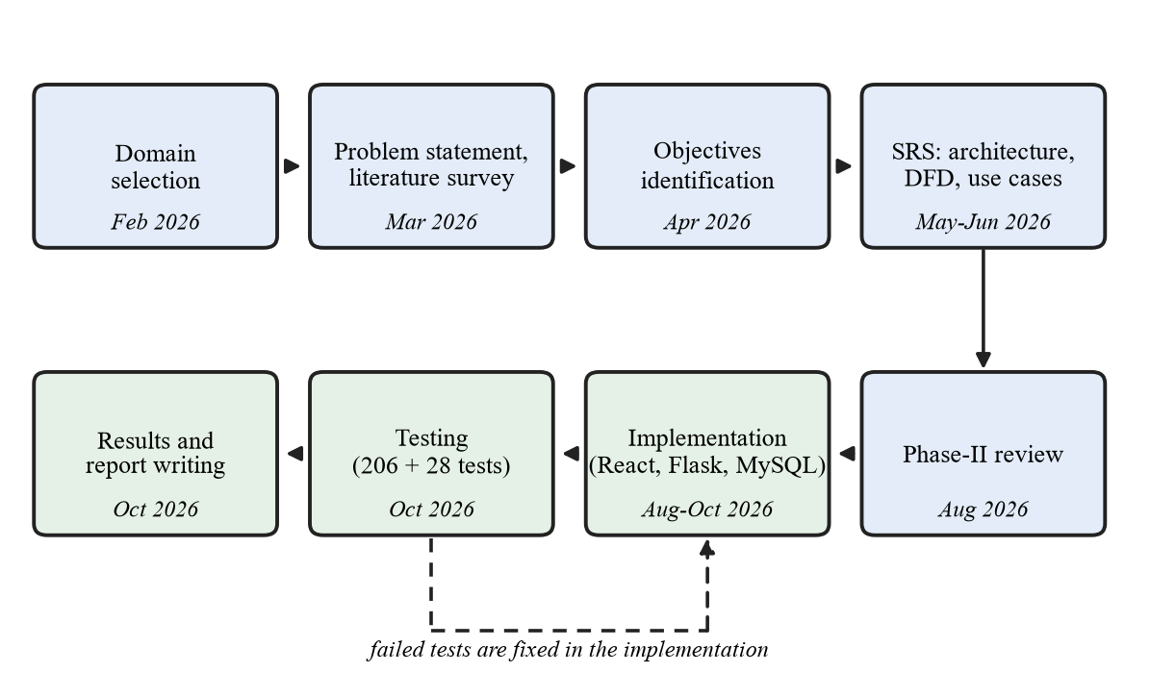
Figure 2.1 Project cycle
Figure 2.1 represents the project cycle, which comprises the following phases:
- Domain selection (Feb 2026): healthcare informatics and prescription intelligence.
- Problem statement and literature survey (Mar 2026): survey of 25 research papers.
- Objectives identification (Apr 2026): the objectives of Section 1.3.
- SRS, architecture, DFD and use cases (May–Jun 2026): requirements and design.
- Phase-II review (Aug 2026): review of the requirements and design.
- Implementation (Aug–Oct 2026): React front end, Flask API and MySQL database.
- Testing (Oct 2026): automated tests; failures fixed in the implementation.
- Results and report (Oct 2026): two dataset-level experiments and the report.
CHAPTER 3

SYSTEM DESIGN
System design is the blueprint of the system: its architecture, the way data are stored and how data and control flow through the components. This chapter covers the project architecture, the database design, the sequence diagram, the data flow diagrams, the database table structure, the flow chart and the utilities of PharmaCompare.

3.1 PROJECT ARCHITECTURE
PharmaCompare is a web application made of a React front end, a Flask REST API and a MySQL database. Figure 3.1 shows its components. The working principle follows one prescription from upload to report:
- The user registers or logs in on the web application; the Flask API checks the password and returns a token that every later request carries.
- The user uploads a prescription image or PDF; the API stores it privately and saves a record in MySQL.
- The OCR engine reads the file, with Google Cloud Vision or EasyOCR as fallback, and the text is grouped into lines with a confidence.
- Each line is matched to the medicine table and receives a match status; the dose, schedule and duration are read from the line.
- A line that is not settled waits for the user, who confirms a product; a choice that differs from the line needs an explicit confirmation, and every decision is recorded.
- The clinical decision engine checks the confirmed medicines for interactions, duplicate ingredients and allergies.
- The prices of the confirmed medicines are compared with products of the same composition, and up to three cheaper options are listed.
- The results are shown on screen with the medicine timeline and can be downloaded as a Smart Health Report in PDF.
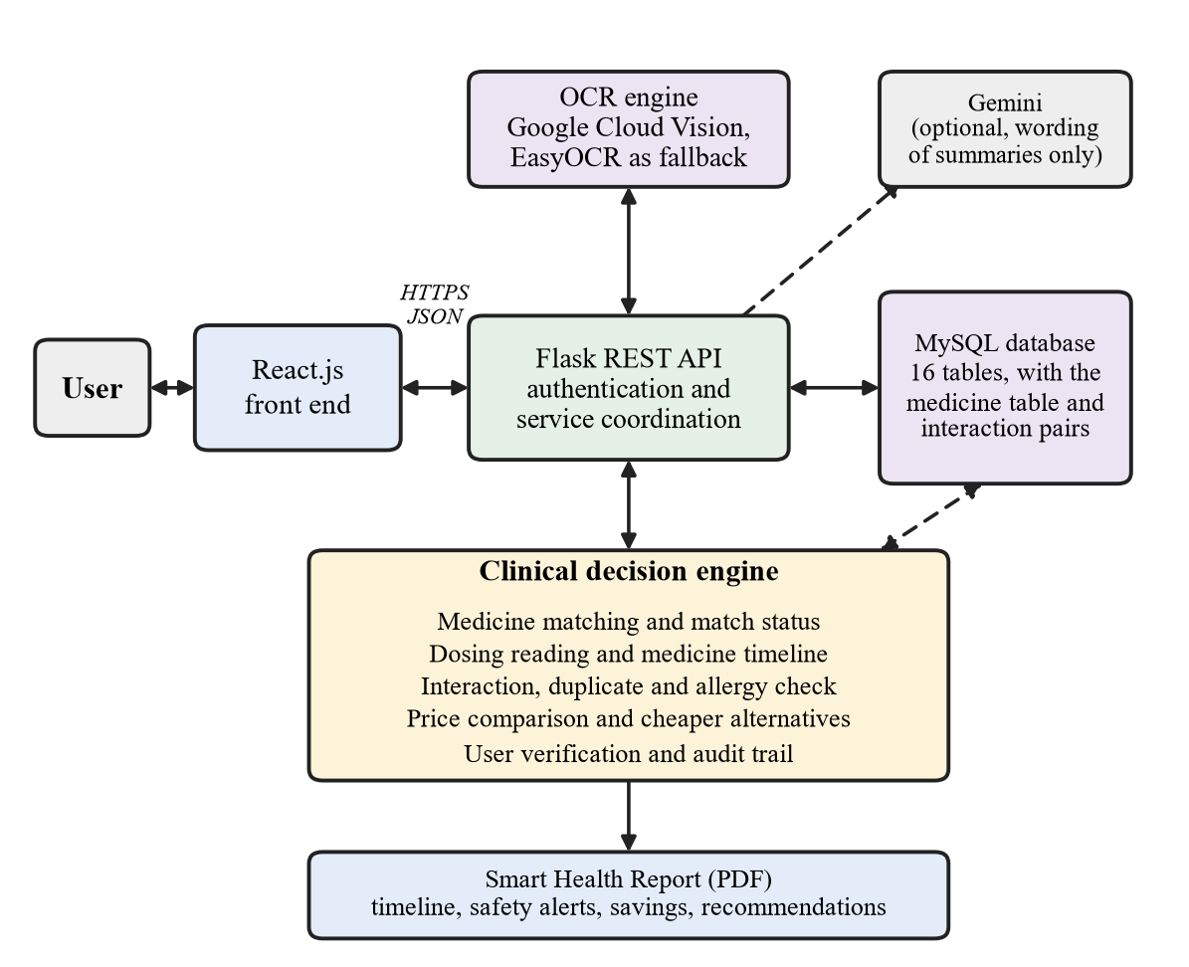
Figure 3.1 Project architecture

3.2 DATABASE DESIGN
The Phase-2 design had ten tables. Drug_Interactions and Safety_Findings were added for the clinical decision engine, and Data_Sources, Pharmacies, Pharmacy_Offers and Partner_Keys for data sources and pharmacy reports, giving sixteen. Table 3.1 gives the purpose of each table and Figure 3.2 shows their relationships.
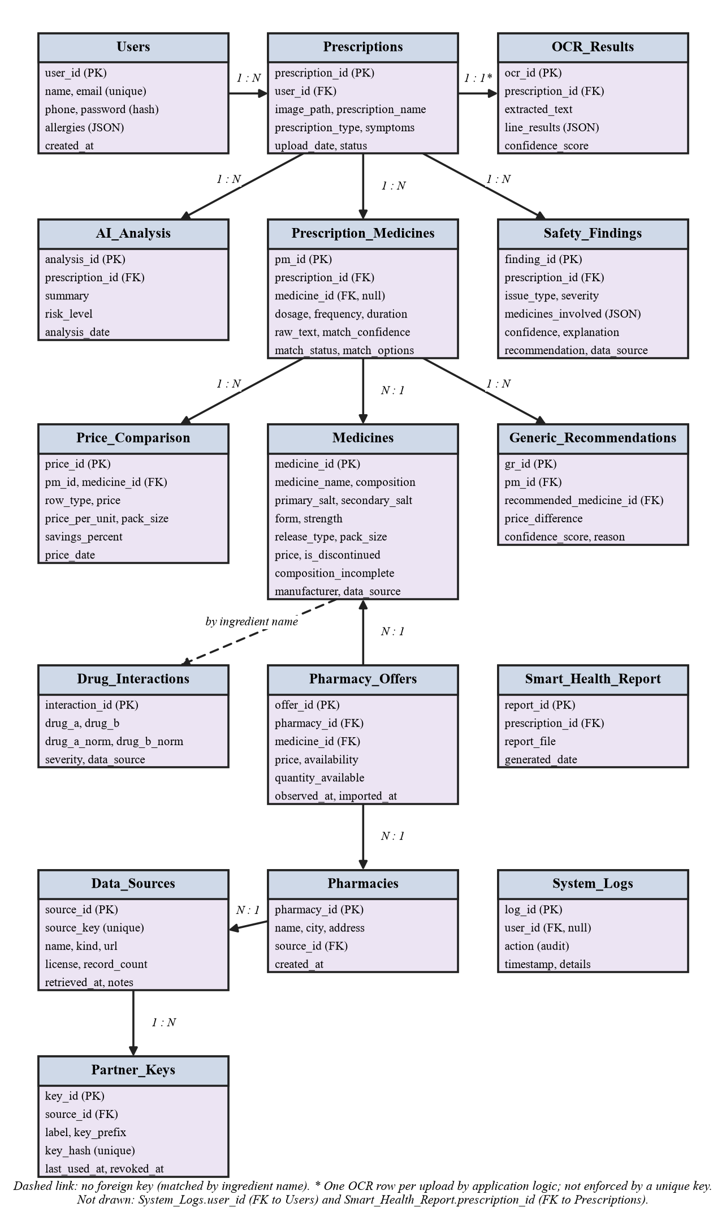
Figure 3.2 Entity-relationship diagram
Table 3.1 Database tables and their purpose
Table | Purpose
Users | Registered accounts, with their declared allergies
Prescriptions | One row per upload: file path, label and status
OCR_Results | Extracted text, per-line confidences and page confidence
Medicines | Reference table of 253,973 medicine products with prices
Prescription_Medicines | Detected lines: raw text, match status and chosen product
Drug_Interactions | DDInter 2.0 interaction pairs with their severity
AI_Analysis | Summary and overall risk level of a prescription
Safety_Findings | One row per safety finding, with severity and advice
Price_Comparison | Prescribed and alternative prices, unit price and saving
Generic_Recommendations | Up to three cheaper comparable options per line
Smart_Health_Report | Path and date of the latest PDF report
System_Logs | Audit trail of verification decisions: the line as read, its status and the warnings shown
Data_Sources | Registry of the datasets and feeds used, with licence, record count and when obtained
Pharmacies | Pharmacies that have reported prices or stock, with the feed that reported them
Pharmacy_Offers | Prices and stock a pharmacy reported, with the time observed; empty while no feed is connected
Partner_Keys | Hashed keys that allow a pharmacy system to send reports

3.3 SEQUENCE DIAGRAM
A sequence diagram shows the order in which the components exchange messages. Figure 3.3 follows one use of the system; the numbers refer to the messages in the diagram.
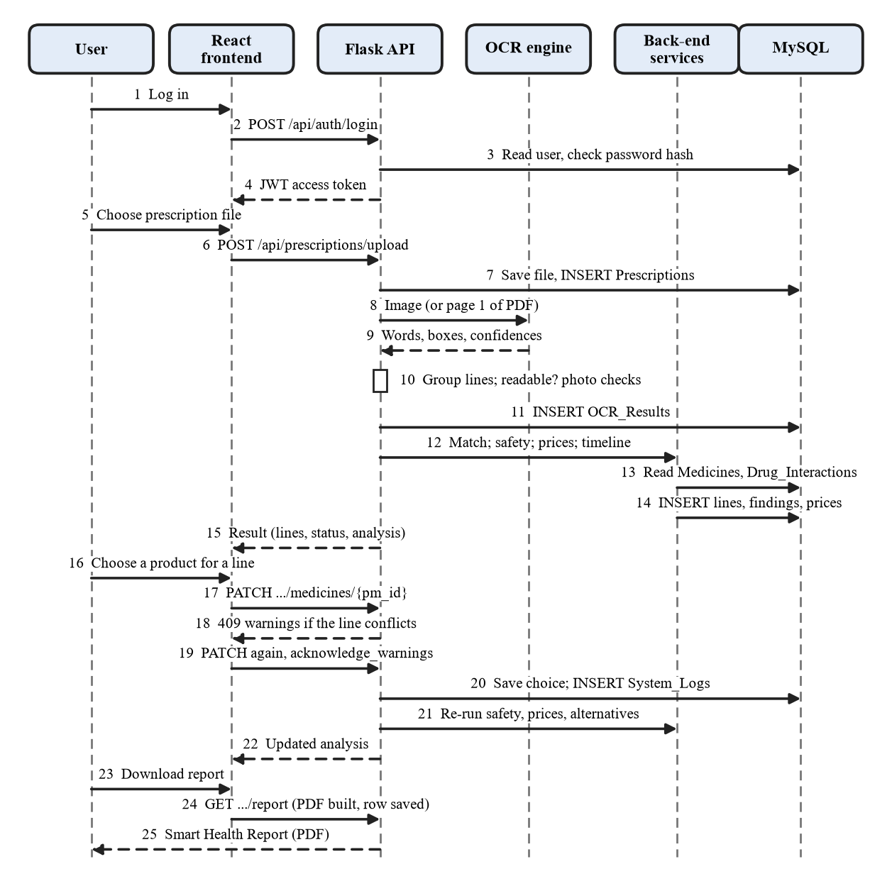
Figure 3.3 Sequence diagram
- The user logs in; the React front end sends the request to the Flask API, which checks the password hash in MySQL and returns a token (1–4).
- The user chooses a prescription file; the front end uploads it with the token, and the API saves the file and a Prescriptions row (5–7).
- The API sends the image to the OCR engine, receives the words with their confidences, groups them into lines, checks readability and stores the OCR result (8–11).
- The back-end services match each line to the Medicines table, check safety, compare prices, build the timeline and store the results (12–14); the API returns the analysis to the front end (15).
- For an unsure line the user chooses a product; if it conflicts with the line the API returns the differences, and the front end sends the choice again with the warnings acknowledged (16–19).
- The API saves the choice, records it in System_Logs, re-runs the safety, price and alternatives stages and returns the updated analysis (20–22).
- The user downloads the report; the API builds the PDF, saves its row and returns the Smart Health Report (23–25).

3.4 DATA FLOW DIAGRAM
A data flow diagram shows how data move between the user, the processes and the data stores. The context diagram (level 0) treats the whole system as one process; the level-1 diagram opens it into its main processes.

Level 0 - context diagram (Block Diagram)
The input, process and output of the system are:
- Input: the prescription file, the declared allergies and the user’s confirmations.
- Process: OCR, medicine matching, safety screening and price comparison.
- Output: the analysed medicines, safety findings, prices and alternatives, and the Smart Health Report.
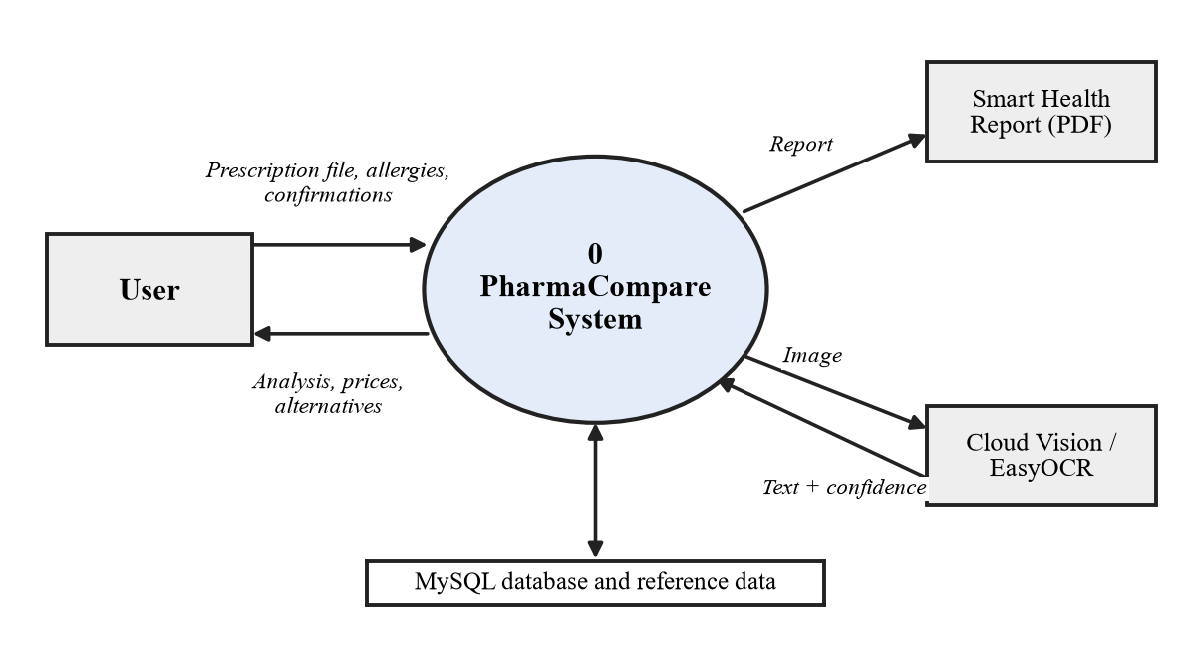
Figure 3.4 Data flow diagram, level 0

Level 1 - main processes
The level-1 diagram opens the system into five processes:
- Capture and extract (OCR): reads the file and stores the text lines with their confidence (D1).
- Detect and confirm medicines: matches the lines to the medicine table (D2), stores their status and the audit log (D3) and takes the user’s confirmations.
- Analyze safety: checks the confirmed lines against the interaction pairs (D4) and stores the findings (D5).
- Compare prices and recommend: stores prices and alternatives (D6) and reads pharmacy reports and data sources (D7).
- Generate report: collects the results and records the PDF (D8).
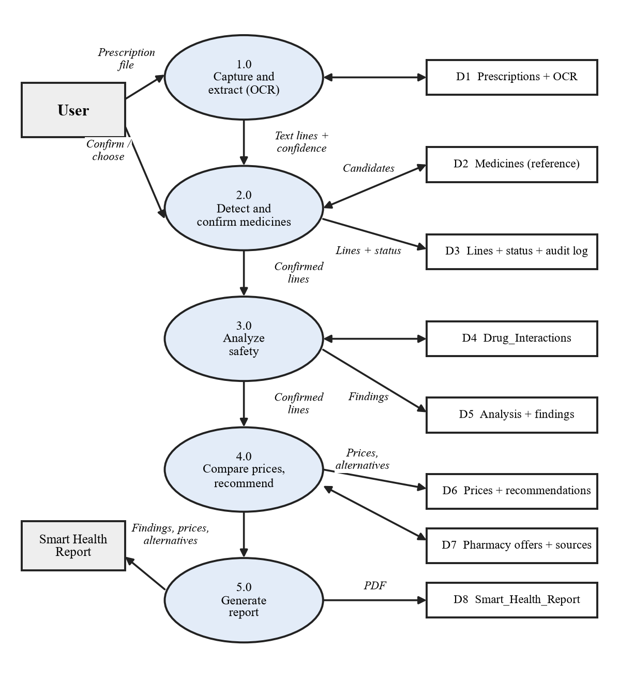
Figure 3.5 Data flow diagram, level 1

3.5 DATABASE TABLE STRUCTURE
Table 3.2 gives the structure of the database tables, taken from the live MySQL schema. All tables use InnoDB and utf8mb4, and foreign keys use ON DELETE CASCADE (ON DELETE SET NULL for System_Logs.user_id), so deleting a prescription removes everything derived from it. The tables for pharmacy reports start empty.
Table 3.2 Structure of the database tables
Users
Column | Data type | Key | Description
user_id | INT | PK | Auto-increment identifier
name | VARCHAR(150) |  | Full name
email | VARCHAR(150) | Unique | Login identifier, unique
phone | VARCHAR(20), NULL |  | Optional phone number
password | VARCHAR(255) |  | Salted password hash (never the password)
created_at | DATETIME |  | Account creation time
allergies | JSON, NULL |  | Self-declared allergies; empty if never declared
Prescriptions
Column | Data type | Key | Description
prescription_id | INT | PK | Auto-increment identifier
user_id | INT | FK | Owner of the prescription (Users)
image_path | VARCHAR(500) |  | Private path of the stored file, with a random name
prescription_name | VARCHAR(255), NULL |  | Label chosen by the user
prescription_type | VARCHAR(100), NULL |  | Optional context supplied by the user
symptoms | JSON, NULL |  | Optional symptoms supplied by the user
upload_date | DATETIME |  | Upload time
status | VARCHAR(50) |  | uploaded, processed, needs_reupload or processing_failed
OCR_Results
Column | Data type | Key | Description
ocr_id | INT | PK | Auto-increment identifier
prescription_id | INT | FK | Prescription that was read (Prescriptions)
extracted_text | TEXT, NULL |  | Text of the whole page
line_results | JSON, NULL |  | The same text as lines, each with its own confidence
confidence_score | DECIMAL(5,2), NULL |  | Mean line confidence of the page
processed_date | DATETIME |  | Time of processing
Medicines
Column | Data type | Key | Description
medicine_id | INT | PK | Auto-increment identifier
medicine_name | VARCHAR(255) |  | Brand or product name (indexed)
composition | VARCHAR(300), NULL |  | Ingredients with strengths, e.g. Paracetamol (650mg)
form | VARCHAR(50), NULL |  | Dosage form, derived from the name
strength | VARCHAR(50), NULL |  | First strength
category | VARCHAR(100), NULL |  | Category (not used by the application)
primary_salt | VARCHAR(150), NULL |  | First ingredient (indexed)
secondary_salt | VARCHAR(150), NULL |  | Second ingredient
manufacturer | VARCHAR(150), NULL |  | Maker
pack_size | VARCHAR(100), NULL |  | Pack, e.g. strip of 15 tablets
release_type | VARCHAR(12), NULL |  | sr, er, cr, pr, dt, odt, chewable, ec, mr or modified; empty for conventional release
composition_incomplete | BOOLEAN |  | Set when the name shows three or more strengths but the composition lists at most two ingredients
price | DECIMAL(10,2), NULL |  | Single reference price of the pack
is_discontinued | BOOLEAN |  | Discontinued flag from the dataset
source_dataset_id | VARCHAR(20), NULL |  | Identifier in the source dataset
data_source | VARCHAR(150) |  | Source tag of the row
imported_at | DATETIME, NULL |  | Import time
Prescription_Medicines
Column | Data type | Key | Description
pm_id | INT | PK | Auto-increment identifier
prescription_id | INT | FK | Prescription the line belongs to (Prescriptions)
medicine_id | INT, NULL | FK | Matched or confirmed product; empty while unconfirmed (Medicines)
dosage | VARCHAR(100), NULL |  | Dose read from the line; empty if not stated
frequency | VARCHAR(100), NULL |  | Frequency read from the line; empty if not stated
duration | VARCHAR(100), NULL |  | Duration read from the line; empty if not stated
raw_text | VARCHAR(500), NULL |  | The line as read by OCR
match_confidence | DECIMAL(5,4), NULL |  | Score of the match
match_status | VARCHAR(30) |  | matched, user_confirmed, needs_verification or user_unmatched
match_options | JSON, NULL |  | Look-alike candidates with reasons, runner-up products, or details typed by the user
Drug_Interactions
Column | Data type | Key | Description
interaction_id | INT | PK | Auto-increment identifier
drug_a | VARCHAR(150) |  | First substance, as named by DDInter
drug_b | VARCHAR(150) |  | Second substance, as named by DDInter
drug_a_norm | VARCHAR(150) |  | Lower-case form of drug_a used for matching (indexed)
drug_b_norm | VARCHAR(150) |  | Lower-case form of drug_b used for matching (indexed)
severity | VARCHAR(30) |  | DDInter’s own scale: Major, Moderate, Minor or Unknown
data_source | VARCHAR(150) |  | Source tag of the row
imported_at | DATETIME, NULL |  | Import time
AI_Analysis
Column | Data type | Key | Description
analysis_id | INT | PK | Auto-increment identifier
prescription_id | INT | FK | Prescription analysed (Prescriptions)
summary | TEXT, NULL |  | Summary of the safety analysis
risk_level | VARCHAR(50), NULL |  | Overall risk level (that of the most severe finding)
analysis_date | DATETIME |  | Time of the analysis
Safety_Findings
Column | Data type | Key | Description
finding_id | INT | PK | Auto-increment identifier
prescription_id | INT | FK | Prescription analysed (Prescriptions)
issue_type | VARCHAR(30) |  | interaction, duplicate, dosage_inconsistency or allergy_check
medicines_involved | JSON, NULL |  | The medicines concerned (id and name)
severity | VARCHAR(30) |  | Major, Moderate, Minor, Unknown or NEEDS_VERIFICATION
confidence | DECIMAL(5,4), NULL |  | Confidence of the finding
explanation | TEXT |  | What was found
recommendation | TEXT |  | Advice, always to consult a doctor or pharmacist
data_source | VARCHAR(150) |  | Where the finding came from
created_at | DATETIME |  | Time the finding was created
Price_Comparison
Column | Data type | Key | Description
price_id | INT | PK | Auto-increment identifier
pm_id | INT | FK | Prescription line the row belongs to (Prescription_Medicines)
medicine_id | INT | FK | Product the row describes (Medicines)
row_type | VARCHAR(20) |  | prescribed or alternative
pharmacy_name | VARCHAR(150), NULL |  | Left empty: only one reference price per product exists
price | DECIMAL(10,2) |  | Pack price
price_per_unit | DECIMAL(10,4), NULL |  | Price of one unit of the pack
pack_size | VARCHAR(100), NULL |  | Pack of the product
price_difference | DECIMAL(10,2), NULL |  | Difference to the prescribed product; empty on the prescribed row
savings_percent | DECIMAL(6,2), NULL |  | Saving over the prescribed product
is_discontinued | BOOLEAN |  | Discontinued flag of the product
data_source | VARCHAR(150) |  | Source tag of the price
price_date | DATETIME |  | When the price was captured in the source dataset, not today
last_updated | DATETIME |  | Time the row was written
Generic_Recommendations
Column | Data type | Key | Description
gr_id | INT | PK | Auto-increment identifier
pm_id | INT | FK | Prescription line (Prescription_Medicines)
recommended_medicine_id | INT | FK | Comparable product suggested (Medicines)
generic_name | VARCHAR(200) |  | Name of the suggested product
price_difference | DECIMAL(10,2), NULL |  | Saving in rupees
confidence_score | DECIMAL(5,2), NULL |  | Bookkeeping score, not a probability
reason | TEXT |  | The facts behind the suggestion
data_source | VARCHAR(150) |  | Source tag
created_at | DATETIME |  | Time the row was written
Smart_Health_Report
Column | Data type | Key | Description
report_id | INT | PK | Auto-increment identifier
prescription_id | INT | FK | Prescription the report belongs to (Prescriptions)
report_file | VARCHAR(500), NULL |  | Path of the generated PDF
generated_date | DATETIME |  | Time of generation
System_Logs
Column | Data type | Key | Description
log_id | INT | PK | Auto-increment identifier
user_id | INT, NULL | FK | User concerned; set to empty if the user is deleted (Users)
action | VARCHAR(150) |  | Action name, e.g. medicine_verification
timestamp | DATETIME |  | Time of the action
details | TEXT, NULL |  | Details; JSON for a verification decision
Data_Sources
Column | Data type | Key | Description
source_id | INT | PK | Auto-increment identifier
source_key | VARCHAR(80) | Unique | Unique key of the source
name | VARCHAR(200) |  | Name of the source
kind | VARCHAR(30) |  | reference_dataset, interaction_dataset, pharmacy_feed or synthetic_demo
url | VARCHAR(500), NULL |  | Where the data came from
license | VARCHAR(200), NULL |  | Licence as recorded; empty when not recorded
record_count | INT, NULL |  | Number of records
retrieved_at | DATETIME, NULL |  | When the data were obtained, not when they were true
notes | TEXT, NULL |  | Measured quality notes
created_at | DATETIME |  | Time the row was written
Pharmacies
Column | Data type | Key | Description
pharmacy_id | INT | PK | Auto-increment identifier
name | VARCHAR(150) |  | Pharmacy name
city | VARCHAR(100) |  | City
address | VARCHAR(255), NULL |  | Address, if given
source_id | INT | FK | Feed that reported the pharmacy (Data_Sources)
created_at | DATETIME |  | Time the row was written
Pharmacy_Offers
Column | Data type | Key | Description
offer_id | INT | PK | Auto-increment identifier
pharmacy_id | INT | FK | Pharmacy that reported (Pharmacies)
medicine_id | INT | FK | Product reported (Medicines)
price | DECIMAL(10,2), NULL |  | Reported price; empty when only stock was reported
availability | VARCHAR(20) |  | in_stock, limited, out_of_stock or unknown
quantity_available | INT, NULL |  | Quantity, if reported
observed_at | DATETIME |  | When the pharmacy observed it (required)
imported_at | DATETIME |  | Time the report was received
Partner_Keys
Column | Data type | Key | Description
key_id | INT | PK | Auto-increment identifier
source_id | INT | FK | Feed the key belongs to (Data_Sources)
label | VARCHAR(100) |  | Name of the key
key_prefix | CHAR(8) |  | First characters of the key, to identify it
key_hash | CHAR(64) | Unique | Hash of the key; the key is never stored
created_at | DATETIME |  | Time the key was created
last_used_at | DATETIME, NULL |  | Time of the last request
revoked_at | DATETIME, NULL |  | Time the key was revoked

3.6 FLOW CHART
A flow chart shows the logical steps of a process. Figure 3.6 represents the main user flow of PharmaCompare, which comprises the following steps:
- Start:
The process begins when the user registers or logs in; every later request needs a valid token.
- Upload and OCR:
The user uploads a JPG, PNG or PDF file; photo-quality notes are added and the text is read and grouped into lines.
- Readability Check:
A page with a mean confidence below 0.35 is rejected and a clearer image is requested.
- Medicine Detection:
Each line is matched to the medicine dataset and its dosing is read. A line that is not settled waits for the user, who may choose, type in or reject a product.
- Confirmed Lines Only:
Only matched or user-confirmed lines continue; a choice that differs from the line needs its warnings to be acknowledged.
- Safety Check:
An interaction, duplicate or allergy risk shows a safety alert, and the analysis continues.
- Price Comparison and Recommendation:
Prices of products with the same composition are compared, and up to three cheaper options are listed.
- Timeline and Report:
The medicine timeline is built and the Smart Health Report is generated for viewing or download as a PDF. The process then ends.
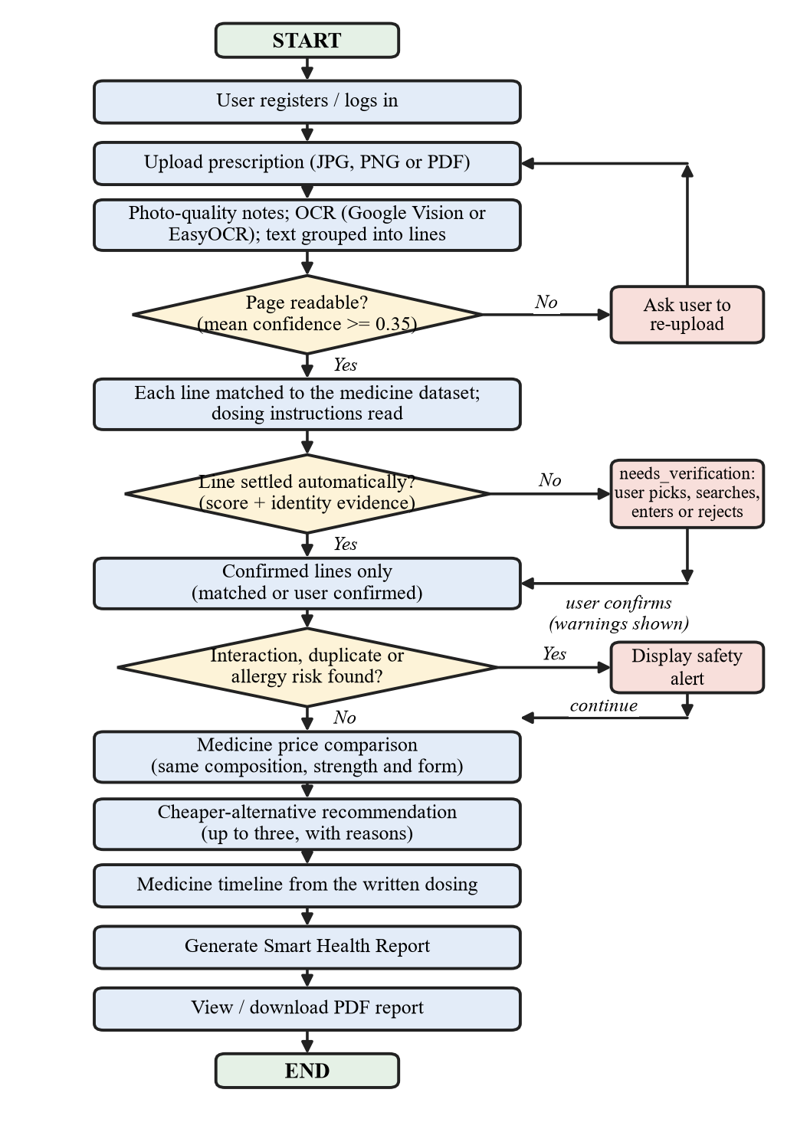
Figure 3.6 Flow chart

3.7 UTILITIES
Besides the main stages, the back end contains small utility modules that several stages depend on. They are listed in Table 3.3.
Table 3.3 Utility modules of the back end
Module | Function
dosage_parser | Reads the frequency and the duration from the text of a line; nothing is inferred
instruction_service | Attaches dosing rows to the medicine above them and reads schedules; a doubtful reading is marked as possible
timeline_service | Builds the medicine timeline once, for both the screen and the PDF
prescription_notes_service | Lists lines that are not medicines (instructions, Hindi notes) apart from the medicines
image_quality_service | Checks sharpness, size, brightness and contrast of a photo and says what to fix; it only warns
release_type | Derives the release mechanism (SR, ER, CR and so on) of a product and detects a release marker on a line
composition | Splits a composition into ingredients and strengths and flags incomplete ingredient lists
match_status | The one vocabulary for how a line came to point at a medicine
manual_entry_service | Stores the details a user types for a medicine the dataset lacks; never matched or priced
medicine_search | Deterministic ranking for the “which medicine is this?” picker; no fuzzy guesses
scan_service | Reads a pack photo, offers candidates through the matcher and deletes the photo
price_quality | Parses pack sizes, computes the price per unit and flags extreme prices
price_provenance_service | States the source, import date and “not live” status of every price
recommendation_notes | The wording of what an alternative does and does not establish, shared by screen and PDF
offer_service | Words what pharmacies have reported, with its age; no report means “not reported”
feed_import_service / partner_feed_service | Validate pharmacy feeds strictly; a row is accepted only if every part is certain
data_validation_service | Checks the medicine data against its own fields and notes what to check
data_sources_service | Lists the data sources with licence, record count and freshness
allergy_service | Compares declared allergies with ingredients, including the penicillin, sulfonamide and NSAID groups
medicine_explainer / report_summary_service | Plain-language explanations and summary; Gemini when a key is set, otherwise written from the stored facts
display_rounding | One way of rounding a percentage, so that the screen and the PDF agree
smart_report_service | Builds the PDF report from results that were already computed
cloud_ocr_service | Calls Google Cloud Vision and removes the API key from any message, log or error
CHAPTER 4

IMPLEMENTATION
This chapter discusses the software tools used, the implementation of each module with the rules and thresholds that it applies, and the design of the front-end screens.

4.1 SOFTWARE TOOLS USED
Table 4.1 Software tools used
Tool / library | Purpose / description
Python 3.14 | Language of the back end, the services, the import scripts and the tests
Flask 3.1 and Flask-CORS 6.0 | REST API with blueprints for authentication, prescriptions, analysis, prices and recommendations
Flask-JWT-Extended 4.7 | Issues and verifies JSON Web Tokens; Werkzeug 3.1 supplies the salted password hashing
MySQL 8.0 and mysql-connector-python 26.7 | Relational database, full-text index on medicine names and compositions, and the data access layer
EasyOCR 1.7 (PyTorch 2.13) | Local OCR engine; the model is loaded once and kept in memory
Google Cloud Vision (REST) | Document text detection with English and Hindi language hints; used first when a key is configured
pypdfium2 5.13, Pillow 12.3, OpenCV 5.0 | Renders the first page of a PDF and prepares images for OCR
difflib (Python standard library) | Similarity ratio used to score candidate medicines
ReportLab 5.0 | Generates the Smart Health Report PDF
Google Gemini API (optional) | Words the “explain this medicine” text and the report summary from stored facts only
React 19, React Router 7, Axios 1 | Single-page front end, routing and API calls
Vite 8 and oxlint 1.79 | Front-end build tool, development server and linter
unittest and Node test runner | Back-end test suite (592 tests) and front-end logic tests (186 tests)
Git | Version control of the source code

4.2 IMPLEMENTATION DETAILS
The implementation follows the stages of the workflow. Each stage is a separate service module, so it can be tested and replaced on its own.

4.2.1 REFERENCE DATA IMPORT
The medicine table holds 253,973 products imported on 28 August 2026 from a community-compiled, MIT-licensed dataset whose original source is not stated; the dosage form is derived from the product name. The interaction data come from the DDInter 2.0 category files: 222,383 raw rows reduce to 160,235 unique pairs. A registry table records each dataset with its licence, record count and import date, and a validation script notes suspect products (11,958 carry at least one note) as a reason to check, never as a correction.

4.2.2 AUTHENTICATION AND SECURITY
- Login: a unique e-mail and a password of at least eight characters, stored as a salted hash; login returns an access token that every other request carries.
- Ownership: every prescription route refuses access to another account.
- Uploads: only PNG, JPEG and PDF files up to 10 MB, stored under the user’s folder with a random name.
- Secrets: API keys come from the environment and never appear in errors, logs or responses.

4.2.3 TEXT EXTRACTION
Google Cloud Vision runs first when a key is configured; EasyOCR runs locally when no key is set or the cloud call fails (either can also be pinned by a setting). The cloud request asks for English and Hindi. A PDF is rendered from its first page. Both engines return word boxes with confidences, which are grouped into printed lines so that instructions to the right of a medicine name stay on the same line. For a line made of fragments x_{i} with confidences c_{i}, the line confidence is the length-weighted mean:
c_{ℓ} = Σ w_{i}·c_{i} / Σ w_{i} , w_{i} = max(|x_{i}|, 1) (4.1)
and the line is marked uncertain if any fragment has c_{i} below 0.55. The page counts as readable when the mean line confidence reaches 0.35:
C = (1/L) Σ c_{ℓ} ≥ 0.35 (4.2)
An unreadable page is stored with the status needs_reupload and the user is asked for a clearer image. Separate photo-quality checks (size, sharpness, brightness and contrast, with thresholds of 600 pixels, 20, 70 and 15) only warn and say what to fix; they never block an upload or change what the OCR reads.

4.2.4 MEDICINE DETECTION
Letterheads, addresses and administrative text are filtered out. For the other lines, candidates are retrieved from the Medicines table by a MySQL full-text search (15 candidates) and a brand-prefix lookup. Each candidate is scored with the similarity ratio of Python’s sequence matcher, sim = 2M/T, against the product name and its primary ingredient. A strength, form, release marker or ingredient on the line that agrees with the candidate gives corroborating signals q_{j} that raise the score:
t = max( sim(ℓ, name), sim(ℓ, salt) ), s = 0.6·t + 0.4·q̄ (4.3)
where q̄ is the mean of the positive signals. The bar is 0.60 with corroboration and 0.78 on text alone. A candidate is disqualified when the line states a different strength, form or release type or an ingredient the product lacks; an unrequested combination product or a conflicting form shorthand subtracts 0.15. A match is settled only if the score reaches 0.90, or every word of the line occurs in the product name, or all named ingredients are present:
settled ⇔ ( s ≥ 0.90 ) ∨ ( exact words ) ∨ ( all ingredients named ) (4.4)
and the dataset must support it: a product with no strength on record cannot settle a line that states one, and a product with an incomplete ingredient list is never settled automatically. Any other line gets its closest guess (score of at least 0.5) with the status needs_verification, and up to three options when several different products fit equally well (within 0.04). The 0.90 bar is a design parameter; it has not been tuned on labelled prescriptions.

4.2.5 USER CONFIRMATION AND VERIFICATION
A line is settled automatically only when its status is matched. Any other line keeps its closest look-alikes with plain-language reasons and waits for the user, who may:
- Choose a candidate or a searched product and press Confirm medicine, which sets the status user_confirmed;
- Type in the details of a medicine that the dataset lacks; it is shown as entered by you and is never matched, priced or checked for interactions;
- Mark the line as none of these, which sets the status user_unmatched.
When the chosen product differs from the line in name, form, strength, ingredient or release type, the server returns the differences and saves the choice only after the user confirms again with acknowledge_warnings; such a choice never counts in the headline savings. Every decision is written to System_Logs with the line as read, its status before the decision, the candidates shown and the warnings acknowledged. Every later stage takes only matched or user_confirmed lines, and confirming, adding or removing a line re-runs the analysis.
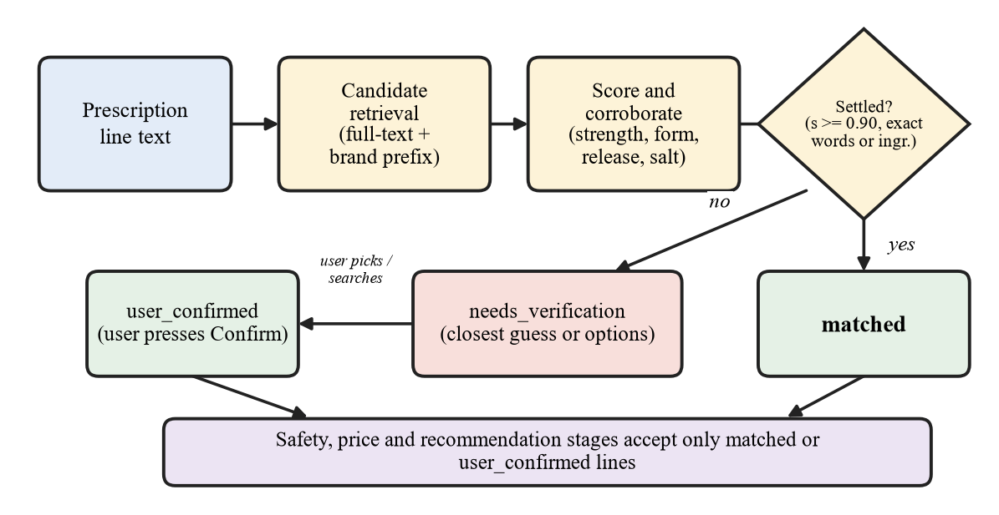
Figure 4.1 Medicine matching and match statuses

4.2.6 DOSING INSTRUCTIONS, NOTES AND MEDICINE TIMELINE
The instruction is usually written beside or below the medicine name, so OCR returns it as separate lines. The instruction reader attaches a dosing row to the medicine above it, never across another medicine, and reads only what the prescription contains:
- A schedule such as 1-0-1 is read as written; digits that ran together are only possibly a schedule, and a strength is never read as one;
- Words such as twice daily or before food and a duration such as for 5 days are read; nothing is defaulted;
- Lines that are not medicines, such as notes for the nurse or notes in Hindi, are listed apart and never matched to a product.
The medicine timeline places each identified medicine in the morning, afternoon, evening or night from its written schedule; a line that is not identified is listed apart. It is built once for the screen and the PDF and is never a dosing recommendation.

4.2.7 SAFETY SCREENING
For every pair of confirmed medicines with different primary ingredients, the names are looked up in the DDInter pair table. One of three outcomes is returned:
- A documented interaction, with DDInter’s severity copied unchanged (Major, Moderate, Minor or Unknown);
- No record, although both ingredients are tracked by DDInter;
- An ingredient that the source does not cover.
The last two outcomes are labelled needs verification and are not a statement of safety. Further checks flag duplicate ingredients, a strength that differs from the matched product’s, and a declared allergy (by name or through the penicillin, sulfonamide and NSAID groups). Every finding ends with advice to consult a doctor or pharmacist.

4.2.8 PRICE COMPARISON AND ALTERNATIVES
Two products i and j are comparable only if they share the ingredients, the full composition with strengths, the dosage form and the release type, and neither is discontinued, unpriced or recorded with an incomplete ingredient list:
i ≈ j ⇔ comp(i) = comp(j) ∧ str(i) = str(j) ∧ form(i) = form(j) ∧ rel(i) = rel(j) (4.5)
Pack sizes differ, so a price P and a pack quantity n give a unit price, and the saving of an alternative j over the prescribed product i is
u = P / n , saving = (P_{i} − P_{j}) / P_{i} × 100 (4.6)
In a comparable group of at least eight priced products, a unit price is flagged as unusually low or high when
u < ũ / 10 or u > 10·ũ (4.7)
where ũ is the group’s median unit price. A flagged price is shown with a warning and never counted as a saving. Up to three cheaper, unflagged, same-quantity options are presented. Every price states its provenance: a reference price is the product’s price in the imported dataset, shown with its import date (a snapshot older than 180 days is called old), and is never a live price; a price that a pharmacy reported is shown separately. Notes next to the alternatives state what was not compared (inactive ingredients, maker quality, bioequivalence) and that the decision belongs to the prescriber or pharmacist.

4.2.9 SMART HEALTH REPORT
The Smart Health Report is a PDF made with ReportLab. It contains a summary, the medicines with their status and dosing, the medicine timeline, the safety findings, the alternatives and the savings, and says where the prices come from. The summary is written by Gemini only when a key is set, from names, strengths, schedules and counts alone, and every sentence is checked against the facts; otherwise a deterministic summary is used. The report computes nothing new, and tests check that its wording and totals equal those on screen.

4.2.10 MEDICINE SEARCH, EXPLANATION AND SCAN
Any medicine can be searched by brand, ingredient or strength; the same search feeds the verification dialog. “Explain this medicine” gives a plain-language description, written by Gemini from the stored record when a key is set and otherwise by a deterministic explainer. The scan reads a photo of a medicine pack once, runs the same matcher and returns the products that fit; it never confirms anything and the photo is deleted after it is read.

4.2.11 PHARMACY REPORTS AND DATA SOURCES
A pharmacy system can report prices and stock as a CSV file or through a keyed request. A row is accepted only when every part is certain, keys are stored only as hashes, and a request is limited in size, rows and rate. Reports are shown separately, with the pharmacy and their age. No pharmacy feed is connected, so the tables are empty and the app states that no live price or stock feed is connected and that availability is not tracked.

4.2.12 API ENDPOINTS AND PARAMETERS
Table 4.2 lists the endpoints that the front end and the tests use; all except register, login and the data sources need the token.
Table 4.2 REST API endpoints
Method and path | Purpose
POST /api/auth/register, /api/auth/login | Create an account; log in and receive a token
GET /api/auth/me; PUT /api/auth/me/allergies | Current user; update the allergy profile
POST /api/prescriptions/upload | Upload, run OCR, detect medicines and analyse
GET /api/prescriptions; GET /api/prescriptions/{id} | History; one prescription with its lines
GET /api/prescriptions/{id}/analysis, /prices, /recommendations | Safety analysis; prices; alternatives
POST /api/prescriptions/{id}/medicines | Add a medicine by hand
PATCH /api/prescriptions/{id}/medicines/{pm_id} | Confirm a product (differences must be acknowledged)
POST .../medicines/{pm_id}/unmatched, /details | Mark a line as none of these; save typed details
DELETE /api/prescriptions/{id}/medicines/{pm_id} | Remove a line
GET /api/prescriptions/{id}/summary, /report, /verification-log | Summary; PDF report; decision history
DELETE /api/prescriptions/{id} | Delete a prescription and everything derived from it
GET /api/medicines/search; POST /api/medicines/scan | Search the medicine table; read a pack photo
GET /api/medicines/{id}/explain, /offers | Explanation; pharmacy reports for a medicine
POST /api/feeds/offers; GET /api/data-sources | Receive pharmacy reports with a key; data sources

Table 4.3 Thresholds and parameters
Parameter | Value | Used for
Page readable | mean line confidence ≥ 0.35 | Rejecting unreadable pages
Uncertain line | any fragment confidence < 0.55 | Marking lines for verification
Match bar, corroborated | 0.60 | Candidate score with strength, form or ingredient evidence
Match bar, text only | 0.78 | Candidate score from text similarity alone
Settled automatically | s ≥ 0.90, or exact words, or all ingredients named | Granting status “matched”
Closest guess | s ≥ 0.50 | Showing a guess for a line that needs verification
Options margin | within 0.04, up to 3 options | Offering a choice instead of one answer
Extreme price | unit price below 1/10 or above 10 times the group median; group of at least 8 | Flagging implausible prices
Recommendations | up to 3 per medicine; saving of 20% or more with at least 2 options scores 1.0 | Bookkeeping score
Photo quality | at least 600 px; sharpness 20, brightness 70, contrast 15 | Warnings about a poor photo
Reference price age | older than 180 days | Calling a dataset snapshot old
Pharmacy report age | stock older than 48 hours; price older than 7 days | Marking a report as old
Partner feed limits | 500 rows, 300 KB, 30 requests a minute | Limiting a feed request
Upload | PNG, JPEG, PDF; 10 MB | File validation

4.3 FRONT-END FORMS DESIGN
The front end is a React single-page application. Public pages (landing, about, login, register) are open to everyone; the other pages sit behind a route guard, and a navigation bar leads to Dashboard, Analyze, Medicines, Scan, Stores, History and About. Figures 4.2 to 4.11 show the main forms, captured from the running application with a test account; the analysis screens are shown in Chapter 6.
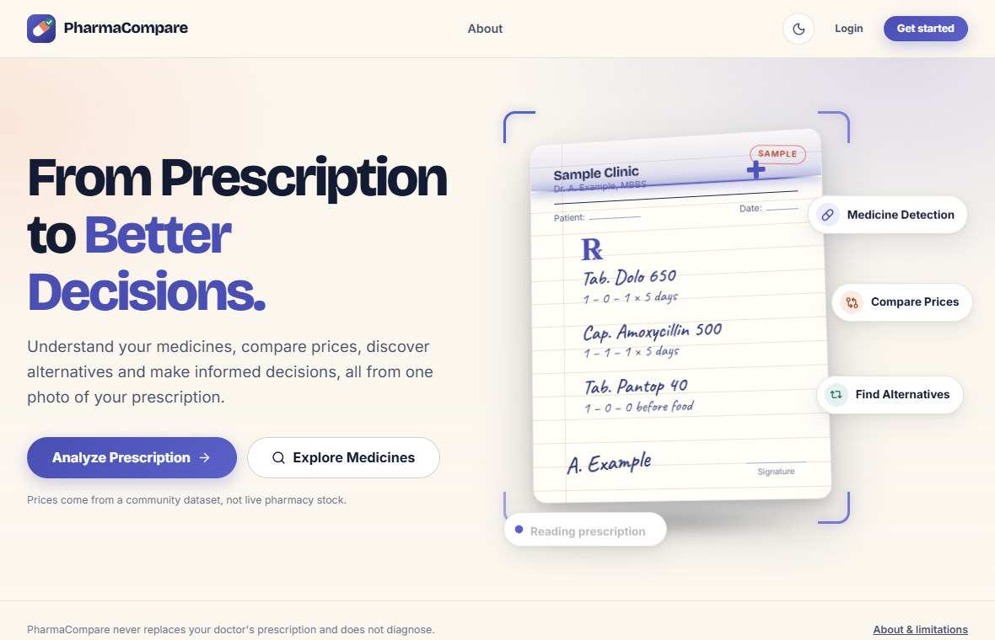
Figure 4.2 Landing page
Figure 4.2 represents the landing page, with the Analyze Prescription and Explore Medicines buttons and the Login and Get started buttons in the header. It states that prices come from a community dataset, not from live pharmacy stock.
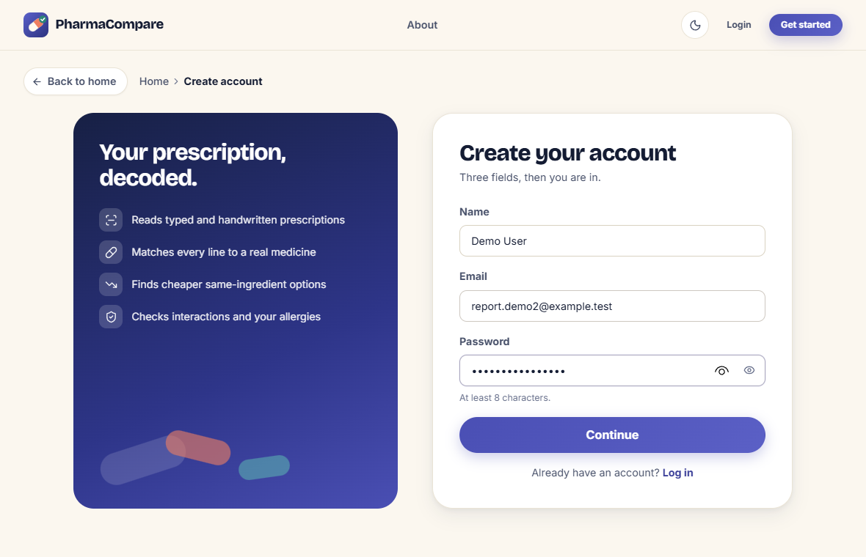
Figure 4.3 Registration form
Figure 4.3 represents the registration form, which asks for a name, an e-mail address and a password of at least eight characters. After Continue the user is taken to the login page.
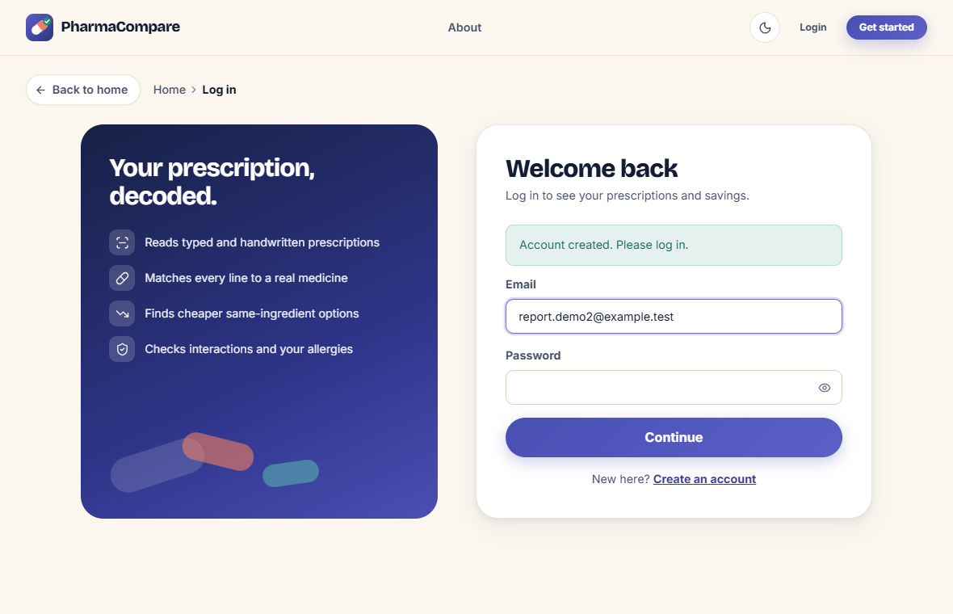
Figure 4.4 Login form
Figure 4.4 represents the login form (e-mail and password). A new user is then taken to a health-preferences page, where drug allergies can be declared or skipped; the list can be edited later on the Profile page.
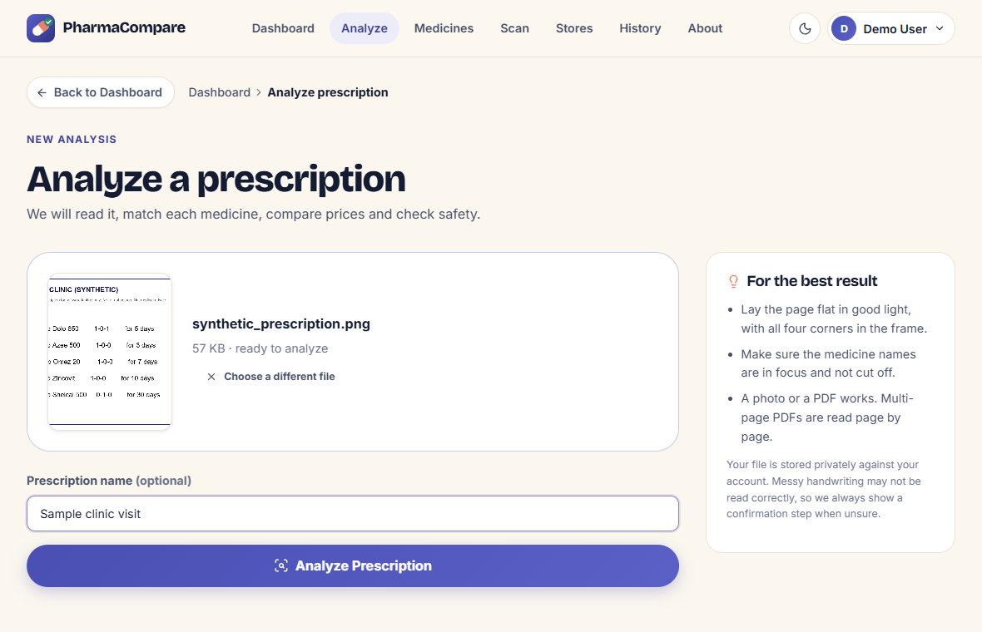
Figure 4.5 Upload page
Figure 4.5 represents the upload page. The user drops or browses for a JPG, PNG or PDF file of up to 10 MB, sees a preview, may name the prescription and presses Analyze Prescription. A five-stage journey is shown while the analysis runs.
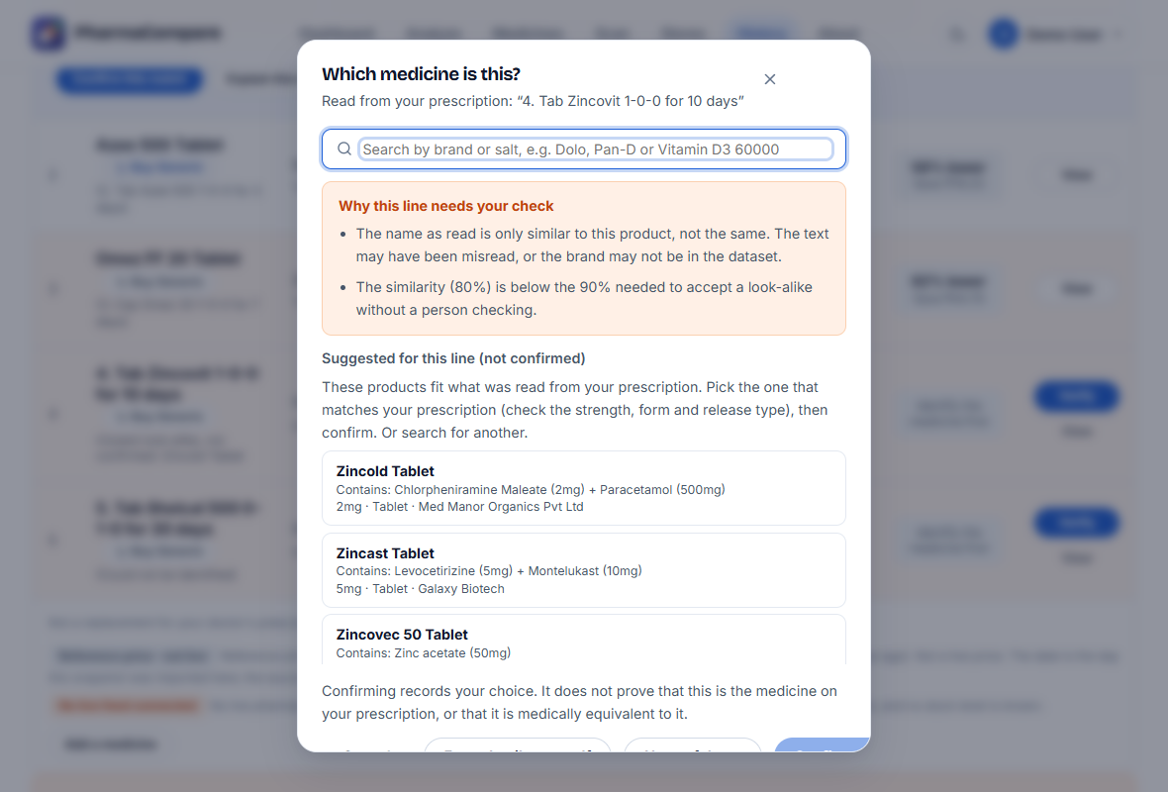
Figure 4.6 Verification dialog
Figure 4.6 represents the dialog opened by Verify. It explains why the line needs a check, lists the look-alikes marked as not confirmed and offers a search box, Enter details yourself and None of these.
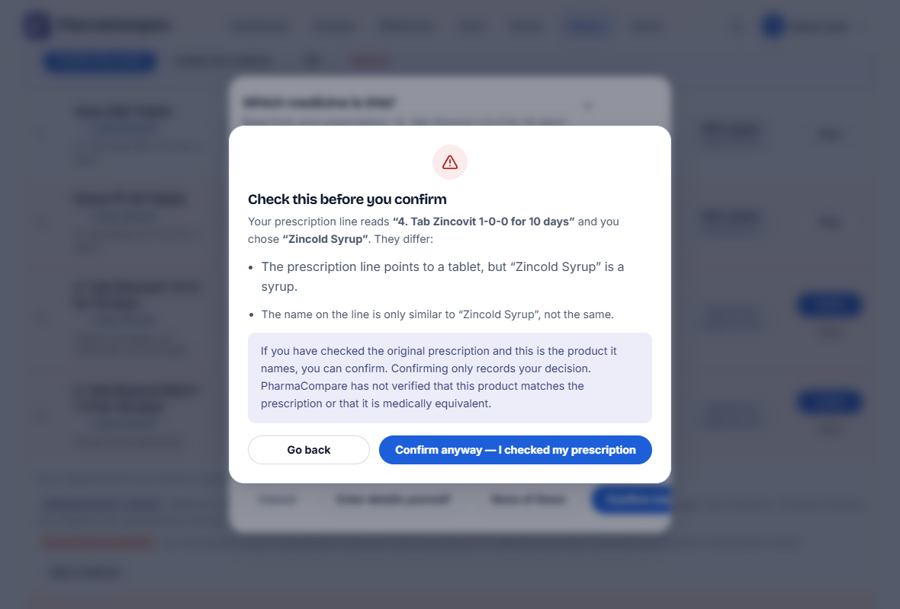
Figure 4.7 Warning before a conflicting confirmation
Figure 4.7 represents the warning shown when the chosen product differs from the line (here a syrup chosen for a line that points to a tablet). The choice is saved only after “Confirm anyway”, and the text says that confirming does not show that the product matches the prescription.
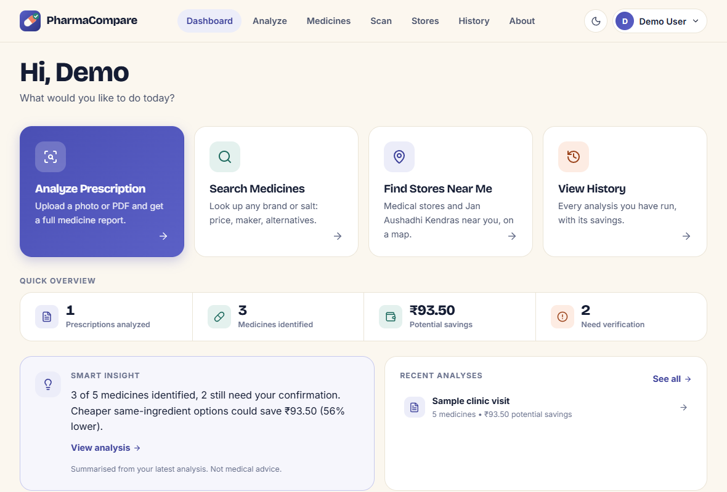
Figure 4.8 Dashboard
Figure 4.8 represents the dashboard: quick actions, a quick overview (prescriptions analyzed, medicines identified, potential savings, lines needing verification), a smart insight and the recent analyses.
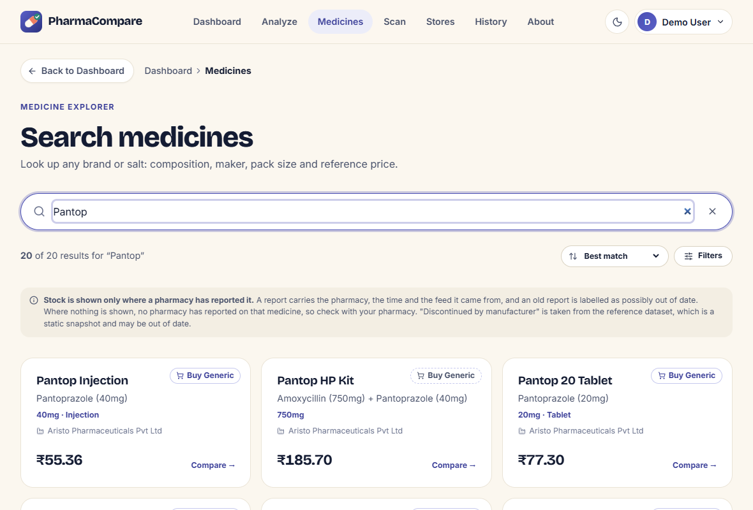
Figure 4.9 Medicine search page
Figure 4.9 represents the medicine search page. A search by brand or salt lists the matching products with composition, strength, form, maker and reference price. A notice explains that stock is shown only when a pharmacy has reported it.
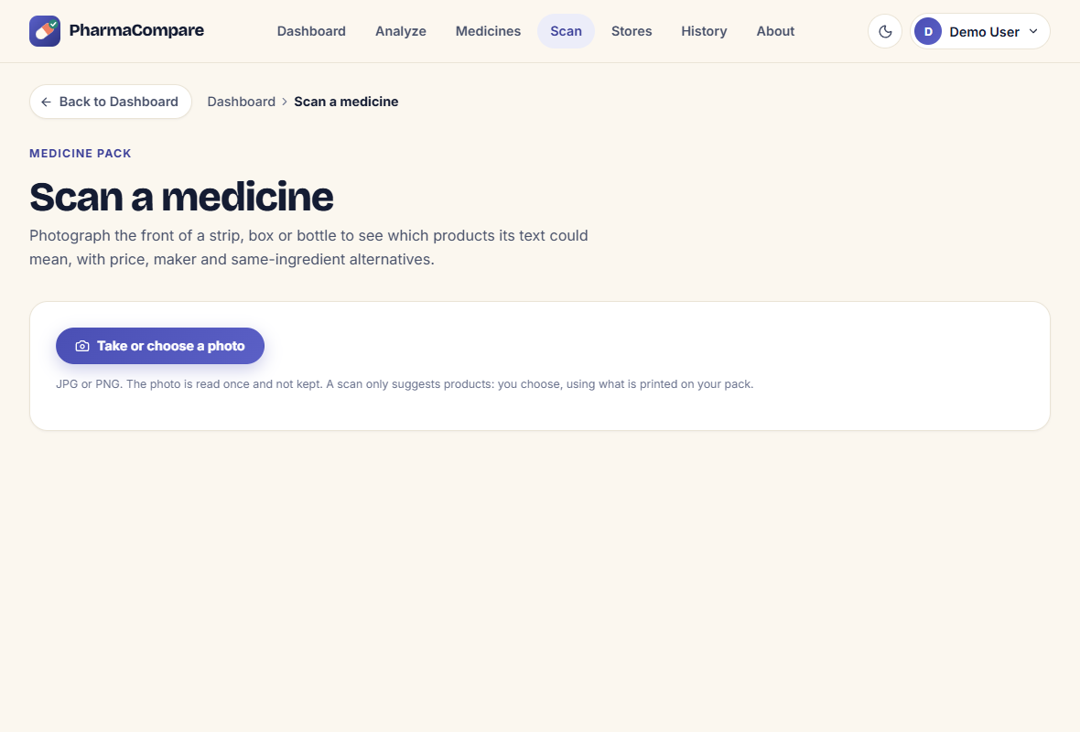
Figure 4.10 Scan a medicine page
Figure 4.10 represents the scan page, where the user takes or chooses a photo of a strip, box or bottle. The photo is read once and not kept, and a scan only suggests products.
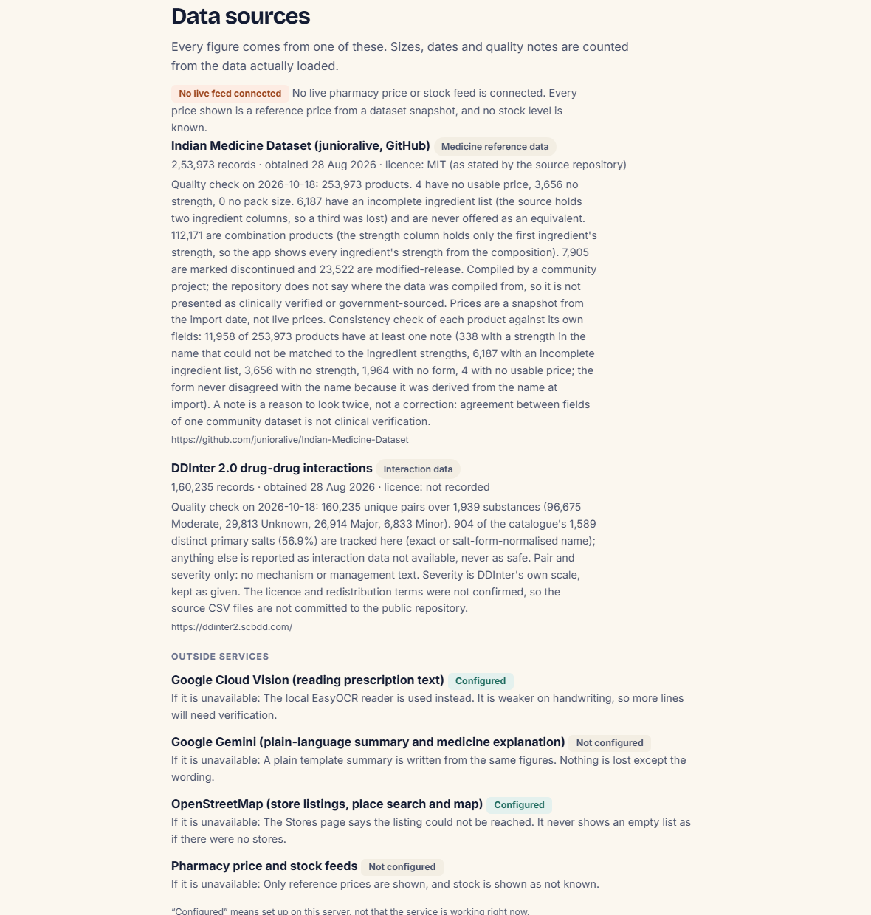
Figure 4.11 Data sources on the About page
Figure 4.11 represents the data sources on the About page: the two datasets with their licence, record count, date obtained and quality notes, the notice that no live feed is connected, and the status of the outside services (configured or not).
Design decisions: a guided journey (uploading, reading, matching, safety, report ready) is shown while an analysis runs; status words are plain, every price is labelled as not live, and stock availability is stated as not tracked unless a pharmacy has reported it; a light and a dark theme are provided.
CHAPTER 5

TESTING
The system was tested at the level of single functions, of modules, of complete functions and of the integrated system. All tests are automated: 592 back-end tests (Python unittest) and 186 front-end logic tests (Node test runner). Most back-end tests use the real medicine dataset and the real database, so they exercise the same data that the application uses.

5.1 SCOPE
The objectives of testing PharmaCompare are:
- To verify that every module works as designed on normal, boundary and invalid input;
- To confirm that an uncertain reading is never analysed as a fact, that a missing interaction record is never reported as safe and that no price is presented as live;
- To confirm that the complete flow from upload to report works with the real dataset and database;
- To confirm that one user cannot reach another user’s prescription and that API keys never appear in logs or responses.
The scope includes:
- Unit testing
- Module testing
- Functional testing
- System testing
The back-end tests ran with Python’s unittest and the front-end logic tests with the Node test runner. The OCR tests read images locally with EasyOCR and make no cloud calls, and Gemini is tested with a mocked answer. The tests check software behaviour; they do not measure OCR or matching accuracy on real prescriptions or the clinical validity of any message.

5.2 UNIT TESTING
Each helper function was tested individually with normal, boundary and invalid input.
Table 5.1 Unit tests
Unit | Test input | Expected output | Actual output | Result
Release type | Name or pack text with SR, ER, CR markers; plain tablet; “OD”; liquid name; conflicting markers | Marker found; conventional gives none; “OD” and liquid markers ignored; conflict flagged modified | As expected | Pass
Composition | “Paracetamol (250mg/5ml)”; combinations; names with three strengths | Ingredients and strengths split; syrup volume not a dose; incomplete list flagged | As expected | Pass
Pack parsing | Strips, bottles, vials, volumes, weights | Counts, volumes and weights kept apart; same quantity needs same amount and kind | As expected | Pass
Extreme-price rule | Groups of fewer than 8; prices near and beyond 10 times the median; zero price | Small groups never judged; flag only beyond 10 times the median; zero is not a unit price | As expected | Pass
Savings eligibility | Cheaper same-pack alternative; each disqualifier in turn | Clean alternative counts; each disqualified alternative does not | As expected | Pass
Dosing instructions | “1-0-1”; “100” run together; durations as handwritten; a strength or a number with a unit | Written schedule read as written; run-together digits only possibly a schedule; a strength never a schedule; nothing invented for text without dosing | As expected | Pass
Photo-quality checks | Clean page; blurred, dark, faint and small versions of it; a file that is not an image | No warning for the clean page; each defect named in plain words; nothing claimed for a non-image | As expected | Pass
Display rounding | A confidence of exactly 92.5% | Rounded half up (93%) on screen and in the PDF | As expected | Pass
Pharmacy feed rows | Missing or future time; zero price; unknown stock word; ambiguous product name | Each row rejected with its reason; an ambiguous name is never chosen | As expected | Pass
Salt-name normalisation | Spelling variants and salt forms; unrelated names | Variants normalised; unrelated names untouched; every alias target exists in DDInter | As expected | Pass
Query parsing | “Pan D”, “Pan-D”, “T. pan-D”; a strength written next to its unit | Same query for every spelling; leading T is a form hint; strength glued to its unit | As expected | Pass
Match gates | Line stating a strength against a product with none; one-ingredient line against a combination | A product with no strength on record cannot settle the line; a combination cannot settle a one-ingredient line | As expected | Pass
Secret redaction | Messages containing the API key in several forms | Key removed in every form; ordinary diagnostics kept | As expected | Pass

Observation:
All unit tests passed. The helper functions handle boundary cases such as groups that are too small to judge, packs of different kinds, names that carry several strengths and schedules that handwriting turns into other digits.

5.3 MODULE TESTING
The system was divided into modules (OCR, matching, dosing and timeline, verification, scan, safety, price and alternatives, pharmacy reports, report, routes and database scripts). Each module was tested for correctness before the modules were combined.
Table 5.2 Module tests
Module | Test description | Expected output | Actual output | Result
OCR | Clean printed image; degraded or unreadable image; cloud service failing or pinned; request languages | Every medicine found; an unreadable image is rejected, not guessed; fallback to EasyOCR is logged; English and Hindi requested | As expected | Pass
Matching | Known brands; under-specified lines; SR line against conventional products; headings, durations and instructions | Known brands match; under-specified lines get options; an SR line never matches a conventional product; headings and instructions are never matched | As expected | Pass
Verification | A look-alike or a different strength, form, release type or ingredient chosen; “none of these”; details typed by the user | Differences returned and nothing saved until acknowledged; the choice never counts in savings; typed medicine never matched or priced | As expected | Pass
Audit trail | Each decision on a line | A System_Logs row records the line as read, its status, the candidates and the warnings; the line text is unchanged | As expected | Pass
Timeline | Identified, unidentified and unread lines | Only identified medicines appear by name; others are listed apart; a possible schedule is marked possible | As expected | Pass
Medicine scan | A pack photo; text that resembles nothing; an OCR failure | Candidates only, never a confirmation; no candidate is invented; the photo is deleted in every case | As expected | Pass
Safety | No confirmed medicine; user with and without declared allergies | “No check ran” message; honest “unchecked” allergy message; owner’s allergies used | As expected | Pass
Price and alternatives | Alternative in a different pack; zero-priced alternative; extreme price; incomplete composition | Different pack not counted; zero price never offered; extreme price flagged and kept; incomplete products never offered | As expected | Pass
Pharmacy reports and price sources | No reports; fresh and stale stock; the same feed imported twice; a bad key; no feed connected | “Not reported”, never “in stock”; stale stock not counted; nothing added twice; one 401 for every bad key; source, import date and “not live” stated | As expected | Pass
Report summary | Faithful, invented and advice-giving summaries; no key; failing Gemini call | A faithful summary is accepted; an invented number or advice is rejected; the local summary replaces it | As expected | Pass
Report (PDF) | Hostile text in a line; every detected line; page numbers | Generation survives; every line has a row; footer numbers every page | As expected | Pass
Routes | Confirm, add, remove, search; another user’s line | Exactly the chosen medicine is saved; other accounts are refused | As expected | Pass
Database scripts | Migration run twice; audit script; fresh install from schema | Migration is idempotent; audit is read-only; fresh schema equals the live one | As expected | Pass

Observation:
All modules functioned independently and produced the expected output. The module tests also confirm the design rule that an uncertain line is never settled by the OCR confidence or the matcher alone.

5.4 FUNCTIONAL TESTING
Functional testing validates the end-to-end behaviour of a function from the user’s input to the system’s output, with the real database.
Table 5.3 Functional tests
Test case | Input condition | Expected output | Actual output | Status
Printed prescription | Image with several medicines | Every medicine found and listed | Found | Pass
Handwritten prescription | Real captured OCR output of a handwritten page, with a Hindi note | Five medicine lines; the note is a note, not a medicine; nothing unconfirmed is priced or safety checked | As expected | Pass
Uncertain OCR line | One line read with low confidence | Only that line flagged “check match”; no saving for it; API and PDF show the same status | As expected | Pass
Look-alike brand | A brand that is not in the dataset | Closest look-alikes with reasons, “not confirmed”; never a suggestion presented as fact | As expected | Pass
Conflicting confirmation | A syrup chosen for a line that points to a tablet | Differences shown; saved only after acknowledgement; kept out of the headline savings; logged | As expected | Pass
Generic-name line | Line names an ingredient but no brand | Flagged “brand unspecified”; no price or saving against one arbitrary brand | As expected | Pass
Access control | A second account requests another user’s prescription or report | Request refused | Refused | Pass
Search | Spellings of “Pan-D”; vitamin D3 60000; release word in the query | The intended brand first; ingredient and release type respected; nonsense returns nothing | As expected | Pass
Screen and PDF consistency | One analysis shown on screen and in the PDF | Same lines, status wording, confidence wording and savings totals | As expected | Pass

Observation:
Functional testing confirmed that the main functions (reading, identification, verification, safety screening, price comparison, timeline and reporting) operate as designed, and that the confirmation gate holds at every stage.

5.5 SYSTEM TESTING
System testing validates the integration of all modules (OCR, matching, safety, prices, report, API and front-end logic) as one unit. The complete suites were run on the final version of the system.
Table 5.4 Back-end test suite by group
Test file | Focus | Tests | Result
test_matching | Matcher behaviour and alternatives | 26 | Pass
test_matching_safety | Gates against look-alike, incomplete and mismatched products | 27 | Pass
test_picker_and_confirmation | Search ranking and the confirmation routes | 37 | Pass
test_verification_workflow | Verification workflow: reasons, conflict warnings, audit trail, typed details | 44 | Pass
2 files | Handwritten-style prescriptions end to end, with real captured OCR output | 34 | Pass
2 files | Generic-name lines, candidates and same-ingredient alternatives | 22 | Pass
2 files | Local OCR, unreadable images, uncertain lines, OCR logging | 25 | Pass
test_image_quality | Photo-quality checks | 16 | Pass
test_instructions_timeline | Dosing instructions, notes and the medicine timeline | 41 | Pass
test_scan | Medicine scan | 14 | Pass
test_report_summary | Report summary and Gemini fallback | 20 | Pass
test_interactions_allergy_pdf | Salt names, allergy ownership, PDF report | 15 | Pass
2 files | Pack parsing, extreme-price rule, savings, release type, composition | 27 | Pass
2 files | Pharmacy reports, price provenance and the partner feed | 68 | Pass
2 files | Data sources and data validation | 32 | Pass
2 files | No key in messages or logs (cloud OCR and Gemini) | 27 | Pass
2 files | Migration, audit script and fresh schema | 6 | Pass
2 files | Independent location feature (not part of the prescription workflow) | 111 | Pass
Total |  | 592 | All passed (378 s)

Table 5.5 Front-end logic test suite by group
Test file | Focus | Tests | Result
analysis | Screen and PDF show the same lines, status, confidence and savings | 16 | Pass
2 files | Verification dialog, warnings and the “none of these” choice | 30 | Pass
handwriting | Handwritten-style prescription on screen | 14 | Pass
4 files | No simulated or live-stock wording; pharmacy reports and sources | 36 | Pass
4 files | Medicine timeline, photo notes, summary and alternatives notes | 21 | Pass
2 files | Medicine scan and the Buy Generic button | 31 | Pass
2 files | Independent location feature (not part of the prescription workflow) | 38 | Pass
Total |  | 186 | All passed

Observation:
- All 778 tests passed (592 back-end and 186 front-end), and none was skipped.
- The suite protects the design rules: an unconfirmed line gets no analysis, price or saving, and the screen and the PDF agree. It checks software behaviour, not OCR accuracy or clinical completeness.
CHAPTER 6

RESULTS
This chapter presents snapshots of the working system, the reference data it runs on, two dataset-level experiments and the status of each objective.

6.1 SNAPSHOTS OF THE PROJECT
To avoid real patient data, a fictional printed prescription (Figure 6.1) was uploaded with a test account. It has five medicine lines; Omez, written as a capsule, exists in the dataset only as a tablet, and Zincovit and Shelcal are not in the dataset. The screens below are the system’s real outputs on this one image; they are a demonstration, not an accuracy measurement.
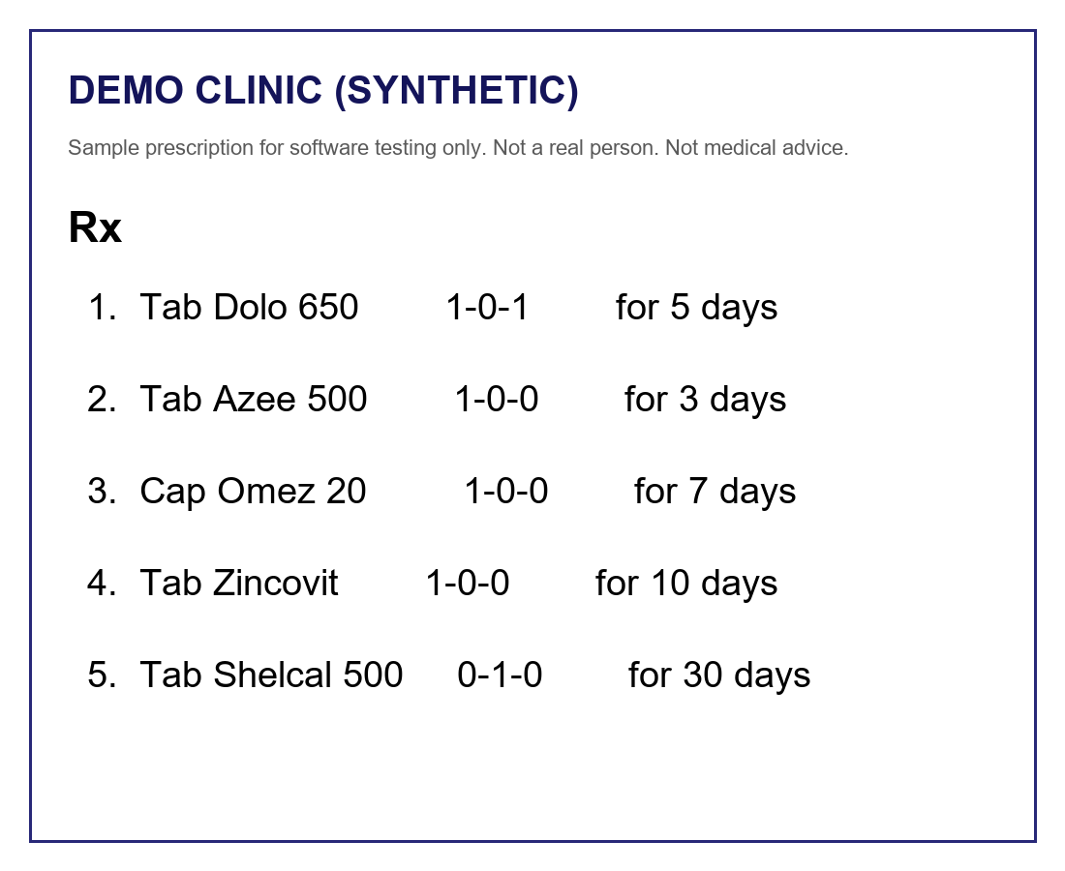
Figure 6.1 Fictional demonstration prescription
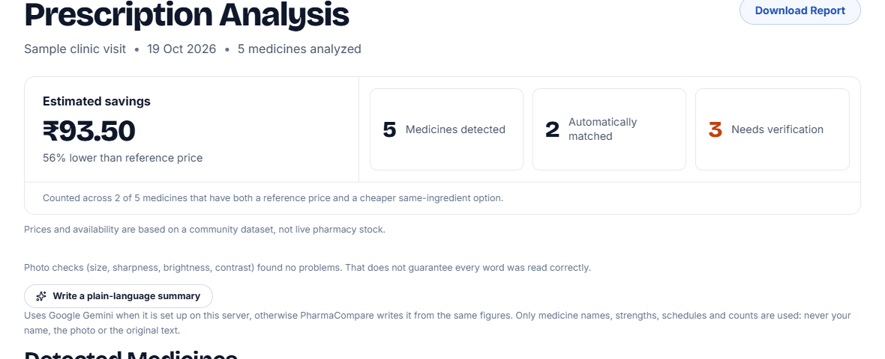
Figure 6.2 Analysis summary
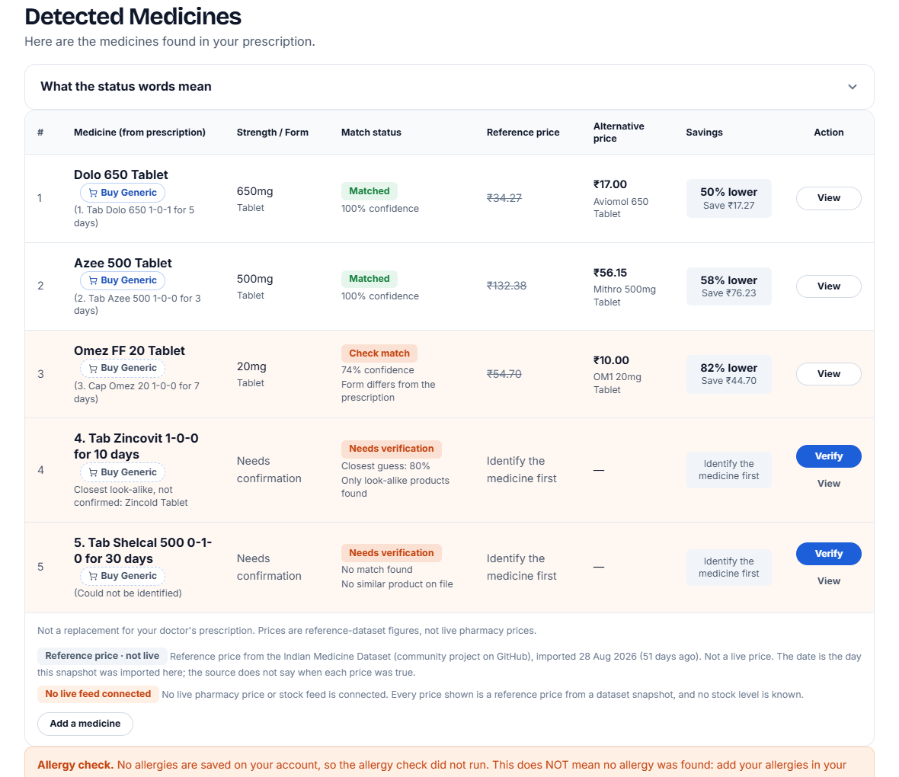
Figure 6.3 Detected medicines
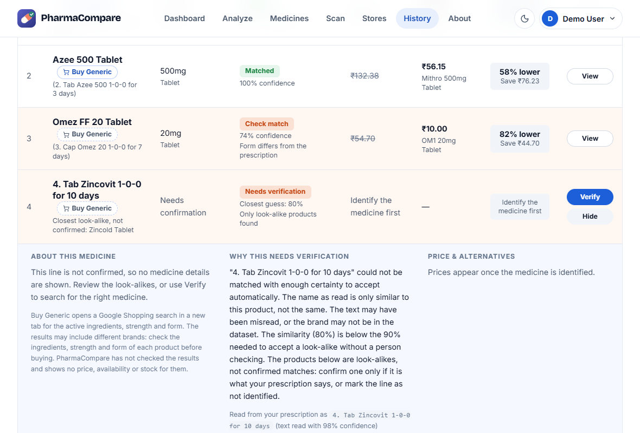
Figure 6.4 Details of a line that needs verification (Zincovit, not accepted)
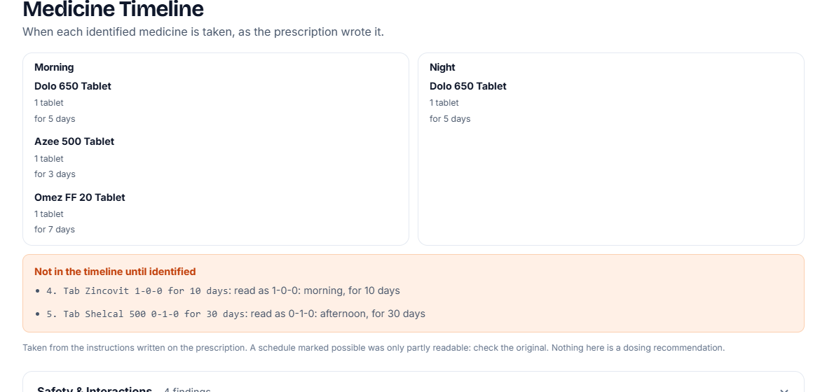
Figure 6.5 Medicine timeline
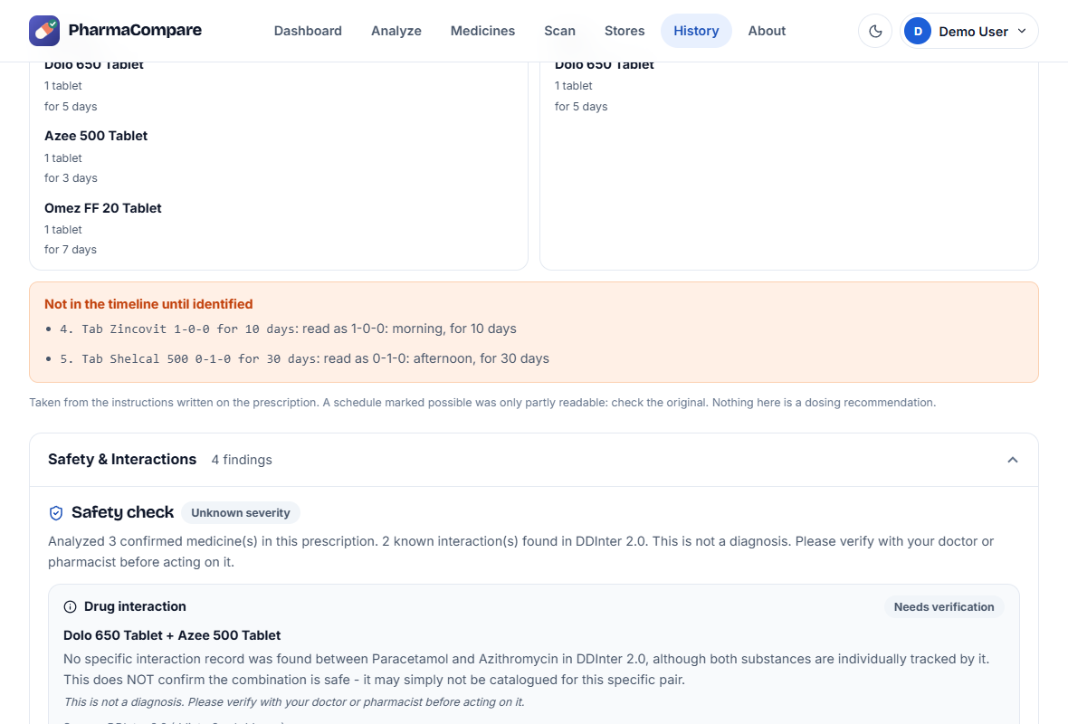
Figure 6.6 Safety and interactions
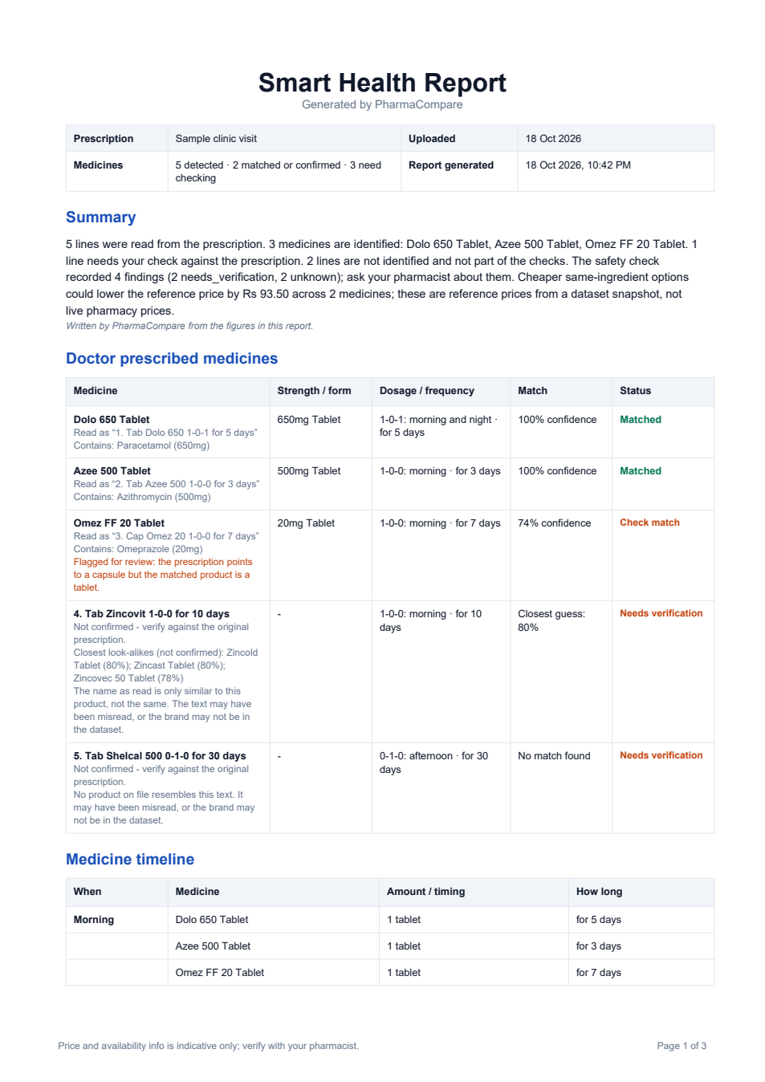 | 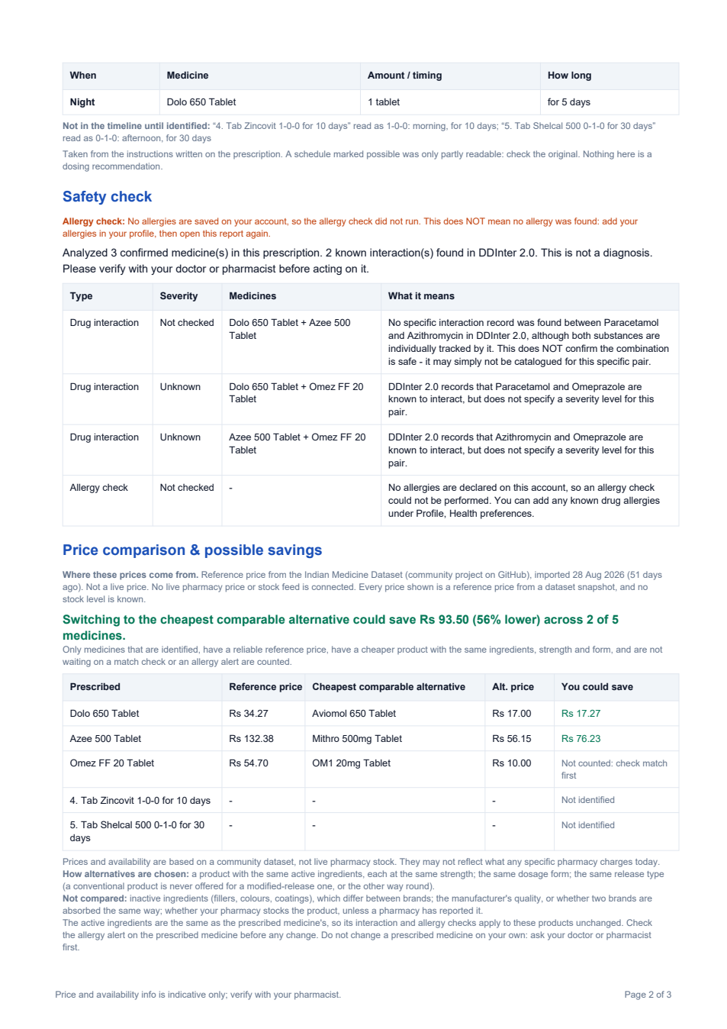
Figure 6.7 Smart Health Report (pages 1 and 2)

6.2 OBSERVATIONS

6.2.1 REFERENCE DATA USED BY THE SYSTEM
Table 6.1 Reference data used by the system
Item | Value
Medicine products in the table | 253,973 (imported 28 August 2026 from a community-compiled dataset of unstated origin)
Distinct primary ingredients | 1,589
Products with an incomplete ingredient list | 6,187 (2.4%)
Interaction pairs from DDInter 2.0 | 160,235 unique pairs over 1,939 names (from 222,383 raw rows)
Ingredients with a DDInter match | about 56% of the distinct ingredients

6.2.2 EXPERIMENT A - INGREDIENT-ONLY VERSUS COMPARABLE-PRODUCT RULE
500 products were drawn at random (seed 20261016) from the 239,995 live, priced products with a complete ingredient list. A simple baseline looked for the cheapest product with the same primary ingredient, whatever its strength, form or pack, and PharmaCompare’s own comparison ran on the same product. The baseline is not a model of any published system.
Table 6.2 Ingredient-only versus comparable rule
Measure | Result
Products for which the baseline offered a cheaper item | 499 of 500
Of these, cheapest item rejected by the comparability and price-quality rules | 460 (92.2%)
Median apparent saving of the rejected suggestions | 91.4%
Products for which at least one comparable alternative was listed | 481 of 500
Products with at least one countable saving | 444 of 500

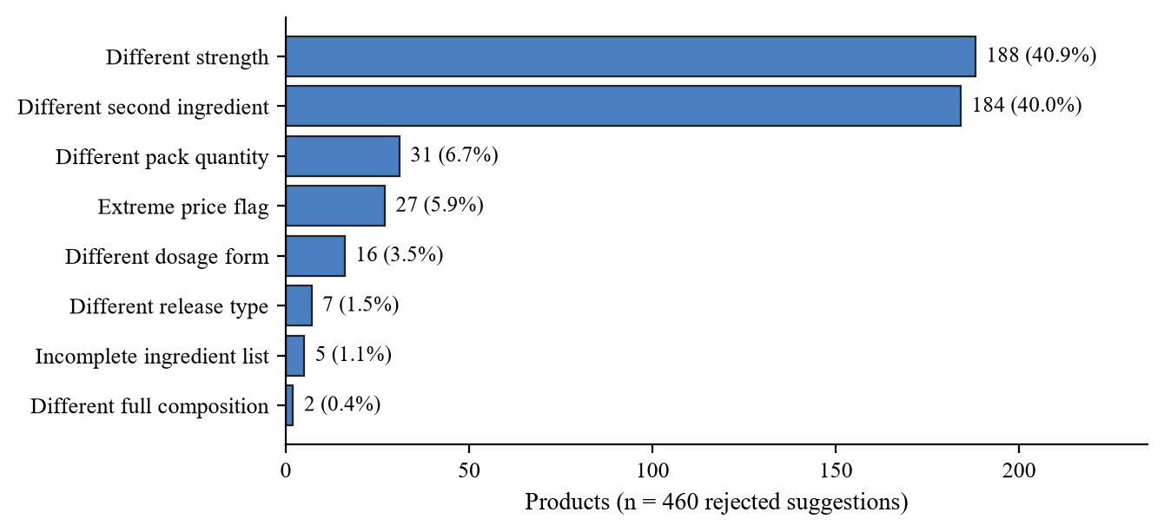
Figure 6.8 Why ingredient-only suggestions fail
The 91.4% apparent saving reflects products of a different strength or composition, not a real saving.

6.2.3 EXPERIMENT B - SYNTHETIC NOISE TEST OF THE MATCHER
With no labelled real prescriptions available, 300 product names (8–40 characters, seed 20261017) were submitted to the matcher unchanged and with one, two or three simulated character edits (confusable substitutions such as o↔0, deletions, duplications). The true product is always in the database and no strength text is present. The test shows how cautious the matcher is, not OCR accuracy.
Table 6.3 Matcher behaviour under simulated noise
Edits per line | Auto-accepted | Auto-accepted wrongly | True product reachable by the user
0 (clean) | 285 (95.0%) | 0 | 290 (96.7%)
1 | 106 (35.3%) | 3 of 106 (2.8%) | 225 (75.0%)
2 | 26 (8.7%) | 0 | 154 (51.3%)
3 | 9 (3.0%) | 0 | 115 (38.3%)

Reachable: auto-accepted correctly, or among the options or the closest guess shown to the user.
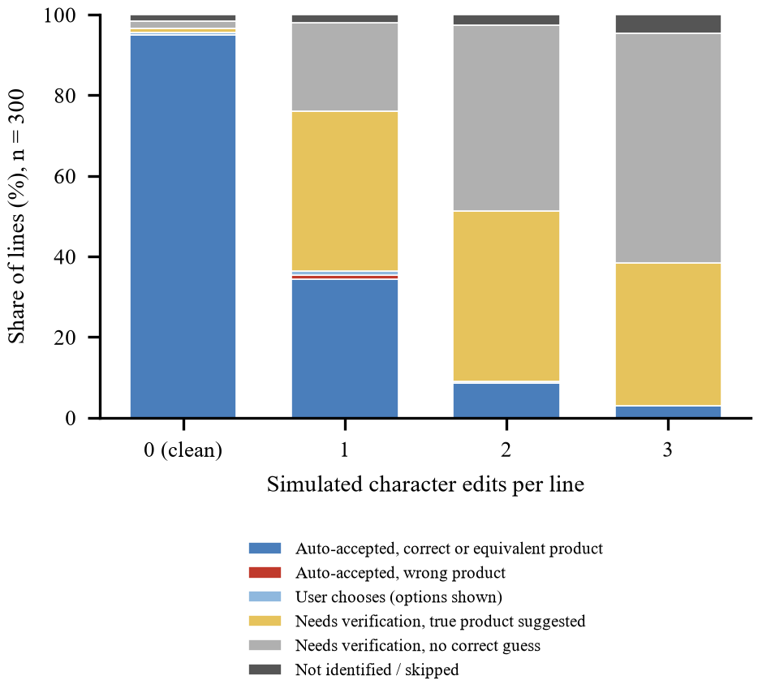
Figure 6.9 Matcher outcomes by simulated edits
With one edit 35.3% of lines were auto-accepted and 3 of 106 (2.8%) wrongly (95% Wilson interval 1.0–8.0%); the matcher refers most noisy lines to the user instead of guessing.

6.2.4 STATUS OF THE OBJECTIVES
Table 6.4 Status of the objectives
Objective | Status | What the system does | Main limitation
1. Real-time price comparison | Partly implemented | Compares products with the same composition, strength, form, release type and pack quantity, per unit; every price states its source, import date and that it is not live; pharmacy-reported prices are shown separately | Reference snapshot of 28 August 2026; no live price source is connected
2. AI-based prescription analysis | Implemented, rule-based | Reads and matches the lines, reads the dosing, and checks interactions, duplicates, strengths and allergies on confirmed lines | No trained model; limited to DDInter coverage; accuracy on real prescriptions not measured
3. Alternative drug recommendation | Implemented | Up to three cheaper products with the same ingredients, strength, form and release type, with notes on what was not compared; never for an unconfirmed line | No therapeutic-equivalence or bioequivalence data
4. Real-time availability tracking | Partly implemented | Receives and shows pharmacy-reported stock with its age; otherwise says that stock is not tracked | No pharmacy sends reports, so no stock level is known
5. Confidence-based decision support | Implemented, heuristic | Status with reasons, a similarity score, conflict warnings and a recorded decision trail gate every later stage | Scores are heuristics, not calibrated probabilities
6. Use of healthcare data sources | Partly implemented | Two registered sources with licence, date and measured quality notes; product-level validation | Neither source is authoritative; no official register is integrated
CHAPTER 7

CONCLUSION

7.1 CONCLUSION
PharmaCompare turns a prescription image into a list of medicines that the user has confirmed, the dosing written on the prescription, rule-based safety messages and comparable-product prices, and it refuses to analyse a line that it cannot settle. It is rule-based, its prices come from a static reference dataset, and no live price or stock feed is connected.
Text is read with Google Cloud Vision or EasyOCR and matched against 253,973 medicine products; only strong matches are accepted automatically and every other line waits for the user. Confirmed medicines are screened against 160,235 interaction pairs and priced against comparable products, and the result is shown on screen and as a Smart Health Report.
All 592 back-end and 186 front-end tests passed, and the comparability rule rejected 460 of 499 ingredient-only price suggestions. The project meets its objectives as a working prototype; accuracy on labelled real prescriptions was not measured, and no clinical validation or user study was done.

7.2 FUTURE SCOPE
The system has the potential for the following enhancements:
- Evaluation on Real Prescriptions
Test with consented, anonymised prescriptions labelled by pharmacists.
- Live Prices and Availability
Connect pharmacy feeds or licensed sources for live prices and stock.
- Treatment-Course Cost
Add the cost of a full course from the schedules already read.
- Regional Languages and Handwriting
Support more regional languages and test on real handwriting.
- Usability and Secure Deployment
Study usability and add privacy controls and secure hosting before real use.

APPENDIX-A
LIST OF ABBREVIATIONS
The abbreviations used in this report are listed in the table below.
Sl. No. | Abbreviation | Full form
1 | AI | Artificial Intelligence
2 | API | Application Programming Interface
3 | BiLSTM | Bidirectional Long Short-Term Memory
4 | CNN | Convolutional Neural Network
5 | CORS | Cross-Origin Resource Sharing
6 | CR | Controlled Release
7 | CRNN | Convolutional Recurrent Neural Network
8 | CSV | Comma-Separated Values
9 | DDInter | Drug–Drug Interaction database
10 | DFD | Data Flow Diagram
11 | ER | Entity–Relationship (diagram); Extended Release (release type)
12 | FK | Foreign Key
13 | IEEE | Institute of Electrical and Electronics Engineers
14 | JPEG | Joint Photographic Experts Group
15 | JSON | JavaScript Object Notation
16 | JSX | JavaScript XML
17 | JWT | JSON Web Token
18 | LLM | Large Language Model
19 | MIT | Massachusetts Institute of Technology (software licence)
20 | NSAID | Non-Steroidal Anti-Inflammatory Drug
21 | OCR | Optical Character Recognition
22 | PDF | Portable Document Format
23 | PK | Primary Key
24 | PNG | Portable Network Graphics
25 | RAM | Random Access Memory
26 | REST | Representational State Transfer
27 | SDLC | Software Development Life Cycle
28 | SR | Sustained Release
29 | SRS | Software Requirement Specification
30 | TrOCR | Transformer-based Optical Character Recognition
31 | YOLO | You Only Look Once (object detector)

APPENDIX-B
HARDWARE AND SOFTWARE DESCRIPTION
The hardware and the software used to build, run and test PharmaCompare are described below.

Hardware description
- Computer – a processor with six cores and 16 GB RAM: runs the MySQL server, the back end and the OCR model.
- Camera or scanner – used by the user to capture the prescription or a medicine pack as a JPG, PNG or PDF file.
- Network connection – needed only by the optional cloud services (Google Cloud Vision and Gemini).

Software description
- Python and Flask – language and web framework of the REST API and the services.
- MySQL 8.0 – relational database holding the sixteen tables, with a full-text index for medicine search.
- EasyOCR / Google Cloud Vision – local and cloud OCR engines used to read the prescription and the pack photo.
- React and Vite – single-page front end and its build tool; Axios for API calls.
- ReportLab – generates the Smart Health Report in PDF.
- DDInter 2.0 – open drug–drug interaction database used for the safety screening.
- Community medicine dataset (MIT licence) – 253,973 Indian medicine products used for matching and price comparison; not an official or verified source.
- Google Gemini (optional) – words the report summary and medicine explanations from stored facts.
- Unittest and the Node test runner – automated back-end and front-end tests.

REFERENCES
[1]. Brits, H., Botha, A., Niksch, L., Terblanché, R., Venter, K. and Joubert, G. (2017) Illegible handwriting and other prescription errors on prescriptions at National District Hospital, Bloemfontein. South African Family Practice, 59(2), 50. https://doi.org/10.4102/safp.v59i1.4658
[2]. Ray, A., Najmi, A., Khandelwal, G. and Sadasivam, B. (2020) A cost variation analysis of drugs available in the Indian market for the management of thromboembolic disorders. Cureus, 12(5), e7964. https://doi.org/10.7759/cureus.7964
[3]. Behera, D.K., Rahut, D.B., Mehboobali, M.D., Tasneem, S.H. and Rajendhran, A. (2025) Medicine affordability and access in India: lessons from generic–branded price variation under the Jan Aushadhi Scheme. Frontiers in Public Health, 13. https://doi.org/10.3389/fpubh.2025.1629835
[4]. Razdan, A., Raghavan, A., Panandikar, M., Pol, A., Hedaoo, K. and Patil, R. (2023) Recognition of Handwritten Medical Prescription using CNN Bi-LSTM With Lexicon Search. 2023 14th International Conference on Computing Communication and Networking Technologies (ICCCNT), 1–6. https://doi.org/10.1109/ICCCNT56998.2023.10307451
[5]. Uz Zaman, M.F. et al. (2024) Recognizing Medicine Names from Bangladeshi Handwritten Prescription Images using TrOCR. 2024 7th Asia Conference on Cognitive Engineering and Intelligent Interaction (CEII), 55–59. https://doi.org/10.1109/CEII65291.2024.00020
[6]. Ali, U., Ranmbail, S., Nadeem, M., Ishfaq, H., Ramzan, M.U. and Ali, W. (2024) Leveraging Deep Learning With Multi-Head Attention for Accurate Extraction of Medicine From Handwritten Prescriptions. 2024 International Conference on Robotics and Automation in Industry (ICRAI), 1–6. https://doi.org/10.1109/ICRAI62391.2024.10894218
[7]. Roy, A., Saha, D. and Debnath, S. (2026) A YOLO-TrOCR Pipeline with Dictionary Refinement for Handwritten Medicine Name Extraction. 2026 International Conference on Power, Electronics, Communications, Computing, and Intelligent Infrastructure (PECCII), 1–6. https://doi.org/10.1109/PECCII70991.2026.11662060
[8]. Devi, M.T.S. and Sudhindra, J. (2026) GENERIC RX: AI-Powered Prescription OCR for Generic Medicine Discovery. 2026 Third International Conference on Innovations in Cybersecurity and Data Science (ICICDS), 1546–1552. https://doi.org/10.1109/ICICDS70526.2026.11604829
[9]. Thota, S. and Shirisha, K. (2026) AI-Powered Prescription Decoder and Generic Medicine Recommender. International Journal on Science and Technology, 17(2). https://doi.org/10.71097/ijsat.v17.i2.10892
[10]. Diaz Amaya, E., Solier Quispe, E.C. and Hijar Flores, J.K. (2024) Information System for price comparison and prescription reading using automation technologies and digitalization of texts for pharmacies in Peru. Proceedings of the 22nd LACCEI International Multi-Conference for Engineering, Education and Technology (LACCEI 2024). https://doi.org/10.18687/laccei2024.1.1.1548
[11]. Jeevidha, S., Yogeshwaran, P., Kannathasan, K. and Anand, A.P. (2026) An Advanced Electronic Health Record for Prescription Analysis Using YOLO and OCR with Spell Correction. 2026 9th International Conference on Computational Intelligence in Data Science (ICCIDS), 1–6. https://doi.org/10.1109/ICCIDS69108.2026.11407882
[12]. Mankash, T., Kota, V.S.C., De, A. and Prakash, P. (2024) MIRAGE: Multimodal identification and recognition of annotations in Indian general prescriptions. arXiv preprint arXiv:2410.09729. (Preprint; author list as shown on the arXiv record.) https://doi.org/10.48550/arXiv.2410.09729
[13]. Agrawal, M., Mishra, V., Jogani, H.S., Kashyap, P. and Mishra, R.G. (2023) A Review of Artificial Intelligence in Medical Prescription Analysis. 2023 3rd International Conference on Pervasive Computing and Social Networking (ICPCSN), 35–43. https://doi.org/10.1109/ICPCSN58827.2023.00014
[14]. Ma, R. et al. (2026) An intelligent OCR-LLM prescription review system for inpatient narcotic and psychotropic drugs. Medicine, 105(38), e50741. https://doi.org/10.1097/MD.0000000000050741
[15]. Patil, R., Peshave, P. and Kamble, M. (2022) Application of Fuzzy Matching Algorithms for Doctors Handwriting Recognition. 2022 IEEE Bombay Section Signature Conference (IBSSC), 1–5. https://doi.org/10.1109/IBSSC56953.2022.10037486
[16]. Kim, W.T. et al. (2024) Medication Extraction and Drug Interaction Chatbot: Generative Pretrained Transformer-Powered Chatbot for Drug-Drug Interaction. Mayo Clinic Proceedings: Digital Health, 2(4), 611–619. https://doi.org/10.1016/j.mcpdig.2024.09.001
[17]. Jagatap, A., Merugu, S. and Comar, P.M. (2025) RxLens: Multi-Agent LLM-powered Scan and Order for Pharmacy. Proceedings of the 2025 Conference of the Nations of the Americas Chapter of the Association for Computational Linguistics: Human Language Technologies (Volume 3: Industry Track), 822–832. https://doi.org/10.18653/v1/2025.naacl-industry.63
[18]. Abdullah, S. and Mamun, K.A. (2026) An offline smartphone check for drug interactions and past reactions in handwritten prescriptions: A technical feasibility study in rural Bangladeshi outpatient care. arXiv preprint arXiv:2608.27239v2. (Preprint, not peer reviewed.) https://doi.org/10.48550/arXiv.2608.27239
[19]. Tian, Y. et al. (2025) DDInter 2.0: An enhanced drug interaction resource with expanded data coverage, new interaction types, and improved user interface. Nucleic Acids Res., 53(D1), D1356–D1362. https://doi.org/10.1093/nar/gkae726
[20]. Alharbi, O.M. (2026) Designing an OCR-Based Medication Support System With Drug–Drug Interaction Alerts for Elderly. IEEE Access, 14, 13688–13701. https://doi.org/10.1109/ACCESS.2026.3651478
[21]. Nasser, F., Hasan, H., Salman, S., Mohanna, A. and Chehab, A. (2026) PharmaBot: A Multimodal AI System for Drug Interaction Detection. 2026 IEEE 5th International Multidisciplinary Conference on Engineering Technology (IMCET), 7–14. https://doi.org/10.1109/IMCET69180.2026.11503766
[22]. Gaikwad, K., Kharche, S., More, R., Kadam, S., Bobade, S. and Patil, P. (2025) OCR AND NER Based Generic Medicine Recommendation System. 2025 International Conference on Intelligent and Secure Engineering Solutions (CISES), 1253–1259. https://doi.org/10.1109/CISES66934.2025.11265361
[23]. Janani, M., Laya, H. and Mathishree, B. (2025) OCR Text Recognition and Recommendation Using Machine Learning. 2025 International Conference on Visual Analytics and Data Visualization (ICVADV), 804–807. https://doi.org/10.1109/ICVADV63329.2025.10961754
[24]. Karmakar, J. et al. (2025) Optimizing Pharmaceutical Affordability: A Composition-Based Algorithm for Medicine Price and Alternative Discovery. 2025 International Conference on Engineering Innovations and Technologies (ICoEIT), 1194–1198. https://doi.org/10.1109/ICoEIT63558.2025.11211845
[25]. Larson M, J.S., Sivakumar, R. and Murugesan, R. (2026) AI-Enabled Brand-to-Generic Medication Recommendation System for Pharmacy: Addressing Consumer Brand-Name Bias. 2026 International Conference on Communication, Computing and Emerging Technologies (IC3ET), 358–363. https://doi.org/10.1109/IC3ET64989.2026.11467238

