Level-6
Final Project

Hotel

Vashisht

Table of Contents
Project Proposal 2
Goals and Objectives 2
Project Scope 3
Project Specifications 3
Target Audience 3
Project Deliverables 3
Resource Requirement 3
Tasks and Achievements of the project 3
Project Assumptions 4
Project Report 4
Detail Design 4
Home Page 4
Customers 4
Staffs 5
Rooms 5
Branches 5
Booking 6
Project Testing 6
Usability Testing 6
User Manual 7
System Summary 7
System Configuration 7

Project Proposal

Goals and Objectives
Purpose of the project is to show an online application for hotel. Admin can add, delete, update, and check data of the hotel staff, customer, rooms, bookings and branches. Only registered users can use application with full access on the other side, unregistered users can only read the data, but they can’t add, delete or edit the data.

Project Scope
This is a 20-day project, and the scope of this project is to create an online hotel reservation web application where customers can easily view information of different hotels and book a room. Booking can also be handled by them.

Project Specifications
- The administrator can add, delete, update and review hotel information.
- The admin will delete and validate reservation information.
- The administrator will handle the client by editing, deleting and accessing information.
- Admin can login by using their credential.

Target Audience

The administrator will handle the client by editing, deleting and accessing information.

Project Deliverables
The deliverables of the project are the following:
Deliverable | Description
Final report | Full report of the project
Coding | Project Code of a Project
Documentation | Manuals and documents
Testing | All of the project's research info will go here.

Resource Requirement
- Asp.net MVC Framework
- Identity framework- ASP
- Windows Operating System
- 64-bit processor and 8-16 GB or more RAM
- Microsoft Office word and excel.

Tasks and Achievements of the project
The following table shows the Project Activities and Achievements:
Weeks | Tasks
1 | Review of study and brainstorming
1 | Documentation for the preparation and project proposal
1 | Concept of the design and implementation of DB and UI
2 | Identity framework Implementation
2 | Coding- admin segment
3 | Testing
3 | Final and closing Documents

Project Assumptions
- While the App is built and implemented, there will be a single admin and client.
- New admins can only be registered by registered administrators.
- The software will be open source and free.

Project Report
Functional –
- Login/Logout.
- Handle bookings.
- Add, edit, delete and review hotel information.
- Edit, delete and check client information.

Non- Functional –
- Compatibility with Browsers
- Compatibility with computers
- Protection and high performance
- Less time for loading and less memory.
- Restricted client access.

Detail Design

Home Page
This is the web application's landing page. In the navigation Home, Customers, staffs, Branches, Bookings register, and login options are open.


Customers

In this web page Users can add, edit, delete and view Customer data.
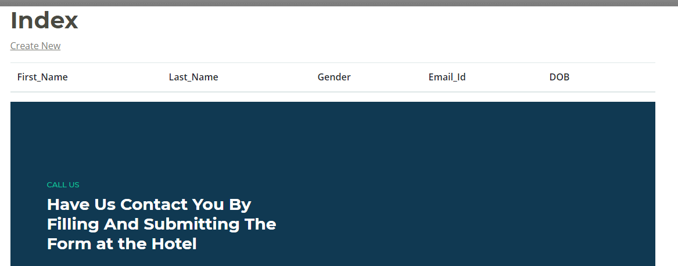

Staffs

In this page users can create new profile and also, they can use edit and delete function. 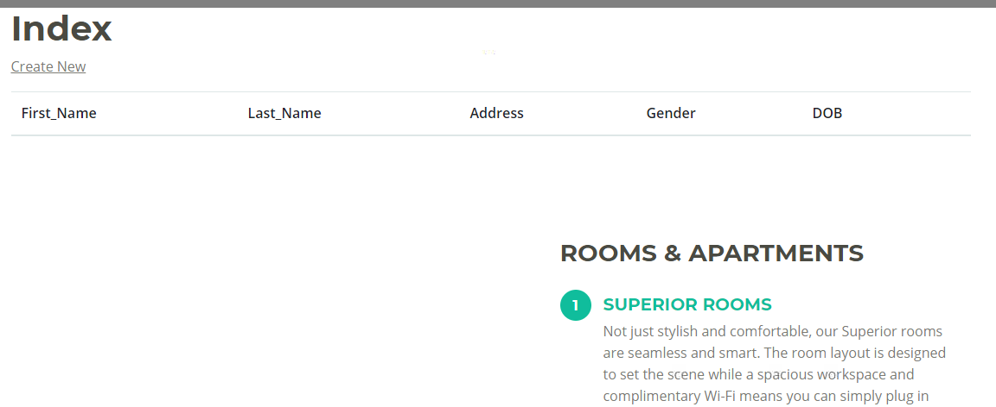

Rooms
In this page User can add name of room by type of it and they can choose number. They can also give ratings.
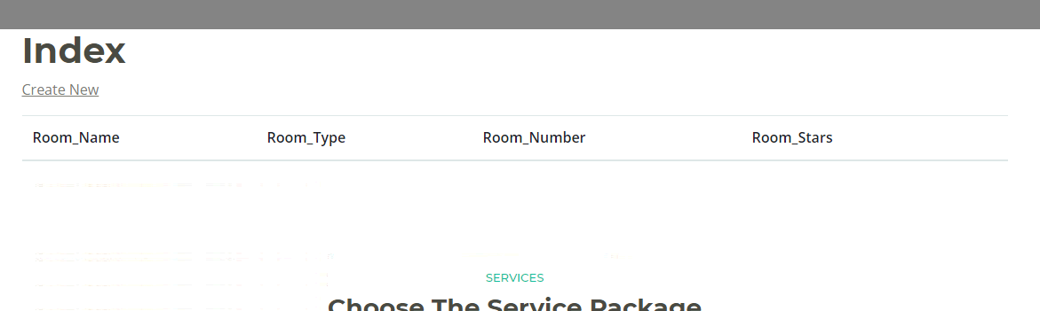

Branches
In this section Users can add branch of hotel by address, contact and Email and then they can edit, delete and view their data.
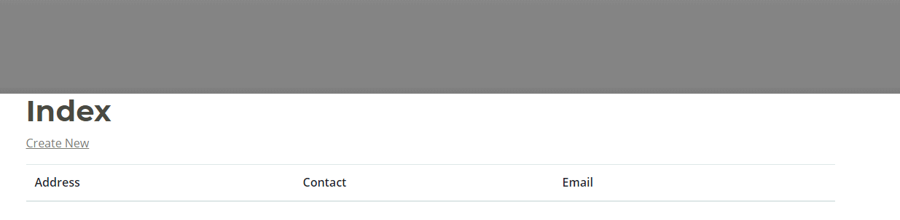

Booking
This page will show that which customer select what room from which staff member of the hotel from particular branch done their bookings
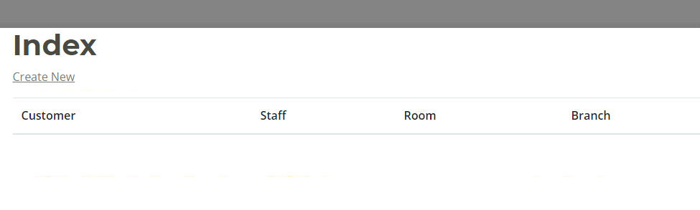

Project Testing

Usability Testing
Tester – 1 |  | Scale
No. | Question | Agree Disagree, Neutral
1 | In order to use this device, do you think you need the assistance of a technical person? | Agree
2 | Are there any contradictions here? | Agree
3 | Is it easy to use the system? | Neutral
4 | I'd like to make regular use of this device. | Disagree
5 | It is nice to integrate | Neutral

User Manual
Admin can add, delete, update, and check details of the hotels and they can also check the details for bookings. Admin can manage clients who can edit, delete, and check details.

System Summary

System Configuration

The web application for hotel reservations can help to find the hotels availability and customers can book on their convenience.

