PATTERN RECOGNITION
CASE STUDY / MINI PROJECT REPORT
15 Marks | Two Reviews – 7.5 Marks Each

Student and Project Details
Course Code / Course Title | 21CSE451T – Pattern Recognition Techniques
Academic Year / Semester | 2026–27 (Odd) / Semester 7
Department / Section | Computational Intelligence (CINTEL) / AC-1
Student Name(s) | Vansh Agrawal
Register Number(s) | RA2311026010120
Project Title | SherdMatch: AI-Based Archaeological Pottery Fragment Matching
Faculty Guide / Reviewer | Dr Nithyashri J
Review Date(s) | Review 1: 29 October 2026 Review 2: 5 November 2026

Project Report

1. Abstract
Archaeological pottery is excavated as hundreds of broken sherds, and finding which pieces physically join is slow expert work. This case study presents SherdMatch, which treats joining as a pattern-recognition problem: given one sherd, rank the others in a collection by the probability that the two fit together. We use the Daxinzhuang-18K benchmark (Ji et al., 2026): 124 sherds with 111 expert-confirmed joins form the test set, supported by simulated fractures and excavation metadata. Each sherd is segmented, normalised and described by colour, LBP texture and ResNet-50/DINOv2 embeddings. Each pair is also checked for fracture-edge fit by aligning complementary curvature segments (Kabsch + ICP). A class-balanced logistic regression fuses twelve pair features into a join probability. Under leak-free vessel-grouped cross-validation, the model places a true partner in the top 10 for 71.8% of queries, against 54.0% for the image-only baseline of Review 1 (+17.7 pts (95% CI +9.7 to +26.6)). Most of that gain comes from combining appearance cues: adding edge geometry changes Hit@5 by +3.2 pts (95% CI -2.4 to +9.7), which is not significant. The edge matcher aligns 47.0% of clean synthetic breaks but only 17.1% of real, eroded ones. A learned appearance ranker is therefore a practical triage tool, whereas fracture geometry needs erosion-robust descriptors.
Keywords: pottery sherd matching, fragment reassembly, image retrieval, contour matching, logistic regression, cultural heritage.

2. Introduction and Problem / Case Study Understanding

2.1 Real-world problem
Pottery is the most common find on most excavations. At the Bronze-Age site of Daxinzhuang (Jinan, Shandong, China), the excavation catalogue alone lists 17,635 sherds from one refuse pit. Before a vessel can be studied for typology, capacity, use-wear or dating, its sherds must be re-associated. Today an archaeologist spreads the sherds on a table and compares them one against another. The work scales with the square of the number of pieces, so it is the first thing to be cut when time or funding runs short. Many collections therefore stay as unsorted bags of fragments.

2.2 The pattern to be recognised
The pattern is a relation between two objects, not a property of one object. A pair of sherds either joins (the pieces were neighbours on the original vessel and share a fracture edge) or does not. We formulate it in two equivalent ways:
- Pair classification: input = two sherd images; output = P(join). This is a binary pattern-recognition problem with extreme class imbalance: in the gold standard only 111 of 7,626 possible pairs (1.46%) join.
- Retrieval / ranking: input = one query sherd; output = all other sherds sorted by P(join). This is how the system is used: an archaeologist inspects the top-k candidates instead of the whole collection.

2.3 Why it is hard
- Look-alike sherds. Most Daxinzhuang sherds are the same grey-to-orange cord-marked ware, so sherds from different vessels look alike (Figure 1).
- Eroded edges. Fracture edges are chipped and worn after ~3,000 years in the ground, so even true partners leave visible gaps when assembled (Figure 6).
- No canonical orientation or position. A sherd can be photographed at any rotation, so every comparison must be rotation-invariant or must search over rotations.
- Two cues that can disagree. Two pieces may look alike but not fit (same ware, different vessel), or fit geometrically by coincidence (straight edges fit many places).
The system built in this project is called SherdMatch: it matches a sherd against a collection and returns the sherds most likely to join it.

2.4 Research question carried over from Review 1
Does adding fracture-edge geometry to image similarity improve top-k matching over image-only retrieval? Hypothesis H1: a model that combines appearance and fracture-edge geometry retrieves true partners at higher Hit@k than appearance alone, because geometry can reject look-alike sherds that cannot physically fit.

2.5 Related work
Fragment reassembly is one of the oldest problems in pattern recognition. Freeman and Garder (1964) solved apictorial jigsaw puzzles by matching boundary shape alone, and Wolfson (1990) formalised curve matching for such boundaries. In 3-D, Papaioannou et al. (2002) and Huang et al. (2006) reassembled fractured objects by matching fracture surfaces. Those methods depend on clean, high-resolution fracture geometry. For pottery specifically, Kampel and Sablatnig (2003) used profile sections to reconstruct vessel shape. Recent 2-D learning work mostly classifies sherds rather than joining them. Chetouani et al. (2020) combined pre-trained CNN features to classify engraved sherd patterns. Pinho et al. (2025) used a pre-trained ResNet-50 to group sherds by surface pattern and colour to assist reconstruction. Yu et al. (2026) showed that sherd recognisers latch onto spurious background features and used contrastive learning to suppress them. The Daxinzhuang-18K benchmark (Ji et al., 2026) is the first large public 2-D collection with expert-verified physical joins, which makes the comparison in this study possible.
Table 1. Positioning against prior work.
Work | Cue used | Data | What it leaves open for this study
Freeman & Garder 1964; Wolfson 1990 | Boundary shape | Synthetic jigsaw pieces | Clean cut edges; no appearance
Papaioannou et al. 2002; Huang et al. 2006 | 3-D fracture surface | 3-D scans | Needs 3-D scanning of every sherd
Kampel & Sablatnig 2003 | Profile section | Rim sherds | Body sherds have no usable profile
Chetouani et al. 2020 | CNN appearance | Engraved sherds | Classifies patterns, does not find joins
Pinho et al. 2025 | ResNet-50 appearance | Decorated sherds | Groups by look; geometry not tested
Yu et al. 2026 | Contrastive CNN | Hemudu sherds | Recognition, not reassembly
This study | Appearance + 2-D fracture edge | Daxinzhuang gold standard (real joins) | Tests whether 2-D edge geometry adds value on real eroded sherds

Research gap. Appearance-based sherd work rarely evaluates on real, expert-confirmed joins, and geometry-based reassembly is mostly evaluated on clean or synthetic breaks. Whether 2-D fracture-edge geometry still helps once edges are eroded, compared fairly against a strong image-only baseline, has not been measured. That comparison is the core of this case study.

2.6 Key terms
Table 2. Archaeological and technical terms.
Term | Meaning in this report
Sherd | A broken fragment of a pottery vessel.
Join / refit | Two sherds that were neighbours on the vessel and share a fracture edge (positive pair).
Vessel group | All sherds connected through joins; a connected component of the join graph.
Exterior / interior view | Photograph of the outer or inner surface of a sherd.
Cord marks | Parallel impressions made by a cord-wrapped paddle while shaping the pot; they form stripes.
Spalling | Flaking off of the surface layer, which changes a sherd's appearance.
Query / gallery | The sherd we search partners for / the collection searched.
Hit@k | Share of queries with at least one true partner among the top k suggestions.
MRR | Mean reciprocal rank of the first true partner.
Pose | Rotation and translation that place a sherd in the assembled position.
Kabsch / ICP | Closed-form best rotation between two point sets / its iterative refinement with re-matched points.

3. Objectives
Table 3. Specific, measurable objectives.
# | Objective | Measurable target / evidence | Status
O1 | Acquire and understand the Daxinzhuang-18K data and metadata | Dataset, metadata and annotation formats documented; pose convention verified | Done (Sec. 4–5)
O2 | Build a reproducible preprocessing pipeline | Segment, normalise and extract contours for 100% of gold and simulated images | Done (Sec. 6)
O3 | Implement an image-only baseline (Review 1 plan) | Hit@k, MRR of ResNet-50 / DINOv2 cosine ranking | Done (Sec. 12)
O4 | Implement fracture-edge geometric compatibility | Pose recovery rate on synthetic and real pairs; pair AUC | Done (Sec. 9, 12)
O5 | Fuse appearance and geometry in a pattern-recognition model and test H1 | Hit@1/5/10, MRR, mAP, P/R/F1 under vessel-grouped CV, with 95% bootstrap CIs | Done (Sec. 11–13)
O6 | Justify the model against alternatives | Logistic regression vs Random Forest vs SVM-RBF, plus an ablation study | Done (Sec. 10)
O7 | Deliver a working prototype | Interactive demo that ranks candidates and previews the best physical fit | Done (app.py)

4. Dataset and Data Understanding

4.1 Source and collection
Daxinzhuang-18K: A Large-Scale 2D Benchmark for Pottery Sherd Retrieval and Reassembly, by Ji, Xue, Wang, Ma, Lang, Fang, Tu and Lu, published on Zenodo (record 21553799, version 1.0.0, July 2026, licence CC-BY 4.0). The sherds come from pit H690 at the Daxinzhuang site in Jinan. Each sherd was photographed on a plain backdrop with a colour/scale card, exterior and interior separately, and catalogued by stratigraphic layer. Joins were confirmed physically by experts.
Table 4. Contents of the Zenodo record and how each part is used.
Part | Content | Size | Used here for
Daxinzhuang-18K (real) | 36,532 JPG photos (1024×771) + metadata workbook, 17,635 catalogue records | 4.7 GB | Metadata study; raw-photo segmentation (E6 planned)
dataset_gold_standard | 248 background-removed RGBA PNGs (124 sherds × exterior/interior), gt_all.json with 111 join records and assembly poses | 53 MB | Main train/test set (E1–E3, E5)
dataset_simulated (8 subsets) | 50,736 synthetic fracture pairs, each with two PNGs and the relative pose | 18 GB | sim_data_8 only (2,212 pairs): geometry sanity check (E4)
expert_confirmed_physical_refit_pairs.xlsx | 251 joining groups (pairs or triples) by sherd ID | 16 KB | Ground truth for the planned raw-photo test (E6)

Because the full record is about 20 GB, we downloaded only what each experiment needs. From the 4.7 GB real-photo archive, the metadata workbook and the needed photos were extracted with HTTP byte-range requests against the zip's central directory, verifying each file's CRC-32. This avoided a full download.

4.2 Samples, labels and features
The unit of analysis is a sherd pair. The gold standard has 124 exterior sherds, giving 124·123/2 = 7,626 unordered pairs, of which 111 are labelled join (class 1) and the rest no join (class 0). The join graph splits into 33 connected components (vessel groups) of 2 to 11 sherds (median 3). Most sherds have one or two partners (56 sherds have exactly one, 44 have two, 18 have three, 6 have four).
Table 5. Gold-standard dataset summary (computed by scripts/figures/explore_dataset.py).
Property | Value
Images (gold) | 248 RGBA PNG, 1024 × 1024, transparent background
Sherds used (exterior view) | 124
Positive pairs / all pairs | 111 / 7,626 (1.46%)
Vessel groups | 33 (largest 11 sherds)
Median sherd area | 82 k px (full resolution)
Median sherd perimeter | 1254 px
Median cord-mark stripe coherence | 0.49 (0 = no direction, 1 = perfect stripes)
Simulated pairs (sim_data_8) | 2,212 from 1 source vessel, many fracture runs

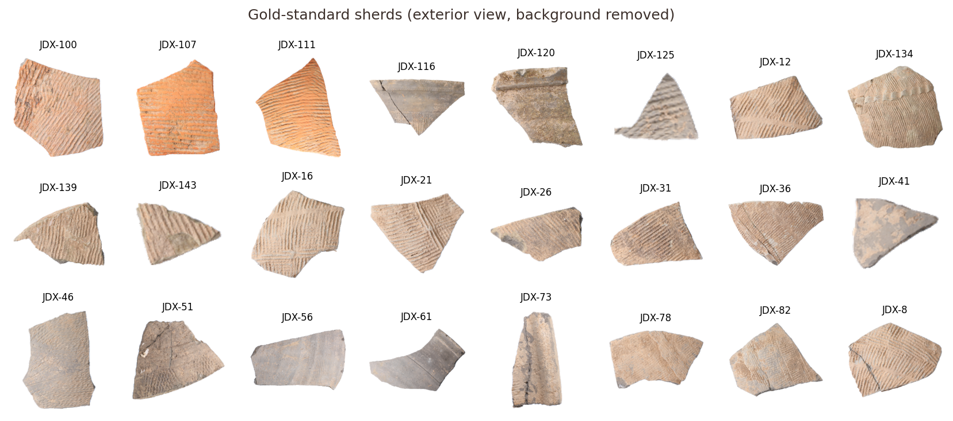
Figure 1. A sample of gold-standard sherds. The ware is uniform: cord-marked, grey to orange, which is why appearance alone confuses vessels.
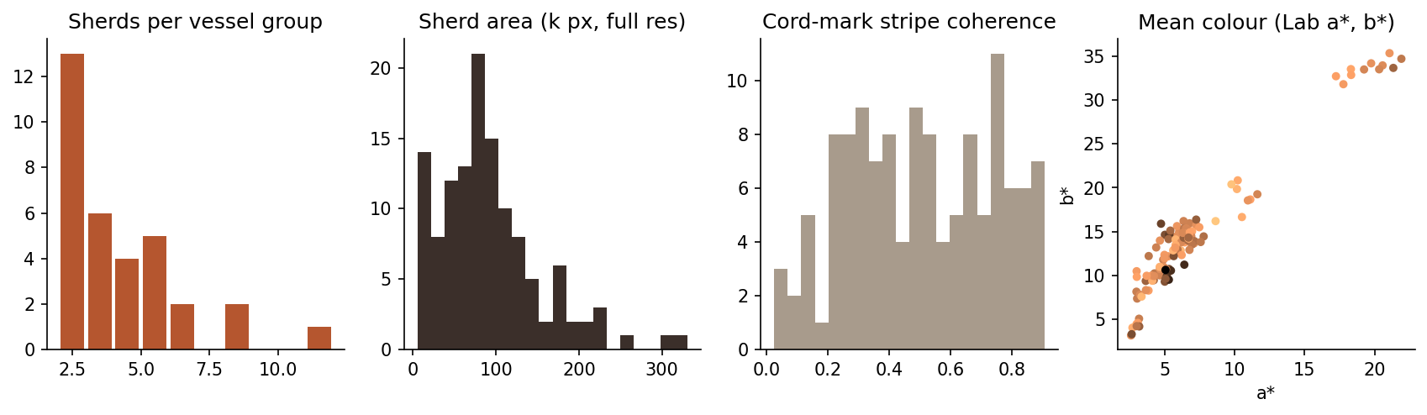
Figure 2. Exploration of the gold standard: vessel-group sizes, sherd areas, strength of the cord-mark stripe pattern, and mean colour in Lab space (colour = lightness).
Observations. (i) Group sizes are skewed: a few large vessels contribute many pairs, so a random pair-level split would put sherds of the same vessel in both train and test. We therefore split by vessel group (Section 11). (ii) Sherd area varies about tenfold, and small sherds have short edges that carry little shape information. (iii) Stripe coherence is moderate (median 0.49), so the stripe direction is a usable but noisy cue. (iv) Colour spreads along a single orange-to-grey axis, the main appearance signal separating vessels.
For each pair we compute 12 features. Four are appearance features and eight describe fracture-edge geometry. All are continuous real numbers:
Table 6. The 12 pair features (inputs to the classifier).
Feature | Type | Meaning
colour_sim | appearance | −χ² distance of 8×8×8 Lab colour histograms
lbp_sim | appearance | −χ² distance of rotation-invariant uniform LBP histograms (P=8,R=1 and P=16,R=2)
resnet_cos | appearance | cosine similarity of ResNet-50 (ImageNet) 2048-d embeddings
dino_cos | appearance | cosine similarity of DINOv2 ViT-S/14 384-d embeddings
geo_score | geometry | contact × overlap penalty × orientation agreement at the best alignment
contact, contact_frac | geometry | edge length (px) that touches within 4 px, absolute and relative to the shorter outline
overlap | geometry | area overlap of the two sherds after alignment (should be ≈ 0)
rmse | geometry | residual of the touching edge points (px)
orient_gap, orient_conf | geometry | angle between the two sherds' cord-mark directions after alignment, and the confidence of that estimate
log_area_ratio | geometry | |log(area A / area B)|

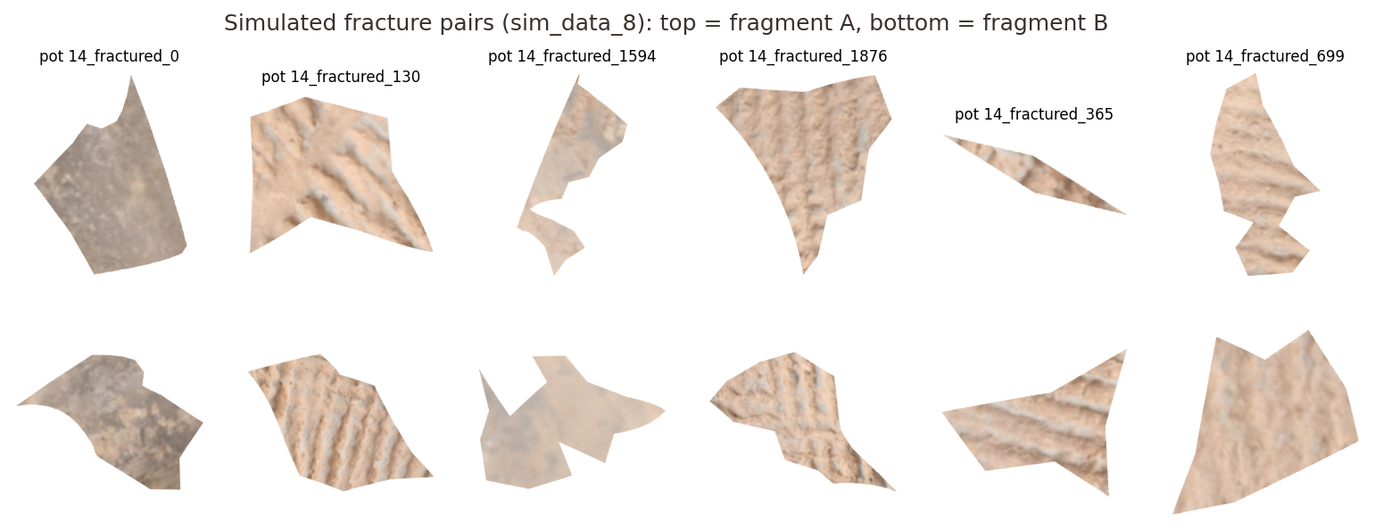
Figure 3. Simulated fracture pairs from sim_data_8. Edges are clean polygon breaks, unlike the eroded real edges.

5. Metadata Understanding

5.1 Excavation metadata workbook
Daxinzhuang_AI_Archaeological_Sherd_Metadata.xlsx has two sheets: Shandong (17,634 records) and Specimens (176 records). Row 1 of each sheet is a legend that describes the fields, not a sherd, and must be skipped when the sheet is loaded.
Table 7. Metadata fields and why they matter.
Field | Meaning | Observed values / relevance
Sherd_ID | Catalogue number of the sherd (JD00001…) | Primary key; the refit spreadsheet uses it
Sherd_Part | Rim, body sherd, base, foot, … | Body sherds dominate (15,546); rims 1,501. Rims carry profile information body sherds lack
Inferred_Vessel_Type | Jar, Li tripod, Gui, Dou, … | Only 547 of 17,634 records are typed, so it is too sparse to use as a label
Exterior_Photo / Interior_Photo | File stems of the two views | Photo numbers ≠ sherd numbers (see 5.2)
Site | Jinan_Daxinzhuang | Constant; one site
Context_Unit | Pit and layer, e.g. H690_Layer_8 | 43 units: stratigraphy, a potential prior (joining sherds usually lie in nearby layers)
Small_Find_No | Registered small-find number | Empty for the main sheet
Notes | Condition notes, e.g. Exterior_Spalled | Surface spalling changes appearance and explains some errors

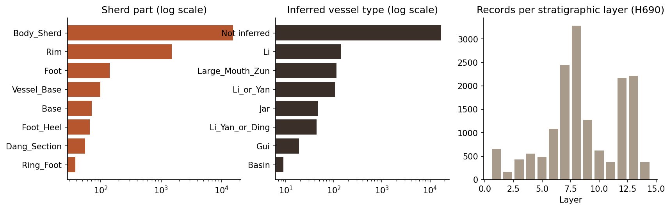
Figure 4. Metadata distributions (log scales): sherd parts, inferred vessel types (mostly not inferred), and records per stratigraphic layer of pit H690.

5.2 A metadata pitfall we found and fixed
A naive reading suggests that sherd JD00076 is photographed in file JD_00076.JPG. The metadata shows otherwise: each sherd has two photo numbers (JD00001 → JD_00001 exterior and JD_00002 interior), so photo numbers run about twice as fast as sherd numbers. Our first download script mapped IDs by number and would have silently paired the wrong photos. The bug was caught by reading the metadata, and the fixed script maps every refit sherd through the Exterior_Photo column. This is a concrete case of metadata preventing a label error that pixels alone could never reveal.

5.3 Annotation metadata (gt_all.json) and pose conventions
Each of the 111 gold records has pair_id, side (all exterior), img_a, img_b and two poses A_action, B_action = [x, y, cos θ, sin θ]. The README does not state the exact convention. From the dataset's reference script we established that each image is first recentred on its alpha-weighted centroid c, then rotated by θ and placed at (x, y), so world = R(θ)(p − c) + t. We confirmed this independently: under this convention the true partners touch along 75–170 px of edge with ≤7% overlap, whereas the alternative rotation sign gives large overlaps. The simulated data use a different convention: rotation about the image centre with the opposite sign of θ. We found it by testing all eight combinations of sign, centre and inversion and keeping the one that produced contact without overlap (211 px mean contact, 4% overlap). Figure 6 re-renders gold joins with our own implementation of the convention.

5.4 Why metadata matters for evaluation
- Leakage control. The vessel-group structure (derived from the join graph) defines the cross-validation folds, so no vessel appears in both training and test data.
- Interpretation of errors. Condition notes (spalling, adhered soil, residue) explain why some sherds' appearance does not match their partners.
- Future priors. Context unit and sherd part are not used by the model yet, but they are realistic priors (Section 14).
Table 8. First records of the Shandong sheet (Site = Jinan_Daxinzhuang for all).
Sherd_ID | Sherd_Part | Exterior_Photo | Interior_Photo | Context_Unit
JD00001 | Rim | JD_00001 | JD_00002 | H690_Layer_1
JD00002 | Rim | JD_00003 | JD_00004 | H690_Layer_1
JD00003 | Body_Sherd | JD_00005 | JD_00006 | H690_Layer_1

6. Data Exploration and Preprocessing

6.1 Data quality issues found
Table 9. Data quality issues and how each is handled.
Issue | Where | Consequence if ignored | Handling
Background | Raw photos: grey/white backdrop + colour card + ink labels | Card or backdrop treated as sherd | Otsu on colour distance to the border colour, rectangularity filter for the card, GrabCut refinement
Illumination / colour cast | All images | Texture features follow lighting, not surface | CLAHE on the L channel (texture only); colour features use raw Lab
Arbitrary rotation | All images | Rotation-dependent features miss partners | Rotation-invariant LBP; 4-rotation averaged deep embeddings; geometry searches over all rotations
Scale must be preserved | Gold and sim | Per-image resizing would change edge lengths | One global working scale (0.5), never per-image resizing
Eroded / chipped edges | Real sherds | Edges do not fit exactly | Contour smoothing (σ = 1.5 samples), contact tolerance of 4 px, ICP refinement
Tiny specks / holes in the mask | Alpha matting edges | Spurious contours | Largest connected component, hole filling, morphological opening
Corrupt / partial files | Downloads | Crashes or silent bad data | CRC-32 check on extraction; image validation on load
Class imbalance (1.46%) | Pair labels | Classifier predicts 'no join' always | Class-balanced weights; PR-based metrics
Leakage via vessel | Pair labels | Inflated scores | Vessel-grouped folds

Missing values, duplicates and outliers in the usual tabular sense do not arise: every gold image has an annotation, no two images are identical (the largest DINOv2 cosine similarity between different sherds is well below 0.999), and every sherd area is plausible. Two of the 36,532 catalogue records lack an interior photo; this does not affect the exterior-only analysis.

6.2 Preprocessing sequence
Table 10. Preprocessing pipeline as implemented in src/pfm/preprocess.py.
Step | Operation | Parameters | Why it suits this data
01 Validate | Open and fully decode; reject empty masks | mask ≥ 200 px | Catches truncated downloads early
02 Standardise | Convert to RGBA; resize by a global factor | scale 0.5 (gold, sim); 1.0 (photos) | Keeps true relative size, which edge matching needs; halves compute
03 Isolate | Alpha > 127 (gold/sim) or Otsu + card filter + GrabCut (photos); largest component; fill holes | rectangularity < 0.88; GrabCut 4 iterations | Fragment shape must be exact for contour matching
04 Normalise | CLAHE on Lab L channel | clip 2.0, 8×8 tiles | Removes lighting gradients but keeps cord-mark relief
05 Edges | Outer contour, oriented consistently, resampled every 3 px, Gaussian-smoothed | step 3 px, σ = 1.5 samples | Equal spacing makes curvature windows comparable between sherds
06 Features | Colour/LBP histograms, deep embeddings, stripe orientation, curvature signature | see Table 6 | Inputs for appearance and geometry cues

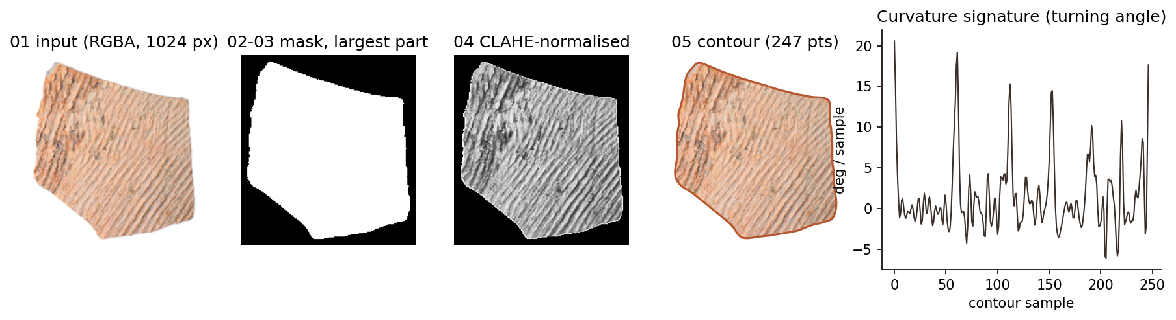
Figure 5. Preprocessing of sherd JDX-100: input, mask, CLAHE-normalised texture, resampled contour, and its curvature (turning-angle) signature. Peaks are corners of the outline.
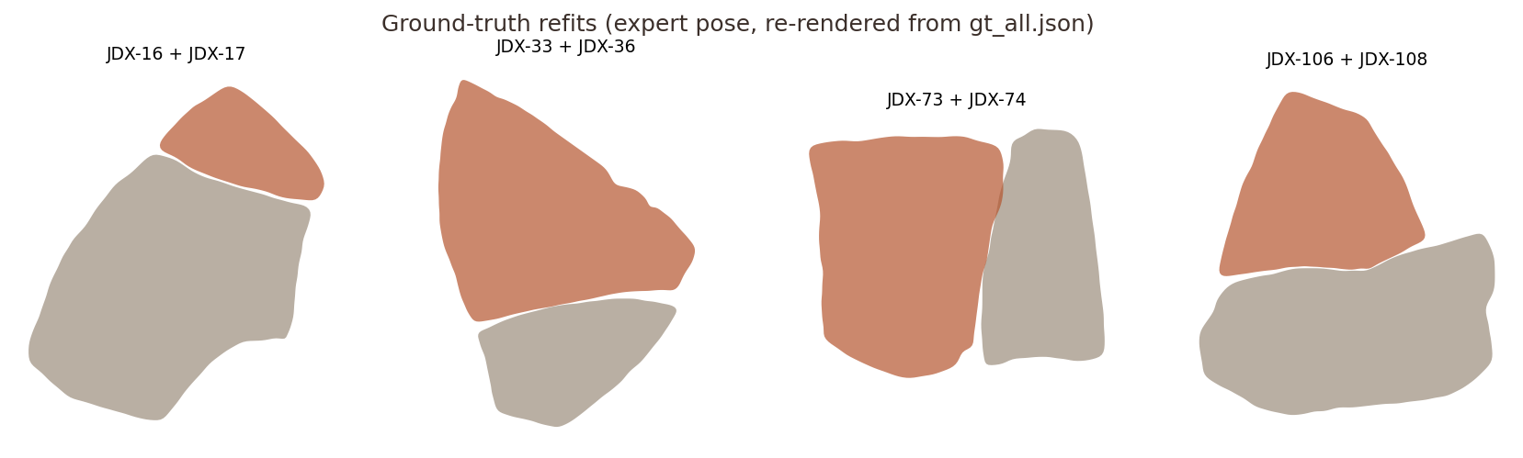
Figure 6. Gold-standard joins re-rendered from the expert poses with our own code. The pieces touch but leave gaps along eroded parts of the edge.
For raw excavation photos the isolation step is harder, because grey sherds sit on a grey backdrop next to a black-and-white scale card. Otsu thresholding alone picked the card in 2 of the first 6 test photos and under-segmented grey sherds. The rectangularity filter removes the card in every photo we inspected, and GrabCut recovers most of each sherd. Two errors remain (Figure 7): the light, low-contrast side of some sherds is cut off (JD_00028, JD_00076), and soft cast shadows are included on the other side. Both distort the outline, which matters for the planned raw-photo experiment (E6).
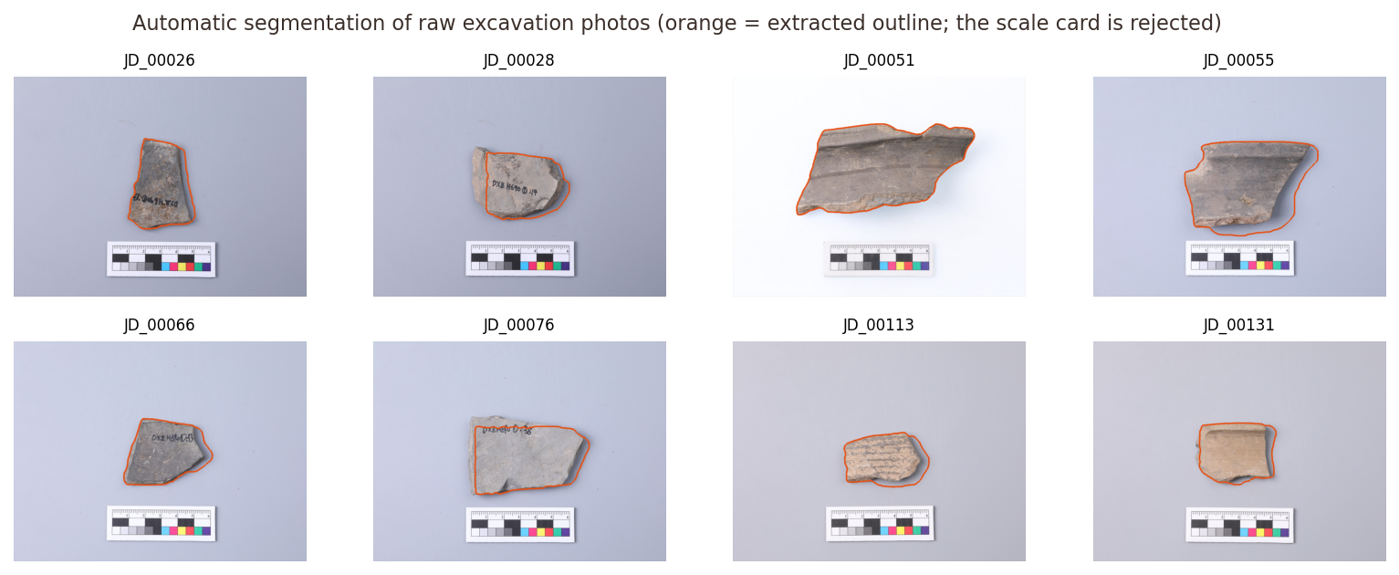
Figure 7. Automatic segmentation of raw excavation photos. The scale card is always rejected; light sherd edges are partly lost and shadows partly included.

7. Scope, Applications, Impact and Limitations

Scope
The system ranks candidate joins for 2-D photographs of individual sherds and previews the best rigid alignment of a pair. It works on the exterior view, assumes sherds are roughly flat in the photo (2-D rigid motion), and is evaluated on one site's ware. It does not perform full multi-piece vessel reconstruction, and it does not decide joins. It produces a short list for an expert to check.

Applications
- Triage in finds processing: show the archaeologist the 5–10 most likely partners for each new sherd.
- Re-examining museum stores where sherds of one vessel ended up in different bags or layers.
- Digital archives: linking photographs of sherds across collections, without handling the objects.
- Teaching: the demo makes the difference between 'looks alike' and 'fits together' tangible.

Expected impact
With the proposed model, an expert who inspects the top 10 candidates finds a true partner for 71.8% of sherds, against 10.5% for random inspection of 10 sherds. In a collection of thousands of sherds, that means looking at ten candidates rather than at everything, for most sherds. The cost is a few seconds of computation per query.

Assumptions
- Photographs are taken at a consistent scale (true for the gold set; approximately true for the field photos, which include a scale card).
- Sherds are rigid and their outline is visible; joining edges are part of the outer contour.
- Expert joins are correct and complete for the pairs listed. Unlisted pairs are treated as non-joins, which can only make the measured precision pessimistic.

Limitations (summary; details in Section 14)
- Real fracture edges are eroded, which limits what 2-D geometry can recover.
- Only 111 positive pairs: enough to fit a linear model, not enough to train a deep network for this task.
- One site and one ware type; generalisation to other assemblages is untested.

8. Novelty / Innovation and Contribution
The individual building blocks (LBP, CNN embeddings, Kabsch alignment, ICP, logistic regression) are standard and are cited as such. The contribution of this project lies in how they are combined and, above all, in how they are evaluated:
Table 11. Contribution of this case study versus existing approaches.
Aspect | What is new in this work | Existing practice
Problem formulation | Joining as pair classification *and* retrieval, scored with archaeologist-centred Hit@k on real expert joins | Sherd *classification* by type or decoration
Evaluation protocol | Vessel-grouped CV (no vessel in train and test), paired bootstrap CIs, synthetic-vs-real comparison of the same matcher | Random splits; synthetic breaks only
Feature design | Complementary curvature windows (A forward vs B reversed and negated), overlap-verified alignment, and a cord-mark orientation-consistency cue | Shape descriptors per sherd, no physical-fit check
Dataset preparation | Pose conventions of gold and simulated sets derived and verified; photo-ID mapping error found and fixed; range-request extraction of only the needed files | Not documented
Analysis | Ablation of every cue, error analysis (same-vessel confusions, sherd size), honest negative result for H1 | Report best number only
Prototype | Interactive demo with ranked candidates, feature evidence and a fit preview | Offline scripts

Individual contribution. This is a one-person project. All code in the repository (preprocessing, features, geometric matcher, experiments, figures, demo, this report) was written, run and analysed by the student, using the public libraries and pre-trained weights listed in Section 16.

9. Pattern Recognition Model Selection and Working
Selected model: a two-cue pairwise classifier. Appearance and fracture-edge geometry features are fused by an L2-regularised, class-balanced logistic regression (LR), whose output probability ranks candidate partners.

9.1 Input, output and stages
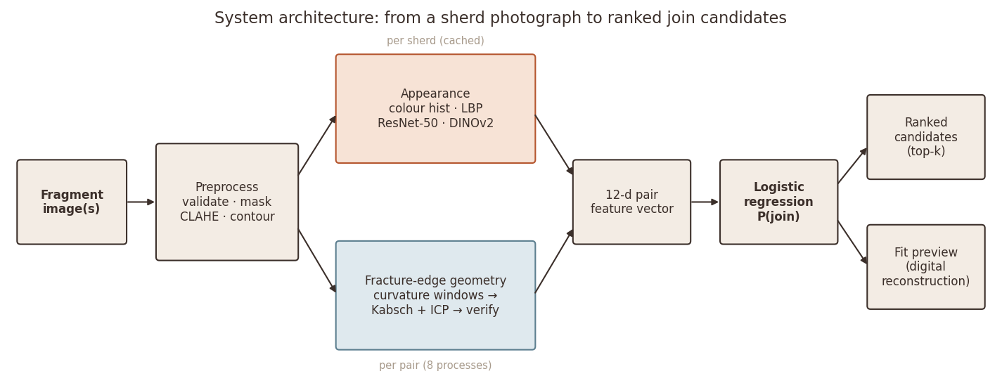
Figure 8. System architecture. Per-sherd descriptors are computed once and cached; the geometric matcher runs per pair.
Table 12. Processing stages.
Stage | Input | Output
1. Preprocess each sherd | Image file | Mask, normalised RGB, contour (N×2), centroid
2. Per-sherd descriptors | Preprocessed sherd | Colour hist (512), LBP (28), ResNet-50 (2048), DINOv2 (384), stripe orientation + coherence
3. Pair geometry | Two contours + orientations | Best rigid transform (R, t) and contact, overlap, rmse, orientation gap
4. Pair feature vector | Stages 2–3 for a pair | x ∈ ℝ¹² (Table 6)
5. Classifier | x | P(join | x) = σ(wᵀz + b), z = standardised x
6. Ranking | P(join) for query vs every gallery sherd | Ranked candidate list + fit preview of the top candidate

9.2 Fracture-edge geometric matcher (stage 3)
Where two sherds join, their outlines follow the same curve but are traversed in opposite directions, and a bump on one is a dent on the other. The matcher exploits this:
- Curvature signature. For each contour, the turning angle κᵢ = wrap(∠(pᵢ₊₁ − pᵢ) − ∠(pᵢ − pᵢ₋₁)) is computed at every 3 px sample.
- Complementary windows. All windows of 32 samples (~96 px, stride 2) from A are compared with all windows from B reversed and negated (−κ_B read backwards), using squared Euclidean distance. Straight windows match everything, so the distance is divided by (0.5 + Σ|κ|), favouring distinctive shapes.
- Alignment. For the 8 best seed pairs (with non-maximum suppression), the rigid transform mapping B's window onto A's is solved in closed form by the Kabsch/SVD method (Kabsch, 1976). It is then refined by two iterations of ICP (Besl & McKay, 1992) on all touching points.
- Verification. Each candidate pose is scored on the whole outline: contact = length of B's edge within 4 px of A; overlap = area of intersection / smaller area (solid sherds cannot overlap); score = contact × max(0, 1 − overlap/0.08) × exp(−(Δφ/20°)²·c). Here Δφ is the angle between the two sherds' cord-mark directions (structure-tensor estimate, Bigün & Granlund 1987) and c is its confidence. The best-scoring pose is kept.
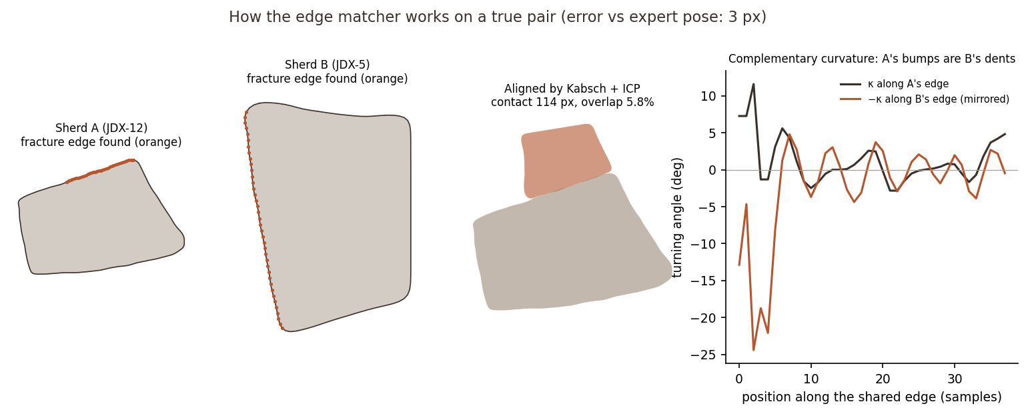
Figure 9. The matcher on a true pair (JDX-12 + JDX-5). It locates the shared fracture edge on both outlines (orange), aligns B to A, and the curvature of A along the joint mirrors that of B. The fit is checked against the whole outline, not only the seed window.
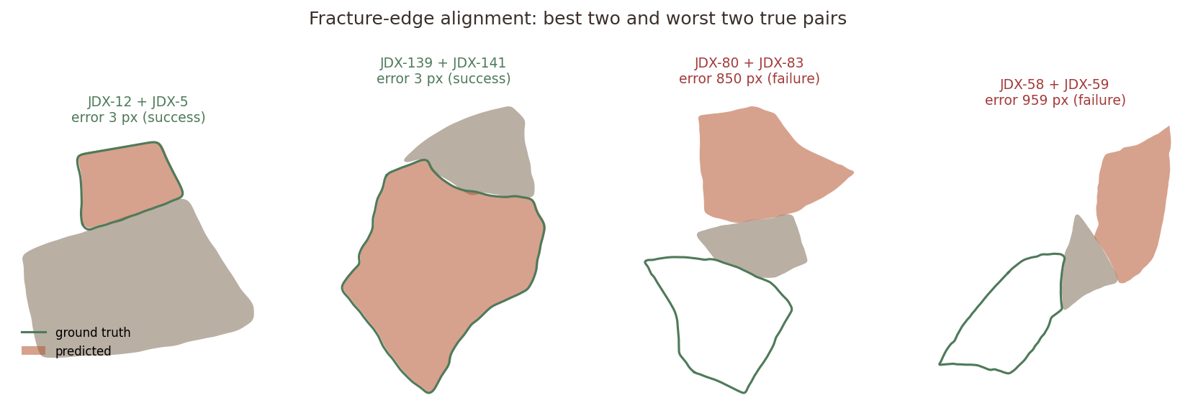
Figure 10. Output of the geometric matcher for true pairs: the two best (error 3 px, the predicted pose coincides with the expert pose) and the two worst (the matcher found a plausible-looking but wrong fit).

9.3 Logistic regression (stage 5)
LR models the log-odds of a join as a weighted sum of the standardised features: log[P/(1−P)] = b + Σⱼ wⱼ zⱼ. Weights are learned by minimising the class-weighted log-loss with an L2 penalty (C = 1). Class weights are inversely proportional to class frequency, so the 111 joins count as much as the 7,515 non-joins. At query time the predicted probability is computed for the query against every other sherd and sorted. Ranking only needs the order of the scores, so the decision threshold matters only for the pair-classification metrics, where it is chosen on training data (Section 11).
Algorithm 1: ranking the gallery for one query sherd q.
input : query image q, gallery G (cached descriptors), trained LR (w, b), scaler (μ, σ)
1 f_q ← preprocess(q) # mask, CLAHE, contour
2 d_q ← descriptors(f_q) # colour, LBP, ResNet-50, DINOv2, stripe angle
3 for each g in G:
4 a ← [−χ²(colour), −χ²(LBP), cos(ResNet), cos(DINOv2)]
5 (R, t) ← argmax over 8 curvature seeds of verify(Kabsch+ICP(f_q, f_g))
6 x ← [a, contact, contact_frac, overlap, rmse, score, Δφ·c, c, |log area ratio|]
7 s_g ← σ( wᵀ (x − μ)/σ + b ) # P(join)
8 return G sorted by s_g (descending), with (R, t) of the top candidate for the fit preview

9.4 Why this model fits the problem
- The decision really is a weighing of evidence from different sources ("similar colour", "edges touch", "stripes line up"). LR expresses exactly that, and its weights can be read and checked for physical plausibility.
- With 111 positives, a model with 13 parameters is well determined. A deep network would overfit.
- It produces calibrated-ish probabilities, which are needed for a ranking across all candidates.
- Training takes milliseconds and prediction is a dot product, so the expensive part (geometry) is the only cost.

9.5 Working prototype
The model is packaged as SherdMatch, a four-page web application (app.py, built with Gradio):
- Home explains the problem for a non-specialist: the scale of the sorting task, why it is hard, the question tested, the four-step approach and the headline results.
- How it works walks through preprocessing, appearance cues, the fracture-edge matcher, the classifier and the evaluation protocol, with the figures from this report.
- Matcher is the working tool. The user clicks a sherd in a visual grid of the 124-sherd collection, or uploads a new image (a PNG with a transparent background, or a photo on a plain backdrop, segmented automatically), and chooses the proposed model or the image-only baseline. The page shows the top-5 candidates as cards with score bars, a table of the evidence behind each score, and a preview of the physical fit of the best candidate, the first step toward digital reconstruction. Expert-confirmed joins are highlighted, so the model's behaviour can be checked live during the review.
- Results summarises the experiments, including the negative finding about geometry.
A collection query answers instantly from cached features; an uploaded sherd takes about 2–6 s on a laptop CPU. Switching the method live makes the main result tangible: for query JDX-103 the image-only baseline ranks the true partner 28th, while SherdMatch ranks it first.
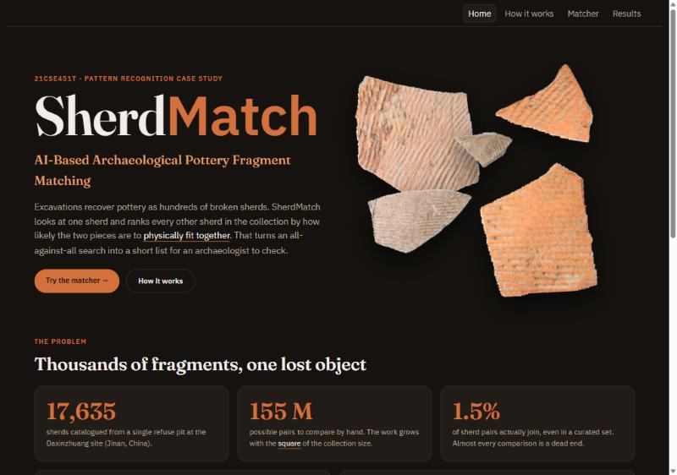
Figure 11. SherdMatch, Home page: the problem explained before the tool is used.
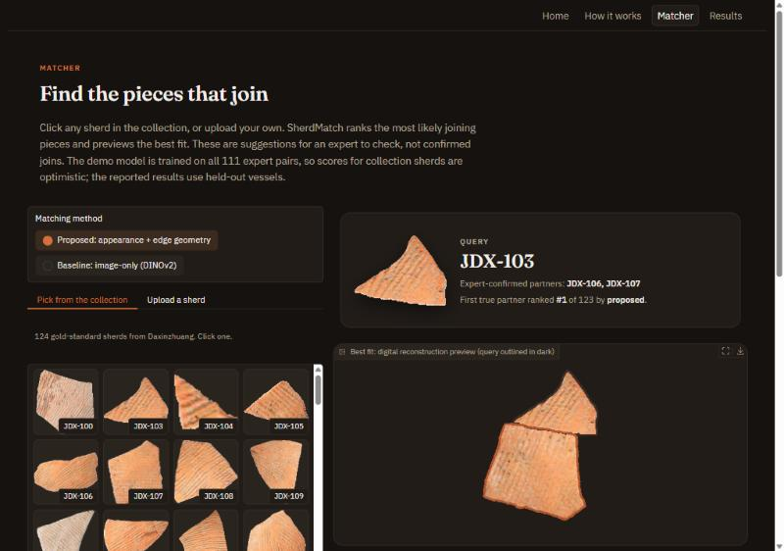
Figure 12. SherdMatch, Matcher page: query JDX-103 picked from the collection grid. Its expert-confirmed partner is ranked first, and the right panel previews the predicted fit.
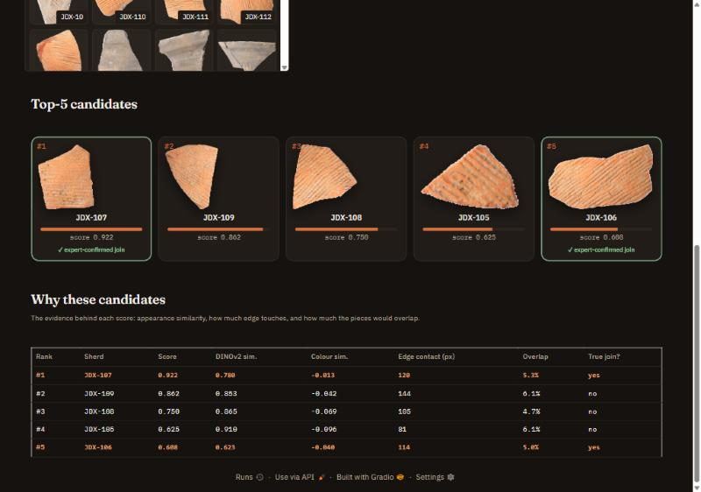
Figure 13. SherdMatch, Matcher page: candidate cards (expert-confirmed joins outlined in green) and the evidence table that explains each score.
Source code. The full project (pipeline, experiments, figures, demo and this report's generator) is public at https://github.com/vansh070605/SherdMatch, and every number in this report is regenerated by scripts/experiments/run_experiments.py and scripts/figures/make_figures.py.

10. Justification for Model Selection
We compared the selected model with the image-only approach planned in Review 1 and with two non-linear classifiers trained on the same 12 features under the same folds:
Table 13. Model comparison on identical features and folds.
Model | Interpretability | Computational cost | Hit@5 | Hit@10 | MRR | Pair F1
DINOv2 embedding (cosine) | High (one similarity) | 1 forward pass / sherd | 0.403 | 0.540 | 0.314 | –
Proposed: appearance + geometry (LR) | High (12 signed weights) | ms to train | 0.556 | 0.718 | 0.364 | 0.287
Appearance + geometry (Random Forest) | Medium (feature importances) | seconds to train | 0.484 | 0.645 | 0.340 | 0.291
Appearance + geometry (SVM-RBF) | Low (kernel) | seconds; scales O(n²) | 0.395 | 0.573 | 0.269 | 0.227

Table 14. Criteria-based comparison.
Criterion | Logistic regression (selected) | Random Forest | SVM (RBF)
Data characteristics: 12 continuous features, 111 positives | Few parameters, well-posed | Many trees on few positives, tends to memorise | Kernel width and C hard to tune with few positives
Interpretability | Signed weights per feature (Figure 18) | Importances only, no direction | None
Complexity / cost | Linear; trivial | 400 trees; moderate | Kernel matrix; grows quadratically
Robustness to imbalance | Class weights | Balanced subsampling | Class weights
Measured ranking quality | Best Hit@5/10 (0.556/0.718) | Lower ranking (0.484/0.645), similar F1 | Lowest (0.395/0.573)

Against the image-only baseline (DINOv2 cosine, the Review 1 plan), the selected model improves Hit@5 by +15.3 pts (95% CI +5.6 to +25.0) and Hit@10 by +17.7 pts (95% CI +9.7 to +26.6). Against the Random Forest, it ranks better (Hit@5 0.556 vs 0.484) with a comparable pair F1 (0.287 vs 0.291). The forest trades precision for recall at its threshold but orders candidates less well. The SVM is worst on every metric. With so few positives the flexibility of non-linear models does not pay off, and the linear model's interpretability is a decisive advantage for an archaeological tool whose suggestions must be explained.
Why not an end-to-end deep (Siamese) network? It would need thousands of real positive pairs. The 111 real joins are too few, and the 50,736 simulated pairs come from clean synthetic breaks of a few vessels. Section 12 shows that the geometry of real breaks differs from synthetic ones, so a network trained on simulation would face a large domain gap. We therefore use pre-trained embeddings as fixed features and learn only a small fusion model, which is the appropriate choice for this data size.

11. Experimental Setup and Evaluation Method

11.1 Validation strategy
5-fold vessel-grouped cross-validation. The 33 vessel groups (connected components of the join graph) are shuffled (seed 0) and assigned to 5 folds. For test fold k, the model is trained only on pairs whose two sherds both lie outside fold k, and it scores every pair that involves a fold-k sherd. Each query is ranked against the full gallery of 123 other sherds, as in real use. A pair whose two sherds fall in different test folds receives the average of its two scores. Because no vessel is ever in both train and test, the model cannot succeed by memorising a vessel's colour.
Decision threshold. For the pair-classification metrics, the threshold that maximises F1 is chosen by an inner 3-fold grouped CV on the training pairs only, then applied to the held-out pairs fully inside the test fold (1,542 pairs in total, 111 positive).

11.2 Experiments
Table 15. Experiments.
ID | Question | Data | Protocol
E1 | Does fusion beat image-only retrieval? | Gold, 124 queries | Vessel-grouped 5-fold CV
E2 | Which classifier? | Same | LR vs RF vs SVM-RBF on identical features and folds
E3 | Which cues matter? | Same | Drop one cue group at a time from the proposed model
E4 | Does the edge matcher work on clean breaks? | sim_data_8, 300 random pairs + 300 negatives | Pose error vs ground truth; AUC vs pairs from different fracture runs
E5 | Does it recover real poses? | 111 gold joins | Mean contour displacement vs expert pose
E6 | Does it transfer to raw field photos? | Expert refit spreadsheet + distractor photos | Planned: gold-trained models, appearance top-30 then geometry re-rank (script ready, not run for this review)

11.3 Environment and parameters
Table 16. Implementation environment and parameters.
Item | Setting
Hardware / OS | Laptop, Windows 11; inference on CPU (PyTorch CPU build), 8 worker processes for geometry
Software | Python 3.12, PyTorch 2.9.1, timm 1.0.29, scikit-learn 1.4.1, OpenCV 4.11, scikit-image 0.26, Gradio 6
Pre-trained models | resnet50.a1_in1k (ImageNet-1k); vit_small_patch14_dinov2.lvd142m at 224 px; 4 rotations averaged
Preprocessing | scale 0.5, contour step 3 px, smoothing σ 1.5, CLAHE clip 2.0
Geometry | window 32, stride 2, 8 seeds, contact tolerance 4 px, overlap penalty 0.08, orientation σ 20°
Classifiers | LR: C = 1, balanced; RF: 400 trees, min leaf 5, balanced subsample; SVM: RBF, C = 1, balanced
Randomness | All seeds = 0; results are deterministic
Runtime | Features for 124 sherds ≈ 40 s; geometry for all 7,626 pairs ≈ 1 min; full CV ≈ 1 min

11.4 Reproducibility
Table 17. Reproducing every result from the repository.
Step | Command | Output
Fetch photo subset | python scripts/data/fetch_real_subset.py | data/raw/Daxinzhuang-18K/… (refit + distractor photos)
Explore data | python scripts/figures/explore_dataset.py | outputs/dataset_summary.json, dataset figures
E1–E5 | python scripts/experiments/run_experiments.py | outputs/results.json, tables, trained model
E6 (planned) | python scripts/experiments/run_real_photos.py | outputs/results_real_photos.json
Figures + CIs | python scripts/figures/make_figures.py; make_method_figures.py | outputs/figures, bootstrap_ci.csv
This report | python scripts/docs/build_report.py | docs/Review2_Case_Study_Report.docx
Demo | python app.py | http://127.0.0.1:7860

11.5 Baselines and metrics
Baselines: random ranking; colour-histogram χ²; LBP χ²; ResNet-50 cosine; DINOv2 cosine (the Review 1 image-only plan); and the raw geometry score. Metrics and why they were chosen:
- Hit@k (k = 1, 5, 10): fraction of queries with at least one true partner in the top k. It is exactly what an archaeologist experiences when checking k candidates.
- MRR: mean of 1/rank of the first true partner. It rewards putting a partner at the very top.
- mAP: mean average precision over all partners of a query, for sherds with several partners.
- CMC curve: Hit@k for k = 1…30, showing the whole trade-off.
- Precision, recall, F1, ROC-AUC, PR-AUC, confusion matrix for the pair classifier. Accuracy is reported but is not informative: with 1.46% positives, predicting 'no join' for everything already scores 98.5%.
- Paired bootstrap 95% CIs (5,000 resamples of the 124 queries) for differences between methods, because 124 queries is a small test set.

12. Results and Analysis

12.1 E1: retrieval of join partners
Table 18. Retrieval results (124 queries, 123 candidates each, vessel-grouped CV). Higher is better except median rank.
Method | Hit@1 | Hit@5 | Hit@10 | MRR | mAP | Med. rank
Random ranking | 0.008 | 0.040 | 0.105 | 0.056 | 0.045 | 43.5
Colour histogram (chi2) | 0.137 | 0.403 | 0.621 | 0.271 | 0.217 | 7.0
LBP texture (chi2) | 0.113 | 0.274 | 0.419 | 0.210 | 0.147 | 13.5
ResNet-50 embedding (cosine) | 0.153 | 0.419 | 0.565 | 0.276 | 0.206 | 8.5
DINOv2 embedding (cosine) | 0.194 | 0.403 | 0.540 | 0.314 | 0.238 | 8.5
Geometry score only (no learning) | 0.016 | 0.137 | 0.274 | 0.096 | 0.074 | 26.0
Geometry features (LR) | 0.024 | 0.105 | 0.250 | 0.095 | 0.075 | 28.0
Appearance features (LR) | 0.258 | 0.524 | 0.677 | 0.392 | 0.308 | 5.0
Proposed: appearance + geometry (LR) | 0.194 | 0.556 | 0.718 | 0.364 | 0.288 | 4.0

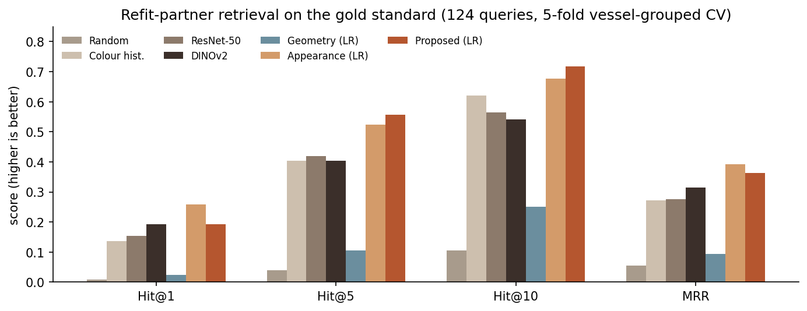
Figure 14. Retrieval metrics of the main methods.
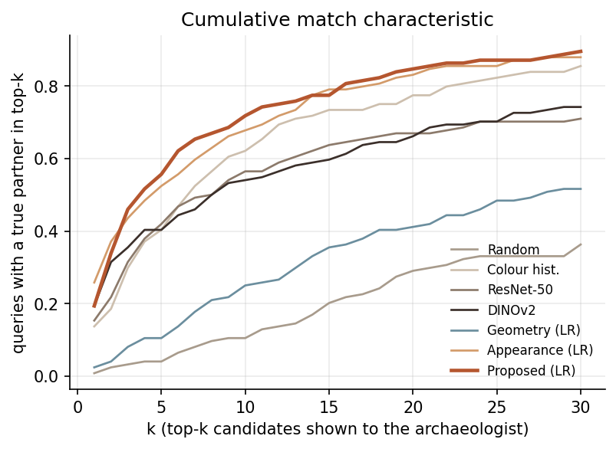
Figure 15. Cumulative match characteristic: share of queries with a true partner within the top k.
Reading the results. Every learned or pre-trained cue is far above random (Hit@10 0.105). Among single cues, the simple colour histogram is as good as deep embeddings (Hit@10 0.621 vs 0.540 for DINOv2). Sherds of one vessel share their firing colour, while the deep models also respond to shape and texture that differ between neighbouring sherds. DINOv2 is the best single cue at the very top (Hit@1 0.194). Geometry alone is weak (Hit@10 0.250): with eroded edges, many wrong pairs find an equally good-looking fit. Learning to combine appearance cues lifts Hit@5 from 0.403 to 0.524 and gives the best Hit@1 and MRR. Adding geometry gives the best Hit@5 (0.556), Hit@10 (0.718) and median rank (4), but lowers Hit@1 from 0.258 to 0.194.

12.2 Statistical significance
Table 19. Paired bootstrap differences in percentage points with 95% confidence intervals. An interval that excludes 0 is significant.
Difference | Hit@1 | Hit@5 | Hit@10 | MRR
Proposed − DINOv2 (image-only) | +0.0 pts  [-8.1 to +7.3] | +15.3 pts  [+5.6 to +25.0] | +17.7 pts  [+9.7 to +26.6] | +5.0 pts  [-0.9 to +11.3]
Proposed − Appearance LR | -6.5 pts  [-12.1 to -1.6] | +3.2 pts  [-2.4 to +9.7] | +4.0 pts  [-2.4 to +10.5] | -2.8 pts  [-6.7 to +0.9]
Appearance LR − DINOv2 | +6.5 pts  [-2.4 to +14.5] | +12.1 pts  [+2.4 to +21.8] | +13.7 pts  [+4.8 to +22.6] | +7.8 pts  [+1.3 to +14.8]

The improvement over the image-only baseline at Hit@5 and Hit@10 is significant. The improvement from adding geometry on top of learned appearance is not significant at Hit@5/10, and the drop at Hit@1 is.
Table 20. Results per cross-validation fold.
Fold | Queries | Vessels | DINOv2  Hit@5 | DINOv2  Hit@10 | Appearance (LR)  Hit@5 | Appearance (LR)  Hit@10 | Proposed (LR)  Hit@5 | Proposed (LR)  Hit@10
1 | 29 | 7 | 0.517 | 0.655 | 0.586 | 0.793 | 0.621 | 0.724
2 | 25 | 7 | 0.240 | 0.440 | 0.480 | 0.600 | 0.600 | 0.720
3 | 29 | 7 | 0.448 | 0.483 | 0.448 | 0.586 | 0.379 | 0.724
4 | 15 | 6 | 0.333 | 0.533 | 0.267 | 0.533 | 0.267 | 0.467
5 | 26 | 6 | 0.423 | 0.577 | 0.731 | 0.808 | 0.808 | 0.846
Std. dev. |  |  | 0.108 | 0.083 | 0.172 | 0.127 | 0.213 | 0.139

The per-fold view shows how much results depend on which vessels are held out. The proposed model beats the image-only baseline at Hit@10 in 4 of 5 folds and at Hit@5 in 3 of 5. Fold-to-fold spread of about ±14 points is comparable to the differences between methods. This is one more reason to rely on the pooled bootstrap intervals rather than on any single split, and it shows that a larger test set is needed before smaller effects can be resolved.

12.3 Pair classification and confusion matrix
Table 21. Pair classification on held-out pairs (1,542 pairs, 111 joins; chance PR-AUC = 0.072).
Model | Precision | Recall | F1 | ROC-AUC | PR-AUC | Accuracy | TP/FP/FN/TN
Geometry features (LR) | 0.139 | 0.081 | 0.102 | 0.592 | 0.108 | 0.897 | 9/56/102/1375
Appearance features (LR) | 0.411 | 0.207 | 0.275 | 0.827 | 0.252 | 0.921 | 23/33/88/1398
Proposed: appearance + geometry (LR) | 0.371 | 0.234 | 0.287 | 0.825 | 0.247 | 0.916 | 26/44/85/1387
Appearance + geometry (Random Forest) | 0.294 | 0.288 | 0.291 | 0.794 | 0.237 | 0.899 | 32/77/79/1354
Appearance + geometry (SVM-RBF) | 0.250 | 0.207 | 0.227 | 0.786 | 0.228 | 0.898 | 23/69/88/1362

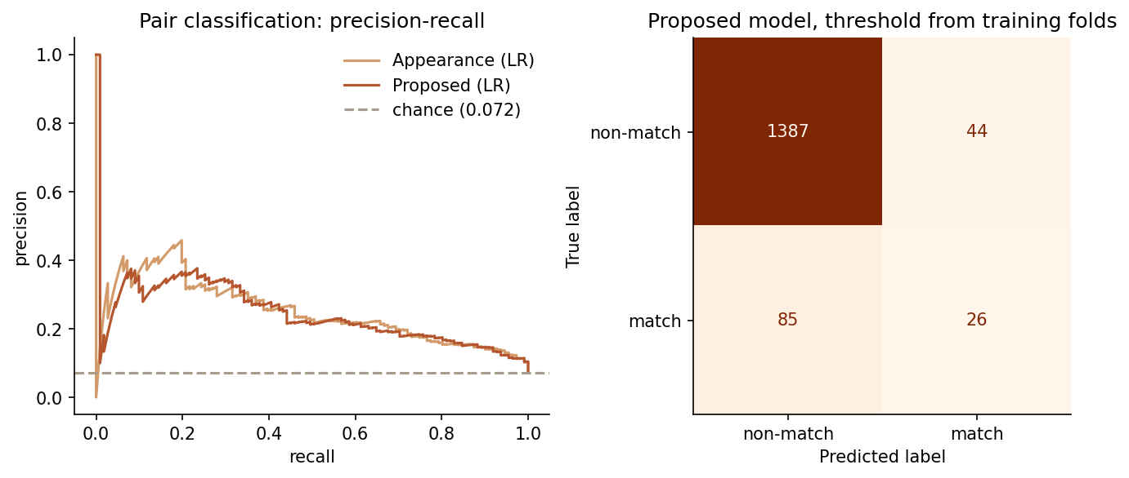
Figure 16. Precision-recall curves and the confusion matrix of the proposed model at the threshold chosen on training folds.
At its operating point the proposed model flags 70 pairs as joins, of which 26 are correct (precision 0.371), and finds 26 of the 111 joins (recall 0.234). Accuracy is 91.6%, but it is almost meaningless here: the trivial all-'no join' classifier reaches 92.8% on these test pairs. PR-AUC is 0.247, 3.4× the chance level. ROC-AUC is high (0.825) because the model easily rejects obviously different sherds. The hard part is the small set of look-alike non-joins, which the PR curve exposes and the ROC curve hides. As a stand-alone verdict ('these two join') the model is not reliable. As a ranker that shortens the list it is useful, which matches its intended use.

12.4 E3: ablation and model weights
Table 22. Ablation: each row removes one group of features from the proposed model.
Variant | Hit@1 | Hit@5 | Hit@10 | MRR | Pair F1
Full proposed model | 0.194 | 0.556 | 0.718 | 0.364 | 0.287
without orientation cue | 0.218 | 0.589 | 0.718 | 0.379 | 0.324
without overlap check | 0.185 | 0.556 | 0.702 | 0.357 | 0.293
without edge contact | 0.202 | 0.589 | 0.742 | 0.365 | 0.303
without deep embeddings | 0.121 | 0.427 | 0.645 | 0.271 | 0.246
without colour | 0.161 | 0.435 | 0.556 | 0.293 | 0.273

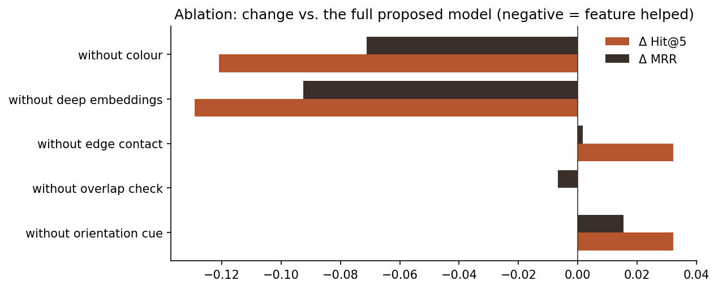
Figure 17. Change in Hit@5 and MRR when a cue is removed. Negative bars mean the cue helped.
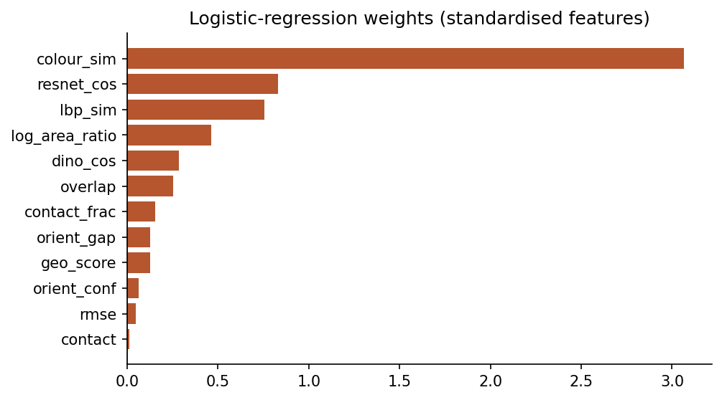
Figure 18. Standardised logistic-regression weights of the proposed model (trained on all gold pairs).
Removing colour or the deep embeddings causes the largest drops (Hit@5 to 0.435 and 0.427), confirming that appearance carries the signal. Removing the orientation cue improves every metric (Hit@5 0.589, F1 0.324), and removing the edge-contact features improves Hit@5/10. The geometric features therefore add noise more than information on these sherds. We did not switch the headline model to the best ablation: choosing a model by its test-fold performance would bias the result upward. Instead we report the pre-specified model and treat the ablation as a finding. The LR weights tell the same story: colour (+3.07) and ResNet (+0.83) dominate. Some geometric weights even have physically implausible signs: overlap is positively weighted (+0.25) and so is the orientation gap (+0.13). This is evidence that, at mostly wrong poses, these features capture incidental shape correlations rather than real fit.

12.5 E4 and E5: geometry on synthetic versus real breaks
Table 23. Pose recovery of the same geometric matcher.
Data | Pairs | Pose within 50 px | Pose within 100 px | Median rotation error
Synthetic clean breaks (sim_data_8) | 300 | 47.0% | 50.0% | 3.3°
Real eroded sherds (gold) | 111 | 17.1% | 20.7% | 69.7°

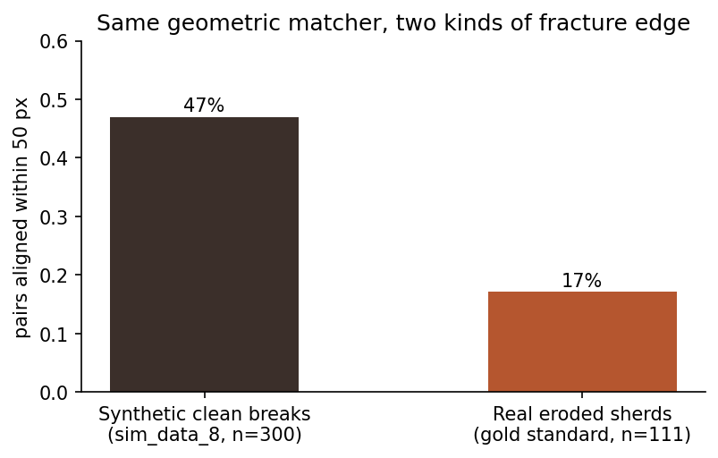
Figure 19. The geometric matcher recovers the correct joint for about half of the clean synthetic breaks but under a fifth of the real ones.
On synthetic breaks the matcher finds the exact joint for 47.0% of pairs (median rotation error 3.3°). On real sherds this falls to 17.1% (median rotation error 70°). A diagnostic on 40 real pairs showed why. At the expert pose, true partners touch along a median of 87 px of edge, whereas the best wrong pose that ICP finds touches along 129 px. On worn edges, maximising contact actively prefers wrong fits. Even on synthetic data, the geometry score separates joins from non-joins only modestly (AUC 0.590), because the negatives come from the same vessel and straight break segments fit many places.

12.6 Error analysis
- Wrong top-1 candidates are mostly other vessels. For the proposed model, 100 queries have a wrong top-1, and only 11 of those (11.0%) are sherds of the same vessel that simply do not touch the query. The main confusion is therefore between different vessels of the same ware, not between neighbours within one vessel.
- The vessel is still found. 21.9% of the top-5 candidates belong to the query's vessel, against 3.2% expected by chance, a 7× enrichment. So the model groups sherds by vessel even when it misses the exact neighbour.
- Small sherds are hardest. Hit@5 rises from 0.439 (smallest third of sherds) to 0.714 (largest third). Small sherds have less surface and shorter edges. The proposed model helps them most: DINOv2 alone reaches only 0.244 on the smallest third.
- Larger vessels are easier (Hit@5 0.625 for vessels of ≥ 5 sherds vs 0.523 for ≤ 3), because their queries have more partners to find.
- Spalled surfaces and colour variation within a vessel (one side of a pot fired darker) explain failures such as JDX-118 in Figure 20. Its partners differ in tone, and the retrieved candidates are plausible look-alikes from other vessels.
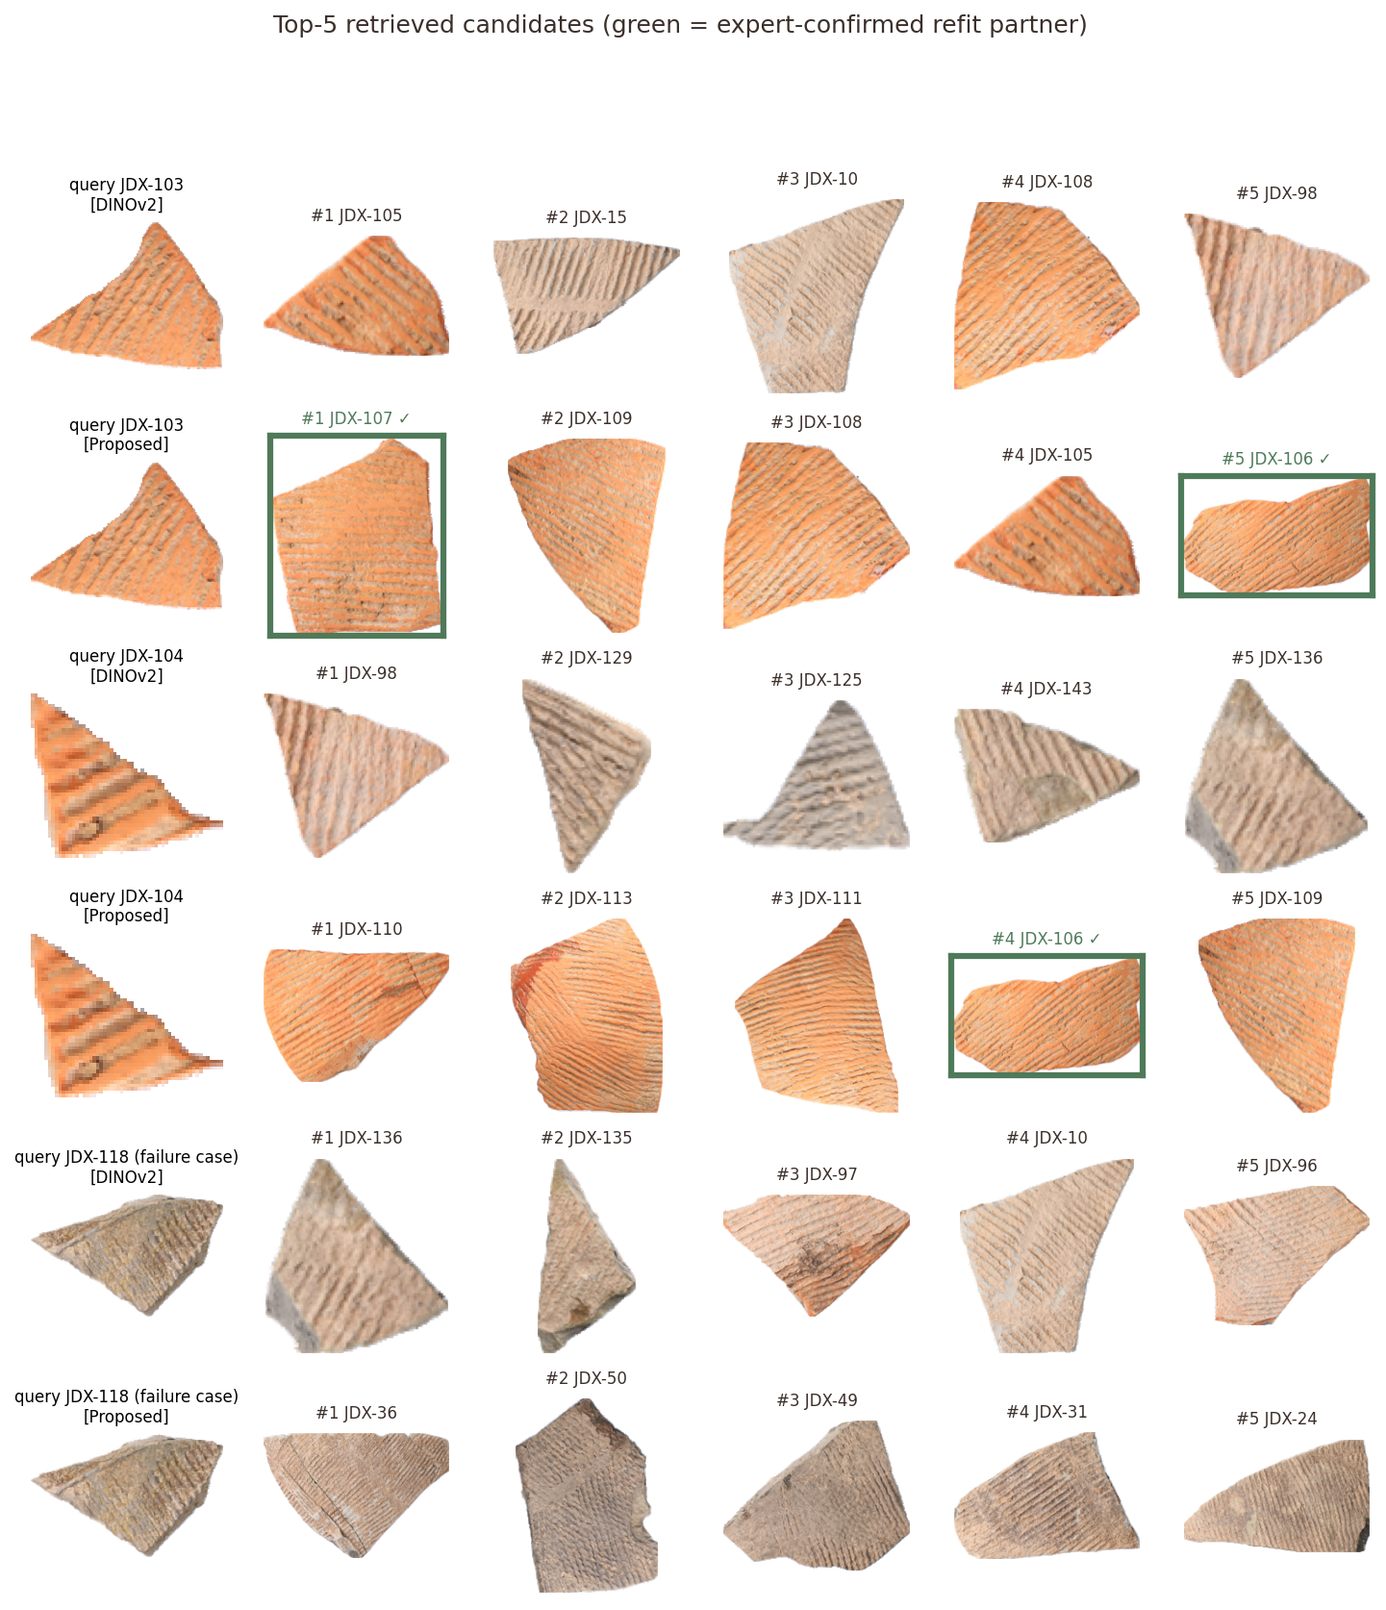
Figure 20. Top-5 candidates from the image-only baseline and the proposed model for three queries (green = expert-confirmed partner). In the first two the proposed model finds partners the baseline misses; the third is a failure case for both.

12.7 Complete results of all configurations
Table 24. All 16 configurations. 'Vessel mAP' scores retrieval of any sherd of the same vessel instead of direct neighbours only.
Configuration | Family | Hit@1 | Hit@5 | Hit@10 | MRR | mAP | Vessel mAP | Pair F1
Random ranking | baseline | 0.008 | 0.040 | 0.105 | 0.056 | 0.045 | 0.059 | –
Colour histogram (chi2) | baseline | 0.137 | 0.403 | 0.621 | 0.271 | 0.217 | 0.223 | –
LBP texture (chi2) | baseline | 0.113 | 0.274 | 0.419 | 0.210 | 0.147 | 0.174 | –
ResNet-50 embedding (cosine) | baseline | 0.153 | 0.419 | 0.565 | 0.276 | 0.206 | 0.230 | –
DINOv2 embedding (cosine) | baseline | 0.194 | 0.403 | 0.540 | 0.314 | 0.238 | 0.266 | –
Geometry score only (no learning) | baseline | 0.016 | 0.137 | 0.274 | 0.096 | 0.074 | 0.085 | –
Geometry features (LR) | learned | 0.024 | 0.105 | 0.250 | 0.095 | 0.075 | 0.089 | 0.102
Appearance features (LR) | learned | 0.258 | 0.524 | 0.677 | 0.392 | 0.308 | 0.308 | 0.275
Proposed: appearance + geometry (LR) | proposed | 0.194 | 0.556 | 0.718 | 0.364 | 0.288 | 0.303 | 0.287
Appearance + geometry (Random Forest) | alternative | 0.202 | 0.484 | 0.645 | 0.340 | 0.271 | 0.288 | 0.291
Appearance + geometry (SVM-RBF) | alternative | 0.137 | 0.395 | 0.573 | 0.269 | 0.204 | 0.241 | 0.227
Ablation: proposed - orientation cue | ablation | 0.218 | 0.589 | 0.718 | 0.379 | 0.295 | 0.305 | 0.324
Ablation: proposed - overlap check | ablation | 0.185 | 0.556 | 0.702 | 0.357 | 0.289 | 0.303 | 0.293
Ablation: proposed - edge contact | ablation | 0.202 | 0.589 | 0.742 | 0.365 | 0.290 | 0.302 | 0.303
Ablation: proposed - deep embeddings | ablation | 0.121 | 0.427 | 0.645 | 0.271 | 0.216 | 0.227 | 0.246
Ablation: proposed - colour | ablation | 0.161 | 0.435 | 0.556 | 0.293 | 0.223 | 0.251 | 0.273

13. Inference and Interpretation

What the evidence supports
- A learned multi-cue ranker is a practical triage tool. Under leak-free evaluation, an expert who checks 10 suggestions finds a true partner for 71.8% of sherds, a significant improvement over the image-only plan of Review 1 (54.0%).
- Hypothesis H1 is only partly supported. The full model is significantly better than the image-only baseline, but the improvement is explained by fusing appearance cues. Adding fracture-edge geometry to learned appearance gives no significant gain at top-5/10 and a significant loss at top-1.
- The bottleneck is the edge data, not the matching algorithm. The same matcher works on half of the clean breaks and under a fifth of the real ones. On eroded edges, a maximum-contact criterion prefers wrong fits.
- Colour is the most informative cue for this ware. It matches deep features as a single cue and has the largest model weight. Vessels were fired unevenly, so colour identifies the vessel better than shape does.

What the model learned and failed to learn
The model learned to group sherds by vessel: its top 5 is 7× enriched in same-vessel sherds. It did not learn to identify the adjacent sherd within a vessel, which is what geometry was meant to add. The physically implausible signs of some geometric weights (positive weight on overlap) show that the geometric features, measured at mostly wrong poses, do not carry the meaning they were designed for.

Were the objectives achieved?
Objectives O1–O7 were all met: the data are understood and documented, the pipeline runs end to end, the baseline and the proposed model were evaluated rigorously, alternatives were compared, and a working prototype exists. The research hypothesis received a clear, evidence-based answer, which is partly negative. We regard that as a valid outcome of the case study, not a failure of it.

Claims we do not make
- We do not claim the system reconstructs vessels. It ranks candidates and previews one rigid fit per pair.
- We do not claim that geometry is useless for sherd joining. Our 2-D outline-based geometry is not robust to erosion; 3-D or thickness-profile geometry was not tested.
- Results are for one site and ware. Other assemblages may favour different cues.

14. Limitations and Future Scope

Technical limitations
- 2-D outlines lose the third dimension: sherd thickness and wall curvature, which experts use first, are invisible.
- Maximum-contact pose selection is fragile on worn edges (Section 12.5). Only the outer contour is used, so a joining edge hidden by perspective is missed.
- The cord-mark orientation estimate is a single global direction. Sherds whose stripes curve or cross are poorly described.
- Pre-trained embeddings were not fine-tuned on pottery.
- Raw-photo segmentation sometimes includes cast shadows.

Data-related limitations
- 111 positive pairs is small: confidence intervals are wide (±5–10 points), and ablation differences of a few points are not significant.
- Only exterior views were used; the gold set also contains interior views.
- Unlisted pairs are assumed not to join; a few may be undiscovered joins.
- One site, one period, one dominant ware.

Future scope
Table 25. Realistic next steps.
Improvement | Expected benefit | Effort
Run E6: zero-shot transfer to 799 raw field photos (script and photos ready) | Tests the conclusions outside the curated benchmark | Low
Use the interior view as a second appearance cue | Independent evidence of the same vessel | Low
Edge-band appearance: compare colour/texture in a thin strip along the aligned joint | Checks continuity across the break, robust to erosion | Medium
Erosion-robust pose scoring learned from the gold poses (positive = expert pose, negative = ICP false fits) | Fixes the contact-maximisation failure | Medium
Fine-tune DINOv2 with a contrastive loss on same-vessel pairs (Yu et al. 2026 style) | Better vessel grouping | Medium
Context priors from metadata (layer distance, sherd part) | Down-weights implausible candidates | Low
Pre-train geometry on all 50,736 simulated pairs, adapt with augmentation that simulates erosion | Bridges the synthetic-real gap | High
Multi-piece assembly: chain pairwise fits into a vessel graph with global consistency | Toward full digital reconstruction | High
3-D scans or thickness profiles | Restores the strongest physical cue | High (needs new data)

15. Conclusion
This case study turned the archaeological task of finding joining pottery sherds into a pattern-recognition problem, a pairwise join/no-join decision used to rank candidates, and evaluated it on real expert-confirmed joins from the Daxinzhuang-18K benchmark. We built a complete pipeline: segmentation and illumination normalisation; colour, texture and deep appearance features; a fracture-edge matcher based on complementary curvature, Kabsch/ICP alignment and overlap checks; a logistic-regression fusion model; and an interactive demo.
Under leak-free vessel-grouped cross-validation, the system puts a true partner in the top 10 for 71.8% of sherds, significantly above the image-only baseline planned in Review 1 (54.0%). The most important finding is less flattering and more useful: the gain comes from combining appearance cues, while 2-D fracture-edge geometry adds no significant benefit on real eroded sherds, even though the same matcher works on clean synthetic breaks. In practice, an appearance ranker can already save experts time today, whereas geometry needs erosion-robust descriptors before it can help.
Key learning: in pattern recognition, the evaluation protocol decides what a number means. Splitting by vessel, using ranking metrics instead of accuracy on a 1.5%-positive problem, bootstrapping the differences, and checking the method on synthetic data turned an apparently positive result into a precise statement of what works and why.

16. References
[1] Ji, D., Xue, T., Wang, Q., Ma, W., Lang, J., Fang, H., Tu, C., & Lu, L. (2026). Daxinzhuang-18K: A large-scale 2D benchmark for pottery sherd retrieval and reassembly (Version 1.0.0) [Data set]. Zenodo. https://doi.org/10.5281/zenodo.21553799
[2] Freeman, H., & Garder, L. (1964). Apictorial jigsaw puzzles: The computer solution of a problem in pattern recognition. IEEE Transactions on Electronic Computers, EC-13(2), 118–127. https://doi.org/10.1109/PGEC.1964.263781
[3] Wolfson, H. J. (1990). On curve matching. IEEE Transactions on Pattern Analysis and Machine Intelligence, 12(5), 483–489. https://doi.org/10.1109/34.55108
[4] Papaioannou, G., Karabassi, E.-A., & Theoharis, T. (2002). Reconstruction of three-dimensional objects through matching of their parts. IEEE TPAMI, 24(1), 114–124. https://doi.org/10.1109/34.982888
[5] Huang, Q.-X., Flöry, S., Gelfand, N., Hofer, M., & Pottmann, H. (2006). Reassembling fractured objects by geometric matching. ACM Transactions on Graphics (SIGGRAPH), 25(3), 569–578. https://doi.org/10.1145/1179352.1141925
[6] Kampel, M., & Sablatnig, R. (2003). Profile-based pottery reconstruction. In Proc. CVPR Workshop on Applications of Computer Vision in Archaeology. https://doi.org/10.1109/CVPRW.2003.10007
[7] Chetouani, A., Treuillet, S., Exbrayat, M., & Jesset, S. (2020). Classification of engraved pottery sherds mixing deep-learning features by compact bilinear pooling. Pattern Recognition Letters, 131, 1–7. https://doi.org/10.1016/j.patrec.2019.12.009
[8] Pinho, M., Mota, G., & da Costa, G. (2025). A deep learning approach to assist in pottery reconstruction from its sherds. Heritage, 8(5), 167. https://doi.org/10.3390/heritage8050167
[9] Yu, X., Li, T., Song, Z., Lu, H., Du, Y., Wu, F., Xiao, H., & Xu, L. (2026). Mitigating spurious features by contrastive learning in pottery sherd recognition. npj Heritage Science, 14, 135. https://doi.org/10.1038/s40494-025-02170-3
[10] He, K., Zhang, X., Ren, S., & Sun, J. (2016). Deep residual learning for image recognition. In Proc. IEEE CVPR (pp. 770–778). https://doi.org/10.1109/CVPR.2016.90
[11] Oquab, M., Darcet, T., Moutakanni, T., et al. (2024). DINOv2: Learning robust visual features without supervision. Transactions on Machine Learning Research. arXiv:2304.07193
[12] Ojala, T., Pietikäinen, M., & Mäenpää, T. (2002). Multiresolution gray-scale and rotation invariant texture classification with local binary patterns. IEEE TPAMI, 24(7), 971–987. https://doi.org/10.1109/TPAMI.2002.1017623
[13] Kabsch, W. (1976). A solution for the best rotation to relate two sets of vectors. Acta Crystallographica Section A, 32(5), 922–923. https://doi.org/10.1107/S0567739476001873
[14] Besl, P. J., & McKay, N. D. (1992). A method for registration of 3-D shapes. IEEE TPAMI, 14(2), 239–256. https://doi.org/10.1109/34.121791
[15] Rother, C., Kolmogorov, V., & Blake, A. (2004). "GrabCut": Interactive foreground extraction using iterated graph cuts. ACM Transactions on Graphics, 23(3), 309–314. https://doi.org/10.1145/1015706.1015720
[16] Zuiderveld, K. (1994). Contrast limited adaptive histogram equalization. In P. Heckbert (Ed.), Graphics Gems IV (pp. 474–485). Academic Press.
[17] Bigün, J., & Granlund, G. H. (1987). Optimal orientation detection of linear symmetry. In Proc. 1st IEEE ICCV (pp. 433–438).
[18] Efron, B., & Tibshirani, R. J. (1993). An Introduction to the Bootstrap. Chapman & Hall.
[19] Pedregosa, F., et al. (2011). Scikit-learn: Machine learning in Python. Journal of Machine Learning Research, 12, 2825–2830.
[20] Paszke, A., et al. (2019). PyTorch: An imperative style, high-performance deep learning library. In Advances in Neural Information Processing Systems 32.
[21] Wightman, R. (2019). PyTorch Image Models (timm). GitHub repository. https://github.com/huggingface/pytorch-image-models
[22] Bradski, G. (2000). The OpenCV library. Dr. Dobb's Journal of Software Tools.
[23] Project code and results: Agrawal, V. (2026). SherdMatch: AI-based archaeological pottery fragment matching. GitHub repository. https://github.com/vansh070605/SherdMatch

Review 1 – Problem, Data, Metadata & Preprocessing
Total: 7.5 Marks. This review assesses conceptual understanding of the problem, data and proposed approach—not merely project execution.
Rubric | Maximum Marks | Marks Awarded
Problem / Case Study Understanding | 1.5
Data Understanding | 1.5
Metadata Understanding | 1.0
Preprocessing | 1.5
Scope & Impact | 1.0
Novelty / Innovation | 1.0
TOTAL | 7.5
Faculty comments / probing questions:
________________________________________________________________________________
________________________________________________________________________________
Student's response / action items:
________________________________________________________________________________
________________________________________________________________________________

Review 2 – Model Selection, Results & Inference
Total: 7.5 Marks. This review assesses the student's ability to select, justify and critically evaluate the pattern recognition model and derive meaningful conclusions. High accuracy alone is not sufficient for high marks.
Rubric | Maximum Marks | Marks Awarded
Model Selection & Understanding | 1.5
Justification for Model Selection | 2.0
Results Analysis | 1.5
Inference / Interpretation | 1.5
Limitations & Future Scope | 1.0
TOTAL | 7.5
Faculty comments / probing questions:
________________________________________________________________________________
________________________________________________________________________________
Student's response / action items:
________________________________________________________________________________
________________________________________________________________________________

Performance-Level Reference
Level | Marks Range (out of 7.5) | Faculty Interpretation
Excellent | >7.0–7.5 | Strong conceptual understanding; convincing justification; critical analysis; meaningful inferences; confident answers.
Good | 5.5–7.0 | Good understanding with minor gaps; generally reasonable justification, analysis and interpretation.
Satisfactory | 3.5–5.4 | Basic understanding; explanations are mostly descriptive and lack deeper reasoning.
Needs Improvement | 0–3.4 | Limited understanding; memorised answers; weak justification or interpretation; heavy dependence on team members.

Final Marks and Sign-off
Review 1 Marks (out of 7.5) | __________
Review 2 Marks (out of 7.5) | __________
Total (out of 15) | __________
Faculty Signature | ____________________________________________
Student Signature | ____________________________________________

Submission Checklist
☐ Problem statement and objectives are clearly stated.
☐ Dataset source, size, features and classes are documented.
☐ Metadata and preprocessing choices are explained and justified.
☐ Scope, impact, limitations and novelty are discussed.
☐ Model working principle and selection rationale are explained.
☐ Evaluation strategy, metrics, graphs and confusion matrix (if applicable) are included.
☐ Results are critically analysed and evidence-based inferences are provided.
☐ References are included and the student can explain their individual contribution.
Faculty evaluation should assess individual understanding, reasoning and interpretation. Technical execution or high accuracy alone should not determine the marks.

