Birla Vishvakarma Mahavidyalaya

Name : | Maitri Shaileshkumar Patel
ID number : | 25CP432
Subject : | Computer Workshop – II (103 SB)

PRACTICAL – 6

- Problem Statement:

Create a webpage named library.html that stimulates a library management system interface. The page must be styled using all three CSS methods (inline, internal, and external) and should include:
- A header section with a title.
- A table displaying book details.
- A list presenting library rules.
Solution should demonstrate the use of basic CSS selectors (Class and ID) and properties for setting fonts, background colors, borders, padding, margins, and styles for lists and tables.

- Output:

Screen 1 -
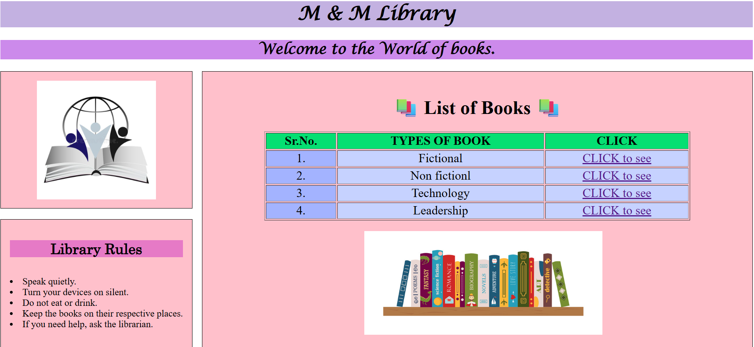

Screen 2 -
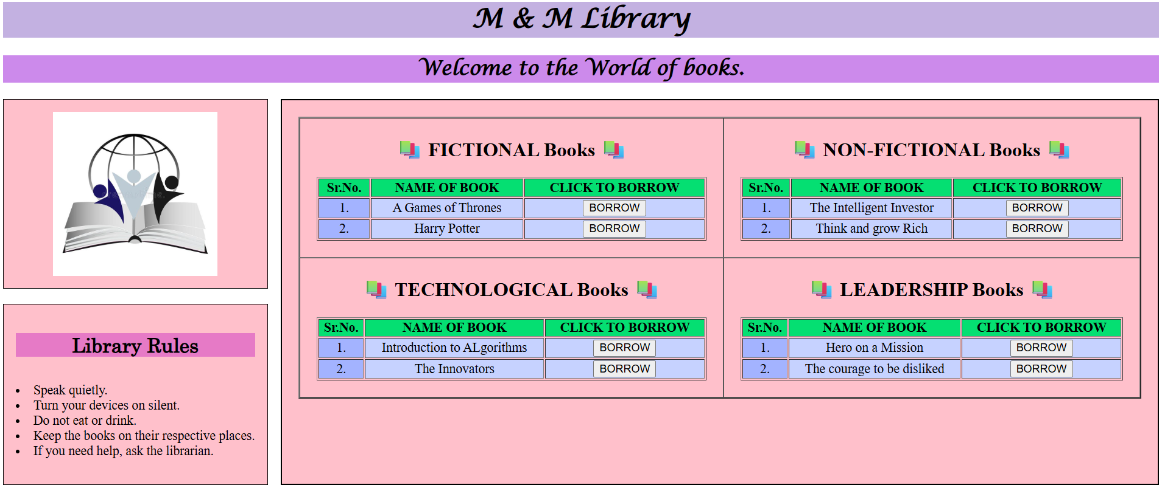

- Code for OUTPUT SCREEN 1:

<DOCTYPE! html>
<html>
<head>
<title>Library system</title>
<meta charset="UTF-8">
<meta name="viewpoint" content="width=device-width,initial-scale=1.0">
</head>
<body>
<h1 style="background-color:rgb(195,177,225); text-align:center;font-family:Lucida Calligraphy;">M & M Library</h1>
<h2 style="background-color:rgb(204, 138, 235); text-align:center;font-family:Lucida Calligraphy;">Welcome to the World of books.</h2>

<main style="display:flex";gap:15px;padding:15px;" >
<div align="center">
<aside style="background-color:pink;padding:15px;border:1px solid;">
<img src="logo.jpg" width="200" height="200" align="center">
</aside>
<br>

<aside style="background-color:pink;padding:15px;border:1px solid;" align="left">
<h2 style="background-color:rgb(230, 122, 198); text-align:center;font-family:Century;">Library Rules</h2>
<p style="font-size:200%;">
<li>Speak quietly.</li>
<li>Turn your devices on silent.</li>
<li>Do not eat or drink.</li>
<li>Keep the books on their respective places.</li>
<li>If you need help, ask the librarian.</l>
</p>
</aside>
</div>
&nbsp;&nbsp;&nbsp;&nbsp;
<artcile style="flex:1;background-color:pink;padding:15px;border:1px solid">

<div class="books" align="center">
<h1 align="center">&#128218 List of Books &#128218</h1>
<table border="1" padding="2" width="80%" align="center" style="font-size:130%;">
<th style="background-color:#05DF72;">Sr.No.</th>
<th style="background-color:#05DF72;">TYPES OF BOOK</th>
<th style="background-color:#05DF72;"> CLICK </th>

<tr align="center" style="background-color:#8EC5FF;">
<td style="background-color:#A3B3FF;">1.</td>
<td style="background-color:#C6D2FF;">Fictional</td>
<td style="background-color:#C6D2FF;"><a href="part1(6).html">CLICK to see</a></td>
</tr>

<tr align="center">
<td style="background-color:#A3B3FF;">2.</td>
<td style="background-color:#C6D2FF;">Non fictionl</td>
<td style="background-color:#C6D2FF;"><a href="part1(6).html">CLICK to see</a></td>
</tr>
<tr align="center">
<td style="background-color:#A3B3FF;">3.</td>
<td style="background-color:#C6D2FF;">Technology</td>
<td style="background-color:#C6D2FF;"><a href="part1(6).html">CLICK to see</a></td>
</tr>
<tr align="center">
<td style="background-color:#A3B3FF;">4.</td>
<td style="background-color:#C6D2FF;">Leadership</td>
<td style="background-color:#C6D2FF;"><a href="part1(6).html">CLICK to see</a></td>
</tr>
</table>
<br>
&nbsp;&nbsp;&nbsp;&nbsp;
<img src="image3.jpg" width="400" height="175">
</div>
</article>
</body>
</html>

- Code for OUTPUT SCREEN 2:

<DOCTYPE! html>
<html>
<head>
<title>Library system 1</title>
<meta charset="UTF-8">
<meta name="viewpoint" content="width=device-width,initial-scale=1.0">
</head>
<body>
<h1 style="background-color:rgb(195,177,225); text-align:center;font-family:Lucida Calligraphy;">M & M Library</h1>
<h2 style="background-color:rgb(204, 138, 235); text-align:center;font-family:Lucida Calligraphy;">Welcome to the World of books.</h2>

<main style="display:flex";gap:15px;padding:15px;" >
<div align="center">
<aside style="background-color:pink;padding:15px;border:1px solid;">
<img src="logo.jpg" width="200" height="200" align="center">
</aside>
<br>

<aside style="background-color:pink;padding:15px;border:1px solid;" align="left">
<h2 style="background-color:rgb(230, 122, 198); text-align:center;font-family:Century;">Library Rules</h2>
<p style="font-size:200%;">
<li>Speak quietly.</li>
<li>Turn your devices on silent.</li>
<li>Do not eat or drink.</li>
<li>Keep the books on their respective places.</li>
<li>If you need help, ask the librarian.</l>
</p>
</aside>
</div>
&nbsp;&nbsp;&nbsp;&nbsp;
<article style="background-color:pink;padding:20px;border:2px solid black;flex:1;">

<table border="2" width="100%" cellspacing="0" cellpadding="20">
<tr>
<td>
<h2 align="center">&#128218 FICTIONAL Books &#128218</h2>
<table border="1" width="100%">
<tr style="background-color:#05DF72;">
<th>Sr.No.</th>
<th>NAME OF BOOK</th>
<th>CLICK TO BORROW</th>
</tr>

<tr align="center">
<td style="background-color:#A3B3FF;">1.</td>
<td style="background-color:#C6D2FF;">A Games of Thrones</td>
<td style="background-color:#C6D2FF;"><input type="submit" value="BORROW"></td>
</tr>

<tr align="center">
<td style="background-color:#A3B3FF;">2.</td>
<td style="background-color:#C6D2FF;">Harry Potter</td>
<td style="background-color:#C6D2FF;"><input type="submit" value="BORROW"></td>
</tr>
</table>
</td>

<td>
<h2 align="center">&#128218 NON-FICTIONAL Books &#128218</h2>
<table border="1" width="100%">
<tr style="background-color:#05DF72;">
<th>Sr.No.</th>
<th>NAME OF BOOK</th>
<th>CLICK TO BORROW</th>
</tr>

<tr align="center">
<td style="background-color:#A3B3FF;">1.</td>
<td style="background-color:#C6D2FF;">The Intelligent Investor</td>
<td style="background-color:#C6D2FF;"><input type="submit" value="BORROW"></td>
</tr>

<tr align="center">
<td style="background-color:#A3B3FF;">2.</td>
<td style="background-color:#C6D2FF;">Think and grow Rich</td>
<td style="background-color:#C6D2FF;"><input type="submit" value="BORROW"></td>
</tr>
</table>
</td>
</tr>

<tr>
<td>
<h2 align="center">&#128218 TECHNOLOGICAL Books &#128218</h2>
<table border="1" width="100%">
<tr style="background-color:#05DF72;">
<th>Sr.No.</th>
<th>NAME OF BOOK</th>
<th>CLICK TO BORROW</th>
</tr>

<tr align="center">
<td style="background-color:#A3B3FF;">1.</td>
<td style="background-color:#C6D2FF;">Introduction to ALgorithms</td>
<td style="background-color:#C6D2FF;"><input type="submit" value="BORROW"></td>
</tr>

<tr align="center">
<td style="background-color:#A3B3FF;">2.</td>
<td style="background-color:#C6D2FF;">The Innovators</td>
<td style="background-color:#C6D2FF;"><input type="submit" value="BORROW"></td>
</tr>
</table>
</td>

<td>
<h2 align="center">&#128218 LEADERSHIP Books &#128218</h2>
<table border="1" width="100%">
<tr style="background-color:#05DF72;">
<th>Sr.No.</th>
<th>NAME OF BOOK</th>
<th>CLICK TO BORROW</th>
</tr>

<tr align="center">
<td style="background-color:#A3B3FF;">1.</td>
<td style="background-color:#C6D2FF;">Hero on a Mission</td>
<td style="background-color:#C6D2FF;"><input type="submit" value="BORROW"></td>
</tr>

<tr align="center">
<td style="background-color:#A3B3FF;">2.</td>
<td style="background-color:#C6D2FF;">The courage to be disliked</td>
<td style="background-color:#C6D2FF;"><input type="submit" value="BORROW"></td>
</tr>
</table>
</td>
</tr>
</table>
</article>
</body>
</html>

- Various tags used in this practical with their uses :

Sr.no | HTML tags | Uses
1. | <!DOCTYPE html> | Defines that the document is a HTML5 document.
2. | <html> | It is the root element of a HTML page.
3. | <head> | Contains meta information about the HTML page.
4. | <title> | Specifies the title of the HTML page.
5. | <body> | It is a container for all the visible contents.
6. | <h1>,<h2> | For adding headings.
7. | <td> | Defines a cell in a table.
8. | <tr> | Defines a table row.
9. | <br> | Inserts a single line break
10. | <img> | For image insertion
11. | <meta charset= “UTF-8”> | Ensures proper text encoding (supports all characters)
12. | < aside> | Sidebar selection for extra information about the music player
13. | < article> | To define independent, self-contained content.
14. | < div> | Used to group and structure content
15. | <meta> | Makes the page responsive on mobile and different screen sizes
16. | <audio> | For inserting audio
17. | <table > | Inserts a table.
18. | <th> | Defines a header cell.

