

*Project Report of*

Smoke Detector

*Submitted by*

## Vansh Kalra

## 2017576

*in the partial fulfillment of the*

*requirements for the award of*

*the degree of*

**B. Tech (CST)**

# Semester IV

2021-22

**Department of Computer Science & Engineering**

**GRAPHIC ERA DEEMED TO BE UNIVERSITY, DEHRADUN**

# CERTIFICATE

**University Roll No**: 2017576 **Class Roll No**: 25

This is to certify that Project Report entitled “ ***Smoke Detector***'' which is submitted by **Vansh Kalra** in partial fulfillment of these requirements at the **4th Semester of B. Tech (CST)** Degree Course prescribed by the Graphic Era University during the year **2021-22** is a record of the candidate’s own work carried out by him under my/our supervision.

#### Date:

**Faculty Signature**

#### Dr. Upma Jain

Assistant Professor

C.S.E Department



**TABLE OF CONTENTS**

1. INTRODUCTION
2. TOOLS USED
3. WORKING PRINCIPLE
4. CODE
5. CIRCUIT DIAGRAM
6. REFERENCES ***A picture containing text, electronics

   Description automatically generated***

# INTRODUCTION

**A smoke detector is an electronic fire-protection device that automatically senses the presence of smoke, as a key indication of fire, and sounds a warning to building occupants.**

Commercial and industrial smoke detectors issue a signal to a fire alarm control panel as part of a building’s central fire alarm system. By law all workplaces must have a smoke detection system.

Household smoke detectors, or smoke alarms, issue an audible and/or visual alarm locally from the detector itself. They can be battery-powered single units or several interlinked hardwired (mains-powered) devices backed up by batteries. The latter must be installed in all new buildings and after major refurbishments.

In this project, we have designed **Arduino Smoke Level Detector using MQ-2 Sensor** for measuring the **level of smoke** in the environment. Simply we have interfaced MQ-2 Gas Sensor module with Arduino. The **Smoke sensor** we used is the **MQ-2 sensor**. Smoke Detectors are very useful in detecting smoke or fire in buildings, and so are the important safety parameters.

**Smoke Detector Circuit** which not only senses the smoke in the air but also reads and displays the **level of Smoke** in the Air. This circuit triggers the Buzzer when Smoke level becomes higher than the desirable limit, this threshold value can be changed in the Code according to the requirement. Instead of MQ-2, you can use **MQ-135, MQ3, MQ5 module** as well. Basically they all have similar functions.

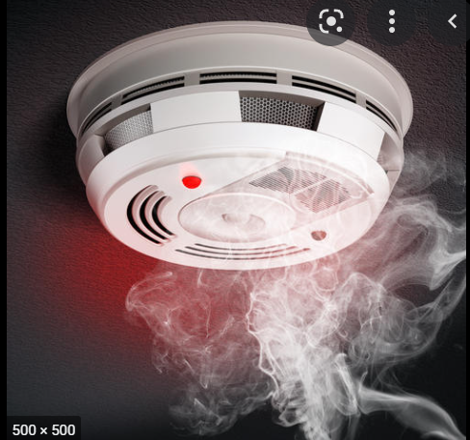

TOOLS USED

1) ARDUINO UNO

[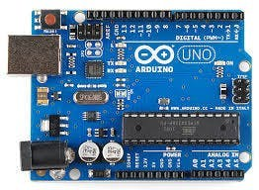](javascript:openLightBox('8110626546',%200);)

Arduino is an open-source electronics platform based on easy-to-use hardware and software. Arduino boards are able to read inputs - light on a sensor, a finger on a button, or a Twitter message - and turn it into an output - activating a motor, turning on an LED, publishing something online. You can tell your board what to do by sending a set of instructions to the microcontroller on the board. To do so you use the Arduino programming language and the Arduino Software.

2) MQ Gas Sensor

[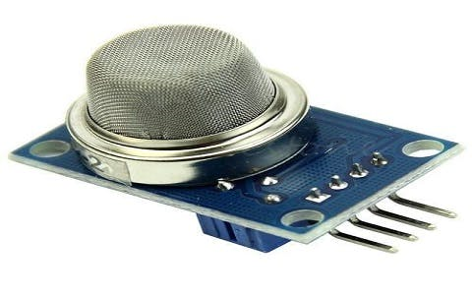](javascript:openLightBox('80f004dd99',%200);)

Sensors are the electronic devices used for interaction with the outer environment. There are various types of sensors available that can detect light, noise, smoke, proximity etc… With the advent in technology, these are available as both analog and digital forms. Besides forming a communication with the outer environment, sensors are also a crucial part of safety systems. Fire sensors are used to detect the fire and take appropriate precautions on time. For smooth functioning of control systems and sensitive electronics, humidity sensors are used for maintaining humidity in the unit. One of such sensor used in safety systems to detect harmful gases is MQ2 Gas sensor.

MQ2 gas sensor is an electronic sensor used for sensing the concentration of gases in the air such as LPG, propane, methane, hydrogen, alcohol, smoke and carbon monoxide.

MQ2 gas sensor is also known as chemiresistor. It contains a sensing material whose resistance changes when it comes in contact with the gas. This change in the value of resistance is used for the detection of gas.

MQ2 is a metal oxide semiconductor type gas sensor. Concentrations of gas in the gas is measured using a voltage divider network present in the sensor. This sensor works on 5V DC voltage. It can detect gases in the concentration of range 200 to 10000ppm.

3) BUZZER

](javascript:openLightBox('475e254833',%200);)

A piezo buzzer is a type of electronic device that’s used to produce a tone, alarm or sound. It’s lightweight with a simple construction, and it’s typically a low-cost product. Yet at the same time, depending on the piezo ceramic buzzer specifications, it’s also reliable and can be constructed in a wide range of sizes that work across varying frequencies to produce different sound outputs.

4) LED’s

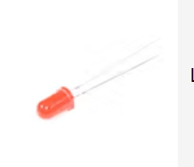

A Light-emitting diode that emits light

5) JUMPER WIRES

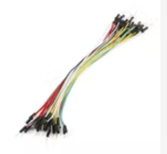

For connecting the elements of the circuit.

5) RESISTORS- To resist the current.

6) ARDUINO IDE

Arduino IDE(Integrated Development Environment) is the software for Arduino. It is a text editor like a notepad with different features. It is used for writing code, compiling the code to check if any errors are there and uploading the code to the Arduino. It is a cross-platform software which is available for every Operating System like Windows, Linux, macOS.

**WORKING PRINCIPLE**

The voltage that the sensor outputs changes accordingly to the smoke/gas level that exists in the atmosphere. The sensor outputs a voltage that is proportional to the concentration of smoke/gas.

In other words, the relationship between voltage and gas concentration is the following:

* The greater the gas concentration, the greater the output voltage.
* The lower the gas concentration, the lower the output voltage.

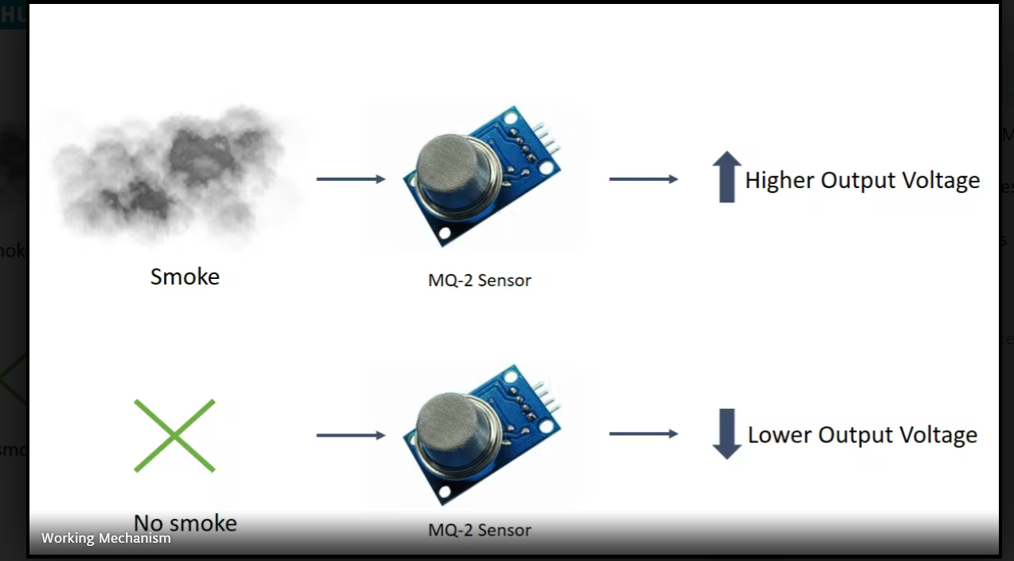

**CODE**

int redLed = 12;

int greenLed = 11;

int buzzer = 10;

int smokeA0 = A5;

// Your threshold value

int sensorThres = 400;

void setup() {

pinMode(redLed, OUTPUT);

pinMode(greenLed, OUTPUT);

pinMode(buzzer, OUTPUT);

pinMode(smokeA0, INPUT);

Serial.begin(9600);

}

void loop() {

int analogSensor = analogRead(smokeA0);

Serial.print("Pin A0: ");

Serial.println(analogSensor);

// Checks if it has reached the threshold value

if (analogSensor > sensorThres)

{

digitalWrite(redLed, HIGH);

digitalWrite(greenLed, LOW);

tone(buzzer, 1000, 200);

}

else

{

digitalWrite(redLed, LOW);

digitalWrite(greenLed, HIGH);

noTone(buzzer);

}

delay(100);

}

**CIRCUIT DIAGRAM**

**REFERENCES**

**-** [**https://en.wikipedia.org/wiki/Smoke_detector**](https://en.wikipedia.org/wiki/Smoke_detector)

**-** [**https://create.arduino.cc/projecthub/mayank-mohan/smoke-level-detector-with-alarm-c8de7e**](https://create.arduino.cc/projecthub/mayank-mohan/smoke-level-detector-with-alarm-c8de7e)

**-** [**https://create.arduino.cc/projecthub/biharilifehacker/how-to-make-smoke-detector-alarm-1c322b**](https://create.arduino.cc/projecthub/biharilifehacker/how-to-make-smoke-detector-alarm-1c322b)

**-** [**https://create.arduino.cc/projecthub/Aritro/smoke-detection-using-mq-2-gas-sensor-79c54a**](https://create.arduino.cc/projecthub/Aritro/smoke-detection-using-mq-2-gas-sensor-79c54a)

**-** [**https://www.geeksforgeeks.org/how-to-make-smoke-detection-alarm-using-arduino/**](https://www.geeksforgeeks.org/how-to-make-smoke-detection-alarm-using-arduino/)

**-** [**https://www.youtube.com/watch?v=jbUgHKAMcvo&t=1s**](https://www.youtube.com/watch?v=jbUgHKAMcvo&t=1s)