TECHNICAL PROJECT REPORT

# Title of Invention / Project : **MOTION DECTECTOR ALARM BUZZER**

# **Team Members / Inventors :**

|  |  |  |  |  |  |
| --- | --- | --- | --- | --- | --- |
| **S. No.** | **Name** | **Department** | **Designation** | **Mobile** | **E-Mail** |
| 1. | Dikshit Kapoor | CSE IBM | Student | 6283165107 | Dikshitkkapoor19@gmail.com |
| 2. | Vanshaj Tyagi | CSE IBM | Student | 9870370379 | Vanshaj.tyagi234@gmail.com |
| 3. | Khushal Thakur | ECE | Mentor | 9646030764 | khushal.thakur@cumail.in |
| 4. | Anshul Sharma | ECE | Mentor | 9478697475 | anshulsharma.ece@cumail.in |
| 5. | Kiran Jot Singh | ECE | Mentor | 9463909689 | kiranjotsingh.ece@cumal.in |
| 6. | Divneet Singh  Kapoor | ECE | Mentor | 9878422653 | divneet.ece@cumail.in |

Section – 1 (IPR Related)

Brief Abstract (500 words):

**PROBLEM YOUR PROJECT IS SOLVING**:

A motion detector alarm system including a movement detecting and signal transmitting member for mounting on or proximate to the object whose movement is to be detected, a signal receiving and alarm generating member for receiving a signal from the movement detecting and signal transmitting member and producing a security response, in other words we can say that Motion detector buzzer is used for detecting motion of a person . It can also be used for the protection of antique things. For example it can be used for protecting Chandigarh University model so that if a person tries to touch it this buzzer beeps and light gets on , which creates a security response and the authorization can look into the matter.

**HOW ARE YOU SOLVING THIS PROBLEM?**

1. For the detection of motion we are using PIRsensor (SR-501).
2. For the security response there is an alarm buzzer .
3. For the successful detection a LED is used.
4. 9V Battery will be good in this project.

**ADDITIONAL MODIFICATIONS THAT CAN CATER TO IMPROVED SOLUTION:**

1. For any modification of this project Arduino Uno can be used for exact distance measurement and delay time can be control through it.
2. Further GSM module can be used for the quick response on person’s mobile phone that a motion is detected at the place.
3. Suppose an alarm gets on , to switch the alarm off we can use RFID method.

# **Existing state-of-the-art and Drawbacks in existing state-of-the-art**

(*Brief background of the existing knowledge*)

|  |  |  |
| --- | --- | --- |
| **S. No.** | **Existing state of art** | **Drawbacks in existing state of art** |
| 1 | Patent no: US8217790B2 | The already existing product is too expensive and is not compatible in every situation. Doesn’t come in different sizes |

# **Novel/Additional modifications that you can propose to improve upon**

# drawbacks

*(List down the features)*

* It can detect human activity within a range of 2-3 meters from the sensor bulb
* It runs on a battery

# Advantages

(*List down the advantages, if each feature is incorporated)*

* It is in small in size.
* It don’t runs on electricity.
* It is user friendly.

# **Block Diagram**

(*Functional diagram depicting the flow of information in your system. Do not define exact components, only use generic terms. Must include modifications as well.)*

BATTERY

LED

PIEZO BUZZER

PIR SENSOR

Section – 2 (Real Project)

# Materials

(*List down the Components, Equipment, etc. actually used in the project*)

Quantity

* Battery 9V …………………………………………………………………… X 1
* LED: RED …………………………………………………………………… X 1
* Voltage Regulator / Transistor BC547 …………………………………. .X 1
* Resistor-1K ohm …………………………………………………………... X 1
* Switch ……………………………………………………………………….. X 1
* PIR Sensor SR501………………………………………………………….. X 1
* Wires ………………………………………………………………………. X 5
* Piezo Buzzer ……………………………………………………………….. X 1
* 7X9cm PCB Prototype solder-able bread……………………………….X 1

# Circuit Diagram :

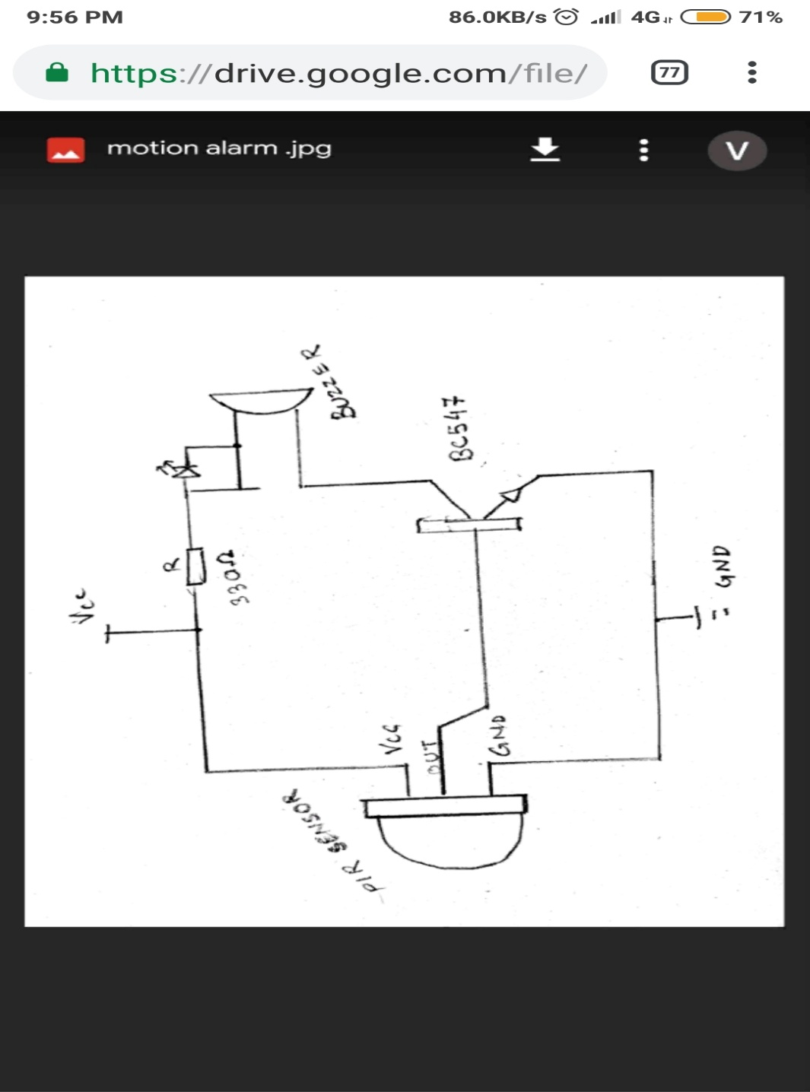

# **Steps of Circuit Completion** :

1. Solve the circuit on PCB Prototype solder-able breadboard

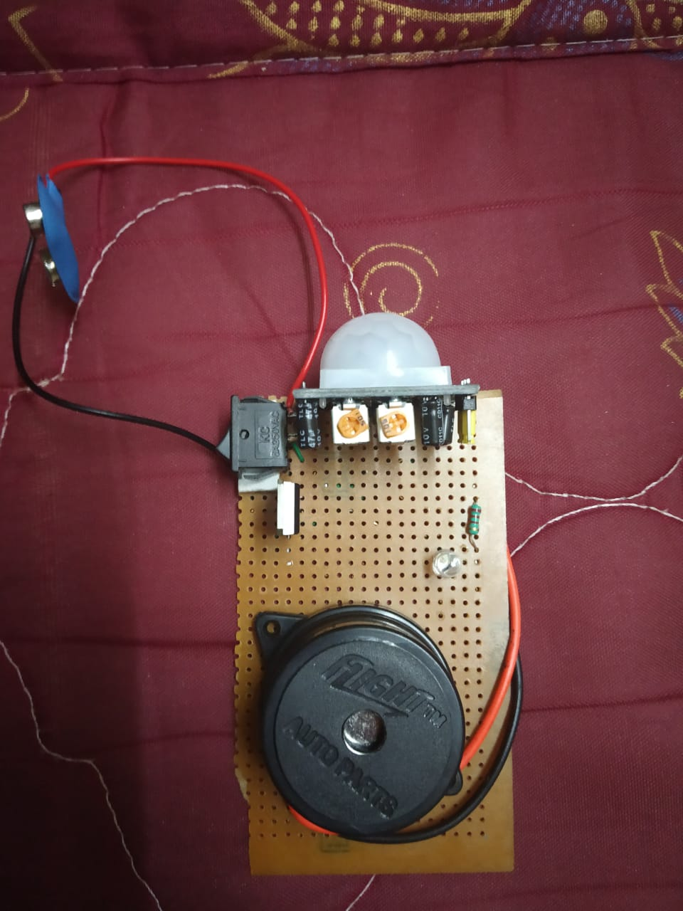

2. Now with the help of solder machine solder the connection at the back side of bread board

(make sure the connection is perfectly fine)

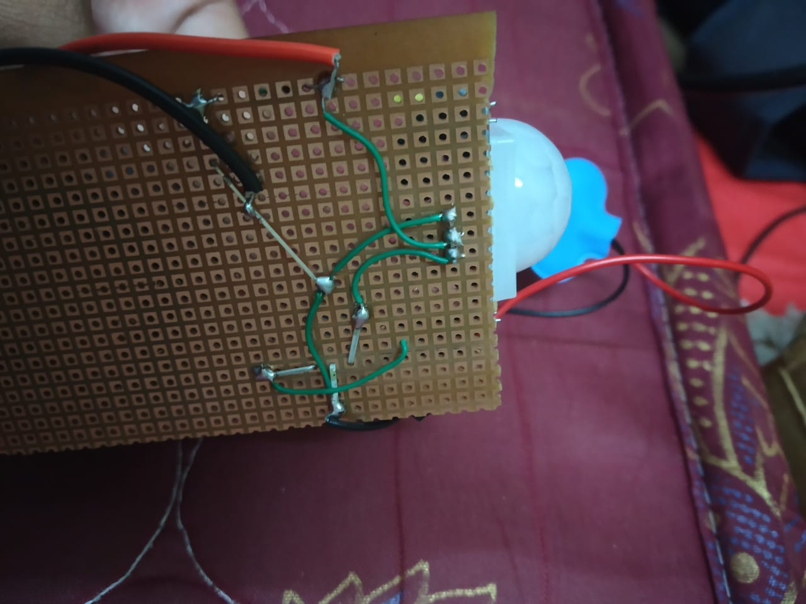

3. Add battery to the circuit now .

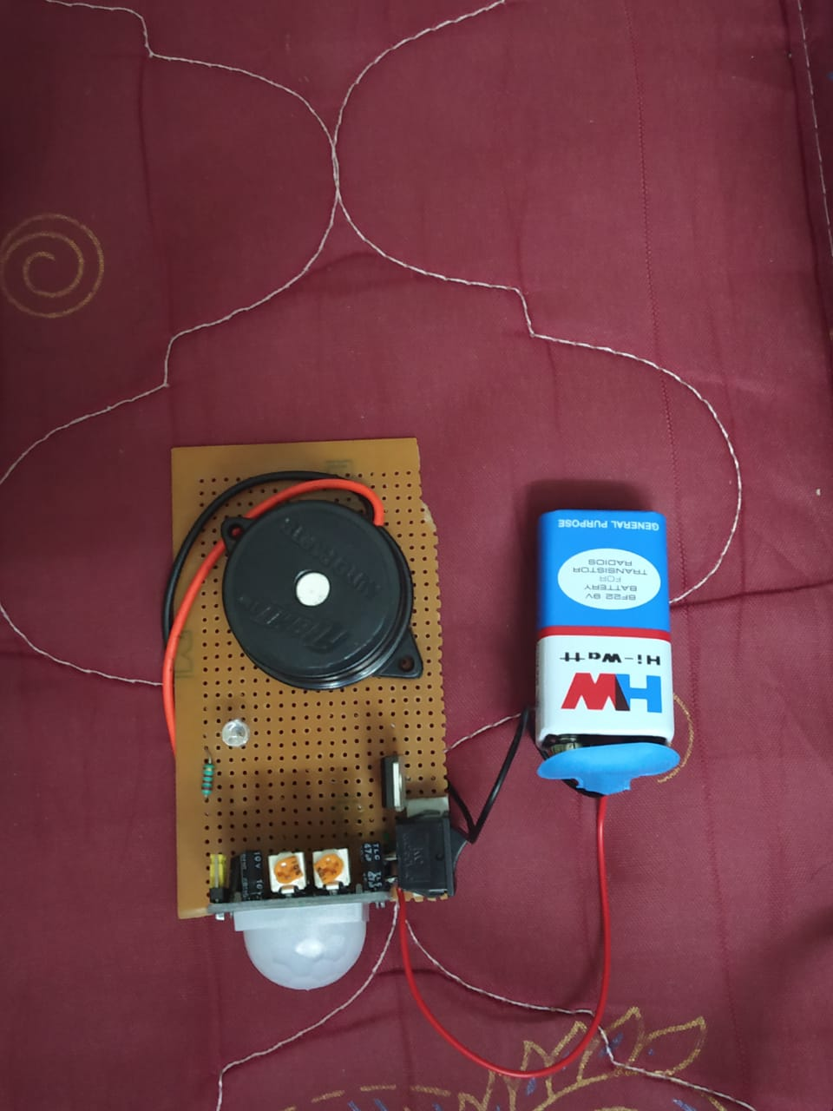

4. Finally it is working !!

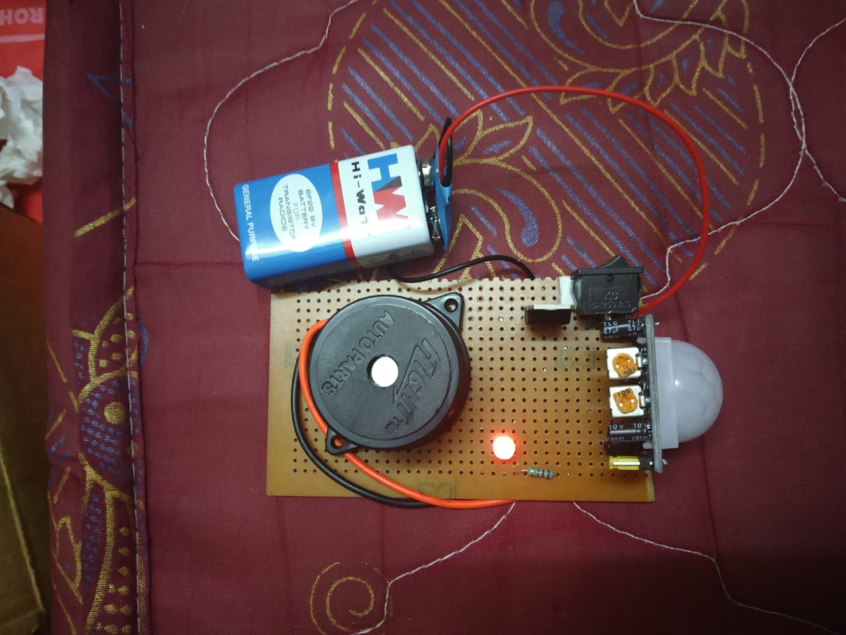

# Program Code :

(*Link of your Github project*)