**Name:-** Vansh Nilesh Badjate  
**PRN:-** 2124UMLM2022  
**DBMS PBL Exam**

**Practical No.07**

1. **Create Table With Constraints**

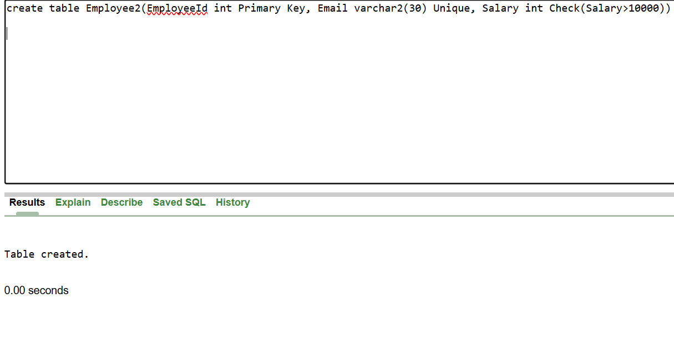

1. **Add Not NULL Constraint to Name Column and Try to insert without name**

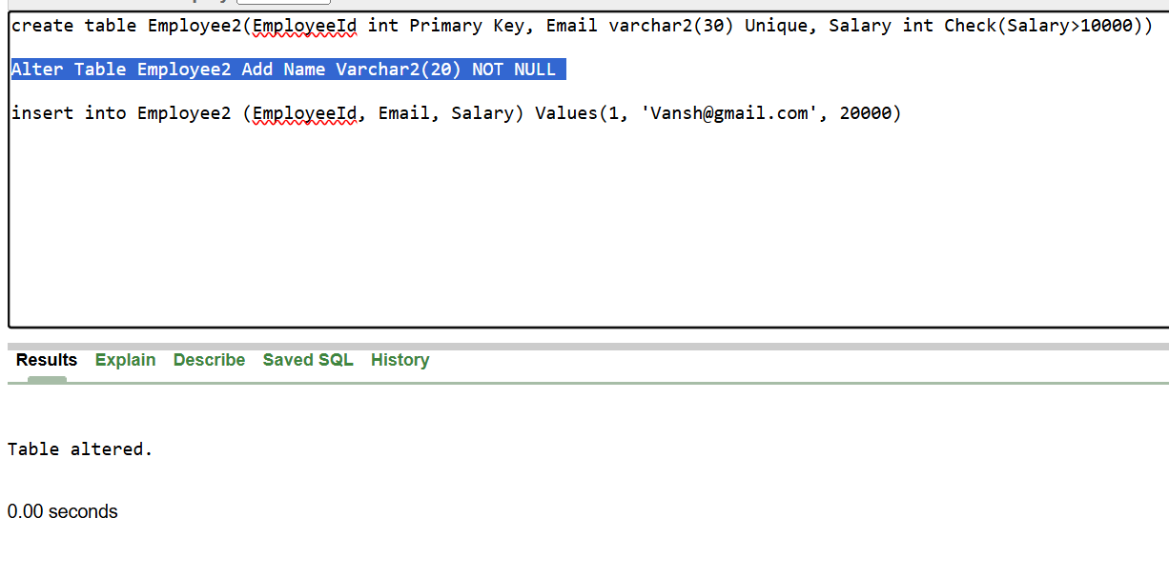

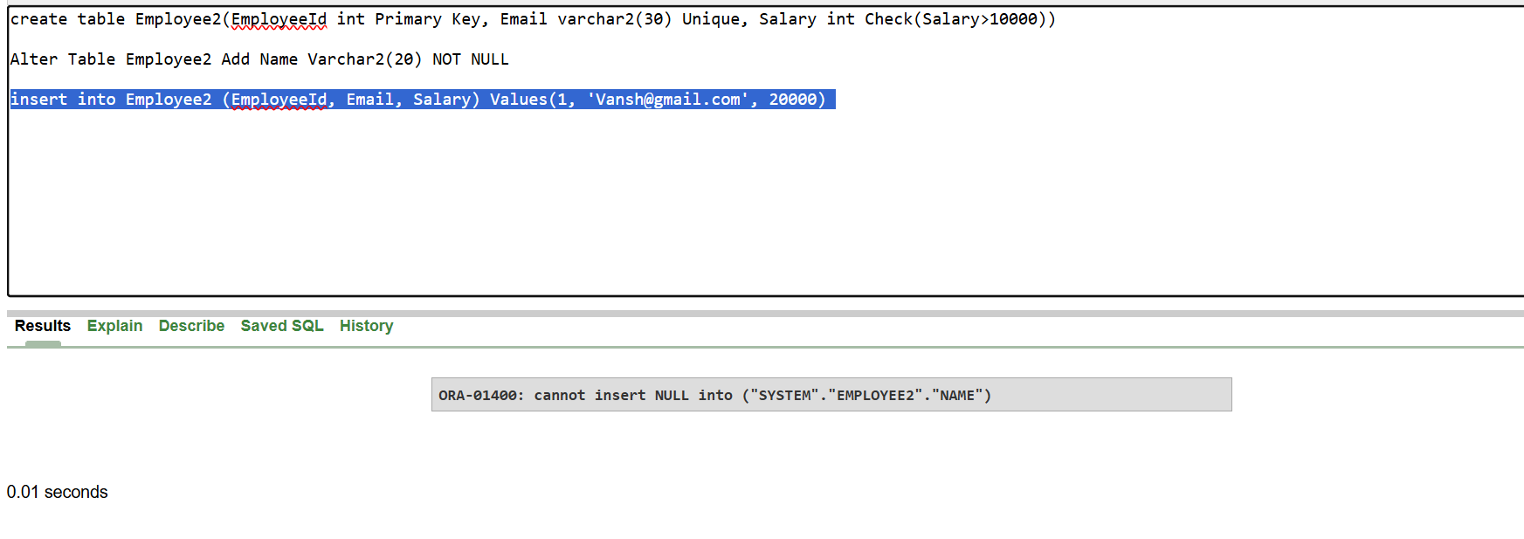

1. **Add Status Column with DEFAULT Value as “Active”**

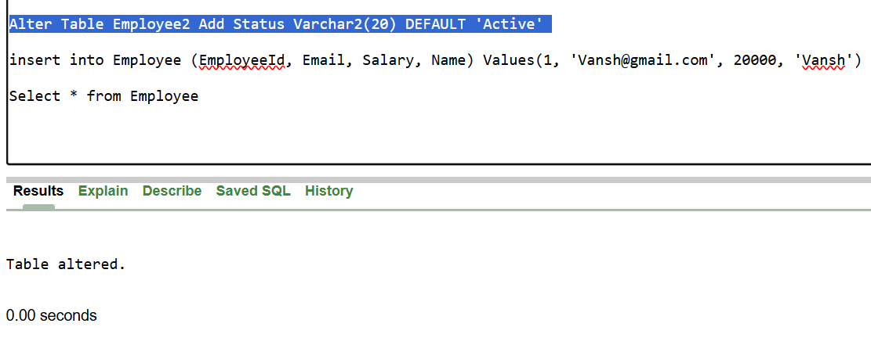

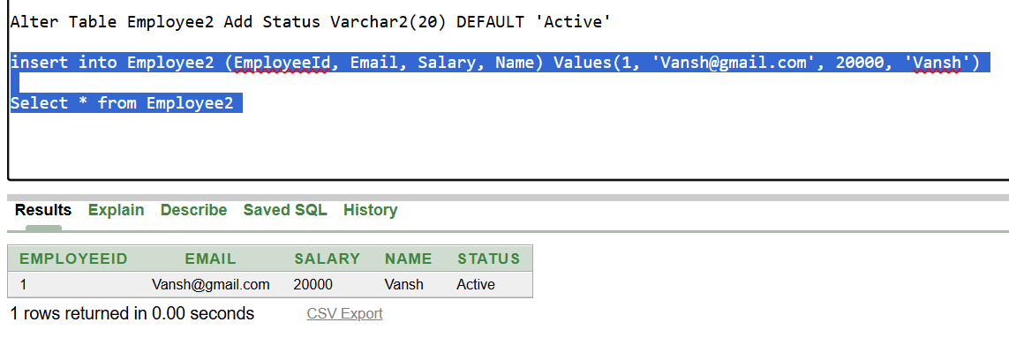

1. **Insert Record with Salary less than 10000 and check constraints**

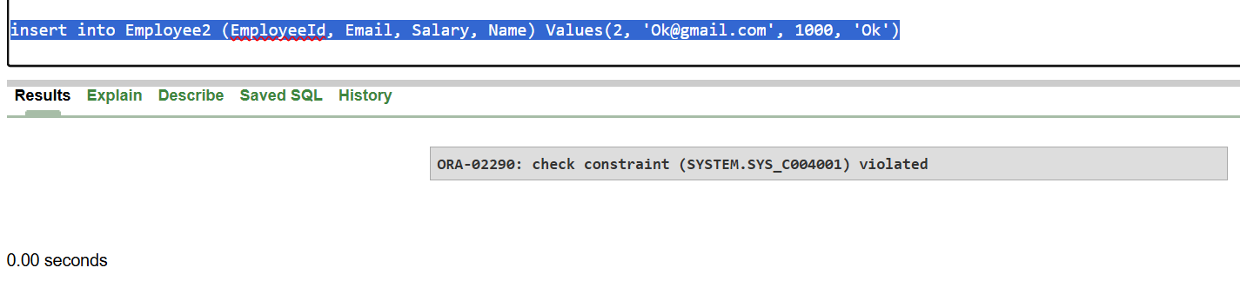

1. **Insert 2 Employee Details with same emailId to check Unique Constraint**

