**Name:-** Vansh Nilesh Badjate  
**PRN:-** 2124UMLM2022

**Practical Set:- 04**  
**Does Caffeine Boost Attention Span?**

1. **One-Way Anova Test To Check Effect of Caffeine on Attention**

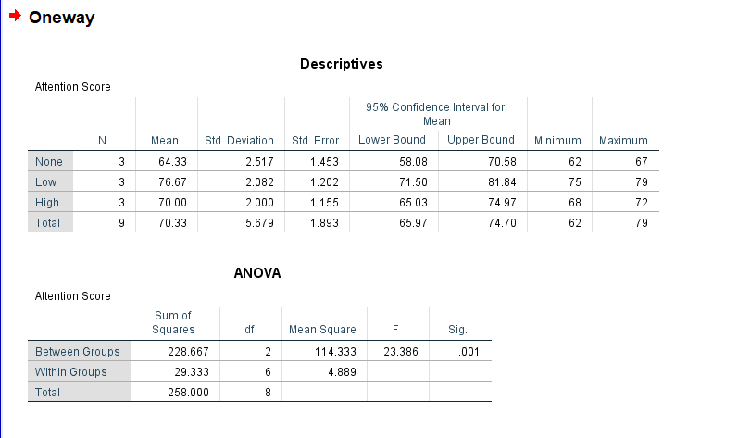

1. **Descriptive Statistics (Average of Attention In Different Intakes)**

|  |  |
| --- | --- |
| **Caffeine_Intake** | **Mean/Average of Attention Span** |
| **None** | 64.3 |
| **Low** | 76.6 |
| **High** | 70.0 |

1. **Does Caffeine Intake Affect on Attention of persons**

Significant Value from ANOVA Test = 0.001

(If Result is <0.005 then result is Statistically Significant)

⃰⃰⃰ 0.001 < 0.005

Hence, Caffeine Intake affect on concentration / Attention of person

1. **Visualization / Graph**

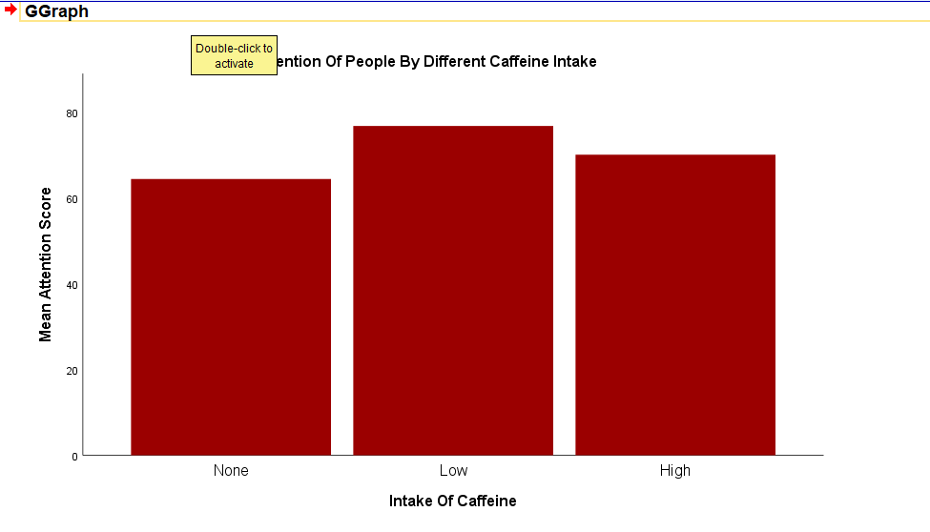

Based on Anova Test & Bar Chart, Caffeine Intake Affect the Attention Span.

As per mean score,

**Low Caffeine Intake** = High Attention

**High Caffeine Intake** = Medium Attention

**None(0) Caffeine Intake** = Lowest Medium