CS316: Compiler Design
Project Part 1 Report
C Code to Optimized Control Flow Graph
Indian Institute of Technology Ropar
S. No. | Name | Roll Number
1 | Tejas Singh | 2024CSB1164
2 | Ankit Mittal | 2024CSB1099
3 | T. Gowtham | 2024CSB1165
4 | Vansh Bansal | 2024CSB1167
5 | Pratham Warpa | 2024CSB1142

1. Introduction
This project implements a static analysis and optimization pipeline that takes raw C source code as input and converts it into an optimized Control Flow Graph (CFG). The work is organized into three phases: building the CFG from the parsed C code, running dataflow analyses on the graph, and applying a set of standard compiler optimizations. The implementation uses Python with the pycparser library for parsing, NetworkX for graph construction and manipulation, and Graphviz for visual output.

2. Phase 1: CFG Construction
Parsing is handled by pycparser, with a two-step fallback. The tool first tries to run the C preprocessor (cpp) on the input file, and if that fails it falls back to a direct CParser parse after stripping comments. For files with syntax errors, it attempts a partial parse by cutting the file at the error line and closing any open braces, so a partial CFG can still be built and the error location can be highlighted visually.
Once a valid AST is available, the CFGBuilder class traverses it recursively. Simple statements (assignments, declarations, return statements, function calls) are each turned into their own basic block. Control structures are expanded into multi-block patterns: an if statement produces a condition block, separate true and false branch subgraphs, and a merge block at the end. A while loop produces a condition block with a back-edge from the loop body's exit. A for loop adds separate init and increment blocks around the condition. A do-while loop places the body before the condition block, with a back-edge for the true branch. The resulting graph is a NetworkX DiGraph where each node stores a BasicBlock object containing the block's label and its list of AST statement nodes.

3. Phase 2: Static Analysis
Two classical dataflow analyses are implemented. Reaching Definitions is a forward analysis. For each basic block, a gen set holds the last definition of each variable written in that block (as a (variable, block_id) pair), and a kill set holds all other definitions of those same variables anywhere in the program. The iterative equations are IN[B] = union of OUT of all predecessors, and OUT[B] = gen[B] union (IN[B] minus kill[B]). The fixed-point loop runs until no IN or OUT set changes. After convergence, the analysis checks each use of a variable in every block against the variables present in that block's IN set to flag potential uninitialized variable uses.
Live Variable Analysis is a backward analysis. The use set for a block contains all variables read before being written in that block, and the def set contains all variables written. The equations are OUT[B] = union of IN of all successors, and IN[B] = use[B] union (OUT[B] minus def[B]). After convergence, dead assignments are identified by simulating liveness backward through each block's statements: an assignment is dead if the variable being assigned is not live at that point in the backward simulation.

4. Phase 3: Optimizations
Five optimization passes are run in sequence. Constant Folding walks every statement's AST and replaces binary operations where both operands are integer or float literals with the computed result. For example, an expression like x * y + 4 where x and y have been substituted with constants will fold down to a single literal.
Constant Propagation uses the Reaching Definitions result to build a per-block environment mapping variable names to constant values. A variable gets an entry if all definitions that reach the block assign it the same constant. It then substitutes ID references in statements with their known constant values. Loop nodes are intentionally skipped to avoid incorrectly propagating loop variables like i = 0 across all iterations.
A second pass of Constant Folding runs after propagation to collapse any new constant expressions that were created by substitution. Dead Code Elimination then removes assignments where the target variable is not live after that point. If a basic block becomes empty after removals, it is spliced out of the graph by reconnecting its predecessors directly to its successors.
If Simplification checks for if-condition blocks whose condition has been reduced to the literal 0 or 1 by earlier passes. In such cases the dead branch and its nodes are removed, and the merge block is cleaned up. Finally, Unreachable Code Removal does a BFS from all START nodes and removes any block not reachable from a function entry.

5. CFG Visualizations
The figures below show the CFG before and after optimization for a sample program containing three functions: add, compute, and main. Functions are rendered as separate dashed clusters. START and END nodes are shown in light blue, control flow nodes (if conditions, loop conditions, merge points) in yellow, and regular statement blocks in white. Error blocks, when present, are shown in red.

Figure 1: Original CFG (before optimization)
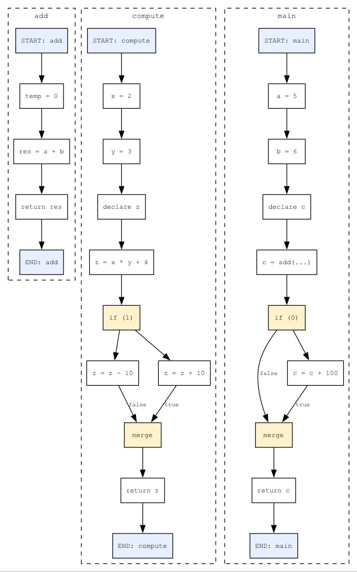
Figure 2: Optimized CFG (after optimization)
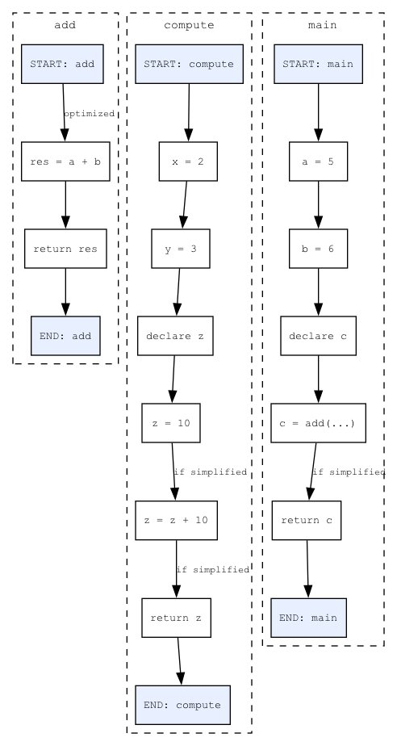
In the original CFG, the compute function contains an if (1) condition with two branches (z = z - 10 and z = z + 10) leading into a merge node. The main function contains an if (0) condition with a branch for c = c + 100. Both conditions are compile-time constants, so the optimizer removes the dead branches entirely. The add function loses the temporary dead assignment temp = 0 via dead code elimination. The final optimized CFG is noticeably smaller, with the constant branches and dead assignments removed.

6. Tech Stack
The project uses Python 3 throughout. pycparser handles C parsing. NetworkX provides the directed graph data structure and algorithms including descendant computation and cycle detection for loop identification. Graphviz renders the CFG to PNG via DOT format, with functions in separate subgraph clusters. The pipeline is invoked as a command-line script, taking a C file as input and producing two PNG outputs along with a text analysis report.

7. Conclusion
The pipeline successfully covers the full flow from raw C source to an optimized CFG. The dataflow analyses correctly identify uninitialized variable uses and dead assignments, and the optimization passes handle the standard classical transformations. The visualization makes it straightforward to verify the effect of each pass. Future work for Part 2 would extend this with loop-invariant code motion using dominator trees, taint analysis for security scanning, and a web dashboard for interactive use.

