Course: Foundations of the physical world (FM113)
Homework, reading, and study
Mechanics:
1) Monday 12 January: Introduction, The laws of Mechanics, Scalars and Vectors, Vector addition/subtraction
Reading: 1.1 Sample 1.1 to 1.10.
Practice: 1.1.1-6, 8-30, 33-36, 38-40.
2) Wednesday 14 January: Dot product, Directional cosines
Reading: 1.2, Sample 1.12-16.
Practice: 1.2.1-24.
3) Friday 16 January: Cross product, Moment vector, Equivalent force system
Reading: 1.3, 1.4, 2.1, Sample 1.25-27, 2.1-2.4
Practice: 1.3.1-13, 1.4.1-13, 1.5.1-11.
4) Monday 19 January: Centre of mass
Reading: 2.2, 5.1.
Practice: 2.2.1-2, 2.2.6, 2.2.8-11.
Homework-1 (due 25 January, 7 pm): M1) 1.4.8 M2) 2.1.10 M3) 2.1.16
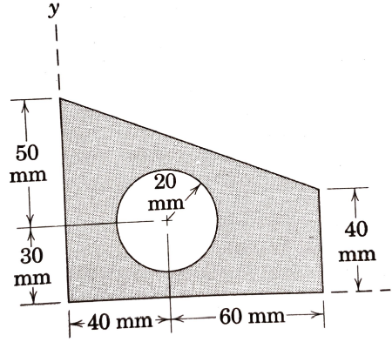
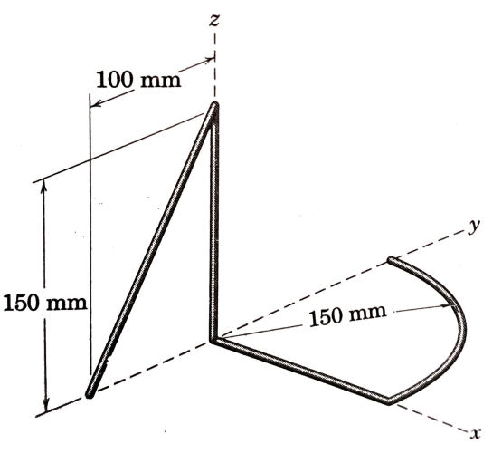
M4) Determine the x and y co-ordinates of the centroid of the shaded area.

M5) Determine the x and y and z co-ordinates of the mass center of the body constructed of uniform slender rod.

5) Wednesday 21 January:
Reading:
Practice:

