Global Olympic Sports Performance Analysis
Project Documentation: Tableau Dashboards, Story and Flask Web Integration
Prepared by: Vansh Billore
Platform: SkillWallet, Data Analytics with Tableau
November 2026

1. Problem Statement
The Olympic Games produce a very large volume of historical data from 1992 to 2026. It is difficult to see which factors drive Olympic success, because performance reflects athletic achievement, sports infrastructure, athlete development and investment strategy.
This project analyses medal achievements across nations, athlete participation, regional performance efficiency, sport category medal distribution, and the relationship between sports investment and medal outcomes for both Summer and Winter Games.

1.1 Scenarios addressed
- Scenario 1, Ms. Priya (National Olympic Committee performance strategist): which sport categories give the highest medal return per athlete, and how does her country compare with the top performers?
- Scenario 2, Mr. Carlos (sports investment analyst): which countries and regions turn sports investment into medals most efficiently, and which regions are under-funded but high-potential?
- Scenario 3, William Robert (broadcast data journalist): how have medal totals changed over time, do host nations win more at home, and which regions dominate?

1.2 Objectives
- Collect and prepare the Olympic medal data and connect it to Tableau.
- Build visualizations, two dashboards and a Tableau story that answer each scenario.
- Embed the published dashboards and story in a Flask web application.
- Record a demonstration video and document the full procedure.

2. Dataset and Data Collection
The project dataset (athletes and medal_results: To complete the project, a simulated dataset with the same structure as the project description was created and used throughout. All numbers in this document come from that dataset, so they differ from the example figures in the problem statement. This is stated openly in the demo video and in the web application footer.

2.1 Dataset summary
Item | Value
File used in Tableau | medal_results.csv
Rows | 5,339
Columns | 14
Countries | 60 (grouped into 6 regions: Africa, Asia, Europe, North America, Oceania, South America)
Sports / sport categories | 50 sports in 15 sport categories
Period | 1992 to 2026, Summer and Winter Games (19 Games)
Total medals | 5,997
Total athletes (sum of Athletes) | 53,865

2.2 Columns
Column | Description
Result_ID | Unique row identifier (hidden in Tableau)
Year, Season | Year of the Games and Summer or Winter
Host_Country | Host nation of that Games
Country, Region | Participating country and its region
Sport, Sport_Category | Sport and its category (for example Aquatics, Skiing, Team Sports)
Athletes | Number of athletes entered for that country and sport
Gold, Silver, Bronze, Total_Medals | Medal counts
Sports_Investment_MUSD | Sports investment of the country in million US dollars

Tools used: Tableau Public (data connection, calculated fields, charts, dashboards, story), Flask and Python (web application), HTML, CSS and Bootstrap (pages), Tableau JavaScript Embedding API (embedding), GitHub (source code).

3. Connecting Data to Tableau
- Open Tableau Public and sign in.
- Under Connect, choose Text file and select medal_results.csv.
- Open Sheet 1 and check that Tableau shows the fields as dimensions and measures.
- Geographic fields (Country, Host Country) were recognised automatically, which allows the world map.
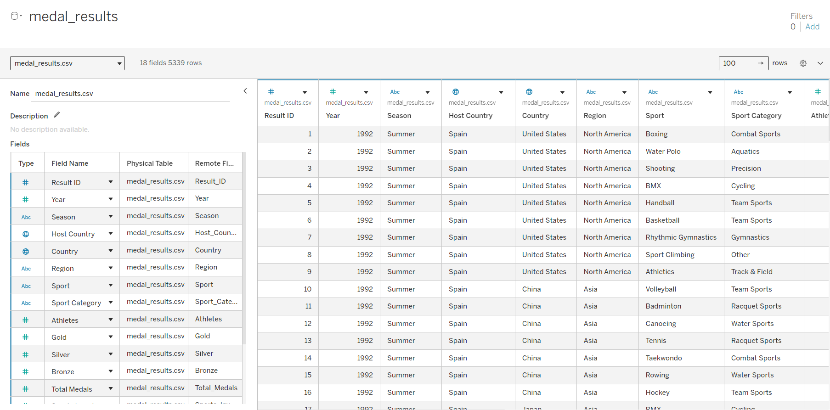

4. Data Preparation
- Checked all 14 columns for missing values: none were found.
- Checked for duplicate rows: none were found.
- Confirmed data types: Country, Region, Season, Sport and Sport Category are text dimensions; Athletes, Gold, Silver, Bronze, Total Medals and Sports Investment are numeric measures.
- Year was kept as a dimension so that it is not summed.
- The Result ID column was hidden because it is not needed for analysis.
- Sports investment repeats on every sport row of a country and Games, so it is aggregated with the average (AVG) and never the sum, to avoid double counting.
- The data was not joined with a second table, because joining would multiply the medal counts.

5. Calculated Fields
Field | Formula | Purpose
Avg Medals per Athlete | SUM([Total Medals]) / SUM([Athletes]) | Medal return per athlete by sport category (Scenario 1)
Medal Efficiency % | SUM([Total Medals]) / SUM([Athletes]) * 100 | Regional efficiency donut chart (Scenario 2)
Host Nation Medals | IF [Country]=[Host Country] THEN [Total Medals] END | Medals a host won at its own Games (Scenario 3)
Medals per $M | SUM([Total Medals]) / AVG([Sports Investment MUSD]) | Bubble size in investment vs medals chart (Scenario 2)

6. Visualizations
Each visualization was built on its own worksheet. Filters used: Season filter on the dashboards and a Top 10 filter on Country for the performance chart.
Worksheet | Chart type | Fields | Answers
Trend of Total Medals Awarded Over the Year | Line chart | Year, Total Medals, Season (colour) | William: medal totals over time
Performance by Country | Vertical bar chart | Country (Top 10), Total Medals | Priya: top performing nations
Avg Medals per Athlete by Sport Category | Bar chart | Sport Category, Avg Medals per Athlete | Priya: best return per athlete
Host Nation Medals | Horizontal bar chart | Host Country, Host Nation Medals | William: home advantage
Investment vs Medal Performance | Bubble chart | Avg Sports Investment, Total Medals, Country, Region, Medals per $M | Carlos: investment and medals
Regional Medal Efficiency | Donut chart | Region, Medal Efficiency % | Carlos: efficiency by region
Medals by Sport Category | Horizontal bar chart | Sport Category, Total Medals | Distribution by sport category
Medals Type Breakdown | Stacked bar chart | Country, Gold, Silver, Bronze | Medal type mix
Total Medal Achievements Across Nations | World map | Country, Total Medals (colour) | Medals across nations
KPI Athletes, KPI Nations, KPI Sport Categories | KPI text sheets | Athletes (sum), Country and Sport Category (distinct count) | Overall participation

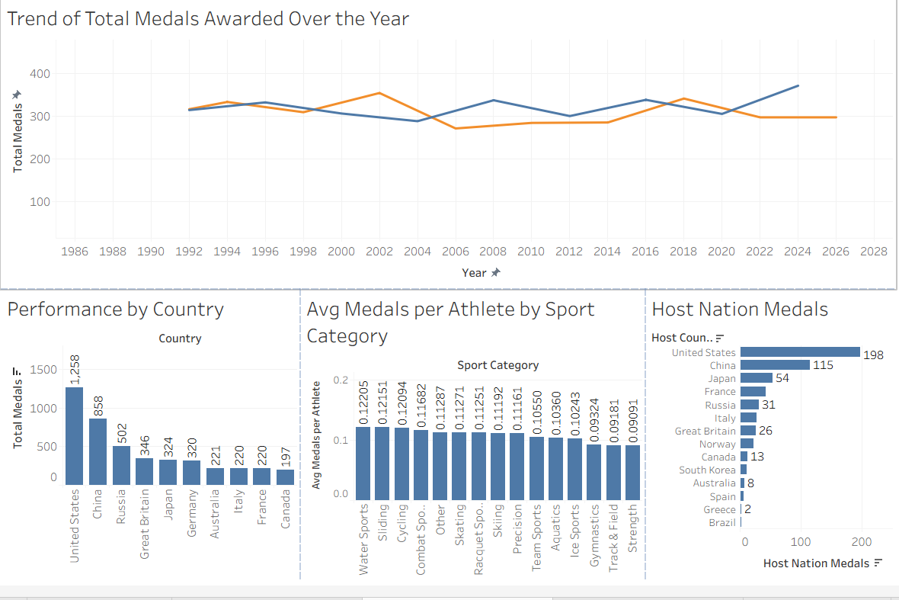

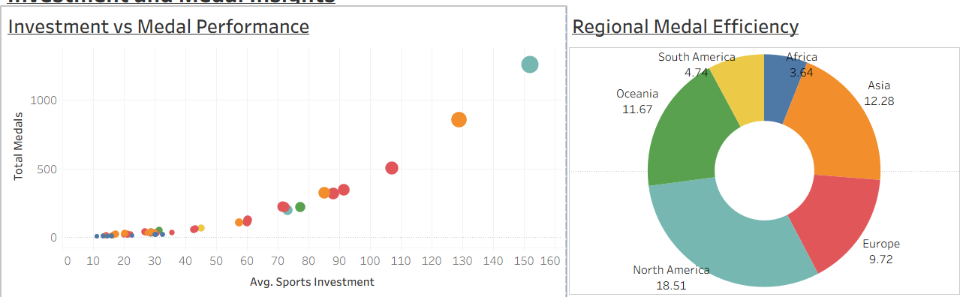

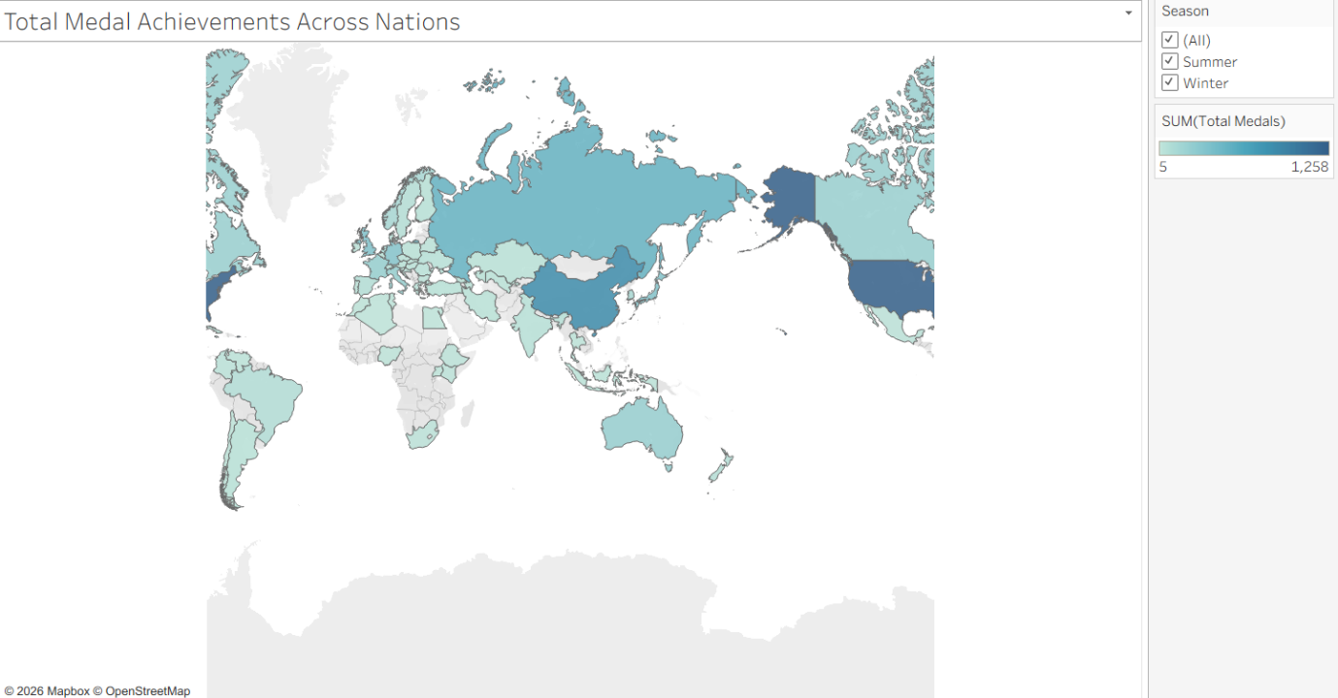

7. Dashboards

7.1 Dashboard 1: Olympic Performance
Contains a KPI row (53,865 athletes, 15 sport categories, 60 nations), the medal trend line chart, performance by country, average medals per athlete by sport category, and host nation medals. Size is set to fit the page, and the Season filter applies to the worksheets.

7.2 Dashboard 2: Investment and Medal Insights
Contains the investment vs medal bubble chart, the regional medal efficiency donut, medals by sport category, the medal type breakdown and the world map of medals, with the Season filter and region legend.

8. Story: Global Olympic Sports
The story has three scenes, each pairing a dashboard with a caption that answers one scenario.
Scene | Dashboard | Caption
1 | Investment and Medal Insights | North America has the highest medal efficiency (18.51%), then Asia (12.28%). Africa and South America are lowest, so they are the regions where extra funding could matter.
2 | Olympic Performance | The US leads with 1,258 medals, followed by China (858) and Russia (502). Water Sports has the highest average medals per athlete (0.122).
3 | Total Medal Achievements Across Nations | Europe leads with 2,440 medals. Host nations gain an edge: the US won 198 medals and China 115 at home.

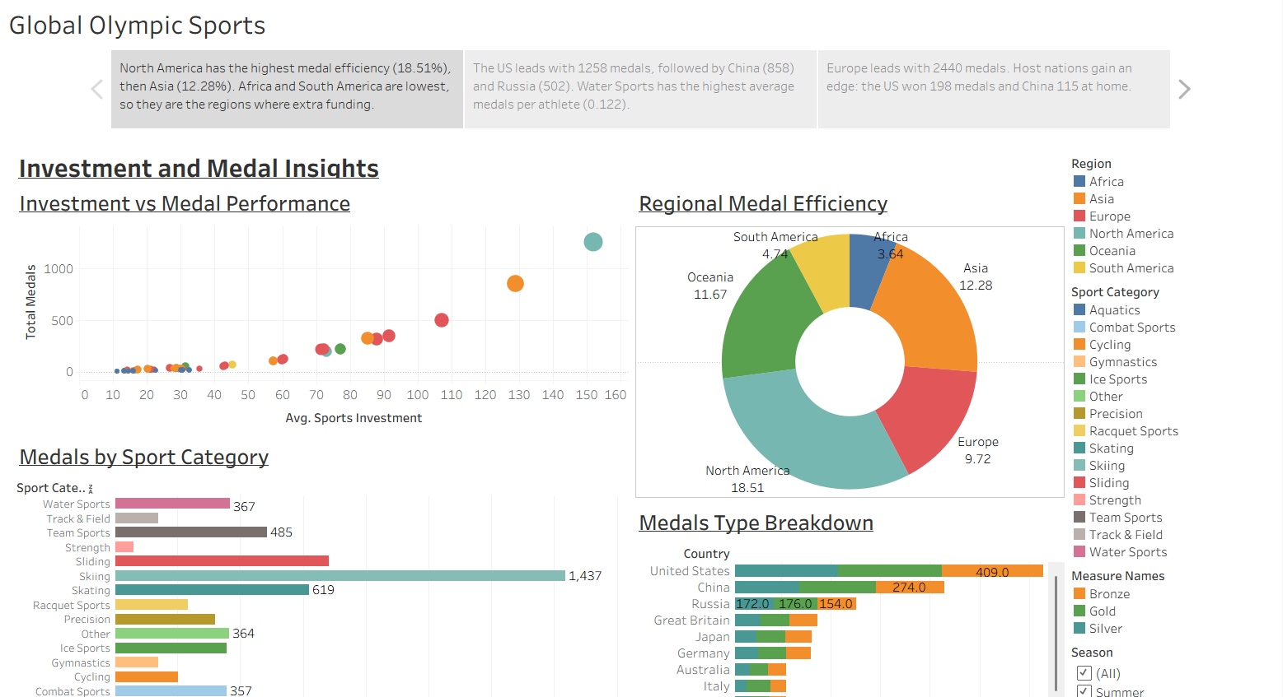

9. Key Insights and Scenario Answers

Scenario 1: Priya
- Top nations by total medals: United States 1,258, China 858, Russia 502, Great Britain 346, Japan 324.
- Water Sports has the highest average medals per athlete (0.122), followed by Sliding (0.122) and Cycling (0.121). Strength is lowest (0.091).
- Recommendation: invest in high-return categories such as Water Sports, Sliding and Cycling, and review low-return categories.

Scenario 2: Carlos
- Medal totals rise with sports investment. The United States is the clear top outlier.
- Medal efficiency by region: North America 18.51%, Asia 12.28%, Oceania 11.67%, Europe 9.72%, South America 4.74%, Africa 3.64%.
- Africa and South America have the lowest efficiency, so they are candidates for targeted grants and development support.

Scenario 3: William
- Host nations win more at home: the United States won 198 medals as host and China 115.
- Regional totals: Europe 2,440, North America 1,534, Asia 1,505, Oceania 270, South America 143, Africa 105.
- Summer and Winter medal totals move differently across the years, which the line chart shows clearly.

10. Performance Testing
Test item | Result
Amount of data loaded | 5,339 rows, 14 columns (medal_results.csv, about 400 KB)
Utilization of data filters | Season filter on dashboards, Top 10 filter on Country, region and sport category legends
Number of calculated fields | 4
Number of visualizations | 12 or more worksheets (see section 6)
Dashboards and story | 2 dashboards, 1 story with 3 scenes
Embedded page loading | Dashboards and story load in the Flask pages after a few seconds

11. Web Integration with Flask
The published dashboards and story are embedded in a Flask web application using the Tableau JavaScript Embedding API.

11.1 Project structure
Item | Purpose
app.py | Flask routes and the Tableau Public links
templates/ | base.html, home.html, about.html, insights.html, embed.html
static/css/style.css | Stylesheet
requirements.txt, README.md | Dependency list and project description

11.2 Pages
Home, About, Insights, Dashboard 1, Dashboard 2 and Story. The layout uses Bootstrap 5, a navigation bar and a footer that states the data note.

11.3 Steps to run
- Install Python and run: pip install flask
- Open a terminal in the project folder.
- Run: python app.py
- Open http://127.0.0.1:5000 in a browser.

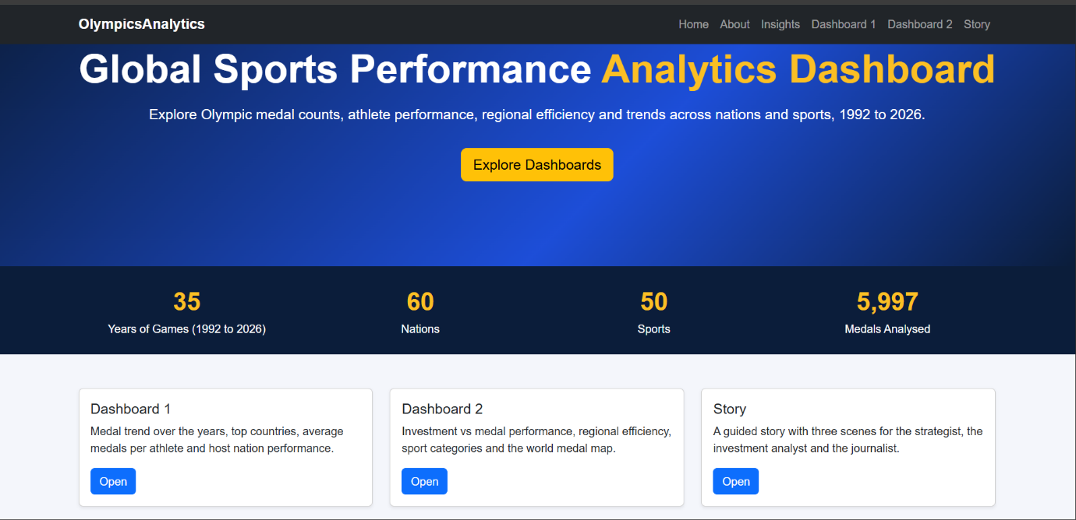

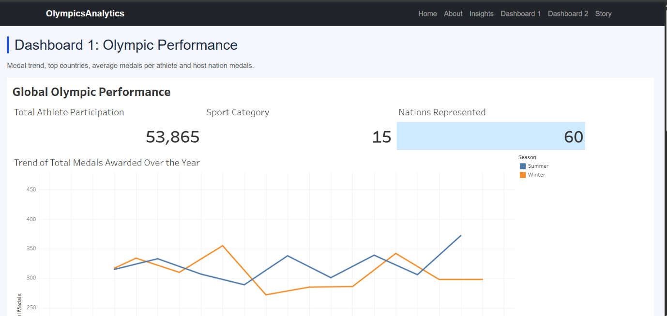

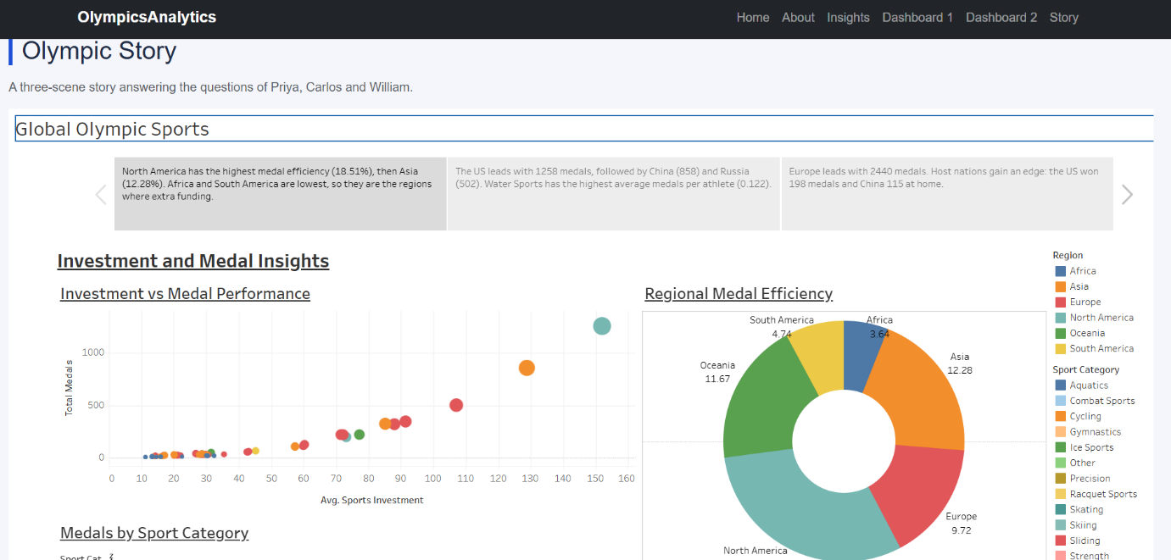

12. Project Links
Item | Link
Tableau Public workbook | https://public.tableau.com/app/profile/vansh.billore/viz/GlobalOlympicSportPerformanceProject/GlobalOlympicSports
GitHub repository | https://github.com/vanshbillore/olympic-sports-analysis
Demo video | https://drive.google.com/file/d/1mz1GfmDecH94gDHBfBsRJvFT_XnQXx-a/view?usp=drive_link

13. Limitations and Conclusion
- The dataset is simulated with the same structure as the project data, so values differ from the example numbers in the problem statement.
- Medal efficiency is defined as total medals divided by athletes, which is one of several possible definitions.
The project met its objectives: the data was connected and prepared in Tableau, four calculated fields and a set of visualizations were built, two dashboards and a three-scene story answer the three scenarios, and everything is embedded in a Flask web application with the source code on GitHub.

