Task 1: Foundation of Cyber Security

Name: Vansh Davne
Domain: Cybersecurity & Ethical Hacking
Organization: ApexPlanet Software Pvt. Ltd.
Duration: 21 Feb 2026 – 21 April 2026
1)Introduction
Cyber Security is a field that involves protecting computer systems, networks, and data from unauthorized access, attacks, and cyber threats. The objective of this task was to understand the Linux environment, learn basic commands, and set up Kali Linux. Kali Linux is a powerful operating system used for ethical hacking and penetration testing.
2️)Kali Linux Setup
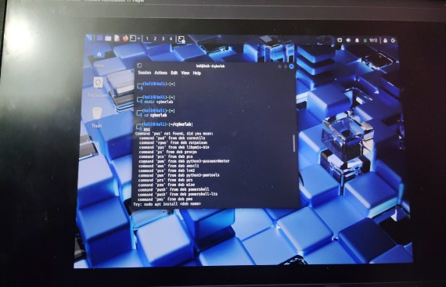


Is task me maine:
VMware Workstation Player install kiya
Kali Linux VMware image download ki
File extract ki using 7-Zip
Virtual machine configure ki
Kali Linux successfully boot kiya
(Screenshot 1: VMware installed)
(Screenshot 2: Kali Linux Desktop Running)

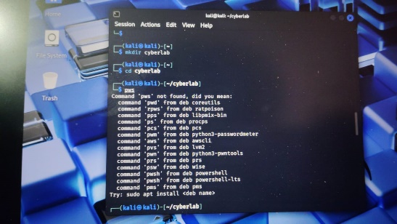
3️)Basic Linux Commands Practiced
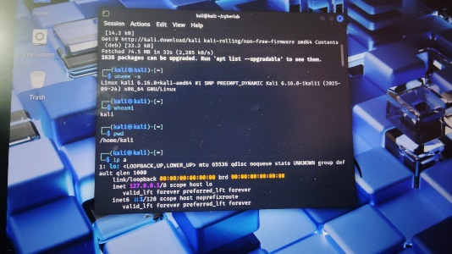

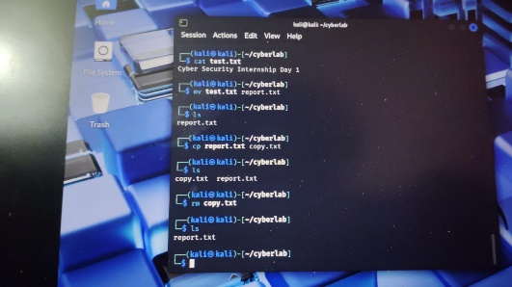
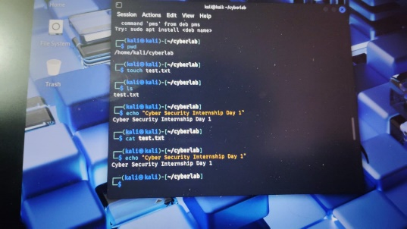

# User Check
Bash
Copy code
whoami
Output: kali
# Current Directory Check
Bash
Copy code
pwd
Output: /home/kali
# Network Information
Bash
Copy code
ip a
IP Address successfully displayed.

4️) File Management Practice
# Folder Create
Bash
Copy code
mkdir cyberlab
cd cyberlab
File Create
Bash
Copy code
touch test.txt
#File Me Text Add
Bash
Copy code
echo "Cyber Security Internship Day 1" > test.txt
File View
Bash
Copy code
cat test.txt
# File Rename
Bash
Copy code
mv test.txt report.txt
# File Copy
Bash
Copy code
cp report.txt copy.txt
# File Delete
Bash
Copy code
rm copy.txt
All commands successfully executed.
5️) What I Learned
Kali Linux installation process
Virtual machine concept
Basic Linux terminal commands
File creation, renaming, copying and deleting
Network information checking
This task helped me understand Linux environment and basic command line operations which are essential for cybersecurity.

6️) Conclusion
In this task, I successfully installed Kali Linux and practiced basic Linux commands. This foundation will help me in future tasks related to networking, scanning, and ethical hacking tools.

