CYCLISTIC BIKE-SHARE
Case Study Report
Converting Casual Riders to Annual Members
Prepared by | Vansh
Role | Junior Data Analyst
Team | Marketing Analytics Team
Submitted to | Lily Moreno, Director of Marketing
Date | March 2026
Data Period | March 2025 — February 2026

1.Business Task
The director of marketing, Lily Moreno, believes that Cyclistic's future success depends on maximizing the number of annual memberships. Rather than targeting entirely new customers, the team identified an opportunity to convert existing casual riders into annual members, as casual riders are already familiar with the Cyclistic program.

Business Task Statement:

Analyze how annual members and casual riders use Cyclistic bikes differently in order to design a targeted marketing strategy that converts casual riders into annual members.

Key Stakeholders
Primary | Lily Moreno — Director of Marketing
Decision Makers | Cyclistic Executive Team
Supporting | Cyclistic Marketing Analytics Team
Supporting | Cyclistic Finance Team

2. Data Sources
The analysis uses 12 months of historical Cyclistic trip data provided by Motivate International Inc. under a public license. The data covers ride activity from March 2025 through February 2026.

Provider | Motivate International Inc.
Period | March 2025 to February 2026 (12 months)
Format | 12 CSV files — one per month
Total Rows | Approximately 5 and half million records
Total Columns | 13 columns
Key Columns | ride_id, rideable_type, started_at, ended_at, start_station_name, end_station_name, member_casual
License | Public data license — Motivate International Inc.[Link]
Privacy | No personally identifiable information — riders cannot be individually identified

ROCCC Assessment
Reliable | First-party data collected directly from Cyclistic bike system
Original | Primary source — not aggregated from third parties
Comprehensive | Full 12 months of data covering all ride types and user types
Current | Most recent 12-month period used
Cited | Licensed and documented by Motivate International Inc.
Verdict | Data is suitable and credible for this analysis

3. Data Cleaning & Processing

Tool Used
Python (Google Colab) was selected as the primary analysis tool. With approximately 5.5 million rows across 12 files, spreadsheet tools like Excel or Google Sheets would be unable to handle the data volume efficiently. Python with the Pandas , Numpy , Matplotlib ,Seaborn library enabled fast merging, cleaning,visualization and analysis of the full dataset.

Columns Added
ride_length | Calculated as ended_at minus started_at — represents duration of each ride in minutes
day_of_week | Extracted from started_at — day name (Monday through Sunday)
month | Extracted from started_at — month name for seasonal analysis
hour | Extracted from started_at — hour of day (0 to 23) for time of day analysis
day_type | Labelled as Weekday or Weekend based on day_of_week

Cleaning Log
# | Issue Found | Action Taken | Impact
1 | Date columns stored as text (object type) | Converted started_at and ended_at to datetime format using pd.to_datetime() | Enabled all time-based calculations
2 | Negative ride_length values | Removed all rows where ride_length was less than or equal to zero | Eliminated data entry errors
3 | Rides longer than 24 hours | Removed rows where ride_length exceeded 1,440 minutes | Removed unreturned or faulty bike records
4 | Null values in station columns | Noted for record — rows retained as station name not required for core analysis | Documented limitation

4. Analysis Summary
Analysis of 12 months of Cyclistic trip data revealed clear and consistent behavioral differences between annual members and casual riders. Members exhibit commuter-style riding patterns — consistent weekday usage, peak activity during commute hours, and stable ridership throughout the year. Casual riders show leisure-based patterns — longer rides, weekend peaks, summer seasonality, and concentration around recreational areas.

Finding 1 | User Split
Annual members account for 65.10% of all rides while casual riders account for 34.90% of rides across the 12-month period.
Business Insight: The casual rider segment represents a significant and accessible conversion opportunity — these riders already use and trust the Cyclistic platform.

Finding 2 | Ride Duration
Casual riders consistently take longer rides on average compared to annual members across all days and months.
Business Insight: Longer ride times suggest casual riders use bikes for leisure and exploration rather than routine point-to-point commuting. A membership offering unlimited ride time could appeal to this behavior.

Finding 3 | Day of Week Pattern
Members are most active on Thursdays while casual riders peak on Saturdays. Member ridership is highest Monday through Friday while casual ridership rises sharply on weekends.
Business Insight: Members ride for commuting. Casual riders ride for leisure. This behavioral difference is the clearest distinction between the two groups.

Finding 4 | Weekday vs Weekend
Member rides are approximately double casual rides on weekdays. However on weekends the gap narrows significantly and both groups show nearly equal ridership volumes.
Business Insight: The near-equal weekend ridership shows casual riders are highly engaged on weekends — presenting a strong opportunity to convert them during their highest motivation period.

Finding 5 | Top Stations — Casual Riders
The number one start and end station for casual riders is DuSable Lake Shore Dr and Monroe St with approximately 30,000 rides originating from this location.
Business Insight: This station is a high-traffic leisure and tourism location. Targeting membership promotions at this station will reach the highest concentration of casual riders.

Finding 6 | Top Stations — Members
The number one start and end station for annual members is Kingsbury St and Kinzie St with approximately 28,000 rides — a location consistent with office and business district commuting.
Business Insight: The contrast between casual and member top stations confirms the leisure vs commute behavioral divide and helps identify where each group can be targeted.

Finding 7 | Time of Day Pattern
Both members and casual riders show peak ridership in the evening hours between 4pm and 7pm (16:00 to 19:00). Members show a secondary morning peak consistent with commute hours.
Business Insight: The shared evening peak is an opportunity to reach both groups simultaneously. The member morning commute peak further confirms routine commuter behavior.

Surprising Discovery — Seasonal Pattern
Winter months — particularly November, December, January, and February — show dramatically lower ridership compared to summer months. This seasonal drop is significantly more pronounced among casual riders than members, further reinforcing that casual riders are leisure-motivated and weather-sensitive.

5. Supporting Visualizations
The following charts were created using Python (matplotlib and seaborn) and represent the key findings from the analysis.
Chart 1 | Member vs Casual Split
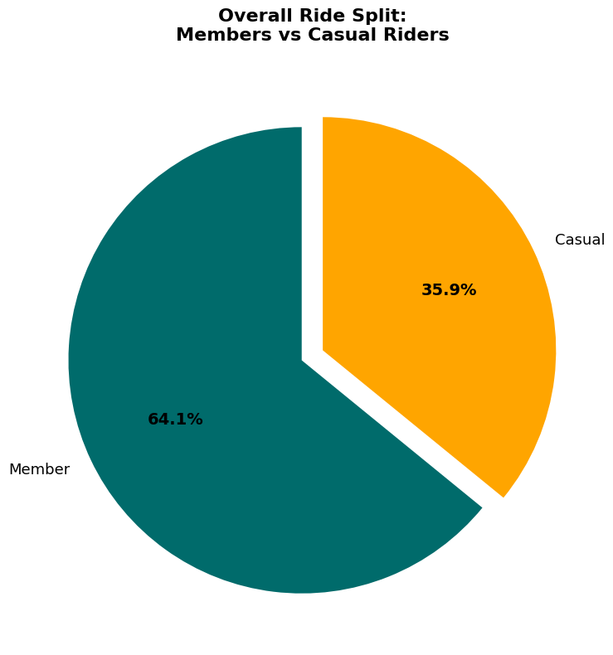

Pie chart showing 65.10% members vs 34.90% casual riders out of total rides

Chart 2 | Average Ride Duration
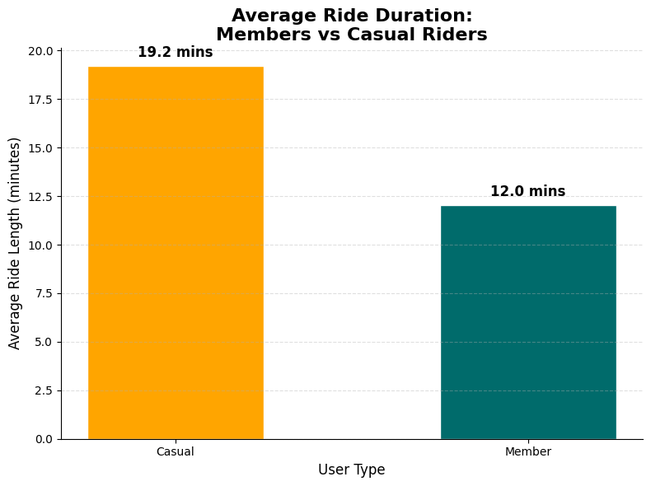
Bar chart comparing average ride length in minutes — casual riders ride longer on average

Chart 3 | Rides by Day of Week
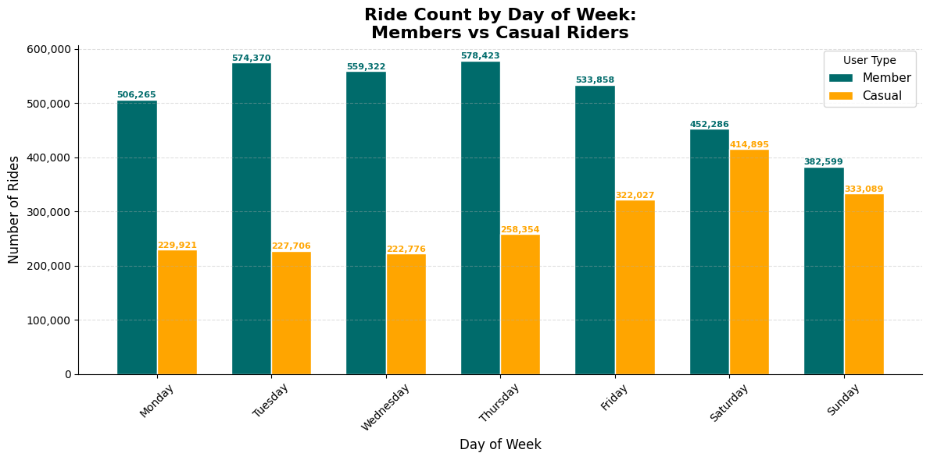
Grouped bar chart showing members peak Thursday and casual riders peak Saturday

Chart 4 | Monthly Ride Trend
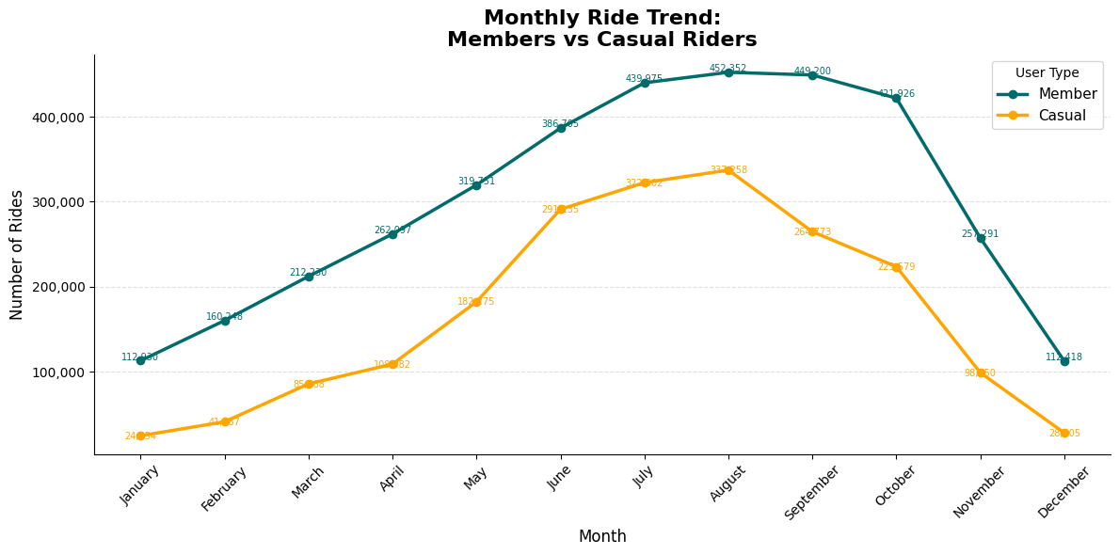
Line chart showing both groups peak in summer with casual riders dropping sharply in winter

Chart 5 | Rides by Hour of Day
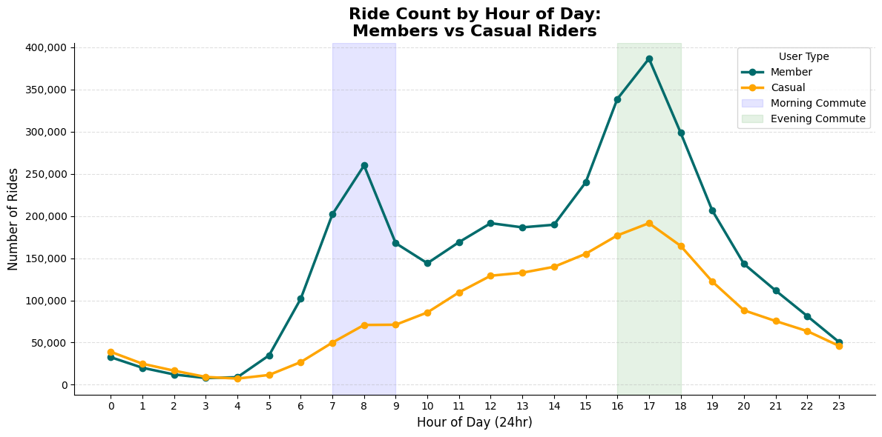
Line chart showing shared evening peak and member morning commute spike

Chart 6 | Weekday vs Weekend
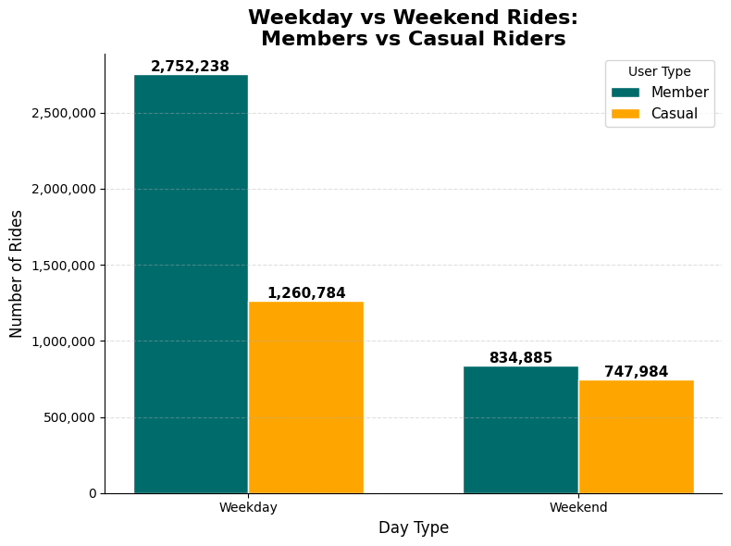
Grouped bar chart showing double member volume on weekdays but near-equal on weekends

6. Top 3 Recommendations
Based on the analysis of 12 months of Cyclistic trip data, the following three recommendations are proposed to convert casual riders into annual members. Each recommendation is directly supported by specific findings from the data.

Recommendation 1 — Station-Based Membership Campaign at DuSable Lake Shore Dr
Based on: Finding 5 — DuSable Lake Shore Dr and Monroe St is the #1 casual rider station with approximately 30,000 rides.
Action: Place QR code membership promotion posters at the docking station and run geo-targeted digital ads to riders within 500 meters of this location. Offer a time-limited discounted annual membership. Extend this approach to the top 10 casual rider stations across Chicago.
Expected Outcome: Directly targets the highest concentration of casual riders at the exact location they already use — maximizing conversion potential with minimal campaign spend.

Recommendation 2 — Saturday Membership Drive with In-App Weekend Promotion
Based on: Finding 3 and Finding 4 — Casual riders peak on Saturdays and weekend ridership is nearly equal between both groups.
Action: Send a push notification to all casual riders every Friday evening offering a weekend-only discounted membership. Highlight the benefit of unlimited rides so casual riders who ride long distances on weekends see immediate value. Run this campaign from March through September to align with peak casual riding months.
Expected Outcome: Catches casual riders at their highest motivation moment — just before their peak riding day — with a relevant offer that matches their actual riding behavior.

Recommendation 3 — Spring Re-Engagement Campaign Before Summer Peak Season
Based on: Surprising Discovery — Casual ridership drops sharply in winter and rebounds strongly in spring and summer.
Action: Launch a targeted email and in-app membership promotion in March and April — just before casual ridership peaks. Frame the offer as an early summer membership deal. Emphasize the cost saving of an annual membership versus paying for individual rides across an entire summer season.
Expected Outcome: Converts casual riders before they commit their summer spending to single-ride passes — capturing them at the moment they are most likely to consider regular cycling as part of their routine.

Next Steps
Immediate | Present findings and recommendations to Lily Moreno and the executive team for approval
Short Term | Launch pilot campaign at DuSable Lake Shore Dr station and measure conversion rate
Medium Term | A/B test Saturday in-app promotion vs spring email campaign to identify highest ROI channel
Data Gaps | Collect demographic data and survey casual riders on membership barriers to refine targeting
Follow Up | Track monthly conversion rate after campaign launch and report back to stakeholders

Cyclistic Bike-Share Case Study • Prepared by Vansh Dhiman • March 2026

