PROJECT REPORT
Tellwarden
Web Security Scanner and Offline Rule-Based IDS Simulator
Item | Detail
Student | Vansh
Programme | IBM SkillsBuild Cyber Security 2026, conducted by BharatCares
Academic course | BCA (Cyber Security), Manipal University Jaipur (online)
Submission files | Vansh_Tellwarden.ipynb, requirements.txt, Vansh_ProjectReport.docx, README.md
Date | 26 October 2026

1. Abstract
Small teams often run a web server and keep logs but have no security tooling. Tellwarden is an educational project that shows how two basic security controls work. The first is a web security scanner that grades HTTPS, security headers and CORS settings. The second is an offline intrusion detection (IDS) simulator that applies seven rule-based detections to log events.
Every detection is a readable rule with a threshold. The project uses no machine learning and no AI model, and it never watches live traffic. All sample data is synthetic and uses documentation IP ranges. The Python implementation runs as a Jupyter notebook with self-checks after every part. A browser prototype built with React and TypeScript shows the same tool as a working interface, with no backend.
In the tests, each of the six sample scenarios triggered exactly the rules it was designed to trigger. The mixed scenario produced eight findings from 958 events, covering all seven rules. Invalid thresholds, malformed CSV rows and unsafe scan targets were all rejected as intended.

2. Introduction

2.1 Problem
Two common weaknesses are easy to miss. A website may lack basic protective headers or serve content over plain HTTP. A server may also be under password-guessing or scanning attempts that nobody notices, because logs are not reviewed. Commercial tools solve both problems but hide how decisions are made, which makes them poor for learning.

2.2 Motivation
A student can learn the most from a tool whose logic is fully visible. Tellwarden keeps every check and every rule small enough to read in one sitting, and it explains each result with evidence, a reason and a fix. The aim is understanding, not coverage.

2.3 Approach in one paragraph
The scanner turns a web response into a small snapshot and runs pure check functions on it. The IDS turns log lines into events, groups them by source, slides a time window over each group and compares counts with thresholds. Both return findings that can be exported. Safety limits (bounded thresholds, file size limits, address guards) protect the tool from misuse.

3. Objectives and Scope

3.1 Objectives
- Implement a scanner that checks HTTPS, security headers and CORS and explains each result.
- Implement an offline IDS with seven rule-based detections and evidence for every finding.
- Make every threshold visible, editable inside a safe range, and testable.
- Validate untrusted input (CSV files and URLs) before use.
- Provide exports (JSON, CSV, Markdown) that cannot run spreadsheet formulas.
- Verify behaviour with automated self-checks and record the results honestly.

3.2 In scope
- Rule-based detection on synthetic or uploaded log files.
- Response-snapshot analysis for scanner checks, with an optional guarded live fetch.
- A notebook for the code and a browser prototype for the interface.

3.3 Out of scope
- Machine learning, anomaly detection or any AI model.
- Live packet capture or real-time monitoring.
- Vulnerability exploitation, authentication testing or crawling.
- A hosted public service. A public scanner needs controls (pinned connections, egress filtering, rate limits) that are not built here.

4. Background

4.1 Security headers and HTTPS
Browsers follow response headers that restrict risky behaviour. Strict-Transport-Security (HSTS) forces HTTPS. Content-Security-Policy (CSP) limits which scripts and resources a page may load. X-Content-Type-Options: nosniff stops content type guessing. Frame protection (frame-ancestors or X-Frame-Options) blocks clickjacking. Referrer-Policy and Permissions-Policy limit data leakage and browser features. Headers that reveal software versions (Server, X-Powered-By) help attackers pick exploits. The OWASP HTTP Headers Cheat Sheet and Secure Headers Project describe recommended values.

4.2 CORS
Cross-Origin Resource Sharing decides which other websites may read a response. Reflecting any requesting origin, or combining a wildcard with credentials, lets a hostile site read private data. When the allowed origin depends on the request, the response should also carry Vary: Origin so caches do not serve the wrong policy.

4.3 Server-side request forgery (SSRF)
A scanner fetches addresses supplied by a user, so it can be tricked into reaching internal systems such as cloud metadata at 169.254.169.254. The defence is to allow only http and https on ports 80 and 443, resolve the host name, and refuse any non-public address, including on every redirect.

4.4 Attack patterns behind the IDS rules
The IDS rules map to techniques in the MITRE ATT&CK knowledge base: password guessing and spraying (T1110.001, T1110.003), use of valid accounts (T1078), network service discovery (T1046) and endpoint denial of service (T1499, shown as indicative only because a request burst alone does not prove an attack).

5. System Design

5.1 Components
Component | Responsibility
Event model | One log line becomes an Event: id, time (UTC), type, source address, optional destination, port, username, service and status.
Rule catalogue | Seven rules with names, severity, ATT&CK mapping, explanation, response and parameter ranges.
Detection engine | Pure function analyse(events, config). Same input always gives the same findings.
Data generator | Six synthetic scenarios from fixed seeds.
CSV validator | Checks type, size, required columns and every row, with row numbers.
Scanner checks | Pure functions from a response snapshot to a status, observation and fix.
Target guard | URL text check and resolved-address check before any live request.
Exporters | JSON, CSV (formula safe) and Markdown reports.

5.2 Data flow
IDS: sample or uploaded file, then validation, then the rule engine, then findings with evidence, then optional export. Scanner: address, then guard, then snapshot (sample or fetched), then check functions, then a grouped result table, then optional export. Nothing is stored between runs.

5.3 Design decisions
- Pure functions. Engine and checks take plain data and return plain data, which makes them easy to test without a network or a clock.
- Bounded thresholds. A typing mistake cannot silently switch a rule off. Out-of-range values raise an error.
- Merged windows. Overlapping hits for one source become one finding, so an incident does not create dozens of alerts.
- Evidence by id. Each finding stores the ids of its events, so a reader can check the claim.
- Honest labelling. Sample data and demonstration results are labelled as such everywhere, including exports.

6. Module A: Web Security Scanner

6.1 Status model
Each check returns one of four statuses: pass (good), warning (present but weak, or a small gap), fail (missing or clearly unsafe) and info (situational, no score impact). The tool reports counts per status and does not compute a single security score, because one number would suggest more precision than these checks have.

6.2 Checks implemented
ID | Check | Logic
HTTPS-01 | Final URL uses HTTPS | Pass if the final address starts with https.
HTTPS-02 | Certificate verifies | Pass if the TLS connection verified the certificate.
HTTPS-03 | HTTP redirects to HTTPS | Pass if the http address answers with a 301, 302, 307 or 308 to https.
HTTPS-04 | No downgrade in chain | Fail if any hop goes from https to http.
HDR-01 | Strict-Transport-Security | Pass at max-age of 31536000 or more with includeSubDomains. Warning if weaker. Fail if missing.
HDR-02 | Content-Security-Policy | Fail if missing. Warning for unsafe-inline, unsafe-eval or a wildcard source.
HDR-03 | X-Content-Type-Options | Pass only for nosniff.
HDR-04 | Framing protection | Pass with frame-ancestors, or X-Frame-Options DENY or SAMEORIGIN.
HDR-05 | Referrer-Policy | Pass for a restrictive policy. Warning if missing.
HDR-06, 07 | Permissions-Policy, COOP | Info if missing, because many sites do not need them.
HDR-09 | Cache-Control on cookies | Warning if a response that sets a cookie lacks no-store or private.
HDR-10 | Server, X-Powered-By | Warning if a product version is disclosed.
CORS-01, 03, 07 | CORS policy | Fail for reflected origin with credentials or wildcard with credentials. Warning for reflection or wildcard. Warning if Vary: Origin is missing.

6.3 Target safety
check_url inspects the text only: scheme must be http or https, no username or password, only ports 80 and 443, and no localhost, .local or .internal names. Literal IP addresses must be public. For a live fetch, the host name is also resolved and every returned address must be public. Redirects are followed by hand, at most five, and each hop is checked again. The live fetch is disabled by default and needs two explicit flags. A known limit is DNS rebinding: the library resolves the name again after the check. A production service should pin the connection to the checked address.

7. Module B: Offline IDS Simulator

7.1 Rule catalogue
Rule | Detects | Default threshold | Severity | ATT&CK
AUTH-001 | Brute force | 5 failures from one address in 300 s | High | T1110.001
AUTH-002 | Password spraying | 10 usernames in 600 s, at most 2 tries each | High | T1110.003
AUTH-003 | Success after failures | 5 failures then a success within 600 s, same user and address | Critical | T1110, T1078
AUTH-004 | Unusual hour login | Successful login outside 07:00 to 20:00 UTC | Low | T1078
NET-001 | Vertical port scan | 15 distinct ports on one host in 60 s | Medium | T1046
NET-002 | Horizontal scan | 10 distinct hosts on one port in 60 s | Medium | T1046
WEB-001 | Request burst | More than 100 requests in 60 s | Medium | T1499 (indicative)
Defaults are teaching values chosen for the sample data. They are not tuned for any real network. Each parameter has a safe range, for example the AUTH-001 threshold may be 2 to 50 and its window 30 to 3600 seconds.

7.2 Algorithm
Events are sorted by time and grouped by the rule key (for example source address). For each group a window of the configured length slides forward one event at a time. A tracker keeps the window state incrementally: a counter for count rules and a frequency map for distinct rules. When the tracker value reaches the threshold, the window is recorded. Windows that overlap are merged into one span, so a long attack gives one finding with the peak value. This costs one pass per group instead of a full re-scan for each event.
AUTH-003 looks back from each successful login and counts failures by the same user and address inside the look-back window. AUTH-004 checks the UTC hour of each successful login. AUTH-002 voids a window if any username has more tries than the per-user cap, which separates spraying from brute force.

7.3 Findings and evidence
A finding holds the rule, severity, entity, first and last time, the observed value, the threshold, an explanation, a suggested response and the ids of the evidence events. Findings are sorted by severity and then time and numbered F-001, F-002 and so on.

7.4 CSV import
Required columns are timestamp, event_type and src_ip. The validator rejects the whole file for a wrong extension, a size over 5 MB, an empty file, missing columns, no data rows or more than 50,000 rows. It rejects single rows for a bad ISO time, an unknown event type, an invalid address, a port outside 0 to 65535, a username over 128 characters, a connection without destination, an authentication event without username, or a duplicate event id. Each error carries its row number so that one bad line does not hide the rest. Timestamps without a time zone are read as UTC.

8. Dataset
No external dataset is used. All events are generated in the notebook with a fixed random seed per scenario, so every run is identical. Addresses come from the documentation ranges 192.0.2.0/24, 198.51.100.0/24 and 203.0.113.0/24 (RFC 5737), so no real system is involved. Normal traffic comes from twelve internal addresses between 08:00 and 18:00 UTC. Each attack is injected with known timing, so the expected rules are known in advance.
Scenario | Events | Injected behaviour | Expected rules
brute_force | 181 | 14 failures on admin, 6 on demo.user, then a success | AUTH-001, AUTH-003
password_spraying | 177 | 13 usernames from one address | AUTH-002
port_scan | 215 | 41 ports on one host and port 445 on 14 hosts | NET-001, NET-002
request_burst | 324 | 164 requests in about one minute | WEB-001
mixed | 958 | All of the above plus a 02:14 login | All seven
normal | 261 | Everyday traffic plus a 02:14 login | AUTH-004 only

Scanner inputs are three hand-written response snapshots called weak, typical and strong. They are examples and not measurements of real websites.

9. Implementation

9.1 Python notebook
The file Vansh_Tellwarden.ipynb holds the full code in three parts. Part A is the IDS (event model, rules, engine, data generator, scenarios, charts, threshold test, CSV validation, exports). Part B is the scanner (target guard, thirteen check functions plus CORS, sample snapshots, optional live fetch, report export). Part C summarises results and limits. The engine uses only the standard library. The notebook uses pandas for tables, matplotlib for charts and requests for the optional live fetch. It needs Python 3.11 or newer and runs in a few seconds without internet.

9.2 Browser prototype
The same rules and sample data were also built as an interactive website to show the interface. It uses React 19, TypeScript, Vite, Tailwind CSS 4, React Router and Lucide icons, with the DM Sans and IBM Plex Mono fonts bundled locally. It has five pages: Platform Overview, Web Security Scanner, Offline IDS Simulator, Detection Rules Guide, and About and Limitations. Navigation is a right-side drawer opened from a hamburger button in the top-right corner of the header. The drawer pushes the content on wide screens and overlays it with a backdrop on screens narrower than 1101 px, and the layout was checked from 320 px to 1600 px wide.
The prototype has no backend. The scanner page never contacts the address typed in. It replays labelled sample results chosen by a "sample outcome" menu. The IDS page analyses bundled events or a CSV file locally in the browser. Export buttons create real JSON, CSV, Markdown and HTML files with the Blob API.
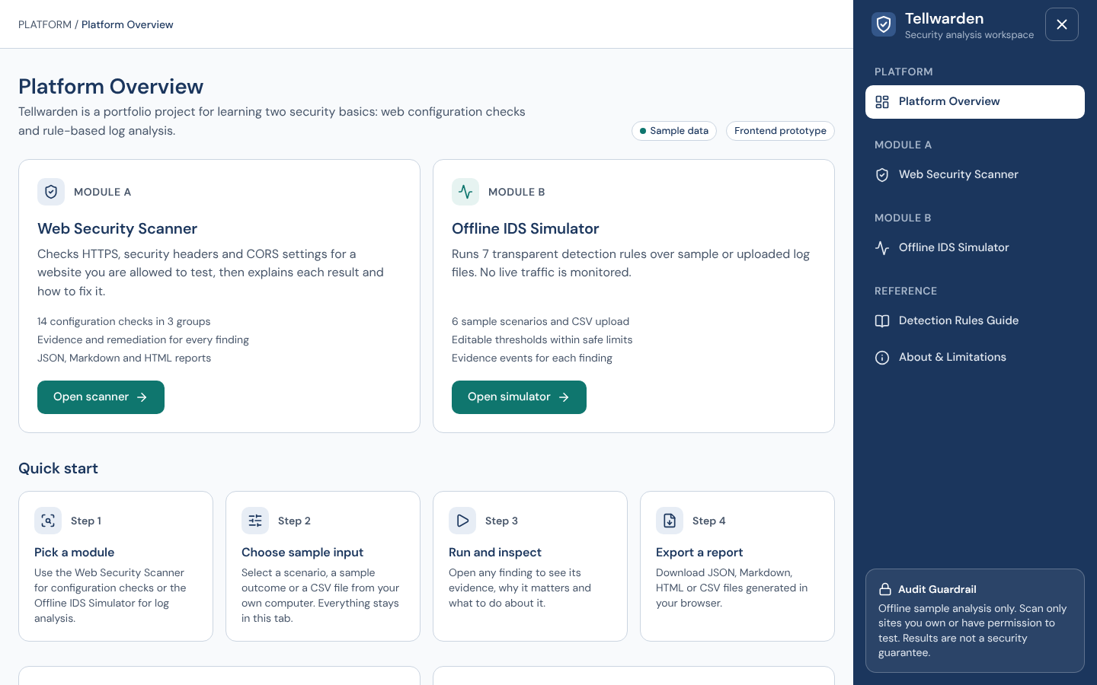
Figure 1. Platform Overview on a desktop screen, with the right-side navigation drawer.
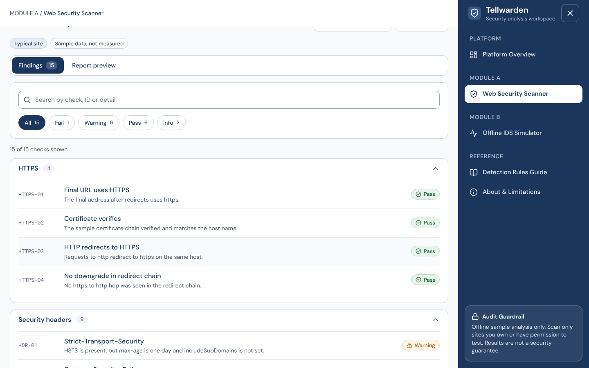
Figure 2. Scanner results for the typical sample outcome, grouped by HTTPS, headers and CORS.
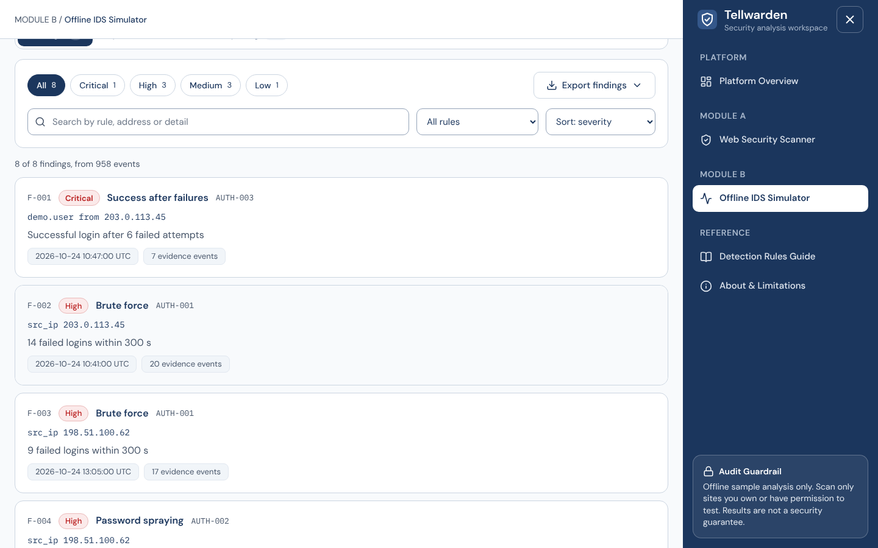
Figure 3. IDS findings for the mixed scenario, with severity filters, search and sorting.
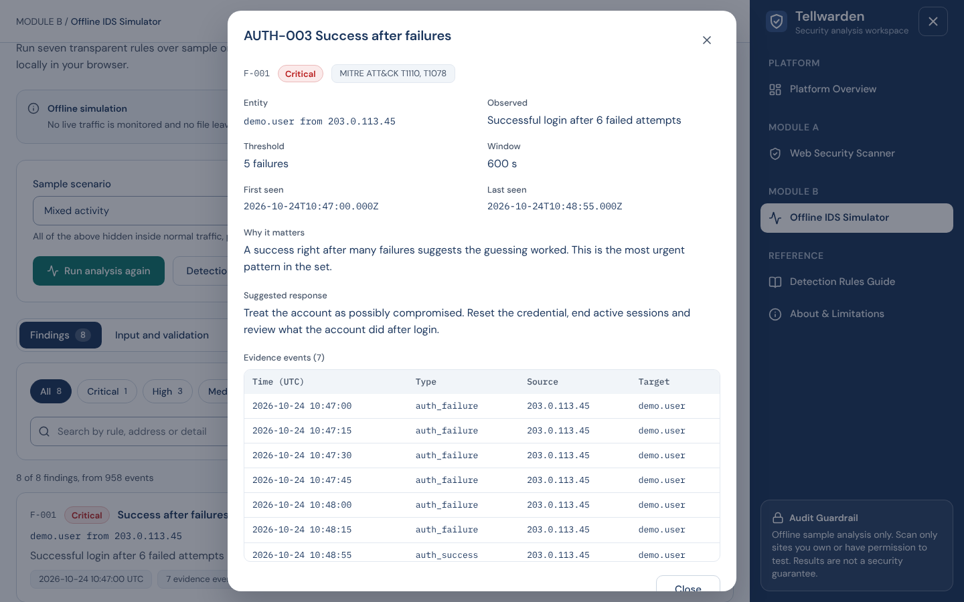
Figure 4. Evidence dialog for one finding, listing the events that caused it.
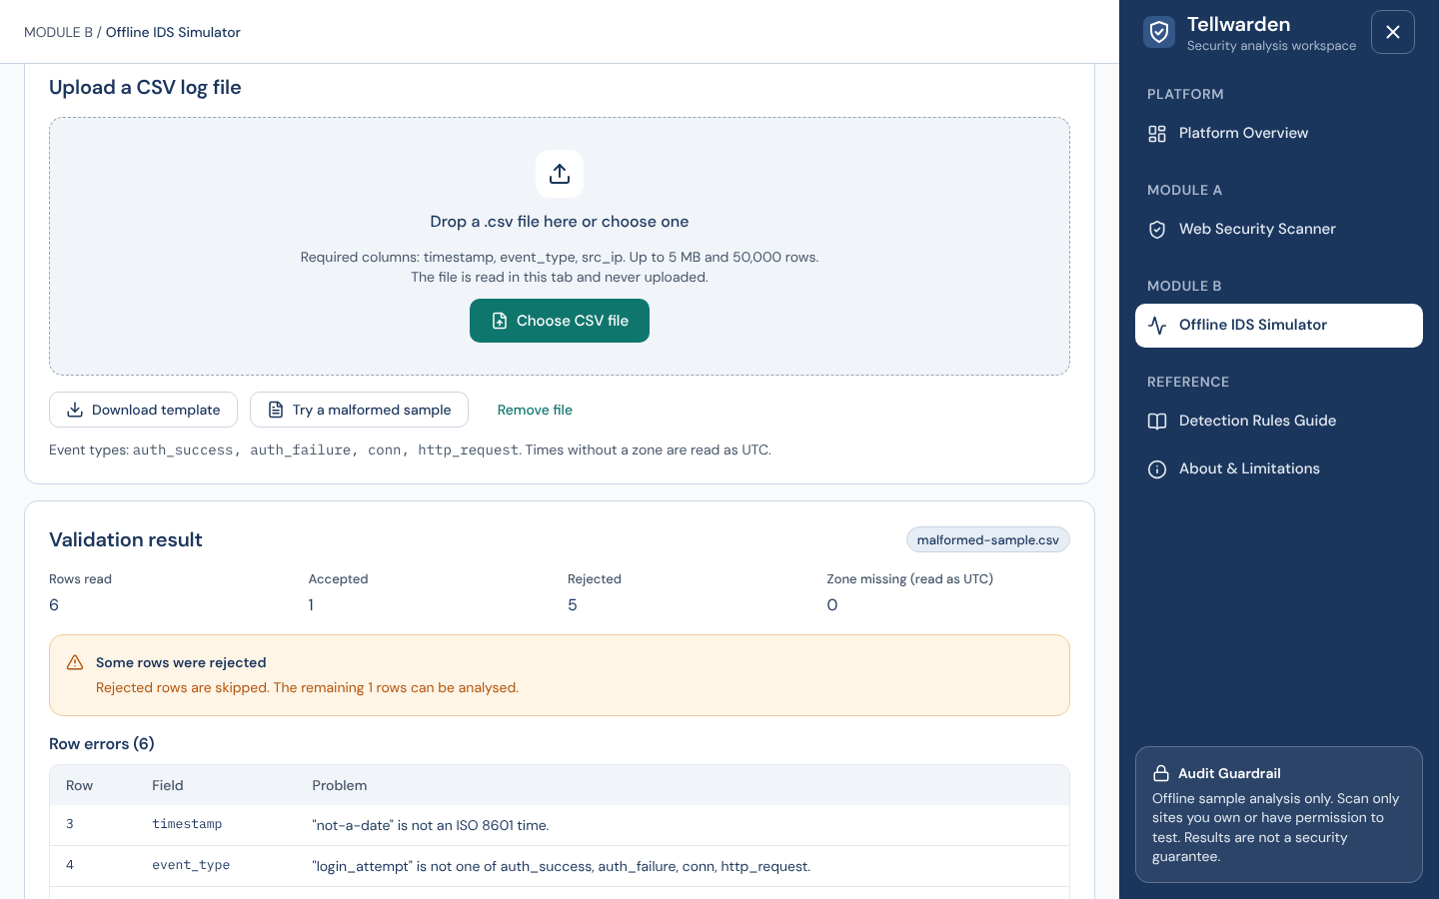
Figure 5. CSV validation of the malformed sample, with row-level errors.
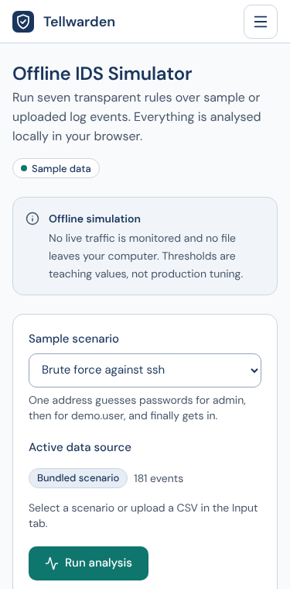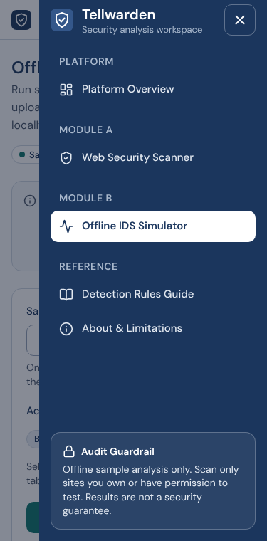
Figure 6. Mobile layout at 375 px. The drawer is closed by default and opens from the right over a backdrop.

10. Testing and Results

10.1 Method
The notebook contains assert statements after each part, so a wrong result stops the run. The notebook was executed from top to bottom with nbconvert, once in the development environment and once in a fresh virtual environment built only from requirements.txt. The browser prototype has 27 unit tests (Vitest) for its engine, CSV validator, URL check and export builders, plus scripted browser runs with Playwright in Chromium.

10.2 IDS results
Scenario | Events | Findings | Rules that fired
brute_force | 181 | 2 | AUTH-001, AUTH-003
password_spraying | 177 | 2 | AUTH-001, AUTH-002
port_scan | 215 | 2 | NET-001, NET-002
request_burst | 324 | 1 | WEB-001
mixed | 958 | 8 | AUTH-001 (two), AUTH-002, AUTH-003, AUTH-004, NET-001, NET-002, WEB-001
normal | 261 | 1 | AUTH-004 (the late-night login, a deliberate false-positive example)

Every expected rule fired in every scenario. The spraying scenario also raised AUTH-001 because one address failed nine times in five minutes, which is a true statement about the data and is noted as an acceptable extra. The normal scenario produced only the unusual-hour finding, which shows that the rules do not fire on everyday traffic. The Python engine and the TypeScript engine in the prototype gave the same finding counts for all six scenarios, although the background traffic is produced by different random generators.
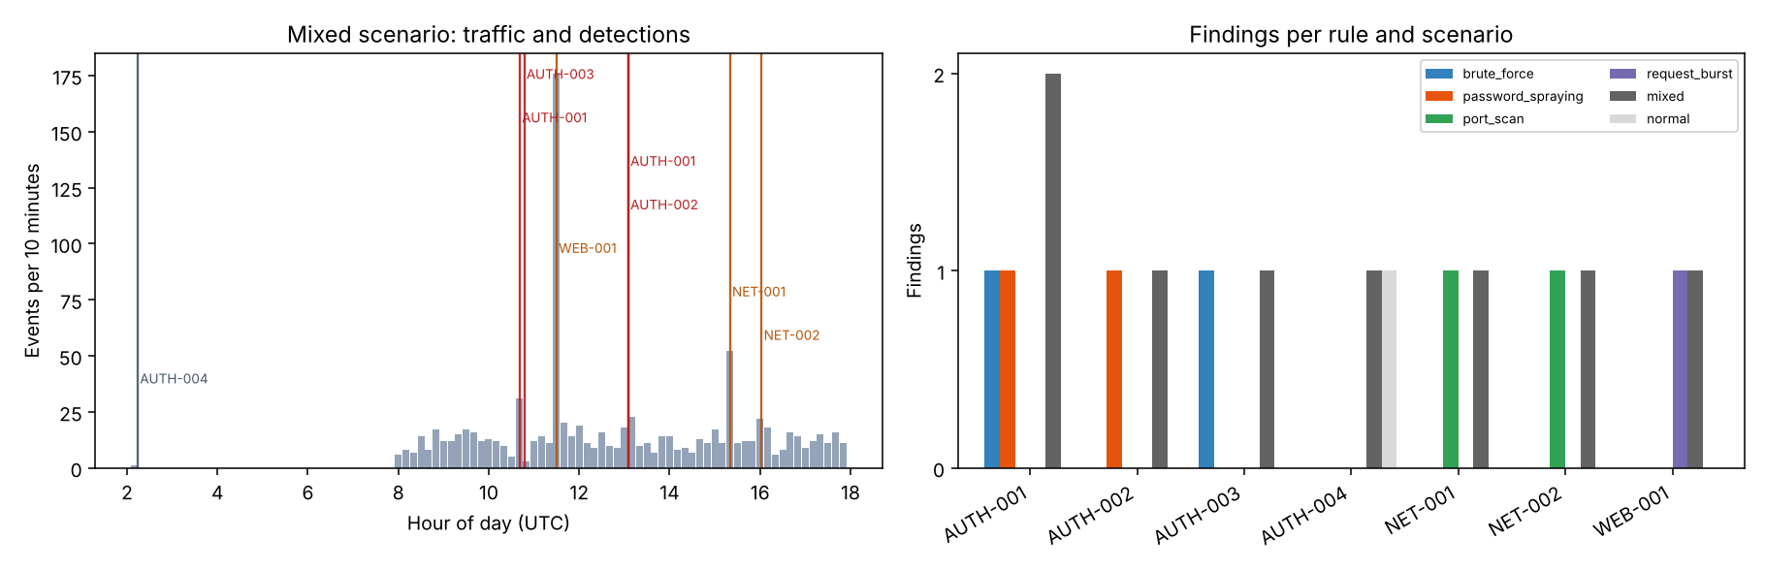
Figure 7. Left: events per ten minutes in the mixed scenario with each finding marked. Right: findings per rule and scenario.

10.3 Threshold and validation tests
Test | Result
AUTH-001 and AUTH-003 thresholds set to 50 on the brute-force scenario | Both findings disappear, so thresholds change results.
AUTH-001 threshold set to 999 | Rejected with a message naming the allowed range 2 to 50.
Valid CSV with 8 failed logins | 8 events accepted, 0 errors, AUTH-001 fires.
Malformed CSV with 6 bad rows | 1 row accepted, 6 row errors with row numbers.
Wrong columns, wrong extension, empty file, file over 5 MB | Each rejected with a clear message.
CSV cell starting with = | Prefixed with an apostrophe in the export.

10.4 Scanner results
Sample site | Pass | Warning | Fail | Info
weak | 0 | 4 | 9 | 2
typical | 7 | 6 | 0 | 2
strong | 13 | 0 | 0 | 1

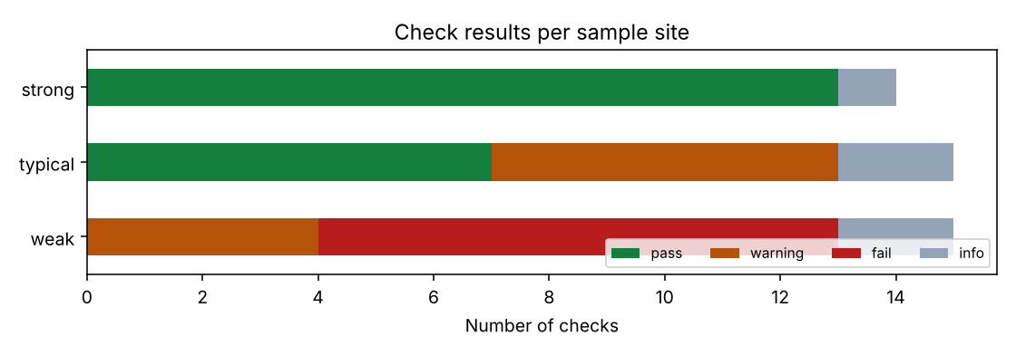
Figure 8. Check results for the three sample sites.
Target guard tests: all ten sample addresses behaved as expected. Allowed: https://example.test. Blocked: localhost, ftp, embedded credentials, 10.0.0.5, 169.254.169.254, a port other than 80 or 443, an invalid text, ::1 and 192.168.1.1. The live fetch refuses to run by default and refuses a private target even when both flags are on. The fetch code itself was tested against a throw-away server on the local machine, using a test-only bypass of the address guard. No external website was contacted at any time.

10.5 Browser prototype tests
Test | Result
Vitest unit tests (engine, CSV, URL, exports) | 27 of 27 passed.
Navigation checks over 11 viewport sizes, 320 to 1600 px | 175 checks passed: no horizontal overflow, drawer on the right, hamburger top-right, Escape, backdrop and link selection close the overlay, focus moves in and returns, focus is trapped, background is inert, body scroll is locked.
Page interaction checks | 68 checks passed: URL validation, loading, cancel, error and retry states, filters, search, modals, tabs, exports (JSON parsed and checked), CSV valid, malformed, wrong type and oversize, thresholds, pagination.
Network and console | No requests outside the page origin and no console errors.

These browser runs used Chromium only. Firefox, Safari, real phones and screen readers were not tested.

11. Security and Ethics
- Authorisation. The scanner asks the user to confirm ownership or written permission. The live fetch is off by default and needs two flags.
- SSRF protection. Text check, resolved-address check, manual redirects with a re-check at each hop, no body download, short timeouts.
- Untrusted input. CSV files are limited in size and rows, and every field is validated. Output into HTML is escaped, and CSV cells are protected against formula injection.
- No guarantees. Reports state that results cover selected configuration checks and do not prove a site is secure.
- Privacy. Nothing is uploaded or stored. In the browser prototype, uploaded files stay in the tab.
- Synthetic data only. Sample addresses come from reserved documentation ranges.

12. Limitations
- Fixed thresholds in sliding windows can miss slow attacks and can flag busy normal periods. Real use would need tuning and review of false positives.
- Synthetic data is cleaner than real logs. Results on real data will differ.
- The scanner reads response headers only. It does not test application logic, authentication, input handling or software vulnerabilities.
- The live fetch is open to DNS rebinding because it does not pin the connection to the checked address.
- WEB-001 is only indicative. A request burst can be a legitimate client, a monitor or a crawler.
- The planned Streamlit interface was not built. The submitted code is the notebook, and the interface is shown by the browser prototype.

13. Future Work
- Connect the browser interface to a real scanner service after the production controls (pinned connections, egress filtering, rate limiting, authentication) are in place.
- Add a Streamlit interface on top of the notebook code.
- Add rules for web log formats such as Apache and Nginx access logs.
- Let the user save and share threshold profiles.
- Compare results with a labelled public dataset to measure false positives and misses.

14. Conclusion
Tellwarden meets its aim of showing how a web configuration scanner and a rule-based IDS work, with logic that can be read, changed and tested. The Python notebook implements all seven detections and the scanner checks, validates its inputs, exports its results and passes its own self-checks in a clean environment. The browser prototype presents the same behaviour through a responsive interface. The project is a teaching tool. It does not replace professional security monitoring, and its results are not a guarantee of security.

15. References
[1] OWASP Foundation. HTTP Headers Cheat Sheet. https://cheatsheetseries.owasp.org/cheatsheets/HTTP_Headers_Cheat_Sheet.html
[2] OWASP Foundation. Secure Headers Project. https://owasp.org/www-project-secure-headers/
[3] OWASP Foundation. Server-Side Request Forgery Prevention Cheat Sheet. https://cheatsheetseries.owasp.org/cheatsheets/Server_Side_Request_Forgery_Prevention_Cheat_Sheet.html
[4] The MITRE Corporation. MITRE ATT&CK, techniques T1110 (Brute Force), T1078 (Valid Accounts), T1046 (Network Service Discovery), T1499 (Endpoint Denial of Service). https://attack.mitre.org/
[5] Hodges, J., Jackson, C., Barth, A. RFC 6797, HTTP Strict Transport Security (HSTS). https://www.rfc-editor.org/rfc/rfc6797
[6] Shafranovich, Y. RFC 4180, Common Format and MIME Type for CSV Files. https://www.rfc-editor.org/rfc/rfc4180
[7] Arkko, J., Cotton, M., Vegoda, L. RFC 5737, IPv4 Address Blocks Reserved for Documentation. https://www.rfc-editor.org/rfc/rfc5737
[8] WHATWG. Fetch Standard, CORS protocol. https://fetch.spec.whatwg.org/#http-cors-protocol
[9] W3C. Content Security Policy Level 3. https://www.w3.org/TR/CSP3/

Appendix A. How to Run
1. Create an environment: python -m venv .venv, then activate it.
2. Install dependencies: pip install -r requirements.txt
3. Open the notebook: jupyter notebook Vansh_Tellwarden.ipynb, then choose Run All Cells.
4. Results and charts are written to an outputs folder next to the notebook.
Browser prototype (optional): unzip tellwarden-web.zip, then run npm install and npm run dev, and open http://127.0.0.1:5173.

Appendix B. Submitted Files
File | Purpose
Vansh_Tellwarden.ipynb | Complete project code with results
requirements.txt | Python dependencies
Vansh_ProjectReport.docx | This report
README.md | Overview, dataset note, technologies, setup and run steps

