LEAD GENERATION
AI AGENT
Using n8n Workflow Automation
Automate business discovery · AI-qualify prospects · Enrich contacts · Store leads
Fully Automated  End-to-end pipeline | AI-Powered  Smart lead scoring | CRM Ready  Google Sheets output

VERSION | 1.0 · n8n Workflow Automation · AI + API Integration · Google Sheets CRM

01 Project Objective
Traditional lead generation requires significant manual effort, hours searching for businesses, collecting contact details, verifying company fit, and organizing data in spreadsheets. This project automates the entire process using n8n, AI models, APIs, and Google Sheets.
The system identifies businesses from a specific location, evaluates suitability as potential clients, enriches missing contact information, and saves only the most relevant prospects, freeing sales teams to focus purely on outreach.

02 Workflow Overview

01 | User Input & Business Discovery  Location and search radius are passed to a business discovery API via HTTP request. Returns local businesses with name, website, category, address, and contact details.

02 | Merge, Clean & Loop  A code node merges and structures returned data. Each record enters a loop for individual evaluation, improving reliability and simplifying error handling.

03 | AI Agent- Lead Qualification  The AI Agent scores each business against the ideal customer profile using type, description, website content, and metadata. Outputs a numeric score with rationale.

04 | Score Gate (IF Node)  Decision node checks if score exceeds the minimum threshold. Low-scoring businesses are auto-rejected; high-quality leads continue to enrichment.

05 | Data Enrichment  If contact info is missing, the workflow fetches the business website, extracts emails and phone numbers via custom code, and checks whether extraction succeeded.

06 | Google Sheets CRM Storage  Qualified, enriched leads are written to Google Sheets with company details, AI score, contact info, website URL, and enrichment results are updated automatically.

03 Workflow Diagram

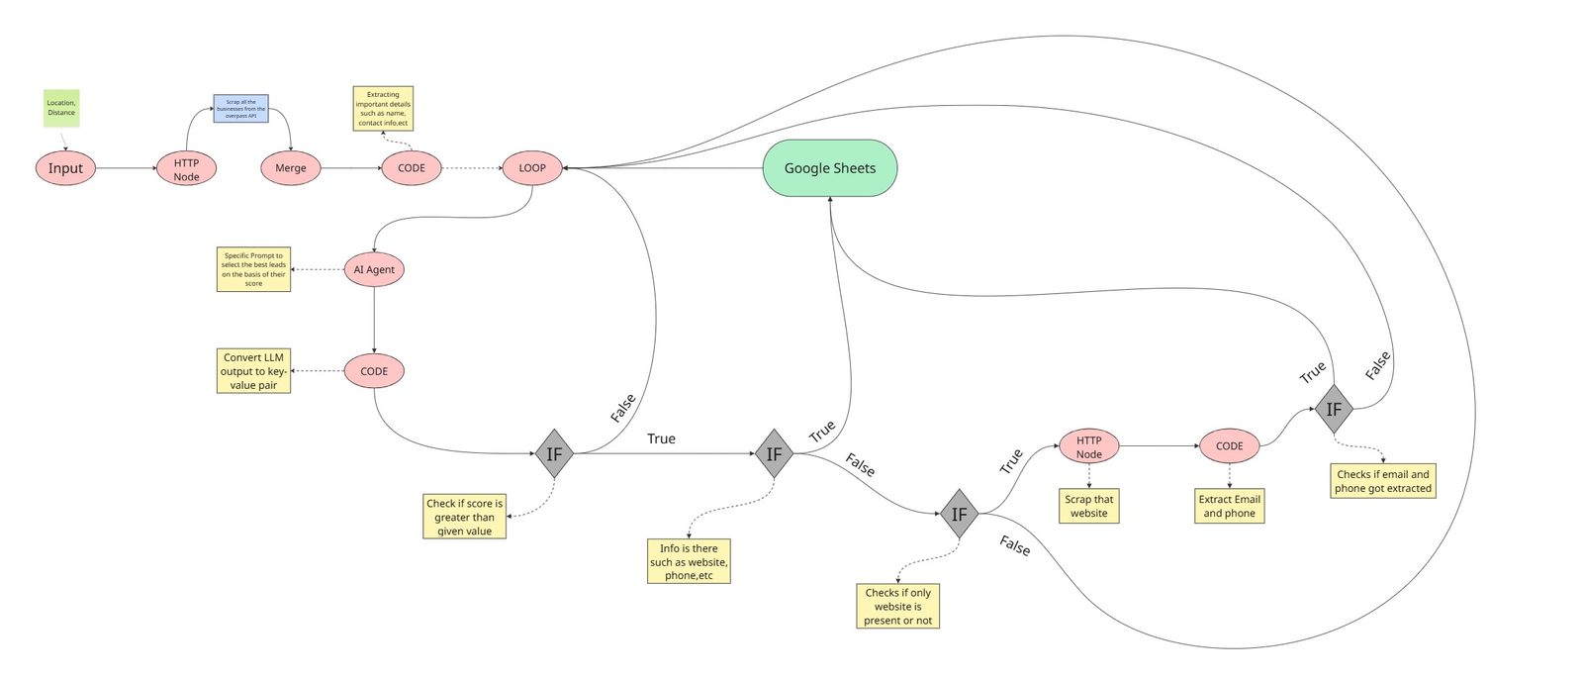

The diagram above shows the complete n8n workflow: user input → HTTP discovery → AI qualification → IF score gate → conditional enrichment branches (website scraping + email/phone extraction) → Google Sheets CRM storage.

04 AI-Powered Lead Qualification
The AI Agent is the core intelligence of the workflow. Rather than treating all discovered businesses as leads, it analyzes available data against predefined criteria mimicking the judgment of a human sales representative.

INPUT | Business type · Description · Website content · Available metadata

OUTPUT | Score (0–100) + rationale + PASS / REJECT decision

Low-scoring businesses are rejected by the IF node automatically. Only high-scoring prospects advance, dramatically improving lead quality and preventing wasted outreach effort.

05 Data Enrichment Process
After passing qualification, the workflow checks for sufficient contact information via two conditional IF nodes:

WEBSITE FOUND | HTTP node fetches the website. Code node extracts publicly listed emails and phone numbers. Final IF checks whether extraction succeeded.

MISSING INFO | Lead is flagged or skipped based on configured thresholds, keeping the CRM clean and actionable.

06 CRM Storage & Benefits
Qualified, enriched leads are written to Google Sheets automatically and no manual data entry needed. The CRM stays continuously updated.

STORED FIELDS | Company details · AI score & rationale · Contact info · Website URL · Enrichment results
UPDATE CYCLE | Continuous leads added automatically on every workflow run, zero manual entry
SCALABILITY | Accounting · Marketing · SaaS · Consulting · Recruitment modify AI criteria to switch segments

07 Future Improvements

Multi-Source Lead Collection
Integrate Google Maps, LinkedIn, Yelp, and business directories to discover more leads across multiple platforms simultaneously.

Apollo / Hunter Integration
Use dedicated enrichment platforms to obtain more accurate and verified contact information at scale.

Advanced Email Discovery
Improve email extraction accuracy using multiple cross-referencing and verification sources.

Personalized AI Cold Emails
Automatically generate customized outreach emails based on each business's profile and website content.

08 Conclusion
The Lead Generation AI Agent demonstrates how workflow automation and AI can streamline prospecting at scale. By combining business discovery, AI qualification, contact enrichment, and automated CRM updates in a single n8n workflow, the system reduces operational effort, improves lead quality, and provides a scalable framework for modern sales and business development teams.

