Sentrix Hackathon
SOC-in-a-Box: Detection, SIEM, WAF & Identity Build
Day 2 Progress Report - June 22, 2026
This is the Day 2 log for the Mini Sentrix Hackathon - a 5-person SOC build covering network and VM infra, Suricata detection, the Wazuh dashboard, a ModSecurity WAF in front of DVWA, and Keycloak identity. Day 2's bar from the hackathon brief is a live SIEM dashboard fed by at least two sources (IDS + WAF), an IAM layer enforcing access on at least one real service, and all three attack simulations (Nmap, Hydra, SQLMap) visible in that dashboard. Each section below maps to a member's lane, what got proven working today with real commands and screenshots, and what's still open before the Day 2 Proof Deck.

1. Where Each Lane Stands
Member | Component | Status | Evidence today
Member 1 - Infra & Network | Kali, Metasploitable2, Ubuntu Security VM, host-only network | On track | VMs reachable; Kali traffic visible from the security VM
Member 2 - IDS / Detection | Suricata | Working | Live alerts for Nmap-style scans, ICMP probes, Kali DHCP fingerprint
Member 3 - SIEM / Dashboard | Wazuh Manager + Dashboard | Working, agents reconciled | 4 agents registered; 2 were pending at screenshot time, now active
Member 4 - WAF / Web Security | ModSecurity + Nginx + DVWA | Working | SQLMap attack blocked (403), full anomaly-score log captured
Member 5 - IAM / SOAR | Keycloak (Sentrix realm) | IAM done, SOAR design stage | 3 roles + 3 users created and mapped; Shuffle workflow still to be built

2. Member 1 - Infrastructure & Network
Network is up across the lab. Kali, the Metasploitable2/target VMs, and the Ubuntu security VM (running Suricata and Wazuh) can all reach each other over the host-only network. The clearest proof of this is the security VM passively picking up Kali's own traffic the moment it joined the network - that only happens if routing and visibility are both actually working, not just configured on paper.
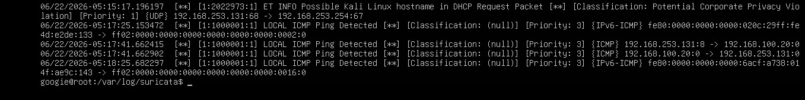
Fig. 1 - Suricata eve.json on the Ubuntu security VM picking up the Kali box over the host-only network (DHCP hostname leak + ICMP ping detections), confirming cross-VM connectivity.
Open for this lane: keep the architecture diagram and the IP/topology table in sync now that the two previously-unregistered Wazuh agents (ubuntu-target, waf-host) are back online. Worth a 10-minute sync with Member 3 so the documented IPs match what's actually live before the demo.

3. Member 2 - IDS / Detection Engineering
Suricata is live on the security VM and generating real alerts off real traffic, not synthetic test rules. The capture in Fig. 1 shows it catching an Nmap-style probe pattern - an ICMP echo plus a DHCP request that leaks the source as a Kali box - coming from a teammate's VM. That single screenshot is the proof point for both the network connectivity (Section 2) and the detection engine itself: the same alerts confirm the VMs can see each other and that Suricata is parsing the traffic correctly.

Commands run
sudo tail -f /var/log/suricata/eve.json | jq 'select(.event_type=="alert")'
nmap -sS <VM2-or-VM3-IP>
nmap -sV -O 192.168.100.20
sudo grep '"event_type":"alert"' /var/log/suricata/eve.json | tail -5 > ~/sample-eve-alert.json
ls -l /var/lib/suricata/rules/
ls -lh /var/lib/suricata/rules/suricata.rules
sudo tail -f /var/log/suricata/fast.log

The jq filter is the actual triage step planned for the live demo - piping eve.json through it strips the stream down to alert-type events only, instead of every flow log, which is what makes it watchable on screen instead of a wall of scroll. The grep into sample-eve-alert.json is the saved evidence artifact going into the report and judge packet.
Takeaway: both the custom local rules (ICMP ping detection) and the community ET ruleset are loaded and firing, which was the main thing to prove today. Still open: a dedicated pass running the actual Nmap -sS / -sV -O scans against the target VM and the Hydra/SQLMap attack chains, to confirm alert quality and tune out false positives before the judged demo.

4. Member 4 - WAF & Web Security
This is the most complete lane as of today. DVWA is deployed behind an Nginx reverse proxy running the OWASP ModSecurity Core Rule Set, and a real SQLMap attack against it was caught and blocked end to end, with full structured logging to back it up.

Stack stood up via Docker Compose
cd Desktop
mkdir waf-setup && cd waf-setup
notepad docker-compose.yml
docker-compose up -d
Compose pulled and started two containers - vulnerables/web-dvwa as the target app and owasp/modsecurity-crs:nginx as the reverse proxy and WAF - connected over a dedicated waf-setup_wafnet Docker network.
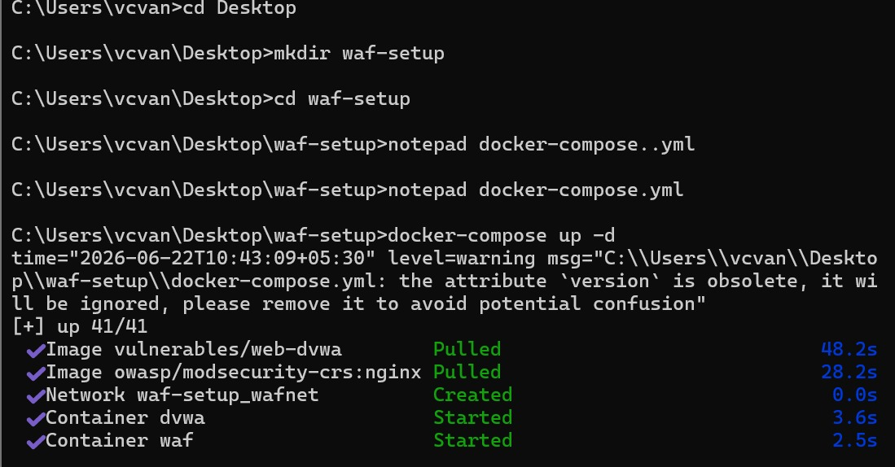
Fig. 2 - docker-compose up -d output: both images pulled and both containers (waf, dvwa) started successfully.
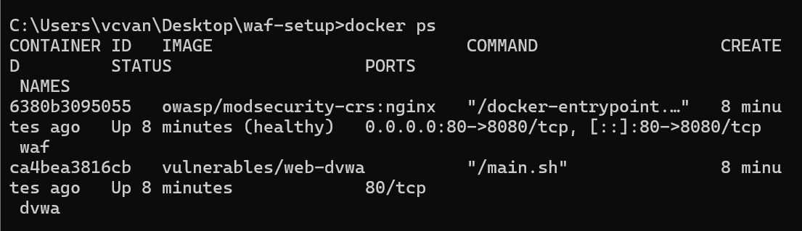
Fig. 3 - docker ps confirming both containers healthy and running: the waf container (owasp/modsecurity-crs:nginx) is marked 'healthy' and port-mapped 80→8080; dvwa is up alongside it.

Attack and block
With the stack live, the team ran SQLMap against the DVWA SQL injection endpoint through the WAF. ModSecurity's OWASP CRS caught it on multiple fronts at once: it flagged the SQLMap user-agent string as a known scanner, matched the payload against the SQL injection attack rules, and separately caught a time-based blind SQLi pattern (a WAITFOR DELAY / pg_sleep style payload). The combined anomaly score crossed the blocking threshold and Nginx returned a 403.
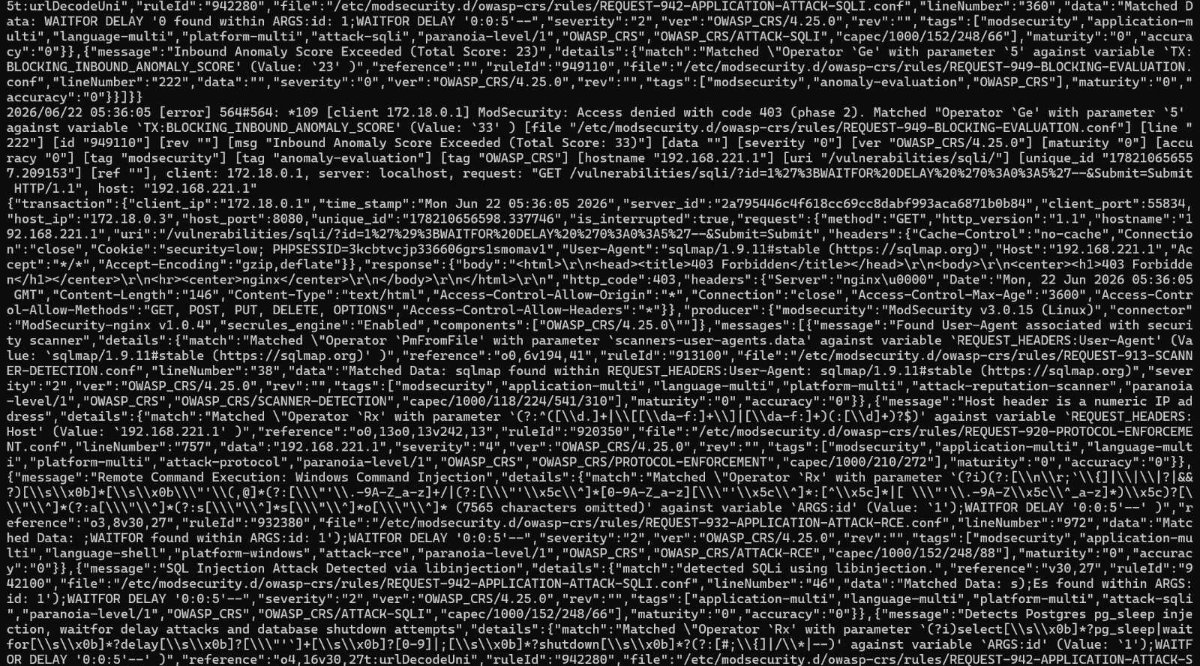
Fig. 4 - Raw ModSecurity audit log for the blocked request: SQLMap user-agent detected, SQL injection via libinjection matched, WAITFOR DELAY time-based blind SQLi pattern matched, inbound anomaly score 33 (threshold exceeded), final response 403 Forbidden from Nginx.
This is the strongest piece of evidence in the build so far - it's not a configuration screenshot, it's an actual attack request and the WAF's full decision trail for blocking it, which is exactly what the success criteria for this lane asks for.
Open for this lane: get this same WAF log flowing into Wazuh (Member 3's side) so the block event shows up on the SIEM dashboard, not just in the container's own logs. That handoff is the one piece needed to satisfy the full success criteria of "block event appears in logs and SIEM."

5. Member 3 - SIEM & Dashboard
Wazuh Manager and Dashboard are deployed and reachable. The Endpoints view confirms the manager is actively tracking all 4 planned agents across mixed OS (Ubuntu and Windows).
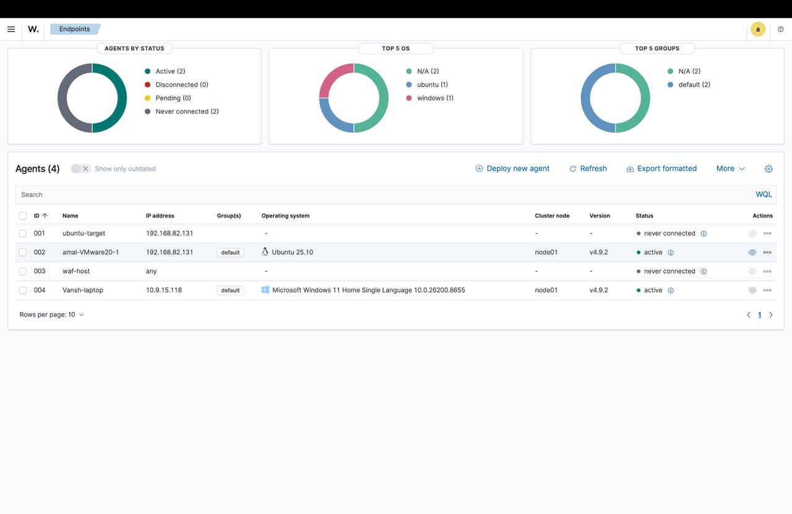
Fig. 5 - Wazuh Endpoints dashboard at the time of this screenshot: amal-VMware20-1 (Ubuntu) and Vansh-laptop (Windows) active; ubuntu-target and waf-host showing 'never connected'. Both have since been reconnected and are reporting in.
By the time of writing, ubuntu-target and waf-host are both online, so agent rollout across all four planned endpoints is effectively done. What's still open for this lane is the log pipeline itself: pulling Suricata alerts into Wazuh (not just leaving them on the security VM's local disk) and wiring up the ModSecurity/WAF logs as a second source, then building the five required panels - alert count by type, top source IPs, WAF blocks, authentication events, and critical security events. None of the dashboard panels are built yet; today was endpoint onboarding and getting the manager stable.

6. Member 5 - IAM & SOAR
Keycloak is deployed and a dedicated realm (Sentrix) is configured with the role-based access control the success criteria asks for.

Roles defined
- SOC_Admin - full administrative access (described in the realm as “ye hai admin”)
- SOC_Analyst - working-tier access for analysts triaging alerts
- SOC_Viewer - read-only access for dashboard viewing
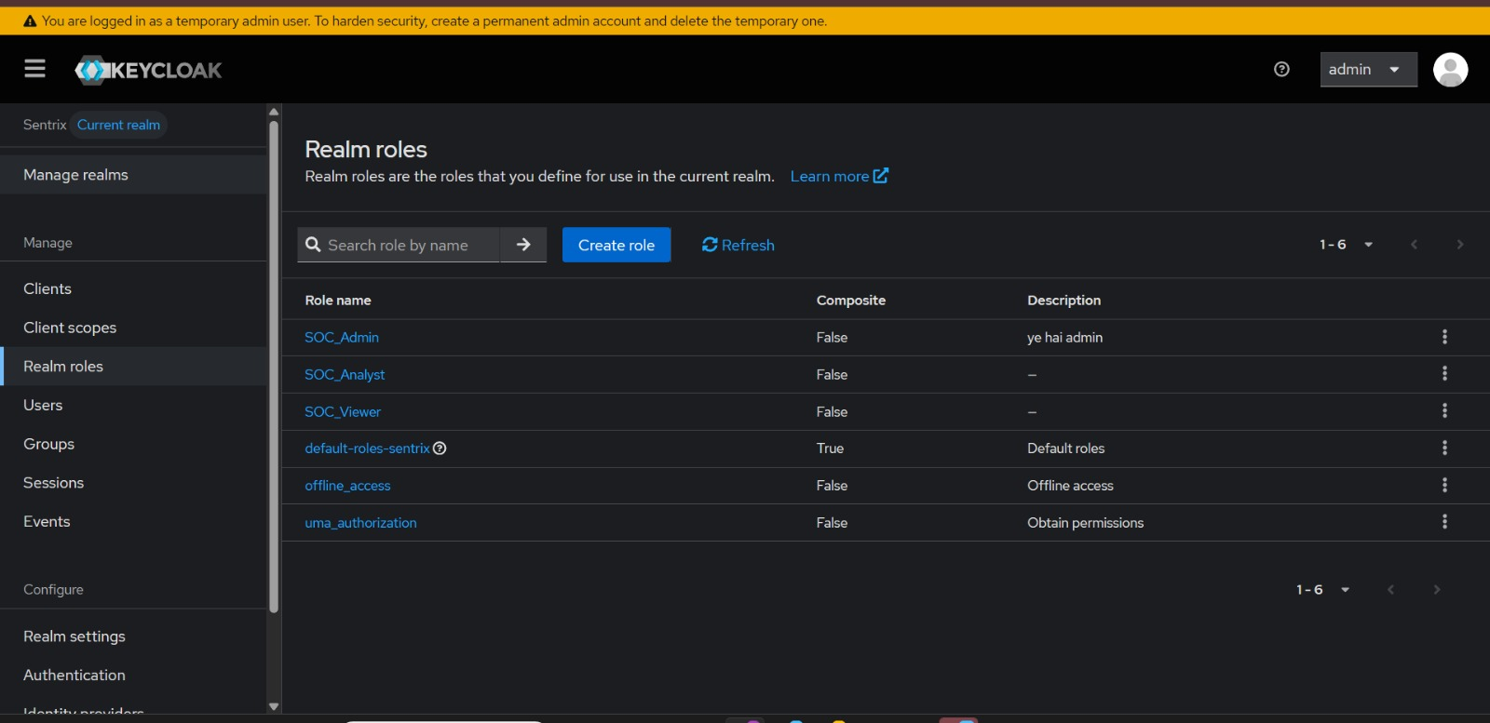
Fig. 6 - Keycloak realm roles inside the Sentrix realm: SOC_Admin, SOC_Analyst, and SOC_Viewer created alongside Keycloak's built-in default roles.

Users created and mapped
Three users exist in the realm - adminuser, analyst1, and viewer1 - matching the three roles one-to-one. The role mapping was tested by assigning SOC_Admin to adminuser and confirming it sticks in the role-mapping view, alongside the default-roles-sentrix baseline role every user inherits.
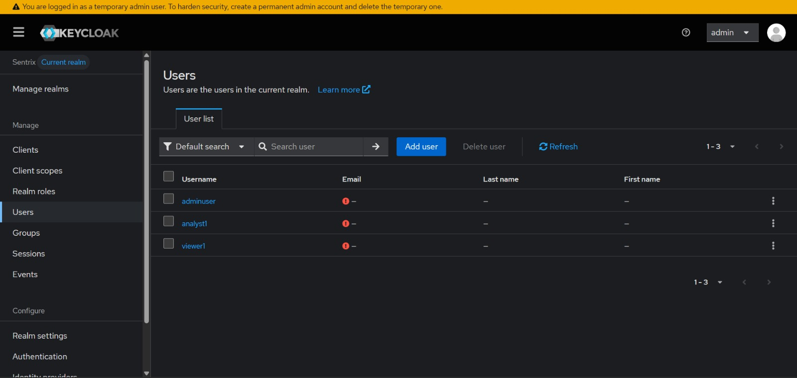
Fig. 7 - Users tab in the Sentrix realm: adminuser, analyst1, and viewer1 created, ready for role assignment.
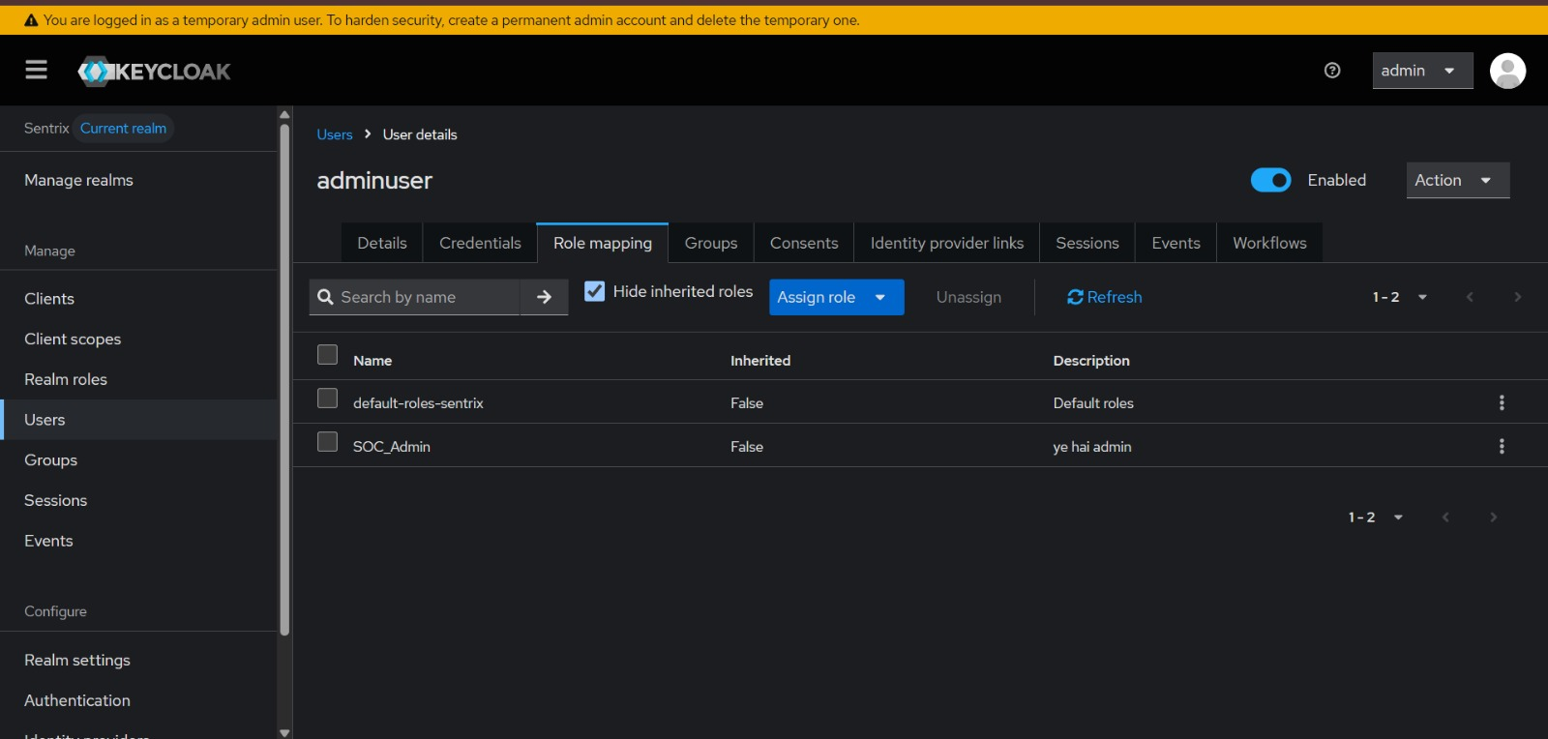
Fig. 8 - Role mapping for adminuser, confirming SOC_Admin is assigned on top of the inherited default-roles-sentrix role. This proves the RBAC model is functional, not just defined.
This satisfies the IAM success criterion - a real, working identity provider with role-based access, not just a stood-up container. What's still pending is the SOAR half of this lane: no Shuffle workflow has been built yet. The plan (Hydra attack → Suricata alert → Shuffle workflow → automatic response → attacker IP blocked) is designed and matches the team's integration plan, but it hasn't been implemented or tested as a live automation. That's the priority for Member 5 next, alongside putting one real service behind Keycloak (e.g. the Wazuh or DVWA login) so “protected service requires authentication” has a concrete demo, not just the realm config.

8. Day 2 Brownie Point - “The Loyal Guard Who Lets Everyone In”
In progress - not yet decoded/implemented at the time of this report. The riddle points at the gap between authentication and behavioral detection: a login system that checks credentials correctly every time is still blind to a login pattern that should never have been allowed - the same identity logging in four times in under ten minutes at 2 AM, for instance. The riddle is asking for something layered on top of Keycloak’s auth success/failure logs: rate-of-login analysis, time-of-day anomaly flags, or repeated-auth-in-a-short-window detection, surfaced as its own alert rather than buried as a string of identical 200-OK events.
This section will be filled in with the actual decode, the implementation, and supporting evidence once that work is done. Flagging it here now so the report doesn’t go silent on a 15-point item - same weight as the entire Day 2 Proof Deck.

9. How the Pieces Fit Together (Demo Flow)
Mapping today's work against the planned Day 2 demo flow:
- Kali launches an Nmap scan - confirmed: Suricata is picking up scan-style traffic from Kali over the host-only network (Fig. 1).
- Suricata detects the scan - confirmed: alerts are generating in real time in eve.json and fast.log.
- Wazuh receives the alert - not yet wired up. This is the main integration gap between Member 2 and Member 3's work.
- Dashboard displays the event - blocked on the previous step; no panels built yet.
- Kali launches a Hydra attack - not run yet today; SQLMap was prioritized instead.
- Suricata detects the Hydra attack - pending, once Hydra is actually run against a target.
- Wazuh displays the alert - pending, same integration gap as step 3.
- Kali launches a SQLMap attack - done. Full attack run against the DVWA SQLi page (Fig. 4).
- ModSecurity blocks the attack - done. 403 returned, multiple CRS rules matched, anomaly score exceeded threshold (Fig. 4).
- WAF logs are generated - done. Full JSON audit log captured (Fig. 4).
- Wazuh receives the WAF logs - not yet done. Same pipeline gap, WAF side.
- Dashboard displays the block event - blocked on the previous step.
- Demonstrate the Keycloak-protected service - partially done. Roles, users, and RBAC are real and working (Fig. 6–8), but no actual service is sitting behind Keycloak auth yet.
- Present the planned SOAR workflow - design only. The Hydra → Suricata → Shuffle → block-IP chain is mapped out but not built.
Net picture: detection (Suricata) and web defense (ModSecurity/WAF) are each independently proven with real attack traffic and real blocks. Identity (Keycloak) is functionally built. The piece tying the whole demo together - getting Suricata and WAF logs actually landing in Wazuh, and getting one real service behind Keycloak - is the single biggest priority for the next working session, since it's what turns five separate working components into the one connected SOC pipeline the demo flow describes.

10. Priorities Going Into the Next Session
Reordered against the actual Day 2 bar from the hackathon brief: a live SIEM dashboard fed by at least two sources (IDS + WAF), an IAM layer enforcing access on at least one real service, and all three attack simulations (Nmap, Hydra, SQLMap) visible in that dashboard. Hitting those three is what separates a working Day 2 from a collection of working demos.
- Wire Suricata's eve.json into Wazuh as a log source (Member 2 + Member 3) - this alone gets one of the two required SIEM sources live.
- Forward the ModSecurity audit log into Wazuh (Member 4 + Member 3) - the second required SIEM source; together these two satisfy the “≥2 sources” bar.
- Run the Hydra brute-force attack against a target service and confirm Suricata catches it (Member 1 + Member 2) - Nmap and SQLMap are proven; Hydra is the one simulation still missing for the “all 3 attacks visible” requirement.
- Build the required dashboard panels in Wazuh once log sources are flowing - alert count by type, top source IPs, WAF blocks, authentication events (Member 3).
- Put one real service behind Keycloak auth and demo a login as analyst1 vs adminuser - this is what turns the IAM lane from “configured” into “enforcing,” which is the actual bar (Member 5).
- Decode and implement the Day 2 Brownie Point (login-pattern anomaly detection on top of Keycloak's auth logs) - currently in progress, worth 15 points, same weight as the full Day 2 Proof Deck (Member 5 + whoever pairs on it).
- Build the actual Shuffle workflow for the Hydra → alert → auto-block chain (Member 5) - currently design-only; this is a Day 3 deliverable but worth starting early.
- Sync the network/IP documentation now that all five Wazuh-relevant endpoints are confirmed active (Member 1 + Member 3).

