The data shared with you is the data of a survey in which people have been asked some questions and answers to those questions are also recorded.

1. Load the data into powerbi and do the cleaning process.
   1. No null values should be there in any column.
   2. No empty columns.
   3. Data type of every column should be correct corresponding to its data.
2. Create Stacked bar chart and show the **Average Salary by Job Title.**
   1. **X axis (title) – Average Salary**
   2. **Y axis (title) – Job Title**

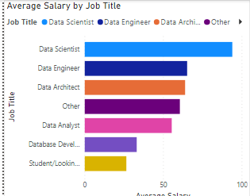

1. Create a stacked columns chart for the **Favorite Programming Language.** 
   1. **X axis (title) - Fav Prog Language**
   2. **Y axis (title) – Count of People**

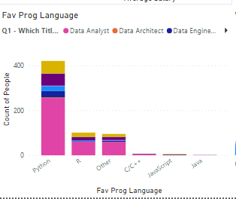

1. Create a gauge chart to show the **work life balance.**

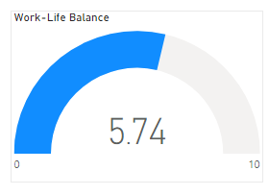

1. Show using a gauge chart **how much people are happy with their salary**

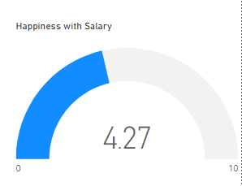

1. Create a Treemap to show the **job title by country**

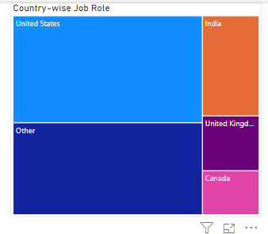

1. Show the count of total people who have participated in the survey.
2. Show the average age of the people participating in the survey.

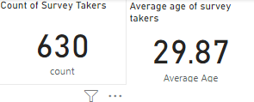

1. Show the **Average Salary by Gender**

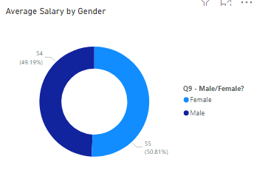

1. Show **Difficulty to break into data**

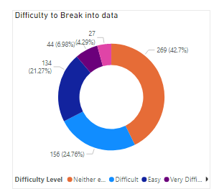

11.The dashboard should look something like this:

