

**Assessment Report**

on

**“Student Performance Prediction”**

submitted as partial fulfillment for the award of

**BACHELOR OF TECHNOLOGY**

**DEGREE**

SESSION 2024-25

in

**CSE(AI&ML)**

By

Vanshika Arora(202401100400208)

**Under the supervision of**

“Mr.Abhishek Shukla”

**KIET Group of Institutions, Ghaziabad**

Affiliated to

**Dr. A.P.J. Abdul Kalam Technical University, Lucknow**

(Formerly UPTU)

**INTRODUCTION**

Predicting student performance is a valuable tool for educational institutions to identify at-risk students and implement timely interventions. In this project, we used a classification model to determine whether a student will **pass or fail** based on their academic behaviour, attendance, and support systems.

We used a dataset containing features such as:

* Absences
* Weekly study time
* Tutoring support
* Parental support
* GPA (used to define pass/fail)

The goal was to build a machine learning model that could classify students accurately based on these features. We selected a **Random Forest Classifier** for this task, given its ability to handle both categorical and numerical data effectively and its robustness against overfitting. The model is trained and evaluated using standard performance metrics like **accuracy**, **precision**, and **recall**, with visualization through a **confusion matrix heatmap** for better interpretability.

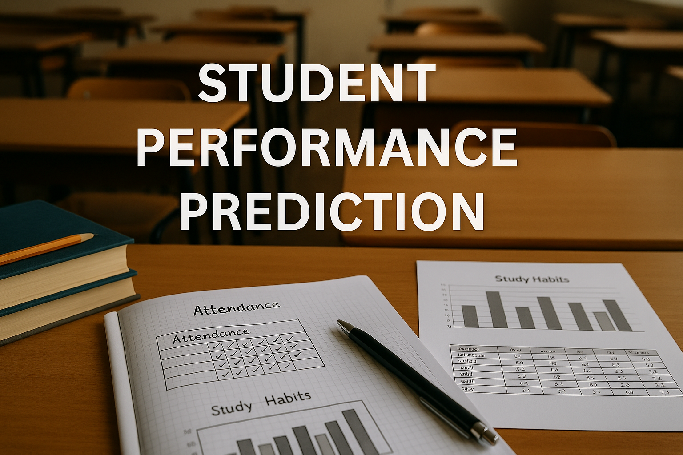

**METHODOLOGY**

1. **Dataset Preparation**:
   * Uploaded the dataset Student Performance Prediction.csv to Google Colab.
   * A new column Pass was created: students with GPA ≥ 2.0 were labeled as "Pass" (1), otherwise "Fail" (0).
2. **Feature Selection**:
   * **Selected features:**

Absences, StudyTimeWeekly, Tutoring, and ParentalSupport.

1. **Model Building**:
   * Used a **Random Forest Classifier**, known for handling mixed data types and providing high accuracy.
   * The dataset was split into training and testing sets (70/30 split).
2. **Evaluation**:
   * **Confusion Matrix:** Visualized as a heatmap to assess the number of true positives, true negatives, false positives, and false negatives.
   * **Accuracy:** Measures the overall correctness of the model.
   * **Precision:** Indicates the proportion of correctly predicted positive observations among all predicted positives.
   * **Recall:** Measures the proportion of actual positive cases that were correctly identified.

**CODE :**

# Step 1: Upload the dataset

from google.colab import files

uploaded = files.upload()

# Step 2: Import libraries and load the data

import pandas as pd

import seaborn as sns

import matplotlib.pyplot as plt

from sklearn.model_selection import train_test_split

from sklearn.ensemble import RandomForestClassifier

from sklearn.metrics import confusion_matrix, accuracy_score, precision_score, recall_score

# Load the dataset

df = pd.read_csv("8. Student Performance Prediction.csv")

# Step 3: Define Pass/Fail label based on GPA

df['Pass'] = (df['GPA'] >= 2.0).astype(int)

# Step 4: Select features and labels

features = ['Absences', 'StudyTimeWeekly', 'Tutoring', 'ParentalSupport']

X = df[features]

y = df['Pass']

# Step 5: Train-test split

X_train, X_test, y_train, y_test = train_test_split(X, y, test_size=0.3, random_state=42)

# Step 6: Train the model

model = RandomForestClassifier(random_state=42)

model.fit(X_train, y_train)

# Step 7: Make predictions

y_pred = model.predict(X_test)

# Step 8: Confusion Matrix

cm = confusion_matrix(y_test, y_pred)

labels = ['Fail', 'Pass']

# Step 9: Plot Confusion Matrix Heatmap

plt.figure(figsize=(6, 4))

sns.heatmap(cm, annot=True, fmt='d', cmap='Blues', xticklabels=labels, yticklabels=labels)

plt.xlabel('Predicted')

plt.ylabel('Actual')

plt.title('Confusion Matrix Heatmap')

plt.tight_layout()

plt.show()

# Step 10: Evaluation Metrics

accuracy = accuracy_score(y_test, y_pred)

precision = precision_score(y_test, y_pred)

recall = recall_score(y_test, y_pred)

print(f"Accuracy: {accuracy:.2f}")

print(f"Precision: {precision:.2f}")

print(f"Recall: {recall:.2f}")

**OUTPUT**

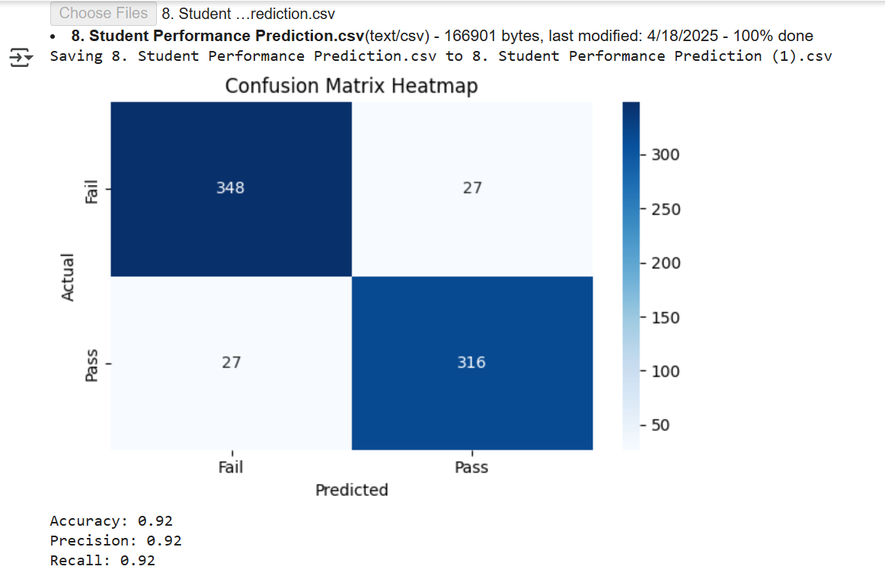

**REFERENCES/CREDITS**

* Dataset: *Student Performance Prediction.csv* (provided)
* Libraries: pandas, scikit-learn, matplotlib, seaborn
* Platform: Google Colab (https://colab.research.google.com/)
* Random Forest Classifier: Scikit-learn Documentation