**SQL SALES ANALYSIS FOR PIZZA SALES OF A RESTAURANT**

1. **Total Revenue for all pizzas ordered**

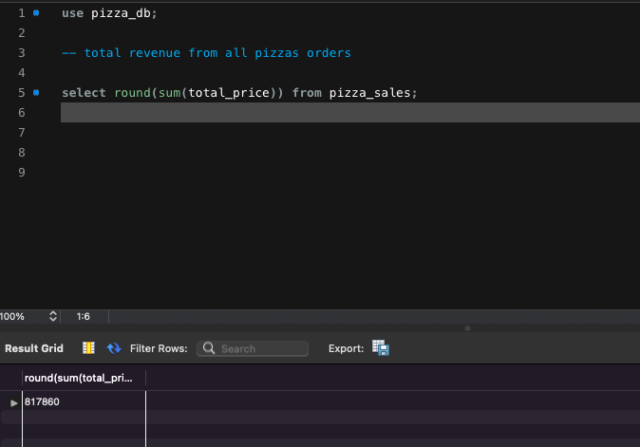

1. **Average order value of pizzas**

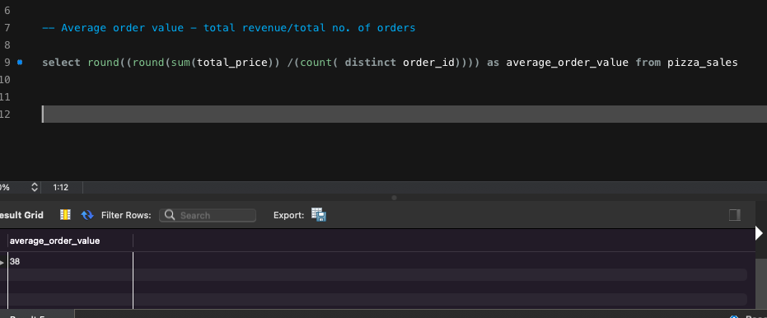

1. **Total pizzas sold**

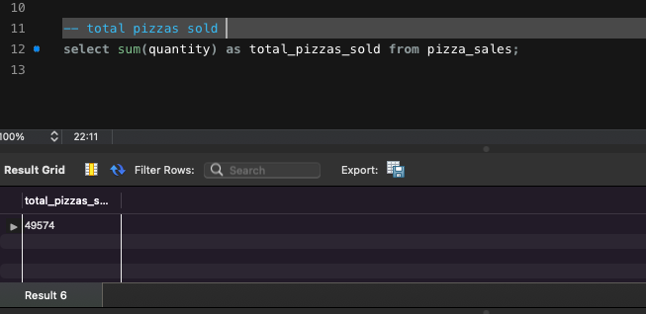

1. **Total orders placed**

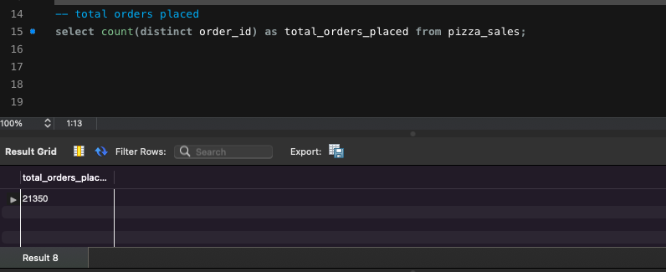

1. **Average pizzas per order**

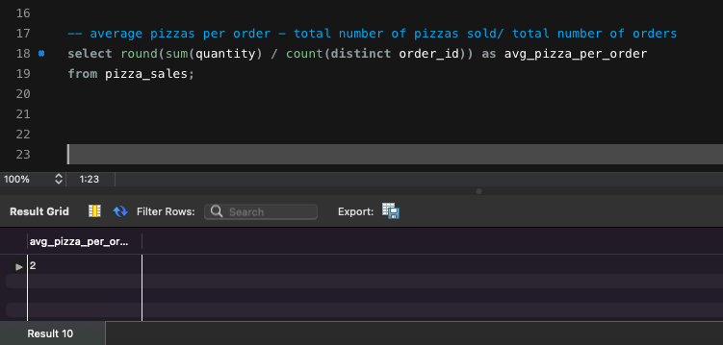

1. **Weekly trend of orders placed**

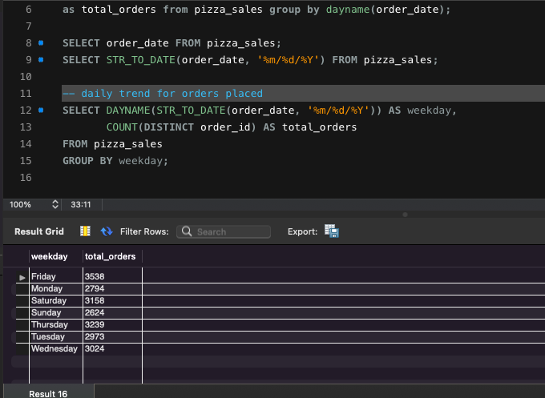

1. **Monthly trend of orders placed**

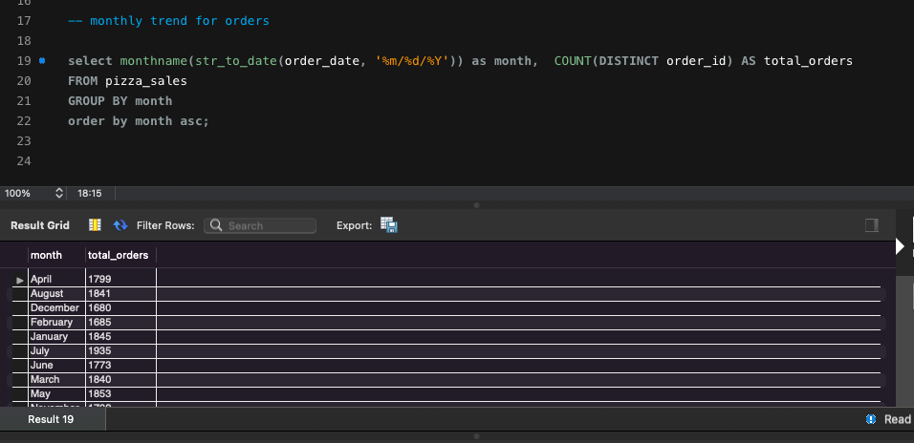

1. **Percentage of sales by pizza category**

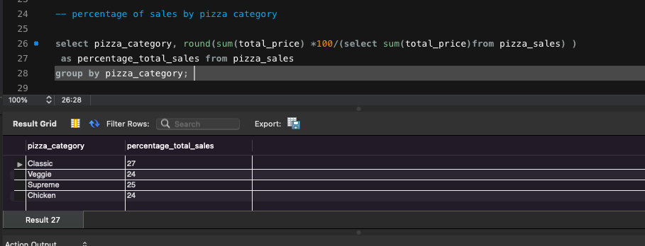

1. **Percentage of sales by pizza size**

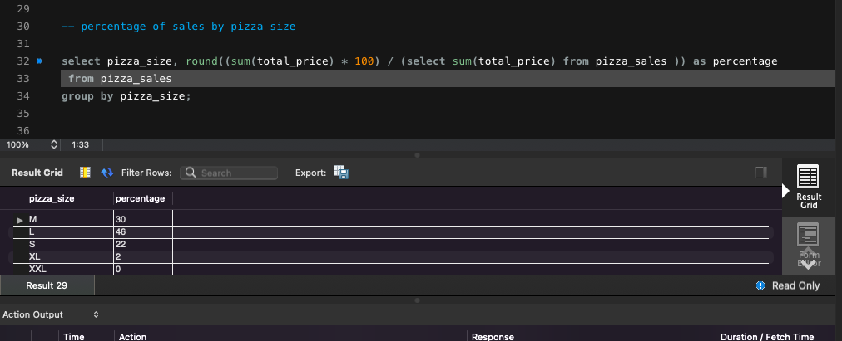

1. **Total pizzas sold by pizza category**

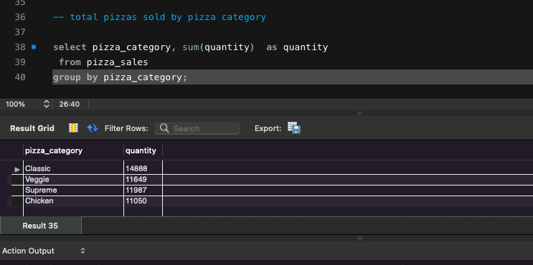

1. **Top 5 best sellers by revenue, total quantity and total orders**

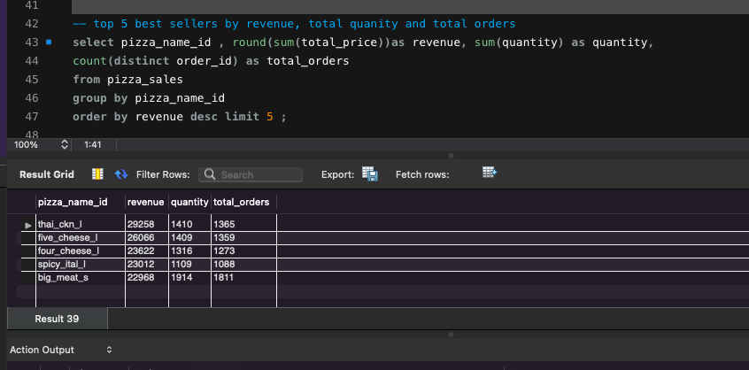

1. **Top 5 worst sellers by revenue, total quantity and total orders**

