Problem 1: School Results Application
Class Diagram

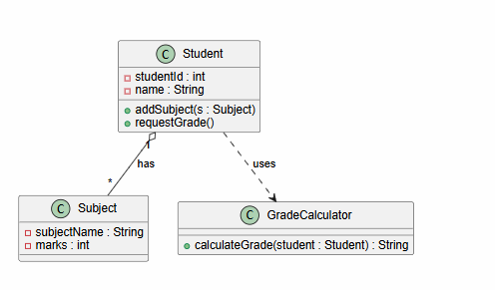
Sequence Diagram
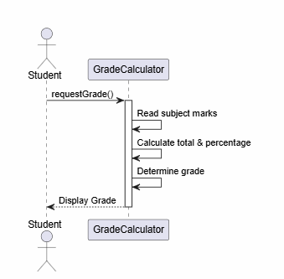

- Object Diagram
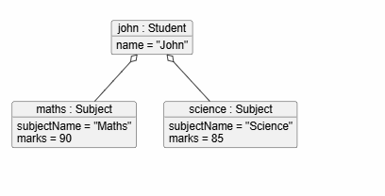
Sample Problem 2: Grocery Store Bill Generation
Class Diagram
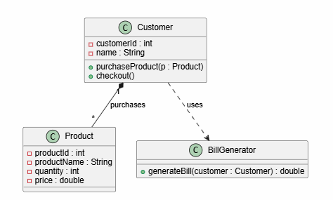

Sequence Diagram
Scenario: A customer checks out at the grocery store, and the total bill is generated.

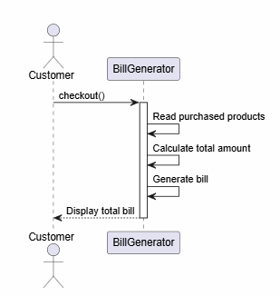

- Object Diagram

