Freight Rate Prediction
Machine Learning Engineer Assessment: validation approach, data split and December chart

1. Summary
Goal: predict posted_rate (USD) for 12,000 loads in validation.csv (Nov-Dec 2025) using 48,000 labelled loads (Jan-Oct 2025). The final model is a bag of six LightGBM regressors trained with an L1 loss on log(rate). On the closest hold-out analogue (train Jan-Aug, predict Sep-Oct) it reaches 3.6% MAPE and R² 0.993 on well-formed loads, and 5.9% MAPE / MAE $139 when the ~1.3% corrupted labels are left in the test set.

2. Data audit and cleaning
Checks were run on both files before modelling. The issues below were found and handled in src/features.py.
Issue | Evidence | Handling
Negative weights | 292 train / 145 validation rows; absolute values match the normal 5k-47.5k range | Treated as sign errors: use |weight|
Weight capped at 47,500 | 1,204 train rows sit exactly at the cap (censored) | Added weight_capped flag
Missing weight | 300 train / 165 validation | Left as NaN (LightGBM native handling) + weight_missing flag
Missing market_index | 374 train / 249 validation | market_index is a market-wide daily level (within-day std 0.02 vs between-day 0.17): filled with same-day median across all files, plus flag
Corrupted target labels | ~340 rows at ~3.6x normal rate-per-mile, ~307 at ~0.2-0.4x (1.35% of rows), spread evenly over months and equipment | Not removable at test time, so the model uses a robust L1 loss (predicts the conditional median)
Distribution shift | market_index averaged 1.08 in train vs 0.93 in validation; validation has 8 cities never seen in training (1,447 rows, 12%) | No raw month/trend feature; geography via lat/lon, distance and bearing instead of city IDs; unseen-city test added
Noisy distance | Same route has ~1.7% per-load distance noise | Added route-mean distance (features only, no labels), haversine distance and road factor

No duplicate load_ids, no duplicate rows and no missing values in the categorical columns were found.

3. Train / test split and validation approach
The validation file is the future relative to the labelled data, so a random K-fold would leak same-day market conditions into training and overstate accuracy. Validation therefore mimics the real task: train on the past, predict the next two months.
- Fold A (forward chaining): train Jan-Jun, test Jul-Aug.
- Fold B (closest analogue of Nov-Dec): train Jan-Aug, test Sep-Oct.
- Fold C (unseen-city stress test): fold B window, but every load touching six held-out cities (Bakersfield, Houston, Milwaukee, Philadelphia, San Francisco, Tulsa) is removed from training and the model is scored only on those loads.
Features that use other rows (daily market_index median, route-mean distance) are built from feature columns only and never from labels, so there is no target leakage. Metrics are reported on all test rows ("raw", labels as given) and on loads with a plausible rate-per-mile of $0.9-$4.0 ("clean"), which isolates model error from label corruption. The final model was refit on all 48,000 rows.

4. Model comparison
Fold B (Sep-Oct hold-out), single models unless noted. MAE in USD.
Model | Raw MAE | Raw MAPE | Clean MAE | Clean R²
Baseline: median $/mile x distance | 257.0 | 11.6% | 204.0 | 0.954
Ridge on log-rate | 159.4 | 6.8% | 104.7 | 0.989
LightGBM, L2 on log-rate | 156.5 | 6.8% | 101.8 | 0.989
LightGBM, Huber on log-rate | 148.1 | 6.3% | 93.4 | 0.992
LightGBM, L1 on log-rate | 141.4 | 6.0% | 86.6 | 0.993
Final: bag of 6 LightGBM (L1) | 138.5 | 5.9% | 83.6 | 0.993

Final model on fold A: raw MAE $116 (5.2% MAPE), clean MAE $65 (3.1% MAPE), clean R² 0.995. On the unseen-city test (fold C) a single L1 LightGBM scored raw MAE $162 (6.7% MAPE) and clean MAPE 3.9%, versus 4.8% for ridge and 9.6% for the baseline, so generalisation to new cities is solid.
Why this model: rate-per-mile is strongly non-linear in distance (about $2.9/mi under 150 miles to $1.9/mi above 2,500) and in quote_signal (U-shaped), with equipment, weight and market interactions, which tree ensembles capture better than a linear model. Modelling log(rate) makes errors proportional, which suits a target that spans $57 to $25,000. The L1 loss predicts the conditional median, so the corrupted labels barely affect the fit; it beat both L2 and Huber on the Sep-Oct hold-out. Averaging six models (two tree sizes, three seeds) reduces variance. Top drivers by gain: distance (40%), route distance, quote_signal, equipment, market_index and weight.

5. Fixed December prediction chart
Produced by the provided score.py from the completed data/december_chart_inputs.csv (Lexington to Fort Wayne, 360 miles, Dry Van, 32,000 lb). The file contains no market_index or quote_signal, so each day uses that day's median value observed in validation.csv (feature columns only). The model predicts about $796-$815 (mean $804, roughly $2.23/mile), a swing of under 3% driven by day-of-week and market conditions; the y-axis is zoomed, which exaggerates the visual variation.
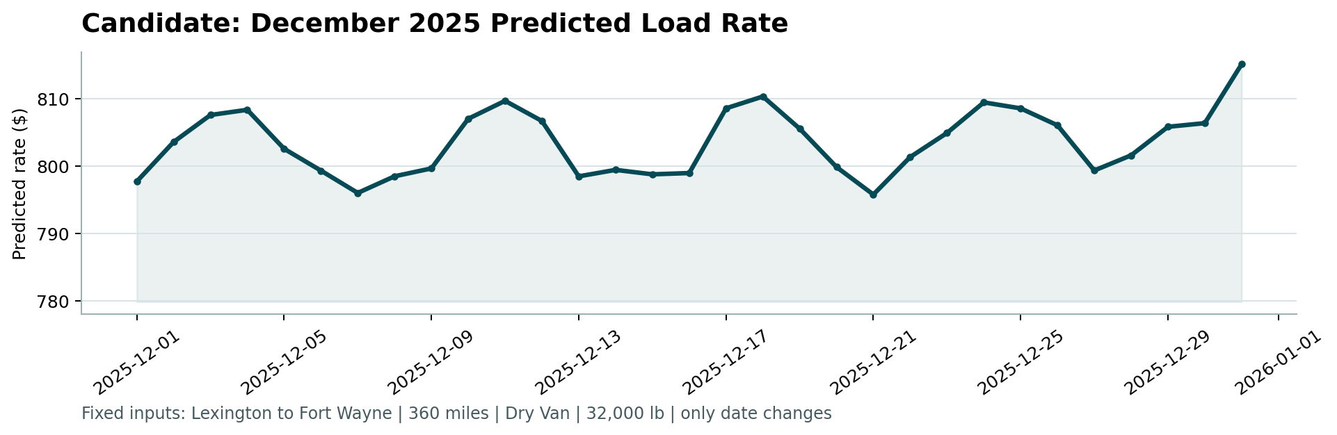

6. Limitations and next steps
- Sep-Oct error is higher than Jul-Aug, which hints at slow drift in market behaviour; with more history a time-weighted fit or monthly refresh would help.
- The true error on the 1.35% corrupted labels cannot be reduced by any feature-based model; a label-quality audit at the source would help most.
- Hyper-parameters were tuned lightly on folds A and B only; no test labels were used for any decision.

