Problem Name: For Loop
Platform: HackerRank
Problem Link: https://www.hackerrank.com/challenges/for-loop-in-c/problem
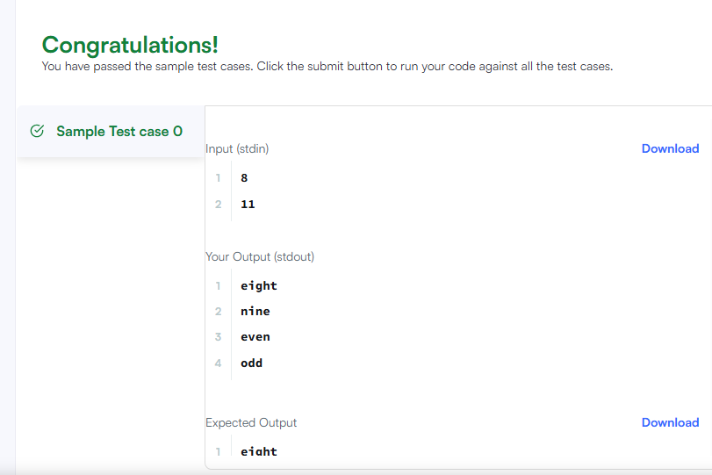 Code:
#include <stdio.h>

int main() {
int a, b;

scanf("%d", &a);
scanf("%d", &b);

char *words[] = {
"zero", "one", "two", "three", "four",
"five", "six", "seven", "eight", "nine"
};

for (in


