**SCRUM**

* Scrum is a framework for developing and sustaining complex products. Ken Schwaber and Jeff Sutherland developed Scrum. Together, they stand behind the Scrum Rules.
* Scrum is a framework within which people can address complex adaptive problems, while productively and creatively delivering products of the highest possible value.
* Scrum is a process framework that has been used to manage complex product development since the early 1990s. Scrum is not a process or a technique for building products; rather, it is a framework within which you can employ various processes and techniques. Scrum makes clear the relative efficacy of your product management and development practices so that you can improve.
* The Scrum framework consists of Scrum Teams and their associated roles, events, artifacts, and rules. Each component within the framework serves a specific purpose and is essential to Scrum’s success and usage. The rules of Scrum bind together the events, roles, and artifacts, governing the relationships and interaction between them.
* Scrum is an iterative software engineering process to develop and deliver software
* The Scrum Framework is a lightweight process. It focuses on increasing the productivity of teams while reducing wastes and redundant activities.
* 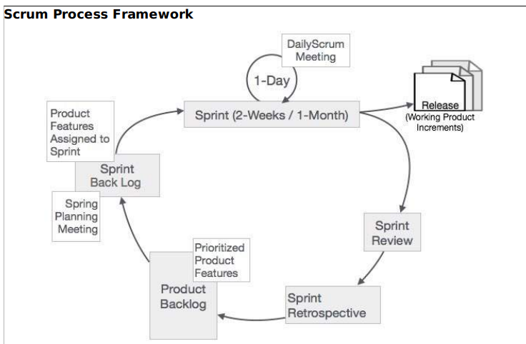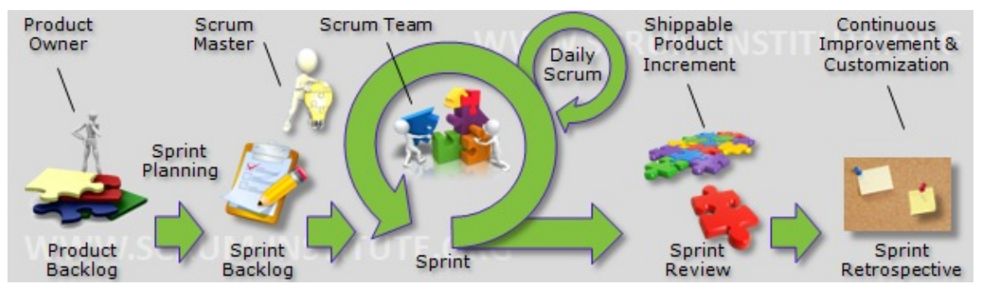
* In Scrum, the prescribed events are used to create regularity. All events are time-boxed events, such that every event has a maximum duration.

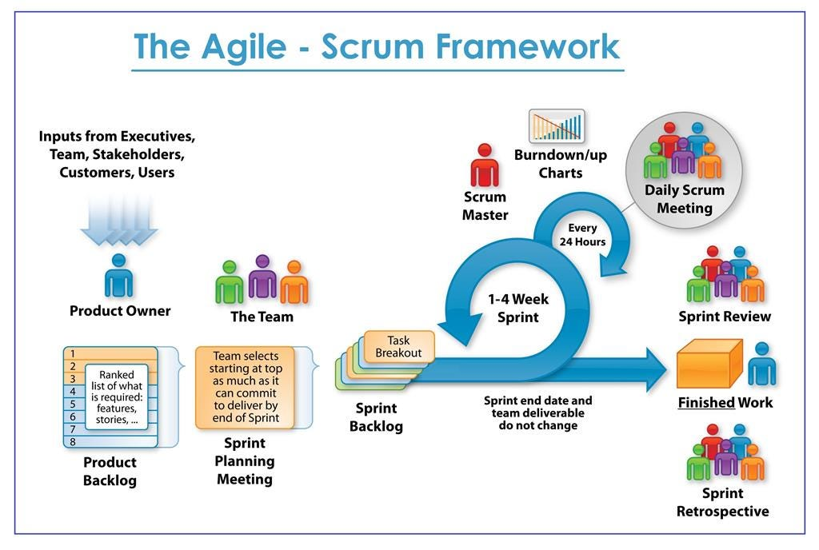

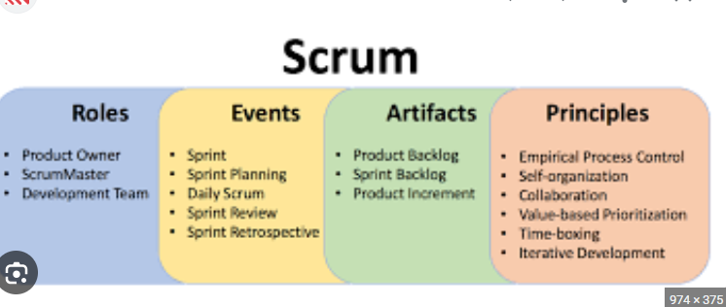

**SCRUM ROLES**

* **Product Owner:** The product owner is responsible for representing the stakeholders and ensuring that the product backlog reflects their needs. They prioritize the backlog items and make sure the development team is working on the most important things.
* The Product Owner is responsible for maximizing the value of the product and the work of the Team
* **The Product Owner is the sole person responsible for managing the Product Backlog. Product**
  + Backlog management includesExpressing Product Backlog items clearly.
  + Ordering the Product Backlog items to best achieve goals and missions.
  + Optimizing the value of the work the Team performs.
  + Ensuring that the Product Backlog is visible, transparent, and clear to all, and shows what the Team will work on further.
  + Ensuring that the Team understands items in the Product Backlog to the level needed
* **Develop and communicate the product vision:** The product owner should have a clear vision for what the product should be and how it will meet the needs of the stakeholders. They should be able to communicate this vision to the development team and other stakeholders in a clear and concise way.
* **Create and manage the product backlog:** The product backlog is a prioritized list of all the work that needs to be done on the product. The product owner is responsible for creating and managing the backlog, ensuring that it is clear, concise, and up-to-date.
* **Prioritize backlog items:** The product owner is responsible for prioritizing the backlog items based on their importance and value to the stakeholders. This helps to ensure that the development team is working on the most important things first.
* **Refine backlog items:** Backlog items are often high-level and need to be refined before the development team can start working on them. The product owner is responsible for working with the development team to refine backlog items, making them more specific and easier to estimate.
* **Accept or reject work:** Once the development team has completed a sprint, the product owner is responsible for accepting or rejecting the work. If the work meets the acceptance criteria, the product owner will accept it. If the work does not meet the acceptance criteria, the product owner will reject it and work with the development team to fix the problems.
* **Stakeholder management:** The product owner is responsible for managing stakeholders and their expectations. This includes keeping stakeholders informed about the progress of the project and addressing any concerns they may have.
* For the Product Owner to succeed, the entire organization must respect his or her decisions. The Product Owner’s decisions are visible in the content and ordering of the Product Backlog. No one is allowed to tell the Team to work from a different set of requirements, and the Team is not allowed to act on what anyone else says. This is ensured by ScrumMaster

**SCRUM MASTER :** A Scrum Master is a crucial role within the Scrum framework, acting as a facilitator, coach, and servant leader for the development team. Their primary responsibility is to **ensure the success of the Scrum team** by guiding them through the Scrum process and removing any obstacles that hinder their progress.

Here's a breakdown of the key aspects of a Scrum Master's role:

**1. Facilitator:**

* **Scrum Ceremonies:** The Scrum Master **leads and facilitates** Scrum ceremonies like Sprint Planning, Daily Stand-up meetings, Sprint Reviews, and Retrospectives. They ensure these meetings are conducted effectively, fostering open communication and collaboration within the team.
* **Communication and Collaboration:** The Scrum Master actively **promotes clear communication and collaboration** between the Product Owner, the Development Team, and other stakeholders. They help resolve conflicts and ensure everyone is aligned with the project goals.

**2. Coach:**

* **Scrum Knowledge:** The Scrum Master acts as a **coach** for the team, **educating them on Scrum principles, practices, and values**. They help the team understand how to effectively utilize the Scrum framework and continuously improve their workflow.
* **Self-Organization:** The Scrum Master **empowers the development team** to become self-organizing and self-managed. They guide the team in identifying and resolving their own impediments, fostering a sense of ownership and accountability.

**3. Servant Leader:**

* **Removing Impediments:** The Scrum Master acts as a **servant leader**, focusing on **removing any obstacles that hinder the team's progress**. They actively identify and address roadblocks, ensuring the team has the resources and support they need to deliver value.
* **Process Improvement:** The Scrum Master **continuously monitors and evaluates the Scrum process** within the team. They work with the team to identify areas for improvement and implement changes to optimize their workflow and effectiveness.

**Additional Responsibilities:**

* **Protecting the Team:** The Scrum Master **shields the development team from external distractions and interruptions** that can impede their focus and productivity.
* **Transparency and Visibility:** The Scrum Master helps maintain **transparency and visibility** of the project by ensuring clear communication and documentation throughout the development process.
* **Continuous Learning:** The Scrum Master stays **up-to-date on the latest Scrum practices and trends** and actively seeks opportunities to learn and improve their own skills.

**In essence, the Scrum Master is the glue that holds the Scrum team together.**

* 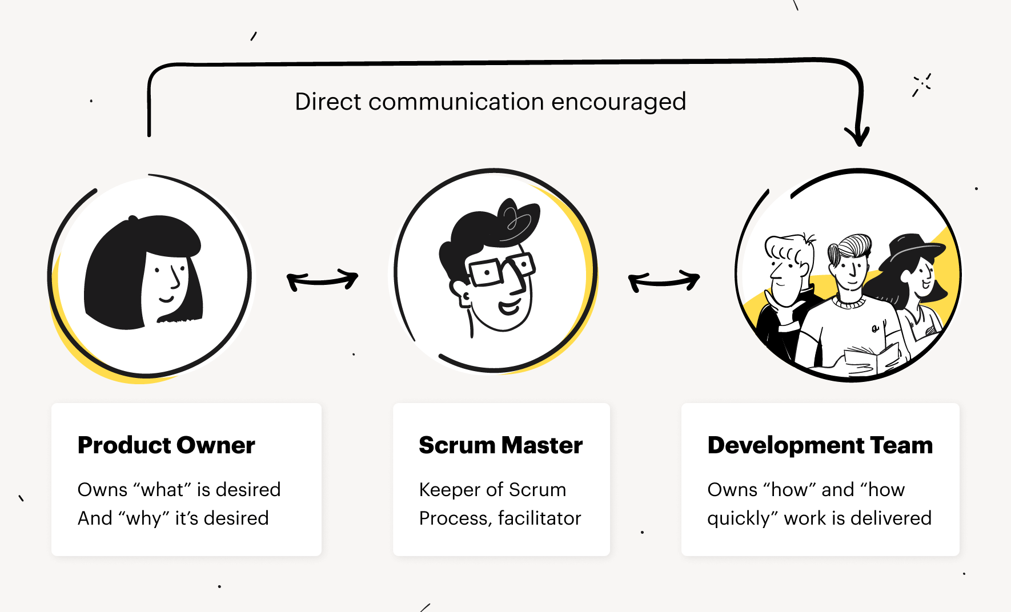

|  |  |  |
| --- | --- | --- |
| Aspect | Product Owner | Scrum Master |
| **Focus** | Product vision and backlog | Scrum process and team support |
| **Responsibilities** | * Owns the product vision and roadmap * Creates and manages the product backlog * Prioritizes backlog items * Refines backlog items with the development team * Accepts or rejects work delivered by the development team * Manages stakeholder expectations and communication | * Facilitates Scrum ceremonies (Sprint Planning, Daily Stand-up, Sprint Review, Retrospective) * Coaches the development team on Scrum practices and principles * Removes impediments hindering the team's progress * Protects the team from external distractions and interruptions * Promotes transparency and visibility within the project |
| **Decision-making** | Makes decisions regarding product features and priorities | Doesn't directly influence product decisions |
| **Stakeholder interaction** | Manages stakeholder expectations and communication | Facilitates communication between stakeholders and the team |
| **Analogy** | CEO of the product | Team coach |

* **ScrumMaster Services to the Product Owner**
  + Finding techniques for effective Product Backlog management.
  + Helping the Scrum Team understand the need for clear and concise Product Backlog items.
  + Understanding product planning in an empirical environment.
  + Ensuring that the Product Owner knows how to arrange the Product Backlog to maximize value.
  + Understanding and practicing agility.
  + Facilitating Scrum events as needed.
* **ScrumMaster Services to the Scrum Team**
  + Coaching the Scrum Team in self-organization and cross-functionality.
  + Helping the Scrum Team to create high-value products.
  + Removing impediments to the Scrum Team’s progress.
  + Facilitating Scrum events as requested or needed.
  + Coaching the Scrum Team in organizational environments in which Scrum is not yet fully adopted and understood**.**
* **ScrumMaster Services to the Organization**
  + The ScrumMaster serves the organization in several ways, includingLeading and coaching the organization in its Scrum adoption.
  + Planning Scrum implementations within the organization.
  + Helping employees and stakeholders understand and enact Scrum and empirical product development.
  + Causing change that increases the productivity of the Scrum Team.
  + Working with other ScrumMasters to increase the effectiveness of the application of Scrum in the organization.

**DEVELOPMENT TEAM**

The development team is the heart of any Scrum project, responsible for **transforming the product vision into reality**. They are a **cross-functional,** **self-organizing** group of individuals with the **skills and expertise** needed to deliver working software increments throughout the development process.

Here's a deeper dive into the characteristics and functions of a development team:

**Key Characteristics:**

* **Cross-functional:** The team comprises individuals with diverse skillsets, encompassing developers, testers, designers, analysts, and other specialists required to complete the project independently.
* **Self-organizing:** The team manages its own work without relying on external direction. They estimate tasks, choose their working methods, and allocate responsibilities amongst themselves.
* **Empowered:** The team has the authority to make decisions about how they work and deliver the product, fostering ownership and accountability.

**Responsibilities:**

* **Delivering working software increments:** The development team is responsible for delivering potentially shippable product increments at the end of each Sprint. These increments represent working functionalities that showcase progress and provide value to stakeholders.
* **Estimating and planning work:** The team estimates the effort required for each backlog item and plans their work for the upcoming Sprint during Sprint Planning.
* **Participating in Scrum ceremonies:** The development team actively participates in all Scrum ceremonies, including Daily Stand-up meetings, Sprint Reviews, and Retrospectives. They provide updates, showcase their work, collaborate on solutions, and continuously improve their processes.
* **Maintaining a high-quality product:** The development team is responsible for writing clean, maintainable code, conducting thorough testing, and ensuring the overall quality of the product throughout the development lifecycle.
* **Adapting to change:** The Scrum framework embraces change, and the development team needs to be adaptable to accommodate evolving requirements and priorities during the project.
* The Team is self-organizing and cross-functional. That means the team comprises of analysts, designers, developers, testers, etc. as appropriate and as relevant to the project. Some people in the industry refer to this team as development team. However, such a reference is leading to controversy that the team can have only developers and no other roles. It is an obvious understanding that it is only a misconception. To develop a software product, we require all the roles and that is the essence of scrum – the team will function in collaboration. Cross-functional teams have all competencies needed to accomplish the work without depending on others not part of the team, and thus time and effort can be saved. The team model in Scrum is designed to optimize flexibility, creativity, and productivity. Optimal Team size is small enough to remain nimble and large enough to complete significant work within a Sprint. The Team size should be kept in the range from five to nine people, if possible. Fewer than five team members decrease interaction and results in smaller productivity gains. Having more than nine members requires too much coordination. The scrum team works together closely, on a daily basis, to ensure the smooth flow of information and the quick resolution of issues. The scrum team delivers product iteratively and incrementally, maximizing opportunities for feedback. Incremental deliveries of a complete product ensure a potentially useful version of working product is always available.

**Scrum Master:**

1. Servant leadership
2. Facilitation skills
3. Conflict resolution
4. Empathy
5. Coaching and mentoring
6. Adaptability
7. Transparency
8. Strong communication
9. Problem-solving
10. Continuous learning

**Product Owner:**

1. Strategic thinking
2. Stakeholder management
3. Decision-making
4. Visionary
5. Prioritization
6. Communication skills
7. Domain knowledge
8. Adaptability
9. Collaboration
10. Ownership

**Development Team:**

1. Collaboration
2. Self-organization
3. Cross-functional skills
4. Accountability
5. Adaptability
6. Communication
7. Continuous improvement mindset
8. Transparency
9. Empowerment
10. Quality-focused

**SCRUM EVENTS**

* Scrum defines several events (sometimes called ceremonies) that occur inside **each sprint: sprint planning, daily scrum, sprint review, and sprint retrospective**
* Scrum Process Framework can be viewed by means of a sequence of events and the corresponding artifacts. The Scrum events are time-boxed events. That means, in a project, every scrum event has a predefined maximum duration. These events enable transparency on the project progress to all who are involved in the project.
* The heart of Scrum is a Sprint, a time-box of two weeks or one month during which a potentially releasable product increment is created. A new Sprint starts immediately after the conclusion of the previous Sprint. Sprints consist of the Sprint planning, daily scrums, the development work, the Sprint review, and the Sprint retrospective.
* In Sprint planning, the work to be performed in the Sprint is planned collaboratively by the Scrum Team.
* The Daily Scrum Meeting is a 15-minute time-boxed event for the Scrum Team to synchronize the activities and create a plan for that day.
* A Sprint Review is held at the end of the Sprint to inspect the Increment and make changes to the Product Backlog, if needed.
* The Sprint Retrospective occurs after the Sprint Review and prior to the next Sprint Planning. In this meeting, the Scrum Team is to inspect itself and create a plan for improvements to be enacted during the subsequent Sprint.

Here's a breakdown of each Scrum event:

**1. Sprint Planning (Timebox: Maximum 8 hours for a one-month Sprint):**

* **Participants:** Product Owner, Development Team, Scrum Master (optional: Stakeholders)
* **Purpose:** Collaboratively plan the upcoming Sprint by selecting Product Backlog items, estimating their effort, and creating a Sprint Backlog that outlines the work to be completed during the Sprint.
* **Outcome:** A clear understanding of the Sprint Goal, a defined Sprint Backlog, and a shared commitment from the team to deliver the planned work.

**2. Daily Scrum (Timebox: 15 minutes):**

* **Participants:** Development Team
* **Purpose:** A brief daily stand-up meeting for the development team to:
  + Discuss progress made on their assigned tasks since the last meeting.
  + Identify any impediments hindering their progress.
  + Adapt their plan for the remaining work in the Sprint.
* **Outcome:** Enhanced transparency within the team, improved problem-solving, and course correction as needed throughout the Sprint.

**3. Sprint Review (Timebox: Maximum 4 hours for a one-month Sprint):**

* **Participants:** Development Team, Product Owner, Stakeholders
* **Purpose:** Showcase the work completed during the Sprint to stakeholders and gather feedback.
* **Activities:**
  + The development team demonstrates the completed product increment.
  + The Product Owner discusses the value delivered and potential adaptations to the product backlog.
  + Stakeholders provide feedback and insights.
* **Outcome:** Transparency and stakeholder alignment, potential backlog refinement based on feedback, and confirmation of the delivered value.

**4. Sprint Retrospective (Timebox: Maximum 3 hours for a one-month Sprint):**

* **Participants:** Development Team, Scrum Master (optional: Product Owner)
* **Purpose:** Reflect on the past Sprint, identify areas for improvement, and plan actions for the next Sprint.
* **Activities:**
  + Discuss what went well during the Sprint.
  + Identify what could be improved in terms of processes, tools, or team dynamics.
  + Define concrete actions to implement the identified improvements.
* **Outcome:** Continuous process improvement, a more efficient and effective team, and a culture of learning and adaptation.

**Importance of Scrum Events:**

These events provide a regular cadence for communication, collaboration, and inspection within the Scrum team. They ensure transparency, enable timely course correction, and foster continuous improvement throughout the development lifecycle. By effectively conducting these events, Scrum teams can deliver value consistently and adapt to changing needs while maintaining a high level of quality and efficiency.

* **SPRINT:**a **sprint** is a **time-boxed** period, typically lasting **one to four weeks**, during which a development team works to complete a set of work items from the product backlog. It's the core unit of development in Scrum, fostering **focused delivery** and **regular feedback loops**.

**Characteristics:**

* **Time-boxed:** The duration of a sprint is fixed and **cannot be extended** once it begins. This ensures predictability and helps the team focus on delivering value within a defined timeframe.
* **Cross-functional effort:** The entire development team, comprising individuals with diverse skillsets, collaborates to complete the work planned for the sprint.
* **Self-organizing:** The team manages its own work within the sprint, estimating tasks, allocating responsibilities, and adapting their approach as needed.
* **Delivering value:** The goal of each sprint is to deliver a **potentially shippable product increment** that represents working functionality and adds value to the product.

**Key Stages of a Sprint:**

1. **Sprint Planning:** The development team, product owner, and scrum master (optional: stakeholders) collaborate to select items from the product backlog, estimate their effort, and create the sprint backlog outlining the work for the upcoming sprint.
2. **Daily Scrum:** The development team holds brief daily stand-up meetings to discuss progress, identify impediments, and adapt their plan for the remaining work.
3. **Development:** The team focuses on completing the tasks outlined in the sprint backlog, utilizing their expertise and collaborating effectively.
4. **Sprint Review:** At the end of the sprint, the development team showcases the completed product increment to stakeholders and gathers feedback.
5. **Sprint Retrospective:** The development team reflects on the past sprint, identifies areas for improvement in their processes, and plans actions for the next sprint.

**Benefits of Sprints:**

* **Increased focus and productivity:** Time-boxed sprints encourage the team to focus on delivering a specific set of deliverables within a defined timeframe.
* **Early and frequent feedback:** Regular sprint reviews and retrospectives enable early identification of issues and continuous improvement throughout the development process.
* **Enhanced transparency and stakeholder alignment:** Sprints provide clear visibility into progress and value delivered, fostering better communication and collaboration with stakeholders.
* **Reduced risk and faster adaptation:** By delivering working increments frequently, sprints allow for early feedback and course correction, minimizing risks and enabling faster adaptation to changing requirements

During a Sprint, a working product Increment is developed. It is usually of duration two weeks or one month, and this duration remains constant for all the sprints in the project. We cannot have varying durations for the different sprints in a project. A new Sprint starts immediately after the conclusion of the previous Sprint. The Sprint Goal is an objective set for the Sprint. It provides guidance to the Team on why it is building the Increment. It is created during the Sprint Planning meeting. The scope of the sprint is clarified and re-negotiated between the Product Owner and the Team as more about the requirements is learned. Thus, each Sprint is associated with it, a definition of what is to be built, a design, and the flexible plan that will guide building it, the development work, and the resultant product increment. A Sprint should be cancelled if the Sprint Goal becomes obsolete. This might occur if the organization changes direction or if market or technology conditions change. A sprint can be cancelled only by product owner, though others have an influence on the same. Due to the short duration nature of Sprints, cancellation during a sprint rarely makes sense. As the sprint cancellations consume resources, for getting re-organized into another Sprint, they are very uncommon. If a Sprint is cancelled, and part of the work produced during the sprint is potentially releasable, the Product Owner typically accepts it. All the incomplete Sprint Backlog Items are put back into the Product Backlog.

## **Sprint Planning: Setting the Stage for Success in Scrum**

**Sprint Planning** is the **crucial first event** in every Scrum cycle, laying the groundwork for a productive and successful Sprint. It's a **time-boxed** meeting where the **development team, product owner, and scrum master** collaborate to define the upcoming Sprint's goals and plan.

**Objectives of Sprint Planning:**

* **Develop a shared understanding of the Sprint Goal:** This goal should be **ambitious yet achievable** and provide a clear direction for the team's efforts during the Sprint.
* **Select Product Backlog items:** The team collaboratively chooses a set of items from the product backlog that they believe can be completed within the Sprint timeframe, considering their complexity, effort, and dependencies.
* **Create the Sprint Backlog:** This backlog outlines the work planned for the Sprint, including the selected product backlog items, their breakdown into tasks, and an estimated effort for each task.
* **Foster team alignment and commitment:** Through active participation and discussion, the team builds a shared understanding of the work ahead and commits to delivering the planned increment.

**Key Elements of Sprint Planning:**

1. **Setting the stage (15 minutes):** The Scrum Master welcomes participants, briefly reviews the purpose of the meeting, and establishes the agenda.
2. **Reviewing the product backlog (45 minutes per month of Sprint duration):** The Product Owner presents the most relevant product backlog items, clarifies their details, and answers any questions from the team.
3. **Selecting product backlog items (up to half the time remaining):** The team discusses and collaboratively selects items for the Sprint, considering their complexity, effort, and dependencies. They also ensure the chosen items align with the proposed Sprint Goal.
4. **Estimating and breaking down work (remaining time):** The team estimates the effort required for each selected item, typically using relative sizing techniques. They then break down the items into smaller, more manageable tasks.
5. **Creating the Sprint Backlog:** The team documents the selected items, their estimated effort, and the planned tasks in the Sprint Backlog.

**Outcomes of a Successful Sprint Planning:**

* A **clear and concise Sprint Goal** that motivates and guides the team.
* A well-defined **Sprint Backlog** outlining the planned work for the Sprint.
* A **shared understanding** among team members of the tasks involved and their individual contributions.
* A **sense of commitment and ownership** from the team towards delivering the Sprint Goal.

The work to be performed in the Sprint is planned in the Sprint Planning Meeting. Sprint Planning Meeting is of duration of maximum of four hours for two weeks sprints and eight hours for one month Sprints. It is the responsibility of the Scrum Master to ensure that the meeting takes place and that all the required attendees are present and understand the purpose of the scheduled meeting. The Scrum Master moderates the meeting to monitor the sustenance of discussion and closure on time.

Sprint Planning focuses on the following two questions –

What needs to be and can be delivered in the Sprint Increment?

How will the work needed for the execution of Sprint be achieved?

The inputs to this meeting are

- The Product Backlog

-The latest product Increment

- Projected capacity of the Team during the Sprint

- Past performance of the Team

The Scrum Team discusses the functionality that can be developed during the Sprint. Product Owner provides clarifications on the Product Backlog items. The team selects the items from the Product Backlog for the Sprint, as they are the best to assess what they can accomplish in the Sprint. The Team comprises of analysts, designers, developers, and testers. The work is carried out in a collaborative fashion, thus minimizing re-work.

The Scrum Team then comes up with Sprint Goal. The Sprint Goal is an objective that provides guidance to the Team on why it is building the Product Increment. The Team then decides how it will build the selected functionality into a working product Increment during the Sprint. The Product Backlog items selected for this Sprint plus the plan for delivering them is called the Sprint Backlog.

Work during a sprint is estimated during sprint planning and may be of varying size and/or effort. By the end of the Sprint Planning meeting, the work is divided into tasks of duration of one day or less. This is to enable the ease of work allocation, and tracking the completion. If the Team realizes that it has too much or too little work, it can renegotiate the selected Product Backlog items with the Product Owner.

The Team may also invite others notpartofScrumTeam to attend the Sprint Planning meeting to obtain technical or domain advice or help in estimation.

## Daily Scrum Meeting: A Daily Dose of Transparency and Collaboration

The **Daily Scrum**, also known as a **Daily Stand-up**, is a **brief, time-boxed meeting** held **every day** during a Sprint in the Scrum framework. It serves as a crucial communication and planning tool for the development team, promoting **transparency, collaboration, and problem-solving**.

**Key Characteristics:**

* **Time-boxed:** Ideally lasting **15 minutes**, the meeting ensures focused and efficient updates.
* **Standing format:** Encourages brevity and active participation.
* **Participants:** Development team only (Scrum Master can optionally participate as an observer).

**Objectives of the Daily Scrum:**

* **Inspect progress:** Each team member briefly shares their progress on assigned tasks since the last meeting.
* **Identify impediments:** Team members highlight any roadblocks hindering their work, allowing for collective problem-solving and support.
* **Adapt the plan:** Based on progress and identified issues, the team may adjust their approach for the remaining work in the Sprint.
* **Promote accountability and transparency:** Regular updates foster a sense of ownership and shared responsibility within the team.

**Structure of the Daily Scrum:**

1. **Each team member answers three questions:**
   * **What did I do yesterday?** (Briefly summarize completed tasks)
   * **What will I do today?** (Outline planned tasks for the day)
   * **Do I have any impediments?** (Raise any challenges or roadblocks)
2. **Discussion and problem-solving:** The team can briefly discuss any raised impediments and collaboratively identify solutions or seek assistance from the Scrum Master if needed.
3. **Actionable outcomes:** The meeting should conclude with clear next steps and a renewed focus on individual and collective goals for the day.

**Benefits of Effective Daily Scrums:**

* **Improved transparency:** Regular updates enhance visibility into individual and team progress.
* **Early identification and resolution of issues:** Proactive problem-solving minimizes roadblocks and delays.
* **Enhanced team collaboration:** Daily interaction fosters communication, coordination, and support within the team.
* **Increased focus and accountability:** Regular check-ins keep the team focused on their daily goals and accountable for their work.

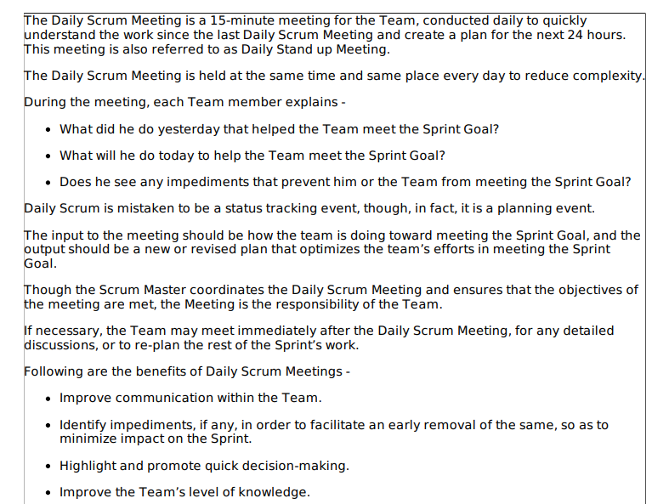

## Sprint Review: Inspecting Progress and Gathering Feedback

The **Sprint Review** is a crucial event in Scrum that takes place at the **end of each Sprint**. It serves as a platform for the **development team** to **showcase the completed product increment** to **stakeholders** and **gather valuable feedback**.

**Objectives of the Sprint Review:**

* **Demonstrate progress:** The development team presents the work completed during the Sprint, highlighting new features, functionalities, and improvements delivered in the increment.
* **Gather feedback:** Stakeholders provide their insights, suggestions, and potential areas for improvement on the showcased work.
* **Adapt the product backlog:** Based on the feedback received, the Product Owner and stakeholders may refine or adjust the product backlog priorities for future Sprints.
* **Increase transparency and collaboration:** The event fosters open communication and collaboration between the development team and stakeholders.

**Key Participants:**

* **Development Team:** Responsible for demonstrating the completed work.
* **Product Owner:** Leads the discussion and clarifies product vision and priorities.
* **Stakeholders:** Provide feedback and insights from their perspective.
* **Scrum Master (Optional):** Facilitates the discussion and ensures the meeting runs smoothly.

**Structure of the Sprint Review:**

1. **Introduction (5 minutes):** The Scrum Master or Product Owner sets the context and welcomes participants.
2. **Demonstration (maximum of half the time):** The development team showcases the completed product increment, highlighting key features and functionalities.
3. **Discussion and feedback (remaining time):** Stakeholders ask questions, provide feedback, and discuss potential improvements or adjustments.
4. **Actionable outcomes:** The Product Owner and team capture key takeaways and potential backlog refinements based on the feedback received.

**Benefits of Effective Sprint Reviews:**

* **Improved transparency:** Stakeholders gain a clear understanding of the team's progress and the value delivered.
* **Early feedback and course correction:** Valuable feedback allows for early identification of potential issues and adaptation of the product roadmap if necessary.
* **Enhanced stakeholder engagement:** Regular interaction fosters better collaboration and alignment between the development team and stakeholders.
* **Increased team motivation:** Seeing the completed work and receiving positive feedback motivates the development team.

## Sprint Retrospective: Reflecting, Learning, and Growing

The **Sprint Retrospective** is the final event in a Scrum Sprint, marking a crucial opportunity for the **development team** to **reflect** on their **past performance**, **identify areas for improvement**, and **plan actionable steps** for the upcoming Sprints.

**Objectives of the Sprint Retrospective:**

* **Inspect and adapt the Scrum process:** The team evaluates how effectively they followed Scrum practices and identifies areas for improvement within the process itself.
* **Identify and address challenges:** The team reflects on any obstacles encountered during the Sprint, analyzes their root causes, and explores solutions to prevent them from recurring.
* **Continuous improvement:** The team collaboratively identifies areas where they can work more effectively and collaboratively in future Sprints.
* **Foster team learning and growth:** The retrospective provides a platform for open discussion, knowledge sharing, and collective problem-solving, contributing to the team's continuous learning and development.

**Key Participants:**

* **Development Team:** Actively participate in the discussion and share their perspectives.
* **Scrum Master (Optional):** Facilitates the discussion and guides the team through the introspection process.
* **Product Owner (Optional):** Can provide insights from their perspective but should avoid dominating the discussion.

**Structure of the Sprint Retrospective:**

1. **Setting the stage (5 minutes):** The Scrum Master welcomes participants, briefly reviews the purpose of the meeting, and establishes the agenda.
2. **Reviewing the Sprint (45 minutes per month of Sprint duration):** The team discusses various aspects of the Sprint, including:
   * **What went well?** (Identify positive aspects, successful practices, and achievements)
   * **What didn't go well?** (Discuss challenges, obstacles, and areas for improvement)
   * **What surprised us?** (Share unexpected outcomes, learnings, and insights)
3. **Identifying improvements (remaining time):** Based on the discussion, the team collaboratively identifies actionable steps for improvement in the following areas:
   * **Scrum process:** Refining how the team implements Scrum practices.
   * **Tools and techniques:** Evaluating the effectiveness of tools and exploring potential improvements.
   * **Teamwork and collaboration:** Identifying ways to enhance communication, coordination, and problem-solving within the team.
4. **Actionable outcomes:** The team documents the identified improvements and assigns ownership for implementing them in the next Sprint.

**Benefits of Effective Sprint Retrospectives:**

* **Continuous process improvement:** Regular reflection and adaptation lead to a more efficient and effective development process over time.
* **Enhanced team collaboration and communication:** Open discussions foster a stronger team culture and improved problem-solving skills.
* **Increased team ownership and accountability:** By actively participating in identifying and implementing improvements, the team takes greater ownership of their work and outcomes.
* **Improved product quality:** Addressing challenges and continuously improving processes contribute to delivering higher-quality products.

|  |  |  |
| --- | --- | --- |
| Aspect | Sprint Review | Sprint Retrospective |
| **Focus** | Inspecting and showcasing completed work | Reflecting on the past Sprint and identifying areas for improvement |
| **Timing** | End of each Sprint | Follows the Sprint Review, final event of the Sprint cycle |
| **Participants** | Development team, product owner, stakeholders | Primarily development team, Scrum Master (optional), Product Owner (optional) |
| **Activities** | Demonstration of completed work, discussion of value delivered, stakeholder feedback | Discussing what went well/not well, identifying areas for improvement, defining action steps |
| **Outcomes** | Increased transparency, stakeholder alignment, confirmed delivered value, potential backlog refinement | Continuous process improvement, enhanced team collaboration, increased team ownership |
| **Analogy** | Product launch event | Team meeting for reflection and improvement |

* Backlog refinement or grooming

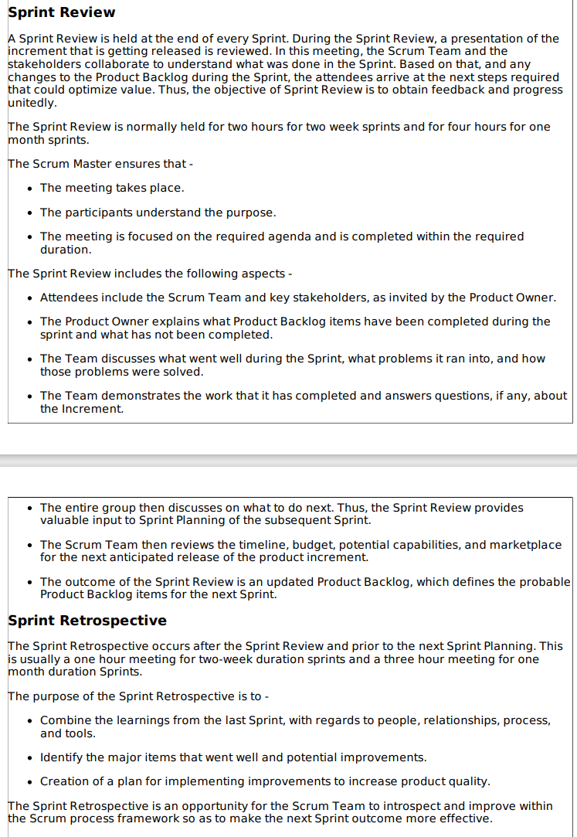

**SCRUM ARTIFaCTS**

Scrum Artifacts provide key information that the Scrum Team and the stakeholders need to be aware of for understanding the product under development, the activities done, and the activities being planned in the project. The following artifacts are defined in Scrum Process Framework

- Product Backlog

-Sprint Backlog

- Burn-Down Chart

- Increment These are the minimum required artifacts in a scrum project and project artifacts are not limited by these.

## **Product Backlog: The Heart of Scrum Product Development**

The **product backlog** is the **foundational artifact** in Scrum, serving as a **prioritized list** of everything that might be needed in the product, including:

* **Features and functionalities:** New capabilities and improvements to existing features.
* **Bug fixes and technical debt:** Addressing existing issues and improving the product's technical foundation.
* **Non-functional requirements:** Performance, security, usability, and other desired characteristics.

**Key Characteristics:**

* **Ordered list:** Items are prioritized based on **value, urgency, risk, and dependencies**.
* **Continuously evolving:** The backlog is never truly complete and can be updated and refined throughout the development process.
* **Transparent and visible:** Accessible to all stakeholders for better understanding of product goals and priorities.
* **Dynamic and adaptable:** Can accommodate changing needs, priorities, and market conditions.

**Ownership and Responsibility:**

* The **Product Owner** is ultimately responsible for the product backlog, owning its creation, management, and prioritization.
* The **development team** actively participates in backlog refinement, providing estimates and insights during Sprint Planning.
* **Stakeholders** can contribute by providing feedback and suggestions, but the Product Owner retains final decision-making authority.

**Benefits of a Well-Managed Product Backlog:**

* **Improved transparency and communication:** Ensures everyone involved understands product goals and priorities.
* **Enhanced focus and efficiency:** Prioritization helps the development team focus on delivering the most valuable features first.
* **Increased flexibility and adaptability:** Allows for adjustments based on changing needs and market feedback.
* **Better stakeholder alignment:** Provides a clear roadmap for stakeholders to understand the product vision and development direction.

**Effective Product Backlog Management:**

* **Prioritization:** Regularly review and refine the backlog based on value, urgency, risk, and dependencies.
* **User stories:** Use user stories to capture requirements in a clear and concise format, focusing on user needs and desired outcomes.
* **Acceptance criteria:** Define clear and measurable acceptance criteria for each backlog item to ensure successful completion.
* **Refinement:** Regularly refine backlog items to ensure they are clear, concise, and understandable for the development team.
* **Transparency:** Maintain an accessible and visible product backlog for all stakeholders

The Product Backlog is an ordered list of features that are needed as part of the end product and it is the single source of requirements for any changes to be made to the product. The Product Backlog lists all features, functions, requirements, enhancements, and fixes that constitute the changes to be made to the product in future releases. Product Backlog items have the attributes of a description, order, estimate, and value. These items are normally termed as User Stories. The Product Owner is responsible for the Product Backlog, including its content, availability, and ordering. A Product Backlog is an evolving artifact. The earliest version of it may contain only the initially known and best understood requirements. The Product Backlog gets developed as the product, and the environment in which it will be used, progress. The Product Backlog constantly changes to incorporate what is required to make it effective. As long as a product exists, its Product Backlog also exists. As the product being built is used and gains value, the Product Backlog becomes a larger and more exhaustive list. Changes in business requirements, market conditions, or technology, cause changes in the Product Backlog, making it a live artifact. Product Backlog refinement means adding detail, estimates, and priority order to the Product Backlog items. This is an ongoing process performed by the Product Owner and the Team. The Scrum Team decides how and when refinement is to be done. Product Backlog items can be updated at any time by the Product Owner or at the Product Owner’s discretion. Higher-ordered Product Backlog items are usually clearer and more detailed than lower-ordered ones. More precise estimates are made based on the greater clarity and increased detail. The lower the order, the lesser is the detail. Product Backlog items that may likely be the candidate requirements for the upcoming Sprint are refined so that these items can be developed during the Sprint. Product Backlog items that can be developed by the Team within one Sprint are deemed to be ready for selection in a Sprint planning meeting.

## Sprint Backlog: A Focused Plan for Each Scrum Sprint

The **sprint backlog** is a crucial artifact in Scrum, serving as a **detailed plan** for the development team during a specific **Sprint**. It's a **subset of the product backlog** containing:

* **Selected product backlog items:** A set of high-priority items chosen from the product backlog that the team believes can be completed within the Sprint timeframe.
* **Decomposition of items:** Each product backlog item is broken down into smaller, more manageable tasks, making them easier to estimate and track.
* **Effort estimates:** The development team estimates the effort required to complete each task, typically using relative sizing techniques like story points.

**Key Characteristics:**

* **Created during Sprint Planning:** Collaborative effort between the product owner, development team, and scrum master to define the sprint backlog.
* **Relatively stable:** Changes are discouraged during the Sprint to maintain focus and avoid scope creep.
* **Visible and transparent:** Accessible to all stakeholders for better understanding of the planned work.
* **Actionable:** Provides a clear roadmap for the development team throughout the Sprint.

**Benefits of a Well-Defined Sprint Backlog:**

* **Enhanced focus and clarity:** Defines the specific work the team will tackle during the Sprint, preventing distractions and ensuring alignment.
* **Improved transparency and communication:** Provides stakeholders with visibility into the planned work and progress.
* **Increased predictability and estimation accuracy:** Breaking down items into tasks allows for more accurate effort estimation and improved Sprint planning.
* **Facilitates daily stand-up meetings:** Serves as a reference point for the daily scrum, enabling the team to discuss progress and identify roadblocks.

**Creating an Effective Sprint Backlog:**

1. **Select product backlog items:** During Sprint Planning, choose high-priority items from the product backlog that align with the Sprint Goal.
2. **Break down items into tasks:** Decompose each product backlog item into smaller, more manageable tasks.
3. **Estimate effort for each task:** The development team collaboratively estimates the effort required to complete each task.
4. **Refine and finalize:** Ensure clarity, understandability, and alignment between all stakeholders before finalizing the sprint backlog.

**Remember, the sprint backlog is a living document.** While changes are discouraged during the Sprint, minor adjustments might be necessary under exceptional circumstances. The key is to maintain transparency and keep all stakeholders informed of any modifications.

The Sprint Backlog is the set of Product Backlog items selected for the Sprint, plus a plan for delivering the product Increment and realizing the Sprint Goal. The Sprint Backlog is a forecast by the Team about what functionality will be made available in the next Increment and the work needed to deliver that functionality as a working product Increment. The Sprint Backlog is a plan with enough detail that can be understood but the Team to track in the Daily Scrum. The Team modifies the Sprint Backlog throughout the Sprint, and the Sprint Backlog emerges during the Sprint. This emergence occurs as the Team works through the plan and learns more about the work needed to achieve the Sprint Goal. As new work is required, the Team adds it to the Sprint Backlog. As work is performed or completed, the estimated remaining work is updated. When elements of the plan are deemed unnecessary, they are removed. Only the Team can change its Sprint Backlog during a Sprint. The Sprint Backlog is a highly visible, real-time picture of the work that the Team plans to accomplish during the Sprint, and it belongs solely to the Team

|  |  |  |
| --- | --- | --- |
| Feature | Product Backlog | Sprint Backlog |
| **Purpose** | Represents the overall product vision and roadmap | Defines the specific work planned for a single Sprint |
| **Content** | Comprehensive list of all potential product needs (features, bug fixes, etc.) | Selected high-priority items chosen from the product backlog |
| **Evolution** | Continuously evolving and refined throughout the development process | Relatively stable during a Sprint, with changes discouraged |
| **Ownership** | Product Owner | Development Team |
| **Timeframe** | Not time-bound | Time-boxed, defined by the Sprint duration (typically 1-4 weeks) |
| **Detail level** | High-level overview of requirements | Detailed breakdown of tasks with associated effort estimates |
| **Analogy** | Complete menu in a restaurant | Daily specials menu offering a limited selection of dishes |

## Understanding the Product Increment in Scrum

In Scrum, the **product increment** is a crucial deliverable that embodies the **cumulative progress** made on the product throughout each Sprint. It represents a **potentially shippable** portion of the final product, showcasing the **added functionality and value** delivered to stakeholders.

**Key Characteristics:**

* **Cumulative:** Each increment builds upon the previous ones, incorporating all completed work from prior Sprints.
* **Potentially shippable:** While not mandatory to release after every Sprint, the increment should be in a state where it could be deployed to users if necessary.
* **Demonstrates progress:** Serves as a tangible representation of the development progress and value delivered.
* **Transparency and feedback:** Provides stakeholders with an opportunity to inspect and provide feedback on the evolving product.

**How the Product Increment is Created:**

1. **Sprint Planning:** During Sprint Planning, the development team selects a set of product backlog items they believe can be completed within the upcoming Sprint.
2. **Sprint Development:** Throughout the Sprint, the development team works on the chosen items, breaking them down into tasks, developing features, and conducting necessary testing.
3. **Sprint Review:** At the end of the Sprint, the development team presents the completed product increment to stakeholders during the Sprint Review.
4. **Iteration and Refinement:** Based on feedback received during the Sprint Review and ongoing learning, the product backlog and future increments are refined for subsequent Sprints.

**Benefits of a Well-Managed Product Increment:**

* **Enhanced transparency and stakeholder engagement:** Allows stakeholders to see the product evolve and provide valuable feedback.
* **Early validation and learning:** Enables early detection of issues and course correction based on user feedback.
* **Reduced risk and improved predictability:** By delivering working increments frequently, the risk of delivering the wrong product is minimized.
* **Increased motivation and team morale:** Seeing tangible progress through working increments can boost team morale and motivation.

**Remember, the product increment is not just about delivering working features.** It's about **demonstrating value, gathering feedback, and continuously adapting** the product based on learnings and stakeholder input.

**AGILE**

AGILE METHODOLOGY

Agile methodologies are a collection of project management approaches that emphasize iterative development, continuous improvement, and collaboration. They are designed to help teams deliver projects in a flexible and responsive way, adapting to changing requirements and priorities.

Here are some of the key characteristics of agile methodologies:

* **Iterative development:** Projects are broken down into smaller, time-boxed iterations, typically lasting 1-4 weeks. Each iteration involves planning, development, testing, and deployment of a small set of features.
* **Continuous improvement:** Teams reflect on their progress at the end of each iteration and identify areas for improvement. This allows them to continuously adapt their approach and improve the quality of the product.
* **Collaboration:** Agile methodologies emphasize close collaboration between team members, stakeholders, and customers. This is facilitated through regular communication and meetings.
* **Flexibility:** Agile methods are designed to be flexible and adaptable to change. This is important in today's fast-paced business environment, where requirements can change frequently.

Some of the most popular agile methodologies include:

* Scrum
* Kanban
* ScrumBan
* Crystal
* **Extreme Programming (XP)**
  + Extreme programming is an Agile project management methodology that targets speed and simplicity with short development cycles and less documentation. The process structure is determined by five guiding values, five rules, and 12 XP practices
  + **Extreme Programming (XP)** is an agile software development methodology that emphasizes **frequent releases, continuous feedback, close collaboration, and continuous improvement**. It takes a set of well-established software engineering practices and "extremes" them to achieve **higher quality software and a better development experience**.
  + Software engineer Ken Beck introduced XP in the 90s with the goal of finding ways to write high-qualitative software quickly and being able to adapt to customers’ changing requirements. In 1999, he refined XP approaches in the book Extreme Programming Explained: Embrace Change.
  + XP is a set of engineering practices. Developers have to go beyond their capabilities while performing these practices. That’s where the "extreme" in the framework’s title comes from.

The XP framework normally involves 5 phases or stages of the development process that [iterate](https://www.altexsoft.com/blog/iterative-process-agile/) continuously:

* **Planning,**the first stage, is when the customer meets the development team and presents the [requirements](https://www.altexsoft.com/blog/business/functional-and-non-functional-requirements-specification-and-types/) in the form of [user stories](https://www.altexsoft.com/blog/user-stories/) to describe the desired result. The team then [estimates](https://www.altexsoft.com/blog/story-points/) the stories and creates a release plan broken down into iterations needed to cover the required functionality part after part. If one or more of the stories can’t be estimated, so-called *spikes*can be introduced which means that further research is needed.
* **Designing**is actually a part of the planning process, but can be set apart to emphasize its importance. It’s related to one of the main XP values that we’ll discuss below -- simplicity. A good design brings logic and structure to the system and allows to avoid unnecessary complexities and redundancies.
* **Coding**is the phase during which the actual code is created by implementing specific XP practices such as coding standards, pair programming, continuous integration, and collective code ownership (the entire list is described below).
* **Testing**is the core of extreme programming. It is the regular activity that involves both unit tests ([automated testing](https://www.altexsoft.com/whitepapers/quality-assurance-quality-control-and-testing-the-basics-of-software-quality-management/) to determine if the developed feature works properly) and acceptance tests (customer testing to verify that the overall system is created according to the initial requirements).
* **Listening**is all about constant communication and feedback. The customers and project managers are involved to describe the business logic and value that is expected.

|  |  |  |
| --- | --- | --- |
| Feature | Extreme Programming (XP) | Scrum |
| **Focus** | Engineering practices for high-quality software | Project management framework for delivering working software in iterations |
| **Practices** | Specific practices like pair programming, TDD, collective ownership | Flexible framework with roles, events, and artifacts |
| **Teamwork** | Close collaboration between developers and customers | Self-organizing teams with minimal external influence during sprints |
| **Planning** | Continuous planning through the planning game | Predefined planning process for each sprint |
| **Release Cycle** | Frequent releases (typically weekly) | Releases at the end of each sprint (typically 2-4 weeks) |
| **Complexity** | Requires higher commitment due to specific practices and collaboration | More adaptable framework, easier to learn and implement |
| **Suitable for** | Projects requiring high code quality, continuous feedback, close collaboration, and skilled team | Wider range of projects due to flexibility and focus on self-organizing teams |

* + 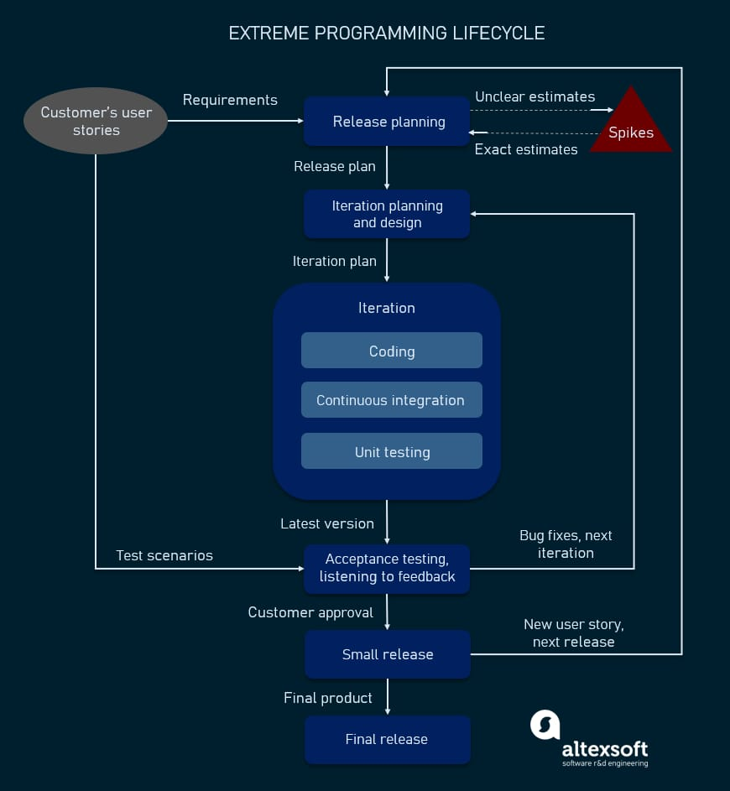

Values of extreme programming

XP has simple rules that are based on 5 values to guide the teamwork:

1. **Communication.** Everyone on a team works jointly at every stage of the project.
2. **Simplicity.** Developers strive to write simple code bringing more value to a product, as it saves time and effort.
3. **Feedback.** Team members deliver software frequently, get feedback about it, and improve a product according to the new requirements.
4. **Respect.** Every person assigned to a project contributes to a common goal.
5. **Courage.** Programmers objectively evaluate their own results without making excuses and are always ready to respond to changes.

These values represent a specific mindset of motivated team players who do their best on the way to achieving a common goal. XP principles derive from these values and reflect them in more concrete ways.

Principles of extreme programming

Most researchers denote 5 XP principles as:

1. **Rapid feedback.** Team members understand the given feedback and react to it right away.
2. **Assumed simplicity.** Developers need to focus on the job that is important at the moment and follow YAGNI (You Ain’t Gonna Need It) and DRY (Don’t Repeat Yourself) principles.
3. **Incremental changes.** Small changes made to a product step by step work better than big ones made at once.
4. **Embracing change.** If a client thinks a product needs to be changed, programmers should support this decision and plan how to implement new requirements.
5. **Quality work.** A team that works well, makes a valuable product and feels proud of it.
   * PRACTICES

### Test-Driven Development:

Is it possible to write a clear code quickly? The answer is yes, according to XP practitioners. The quality of software derives from short development cycles that, in turn, allow for receiving frequent feedback. And valuable feedback comes from good testing. XP teams practice test-driven development technique (TDD) that entails writing an automated unit test before the code itself. According to this approach, every piece of code must pass the test to be released. So, software engineers thereby focus on writing code that can accomplish the needed function. That's the way TDD allows programmers to use immediate feedback to produce reliable software

### The Planning Game

This is a meeting that occurs at the beginning of an [iteration cycle](https://www.altexsoft.com/blog/iterative-process-agile/). The development team and the customer get together to discuss and approve a product's features. At the end of the planning game, developers plan for the upcoming iteration and release, assigning tasks for each of them.

### On-site Customer

As we already mentioned, according to XP, the end customer should fully participate in development. The customer should be present all the time to answer team questions, set priorities, and resolve disputes if necessary.

### Pair Programming

This practice requires two programmers to work jointly on the same code. While the first developer focuses on writing, the other one reviews code, suggests improvements, and fixes mistakes along the way. Such teamwork results in high-quality software and faster knowledge sharing but takes about [15 percent more time](https://collaboration.csc.ncsu.edu/laurie/Papers/dissertation.pdf). In this regard, it’s more reasonable trying pair programming for long-term projects.

### Code Refactoring

To deliver business value with well-designed software in every short iteration, XP teams also use refactoring. The goal of this technique is to continuously improve code. Refactoring is about removing redundancy, eliminating unnecessary functions, increasing code coherency, and at the same time decoupling elements. Keep your code clean and simple, so you can easily understand and modify it when required would be the advice of any XP team member

### Continuous Integration

Developers always keep the system fully integrated. XP teams take iterative development to another level because they commit code multiple times a day, which is also called [continuous delivery](https://www.altexsoft.com/blog/business/continuous-delivery-and-integration-rapid-updates-by-automating-quality-assurance/). XP practitioners understand the importance of communication. Programmers discuss which parts of the code can be re-used or shared. This way, they know exactly what functionality they need to develop. The policy of shared code helps eliminate integration problems. In addition, automated testing allows developers to detect and fix errors before deployment.

### Small Releases

This practice suggests releasing the [MVP](https://www.altexsoft.com/blog/business/minimum-viable-product-types-methods-and-building-stages/) quickly and further developing the product by making small and incremental updates. Small releases allow developers to frequently receive feedback, detect bugs early, and monitor how the product works in production

### Simple Design

The best design for software is the simplest one that works. If any complexity is found, it should be removed. The right design should pass all tests, have no duplicate code, and contain the fewest possible methods and classes. It should also clearly reflect the programmer’s intent.

### Coding Standards

A team must have common sets of coding practices, using the same formats and styles for code writing. Application of standards allows all team members to read, share, and refactor code with ease, track who worked on certain pieces of code, as well as make the learning faster for other programmers. Code written according to the same rules encourages collective ownership.

### Collective Code Ownership

This practice declares a whole team’s responsibility for the design of a system. Each team member can review and update code. Developers that have access to code won't get into a situation in which they don't know the right place to add a new feature. The practice helps avoid code duplication. The implementation of collective code ownership encourages the team to cooperate more and feel free to bring new ideas.

### System Metaphor

System metaphor stands for a simple design that has a set of certain qualities. First, a design and its structure must be understandable to new people. They should be able to start working on it without spending too much time examining specifications. Second, the naming of classes and methods should be coherent. Developers should aim at naming an object as if it already existed, which makes the overall system design understandable.

### 40-Hour Week

XP projects require developers to work fast, be efficient, and sustain the product’s quality. To adhere to these requirements, they should feel well and rested. Keeping the work-life balance prevents professionals from burnout. In XP, the optimal number of work hours must not exceed 45 hours a week. One overtime a week is possible only if there will be none the week after.

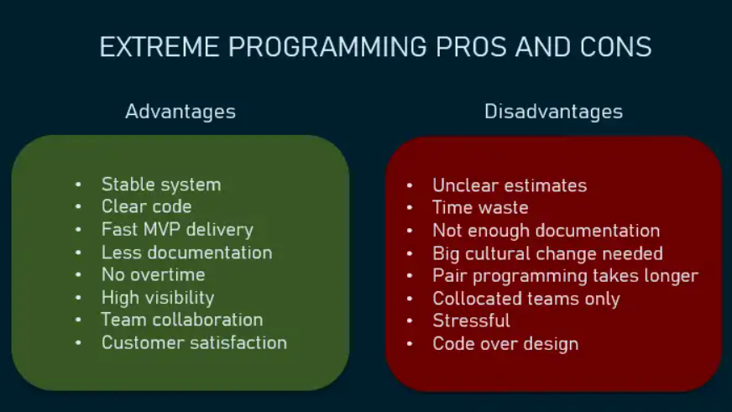

* + 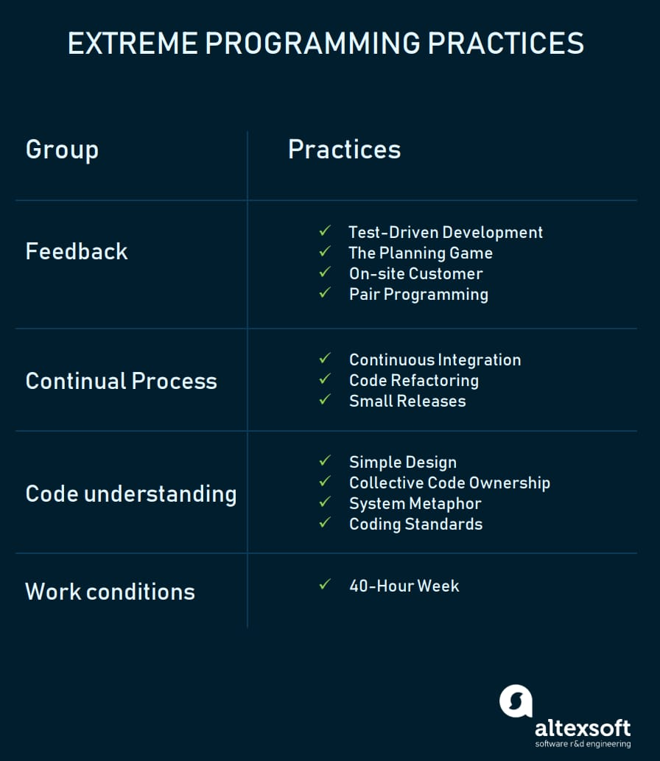
* **Feature-Driven Development (FDD)**
  + **FDD (Feature-Driven Development)** is an iterative and incremental **agile** methodology that focuses on **delivering working software features** in a **short and predictable timeframe**. It emphasizes **collaboration, documentation, and continuous improvement**.
  + Feature Driven Development (FDD) is an [agile framework](https://www.productplan.com/glossary/agile-framework/) that, as its name suggests, organizes software development around making progress on features. Features in the FDD context, though, are not necessarily product features in the commonly understood sense

**Key Characteristics:**

* **Feature-driven:** Breaks down projects into small, well-defined features that deliver value to the customer.
* **Iterative and incremental:** Develops features in short iterations (typically 2-4 weeks) with frequent deliveries.
* **Collaborative:** Encourages close collaboration between developers, customers, and other stakeholders.
* **Documentation-driven:** Uses clear documentation to capture requirements, design decisions, and test plans.
* **Continuous improvement:** Regularly reflects on the process and identifies areas for improvement.

**FDD Process:**

1. **Develop a Feature List:** Collaboratively define a prioritized list of features with the customer.
2. **Plan by Feature:** Break down each feature into smaller tasks and estimate effort.
3. **Design by Feature:** Create a detailed design for each feature.
4. **Develop by Feature:** Implement the feature in code.
5. **Inspect by Feature:** Conduct a formal inspection of the completed feature with stakeholders.
6. **Test by Feature:** Perform thorough testing of the feature.
7. **Promote by Feature:** Integrate the completed feature into the main codebase.

**Benefits of FDD:**

* **Improved predictability:** Provides a clear roadmap for development and helps to deliver features on time and within budget.
* **Enhanced communication:** Encourages collaboration and communication between stakeholders.
* **Reduced risk:** Early and frequent inspection helps to identify and address issues early.
* **High-quality software:** Focus on documentation and testing leads to higher quality software.

**Challenges of FDD:**

* **Requires discipline:** The process can be demanding and requires discipline from all stakeholders.
* **May not be suitable for all projects:** Can be complex for small or simple projects.
* **Documentation overhead:** Creating and maintaining documentation can be time-consuming.

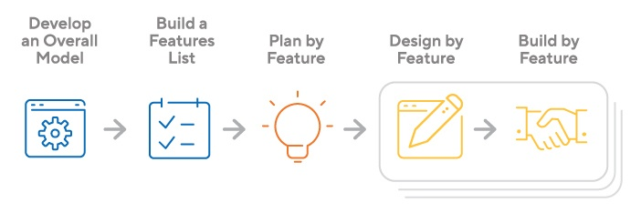

* **Dynamic Systems Development Method (DSDM)**

DSDM is an iterative Agile product development framework. It aims to work efficiently, delineate stages of the development life cycle and provide tangible benefits to all parties involved with a project. This method works throughout the entire project life cycle, offering guidance about the best practices for delivering products on time and within budget. It also seeks to demonstrate scalability and to address the needs of all project sizes and for any industry or business sector.The focus of DSDM is to help professionals work more effectively as a cohesive team, striving to achieve a common goal. It encourages teams to move progressively from one stage of development to the next once each stage provides enough value. It's also vendor-independent, meaning any technical environment or business can use it without access to any specific techniques and tools.

**Core principles of DSDM**

This framework relies on the following foundational beliefs:

* **Focus on the business need.**DSDM teams work towards achieving projects that align with greater business objectives and exist within parameters that make sense for the business.
* **Deliver on time.**Prompt delivery is a vital part of DSDM projects, as one of the method's goals is to reap benefits early.
* **Collaborate.**It's crucial that DSDM teams involve all relevant parties and grant each other the means to give feedback and make decisions.
* **Maintain high quality.**DSDM teams set clear standards before beginning work and evaluate their progress regularly to ensure they're meeting these standards.
* **Build incrementally from firm foundations.**Teams strive to produce the right amount of work at the right time to ensure they produce work that aligns with their plans.
* **Develop iteratively.**Teams implement feedback promptly and adapt to ongoing changes in a project's specifications and needs.
* **Communicate continuously and clearly.**DSDM teams can use a variety of tools to provide written, verbal and visual updates to teammates, other departments, managers and interested parties.
* **Demonstrate control.**A team leader or [project manager](https://www.indeed.com/q-project-manager-jobs.html?from=careerguide-autohyperlink-en-US) practices transparency to make all team members aware of changes, plans, progress, updates and goals

**5 phases of the DSDM life cycle**

DSDM typically includes the following five major phases:

**1. Feasibility**

During this stage, you can review the project's specifications to determine if it's realistic for your team to achieve. Consider if you can meet your goals with the budget, timeline and technology available to you. If you determine your plan is unattainable, you can revisit it to develop one that suits your capabilities.

**2. Business study**

Once you know the project is technically possible, research the project from a business perspective. Review if it aligns with the organization's overall objectives, if it competes effectively with other organizations in your industry and if it meets the needs of potential users. You can supplement your plan with sensible details that align with business objectives.

**3. Functional model iteration**

During this phase, you build a prototype that meets the specifications determined in earlier phases. It's important to test and evaluate the prototype to ensure it works as intended and contains all important functionalities. You can repeat this phase until you have an effective prototype on which you want to base your final product.

**4. Design and build**

You can then refine your prototype to optimize its efficiency. During this time, you might design additional components to strengthen your project and address any issues. Test your product carefully to ensure it's responsive, functional and easy to use.

**5. Implementation**

You then release your project into its operational environment to learn if it's effective. Users learn how to operate it, and they provide feedback. When you finish this stage, you know if the product is complete or if you have new challenges. Depending on the feedback you receive, you might return to a previous stage to adjust your system until it's successful.

**Benefits of DSDM:**

* **Improved project control:** Timeboxed phases and clear deliverables provide better control over project scope and schedule.
* **Enhanced user satisfaction:** User involvement throughout the process leads to a product that better meets their needs.
* **Reduced risk:** Early prototyping helps identify and address issues early, minimizing risks.
* **Increased flexibility:** Adaptable to changing requirements and project priorities.

**Challenges of DSDM:**

* **Requires skilled facilitators:** Successful implementation depends on experienced facilitators to guide the process.
* **May not be suitable for all projects:** Can be complex for small or simple projects.
* **Initial investment in training:** Requires initial training for team members on the DSDM framework.

## crystal: A Family of Agile Methodologies

Crystal is not a single methodology but rather a **family of agile methodologies** designed to be lightweight and adaptable to different project needs. Unlike other frameworks with specific practices and structures, Crystal focuses on **principles and values**, allowing teams to choose the most suitable approach based on project size, team dynamics, and criticality.

Crystal methodology is actually a grouping of different methods and it always takes team size into account. Because of that, Crystal can be further broken down into color groups that hinge on the size of the team and the complexity or size of the project.

Think about it this way: small teams can move quickly and have more straightforward collaborations. But, as the team size grows, that often means the complexity of the project does too

**Key characteristics of Crystal:**

* **Focus on people and interaction:** Prioritizes collaboration, communication, and empowerment of individuals over processes and tools.
* **Lightweight and adaptable:** Offers different Crystal methods (Clear, Yellow, Orange, Red) tailored to varying team sizes and project complexities.
* **Emphasizes reflection and improvement:** Encourages continuous learning and adaptation through regular reflection and feedback loops.
* **Value-driven:** Guides decision-making based on core values like honesty, openness, and respect.

Crystal is an [agile framework](https://www.productplan.com/glossary/agile-framework/) focusing on individuals and their interactions, as opposed to processes and tools. In other words, this framework is a direct outgrowth of one of the core values articulated in the [Agile Manifesto](https://www.agilealliance.org/agile101/the-agile-manifesto/).

The Crystal agile framework is built on two core beliefs:

* Teams can find ways on their own to improve and optimize their workflows
* Every project is unique and always changing, which is why that project’s team is best suited to determine how it will tackle the work

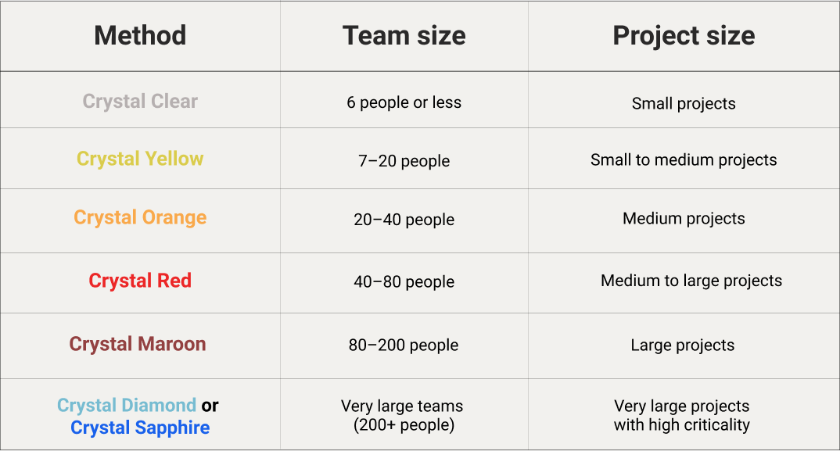

 Each of the above Crystal methods has a unique framework and guidelines about everything from team communication to releases to how teams are split up.

**Let’s know about the history of the Crystal Method**: The crystal method was developed by an American scientist named Alistair Cockburn who worked at IBM. He decided not to focus on step-by-step developmental strategies, but to develop team collaboration and communication. Some of the traits of Cockburn’s Crystal method were:

* Human-powered i.e. the project should be flexible and people involved in preferred work.
* Adaptive i.e. approaches don’t have any fixed tools but can be changed anytime to meet the team’s specific needs.
* Ultra-light i.e. this methodology doesn’t require much documentation.

**Benefits of Crystal:**

* **Highly adaptable:** Can be tailored to diverse project contexts and team preferences.
* **Empowers teams:** Encourages ownership and responsibility among team members.
* **Promotes collaboration and communication:** Fosters a culture of open communication and teamwork.
* **Focuses on value delivery:** Emphasizes delivering the most valuable features first.

**Challenges of Crystal:**

* **Requires experienced and self-organizing teams:** Success relies heavily on team maturity and ability to manage themselves effectively.
* **Lack of structure can be daunting:** The flexible nature might be challenging for teams accustomed to more structured methodologies.
* **Limited guidance for specific practices:** Requires additional effort to define team processes and tools within the Crystal framework.

|  |  |  |  |  |  |  |  |  |
| --- | --- | --- | --- | --- | --- | --- | --- | --- |
| Feature | FDD (Feature-Driven Development) | Scrum | Kanban | XP (Extreme Programming) | Crystal |  | DSDM (Dynamic Systems Development Method) | Lean |
| **Focus** | Delivering working features in short iterations | Delivering working software in short sprints | Continuous flow of work | High-quality software through continuous practices | Lightweight, adaptable to project needs |  | User-driven, iterative development | Eliminating waste, maximizing value |
| **Practices** | Feature-driven, iterative, collaborative, documentation-driven | Roles, events, artifacts, time-boxed sprints | Visual board, work in progress limits, continuous improvement | Pair programming, TDD, collective code ownership, small releases | Collaborative, reflective, adaptable |  | Iterative, timeboxed phases, prototypes | Kanban-like boards, focus on flow and value |
| **Planning** | Feature list prioritization, detailed planning by feature | Sprint planning, backlog refinement | Kanban board prioritization, ongoing adjustments | Continuous planning through the planning game | Adaptable based on project size and complexity |  | Feasibility study, iterative cycles, timeboxed phases | Continuous improvement, focus on value delivery |
| **Releases** | Frequent releases by feature | Releases at the end of each sprint | Continuous deployment encouraged | Frequent releases in small increments | Frequent releases based on project needs |  | Iterative releases throughout the project | Continuous delivery encouraged |
| **Complexity** | More structured and demanding | Moderately complex, requires understanding of roles and events | Flexible and adaptable | Requires skilled and experienced team | Lightweight and adaptable |  | Structured, user-driven approach | Requires understanding of lean principles |
| **Suitable for** | Predictable projects with well-defined features | Diverse range of projects | Ongoing projects with changing requirements | High-quality software development projects | Small to medium-sized projects |  | User-driven projects with rapid feedback | Projects seeking to eliminate waste and improve efficiency |

Here are some of the benefits of using agile methodologies:

* **Increased flexibility and responsiveness:** Agile methods allow teams to adapt to changing requirements and priorities more easily than traditional methods.
* **Improved quality:** The emphasis on continuous improvement and testing helps to ensure that products are delivered with high quality.
* **Increased customer satisfaction:** Agile methods encourage close collaboration with customers, which can lead to a better understanding of their needs and increased satisfaction with the final product.
* **Increased team morale:** Agile methods can help to improve team morale by giving team members more ownership over their work and by encouraging collaboration.

However, there are also some challenges associated with using agile methodologies:

* **Requires a change in mindset:** Agile methods require a different way of thinking about project management than traditional methods. This can be difficult for some teams to adopt.
* **Can be difficult to scale:** Agile methods can be difficult to scale to large projects or teams.
* **Requires a high degree of discipline:** Agile methods require a high degree of discipline from team members in order to be successful.

## **The development of lean agile**

Lean agile, or lean software development, originates from the principles of [lean manufacturing](https://www.twi-global.com/technical-knowledge/faqs/faq-what-is-lean-manufacturing). The concept was brought into manufacturing to improve profits by reducing costs instead of solely relying on increased sales. If a company can eliminate waste and become more efficient, it can save money, thereby increasing overall profits.

Lean agile is an agile methodology that, in basic terms, is quite simple: improve efficiency by eliminating waste. Unlike traditional, waterfall project management, which dictates a set plan laid out by a project manager, lean agile strives to reduce all tasks and activities that don’t provide real value. This helps ensure everyone involved in a project or product development can work at optimal efficiency.

If you’re looking to dive into the history of lean agile, [Lean Enterprise Institute Inc.](https://www.lean.org/WhatsLean/), founded in 1997 by James P. Womack, PhD, is a leading resource for lean methodology. It aims to help people and teams work better through lean thinking and practices.

Lean practices are popular because they can be applied to other agile approaches and [software development methods](https://www.easyagile.com/blog/software-development-methodologies). Lean agile provides a clear application for [scaling agile](https://www.easyagile.com/blog/scaled-agile-framework/), which is often difficult for large or growing organizations.

## The benefits of lean agile

In case you’re not on board with lean agile yet, let’s review its main benefits.

### Waste less time

Time is wasted when processes don’t run smoothly. In lean manufacturing, it’s important for goods and services to be delivered quickly and effectively. No one's time should be wasted on the job, and companies should aim for shorter lead times without sacrificing quality.

Wasting time in any industry is expensive, but it’s particularly important to pay attention when working in agile software development. Even a small bottleneck or broken process can completely throw off a workflow or product deadline. Lean agile helps development teams manage time effectively to ensure everyone is utilized, no one's time is wasted, and roadblocks are anticipated in advance.

### Reduce costs

When businesses eliminate waste, they save money. In its original form, lean manufacturing ensured companies had the right amount of materials, employees, and working hours at any given time. Overproduction, overhiring, or simply having too many materials to store are expensive wastes that can be eliminated through better management of systems and processes.

Any business, no matter the industry, will save money with improved efficiency. Lean agile ensures that waste is continually eliminated and agile teams continue to fine-tune processes for optimal efficiency.

### Improve work quality

With lean agile, it’s not only about efficiency — it's about maintaining efficient processes while bringing a quality product to customers and stakeholders. When businesses intentionally improve processes, they remain competitive. Lean principles consider the customer value of any action or decision to ensure needs are always met or exceeded.

## The five principles of lean agile

There are [five core principles](https://www.asme.org/topics-resources/content/5-lean-principles-every-should-know) for implementing lean methodology:

1. Value
2. Value stream
3. Flow
4. Pull
5. Perfection

These principles describe a five-step process that guides the implementation of lean techniques for manufacturing, software development teams, and other agile practicing industries.

### 1. Identify value

The first step requires you to step into the shoes of the customer. Value is what the customer needs and wants from a specific project or product.

Consider from the customers’ point of view: What are their expectations? What are they willing to pay for? How do they want their needs met?

Sometimes, customers may be unable to define exactly what they’re looking for — especially if it’s a new product or technology they’re unfamiliar with.

In any case, the project cannot move forward without clearly identifying what it will take to provide customer satisfaction. You’ll need to identify the end goal (value) customers are hoping to find with the product or service.

### 2. Map the value stream

Next, the team [visually maps](https://www.easyagile.com/blog/principles-of-an-agile-product-roadmap/) each of the steps and processes it will take to bring the product from inception to delivery. By making each step visible and always keeping the value top-of-mind, it’s easier to see which steps don’t directly contribute to continuous delivery. Once wasteful steps are found, the team finds ways to eliminate those steps or reduce them as much as possible.

Getting rid of waste ensures your company doesn’t unnecessarily spend money on steps and processes that don’t add value. And — most importantly — the customer gets exactly what they’re looking for.

### 3. Create flow

Once the waste is eliminated from the value stream, the next step is ensuring the remaining processes work as effectively and efficiently as possible, which means no delays, disruptions, or bottlenecks. It’s important for the steps that create value to work in tight sequences to ensure the product flows smoothly toward the customer.

In order to achieve this kind of agile transformation, lean businesses must train their employees to be adaptive and multi-skilled, create cross-functional teams, break down and reconfigure steps in the production, and balance employee workloads.

### 4. Establish a pull system

With enhanced flow, your team can deliver products and services faster. A pull system enables “just-in-time” manufacturing and delivery, limiting inventory and work in progress (WIP) items by only producing enough to meet customer demand.

By establishing a pull system, you create products and services as needed as opposed to creating them in advance, which leads to a growing inventory or list of tasks that need to be stored and managed — draining your bottom line.

### 5. Seek perfection

By completing steps 1-4, waste is eliminated — for now. However, the work is never done. There is always a process that could be improved, and there will always be steps in project and product development that waste time and money or don’t deliver value. That’s why the fifth step of seeking perfection is key.

Lean takes time to implement, and going through the process once is not enough. Build a continuous improvement mindset into your company culture, and never settle for the same old

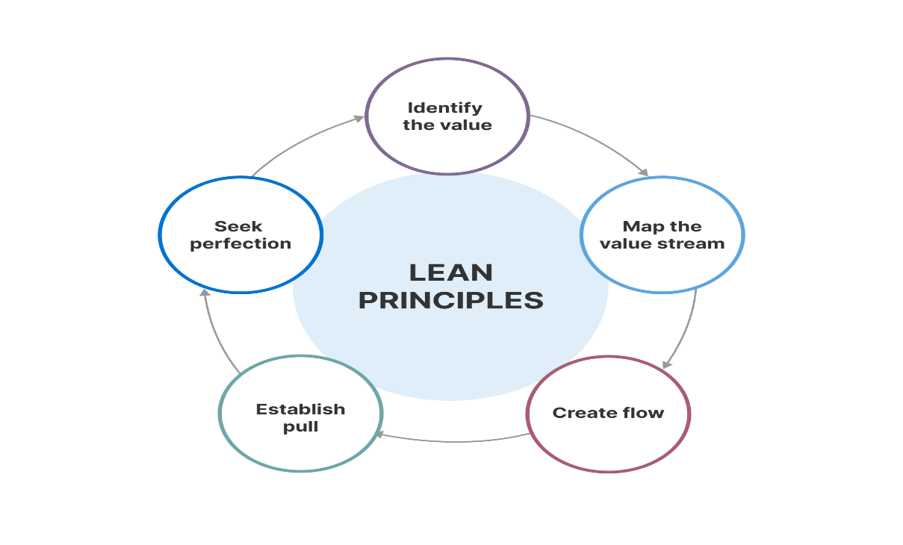

**Information technology service management** (**ITSM**) are the activities performed by an organization to design, build, deliver, operate and control [information technology](https://en.wikipedia.org/wiki/Information_technology) (IT) services offered to customers.

ITSM refers to implementing, delivering and maintaining IT services in the best possible way to meet the business needs. It is collaboration of people ,process and technology to deliver the required service.eg , Software user interface .It is a bridge between IT and customer. How does ITSM is implemented ? ITIL is framework for ITSM , contains 26 process (like INCIDENT MANAGEMENT,CHANGE MANAGEMENT ,PROBLEM MANAGEMENT )

ITSM stands for **IT Service Management**. It refers to the **practices and processes** used by an organization to **design, deliver, operate, and control** its **IT services**. The goal of ITSM is to **align IT services with the needs of the business** and to **deliver them in a way that is efficient, effective, and cost-effective**.

ITSM encompasses a wide range of activities, including:

* **Service Design:** This involves defining the services that will be offered, as well as the processes and resources that will be required to deliver them.
* **Service Delivery:** This involves delivering the services to the users, including provisioning, configuration, and deployment.
* **Service Operation:** This involves maintaining the services and ensuring that they are available and performant.
* **Service Improvement:** This involves continuously improving the quality of the services.

ITSM is a **mature discipline** with a number of **frameworks** and **best practices** available. The most popular framework is the **Information Technology Infrastructure Library (ITIL)**. ITIL provides a set of **guidelines and recommendations** for implementing ITSM practices.

**Benefits of ITSM:**

* Improved service quality and availability
* Increased user satisfaction
* Reduced costs
* Improved communication and collaboration between IT and the business
* Increased agility and responsiveness to change

**ITIL** stands for **Information Technology Infrastructure Library**. It's a **set of practices and a framework** for organizations to follow for **IT service management (ITSM)** and **IT asset management (ITAM)**. Its core focus is on **aligning IT services with the needs of the business**. ITIL describes **processes, procedures, tasks, and checklists** that are **neither organization-specific nor technology-specific**. This allows organizations to establish a **baseline**, which can be used to **demonstrate compliance** and **measure improvements**.

TIL has **evolved over time**, with the latest version being **ITIL 4**, released in **February 2019**. ITIL 4 is a **modular framework**, which means that organizations can choose to implement the entire framework or just the parts that are most relevant to their needs.

Here are some of the **key benefits of using ITIL**:

* **Improved service quality and availability:** ITIL provides a framework for organizations to identify and prioritize their IT services, as well as to establish processes for delivering and supporting those services. This can lead to improved service quality and availability.
* **Increased user satisfaction:** By focusing on aligning IT services with the needs of the business, ITIL can help organizations to deliver services that meet the needs of their users. This can lead to increased user satisfaction.
* **Reduced costs:** ITIL can help organizations to identify and eliminate inefficiencies in their IT service delivery processes. This can lead to reduced costs.
* **Improved communication and collaboration between IT and the business:** ITIL provides a common language for IT and the business to discuss IT services. This can help to improve communication and collaboration between the two groups.
* **Increased agility and responsiveness to change:** ITIL provides a framework for organizations to continuously improve their IT service delivery processes. This can help organizations to be more agile and responsive to change.

### RELATION BETWEEN AGILE SCRUM ,LEAN , DEVOPS AND IT SERVICE MANAGEMENT (ITIL)

* Agile and Scrum are often used together, with Scrum being a framework for implementing Agile principles in software development projects.
* Lean principles can be applied in Agile, Scrum, and DevOps environments to identify and eliminate waste, improve flow, and optimize processes.
* DevOps practices complement Agile and Lean methodologies by promoting collaboration, automation, and continuous improvement across development and operations teams.
* ITIL provides a broader framework for managing IT services, including aspects like service strategy, design, and operation, which can be integrated with Agile, Scrum, Lean, and DevOps practices to ensure alignment with business goals and customer needs.

**Agile (including Scrum):**

* Focuses on **flexible and iterative development**, breaking down work into small chunks (sprints) and adapting to changing requirements.
* **Relationship to ITIL:** Both aim for **continuous improvement**, but Agile takes a more flexible and user-centric approach, whereas ITIL provides a structured framework.

**Lean:**

* Emphasizes **waste reduction** and **efficiency** through continuous improvement and eliminating unnecessary steps.
* **Relationship to ITIL:** Both focus on **efficiency and optimizing processes**, but Lean has a broader application beyond IT, while ITIL is specific to IT services.

**DevOps:**

* Breaks down silos between **development, operations, and security** to create a **continuous flow of value** to the customer.
* **Relationship to ITIL:** Both aim for **improved service delivery** and **collaboration**, but DevOps focuses on continuous integration and delivery (CI/CD), while ITIL emphasizes IT service management processes.

**ITIL:**

* Provides a **structured framework** for **IT service management**, focusing on aligning IT services with business needs and delivering them efficiently.
* **Relationship to the above:** ITIL can be **integrated** with these approaches. Agile and DevOps can be used within ITIL for specific processes, and Lean principles can inform ITIL for continuous improvement.

Here's a table summarizing the key points:

|  |  |  |
| --- | --- | --- |
| Approach | Focus | Relationship to ITIL |
| Agile (Scrum) | Flexible, iterative development | Offers more flexibility, ITIL provides structure |
| Lean | Waste reduction, efficiency | Both focus on improvement, Lean broader application |
| DevOps | Collaboration, continuous value flow | Both aim for improved delivery, DevOps emphasizes CI/CD |
| ITIL | Structured framework for IT service management | Can be integrated with other approaches |

ITIL provides the framework and organized processes, while Lean reminds team members to reduce waste (for IT, this is in the form of time and non-utilized talent) and Agile helps team members to work more quickly and adapt to change.Top of Form

Together, Lean, ITIL, and Agile offer:

* Faster resolution of issues
* Improved productivity for agents
* A better overall customer experience
* Reduction in wasted time and ultimately, money

**DEVOPS components and lifecycle**

*DevOps lifecycle is defined as a combination of different phases of continuous software**development, integration, testing, deployment, and monitoring.*

***DevOps lifecycle is defined as a combination of different phases of continuous software development, integration, testing, deployment, and monitoring. A competent DevOps lifecycle is necessary to build superior quality software through the system. This article explains the DevOps lifecycle, its key components, and best practices in detail.***

**What Is DevOps Lifecycle?**

[**DevOps**](https://www.spiceworks.com/tech/devops/articles/what-is-devops/)**lifecycle is a combination of different phases of continuous software** development, integration, testing, deployment, and monitoring. A competent DevOps lifecycle is necessary to leverage the full benefits of the DevOps methodology.

The DevOps approach embraces continuous innovation, agility, and scalability to build, test, consume, and evolve software products. It promotes a culture of experimentation, feedback, and constant learning to reinvent products, services, and processes. However, to implement DevOps, a proper understanding of different phases of the DevOps lifecycle is crucial.

**DevOps Lifecycle: Key Components**

The DevOps lifecycle optimizes development processes from start to end and engages the organization in continuous development, resulting in faster delivery times. This process mainly consists of the following seven stages.

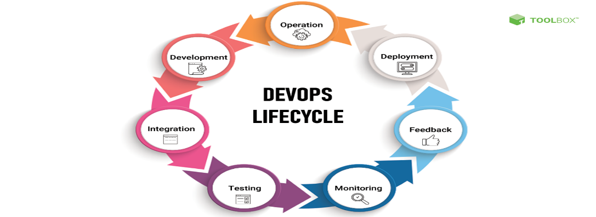

**DevOps Lifecycle**

1. **Continuous development**

Continuous development involves planning and [coding](https://www.spiceworks.com/tech/devops/articles/developer-tips-for-secure-coding/) the software. Here, the entire development process gets broken down into smaller development cycles. This process makes it easier for the DevOps team to accelerate the overall software development process. This phase is instrumental in mapping the vision for the entire development cycle, enabling developers to fully understand project expectations. Through this, the team starts visualizing its end goal as well.

There are no DevOps tools required for [planning](https://www.spiceworks.com/tech/devops/articles/devops-strategies-to-test/), but many version control tools are used to maintain code. This process of code maintenance is called source code maintenance. Popular tools for source code maintenance include JIRA, Git, Mercurial, and SVN. Moreover, there are different tools for packaging the codes into executable files, such as Ant, Gradle, and Maven. These executable files are then forwarded to the next component of the DevOps lifecycle.

2. **Continuous integration**

Continuous integration (CI) includes different steps related to the execution of the test process. Along with this, clients also provide information to be incorporated for adding new features to the application. Most changes happen in the source code during this phase. CI becomes the hub for resolving these frequent changes on a daily or monthly basis. Building code is a combination of unit and integration testing, code review, and packaging. Since [developers](https://www.spiceworks.com/tech/devops/articles/developer-tips-for-secure-coding/) make frequent changes, they can quickly spot problems (if any) and resolve them at an early stage.

This phase experiences continuous integrations of new code functionalities with the existing source code. Due to continuous development, the updated code seamlessly integrates within the entire system. Jenkins is one of the most popular tools for continuous integration. It helps in fetching the updated code and preparing an executable build.

**3. Continuous testing**

Next in the DevOps lifecycle is the testing phase, wherein the developed code is tested for bugs and errors that may have made their way into the code. This is where quality analysis (QA) plays a major role in checking the usability of the developed software. Successful completion of the QA process is crucial in determining whether the software meets the client’s specifications.

Automation tools, such as JUnit, Selenium, and TestNG, are used for continuous testing, enabling the QA team to analyze multiple code-bases simultaneously. Doing this ensures that there are no flaws in the functionality of the developed software.

Moreover, to simulate the entire test environment, Docker containers are used in [continuous testing](https://www.spiceworks.com/tech/devops/guest-article/the-devops-tightrope-balancing-shifting-left-and-right/). A Docker container is a standalone, lightweight executable package with everything to run an app: system tools, system libraries, runtime code, and settings.

Automated testing is done on automation tools like Selenium, after which the reports are generated on another automation tool, for example, TestNG. Automation of the entire testing phase also becomes possible with the help of the continuous integration tool Jenkins. Automation testing plays a vital role in saving time, labor and effort.

**4. Continuous deployment**

Continuous deployment (CD) ensures hassle-free product deployment without affecting the application’s performance. It is necessary to ensure that the code is deployed precisely on all available servers during this phase. This process eliminates the need for scheduled releases and accelerates the feedback mechanism, allowing developers to address issues more quickly and with greater accuracy.

Containerization tools help achieve continuous deployment through configuration management. A containerization tool like Vagrant helps achieve consistency across test, development, staging, and production environments. [Containerization](https://www.spiceworks.com/security/cloud-security/articles/what-is-container-security-definition-components/) deals with bringing virtualization to the level of an operating system.

Continuous deployment is guaranteed to benefit your organization once you have a reliable automated testing environment in place. Configuration management holds a lot of value in the continuous deployment phase. It involves configuring and maintaining consistency in the functional requirement of the app. Popular DevOps tools used for configuration management include Ansible, Puppet, and Chef that help execute quick deployment of new code.

**5. Continuous monitoring**

[Monitoring](https://www.spiceworks.com/it-security/application-security/articles/is-application-performance-monitoring-key-to-protecting-critical-infrastructure-against-cyberattacks/) the performance of a software product is essential to determine the overall efficacy of the product output. This phase processes important information about the developed app. Through continuous monitoring, developers can identify general patterns and gray areas in the app where more effort is required.

Continuous monitoring is an operational phase where the objective is to enhance the overall efficiency of the software application. Moreover, it monitors the performance of the app as well. Therefore, it is one of the most crucial phases of the DevOps lifecycle.

Different [system errors](https://www.spiceworks.com/tech/devops/articles/chaos-engineering-test-system-resilience-before-a-disaster-strikes/) such as ‘server not reachable’, ‘low memory’, etc., are resolved in the continuous monitoring phase. It also maintains the availability and security of the services. Network issues and other problems are automatically fixed during this phase at the time of their detection.

Tools such as Nagios, Splunk, Sensu, ELK Stack, and NewRelic are used by the operations team to monitor user activities for improper behavior. As a result, during continuous monitoring, developers can proactively check the overall health of the system.

Proactive checking improves the [reliability](https://www.spiceworks.com/it-security/data-security/guest-article/whos-responsible-for-data-protection-in-the-wfh-era-it-or-devops/) and productivity of the system and also reduces maintenance costs. Moreover, important and major issues are directly reported to the development team to be corrected in the initial stages. This leads to faster resolution of issues.

**6. Continuous feedback**

Continuous feedback is essential to ascertain and analyze the final outcome of theapplication. It sets the tone for improving the current version and releasing a new version based on stakeholder feedback.

The overall process of app development can only be improved by analyzing the results from the software operations. Feedback is nothing but information gathered from the client’s end. Here, information is significant, as it carries all the data about the performance of the software and its related issues. It also contains suggestions given by end users of the software.

**7. Continuous operations**

The last stage in the DevOps lifecycle is the shortest and easiest to grasp. Continuity is at the heart of all DevOps operations that helps automate release processes, allows developers to detect issues quickly, and build better versions of software products. Continuation is key to eliminate diversions and other extra steps that hinder development.

Development cycles in continuous operations are shorter, allowing organizations to advertise constantly and accelerate the overall time to market the product. [DevOps](https://www.spiceworks.com/tech/devops/articles/why-agile-devops-is-now-the-default-standard-for-software-development/) enhances the value of software products by making them better and more efficient, thereby attracting new customers towards it

## Automating Builds in Detail

Automating builds is a central pillar of DevOps and plays a crucial role in streamlining the software development process. Here's a deeper dive into its intricacies:

**1. What is Build Automation?**

It's the process of **automatically** transforming your source code into a deployable artifact (e.g., an executable file, website) through a series of pre-defined steps. This eliminates manual tasks and ensures consistency and efficiency throughout the build process.

**2. Why Automate Builds?**

* **Increased Efficiency:** Saves developers time and effort, allowing them to focus on core development tasks and reduce repetitive work.
* **Improved Consistency:** Ensures all builds are performed consistently, minimizing the risk of errors introduced by manual intervention.
* **Faster Feedback Loops:** Enables automated testing after every build, providing quicker feedback and allowing developers to identify and fix issues early on.
* **Reduced Errors:** Decreases the likelihood of human error during manual build processes.
* **Easier Collaboration:** Facilitates building and testing across different environments and configurations.

**3. The Build Process:**

* **Version Control System (VCS):** The build process typically starts with a **trigger**, which can be:
  + **Code changes:** When a developer commits changes to the source code repository (e.g., Git).
  + **Scheduled builds:** Predefined schedule to run builds periodically.
  + **Manual triggers:** Initiated by a developer or other external event.
* **Build Tool:** The trigger activates a **build tool** (e.g., Jenkins, Maven, Gradle) that retrieves the latest code from the VCS.
* **Build Steps:** The build tool executes predefined **build steps**, which may include:
  + **Compiling:** Converting source code into machine-readable instructions (e.g., compiling Java code into bytecode).
  + **Packaging:** Bundling the compiled code with necessary resources (e.g., libraries, configuration files) into a deployable format.
  + **Running Tests:** Executing automated tests to ensure code functionality and identify potential regressions.
  + **Static Code Analysis:** Analyzing code for style violations, security vulnerabilities, and potential bugs.
  + **Generating Documentation:** Automatically generating API documentation from the source code.
* **Build Output:** After successful execution of all steps, the build tool generates a final **build output**, which is typically a deployable artifact ready for further deployment processes.

**4. Popular Build Tools:**

* **Jenkins:** Open-source, platform-independent tool offering extensive customization and plugin support.
* **Maven:** Project build and management tool specifically designed for Java projects, enforcing a standard build lifecycle.
* **Gradle:** Open-source build automation tool with a flexible Groovy-based DSL, supporting various programming languages and build tasks.
* **CircleCI:** Cloud-based continuous integration and delivery (CI/CD) platform offering automated builds, testing, and deployments.
* **Travis CI:** Open-source CI platform specifically focused on building and testing projects hosted on GitHub.

**5. Best Practices for Build Automation:**

* **Define clear build steps:** Document and version-control your build configuration to ensure consistency and maintainability.
* **Modularize build steps:** Break down complex builds into smaller, reusable steps for better organization and easier troubleshooting.
* **Implement continuous integration (CI):** Integrate automated builds with your source code management system to trigger builds and run tests after every code change, catching issues early on.
* **Automate testing:** Include automated unit, integration, and other relevant tests as part of the build process to ensure code quality and functionality.
* **Monitor build results:** Set up notifications and monitoring systems to track the success or failure of builds and identify any issues promptly.

Automated testing is a software development practice that utilizes software tools to **execute test cases** and **compare actual outcomes with expected results** in an **automated** fashion. This helps save time and effort, improve test coverage, and streamline the overall software development process.

**Why use automated testing?**

* **Increased Efficiency:** Automates repetitive testing tasks, freeing up human testers for more complex and exploratory testing.
* **Improved Test Coverage:** Allows running a larger number of test cases compared to manual testing, leading to more comprehensive coverage and increased bug detection.
* **Faster Feedback Loops:** Enables automated testing after every build or code change, providing quicker feedback and facilitating faster bug fixes.
* **Reduced Errors:** Minimizes the risk of human errors often introduced in manual testing.
* **Improved Consistency:** Ensures all tests are executed consistently across different environments and configurations.

**Types of Automated Testing:**

* **Unit Testing:** Tests individual software units (e.g., functions, modules) in isolation.
* **Integration Testing:** Tests how different software units interact and work together.
* **Functional Testing:** Verifies that the software functions according to its defined requirements.
* **Regression Testing:** Ensures that new code changes haven't introduced bugs into previously working functionalities.
* **API Testing:** Tests the functionality, reliability, and performance of APIs (Application Programming Interfaces).
* **Non-Functional Testing:** Evaluates non-functional aspects of software like performance, security, and usability.

**Popular Automated Testing Tools:**

* **Selenium:** Open-source framework for web application automation across various browsers.
* **Appium:** Open-source framework for mobile app automation on various platforms (Android, iOS).
* **JUnit (Java):** Unit testing framework widely used in Java development.
* **TestNG (Java):** Another popular unit and integration testing framework for Java.
* **Pytest (Python):** Popular unit testing framework for Python projects.
* **Cypress:** End-to-end testing framework for web applications with a focus on developer experience.

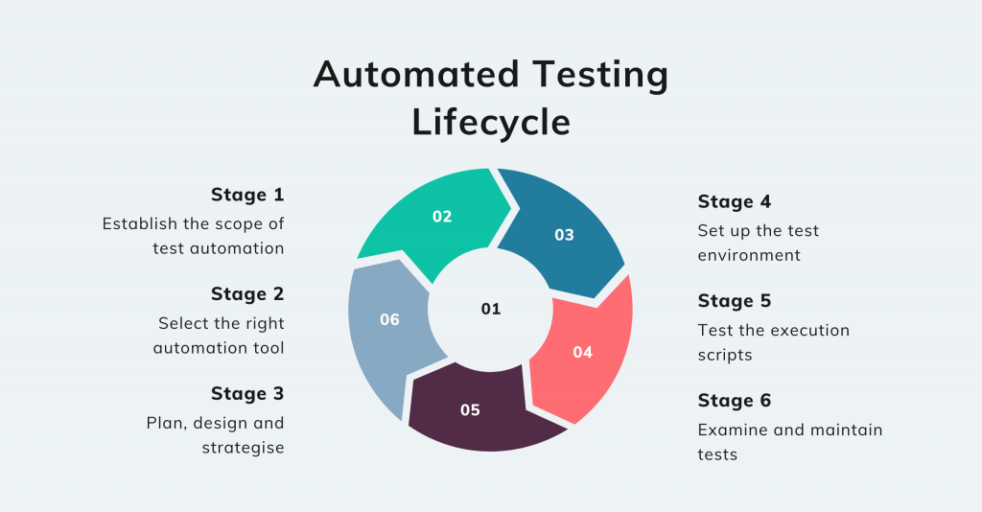

**Establish scope of test automation**

The first step, establishing the scope, means recognising the automation tests’ workability. In this step, we’ll decide which of the application’s modules and test cases can be mechanised, and consider variables like cost, team size and abilities.

**Select right automation tool**

Once we’ve established the scope, we will consider the right automation tool for your product, taking into account the project’s goals, advancements and budget.

**Plan, design and strategise**

The most critical phase of the automated testing lifecycle, this step specifies how to approach and achieve the automation test’s goals. At this stage, our software engineers will make an automated test plan considering the automation tools and framework we’ll use, and develop a test architecture to describe the test’s structure.

**Set up test environment**

In this phase, we’ll set up a machine or remote machine to execute the test scripts. Several key areas of the test environment will be considered, including the test data, multi-browser testing and the tool’s configuration and licence.

**Test script execution**

Once we introduce the test environment, we’ll execute the test script and ensure all the test cases run accurately. A test script should run in various conditions over different stages. Then, once the script has been executed, we’ll compose a bug report outlining any errors that may have occurred.

**Examine and maintain tests**

The final stage involves conducting the automated tests to determine the functionality and validity of the software. After all the tests have been carried out, our software engineers will examine them to see whether the product requires another automated test attempt.

## Test-Driven Development (TDD): Building Confidence Through Testing

Test-driven development (TDD) is a software development approach that emphasizes **writing tests before writing the actual code**. This practice focuses on creating a **red-green-refactor** cycle to ensure code quality and functionality.

**Here's how TDD works:**

1. **Red:** Start by writing a **failing test** for the new functionality you want to develop. This test defines the expected behavior of the code you haven't written yet.
2. **Green:** Write the **minimum amount of code** necessary to make the failing test pass. This ensures the code fulfills the specific functionality outlined in the test.
3. **Refactor:** **Refactor** your code without breaking the existing tests. This helps improve the code structure, readability, and maintainability while ensuring existing functionality remains intact.

**Benefits of TDD:**

* **Improved code quality:** TDD encourages writing clear and concise code that meets specific requirements defined in the tests.
* **Enhanced confidence in code:** Developers gain greater confidence in the code's functionality and reliability as each test ensures a specific aspect works as intended.
* **Well-documented code:** The test cases themselves act as living documentation, clarifying the purpose and behavior of the code.
* **Early detection of issues:** Writing tests upfront helps identify potential problems early on in the development process, leading to faster bug fixing and fewer regressions.
* **Focus on requirements:** TDD encourages a clear understanding of requirements before coding, ensuring the developed code aligns with the desired functionality.

**Challenges of TDD:**

* **Initial learning curve:** Adopting TDD can require a shift in mindset and practice for developers not familiar with the approach.
* **Time investment:** Writing tests upfront can initially take longer than traditional coding approaches, although this time investment often pays off in the long run.
* **Not suitable for all scenarios:** TDD might not be the best approach for all projects or tasks, especially for quick prototypes or simple functionalities.

**Test Driven Development** is the process in which test cases are written before the code that validates those cases. It depends on repetition of a very short development cycle. Test driven Development is a technique in which automated Unit test are used to drive the design and free decoupling of dependencies. The following sequence of steps is generally followed:

1. Add a test – Write a test case that describe the function completely. In order to make the test cases the developer must understand the features and requirements using user stories and use cases.
2. Run all the test cases and make sure that the new test case fails.
3. Write the code that passes the test case
4. Run the test cases
5. Refactor code – This is done to remove duplication of code.
6. Repeat the above mentioned steps again and again

**Motto of TDD:**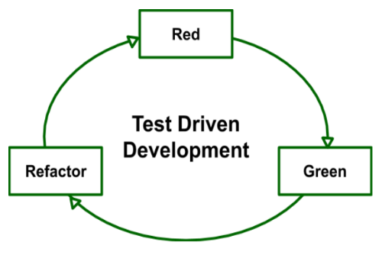

1. **Red –** Create a test case and make it fail
2. **Green –** Make the test case pass by any means.
3. **Refactor –** Change the code to remove duplicate/redundancy.

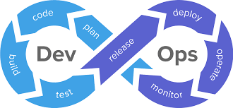

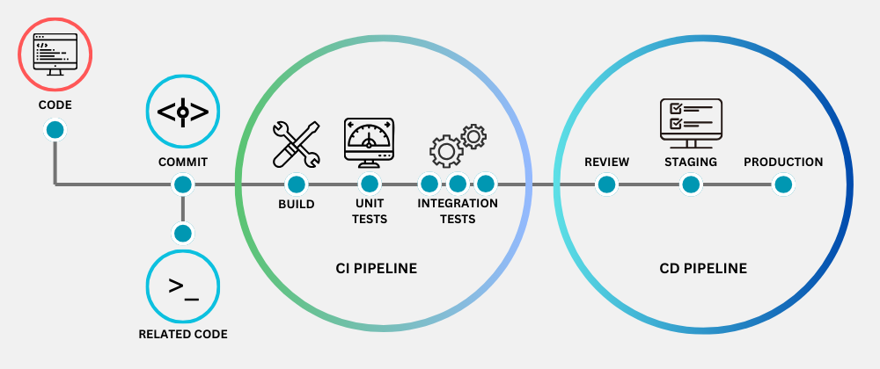

**CI typically works:**

1. **Code Changes:** A developer makes changes to their local codebase.
2. **Version Control System (VCS):** The developer commits the changes to a version control system like Git.
3. **Trigger:** This triggers a CI tool (e.g., Jenkins, GitLab CI/CD) to initiate the build and test process.
4. **Build:** The CI tool retrieves the latest code from the VCS and builds the project according to pre-defined configurations.
5. **Testing:** Automated tests (unit, integration, etc.) are executed to verify the code's functionality and identify any regressions.
6. **Results:** The CI tool reports the build and test results, notifying developers of successes or failures

|  |  |  |
| --- | --- | --- |
| Feature | Continuous Delivery (CD) | Continuous Deployment (CD) |
| **Focus** | Automating delivery of code changes to various environments | Automatically deploying code changes to production after successful testing |
| **Deployment Trigger** | Manual approval, successful CI pipeline, or other pre-defined triggers | Successful CI pipeline (including builds and tests) |
| **Environment Targets** | Deploys to any environment (dev, test, staging, production) based on configuration | Primarily deploys to production, although deployments to other environments may be included |
| **Human Intervention** | Requires manual approval or intervention for deployments to certain environments, especially production | Minimal to no human intervention in the deployment process |
| **Risk Tolerance** | Suitable for organizations with moderate risk tolerance, allowing for controlled deployments and manual approval before production | Suitable for organizations with high risk tolerance and strong confidence in their automated testing and deployment processes |
| **Benefits** | Faster deployments, reduced errors, improved consistency, lower risk of major rollbacks, increased collaboration | All benefits of CD, plus faster time to market, continuous feedback loop, reduced manual effort |
| **Challenges** | Requires clear approval and governance processes to manage deployments | Requires robust automated testing and deployment processes, high level of confidence in automation, and a culture of embracing potential frequent deployments |

Both **Continuous Integration (CI)** and **Continuous Delivery (CD)** are crucial practices within the DevOps methodology, but they address different aspects of the software development and delivery process:

**Continuous Integration (CI):**

* Focuses on **frequent merging of code changes from developers** into a central repository, followed by **automated builds and tests**.
* **Goals:**
  + Early detection of bugs and integration issues.
  + Improved code quality through consistent testing.
  + Faster feedback loops for developers.
  + Reduced risk of integration problems later in the development cycle.
* **Key aspects:**
  + Triggers on code changes (commits) in a version control system (VCS).
  + Performs automated builds and various tests (unit, integration, etc.)
  + Provides feedback to developers about the success or failure of builds and tests.

**Continuous Delivery (CD):**

* Builds upon CI and **automates the delivery of code changes to various environments (e.g., dev, test, staging, production)**.
* **Goals:**
  + Faster deployments of code changes.
  + Reduced errors through automation.
  + Consistent deployments across different environments.
  + Lower risk of major rollbacks due to frequent smaller deployments.
  + Increased collaboration between development and operations teams.
* **Key aspects:**
  + Often triggered by a successful CI pipeline completion.
  + Automates deployment tasks like transferring code artifacts and configuring environments.
  + May involve manual approval or verification steps before deployment to certain environments (especially production).

**Here's an analogy to understand the difference:**

Imagine building a car:

* **CI:** Similar to assembling the car parts (engine, wheels, etc.) and checking if they fit together correctly. This is done frequently to identify any issues early on.
* **CD:** Similar to taking the assembled car for a test drive in different environments (track, city streets, etc.). This ensures the car functions properly in various conditions before delivering it to the customer (production).

**In conclusion:**

* CI is an essential first step, ensuring code quality and facilitating smooth integration.
* CD leverages CI and automates the delivery process, enabling faster and more reliable deployments.

Configuration management is a fundamental pillar of DevOps. It's the practice of automating the process of defining, maintaining, and deploying the desired state of systems and applications. In simpler terms, it ensures that all your systems, from development environments to production servers, are configured consistently and correctly.

Here's why configuration management is crucial in DevOps:

* **Consistency:** It guarantees that all systems are set up and configured identically, eliminating inconsistencies that can lead to errors and unexpected behavior.
* **Automation:** It automates mundane and repetitive tasks, freeing up engineers to focus on more creative and strategic work.
* **Infrastructure as Code (IaC):** It enables treating infrastructure like software, allowing you to define configurations in code files that can be version controlled, tested, and deployed just like any other code. This fosters collaboration, simplifies infrastructure management, and facilitates faster deployments.
* **Improved Agility:** By automating deployments and ensuring consistent configurations, it empowers DevOps teams to release software faster and more reliably.

Here are some of the key benefits of using configuration management in DevOps:

* **Reduced errors and improved reliability:** Consistent configurations minimize the risk of errors and ensure all systems are functioning as intended.
* **Increased efficiency:** Automating configuration tasks saves time and resources, allowing teams to focus on higher-value activities.
* **Improved scalability and maintainability:** Infrastructure as code makes it easier to scale infrastructure and maintain consistent configurations across multiple environments.
* **Enhanced collaboration and transparency:** Version control and shared configuration files facilitate collaboration and improve transparency within DevOps teams.

Popular configuration management tools used in DevOps include Ansible, Puppet, Chef, and SaltStack. These tools provide various functionalities to manage configurations across different operating systems, applications, and infrastructure components.

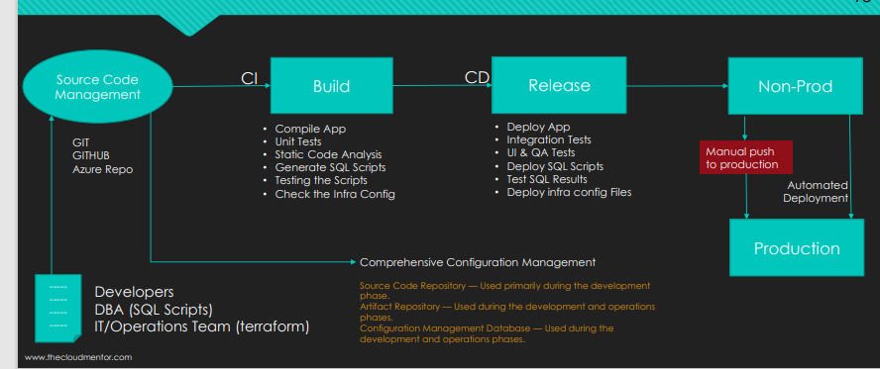

Automated monitoring is the continuous and autonomous process of collecting, analyzing, and alerting on data from various systems, applications, and infrastructure components. It plays a critical role in maintaining the smooth operation and performance of any IT environment, especially within the DevOps context.

**Here's how automated monitoring works:**

1. **Data Collection:** Monitoring tools gather data from different sources using various methods, including APIs, logs, network traffic, and performance metrics. This data can be collected in real-time or at periodic intervals.
2. **Data Analysis:** The collected data is then analyzed against predefined thresholds or baselines. These thresholds represent the acceptable range of values for each metric being monitored.
3. **Alerting and Notification:** If the analysis detects any anomalies or deviations from the expected values (breaches of thresholds), alerts are triggered. These alerts can be communicated through various channels like email, SMS, or internal dashboards, notifying relevant personnel of potential issues.
4. **Automation and Remediation:** In some advanced systems, automated actions can be triggered based on specific alert conditions. This can involve restarting services, scaling resources, or initiating predefined workflows to address the issues automatically.

**Benefits of Automated Monitoring:**

* **Improved Proactive Problem Detection:** By continuously monitoring critical systems, issues are identified and addressed before they escalate into major outages or performance bottlenecks.
* **Reduced Downtime and Increased Uptime:** Early detection of issues minimizes downtime and ensures smooth operation of systems and applications.
* **Enhanced Efficiency and Reduced Costs:** Automating monitoring tasks frees up IT personnel from manual monitoring, allowing them to focus on more strategic work and reducing operational costs.
* **Improved Decision-Making:** Real-time data insights enable data-driven decisions regarding resource allocation, capacity planning, and proactive maintenance.
* **Increased Visibility and Transparency:** Monitoring provides a comprehensive view of system health and performance, facilitating better collaboration and communication among teams.

**Commonly Used Tools for Automated Monitoring:**

* **Infrastructure Monitoring Tools:** Prometheus, Nagios, Zabbix
* **Application Performance Monitoring (APM) Tools:** Datadog, New Relic, AppDynamics
* **Cloud Monitoring Tools:** Amazon CloudWatch, Azure Monitor, Google Cloud Monitoring
* **Log Management Tools:** ELK Stack (Elasticsearch, Logstash, Kibana), Splunk

**Integration with DevOps:**

Automated monitoring is tightly integrated with the DevOps workflow, providing valuable insights throughout the software development lifecycle:

* **Development:** Monitoring performance metrics during development helps identify and address potential issues early in the development cycle.
* **Testing:** Monitoring ensures that test environments are functioning correctly and provides data for performance testing.
* **Deployment:** Continuous monitoring helps track the success of deployments and identify any deployment-related issues.
* **Operations:** Monitoring is crucial for maintaining system stability, identifying performance bottlenecks, and troubleshooting incidents in production environments.

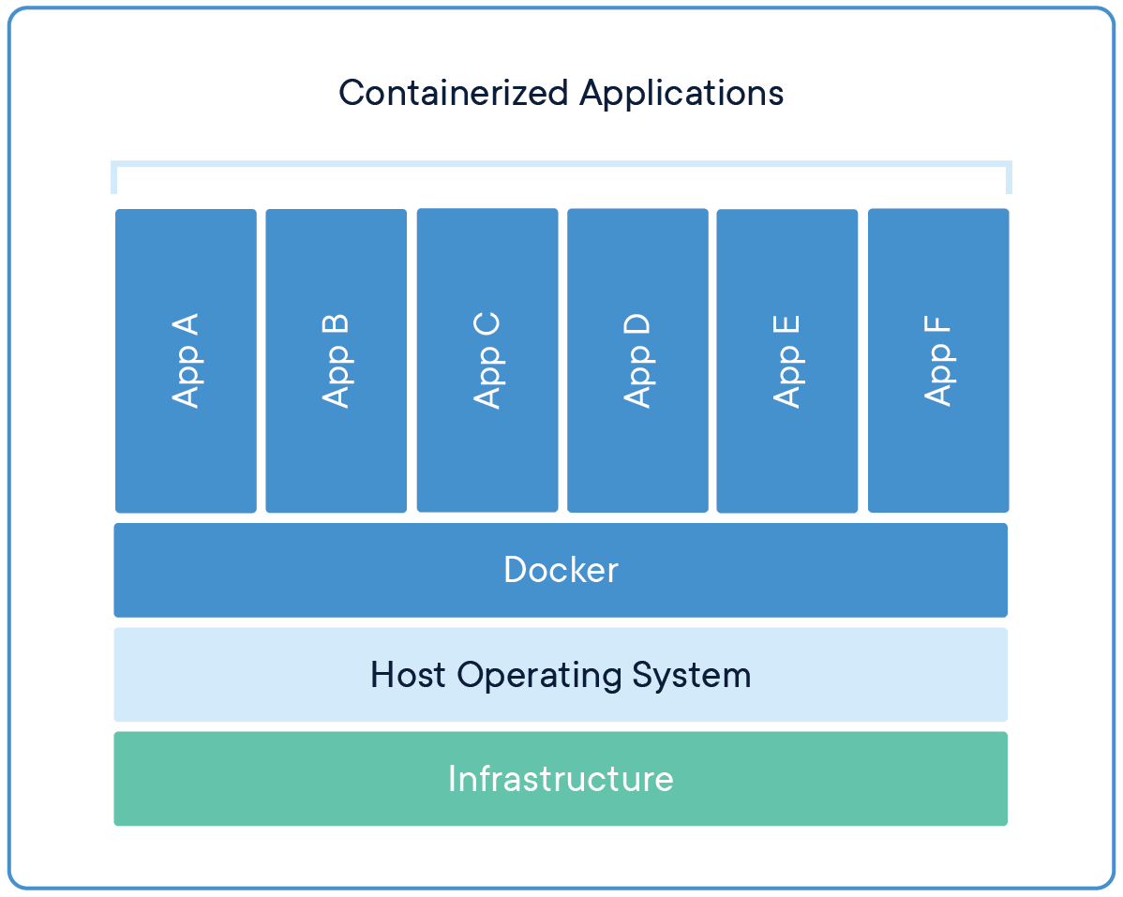

Docker is a popular platform for **containerization**, a technology that allows you to package your application and its dependencies into a lightweight, portable unit called a **container**. This containerization approach offers several advantages, including:

* **Portability:** Containers run consistently across different environments (development, testing, production) regardless of the underlying operating system.
* **Isolation:** Applications in containers are isolated from each other and the host system, preventing conflicts and improving security.
* **Efficiency:** Containers share the host operating system kernel, making them more efficient than virtual machines.
* **Reproducibility:** Containers offer a consistent and predictable environment for running applications.

Here's a breakdown of the key steps involved in using Docker for containerization:

**1. Building Docker Images:**

* **Dockerfile:** This is a text file that defines the instructions for building a Docker image. It specifies the base operating system, installs dependencies, copies application code, and configures the environment.
* **Building the Image:** The docker build command is used to build the Docker image based on the instructions provided in the Dockerfile. This creates a single, executable image file containing everything needed to run the application.

**2. Running Docker Containers:**

* **Docker Engine:** This is the software that runs on your system and manages the creation and execution of containers.
* **Running a Container:** The docker run command is used to run a container from a previously built image. This creates a running instance of the container, isolated from other running containers and the host system.
* **Container Lifecycle:** Once a container is running, you can interact with it using various commands like docker stop to stop it, docker ps to list running containers, and docker logs to view the container's logs.

**Additional Features:**

* **Docker Hub:** This is a public registry where you can find and share Docker images. You can pull existing images from Docker Hub or push your own images for sharing or private use.
* **Docker Volumes:** Volumes allow you to persist data outside of the container, ensuring it's not lost when the container stops or is deleted.
* **Docker Networks:** Docker allows you to create virtual networks for your containers to communicate with each other securely.

**Benefits of using Docker:**

* **Simplified application development and deployment:** Docker streamlines the process of building, testing, and deploying applications by providing a consistent environment.
* **Faster development cycles:** Easier collaboration and faster feedback loops between development and operations teams lead to quicker development cycles.
* **Improved resource utilization:** Containers are lightweight and efficient, allowing you to run more applications on the same hardware compared to traditional virtual machines.
* **Scalability:** Docker containers can be easily scaled up or down to meet changing demands.

## Containerization: Packaging Applications for Portability and Efficiency

Containerization is a software development and deployment technology that packages an application's code, runtime environment, and dependencies into a standardized unit called a **container**. This containerization approach offers several advantages over traditional deployment methods, including:

**Portability:** Containers are self-contained units that run consistently regardless of the underlying operating system. This makes them highly portable and allows them to be easily moved between different environments (development, testing, production) without requiring modifications.

**Isolation:** Each container runs in its own isolated space, separate from other containers and the host system. This isolation ensures that applications do not interfere with each other or the host system, improving security and reliability.

**Efficiency:** Unlike virtual machines, containers share the host operating system kernel, making them more lightweight and efficient in terms of resource utilization. This allows you to run more applications on the same hardware compared to traditional methods.

**Reproducibility:** Since container images encapsulate the entire application environment, they guarantee reproducible deployments. This helps maintain consistency and predictability across different environments, making troubleshooting and debugging easier.

### UNIT -1

### Project lifecycle The project life cycle refers to the series of stages that a project goes through, from its conception to its completion. It provides a structured framework for managing projects effectively and efficiently. Here's a breakdown of the five key phases of the project life cycle:

**1. Initiation:**

* This is the **starting point** of the project, where the **idea is conceived** and the project is **formally approved**.

Project Initiation Phase

* Key activities in this phase include:
  + Identifying the project need and objectives.
  + Conducting a feasibility study to assess the project's viability.
  + Defining the project scope and boundaries.
  + Obtaining stakeholder buy-in and securing resources.
  + Appointing a project manager and forming the project team.

**2. Planning:**

* This phase involves **developing a detailed roadmap** for the project execution.

Project Planning Phase

* Key activities in this phase include:
  + Defining project deliverables and establishing a breakdown of tasks (Work Breakdown Structure - WBS).
  + Estimating task durations and resource requirements.
  + Creating a project schedule using techniques like Gantt charts or PERT charts.
  + Identifying potential risks and developing mitigation strategies.
  + Establishing communication and reporting plans.

**3. Execution:**

* This is the **action phase** where the **project work is actually carried out**.

Project Execution Phase

* Key activities in this phase include:
  + Assigning tasks to team members and managing their workload.
  + Monitoring progress against the plan and addressing any deviations.
  + Managing risks and issues as they arise.
  + Communicating project status updates to stakeholders.
  + Ensuring quality control and meeting project standards.

**4. Monitoring and Controlling:**

* This phase involves **closely monitoring project progress** against the plan and **taking corrective actions** as needed.

Project Monitoring and Controlling Phase

* Key activities in this phase include:
  + Tracking progress of tasks, timelines, and costs.
  + Identifying and analyzing variances from the plan.
  + Implementing corrective actions to address deviations and get the project back on track.
  + Updating the project schedule and budget as necessary.

**5. Closure:**

* This is the **final phase** where the project is **formally completed** and **delivered to the stakeholders**.

Project Closure Phase

* Key activities in this phase include:
  + Completing all outstanding tasks and deliverables.
  + Conducting project acceptance and handover to the client.
  + Evaluating project performance against objectives and learning lessons for future projects.
  + Documenting project outcomes and archiving project information.
  + Disbanding the project team and releasing resources.

Following a well-defined project life cycle helps ensure that projects are **completed on time, within budget, and to the required quality standards**. It also provides a **clear framework for communication, collaboration, and risk management** throughout the project journey.

A **feasibility study** is a **comprehensive assessment** conducted to **evaluate the practicality, viability, and potential success** of a proposed project or venture. It aims to **objectively analyze** all **critical aspects** of the project to **inform decision-making** on whether to proceed, modify, or abandon the project altogether.

Here's a breakdown of the key points about feasibility studies:

**Purpose:**

* To **determine the likelihood of success** of a project by analyzing its strengths, weaknesses, opportunities, and threats (SWOT analysis).
* To **identify potential risks and challenges** associated with the project.
* To **estimate the resources required** (financial, human, technological) and their **associated costs**.
* To **compare potential benefits and drawbacks** of the project to assess its overall feasibility.

**Types of Feasibility:**

* **Technical feasibility:** Assesses if the project can be **completed with available technology and resources**.
* **Economic feasibility:** Evaluates the project's **financial viability** and potential return on investment (ROI).
* **Legal and regulatory feasibility:** Examines if the project complies with all **relevant laws and regulations**.
* **Market feasibility:** Analyzes the **market demand** for the project's product or service.
* **Operational feasibility:** Assesses the **organizational capability** to execute and manage the project effectively.

A feasibility study typically includes the following:

* **Market and Demand Analysis:** This analysis assesses the potential market for the project's product or service, including the size of the market, the target customer, and the competition.
* **Technical Feasibility:** This analysis assesses whether the project can be completed successfully from a technical standpoint. This includes factors such as the availability of resources, technology, and expertise.
* **Financial Feasibility:** This analysis assesses the financial viability of the project, including the project's costs, revenues, and profitability.
* **Organizational Feasibility:** This analysis assesses whether the organization has the necessary resources and capabilities to carry out the project successfully.
* **Social and Environmental Impact Assessment:** This analysis assesses the potential social and environmental impacts of the project.

*- Economic and Market Analysis - Technical Analysis - Market Analysis - Financial Analysis - Economic Benefits - Project Risk and Uncertainty - Management Aspects*

***MARKET AND DEMAND ANALYSIS***

## Market and Demand Analysis: Understanding Your Target Audience and Market Potential

Market and demand analysis is a crucial step in the **feasibility assessment** of a project. It involves **thoroughly examining the target market and the potential demand for the project's product or service**. This analysis provides key insights to help you:

* **Make informed decisions about product development and marketing strategies.**
* **Estimate the potential revenue and profitability of your project.**
* **Identify potential risks and opportunities in the market.**

Here are the **key aspects** of a market and demand analysis:

**1. Market Definition and Segmentation:**

* **Target Market Identification:** This involves pinpointing the specific group of customers you aim to reach with your product or service. Consider demographics (age, income, location), psychographics (values, interests, lifestyles), and behavioral factors (usage patterns, purchase decisions).
* **Market Size Estimation:** Quantify the total number of potential customers within your target market. Utilize industry reports, government data, and market research studies to obtain reliable estimates.
* **Market Segmentation:** Subdivide the entire market into smaller, more manageable segments based on shared characteristics. This allows for a more focused and targeted approach towards understanding customer needs and preferences within each segment. Common segmentation bases include demographics, psychographics, and behavioral factors.

**2. Market Trend Analysis:**

* **Current Trend Analysis:** Analyze prevailing trends in the market relevant to your project. This could encompass consumer purchasing habits, technological advancements, regulatory changes, and economic factors. Tools like trend reports, industry publications, and competitor analysis can be valuable resources.
* **Future Trend Forecasting:** Attempt to predict how the market might evolve in the coming years. Consider factors like emerging technologies, changing consumer needs, and potential socio-economic shifts. This foresight helps tailor your project to anticipate future market demands and maintain relevance.

**3. Competitive Landscape Analysis:**

* **Competitor Identification:** Identify all existing companies offering similar products or services to your project. Thoroughly research their offerings, market positioning, and target audience.
* **Competitive Strengths and Weaknesses Evaluation:** Analyze each competitor's strengths (e.g., brand recognition, pricing strategy, distribution channels) and weaknesses (e.g., limited product range, poor customer service) to understand their competitive advantage and potential vulnerabilities.
* **Competitive Gap Identification:** Pinpoint areas where your project can offer unique value and differentiate itself from the competition. This could involve innovative features, superior customer service, or a more competitive pricing strategy.

**4. Demand Estimation and Forecasting:**

* **Market Research:** Conduct market research activities like surveys, focus groups, and interviews to gather data on customer needs, preferences, and willingness to pay for your product or service. Consider utilizing online surveys, social media listening, and online discussion forums as additional data sources.
* **Sales Forecasting:** Based on gathered data and market trends, estimate the potential sales volume and revenue for your project over a specific timeframe. Utilize statistical techniques like regression analysis and market share forecasting to create a realistic sales forecast.
* **Demand Elasticity Analysis:** Analyze how the demand for your product or service might change in response to various factors, such as price changes, economic fluctuations, and competitor activity. This helps you understand the potential impact of external factors on your project's revenue and profitability.

**Benefits of conducting a feasibility study:**

* **Reduces the risk of project failure** by identifying potential issues early on.
* **Supports informed decision-making** by providing valuable insights and data.
* **Helps in resource allocation** by estimating required resources and costs.
* **Improves communication and collaboration** among stakeholders involved in the project.
* **Increases the chances of project success** by starting with a well-defined plan and realistic expectations.

### PROJECT MANAGEMENT

* Project management is the **process of leading the work of a team to achieve specific project goals within defined constraints**. These constraints typically include **scope, time, and budget**.
* It involves the application of **processes, methods, skills, knowledge, and experience** to ensure a project is completed successfully.

**Planning and Organization:**

* Defining project goals and objectives.
* Breaking down the project into manageable tasks and activities.
* Estimating resources (time, budget, people, equipment) needed.
* Developing a project plan outlining the approach and timeline.

**2. Execution and Control:**

* Leading and motivating the project team.
* Assigning tasks and monitoring progress.
* Identifying and managing risks and issues.
* Making adjustments to the plan as needed.

**3. Communication and Collaboration:**

* Keeping stakeholders informed about project progress.
* Facilitating communication among team members.
* Resolving conflicts and fostering collaboration.

**4. Project Completion and Evaluation:**

* Delivering the project deliverables as planned.
* Evaluating the project's success against its objectives.
* Learning from the project and implementing improvements for future endeavors.

**Why is project management important?**

Effective project management is essential for:

* **Meeting project goals within budget and time constraints.**
* **Minimizing risks and ensuring project success.**
* **Improving communication and collaboration among stakeholders.**
* **Optimizing resource and time utilization.**
* **Delivering high-quality outcomes.**

**Project management methodologies- agile, waterfall , etc ,(**phases of project)

### PROJECT IDENTIFICATION

Project identification is the **initial stage** in the project management process, where you **recognize and define a potential project**. It involves pinpointing a **need, problem, or opportunity** that can be addressed through a dedicated effort with a **defined scope and objectives**. This stage lays the groundwork for further assessment and development of the project.

Here are some key aspects of project identification:

**Identifying Opportunities:**

* **Market Needs and Trends:** Analyzing market trends and identifying unmet needs or potential gaps that a project can address.
* **Organizational Needs:** Recognizing internal challenges or areas for improvement within the organization that a project could solve.
* **Brainstorming and Creativity:** Encouraging creative thinking and identifying innovative solutions to existing problems.

**Defining the Project:**

* **Problem Statement:** Clearly outlining the issue or opportunity that the project aims to address.
* **Project Objectives:** Setting specific, measurable, achievable, relevant, and time-bound (SMART) goals for the project.
* **Project Scope:** Defining the boundaries and deliverables of the project to ensure focus and avoid scope creep.

**Feasibility Assessment:**

* **Preliminary Evaluation:** Assessing the feasibility of the project from various perspectives, including technical, financial, and operational aspects. This helps determine if the project is viable and worthwhile to pursue further.

### 

### Opportunity Studies/Support Studies: This initial phase involves conducting studies to identify potential opportunities or needs that the project could address. This might involve market research, environmental scans, or other assessments to understand the context in which the project will operate.

### Identification of Product/Service: Once opportunities or needs are identified, the next step is to specify the product or service that the project will deliver to capitalize on those opportunities or address those needs. This step involves defining the features, functionalities, and specifications of the product or service.

### Prefeasibility Study: This study is a preliminary assessment conducted to evaluate the potential of the project before committing to a full-scale feasibility study. It typically includes a high-level analysis of technical, economic, and financial aspects to determine whether the project is worth pursuing further.

### Feasibility Study (Techno-Economic Feasibility): The feasibility study is a comprehensive analysis that examines the technical feasibility, economic viability, and financial feasibility of the project. This involves detailed assessments of technical requirements, market demand, competition, regulatory considerations, and financial projections to determine whether the project is feasible and financially viable.

### Project Appraisal: Once the feasibility study is completed, the project undergoes an appraisal process where the findings of the study are reviewed and evaluated by relevant stakeholders. This may involve assessing the risks, benefits, and overall alignment of the project with organizational objectives to make an informed decision about whether to proceed with the project.

### Detailed Project Report: If the project is deemed feasible and approved, the next step is to develop a detailed project report that outlines the project scope, objectives, implementation plan, resource requirements, and financial projections in a comprehensive manner. This report serves as a blueprint for executing the project and guides its implementation through all phases.

### PROJECT COST ESTIMATE

A **project cost estimate** is a **forecasted assessment** of the **financial resources required** to complete a project successfully. It plays a crucial role in project management by enabling:

* **Informed decision-making:** Evaluating the project's financial feasibility, resource allocation, and potential profitability.
* **Budgeting and resource allocation:** Setting realistic budget expectations and allocating resources effectively to complete project activities.
* **Risk management:** Identifying potential cost overruns and implementing strategies to mitigate them.
* **Project monitoring and control:** Tracking actual costs against the estimate and adjusting the budget as needed throughout the project lifecycle.

Here's a breakdown of the key steps involved in creating a project cost estimate:

**1. Define Project Scope:**

* Clearly define the project's scope, including deliverables, activities, and timelines. A well-defined scope serves as the foundation for accurate cost estimation.

**2. Identify Cost Categories:**

* **Direct Costs:** These are costs directly attributable to the project, such as:
  + **Labor Costs:** Salaries, wages, and benefits of personnel involved in the project.
  + **Material Costs:** Costs of materials, equipment, and supplies needed for the project.
  + **Contracted Services:** Costs of outsourcing services for specific project tasks.
* **Indirect Costs:** These are overhead costs not directly linked to specific project activities, such as:
  + **Facility Costs:** Rent, utilities, and maintenance of the project workspace.
  + **Administrative Costs:** Costs associated with general project administration, such as office supplies and communication expenses.
  + **Contingency Costs:** Allowances for unexpected expenses or unforeseen circumstances.

**3. Estimation Techniques:**

* **Expert Judgment:** Utilize the knowledge and experience of project managers, subject matter experts, or external consultants to estimate costs.
* **Analogous Estimating:** Based on historical data from similar projects, adjust for project specifics.
* **Parametric Estimating:** Utilize industry-specific formulas or cost databases to estimate based on project characteristics (e.g., project size, complexity).
* **Bottom-up Estimating:** Break down the project into smaller units (tasks, activities) and estimate costs for each, then sum them up for the entire project.

**4. Develop a Cost Estimate:**

* Use chosen techniques and cost categories to estimate the costs for each project activity.
* Consider factors like inflation, currency fluctuations, and potential risks that might impact costs.
* Utilize project management software or spreadsheets to consolidate and present the cost estimate in a clear and organized format.

**5. Refine and Monitor:**

* Regularly revise your estimate throughout the project lifecycle as new information becomes available or adjustments are made to the project scope.
* Monitor actual costs against the estimate and proactively identify and address any deviations.

### FINANCIAL APPRAISAL

Financial appraisal is the process of assessing the financial health and viability of an asset, project, or business. It involves a comprehensive analysis of its financial statements, cash flow, and future prospects to make informed decisions about its value, feasibility, or risk.

There are two main types of financial appraisals:

1. **Investment appraisal:** This type of appraisal is used to assess the potential profitability and risks of an investment project, such as starting a new business, launching a new product, or acquiring another company.
2. **Business valuation:** This type of appraisal is used to determine the fair market value of a business, which is often needed for transactions such as mergers and acquisitions, selling a business, or estate planning.

financial appraisals are used in various situations, including:

* **Making investment decisions:** Investors use financial appraisals to assess the potential risks and returns of investments before committing their capital.
* **Securing funding:** Businesses often need to provide financial appraisals to lenders and investors when seeking loans or raising capital.
* **Mergers and acquisitions:** Financial appraisals are crucial in determining the fair value of businesses involved in mergers and acquisitions.
* **Estate planning:** Financial appraisals are used to value businesses and other assets for estate planning purposes.

Financial appraisals are conducted using various methods and techniques, including:

**1. Payback Period:**

* **Definition:** The time it takes for an investment to recover its initial cost from its generated cash flows.
* **Formula:** Payback Period = Initial Investment / Average Annual Cash Flow
* **Example:** You invest $10,000 in a new machine that generates $2,500 in annual cash flow. The payback period would be 10,000 / 2,500 = 4 years.
* **Limitation:** Ignores the time value of money and cash flows beyond the payback period.

**2. Return on Investment (ROI):**

* **Definition:** A simple metric to measure the percentage gain on an investment.
* **Formula:** ROI = (Gain from Investment / Initial Investment) x 100%
* **Example:** You buy a stock for $100 and sell it for $120. Your ROI would be (120 - 100) / 100 x 100% = 20%.
* **Limitation:** Doesn't consider the time frame or the size of the investment.

**3. Net Present Value (NPV):**

* **Definition:** The present value of all future cash flows of an investment minus the initial investment.
* **Formula:** NPV = Σ (Cash Flow at Year t / (1 + Discount Rate)^t) - Initial Investment
* **Example:** You are considering a project with an initial investment of $10,000, generating annual cash flows of $3,000 for 5 years. Assuming a discount rate of 10%, the NPV would be calculated using a spreadsheet or financial calculator. A positive NPV suggests the project creates value.
* **Advantage:** Considers the time value of money and all future cash flows.

**4. Profitability Index (PI) / Benefit-Cost Ratio:**

* **Definition:** The ratio of the present value of future cash flows to the initial investment.
* **Formula:** PI = Present Value of Cash Flows / Initial Investment
* **Example:** Using the same project example as NPV, if the calculated present value of cash flows is $15,000, the PI would be 15,000 / 10,000 = 1.5. A PI greater than 1 indicates the project is profitable.
* **Advantage:** Provides a single index to assess the project's relative attractiveness.

**5. Internal Rate of Return (IRR):**

* **Definition:** The discount rate that makes the NPV of an investment equal to zero.
* **Formula:** Requires solving a complex equation or using financial software.
* **Example:** Using the same project example, the IRR would be the discount rate at which the NPV becomes zero. This rate can be found using trial and error or specific financial functions in software.
* **Advantage:** Considers the time value of money and reflects the project's inherent profitability.

Financial appraisal is an **analytical process** that assesses the **economic viability and financial feasibility** of a project. It involves:

1. **Cost Estimation:** Estimating all project costs, including initial investments and operational expenses.
2. **Revenue Forecasting:** Projecting future income based on market demand, pricing, and sales volume.
3. **Financial Projections:** Forecasting cash flow, income statement, and balance sheet over the project's lifespan.
4. **Investment Appraisal Techniques:** Applying various techniques like:
   * **Net Present Value (NPV):** Measures present value of future cash flows, indicating financial viability if positive.
   * **Internal Rate of Return (IRR):** Represents expected project return rate, compared to cost of capital for decision-making.
   * **Payback Period:** Time to recover initial investment through project cash flows.
   * **Profitability Index (PI):** Ratio of present value of future cash flows to initial investment, indicating positive returns if greater than 1.
5. **Sensitivity Analysis:** Evaluating how changes in key variables affect project outcomes, identifying potential risks and uncertainties.
6. **Risk Assessment:** Recognizing and evaluating financial, operational, and external risks to the project's financial performance.
7. **Decision Making:** Using the appraisal results, stakeholders make informed decisions to proceed, modify, seek additional funding, or abandon the project based on its financial merit.

### UNIT -3

### PROJECT MANAGEMENT FEATURES

**1. Project Planning and Scheduling:**

* **Goal Setting:** Define SMART goals (Specific, Measurable, Achievable, Relevant, and Time-bound) to provide direction and clarity to the project.
* **Milestone Creation:** Break down the project into key milestones that represent significant achievements towards the final goal.
* **Task Breakdown:** Divide the project into smaller, manageable tasks using work breakdown structures (WBS) to ensure nothing falls through the cracks.
* **Dependency Management:** Identify relationships between tasks, ensuring dependent tasks (those requiring completion of another task first) are scheduled accordingly.
* **Resource Allocation:** Assign tasks to team members based on their skills and availability, optimizing resource utilization.
* **Scheduling Tools:** Utilize Gantt charts, calendars, and other visual tools to create a realistic and flexible project schedule that considers dependencies and resource availability.

**2. Task Management:**

* **Task Prioritization:** Prioritize tasks based on importance and urgency using tools like the Eisenhower Matrix, ensuring critical tasks are addressed first.
* **Subtask Creation:** Break down complex tasks into smaller, more manageable subtasks, making them easier to assign, track, and complete.
* **Checklist Creation:** Create checklists for each task, outlining the steps required for completion, promoting clear communication and ensuring no crucial steps are missed.
* **File Attachments:** Attach relevant files and documents to each task, providing team members with the resources needed to complete the task effectively.
* **Progress Tracking:** Implement progress tracking tools like progress bars or percentage completion indicators to visualize individual and overall project progress.
* **Comments and Discussions:** Enable communication and collaboration on tasks through comments and discussions, allowing team members to share updates, ask questions, and provide feedback.

**3. Team Collaboration:**

* **Communication Channels:** Utilize various communication channels like chat, video conferencing, and email to foster communication, collaboration, and problem-solving within the team.
* **File Sharing and Permissions:** Securely share project documents and files with team members, setting access permissions to control who can view, edit, or share them further.
* **Version Control:** Track changes made to documents and files, allowing teams to revert to previous versions if necessary and ensuring everyone is working with the latest information.
* **Meeting Management:** Schedule and manage project meetings through integrated calendars and meeting tools, promoting efficient and focused discussions.
* **Teamwork Features:** Utilize features like shared whiteboards, task boards, and real-time collaborative editing to facilitate brainstorming, planning, and problem-solving as a team.

**4. Reporting and Analytics:**

* **Real-time Dashboards:** Visualize key project metrics like budget spent, task completion rates, and resource utilization in real-time dashboards, enabling proactive decision-making.
* **Customizable Reports:** Generate reports tailored to specific needs, providing detailed insights into project performance, resource allocation, and potential risks.
* **Trend Analysis:** Analyze trends in project data to identify areas for improvement and predict potential roadblocks before they occur.
* **Performance Tracking:** Track key performance indicators (KPIs) to measure project progress and success against established goals and objectives.

**5. Additional Features:**

* **Resource Management:** Manage team member availability and workload through tools like skills matrices and workload reports, preventing resource overload and ensuring team members are utilized effectively.
* **Budgeting:** Set and track project budgets using features like budget allocation, expense tracking, and forecasting tools, ensuring financial accountability and preventing cost overruns.
* **Risk Management:** Identify and assess potential risks that could impact the project, and develop mitigation plans to minimize their impact or prevent them from occurring altogether.
* **Mobile Access:** Access project information, manage tasks, and collaborate with team members on the go using mobile apps, promoting flexibility and efficiency.

### RISK ANALYSIS

### Risk and Uncertainty are associated with every project. Risk is related to occurrence of adverse consequences and is quantifiable. It is analysed through probability of occurrences. Where as uncertainty refers to inherently unpredictable dimensions and is assessed through sensitivity analysis. It is therefore necessary to analyse these dimensions during formulation and appraisal phase of the programme. Factors attributing to risk and uncertainties of a project are grouped under the following;

### Technical –relates to project scope, change in technology, quality and quantity of inputs, activity times, estimation errors etc.

### Economical- pertains to market, cost, competitive environment, change in policy, exchange rate etc.

### Socio-political- includes dimensions such as labour, stakeholders etc.

### Environmental – factors could be level of pollution, environmental degradation etc.

## RISK Analysis: Mitigating Uncertainty in Projects

**Risk analysis** is a crucial process in project management that helps identify, assess, and prioritize potential threats or uncertainties that could negatively impact the project's success. By proactively analyzing risks, project managers can develop mitigation strategies to minimize their impact or even prevent them from occurring altogether.

Here's a breakdown of the key steps involved in risk analysis:

**1. Risk Identification:**

* **Brainstorming:** Gather team members and stakeholders to brainstorm potential risks through techniques like brainstorming sessions, workshops, or scenario planning.
* **Data Analysis:** Analyze historical project data, industry trends, and external factors to identify potential risks specific to the project and its environment.
* **Expert Knowledge:** Leverage the expertise of team members, subject matter experts, and external consultants to identify potential risks specific to their areas of knowledge.

**2. Risk Assessment:**

* **Likelihood:** Once risks are identified, assess the likelihood of each risk occurring using a qualitative (low, medium, high) or quantitative (percentage chance) scale.
* **Impact:** Evaluate the potential impact of each risk on the project's objectives, considering factors like cost, schedule, quality, and stakeholder satisfaction.
* **Risk Scoring:** Multiply the likelihood and impact scores to calculate a risk score, prioritizing risks based on their combined potential for negative consequences.

**3. Risk Mitigation:**

* **Develop Mitigation Strategies:** Based on the risk score, develop mitigation strategies for each identified risk. These strategies can involve:
  + **Avoidance:** Eliminating the risk altogether by changing the project approach.
  + **Transference:** Transferring the risk to another party through insurance or outsourcing.
  + **Mitigation:** Reducing the likelihood or impact of the risk through contingency plans, preventative measures, or resource allocation.
  + **Acceptance:** Accepting the risk if the potential impact is minimal or unavoidable.

**4. Risk Monitoring and Control:**

* **Regularly Monitor Identified Risks:** Continuously monitor identified risks throughout the project, as the likelihood and impact of risks can evolve over time.
* **Update Mitigation Strategies:** Adapt and update mitigation strategies as needed based on changes in the project or the risk landscape.
* **Communicate Effectively:** Communicate identified risks and mitigation plans clearly and regularly to all stakeholders to ensure everyone is aware of potential threats and actions being taken.

### PROJECT CONTROL

* Many large projects frequently experience overshot timelines, cost overruns, and increasing workloads. This could be due to insufficient information during estimations, judgment bias, scope creep and many other factors.
* The reason this happens is not due to lack of effort or intention. This happens because of lack of project control and management. It is important to note that project control plays a significant role in ensuring that the project stays on schedule, and within budget while ensuring quality of the delivered product.
* A project manager is responsible for managing as well as controlling a project. That means as a project manager it is important to ensure that the project is being scheduled correctly, and the budget and quality of the project is maintained.
* A project manager must have relevant knowledge and expertise in managing different domains of a project. This can either be acquired through formal education or on the job.

## **What is Project Controlling in Project Management?**

* Project controlling is the process of gathering data on the progress of the project schedule and the cost incurred, and ensuring that it is on track.
* The project controlling process includes evaluating the project progress, forecasting the future based on current measurements and then implementing measures to improve performance.
* Since the project environment is dynamic and unpredictable, controlling projects is fairly challenging as things don’t always go the way planned.

## **Why are Project Controls Important?**

* Project control process is directly correlated to stakeholder’s expectations and project progress. Usually projects fail as a result of collection of small issues that cause significant impact to the schedule, cost, quality and risk in the entirety of the project.
* These small issues are identified and dealt with under the project control process such that the project does not go off track.
* Project managers understand that whether it’s a construction project or a website launch for a small business, additional costs, unexpected delays or unpredictable circumstances can arise at any point. However the lack of project controls to anticipate and resolve these issues can result in the project being off track eventually.

## **Features of Project Controlling**

* Applied at Every Level: Controlling is a top down process wherein the top management lays out the strategic plans and budget constraints of a project, and this is applied at the project operational level.
* Ongoing Process: The controlling process has to be applied throughout the project duration and is a continuous process to monitor progress and control deviations. This helps the organization adopt a proactive approach rather than a reactive one.
* Regular Feedback: By regularly measuring the project progress against estimations, the project receives regular feedback on the progress or deviations.
* Flexible: The project controlling process can be adapted to the needs of a project and can be updated according to the phase of a project.

## **Benefits of Project Controls**

* Optimized Resource Consumption: This process helps to ensure that the available resources are used effectively and efficiently by tracking the processes regularly and ensuring the project is completed according to the plan.
* Facilitates Decision Making: Regular tracking of the processes and deliverables helps an organization in making timely decisions that can get the project on track timely in case of any deviations.
* Accountability: Project controlling helps in establishing clear accountability and responsibility lines.
* Better Coordination: Since the processes are evaluated regularly and impact of each activity is measured against the desired outcome, this fosters more transparency and better coordination between the teams to resolve problems early.
* Regular Reporting: The process involves regularly measuring the performance of current processes and comparing them to the planned results. Thus, the status of the project is regularly reported.
* Avoiding Gold Plating and Scope Creep: Adding extra features to the product (Gold plating) or expanding the scope of the project without requesting for a formal change request ( scope creep) are avoided by project controlling as each change is measured against the originally approved plan.

## **Steps Involved in Project Controls Process**

The process of Project controlling can be divided into 4 easy steps and they are explained in brief below:

1. **Standards and Baselines:** Determining the qualitative or quantitative standards in order to ensure that the deliverables meet certain expectations. Baseline ( an approved plan accepted during the planning stage) is used to evaluate the performance of the project deliverable.
2. **Measurement**: Once the standards and baselines are established, the project operations and deliverables are measured. This provides status updates in the form of progress reports, dashboards and checklists.
3. **Analyzing the Data:** Comparing the collected data with the predetermined standards and baselines to determine if there are any differences.
4. **Corrective Steps**: If the differences are more than the tolerable limit and can be corrected, this step involves taking action towards resolving the differences.

## **Types of Project Controls**

1. **Feedback Control:** This type of control uses inspection and feedback as a method to ensure that the product is as per the original requirements
2. **Concurrent Control:**This type is focused on ensuring that the project timelines and important milestones are met, and if any corrective actions are needed to ensure the project stays on schedule.
3. **Predictive Control:** This type of control measures the current performance of the project or the actual cost incurred till date, and forecasts the estimated performance or cost towards the end of the project.

## **Project Controls Techniques**

### 1. Small Work Packages

Small work packages ensure more accurate estimates and better control over the project activities.

When work packages are scheduled to be completed within one or two reporting periods, the ability to detect a delay or trouble is much easier and is useful for controlling the project. With early detection, one can work on the preventive and corrective measures faster and reduce the impact on other critical factors.

### 2. Baselines

The baselines are really important in the project control process, as the performance of the project is measured against the baselines.

The process includes establishing a baseline, measuring and reporting against the baseline, and deciding whether the baseline needs to be maintained or updated on the basis of an approved change request.

### 3. Status Meetings

The most common and simple technique is the status meeting. Regular status meetings help to maintain transparency, accountability, and responsibility for small work packages.

This tool is also used to manage expectations and ensure information is shared regularly amongst project team members.

### 4. Completion Criteria

Understanding what is meant by “done” is very important as what is done for the project team may not be completed according to the client. This helps all the stakeholders to be on the same page when it comes to project deliverables. This helps the team in being productive and avoids ambiguity in status reports.

### 5. Reviews

For maintaining quality and expectations, reviews can be used for project deliverables. The steps to follow for key deliverables here are review, receive feedback and correct, if required.

These reviews can be in the form of design reviews, process reviews, audits, walk throughs, and inspection.

### 6. Milestones and Checkpoints

Establishing checkpoints and milestones to review the project progress , address key issues, and take corrective actions if necessary for keeping the project on track is an important technique for project control. This technique is also useful for the senior management and sponsors of the project to reevaluate their investments in the project and redirect funds if needed.

### 7. Track Requirements

In order to avoid scope creep or any other changes in the existing scope of the project, a traceability matrix can be used to control the project. A traceability matrix provides a link between the original stated requirements, the final product and the reason this requirement was made.

### 8. Formal Sign Offs

The process of receiving a final go ahead from the client to ensure the project deliverable is accepted and complies with the requirements, is a formal way of controlling the project and ensuring the key stakeholders are engaged regularly about the project progress.

### 9. Independent QA Auditor

In this technique, an independent Quality Auditor is appointed to monitor the project progress and inspect whether the deliverables meet the criteria and quality agreed upon. This technique can be used to inspect the project deliverables or the project management processes.

### 10. V Method

The V-method is referred to the technique that uses verification and validation for ensuring the project deliverable is according to the accepted requirements.

### PROJECT AUDIT

A **project audit** is a systematic and independent review of a project's **processes, performance, and outcomes** against pre-defined objectives, goals, and established criteria. It acts as a **comprehensive health check** for the project, aiming to:

* **Assess the project's effectiveness:** Evaluate whether the project is achieving its intended objectives and delivering the desired outcomes.
* **Identify areas for improvement:** Uncover areas where the project is not performing as well as it could and suggest improvements in processes, methodologies, or resource allocation.
* **Ensure alignment with organizational goals:** Verify that the project aligns with the organization's overall strategic objectives and contributes to its success.
* **Identify non-compliance with regulations or standards:** Evaluate if the project adheres to any relevant industry regulations, ethical standards, or organizational policies.

**Who conducts project audits?**

Project audits can be conducted by various entities, depending on the specific needs and organizational structure. Here are some common possibilities:

* **Internal Audit Department:** Many organizations have dedicated internal audit departments with the expertise and objectivity to conduct independent project reviews.
* **Steering Committee or Advisory Board:** A project's governing body, such as a steering committee or advisory board, may appoint external auditors to perform an independent review.
* **External Auditors:** Organizations can hire external audit firms with specialized project management expertise for a completely independent perspective.

**What are the different types of project audits?**

There are various types of project audits, each focusing on specific aspects of the project:

* **Process audits:** Assess the effectiveness and efficiency of the project management processes, including planning, scheduling, risk management, and communication.
* **Compliance audits:** Verify that the project adheres to established policies, procedures, regulations, or industry standards.
* **Performance audits:** Evaluate the project's success in achieving its intended outcomes and objectives, focusing on areas like cost, schedule, and quality.
* **Post-project audits:** Conducted after project completion to evaluate overall project performance, identify lessons learned, and inform future project improvement initiatives.

**Benefits of Project Audits:**

* **Improved project performance:** By identifying areas for improvement and providing recommendations, project audits can lead to more efficient and effective project execution.
* **Enhanced decision-making:** Insights from project audits can help inform future project decisions and resource allocation strategies.
* **Increased accountability:** Project audits promote transparency and accountability by providing an independent assessment of project performance.
* **Reduced risk:** Early identification of potential issues through project audits allows for proactive risk mitigation strategies.

**Methods:**

There are various established methodologies for conducting project audits, each with its own strengths and weaknesses. Here are a few popular options:

* **Project Management Institute (PMI) Audit Standard:** This method offers a comprehensive framework for auditing projects of all sizes and complexities. It emphasizes compliance, performance, and process aspects.
* **International Organization for Standardization (ISO) 19011 Guidelines:** These generic guidelines provide a framework for conducting audits of various management systems, including projects. They focus on objectivity, independence, and evidence-based conclusions.
* **Customized Approach:** Organizations can also develop **custom audit methodologies** tailored to their specific needs, project type, and risk profile. This allows for greater flexibility but requires expertise in audit design and execution.

**Tools:**

While specific tools may vary depending on the chosen methodology, here are some commonly used resources for project audits:

* **Project Management Software:** Existing project management software (e.g., Asana, Trello, Microsoft Project) can provide valuable data for the audit, such as task completion rates, resource allocation, and communication logs.
* **Document Management Systems:** These systems store and manage project documents, contracts, and other relevant information, facilitating access and review during the audit process.
* **Data Analytics Tools:** Specialized software can help analyze large datasets from various sources, providing insights into project performance trends and identifying potential deviations from baselines.
* **Interview and Survey Tools:** Tools like online surveys or interview scheduling platforms can facilitate efficient data collection from project stakeholders and team members.
* **Audit Management Software:** Dedicated software can help manage the audit process, including planning, scheduling, document management, and reporting.

### PROJECT TERMINATION

## Project Termination: Wrapping Up Successfully or Unsuccessfully

Project termination refers to the **formal ending of a project**, regardless of whether it meets its initial objectives or not. It's crucial to manage project termination effectively to ensure a smooth and efficient closure, regardless of the outcome.

Here's a breakdown of the key phases involved in project termination:

**1. Decision to Terminate:**

* **Evaluation:** Analyze the project's current status against its goals and objectives. Consider factors like budget constraints, changing priorities, risk realization, or successful completion.
* **Stakeholder Involvement:** Involve key stakeholders in the decision-making process, ensuring transparency and alignment.
* **Formalization:** Document the decision to terminate the project with clear justification and communication to all relevant parties.

**2. Project Closure Activities:**

* **Deliverables Completion:** Ensure all promised deliverables are finalized and delivered to the client or stakeholders, even if in a scaled-down version.
* **Acceptance and Sign-off:** Obtain formal acceptance of completed deliverables from the client or stakeholders, documenting their approval.
* **Resource Release:** Release resources assigned to the project, such as personnel, equipment, and facilities, for allocation to other initiatives.

**3. Documentation and Archiving:**

* **Project Records:** Compile and archive all relevant project documentation, including plans, reports, meeting minutes, and communication records.
* **Lessons Learned:** Capture key learnings and insights gained throughout the project, highlighting both successes and challenges. This knowledge can inform future projects and improve overall project management practices.
* **Financial Closure:** Finalize all project-related finances, settling outstanding bills and ensuring proper budget closure.

**4. Post-Project Review:**

* **Conduct a project review:** Depending on the project's nature and complexity, consider conducting a formal review involving key stakeholders. This allows for reflection on the project's execution, successes, and failures.
* **Capture and Share Learnings:** Disseminate the captured lessons learned from the project review to relevant parties within the organization, fostering knowledge sharing and continuous improvement.

**Types of Project Termination:**

There are two main types of project termination:

* **Natural Termination:** This occurs when a project successfully reaches its predetermined goals and objectives. All deliverables are completed and accepted, and the project is formally closed.
* **Early Termination:** This happens when a project is stopped before its planned completion due to various reasons, such as budget limitations, scope changes, feasibility issues, or risk realization.

Project Termination is a crucial step in a project life cycle. However, unlike other steps, which are a must in order to execute a project efficiently, project termination is implemented when the project fails to deliver value or defined objectives. The prime goal of project termination is to cut down on losses incurred by a business during execution.

While these are some of the common factors associated with project termination, other factors include:

* Failure to meet deadlines
* Change of requirements
* Significant rise in the cost of the project, vis-a-vis the estimated revenue generated
* Lack of resources and project planning
* Outgrowth of the assigned budget and utility
* Failure of collaboration between the business and client.

Considering the above factors, among many others, the project is put to an end regardless of its completion, and its resources are reassigned to other projects.

To understand the project termination definition, let us take the example of New Coke. This project had to be aborted because it was unable to sell the product. As a result, $30 million worth of inventory (back-stocked accumulated inventory) that was created to launch the product in the market became a dead stock.

Besides, Google Glass, Amazon Fire Phone, and McDonald's Arch Deluxe Burger are classic examples of project termination. In broader terms, these projects were terminated as they could not fulfill their objectives, and the companies saw that these projects could not deliver the desired, expected results.

## **Types of Project Termination**

Learning about the different types of project termination can help you define project termination and understand its significance. Following are the two types of project termination:

### 1. Natural Project Termination

A natural project termination occurs when a project reaches its closure, successfully fulfills its objectives, is approved by the client, and is not terminated mid-way. It is declared to have successfully reached its completion and is closed. A formal closure is a part of natural project termination, which includes a final run-through of the product, formal approval from the client, acceptance, then handover of the project/product to the client or sponsor, finishing the project records, and finally, a proper documentation to mark the end of the project life cycle. Successful termination of a project allows the team to have a rest period, start another task, or migrate to other projects.

### 2. Unnatural Project Termination

There are times when a project has to be stopped abruptly in the middle of its execution due to numerous factors and thus sees an unnatural termination. A consciously planned closure is the only way to deal with a project that is not working out the actual way or is no longer relevant to the current demands. As mentioned before, many factors can feed the need for an unnatural project termination. An example of an unnatural project termination is when the customer declares an overspend in the budget, and thus the project needs to pause.

There are various reasons why a project might be terminated, categorized broadly into two groups: **reasons related to project success** and **reasons related to project failure**.

**1. Reasons Related to Project Success:**

* **Natural Completion:** This occurs when the project successfully achieves its predefined goals and objectives. All deliverables are completed and accepted, marking the project's natural conclusion.
* **Reaching Key Milestones:** Sometimes, reaching crucial milestones that demonstrate the project's effectiveness or exceeding initial expectations can lead to a decision to terminate the project early and shift resources to other initiatives.

**2. Reasons Related to Project Failure:**

These often involve unforeseen circumstances or challenges that hinder the project's ability to achieve its intended goals. Here are some common reasons:

* **Budget Shortfalls:** Running out of funds due to unforeseen costs, cost overruns, or changes in the funding environment can necessitate project termination.
* **Scope Creep:** Uncontrolled growth in project scope, leading to increased costs, schedule delays, and resource constraints, can force project termination to mitigate further issues.
* **Technical Challenges:** Encountering insurmountable technical difficulties or realizing that the project's goals are technically unfeasible can lead to project termination.
* **Change in Priorities:** A shift in organizational priorities or strategic direction might render the project irrelevant, prompting its termination.
* **Stakeholder Disagreement:** Lack of support, conflicting priorities, or dissatisfaction from key stakeholders can lead to project termination.
* **Risk Realization:** The occurrence of a major risk that significantly impacts the project's viability or creates unacceptable consequences can necessitate termination.
* **External Factors:** Unforeseen external factors like market changes, legal or regulatory constraints, or natural disasters can force project termination.

### Unit -2 PROJECT SCHEDULING

Project scheduling is the backbone of any successful project. It's essentially a roadmap that outlines the tasks, resources, and timeline needed to complete a project on time and within budget. Here's a breakdown of the key aspects:

**What it is:**

* A **timetable** outlining the project's **activities, milestones, deliverables**, and their **dependencies**, along with **start and end dates**.
* A crucial tool for **communication** and **organization**, informing everyone involved about the project's roadmap.

**Benefits:**

* **Increased efficiency and productivity:** By having a clear plan, teams can work more efficiently and avoid wasting time on figuring out what needs to be done next.
* **Improved resource allocation:** Scheduling helps ensure resources (people, equipment, etc.) are available when needed, preventing bottlenecks and delays.
* **Enhanced risk management:** By identifying potential dependencies and resource constraints, you can proactively address risks and develop mitigation plans.
* **Better communication and collaboration:** A shared schedule fosters clear communication and collaboration among team members and stakeholders.

**Creating a project schedule:**

1. **Break down the project:** Identify the key tasks (activities) and deliverables needed to complete the project. Use a **work breakdown structure (WBS)** to break down complex projects into smaller, manageable tasks.
2. **Estimate durations:** Determine the estimated time required to complete each task, considering factors like effort, resources, and dependencies.
3. **Identify dependencies:** Specify which tasks need to be completed before others can start. This helps avoid delays caused by waiting on unfinished tasks.
4. **Choose a scheduling tool:** Utilize various tools like **Gantt charts**, **network diagrams**, or **project management software** to visually represent the schedule.
5. **Assign resources:** Allocate necessary resources like personnel, equipment, and materials to each task.
6. **Set deadlines:** Establish realistic deadlines for each task, considering dependencies and buffer time for potential delays.
7. **Communicate and monitor:** Share the schedule with all stakeholders and monitor progress regularly. Be prepared to adjust the schedule as needed based on real-time progress and unforeseen circumstances.

### Project management involves decision making for the planning, organizing, coordination, monitoring and control of a number of interrelated time bound activities. Project Manager therefore, often depends on tools and techniques that are effective enough not only for drawingup the best possible initial plan but also capable of projecting instantaneously the impact of deviations so as to initiate necessary corrective measures. The search for an effective tool has resulted in development of a variety of techniques. These project management techniques can be classified under two broad categories i.e., Bar Charts and Networks.

### Bar Charts Bar charts are the pictorial representation of various tasks required to be performed for accomplishment of the project objectives. These charts have formed the basis of development of many other project management techniques.

### - Gantt Chart

### Henry L Gantt (1861 – 1919) around 1917 developed a system of bar charts for scheduling and reporting progress of a project. These charts latter were known as Gantt Charts. It is a pictorial representation specifying the start and finish time for various tasks to be performed in a project on a horizontal time-scale. Each project is broken down to physically identifiable and controllable units, called the Tasks. These tasks are indicated by means of a bar, preferably at equi-distance in the vertical axis and time is plotted in the horizontal axis (Figure 1). In this figure “Task A” is land preparation, “Task B” is procurement of inputs etc. Land preparation (Task A) takes five days starting from day one. However in practice the time scale is superimposed on a calendar i.e., if land preparation starts on 1st June it would be completed by 5 th June.

### Length of the bar indicates required time for the task whereas the width has no significance. Though the bar chart is comprehensive, convenient, and very effective, it has the following limitations:

### • Like many other graphical techniques are often difficult to handle large number of tasks in other words a complex project.

### • Does not indicate the inter relationship between the tasks i.e., if one activity overruns time what would be the impact on project completion.

### 

### -Milestone Chart

### Milestone chart is an improvement over the bar chart (Gantt chart) by introducing the concept of milestone. The milestone, represented by a circle over a task in the bar chart indicates completion of a specific phase of the task (Figure 2). For example land preparation (Task A) includes ploughing and leveling. From the simple bar chart it is difficult to monitor progress of the ploughing. Introduction of a milestone on day 3 would specify that the ploughing would be completed by day 3 of the project i.e. 3rd June. In a milestone chart a task is broken down in to specific phases (activities) and after accomplishment of each of the specific activity a milestone is reached or in other words an event occurs. The chart also shows the sequential relationship among the milestones or events within the same task but not the relationship among milestones contained in different tasks. For example in figure 2, the milestone 2 of task A cannot be reached until the milestone 1 is crossed and the activity between milestone 1 and 2 is over. Similarly, in task B the milestone 4 can begin only after completion of milestone 3. But the relationship between the milestone of task A and task B is not indicated in the milestone chart. Other weaknesses of this chart are as follows:

### • Does not show interdependence between tasks. • Does not indicate critical activities. • Does not consider the concept of uncertainty in accomplishing the task. • Very cumbersome to draw the chart for large projects.

### Networks The network is a logical extension of Gantt’s milestone chart incorporating the modifications so as to illustrate interrelationship between and among all the milestones in an entire project. The two best-known techniques for network analysis are Programme Evaluation and review Technique (PERT) and Critical Path Method (CPM).

### These two techniques were developed almost simultaneously during 1956-1958. PERT was developed for US navy for scheduling the research and development activities for Polaris missiles programme. CPM was developed by E.I. du Pont de Nemours & Company as an application to construction project. Though these two methods were developed simultaneously they have striking similarity and the significant difference is that the time estimates for activities is assumed deterministic in CPM and probabilistic in PERT. There is also little distinction in terms of application of these concepts. PERT is used where emphasis is on scheduling and monitoring the project and CPM is used where emphasis is on optimizing resource allocation. However, now-a-days the two techniques are used synonymously in network analysis and the differences are considered to be historical

### Both CPM and PERT describe the work plan of project where arrows and circles respectively indicate the activities and events in the project. This arrow or network diagram includes all the activities and events that should be completed to reach the project objectives. The activities and events are laid in a planned sequence of their accomplishments. However, there are two types of notations used in the network diagram. They are as under,

### 

**Project scheduling** is a crucial aspect of successful project management. It involves creating a realistic roadmap outlining tasks, timelines, and dependencies to achieve project goals on time and within budget. Two prominent techniques for project scheduling are **Program Evaluation and Review Technique (PERT)** and **Critical Path Method (CPM)**.

**Origins and Similarities:**

* **Developed concurrently:** Both PERT and CPM were developed around the same time in the late 1950s, addressing needs in different industries.
* **Project Management Focus:** Both techniques focus on project management, specifically **scheduling, planning, and network analysis**. However, their initial applications differed slightly.

**Key Differences:**

The significant difference between PERT and CPM lies in their approach to **time estimation**:

* **PERT (Program Evaluation and Review Technique):**
  + **Probabilistic Time Estimates:** Uses **three time estimates** for each activity: optimistic, most likely, and pessimistic. This accounts for the **variability** in task durations.
  + **Developed for:** Projects with inherent uncertainty in task durations, such as **research and development projects**.
  + **Emphasis:** **Scheduling and monitoring projects** due to the probabilistic nature of tasks.
* **CPM (Critical Path Method):**
  + **Deterministic Time Estimates:** Assumes **fixed durations** for activities.
  + **Developed for:** Projects with more predictable task durations, such as **construction projects**.
  + **Emphasis:** **Optimizing resource allocation** due to the certainty in task durations.

**Modern Application:**

Despite these historical differences, both methods are now used **interchangeably** in network analysis. The distinction between them is primarily considered **historical** as both offer valuable functionalities in project scheduling.

**Additional Information:**

* **Network Diagrams:** Both PERT and CPM utilize **network diagrams** to represent project tasks and their dependencies.
* **Critical Path:** Both methods can identify the **critical path**, which is the sequence of tasks that determines the overall project duration.

**Choosing the Right Technique:**

The choice between PERT and CPM depends on the specific project characteristics:

* **Uncertainty in task durations:** For projects with **high uncertainty**, use **PERT**.
* **Predictability of task durations:** For projects with **high predictability**, use **CPM**.

## All About PERT: Program Evaluation and Review Technique

**What is PERT?**

The Program Evaluation and Review Technique (PERT) is a project management tool used for **scheduling, planning, and monitoring projects** with **uncertain task durations**. Developed in the late 1950s by the US Navy, PERT was designed to manage the complexities of research and development projects where task durations are inherently unpredictable.

**Key Features of PERT:**

* **Probabilistic Time Estimates:** Unlike the Critical Path Method (CPM) which assumes deterministic (fixed) durations, PERT acknowledges the **variability** in task completion times. It uses three time estimates for each activity:
  + **Optimistic Time (O):** The shortest possible time a task can be completed under ideal circumstances.
  + **Most Likely Time (M):** The most realistic time estimate for completing the task.
  + **Pessimistic Time (P):** The longest possible time a task might take if things go wrong.
* **Statistical Calculations:** Based on these time estimates, PERT uses statistical formulas to calculate the **expected duration** and **variance** of each activity and the entire project. This allows for a more **realistic and flexible** project schedule that accounts for potential delays and uncertainties.
* **Network Diagrams:** Similar to CPM, PERT utilizes **network diagrams** to depict the project tasks and their dependencies. This visual representation helps identify the **critical path**, which is the sequence of tasks that determines the overall project duration.

**Benefits of Using PERT:**

* **Increased Project Visibility:** Provides a clear picture of the project timeline, potential risks, and uncertainties associated with task durations.
* **Improved Resource Allocation:** Allows for better anticipation of resource needs based on the probabilistic nature of tasks.
* **Enhanced Risk Management:** Helps identify and mitigate potential risks associated with task variability.
* **More Realistic Scheduling:** Enables creating a more realistic and achievable project schedule that considers inherent uncertainties.

**Applications of PERT:**

Although originally designed for R&D projects, PERT can be applied to various scenarios where task durations are uncertain, such as:

* Software development
* Product launches
* Marketing campaigns
* Engineering projects
* Construction projects (when task variability is significant)

**Limitations of PERT:**

* Requires more data and effort compared to CPM due to the need for three time estimates for each activity.
* Statistical calculations can be complex for some users.

## All About CPM: Critical Path Method

The Critical Path Method (CPM) is a project management technique used for **scheduling, planning, and monitoring projects** with **relatively predictable task durations**. Developed in the late 1950s, CPM was initially used for construction projects but is now widely applied in various industries.

**Key Features of CPM:**

* **Deterministic Time Estimates:** Unlike PERT, CPM assumes **fixed durations** for each activity based on historical data, expert judgment, or estimations. This allows for a more **straightforward** approach to scheduling.
* **Network Diagrams:** Similar to PERT, CPM utilizes **network diagrams** to visually represent project tasks and their dependencies. These diagrams help identify the **critical path**, the sequence of dependent tasks that determine the overall project duration.
* **Critical Path Analysis:** By analyzing the network diagram, CPM identifies the critical path. Any delays in critical tasks will directly impact the project deadline, highlighting the importance of closely monitoring these tasks.
* **Resource Optimization:** CPM can be used to **optimize resource allocation** by identifying potential bottlenecks and conflicts where multiple tasks require the same resources at the same time.

**Benefits of Using CPM:**

* **Simple and Easy to Understand:** Due to its reliance on fixed time estimates, CPM is generally considered easier to learn and implement compared to PERT.
* **Clear Project Roadmap:** Provides a straightforward visual representation of the project schedule and critical path, facilitating communication and collaboration among team members.
* **Improved Efficiency:** Helps identify potential resource bottlenecks and conflicts, allowing for efficient resource allocation and preventing delays.
* **Risk Management:** By focusing on the critical path, CPM allows for proactive risk management strategies to mitigate potential delays in critical tasks.

**Applications of CPM:**

CPM is widely applicable in various industries and project types, including:

* Construction projects (its original application)
* Software development
* Manufacturing
* Marketing campaigns
* Event planning

**Limitations of CPM:**

* Does not account for the inherent variability in task durations, which can lead to unrealistic schedules if not carefully considered.
* Requires accurate time estimates for each activity, which may not always be readily available.

|  |  |  |
| --- | --- | --- |
| Feature | PERT | CPM |
| **Time Estimation** | Probabilistic (Optimistic, Most Likely, Pessimistic) | Deterministic (Fixed) |
| **Project Focus** | Scheduling & Monitoring | Resource Allocation |
| **Applicability** | High Uncertainty Projects (R&D, Innovative) | High Predictability Projects (Construction, Manufacturing) |
| **Complexity** | More Complex (3 Time Estimates, Statistical Calculations) | Simpler (Fixed Durations) |
| **Critical Path** | Identifies, helps manage impact of delays | Identifies, helps focus resource allocation on critical path |
| **Network Diagram** | May include slack time (non-critical tasks) | Focuses on critical path, less emphasis on slack |
| **Risk Management** | More flexible due to probabilistic estimates | Less flexible, relies on accurate fixed estimates |
| **Schedule Adjustments** | Easier to adjust due to probabilistic estimates | May require more effort due to fixed estimates |
| **Data Requirements** | Requires more data (3 estimates) | Requires less data (1 estimate) |
| **Learning Curve** | Steeper learning curve due to statistical calculations | Generally easier to learn and implement |
| **Software Compatibility** | Most project management software supports both | Most project management software supports both |

### A precedence relationship refers to the logical connection between two tasks, events, or activities, establishing the order in which they should be completed. It specifies that one task (the predecessor) must be finished before another task (the successor) can begin.

here are four main types of precedence relationships:

1. **Finish-to-Start (FS):** The most common type, where the **predecessor task must be completed entirely** before the successor task can begin. For example, you cannot paint a wall (successor) before you finish patching the holes (predecessor).
2. **Start-to-Start (SS):** The successor task **cannot start** until the predecessor task **starts**. This is less common but might be used in situations where two tasks need to be coordinated or synchronized.
3. **Finish-to-Finish (FF):** The successor task **cannot be completed** until the predecessor task **finishes**. This is also less frequent and might be used when the completion of one task signifies the completion of another, like finalizing a contract (successor) after both parties have signed (predecessor).
4. **Start-to-Finish (SF):** The **beginning** of the successor task **depends on the start** of the predecessor task, but not necessarily its completion. This is rare and might be used in situations where one task triggers the start of another, but the latter can be completed independently.

### 

Critical path calculation, also known as Critical Path Method (CPM), is a technique used in project management to identify the **longest sequence of tasks** that need to be completed to finish a project on time. Any delay in these tasks will directly delay the entire project's completion. Here's an overview of the calculation process:

**1. Define Tasks and Dependencies:**

* Break down the project into individual **tasks** with clear **durations**.
* Identify **dependencies** between tasks, which specify which tasks need to be completed before others can start.

**2. Create a Network Diagram:**

* Use a visual tool like a Program Evaluation and Review Technique (PERT) chart or a Gantt chart to represent the tasks and their dependencies.

**3. Calculate Early Start (ES) and Early Finish (EF):**

* Assign an **ES** of 0 to the first task in the project.
* For subsequent tasks, **ES** is the **maximum EF** of all its **predecessor tasks**.
* Calculate **EF** by adding the task's **duration** to its **ES**. This represents the earliest time a task can be finished if all its predecessors start at their **ES**.

**4. Calculate Late Start (LS) and Late Finish (LF):**

* Start with the project's **desired completion date** and work backward.
* Assign **LF** to the project's end date.
* Calculate **LS** of a task by subtracting its **duration** from its **LF**. This represents the latest time a task can start without delaying the project.

**5. Identify the Critical Path:**

* Tasks with **ES equal to LS** are on the **critical path**. Any delay in these tasks will directly impact the project's completion date.
* Tasks with **ES not equal to LS** have **float** or **slack**, meaning they can be delayed by that amount without affecting the project's overall timeline.

**Benefits of Critical Path Calculation:**

* **Improved project schedule accuracy:** Helps identify potential bottlenecks and areas where delays can occur.
* **Better resource allocation:** Helps prioritize tasks and allocate resources efficiently.
* **Enhanced risk management:** Allows for proactive identification and mitigation of potential risks.

## Critical Path Calculation Example:

**Project:** Launching a new mobile app

**Tasks:**

* A: Design user interface (UI) - 4 days
* B: Develop backend functionalities - 6 days
* C: Test UI and functionalities - 3 days
* D: Write marketing copy - 2 days
* E: Create app store listing - 1 day

**Dependencies:**

* C can only start after both A and B are finished.
* D and E can both start after B is finished, but they can be done independently.

**Step 1: Create a Network Diagram:**

A (4 days) -> C (3 days)

/ \

B (6 days) \

D (2 days)

\

E (1 day)

**Step 2: Calculate Early Start (ES) and Early Finish (EF):**

|  |  |  |  |
| --- | --- | --- | --- |
| Task | Predecessors | ES | EF |
| A | - | 0 | 4 |
| B | - | 0 | 6 |
| C | A, B | Max(4, 6) | 6 + 3 = 9 |
| D | B | 6 | 6 + 2 = 8 |
| E | B | 6 | 6 + 1 = 7 |

drive_spreadsheetExport to Sheets

**Step 3: Calculate Late Start (LS) and Late Finish (LF):**

We know the project needs to be completed in **9 days** (longest EF)

|  |  |  |  |
| --- | --- | --- | --- |
| Task | Successors | LF | LS |
| C | - | 9 | 9 - 3 = 6 |
| D | - | 8 | 8 - 2 = 6 |
| E | - | 7 | 7 - 1 = 6 |
| B | C, D, E | Min(6, 6, 6) | 6 - 6 = 0 |
| A | B | 0 | 0 - 4 = -4 (invalid, reset to 0) |

drive_spreadsheetExport to Sheets

**Step 4: Identify the Critical Path:**

Tasks with **ES equal to LS** are on the critical path. Here, B, C, and D have **ES = LS = 0**, forming the **critical path:**

A (4 days) -> C (3 days) -> D (2 days)

/ \

B (6 days) \

E (1 day)

**Conclusion:**

* The critical path for launching the app is **B -> C -> D**, taking a total of **9 days**.
* Any delay in tasks B, C, or D will directly delay the app launch.
* Tasks A and E have **float** (A has 4 days, E has 1 day), meaning they can be delayed without affecting the overall project timeline.

## Float Calculations and Importance in Project Management

**Float calculations** play a vital role in project management by providing insights into the **flexibility** and **buffer time** available within a project schedule. These calculations help project managers **identify potential risks, prioritize tasks, and make informed decisions** to ensure successful project completion.

Here are the two main types of float calculations used in project management:

**1. Total Float:**

* Represents the **maximum amount of time a task can be delayed** without **impacting the project's overall completion date**.
* It considers the **entire project schedule and dependencies** between tasks.

**Formula:** Total Float = Latest Finish (LF) - Earliest Finish (EF)

**2. Free Float:**

* Represents the **maximum amount of time a task can be delayed** without **impacting the start date of its immediate successor tasks**.
* It only considers the **specific task and its immediate successors**, not the entire project schedule.

**Formula:** Free Float = Latest Start (LS) - Earliest Finish (EF)

**Importance of Float Calculations:**

* **Identify buffer time:** By understanding float values, project managers can identify tasks with buffer time, allowing them to **better allocate resources** and **plan for potential delays** in other critical tasks.
* **Prioritize tasks:** Tasks with low or negative float are **critical** and require close monitoring and prioritization to avoid impacting the project timeline.
* **Make informed decisions:** Float calculations help project managers make **informed decisions about schedule adjustments** and resource allocation to mitigate risks and maintain project deadlines.
* **Proactive risk management:** Understanding float allows for **proactive identification of potential risks** and taking necessary actions to address them before they impact the project schedule.

Crashing an activity in project management refers to the practice of **reducing the duration** of a specific activity by **increasing the resources** allocated to it. While this approach can expedite the project completion date, it comes at the **cost of increased resource expenses**. Therefore, the question of cost reduction through crashing activities requires a nuanced approach.

Here's why **crashing an activity does not directly lead to cost reduction**:

* **Increased Resource Costs:** Crashing typically involves assigning **additional personnel, overtime, or expedited equipment**, which translates to **higher resource costs**. These costs can significantly outweigh any perceived savings from completing the project sooner.
* **Law of Diminishing Returns:** Crashing often follows the **law of diminishing returns**. As you allocate more resources to shorten an activity's duration, the rate of reduction in duration gradually diminishes. Eventually, reaching the minimum possible duration becomes prohibitively expensive.

However, in certain scenarios, **crashing some activities can indirectly contribute to cost savings**:

* **Reduced Holding Costs:** Crashing a project can help **minimize holding costs** associated with ongoing activities, such as warehouse storage fees, equipment rentals, or salaries for idle team members. By shortening the project's overall duration, these holding costs can be reduced.
* **Early Project Completion Benefits:** Early project completion can lead to benefits that translate into cost savings, such as:
  + **Early access to revenue:** In projects where revenue generation starts upon completion, achieving an earlier completion date can lead to **earlier revenue streams** and potentially offset crashing costs.
  + **Reduced penalty costs:** If your project completion is tied to contractual deadlines with penalties for delays, crashing critical activities can help **avoid penalty costs** that might outweigh the crashing cost itself.

Therefore, the decision to crash an activity for cost reduction requires a **thorough evaluation** considering the following factors:

* **Crashing cost**: Estimate the additional resource costs associated with crashing the activity.
* **Holding cost reduction**: Determine the potential reduction in holding costs by shortening the overall project duration.
* **Early completion benefits**: Analyze potential benefits like early revenue generation or avoiding penalty costs.
* **Impact on project scope and quality**: Ensure crashing doesn't compromise project scope or quality, which can lead to cost overruns later.

**PERT (Program Evaluation and Review Technique)** is a widely used project management methodology focusing on **estimating project timelines and identifying critical paths**. While effective in managing project schedules, the traditional PERT framework doesn't explicitly consider project costs.

**PERT/Cost** is an extension of the traditional PERT method that addresses this limitation by **incorporating cost estimates** into the project network. It allows project managers to:

* **Plan and schedule project costs:** Similar to estimating activity durations in PERT, PERT/Cost involves estimating **three cost values** for each activity:
  + **Optimistic Cost (OC):** The lowest possible cost for completing the activity under ideal conditions.
  + **Most Likely Cost (MLC):** The most realistic cost estimate for completing the activity.
  + **Pessimistic Cost (PC):** The highest possible cost for completing the activity under unfavorable conditions.
* **Calculate expected activity cost:** Using a weighted average formula, PERT/Cost calculates the **expected cost (EC)** for each activity, considering the three cost estimates:
* EC = (OC + 4 * MLC + PC) / 6
* **Calculate total project cost:** By summing the expected costs of all activities, PERT/Cost provides an **estimated total project cost**.
* **Identify cost risks:** By analyzing the range between optimistic and pessimistic cost estimates, PERT/Cost helps identify activities with **higher cost variability** and potential cost overrun risks.
* **Monitor and control project costs:** Throughout the project lifecycle, project managers can compare actual costs against the expected costs identified through PERT/Cost. This allows for **proactive cost control measures** to be implemented if necessary.

**Benefits of using PERT/Cost:**

* **Improved project cost estimation:** Provides a more realistic and data-driven approach to estimating project costs compared to relying on single-point estimates.
* **Enhanced cost risk management:** Identifies and helps mitigate potential cost overruns by highlighting activities with high cost variability.
* **Better informed decision-making:** Enables project managers to make informed decisions about resource allocation, scheduling adjustments, and budget allocation based on cost data.

**Limitations of PERT/Cost:**

* **Requires additional effort:** Implementing PERT/Cost involves providing three cost estimates for each activity, adding complexity compared to traditional PERT.
* **Relies on accurate estimates:** The effectiveness of PERT/Cost hinges on the accuracy of the provided cost estimates. Inaccurate estimates can lead to misleading outcomes.

While PERT/Cost offers valuable benefits, it's crucial to remember that it's a **tool** and not a guaranteed solution. Its effectiveness relies on **competent implementation** and a **critical evaluation of its results**.

The key difference between PERT and PERT/Cost lies in their **focus and functionality**:

**PERT (Program Evaluation and Review Technique):**

* **Focus:** Primarily focused on **scheduling** and **managing project timelines**.
* **Capabilities:**
  + Estimates activity durations based on **optimistic, pessimistic, and most likely estimates**.
  + Identifies the **critical path**, the sequence of activities that determines the project's overall duration.
  + Analyzes project schedule for potential **bottlenecks and delays**.

**PERT/Cost (Program Evaluation and Review Technique/Cost):**

* **Focus:** Expands on PERT by incorporating **cost management** into the project network.
* **Capabilities:**
  + Inherits all functionalities of PERT.
  + Estimates **three cost values** for each activity: optimistic, most likely, and pessimistic.
  + Calculates the **expected cost** of each activity and the **total project cost**.
  + Identifies activities with high **cost variability** and potential cost overrun risks.
  + Facilitates **cost monitoring and control** throughout the project lifecycle.

Here's a table summarizing the key differences:

|  |  |  |
| --- | --- | --- |
| Feature | PERT | PERT/Cost |
| **Focus** | Scheduling and Time Management | Scheduling, Time Management, and Cost Management |
| **Cost Estimation** | No | Yes (Three-point estimates) |
| **Expected Cost** | No | Yes (Calculated based on estimates) |
| **Cost Risk Management** | Limited | Yes (Identifies high-risk activities) |
| **Cost Monitoring** | No | Yes (Compares actual vs. expected cost) |

drive_spreadsheetExport to Sheets

**In essence, PERT/Cost builds upon the foundation of PERT by adding a cost management dimension, enabling a more comprehensive and holistic approach to project planning and control.**

Project cost control is the **process of monitoring, managing, and minimizing project expenditures** to ensure they stay within the approved budget. It involves a **proactive and continuous** approach throughout the entire project lifecycle. Here are the key aspects of project cost control:

**Planning and Estimating:**

* **Develop a realistic and detailed budget:** This forms the baseline for comparing actual costs.
* **Estimate costs for all project activities:** Consider labor, material, equipment, and other related expenses.
* **Identify potential cost risks:** Analyze factors that could lead to cost overruns and develop mitigation strategies.

**Monitoring and Tracking:**

* **Track actual costs incurred against the budget regularly.**
* **Monitor resource utilization** (e.g., labor hours, material usage) to identify any deviations from planned costs.
* **Use project management software or spreadsheets** to record and analyze cost data.

**Controlling and Managing Costs:**

* **Analyze variances:** Identify and understand the reasons for deviations from the budget.
* **Take corrective actions:** Implement strategies to address cost overruns, such as renegotiating contracts, exploring cost-saving alternatives, or revising project scope.
* **Communicate effectively:** Keep stakeholders informed about budget and cost changes and the rationale behind any corrective actions.

**Benefits of Effective Project Cost Control:**

* **Increased project success rate:** Staying within budget reduces the risk of project failure due to financial constraints.
* **Improved resource allocation:** Efficient cost control allows for better allocation of resources and avoids unnecessary spending.
* **Enhanced stakeholder confidence:** Effective cost management builds trust and confidence among stakeholders.
* **Improved decision-making:** Data-driven cost control facilitates informed decisions about project scope, schedule, and resource allocation.

Here are some **additional techniques** that can be used for effective project cost control:

* **Value engineering:** Analyze project components to identify alternative solutions that deliver the same functionality at a lower cost.
* **Earned value management (EVM):** This methodology compares the project's planned value (budget) with the earned value (completed work) to identify potential cost and schedule deviations early.
* **Regular project reviews:** Conduct regular reviews to assess project progress, identify cost-related issues, and take corrective actions as needed.

By implementing a **comprehensive project cost control strategy**, project managers can significantly improve the likelihood of project success while delivering value within the allocated budget.

## Resource Scheduling: Mastering the Art of Assigning and Utilizing Your Workforce

Resource scheduling is a fundamental aspect of project management that focuses on **assigning the right resources to the right tasks at the right time**. It's a crucial process that ensures project success by:

* **Optimizing resource utilization:** By efficiently allocating resources, you avoid under or overutilization, maximizing their productivity and minimizing costs.
* **Meeting project deadlines:** Effective resource scheduling ensures tasks are completed by qualified individuals within the allocated timeframe, contributing to on-time project delivery.
* **Minimizing project risks:** Proactively identifying and managing potential resource conflicts and bottlenecks helps mitigate risks and prevent project delays.
* **Improving project communication and collaboration:** A clear resource schedule creates transparency regarding who is responsible for what, fostering better communication and collaboration within the project team.

**The Steps Involved in Resource Scheduling:**

1. **Identify Project Requirements:**
   * Define the project scope and break it down into individual tasks.
   * Estimate the duration and effort required for each task.
   * Identify the specific skills and expertise needed to complete each task.
2. **Inventory Available Resources:**
   * Create a list of available resources, including personnel, equipment, and facilities.
   * Consider their skill sets, experience, availability, and limitations.
3. **Match Resources to Tasks:**
   * Match required skills and expertise with available resources for each task.
   * Consider factors like resource availability, workload, and preferences when making assignments.
4. **Create a Resource Schedule:**
   * Use project management software, spreadsheets, or visual tools to create a schedule.
   * The schedule should clearly depict:
     + **Tasks:** Name and description of each task.
     + **Resources:** Assigned individuals or teams for each task.
     + **Start and end dates:** Duration and timeframe for each task.
     + **Dependencies:** Any relationships between tasks that impact the schedule.
5. **Monitor and Update the Schedule:**
   * Regularly monitor the progress of tasks and adjust the schedule as needed.
   * Account for changes in resource availability, delays, and unforeseen circumstances.

**Additional Considerations:**

* **Resource leveling:** This technique helps balance the workload across resources, preventing overallocation and ensuring everyone contributes efficiently.
* **Resource constraints:** Analyze the project's limitations in terms of available resources and their capacity.
* **Communication and collaboration:** Keep stakeholders informed about resource allocation and schedule updates to ensure transparency and smooth project execution.

**By effectively implementing resource scheduling practices, project managers can leverage their workforce optimally, maximize efficiency, and achieve project goals with greater success.**

## Resource Leveling: Balancing Your Project Workforce for Optimal Performance

Resource leveling, in conjunction with resource scheduling, plays a crucial role in achieving **efficient project execution**. It's the process of **adjusting a project schedule** to **balance the workload** across resources (people, equipment, facilities) and **avoid overallocation**. This ensures:

* **Efficient resource utilization:** Resources are used effectively without being overworked or underutilized, leading to improved productivity and cost-effectiveness.
* **Reduced project risks:** Overallocation can lead to delays, burnout, and quality issues. Leveling mitigates these risks by avoiding overloading resources.
* **Improved project flow:** A balanced schedule promotes smoother execution by preventing bottlenecks and resource conflicts that could disrupt the project flow.

**Strategies for Resource Leveling:**

There are various strategies to achieve resource leveling:

* **Shifting start/end dates of tasks:** Analyze the schedule and consider rescheduling non-critical tasks to distribute the workload more evenly and avoid periods of heavy resource demands.
* **Adjusting resource allocation:** Explore reallocating tasks among team members with appropriate skills, bringing in additional resources temporarily, or negotiating dependencies to create more flexibility.
* **Utilizing part-time or temporary resources:** Consider employing part-time or temporary workers to handle specific tasks during peak periods, reducing the burden on full-time employees.

**Benefits of Effective Resource Leveling:**

* **Improved resource satisfaction:** By avoiding overallocation, you can prevent burnout and maintain a positive work environment, leading to higher employee morale and satisfaction.
* **Enhanced project visibility:** A leveled schedule provides a clearer picture of resource usage, allowing for better project planning and proactive issue identification.
* **Optimized project costs:** Efficient resource utilization and avoiding unplanned overtime work can lead to cost savings and improved project budget control.

**Factors to Consider:**

* **Project dependencies:** Some tasks might have strict dependencies, limiting your ability to adjust their start/end dates.
* **Resource skillsets:** Ensure assigned tasks match the skillsets and expertise of the allocated resources.
* **Impact on project timeline:** While aiming for balanced workload, ensure adjustments don't significantly extend the overall project timeline beyond acceptable limits.

**Tools and Techniques:**

* **Project management software:** Many programs offer resource leveling functionalities, allowing visualization of resource availability and workload distribution.
* **Critical path method (CPM):** This technique identifies the critical path, highlighting tasks crucial for project completion. Leveling efforts should prioritize not impacting critical tasks.
* **Resource leveling algorithms:** Some software utilizes algorithms to automatically adjust the schedule for better resource balance.

**Conclusion:**

By employing **resource leveling strategies** strategically and considering various factors, project managers can achieve **optimal resource utilization**, mitigate project risks, and ensure a **smooth and efficient project execution** with a satisfied workforce.

Both **resource scheduling** and **resource leveling** are crucial project management techniques that focus on managing the **project's workforce**. However, they address different aspects of this task:

**Resource Scheduling:**

* **Focus:** Assigning **specific individuals or teams** to **specific tasks** within a project.
* **Goal:** Ensure the **right people with the right skills** are **assigned to the right tasks at the right time**.
* **Activities:**
  + Matching available resources with the required skills.
  + Assigning tasks based on expertise and availability.
  + Creating a **resource schedule** outlining who is assigned to what task and when.

**Resource Leveling:**

* **Focus:** **Balancing the workload** placed on individual resources or teams throughout the project.
* **Goal:** **Avoid overallocation** of resources while ensuring tasks are completed **efficiently** and within their **timeframes**.
* **Activities:**
  + Analyzing the resource schedule for potential **overallocation** of resources.
  + **Adjusting the schedule** by:
    - Shifting start/end dates of tasks.
    - Adjusting resource allocation.
    - Negotiating dependencies.

**Here's a table summarizing the key differences:**

|  |  |  |
| --- | --- | --- |
| Feature | Resource Scheduling | Resource Leveling |
| **Focus** | Assigning resources | Balancing workload |
| **Goal** | Match skills, meet deadlines | Avoid overallocation, efficient execution |
| **Activities** | Matching resources, creating schedule | Analyzing schedule, adjusting schedule |
| **Outcome** | Resource schedule | Balanced workload |

drive_spreadsheetExport to Sheets

**Analogy:**

Think of resource scheduling as **filling a shopping cart** with groceries (tasks). You want to ensure you have the right items (skilled resources) and put them in the cart (assign them to tasks) at the right time.

Resource leveling, on the other hand, is like **weighing the shopping cart**. You want to ensure the weight (workload) is evenly distributed across the bags (resources) to avoid overloading any single bag and keep things balanced.

**Key Points:**

* **Resource scheduling comes first:** You need to assign resources to tasks before you can level the workload.
* **They work together:** Both are necessary for efficient project execution.
* **Resource leveling might impact the schedule:** Adjusting the schedule to balance workload might slightly extend the project timeline.

By understanding the different aspects of **resource scheduling and resource leveling**, project managers can effectively utilize their workforce, **optimize project efficiency**, and achieve project goals with greater success.