**testing**

1) **Which of the below is INVALID CRUD operation/method supported by HTTP**?

1. a)Listing information of employees //read-get
2. b)Creating information of newly joined employees in system //create-post
3. c)Updating information of employees like address in system //update-put/patch
4. **d)Copying data of all employees from one system to another system**
5. e)NULL

//I have also selected this

2**)Which of the following are part of a test case?**

**Test case contains -**test case id, test priority, name of module, test designed by, date of test designed, test executed by, date of test execution, name/test title , description of test , pre/post condition , dependencies, test step ,test data ,expected result , actual result ,pass/fail

i) Priority

ii) Severity

iii) Operating System details

iv) Name of the person who wrote the test case

1. a)i,iii, iv only
2. b)i, ii, iii only
3. **c)All of the above**
4. d)None of above
5. e)NULL

//not asked in mine

Functional design/system design ----system testing

High level design/ two components----integration testing

Modular design/low level/program specification/detailed design----unit testing

Regression testing/Maintenace testing

User acceptance testing -alpha/beta

3**) To test the data transfer between the modules is done using**

1. a**)Integration Testing**
2. b)Unit Testing
3. c)Performance testing
4. d)Sanity testing
5. //I have selected the same

4) **Whenever a new module/feature/changes is added/removed to/from the software, it is tested to check whether it is working fine or not**

1. a)Retesting
2. **b)Regression testing**
3. c)Smoke testing
4. d)Any of the above

smoke testing /sanity testing is quick and non exhaustive testing ,only check most crucial functionalities , therefore no manual intervention

**5) Smoke testing is**

1. **a)Functionality test without user input**//chatgpt
2. **b)Functionality test with user input//**google gemini -with limited user input
3. c)Performance test without user input
4. d)Performance test with user input
5. e)ONULL

**6) Which of the following HTTP status code means created and received in case of POST method?**

1. 200
2. 201
3. 204
4. 202

**7) Which of the below is INVALID statement about stateful services?**

* **In stateful service a request cannot be dependent on a past request and a service treats each
* An example of stateful service is where user is logging into your bank's website.
* In stateful service to process the second request, the server needs to remember the last reque
* Stateful and stateless are two different types of services.
* NULL a)

8**) Consider a typical Leave Management system, if QA Engineer is asked to test all the possible combinations ,what will be the consequences**

* Nothing
* Time required will increase.
* Cost will increase.
* Both Time and Cost will increase. d)

9)) **A program validates numeric fields as follows: values less than 10 are rejected, values between 10 and 21 are accepted, values greater than or equal to 22 are rejected. Which of the following input values cover all of the equivalence partitions**?

a. 10,11,21

b. 3,20,21

c. 3,10,22

d. 10,21,22

10) **Which type of testing is required in the following test case: (doubt)**

* A librarian has to enter a complex sql query to get the list of issued books?
* Server Testing
* Performance Testing
* Database testing
* User acceptance testing
* Integration testing

It shows the struggle of user –librarian , therefore uat

**11) state of defect does not contain**

* state
* deferred
* Verified
* not a defect

status of defects contain- new, rejected, differed, duplicate, in progress , fixed, pending retest, retest, verified,close , reopen

**oops**

**1)A CEO's office has multiple telephone lines for communication. The lines can be reallocated to others if required. Which**

* a)Aggregation
* b)Composition
* c)Inheritance
* None of these

//not in mine

2) **For protecting the client classes from changes in attributes and getting control over state of the object, which one of the**

* Make all attributes public
* Make all attributes private
* Make all attributes protected
* Make all attributes default scope
* //I have selected the same

**3) In UML how is class represented?**

* Rounded rectangle with 3 partitions
* Ellipse
* Rectange with 3 partitions
* Dotted Rectange with 3 partitions
* //not in mine

4**) Class "Car" inherits from class "Vehicle". Both the classes have method implementation for start(). Which one of th**

* **Method Overriding**
* Method Overloading
* Reification
* None of these
* //I have done the same

5) 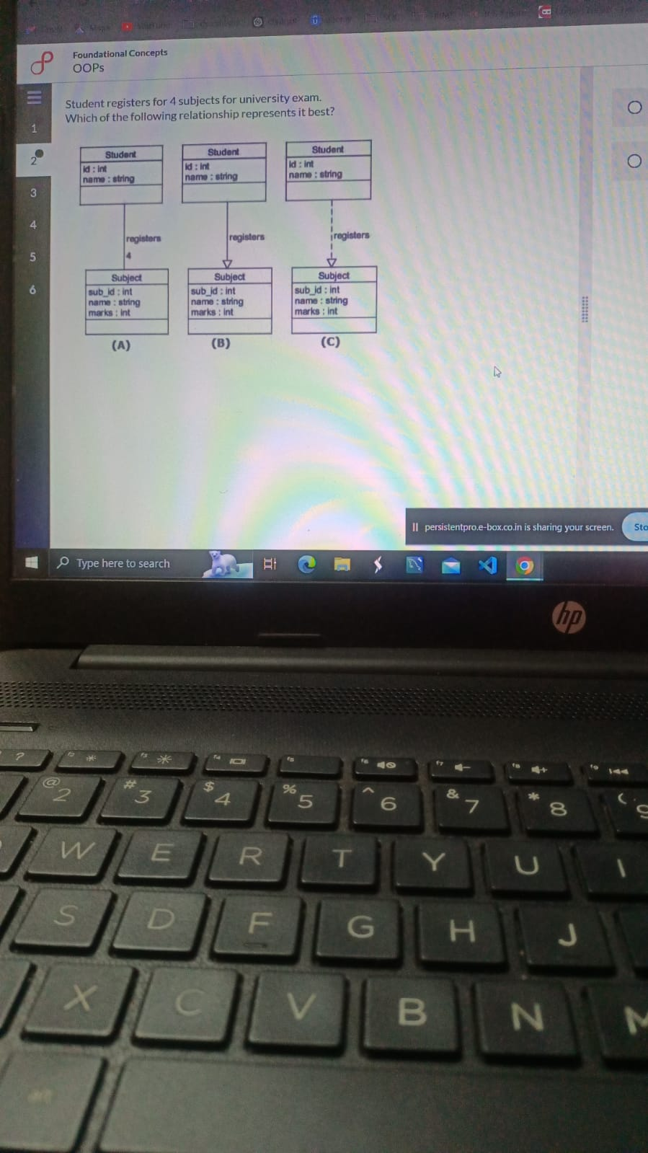

**A // I HAVE ALSO SELECTED**

**6)** **A browser web page contains 4 Radio buttons. When page is closed, all 4 radio buttons are destroyed.which relationship models interaction between page and button test**

* Aggregation
* Composition
* Inheritance
* 2
* 3
* None of these

7) **A variable which is property of class and not object is called?**

* Static
* Public
* Protected
* Private

SDLC

1**)Iterative development life cycle provides which of the following benefits?**

* It reduces cost and efforts by 50%.
* As this skill is uncommon, customers pay more for this life cycle
* We can deliver the complete work product once at the end of the project.
* Customer starts getting intermediate deliverables much before project ends. This gives opportune
* //I HAVE SELECTED SAME

2**)Strengths of Iterative incremental models are**

* **Prioritization of requirements //MOST APPROPRIATE ACCORDING TO GEMINI**
* Faster product delivery
* **customer feedback to each product increment//MOST APPROPRIATE ACCORDING TO CHATGPT**
* Lowers initial delivery cost

3**) Select most appropriate option. Prototype models are used for**

* Small projects
* Complex projects
* Risk Analysis
* Maintenance Projects
* //I HAVE DONE WRONG

4**) is a combination of an iterative development process model and a sequential linear development model.**

* Agile Model
* RAD model
* Spiral Model
* Iterative Model

//not in mine

**5) Agile Methodologies consisting of**

* Individuals and interactions
* Working software
* Customer collaboration
* Responding to change

All of above

//I have selected this

**6) In SDLC Waterfall Model, the Design phase helps in**

* defining Business use case.
* Odefining system architecture.
* Odefining requirements.
* None of the above
* //not in mine

**7) The product provides by scrum team in this shortest period is known as a sprint.**

* TRUE
* OFALSE

**8. Which of the following are disadvantage of the agile model?**

* The development team should be highly professional and client-oriented.
* New requirement may be a conflict with the existing architecture
* There may be difficult to estimate the final coast of the project due to constant iteration
* **All of the above**
* View Answer

Ans : D

Explanation: All of the above are disadvantage of the agile model

9) **SRS stands for?**

* 1. System requirements specification
  2. System respond software
  3. Software respond system
  4. Software requirements specification

10) **Requirement Analysis consists of**

* Analyze business functionality
* Analyze various development approaches available
* Analyzing designing approach
* All of above

11) .**Which model is useful when a project can be broken down into small code.**

* Agile Model
* RAD model
* Spiral Model
* Iterative Model

**GIT**

**1)Select a command from the following commands which will not create a commit-**

* **$ git add**
* $ git commit
* $ git push
* $ git reset-hard (undo commits)

// I have selected the same

**2) Select a command from the following commands which will not help to stash your unstaged changes-**

* git stash
* git stash pop
* git checkout stash
* git stash checkout
* //I have done wrong

**3) Select a command from the following commands which will not help to push local changes to remote repository**-

* git push-force
* git push
* git reset-hard
* Ogit checkout remote
* //I have done wrong

**4) Select a command from the following commands which will be used to undo a commit-**

* git reset
* Ogit revert
* git checkout
* git stash

// not in mine

5**) ASSUME YOUR CUSTOMER REPORTED A BUG IN THE PRODUCTION ENVIROMNET .YOU HAD PROVIDED A HOT FIX COMMIT FROM RELEASE BRANCH.SELECT THE CORRECT COMMAND**

**a**)GIT CHECKOUT b)GIT CHERRY-PICK C)GIT MERGE D)GIT PULL

//I have selected merge

6) **In a Git environment, a colleague mistakenly deleted a key branch from the report and no other member has a copy of it, how will you retrieve the branch with sequence of**

Git reflog

Git checkout

Create Branch

1. **Check git reflog**: Run **git reflog** to view a history of recent actions in the repository, including branch deletions. Look for the commit hash associated with the deletion of the branch.
2. **Identify the Deleted Branch Commit**: Locate the commit hash where the branch was deleted. The reflog entry should indicate the commit where the branch was last seen.
3. **Create a New Branch**: Once you've identified the commit hash associated with the deletion, create a new branch using that commit hash.

git checkout -b <new-branch-name> <commit-hash>

Replace **<new-branch-name>** with the name you want to give to the recovered branch, and **<commit-hash>** with the commit hash you identified from the reflog.

7) **select a command from the following commands which will not help to rebase local branch-**

* **git rebase**
* **git checkout**
* **git push—force**
* **git reset—soft**

reason: This command is used to forcefully push local commits to a remote repository, but it doesn't directly involve rebasing a local branch. The other commands listed (**git rebase**, **git checkout**, and **git reset --soft**) are commonly used during the process of rebasing a local branch.( according to chatgpt)

8) **. Select a command from the following commands which will be used to undo a commit-**

* git reset
* git revert
* git checkout
* git stash

**DBMS**

**1)What will happen after executing the following query?**

select department_id as deptid, sum(salary) as sum_of_sal from employee group by department id

having sum(salary)>45000;

* Successful execution with number of records
* Error because of deptid
* Error because of group by
* Error because of sum of sal
* //NOT IN MINE

2) **What is the outcome of the query?**

SELECT FROM payments

Where amount= (SELECT MIN(amount) FROM payments) AND sales person_id in (SELECT sales person id FROM salesman where office_code='PUNE')

* Details of the lowest payment which is taken by a sales person whose office is PunE
* Details of lowest paying customer from Pune location
* Details of sales persons of Pune and their orders
* Details of the highest payment which is taken by a sales person whose office is Pune
* //NOT IN MINE

3) **Which Statements are true about 'Order By' clause.**

i) It can be used with alias in the select statement

ii) If order is not mentioned then the default order is descending

iii) The order by clause can be used with column position in the select list.

* only i) and ii)
* **only i) and iii)**
* only ii) and iii)
* all i), ii) and iii)

**4) Select from employee join takes using (emp_id); this query is equivalent to:**

* Select from employee outer join takes using (emp_id);
* *Select from employee inner join takes using (emp_id);
* *◎ Select * from employee left outer join takes using (emp_id);
* None of the above

5) 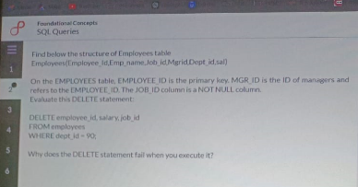

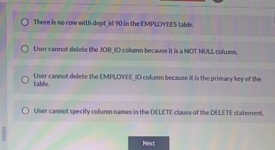

**D IS THE ANSWER**

**6)** 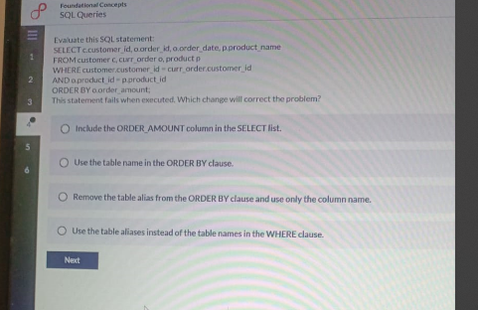d is the answer

7) 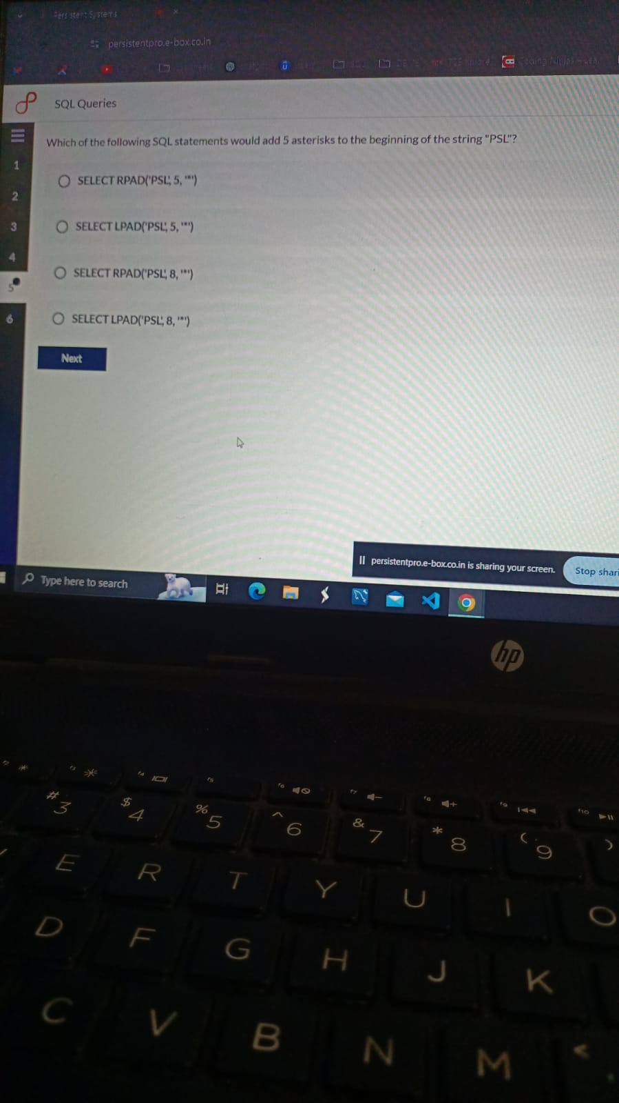 D is the answer

8) **DBMS is an interface between**

* Database and User
* Database and SQL
* Database application and database
* Data and Database

9)**SUBQUERY CAN BE USED IN**

**a)FROM CLAUSE OF SELECT STATEMENT**

**B)WHERE CLAUSE OF SELECT STATEMENT**

**C)GROUP BY CLAUSE OF SELECT STATEMENT**

**D)SET CLASUSE OF UPDATE STATEMENT**

**E)WHERE CLAUSE OF DELETE STATEMENT**

**F)ORDER BY CLAUSE OF SELECT STATEMENT**

**10) WHICH OF THE FOLLOWING IS NOT A VALID IMPLICIT CONVERSION PERFORMED BY ORACLE?**

**1) NUMBER TO DATE**

**2)DATE TO VARCHAR2**

**3)VARCHAR2 TO DATE**

**11)consider two table as orders and customer each order has a customer is associated with it which sql join type you should use to retrieve a list of all customers along with their corresponding order even if they did not place any order**

**LEFT OUTER JOIN**

**12) which of the following datatype is most appropriate for storing a string upto 255 character**? a)text b)binary c)blob d)none

**13)** **write a query to select seniormost employee of company**

SELECT *

FROM employees

WHERE join_date = (

SELECT MIN(join_date)

FROM employees

);

**which statement is/are correct about subquery** i)it executer outer query first ii) it remains inside the subquery and can be used later as per the record iii) it uses buffer cache and remain their for long time

i and ii