A development team of Sunrise Enterprises, is creating a high-level plan for the project, including resource allocation, timelines and budget estimates.which phase of sdlc does this scenario represent

Requirements analysis

Design

Planning

Implementation

A software development team is gathering requirements for a new mobile application. They receive conflicting feedback from different user groups regarding app's user interface design.which approach would be most effective for resolving these conflicts?

Prioritize the feedback from the largest user group

Conduct usability testing to validate design decisions

Delegate design decisions to the development team

Proceed with the design based on personal preferences of the project manager

During the requirement gathering phase, a BA team of SoftCode public Ltd conducts interviews with stakeholder to gather insights into their needs.but some stakeholders are hesitant to provide candid feedback. Which action would be most appropriate in this situation?

Rely solely on documented requirements to avoid bias

Conduct anonymous surveys to encourage honest feedback

Schedule follow-up meetings to build rapport and trust

Proceed with the gathered information without addressing stakeholder concerns

A development team of TemCollab Pvt Ltd, is facing difficulties in understanding the requirements provided by client. They feel that the extensive documentation provided is not helping them grasp the client's needs effectively. Which Agile principle is not being adequately followed in this scenario?

Working software over comprehensive documentation

Customer collaboration over contract negotiation

Responding to change over following a plan

Deliver value early and often

In PulsePixels Tech, development team is consistently delivering working software at the end of each sprint. However product lacks certain features identified by the stakeholders.which agile principle is not being fully adhered to in this scenario?

Deliver value early and often

Customer collaboration over contract negotiation

Responding to change over following a plan

Working software over comprehensive documentation

A project manager notices that the team is hesitant to voice their opinions during team meetings, resulting in lack of collaboration and innovation which agile principle is being compromised in the scenario?

Individuals and interactions over processes and tools

Working software over comprehensive documentation

Customer collaboration over contract negotiation

Responding to change over following a plan

Select the commands that we can use to create local repositories. (Choose most correct 2 options)

git fork

git push

git pull

git clone

You want to use git status to check the state of a file. Which of the following is not a possible state in Git?

Staged

Untracked

Tracked

Modified

What are the two basic jobs of Git?

Limiting business and directories

Recording changes and safety

Ensuring commenting and repositories

Protecting hashes and strings

Select the appropriate option that is true about fetch in Git remote:-

Fetch just updates your local copy of remote branch

Fetch updates and merge your local copy

Fetch and Pull are the same

Fetch is not so convenient to use as we have pull as an option

Which all options are true about Git stash?

adds label on commit history

Temporary storage area

Saved changes which can be reapplied in future

review area

What is the difference between 'git remote' and 'git clone?

remote is to push and clone is to pull

git remote create remote branch and git clone creates local branch

git remote point to Head and git clone removes local reference

'git remote add' just creates an entry in your git config that specifies a name for a particular URL. And git clone creates new git repository by copying existing one.

Which keyword used with UNION retains duplicate rows?

ALL

DISTINCT

STRICT

MORE

In the database which of the following statement/is/are true.

TRUNCATE can be rolled back; but DROP can not be rolled back.

DROP can be rolled back; but TRUNCATE can not be rolled back.

Both TRUNCATE and DROP can not be rolled back.

None of the above

Choose the correct statement to display position of 'p' in a given string 'Technoprogram'.

Select mid('Technoprogram'p') from dual;

Select substr("Technoprogram","p') from dual;

Select instr('Technoprogram','p') from dual;

All of the above

Which of the following creates a virtual relation for storing the query?

Function

View

Procedure

None of the above

[2:00 PM, 3/14/2024] Aaji: Updates that violate ----- are disallowed.

Authoriztion

Transaction control

Integrity Controls

None of the above

[2:00 PM, 3/14/2024] Aaji: Select the benefits of Testing Strategy from below,

a. progressive and additive test tasks,

b. earlier identification of testing requirements.

C. dependencing of testing and development tasks and resources

d. well defined tests

a,b

a,b,c

a,b,d

a,c,d

[2:00 PM, 3/14/2024] Aaji: Choose the correct options.

The common risk that leads to the project failure are,

a. Not having enough resources.

b. Limited Budget.

c. Time Limitations.

d. Test responsibilities

a, b

a,b,c

a,c

a,b,c,d

[2:00 PM, 3/14/2024] Aaji: Select the typical Test deliverables that are provided before testing phase,

a. Test plans document.

b. Test cases documents

c. Test Design specifications.

d. Test Scripts

a,b

b,c

a,b,c

a,b,d

[2:00 PM, 3/14/2024] Aaji: Choose the correct options about Test Plans,

A. A single high level test plan for any product/project unifies all other test plans.

B. The different test plan types are Master test plan & Test Level Specific test plan.

C. Test Plan should have Plan Identifier.

D. Test plan should also have the scope of the project defined.

A,C

A,C,D

A,B,C

Only D

[2:00 PM, 3/14/2024] Aaji: Choose correct statements about Metrics from below,

a. Use metrics for which one can collect accurate and complete data must be used.

b. Metrics must be easy to explain and evaluate.

c. Benchmark for Metric(s) varies form organization to organization and also from person to person.

a,b

a,c

a,b,c

b,c

[2:00 PM, 3/14/2024] Aaji: Front-end errors in requirements and design cannot be found and removed via only testing it needs to be pretested through

reviews and

Inspections

regression testing

Retesting

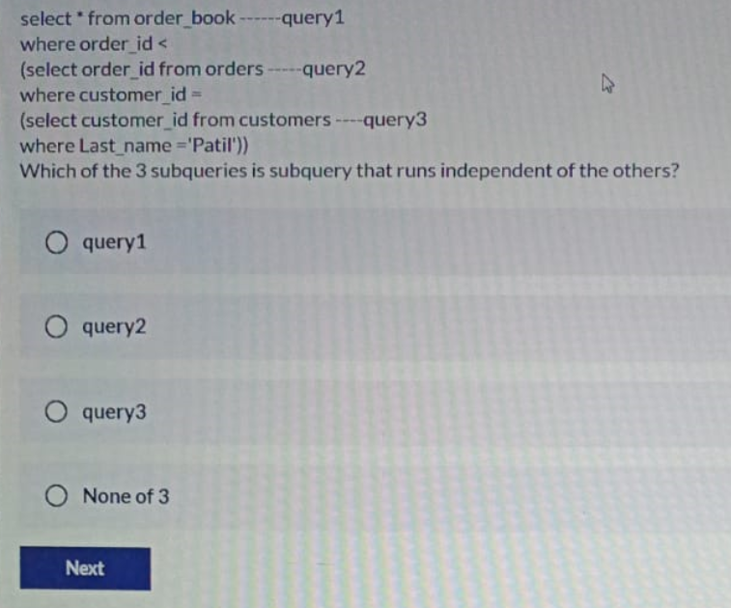

Query 3

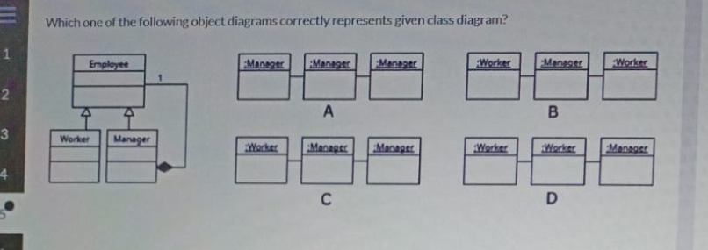

C

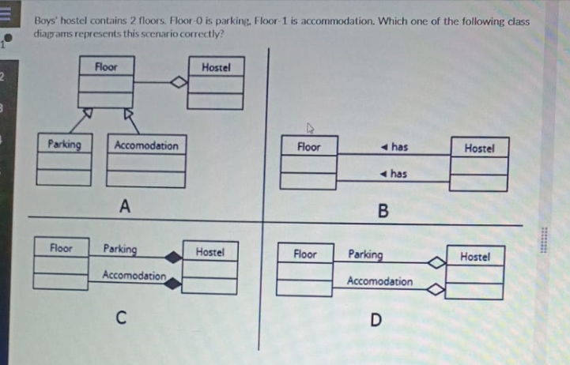

A

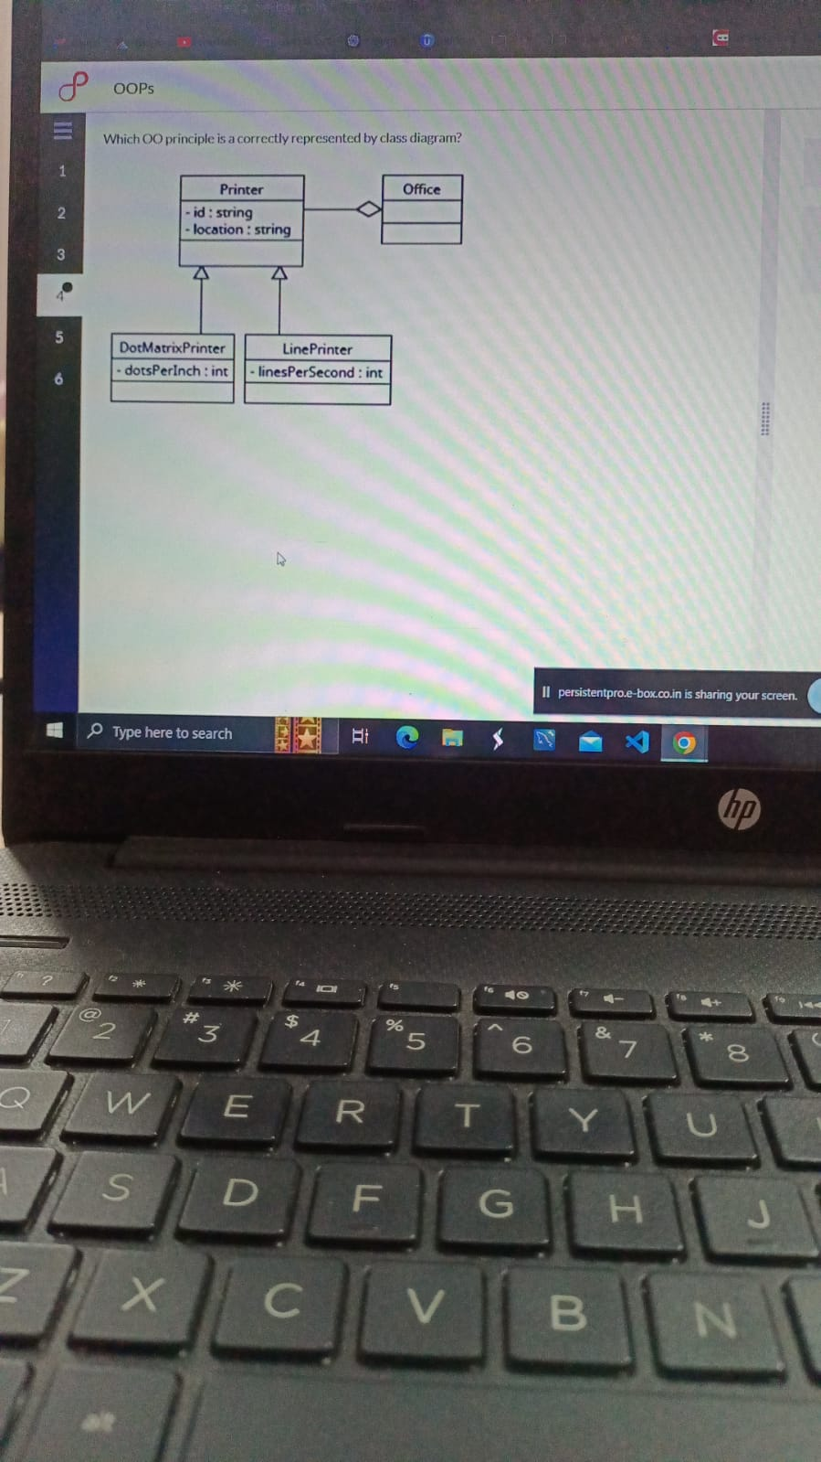

Code reuse

a student has three attributes -id,name , age .which can be a derived attribute -age