INTERNSHIP REPORT
on
Designing a Digital Banking Super Dashboard
Submitted as part of the UI/UX Design Internship Program
at Codec Technologies Pvt. Ltd.
Submitted By
[Your Full Name]
[Your Roll Number]
UI/UX Design Intern
To School of Computer Science Engineering
[Your University / College Name, Location]
Duration: [Start Date] – [End Date]
AICTE & ICAC Approved Internship Program — National Internship Portal

Internship Details
Student Name | [Your Full Name]
Designation | UI/UX Design Intern
Organization | Codec Technologies Pvt. Ltd.
Duration | [Start Date] – [End Date] (1 Month)
Mode | Pan India, Hybrid
Program | AICTE & ICAC Approved Internship, National Internship Portal
Project Title | Design and Development of a Digital Banking Super Dashboard

1. Acknowledgement
I would like to express my sincere gratitude to Codec Technologies Pvt. Ltd. for giving me the opportunity to undergo this internship and work on a live, hands-on UI/UX design project. I am thankful to my project mentors for their guidance and feedback throughout the program. This internship, conducted under the AICTE & ICAC approved program on the National Internship Portal, helped me gain valuable practical exposure to user experience research, interaction design and interface design concepts that go beyond classroom learning.

2. Company Profile
Codec Technologies Pvt. Ltd. is a global platform dedicated to empowering learners and connecting diverse talent to create meaningful career opportunities worldwide. The company delivers dedicated IT and business consultancy services across 27+ countries, empowering global innovation and strategic growth. It is a recognized Google for Education partner and is ISO 9001:2015 certified, and it runs its internship programs through the National Internship Portal under the Ministry of Education.

3. Introduction
This report summarizes the work carried out during a one-month UI/UX Design internship at Codec Technologies Pvt. Ltd. The internship provided hands-on exposure to how real-world digital products are researched, designed and validated from a user experience standpoint. As part of the internship, a Digital Banking Super Dashboard was designed for the FinTech domain — a full banking experience covering payments, loans, investments and cards within a single, coherent interface. The sections below walk through the problem statement, objectives, tools used, design methodology, results and key learnings from the project.

4. Problem Statement
Everyday banking users need to manage payments, loans, investments and cards from one place, but banking interfaces are often either oversimplified (hiding useful information) or overwhelming (exposing too much financial complexity at once). Any solution must also always balance ease of use with strong security, since banking actions are inherently sensitive. The project addresses this by designing a single, coherent dashboard that surfaces the most important financial information at a glance, keeps secondary detail one click away, and treats security as part of the everyday experience rather than a separate afterthought.

5. Weekly Work Summary
The one-month internship was structured week by week, moving from learning UX fundamentals to designing and finishing the project:
Week | Work Done
Week 1 | Onboarding, orientation and introduction to UI/UX design principles and the design process. Explored the internship platform and finalized the project brief.
Week 2 | Conducted problem framing, built user personas and information architecture for the Digital Banking Super Dashboard.
Week 3 | Created low-fidelity wireframes for the dashboard home and the send-money transfer flow, then iterated to a high-fidelity design.
Week 4 | Refined the design against usability heuristics, fixed issues found during self-review and peer feedback, and prepared the final project report and presentation.

6. Objectives
- Apply the end-to-end UX design process — research, define, wireframe, prototype, test — to a real-world FinTech design brief.
- Design an intuitive, accessible interface for a complex, data-heavy banking domain.
- Practice information architecture and interaction design for a multi-feature dashboard.
- Understand how to design for trust and security without adding friction to everyday use.
- Deliver a portfolio-ready wireframe set and documented design rationale by the end of the internship.

7. Tools and Technologies Used
- Figma — wireframing, high-fidelity UI design and interactive prototyping.
- FigJam / Miro — user flow mapping, information architecture and brainstorming.
- Design systems & UI kits — for consistent typography, color, spacing and components.
- Nielsen's 10 Usability Heuristics — used as an evaluation checklist for the design.
- Basic user research methods — personas, empathy mapping and competitor analysis.

8. UX Design Methodology
The project followed a five-stage UX design workflow, mirroring a typical industry design sprint:
- Research & Discovery — understood the target users, their goals and pain points around everyday banking.
- Define & Ideate — built personas, user flows and information architecture to structure the problem.
- Wireframe (Low-Fidelity) — sketched the core screens quickly to validate structure and content priority before visual design.
- Prototype (High-Fidelity) — added visual design: typography, color, spacing, states and micro-content.
- Test & Iterate — reviewed each screen against usability heuristics and refined based on feedback.
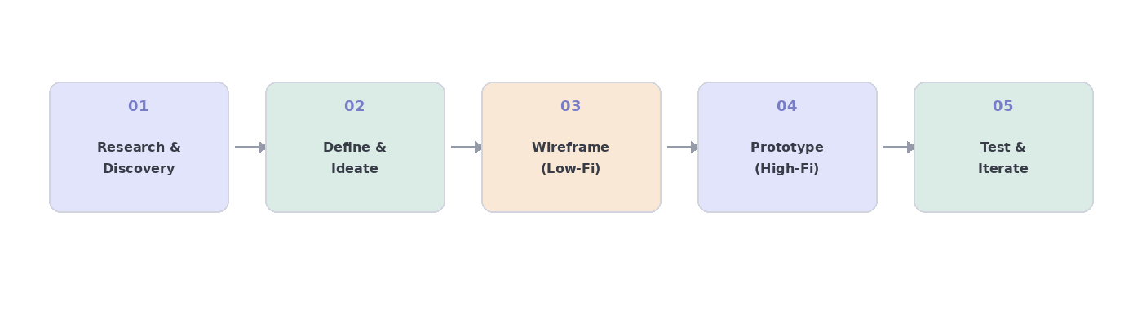
Figure 1 — The five-stage UX design process followed for this project

9. Project Overview — Digital Banking Super Dashboard

Industry Focus: FinTech
The goal was to design a full banking experience covering payments, loans, investments and cards within a single, coherent dashboard — without overwhelming the user or compromising on security.

Key UX Challenges
- Security + simplicity — sensitive actions (transfers, card changes) needed strong confirmation steps without adding friction to everyday use.
- Transaction flows — multi-step actions like payments and transfers needed to feel quick, clear and reversible where possible.
- Financial data clarity — balances, spending and loan information needed to be scannable at a glance, with detail available on demand.

Design Solution
- A persistent left-hand navigation groups Accounts, Payments, Loans, Investments and Cards, keeping the full product accessible without clutter.
- A summary-first dashboard home surfaces total balance, monthly card spend and active loans as glanceable cards, with a spending chart and recent transactions list below.
- Quick actions (send money, pay bill, freeze card, apply for loan) are placed prominently so common tasks never require deep navigation.
- Progressive disclosure hides secondary detail (transaction breakdowns, statements) behind a click, keeping the primary view calm and focused.
- Color-coded amounts (green for incoming, red for outgoing/dues) support quick scanning without relying on text alone.
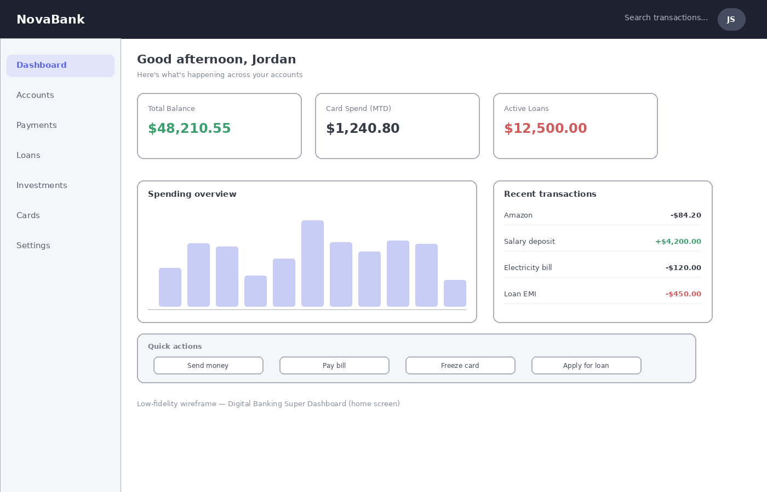
Figure 2 — Low-fidelity wireframe of the Digital Banking Super Dashboard home screen

10. Design Flow — Send Money Transaction
Beyond the dashboard home, a core secondary flow was designed to show how the same principles apply to a sensitive, multi-step banking action: sending money to another account.
- Step 1: The user selects a recipient and enters an amount from the Send Money quick action.
- Step 2: A review screen summarizes the recipient, amount and any fees, giving the user a clear checkpoint before committing.
- Step 3: For transfers above a set threshold, the user confirms with a security PIN, keeping high-value transfers protected without slowing down everyday, low-value ones.
- Step 4: A confirmation state shows the transfer succeeded, with the option to view it in the transaction history.
This staged flow keeps each screen focused on one decision at a time, and reserves the extra security step for the situations that actually need it — a direct application of the “security + simplicity” challenge identified earlier.
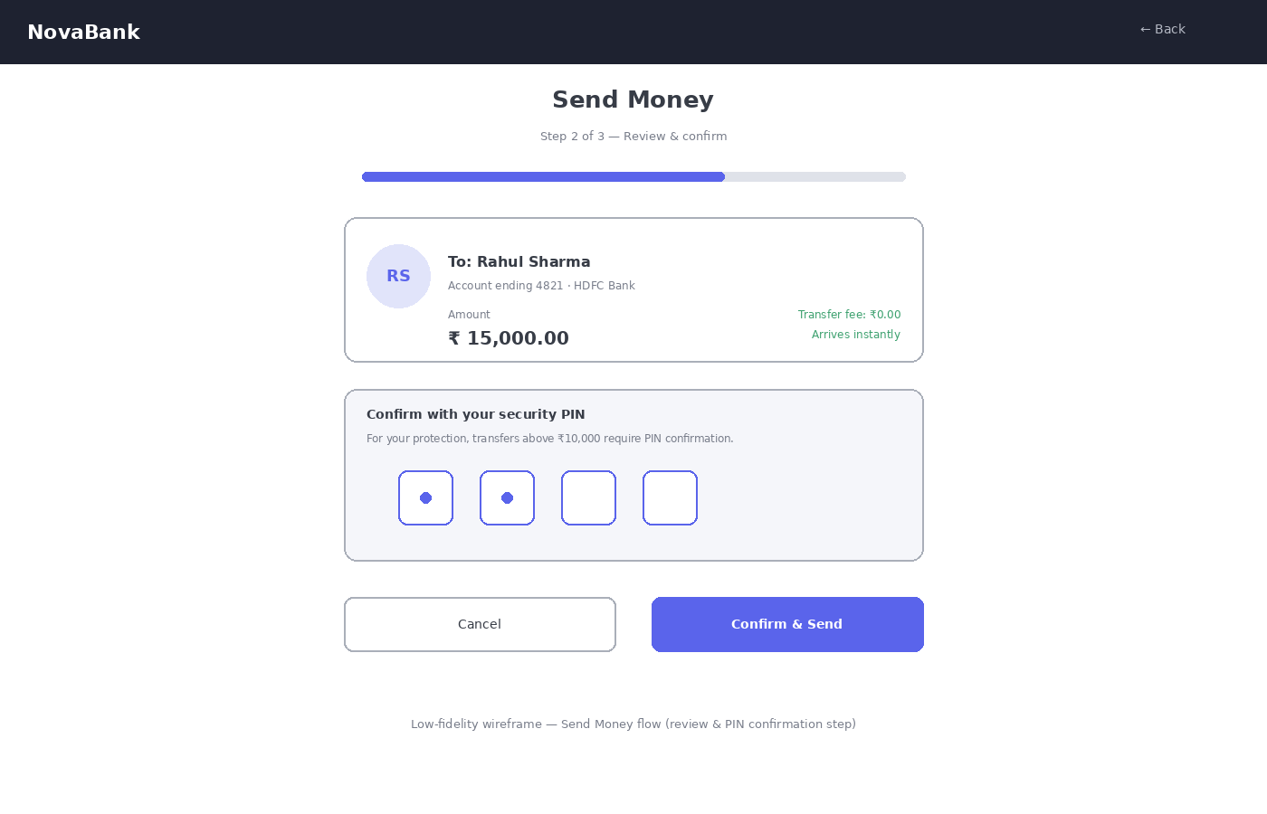
Figure 3 — Low-fidelity wireframe of the Send Money review & PIN confirmation step

11. Results and Key Deliverables
The design brief was carried from problem framing through to a reviewed, presentation-ready wireframe set. Deliverables produced during the internship include:
- User personas — a busy working professional and a small business owner, representing the two primary user types.
- An information architecture grouping Accounts, Payments, Loans, Investments and Cards.
- Core screens: dashboard home, quick actions, recent transactions, and the send-money transfer flow (review + PIN confirmation).
- A documented set of UX patterns used throughout: progressive disclosure, color-coded amounts, and a staged, checkpoint-based confirmation flow for sensitive actions.

12. Challenges Faced
- Balancing information density with simplicity when designing for finance data that users check daily.
- Deciding exactly which actions deserved extra security friction (like a PIN step) without slowing down routine use.
- Keeping the visual design consistent across many screens without a shared, pre-existing design system.
- Working within the time constraints of a one-month internship while completing a full case study to a portfolio-ready standard.

13. Learning Outcomes
- Understood how to run a structured UX process — research, define, wireframe, prototype, test — under real project constraints.
- Practiced translating complex, sensitive financial information into clear, scannable interfaces.
- Learned how to design for trust and security without sacrificing everyday usability.
- Gained experience evaluating designs against usability heuristics and iterating based on that feedback.
- Learned how to present design work and rationale clearly to a non-designer audience.

14. Future Scope
While the current design is intentionally scoped as an internship case study, it can be extended in several ways as a next step in learning:
- Conduct moderated usability testing with real users to validate the current design decisions.
- Build a full design system and component library so the product has consistent, reusable UI components.
- Add motion and micro-interactions (e.g. animated confirmations, transition states) to improve perceived responsiveness.
- Run a formal accessibility audit against WCAG guidelines, including screen-reader and keyboard-navigation testing.
- Extend the dashboard with additional flows such as bill splitting, recurring payments and budgeting insights.

15. Conclusion
The one-month UI/UX Design internship at Codec Technologies Pvt. Ltd. provided valuable, hands-on exposure to the practical side of designing enterprise digital products. Through the design of a Digital Banking Super Dashboard, the fundamentals of user research, information architecture, wireframing and usability evaluation were learned and applied to a high-stakes, data-heavy domain. The project met all its stated objectives and resulted in a portfolio-ready wireframe set that can be explained and defended step by step, forming a strong foundation for exploring more advanced UX design and product design work in the future.
Certificate of Internship and Offer Letter issued by Codec Technologies Pvt. Ltd. are attached as supporting documents.

