“Programming in C Project”
EVALUATION REPORT
ON
“Inventory Management System”

Submitted By: Submitted To:
Vanshika Giri Mr. Milton Kumar
SAP ID: 590021900
Batch: B43
GitHub


Repository Link
“vanshika2621/InventoryManagementSystem-C-Project”

INDEX

Contents:
Topic 1: Abstract
Topic 2: Problem Definition
Topic 3: System Design & Flow Chart
Topic 4: Algorithm (Simplified)
Topic 5: Implementation Details (C Code)
Topic 6: Testing & Results
Topic 7: Conclusion & Future Scope
Topic 8: References

Abstract
This project implements a simple Inventory Management System using the C programming language. It allows users to add products, view inventory, update stock, delete products, search for products and save the inventory data to a file. The project demonstrates the use of arrays, functions, loops, file handling, and string manipulation.

Problem Definition

The goal of this project is to design and implement a console-based Inventory Management System. The system must allow users to manage product records efficiently with options to add, update, delete, search, and store inventory records permanently

System Design

The system is divided into the following functional modules:
- Add Product
- View Inventory
- Update Stock
- Delete Product
- Search Product
- Save & Exit

Flow Chart
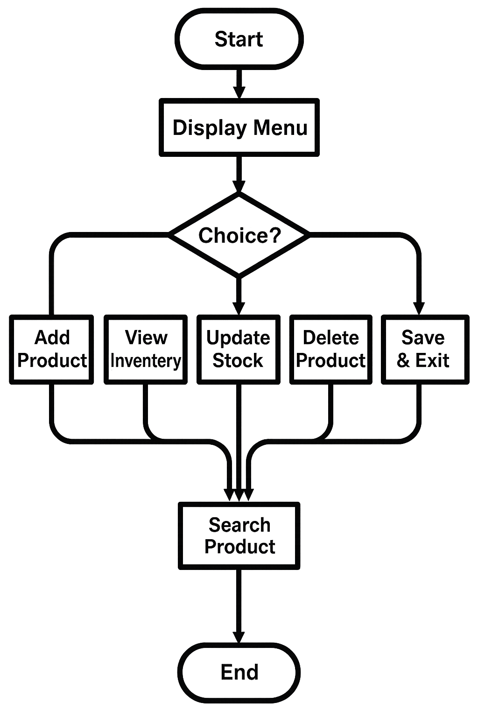
Algorithm (Simplified)

- 1. Display menu options.
- 2. Take user choice.
- 3. Perform selected operation.
- 4. Repeat until Save & Exit is chosen.

Implementation Details (C Code)
#include <stdio.h>
#include <string.h>
#define MAX 100
// Global Arrays
char productNames[MAX][50];
int productQuantities[MAX];
float productPrices[MAX];
int count = 0; // Total number of products
// Function Declarations
void addProduct();
void viewInventory();
void updateStock();
void deleteProduct();
void searchProduct();
void saveAndExit();
int main()
{
int choice;
while (1)
{
printf("\n---------------------------------");
printf("\n INVENTORY MANAGEMENT SYSTEM");
printf("\n---------------------------------");
printf("\n1. Add Product");
printf("\n2. View Inventory");
printf("\n3. Update Stock");
printf("\n4. Delete Product");
printf("\n5. Search Product");
printf("\n6. Save & Exit");
printf("\n---------------------------------");
printf("\nEnter your choice: ");
scanf("%d", &choice);
if (choice == 1)
addProduct();
else if (choice == 2)
viewInventory();
else if (choice == 3)
updateStock();
else if (choice == 4)
deleteProduct();
else if (choice == 5)
searchProduct();
else if (choice == 6)
{
saveAndExit();
break;
}
else
printf("\nInvalid choice! Try again.");
}
return 0;
}
// Add Product
void addProduct()
{
char name[50];
int qty;
float price;
int found = 0;
printf("\nEnter Product Name: ");
scanf("%s", name);
printf("Enter Quantity: ");
scanf("%d", &qty);
printf("Enter Price: ");
scanf("%f", &price);
for (int i = 0; i < count; i++)
{
if (strcmp(productNames[i], name) == 0)
{
productQuantities[i] += qty;
productPrices[i] = price;
printf("\nProduct '%s' updated successfully!\n", name);
found = 1;
break;
}
}
if (!found)
{
strcpy(productNames[count], name);
productQuantities[count] = qty;
productPrices[count] = price;
count++;
printf("\nProduct '%s' added successfully!\n", name);
}
}
// View Inventory
void viewInventory()
{
if (count == 0)
{
printf("\nInventory is empty.\n");
return;
}
printf("\n-----------------------------------------");
printf("\n%-15s %-10s %-10s", "Product", "Quantity", "Price");
printf("\n-----------------------------------------");
for (int i = 0; i < count; i++)
{
printf("\n%-15s %-10d %-10.2f",
productNames[i],
productQuantities[i],
productPrices[i]);
}
printf("\n-----------------------------------------\n");
}
// Update Stock
void updateStock()
{
char name[50];
int newQty, found = 0;

printf("\nEnter Product Name to Update: ");
scanf("%s", name);
for (int i = 0; i < count; i++)
{
if (strcmp(productNames[i], name) == 0)
{
printf("Enter New Quantity: ");
scanf("%d", &newQty);
productQuantities[i] = newQty;
printf("\nStock updated successfully!\n");
found = 1;
break;
}
}
if (!found)
printf("\nProduct not found!\n");
}
// Delete Product
void deleteProduct()
{
char name[50];
int found = 0;
printf("\nEnter Product Name to Delete: ");
scanf("%s", name);
for (int i = 0; i < count; i++)
{
if (strcmp(productNames[i], name) == 0)
{
for (int j = i; j < count - 1; j++)
{
strcpy(productNames[j], productNames[j + 1]);
productQuantities[j] = productQuantities[j + 1];
productPrices[j] = productPrices[j + 1];
}
count--;
printf("\nProduct deleted successfully!\n");
found = 1;
break;
}
}
if (!found)
printf("\nProduct not found!\n");
}
// Search Product
void searchProduct()
{
char name[50];
int found = 0;
printf("\nEnter Product Name to Search: ");
scanf("%s", name);
for (int i = 0; i < count; i++)
{
if (strcmp(productNames[i], name) == 0)
{
printf("\nProduct Found!");
printf("\nName: %s", productNames[i]);
printf("\nQuantity: %d", productQuantities[i]);
printf("\nPrice: %.2f\n", productPrices[i]);
found = 1;
break;
}
}
if (!found)
printf("\nProduct not found!\n");
}
// Save & Exit
void saveAndExit()
{
FILE *fp;
fp = fopen("inventory.csv", "w");
if (fp == NULL)
{
printf("\nError saving file!\n");
return;
}
fprintf(fp, "Product,Quantity,Price\n");

for (int i = 0; i < count; i++)
{
fprintf(fp, "%s,%d,%.2f\n",
productNames[i],
productQuantities[i],
productPrices[i]);
}
fclose(fp);
printf("\nInventory saved to inventory.csv");
printf("\nExiting program...\n");
}

Testing & Results

The system was tested using multiple product entries. All operations such as add, update, delete, and search worked successfully. The inventory file was correctly saved in CSV format.

Conclusion & Future Scope

The Inventory Management System works efficiently for small businesses. Future improvements can include database connectivity, login authentication, graphical user interface, and barcode scanning.

References
1. Balagurusamy, E. (2017). Programming in ANSI C (8th ed.). McGraw Hill Education, India.
2. Forouzan, B. A., & Gilberg, R. F. (2018). Computer Science: A Structured Programming Approach Using C. Cengage Learning.
3. Studytonight. (2024). Stock Management System Project using C Language.
Available at: https://www.studytonight.com
4. Tutorialspoint. (2024). C Program to Store Inventory Using Structures.
Available at: https://www.tutorialspoint.com
5. Sanfoundry. (2023). C Program for Inventory Management System.
Available at: https://www.sanfoundry.com
6. GitHub Open Source Repository. (2024). Inventory Management System in C.
Available at: https://www.github.com

