FINAL EVALUATION &
PRESENTATION REPORT
Integrating Data Strategy, Preparation, EDA, Forecasting and Data Quality for Fashion Analytics
A practical report for a Junior Data Science Analyst portfolio
Illustrative figures and metrics are synthetic examples, not verified commercial findings.

Executive Summary
This report brings together the major stages of a fashion analytics workflow: data strategy, acquisition and preprocessing, exploratory data analysis (EDA), predictive analytics, data quality and error handling, and communication of results. The aim is to turn data work into decisions that fashion teams can act on, including assortment planning, demand and inventory management, product-content improvement, pricing review and supplier coordination. The report emphasizes that technical outputs create value only when data limitations are understood, models are evaluated against suitable baselines, and findings are presented with clear business context. The charts and numeric examples included here are explicitly illustrative and use synthetic data; they should be replaced or recalculated using validated real data before making commercial claims.

1. Integrated Project Narrative
- Data strategy: define the business question, decision owner, target metric, available sources, constraints and success criteria before selecting tools.
- Data acquisition and preprocessing: document provenance, permissions, retrieval date, schema and data dictionary; preserve raw files and create reproducible transformations.
- Exploratory data analysis: inspect distributions, missingness, category mix, relationships and outliers; use charts to discover patterns and formulate hypotheses, not to claim causation.
- Predictive analytics: create a time-aware forecast benchmark, compare candidate models and translate forecast error into operational decisions.
- Data quality and error handling: quantify completeness, validity, consistency, uniqueness and freshness; flag suspicious records, correct only with evidence and keep an audit trail.
- Presentation and action: connect validated findings to a named decision, proposed action, expected measure of success and follow-up review.
The coherent story is: establish the decision, prove the data is fit for purpose, explain what the data says, test whether forecasts add value, and recommend an action with measurable outcomes.

2. Business Questions and Actionable Use Cases
Business question | Analytical approach | Potential decision
Which product categories drive demand? | EDA of sales/units by category, season, channel and region. | Assortment depth, buying priorities and campaign allocation.
How much stock may be needed next period? | Time-series forecast with chronological validation and a baseline. | Replenishment quantities and safety-stock review.
Where are product records unreliable? | Completeness, validity, duplicate and cross-field checks. | Fix product content and prevent unreliable reporting.
Which products have unusual price or return patterns? | Robust distribution checks, segment comparisons and investigation. | Audit promotions, descriptions, fit/quality signals and data mappings.
Which data sources are fit for analysis? | Coverage, provenance, freshness, licensing and schema review. | Prioritize trusted sources and data acquisition investments.

3. Illustrative Visualizations and Storytelling
The following charts are examples of how to communicate analytical outputs. The numbers are synthetic and should not be interpreted as actual market results.

3.1 Demand forecast comparison
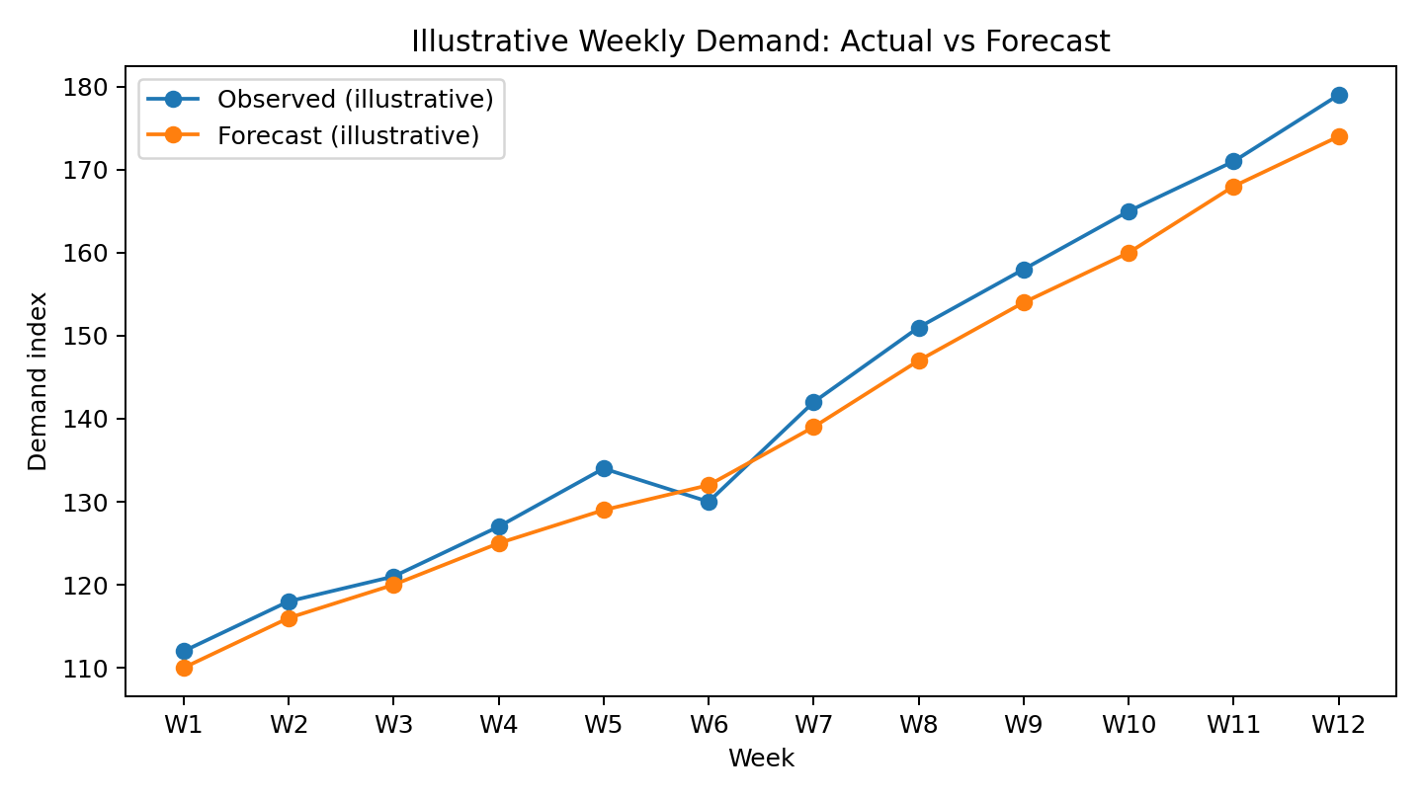
Storytelling message: compare observed demand with the forecast over the same chronological period. Highlight where errors are largest and whether the model systematically under- or over-forecasts. For a business audience, connect those errors to potential stockouts, excess inventory and replenishment decisions.

3.2 Category mix
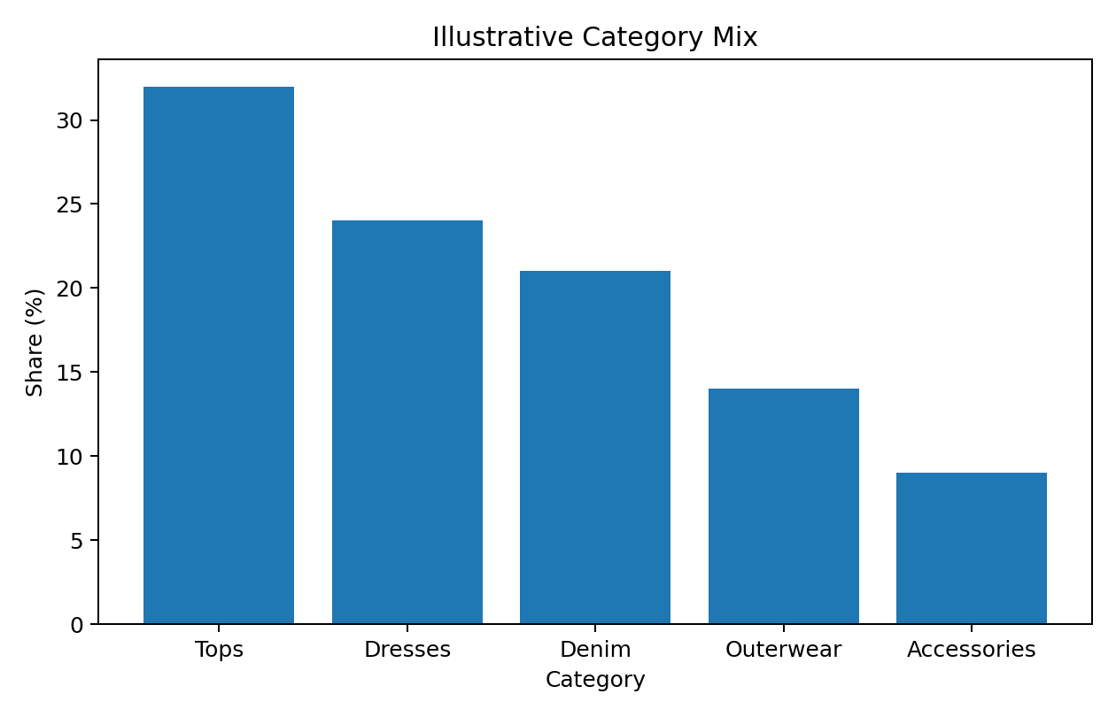
Storytelling message: a category-mix chart can help identify where demand or sales are concentrated. Always state whether the measure is revenue, units, orders or share of a synthetic index; these measures answer different questions. Use a sorted bar chart for precise comparison and avoid implying profitability from sales share alone.

3.3 Data quality scorecard
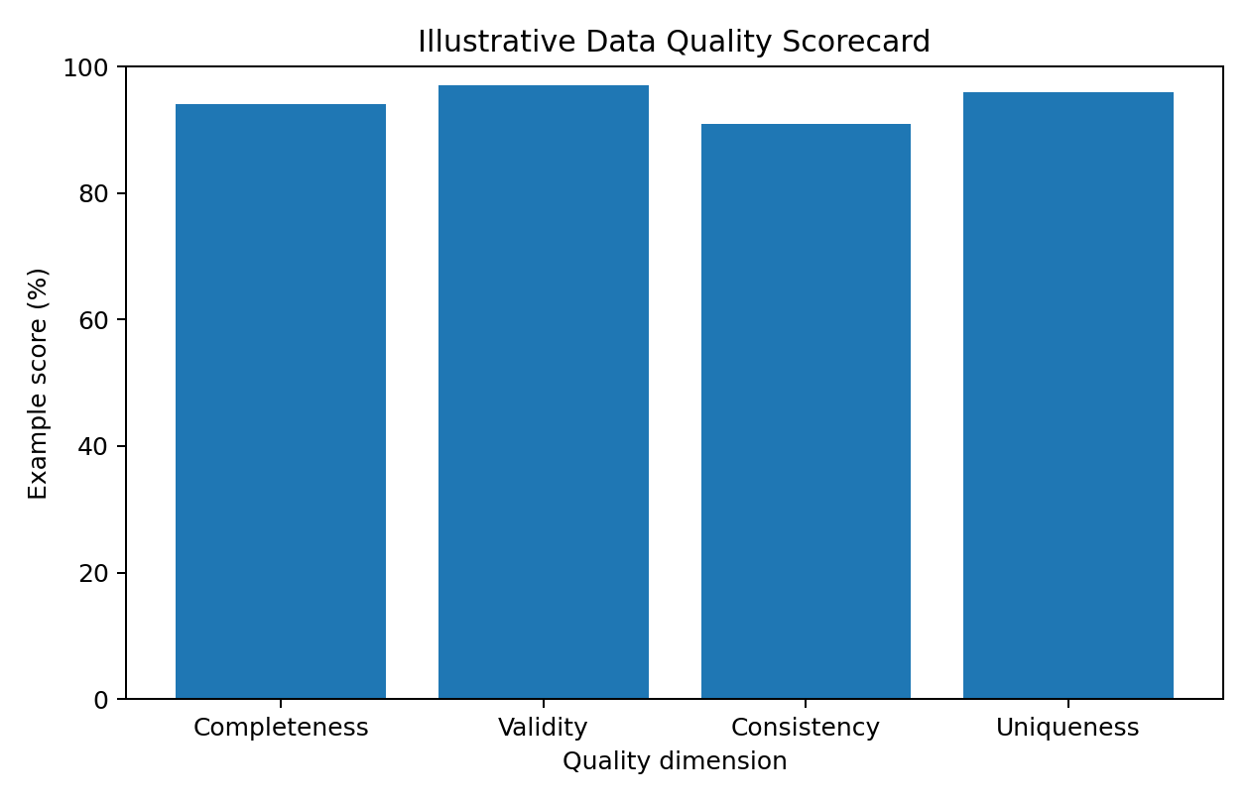
Storytelling message: scorecards make data limitations visible. Each percentage needs a defined rule, denominator, time window and owner. A high aggregate score should not hide a severe defect in a critical field such as fibre composition, size or price.

4. Evaluation Methodology

4.1 Data preparation and quality evaluation
- Completeness: non-missing required values divided by required values expected.
- Validity: records passing agreed type, format, range and controlled-vocabulary rules.
- Consistency: records passing cross-field and cross-system rules.
- Uniqueness: unexplained duplicate business keys; define keys carefully because variants may legitimately share a base SKU.
- Timeliness: data age and proportion updated within the agreed service-level target.
- Evaluate before and after cleaning with the same rules; retain raw values, log corrections and manually audit a sample of changed records.

4.2 EDA evaluation
Assess whether the analysis answers the original business question, whether sample coverage is sufficient, whether missingness and outliers are understood, and whether visualizations accurately represent units and denominators. Validate key summaries with independent calculations and segment checks. EDA is primarily descriptive; correlation or a visible pattern alone does not prove causation.

4.3 Forecast evaluation
Use a chronological holdout or rolling-origin backtesting rather than a random split for time-series data. Compare against simple baselines such as last-period and seasonal-naïve forecasts. Use MAE for interpretable average absolute error, RMSE to penalize larger errors, and WAPE when a portfolio-level percentage error is useful and total actual volume is non-zero. MAPE is problematic when actual values are zero or close to zero. Report metrics by category, horizon and season, and check bias (consistent over- or under-forecasting).
Illustrative metric | Example result | Interpretation
MAE | 3.17 demand-index points | Average absolute difference between observed and forecast values in the synthetic example.
RMSE | 3.44 demand-index points | Penalizes larger misses more strongly than MAE.
WAPE | 2.22% | Total absolute error divided by total observed volume; meaningful only with a non-zero denominator.
These scores are calculated only from the synthetic values in this report and are not evidence that a model is accurate for real fashion demand. A model should be selected only if it improves on the baseline across relevant backtests and is operationally useful.

5. Findings, Limitations and Interpretation
- The end-to-end workflow links business framing, reliable data preparation, descriptive analysis, forecasting, quality controls and communication.
- Synthetic examples demonstrate the presentation and evaluation process but cannot support real conclusions about customer demand, category performance or market growth.
- Public datasets may be incomplete, outdated, geographically narrow, biased toward a platform or collected using different definitions. Record these limitations and avoid treating proxy metrics as direct sales.
- Forecast performance can deteriorate after season changes, promotions, assortment changes, supply disruption or changes in customer behaviour; monitor drift and refresh models when justified.
- Data quality corrections can introduce bias if values are imputed without considering why they are missing or if legitimate extreme values are removed.

6. Strategic Recommendations
- Start with a decision-led question. Agree on a business owner, KPI, decision cadence and threshold for action before analysis begins.
- Build a trusted data foundation. Maintain source documentation, versioned schemas, data dictionaries, units, licences and raw-data preservation.
- Automate quality checks. Run validation at ingestion and before reporting; alert on unexpected missingness, duplicates, schema drift and stale data.
- Use baseline-first modelling. Compare complex models with simple baselines and deploy only when performance gains are stable, interpretable and valuable.
- Translate forecasts into decisions. Combine demand estimates with lead time, minimum order quantities, service levels, stock position, markdown risk and business constraints.
- Design audience-specific communication. Give executives the decision and expected impact first; give analysts the methodology, assumptions, metrics and reproducibility details.
- Monitor outcomes. Track forecast error, stockouts, overstock, markdowns, data defects and adoption after implementation; review performance on a regular cadence.
- Improve responsibly. Protect customer and supplier information, follow data licences, disclose uncertainty, and avoid unsupported claims about sustainability or material composition.

7. Presentation Framework for Stakeholders
Slide / section | Purpose | Presentation guidance
1. Decision and headline | State the business question and the key takeaway. | One concise headline; explain what decision is needed.
2. Data and trust | Show sources, coverage, timeframe and quality limitations. | Include sample size, freshness and key caveats.
3. What happened? | Present descriptive findings. | Use clear chart titles, units, labels and comparable periods.
4. What may happen next? | Present forecast and baseline comparison. | Show holdout period, error metrics and uncertainty.
5. So what? | Connect analysis to business impact. | Translate error or trend into inventory, margin or customer implications.
6. Recommended action | Set owners, timing and success measures. | List next steps, risks and when results will be reviewed.

8. Further Improvements and Future Roadmap
- Replace synthetic examples with a permitted, documented public dataset or approved company data, and regenerate all charts and metrics.
- Add rolling-origin backtests, seasonal and category-level baselines, prediction intervals, and error analysis for peak seasons.
- Build a reproducible pipeline with automated tests, logging, version control and a dashboard for quality and model monitoring.
- Evaluate business metrics alongside model metrics, such as stockout rate, inventory turnover, sell-through, markdown rate and forecast bias.
- Review whether product attributes such as price, promotions, season, material, size availability and lead time improve forecast performance without creating leakage.

9. Conclusion
A junior data science analyst adds value by making analysis reliable, understandable and actionable. Integrating data strategy, preprocessing, EDA, forecasting and data quality creates a disciplined path from raw records to business decisions. The strongest final presentation is transparent about what is known, what remains uncertain, how performance was measured and what action should follow. The next step is to reproduce the workflow on validated real data, compare candidate methods against baselines, and measure the business outcome after recommendations are implemented.

Appendix A: Reproducibility Notes
The accompanying CSV files and charts are illustrative synthetic examples prepared to demonstrate reporting structure. The forecast metrics above are calculated from the included illustrative demand and forecast series. They are not results from the user's earlier notebooks or from an external commercial dataset. For a final assessed submission, replace these examples with verified outputs from the earlier project files where available.

Appendix B: Recommended Project Artifacts
- README with project objectives, scope, data sources, setup and limitations.
- Data dictionary and source/licence notes.
- Version-controlled preprocessing and validation scripts.
- EDA notebook with documented assumptions and chart captions.
- Forecast notebook with chronological split, baseline, model metrics and residual analysis.
- Final report, exported figures, quality summary and a concise presentation deck.

