EXPLORATORY DATA ANALYSIS
FOR FASHION TREND INSIGHTS
A structured workflow for exploring, visualising and interpreting fashion data
Prepared: 23 October 2026
Note: Charts in this report use illustrative synthetic values to demonstrate analysis methods. They are not real market findings.

Executive Summary
Exploratory data analysis (EDA) helps fashion businesses understand what customers search for, which categories attract attention, how prices and ratings vary, and when demand may rise or fall. This report sets out a reproducible EDA workflow for publicly available fashion-related data, from choosing and preparing sources to summary statistics, relationship analysis, outlier investigation and visual interpretation. The examples show how line charts, bar charts, pie charts and scatter plots can reveal different patterns. Because the report does not analyse a verified retailer dataset, all sample charts and interpretations are illustrative; they demonstrate the kind of insight an analyst should test rather than assert as an actual market result.

1. Objectives and Business Questions
The purpose is to use data to answer practical questions, not simply produce charts.
- Trend tracking: Which product themes or search terms are gaining or losing interest over time?
- Seasonality: Are there recurring peaks around weather changes, holidays, fashion events or sale periods?
- Category planning: Which categories receive the largest share of observed interest, listings or sales in the selected dataset?
- Price and customer response: Do price bands, product attributes, review scores and return indicators move together?
- Decision support: What should merchandising, buying, marketing or inventory teams test next?

2. Data Selection and Preparation
Select data that matches the question and records the right unit of analysis. Possible public sources include Google Trends for relative search interest; Kaggle or Hugging Face for practice datasets containing product attributes, reviews or images; UN Comtrade for textile/apparel trade flows; World Bank Open Data and Eurostat for market context; and Open-Meteo for weather features. Official downloads or documented APIs are preferred. Before use, check licence terms, geographic and time coverage, update frequency, and source limitations. Search-interest indices are relative measures, not counts of purchases.
Keep a source register with URL, publisher, access date, licence, filters, date range, geography, and file version. Preserve the original file, then create a working copy. Inspect row counts, schema, missingness, duplicate rows, date ranges, unique product IDs, currency and units. Parse dates and numeric fields consistently; standardise category labels; check whether missing values mean unknown or not applicable; and remove duplicates only after defining the intended row grain. Avoid replacing missing prices or sales with zero without a business reason. Save the cleaning rules in a script or notebook so another analyst can reproduce them.

3. Exploratory Analysis Process

3.1 Summary statistics and distributions
Start with row and column counts, data types, distinct values, missing-value percentages, and duplicate counts. For numeric variables such as price, rating, review count or monthly search index, calculate mean, median, standard deviation, quartiles, minimum and maximum. The mean can be pulled upward by expensive luxury products, so compare it with the median and inspect distributions. For categorical variables, calculate frequency and percentage by category, colour, material, size, and availability.

3.2 Time-based trend and seasonality analysis
Aggregate observations to a consistent time interval, such as week or month. Plot search interest, listings, sales or review volume over time; annotate promotions and holidays where the information is available. Compare year-over-year patterns when multiple years exist. Rolling averages can reduce short-term noise, but they can also hide sudden shifts. To test whether search interest predicts sales, align periods and geographies and compare against a simple baseline; correlation alone does not prove that searches cause purchases.

3.3 Relationships and correlation
Use scatter plots and correlation matrices to inspect relationships between price, discount, rating, review count, sales and search interest. Pearson correlation is useful for approximately linear relationships; Spearman correlation can be more appropriate for monotonic relationships or ranked data. Correlations may be distorted by season, promotion, category mix, product availability or confounding factors. Treat them as hypotheses for further investigation, not causal conclusions.

3.4 Outlier detection
Use boxplots, histograms, quantiles and the interquartile-range (IQR) rule to flag unusually high prices, extreme discounts, impossible ratings, or sudden spikes in search volume. Investigate flagged records against source definitions. An extreme price may reflect a luxury item rather than an error; an abrupt trend spike may be a real viral moment or a data issue. Do not delete or cap outliers automatically—record the rationale and compare results with and without the treatment.

4. Visualisation Strategy and Illustrative Examples
Each chart should answer one question, have labelled axes and units, identify the period and source, and distinguish observed data from estimates.

4.1 Line chart — tracking change over time
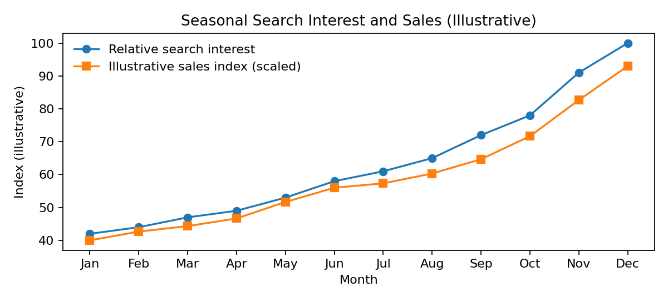
Figure 1. Illustrative monthly search-interest and scaled sales indices. Synthetic values only; not observed market data.
Why use it: A line chart makes direction, turning points, recurring seasonality and possible lead-lag patterns easier to see. In this illustration both series rise toward year-end. A real analyst should check whether the pattern repeats across years and whether promotion calendars or data coverage explain it. The scaled series is for visual comparison only; different units should not be interpreted as directly comparable magnitudes.

4.2 Bar chart — comparing categories
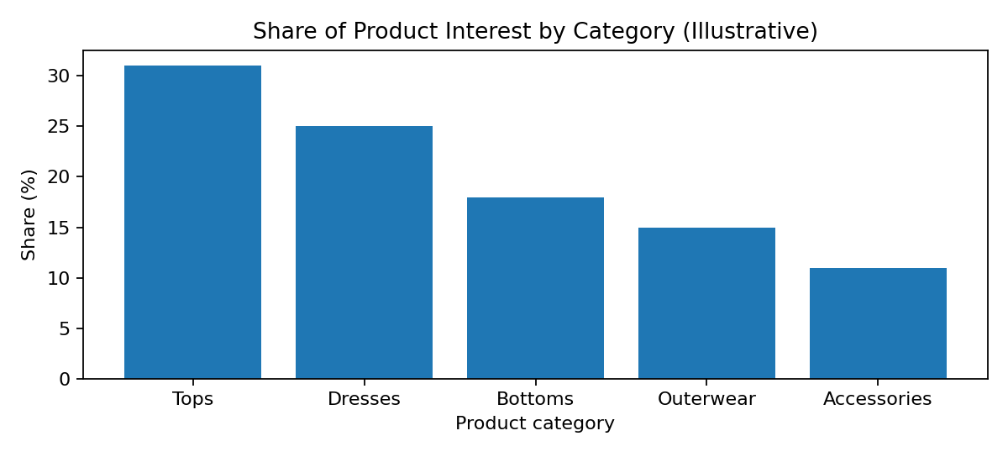
Figure 2. Illustrative share by product category. Synthetic values only.
Why use it: Bars support direct comparison between discrete groups, such as product categories, colours or price bands. In the example, Tops and Dresses have the largest illustrated shares. If this were real data, a buyer could investigate whether these categories deserve more assortment or marketing attention, while checking profitability, stock availability and customer segments before changing budgets.

4.3 Pie chart — showing composition
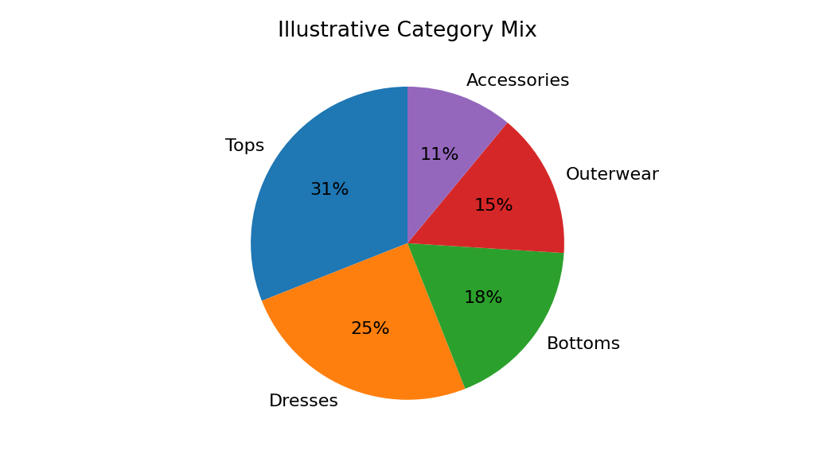
Figure 3. Illustrative category mix summing to 100%. Synthetic values only.
Why use it: A pie chart can communicate a small number of parts of a whole when categories are mutually exclusive and sum to 100%. It is less effective with many similar-sized slices; a sorted bar chart is often easier to compare. Use a pie only when the total and denominator are clear, such as category share of a defined set of listings.

4.4 Scatter plot — exploring product-level relationships
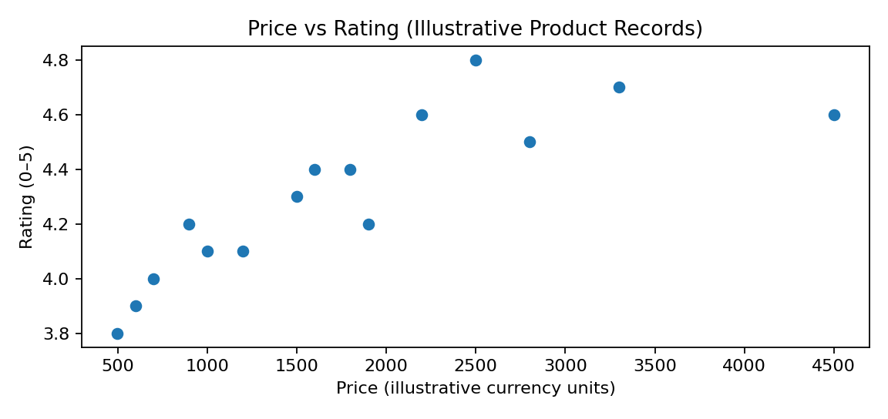
Figure 4. Illustrative product price and rating records. Synthetic values only.
Why use it: Each point represents one record and helps reveal clusters, unusual observations and possible relationships between two numeric variables. The illustrated points do not show a strong, simple price-rating pattern. With real data, colour points by category and consider review count or product age; avoid concluding that higher prices cause better ratings.

5. Interpreting Findings for Fashion Decisions
The figures above demonstrate the interpretation process, not real market findings. A responsible EDA narrative should separate observation, possible explanation and action to test.
Observed pattern to test | Potential interpretation | Possible decision / next test
Search interest rises before category sales | Search may provide an early signal, but other factors may explain both. | Test a lagged forecast against a seasonal baseline; use small, reversible buying experiments.
A category has a high share of listings or interest | It may be popular, over-supplied, or simply more heavily promoted. | Compare sell-through, margin, stock-outs and competition before increasing assortment.
Large price outliers appear | Could be luxury products, bundles, currency errors or data-entry issues. | Validate records and analyse separate price segments rather than deleting automatically.
Ratings differ by product type | Quality, fit, review volume and customer expectations may vary. | Segment ratings by category and review count; inspect review text and return reasons if legally available.
A trend spike lasts only one week | Could be a viral event rather than durable demand. | Look for persistence over several periods and corroborate with independent sources.

6. How Insights Support Decisions
- Merchandising and buying: use sustained category and attribute signals to shape product tests, size curves and assortment planning.
- Inventory: combine demand patterns with stock availability and lead times before making replenishment recommendations.
- Marketing: tailor campaign timing and creative to observed interests, then measure incremental outcomes with controlled tests.
- Pricing: compare product segments and discount response while monitoring margin, not revenue alone.
- Trend forecasting: triangulate search, product listings, reviews, weather and trade data; monitor persistence and uncertainty rather than treating a single chart as a forecast.

7. Tools, Quality Checks and Reproducibility
A practical toolkit is Python with pandas and NumPy for data preparation, Matplotlib or Seaborn for visualisation, and Jupyter Notebook for a documented analysis. Power BI or Tableau can be used for an interactive dashboard. A reproducible project should keep raw data unchanged, store cleaning and chart code, record package versions, define KPI formulas, and save the data-quality report. Before publishing, check chart titles, axes, legends, denominators, time zones, sample sizes and missing-data treatment. Do not present synthetic examples as findings, and do not claim causation from descriptive EDA alone.

8. Challenges and Mitigation
- Public data may not represent a specific retailer or all consumers: state scope and limitations clearly.
- Search indices and social engagement are proxies, not purchases: validate against actual sales where authorised.
- Seasonality can be confused with trend growth: compare multiple years and use seasonal baselines.
- Missing values and duplicates can distort charts: profile quality before analysis and document treatments.
- Many comparisons can produce misleading patterns: define questions in advance and validate promising findings on new periods or datasets.
- Chart choices can mislead: use clear units, sensible scales, visible denominators and accessible labels.

9. Conclusion
EDA provides the foundation for data-informed fashion decisions by revealing patterns, distributions, relationships and anomalies before predictive models are built. A structured process—selecting appropriate data, validating quality, summarising variables, analysing time patterns, investigating correlations and outliers, and choosing suitable visualisations—helps analysts communicate findings clearly. The most valuable output is not a chart alone, but a defensible insight, its uncertainty, and a practical next step that can be tested. The examples in this report are illustrative; actual conclusions must be based on a verified dataset with documented provenance.

References and Data Sources
- Google Trends — https://trends.google.com/trends/
- UN Comtrade — https://comtradeplus.un.org/
- World Bank Open Data — https://data.worldbank.org/
- Eurostat — https://ec.europa.eu/eurostat/
- India Open Government Data Platform — https://www.data.gov.in/
- Kaggle Datasets — https://www.kaggle.com/datasets
- Hugging Face Datasets — https://huggingface.co/datasets
- Open-Meteo — https://open-meteo.com/
- Pandas documentation — https://pandas.pydata.org/docs/
- Matplotlib documentation — https://matplotlib.org/stable/

