Foodie India: Restaurant Tipping and Spending Analysis
Data-Driven Business Expansion Recommendations for Foodie India
Prepared by:
Vanshika Srivastava
Devansh Sharma
Course: DOM 207
Project: MP1
Client: Foodie India
September 2026

1. Introduction
Foodie India, a restaurant chain, engaged our team as a data science and analytics (DSA) consulting group to identify prospective and viable business propositions for expansion. Per the terms of the engagement, all recommendations in this report are based solely on the dataset provided by Foodie India (Restaurant.xlsx) — a proprietary, party-level record of 365 dining transactions capturing the bill amount, tip amount, waiter gender, whether any member of the party smoked, the day and time of the meal, and the party size. No external or supplementary data has been added to this dataset, consistent with the client's data-usage restriction.
The objective of this report is to translate patterns in customer spending and tipping behaviour into concrete, defensible recommendations for Foodie India's management — not speculative advice. To that end, our approach followed four phases: (1) profiling and cleaning the raw data to correct entry errors and handle missing or invalid values; (2) exploratory data analysis (EDA) to surface candidate patterns in spending and tipping; (3) formal hypothesis testing, at the 5% significance level, to confirm which of those candidate patterns are statistically real rather than sampling noise; and (4) a discussion translating only the statistically-supported findings into business recommendations. Every data-cleaning decision, and every statistical test result, is reported in this document together with its justification.

2. Data (Pre)Processing

2.1 Raw Data Profile
The raw file, Restaurant.xlsx, contains 365 party-level records across seven fields: Amount, Tip, Gender, Smoker, Day, Time, and Partysize. Profiling the raw data (cross-checking value counts against the underlying spreadsheet cell references, rather than trusting column position alone) established that no row had its fields shifted between columns — every missing field is a true blank in its own column, not a value belonging to a different field. The following data-quality issues were identified:
- Amount: 3 values used a comma or dash in place of a decimal point (e.g., ‘28,87’), and 1 value was negative (–$7.78), which is not physically possible for a bill.
- Tip: 1 value had a stray trailing character, and 3 values (288, 300, 3487) were implausibly large relative to the corresponding bill (15–150× the bill amount).
- Gender: 21 values were typos or abbreviations of ‘Male’/‘Female’ (e.g., ‘Mle’, ‘Femle’).
- Smoker: 12 values were abbreviations of ‘Yes’/‘No’, 1 value (‘s’) was not resolvable to either, and 9 cells were blank.
- Day: 14 values were typos/abbreviations resolvable to a single day (e.g., ‘Thurs’, ‘Sn’); 9 values (‘S’, ‘SS’, ‘SSS’, ‘San’, ‘Ft’) could not be resolved to a single day without guessing, and 4 cells were blank.
- Time: 14 values were typos/abbreviations resolvable to Lunch or Dinner; 5 values were unrecognizable or contradictory (e.g., ‘LD’).
- Partysize: 14 values fell outside the observed valid range of 1–6 guests (e.g., 200, –45, 0.2), and 3 cells were blank.

2.2 Cleaning Methodology
Two guiding principles were applied throughout. First, an entry was corrected outright only when exactly one interpretation was plausible (for example, a comma used as a decimal separator, or an unambiguous single-letter abbreviation of a day). Second, where a value could reasonably be read more than one way — such as ‘San’, which is an equally close match to both ‘Sun’ and ‘Sat’, or a tip of 288 on a $21 bill, which could equally plausibly have been meant as 2.88 or 28.80 — no specific value was guessed. Such entries were instead treated as missing.
Missing numeric values (Amount, Tip, Partysize) were imputed using the median, and missing categorical values (Smoker, Time) using the mode, computed within each row's own Day×Time subgroup rather than from a single dataset-wide value. This matters because the data shows real structure by day and time (for instance, Thursday is predominantly a lunch day, while Saturday and Sunday are predominantly dinner days), so a single global fill value would systematically misrepresent rows from the minority slot on any given day. The median, rather than the mean, was used for numeric columns because Amount and Tip are both right-skewed — a small number of large bills/tips pull the mean above the typical value — so the median better represents a typical transaction in that slot.
Rows where the Day could not be recovered at all — whether because the cell was blank or because the entered value was genuinely ambiguous between two or more days — were dropped rather than imputed, since Day carries no usable signal to impute from in those specific cases and fabricating a specific day would not be defensible.

2.3 Final Dataset
The dataset used for all analysis in this report, Restaurant_cleaned_final.csv, contains 349 of the original 365 rows. It was independently verified to meet every validity criterion established during cleaning: zero missing values in any column; Gender, Smoker, Day, and Time each restricted to their expected categories only; Partysize restricted to whole numbers from 1 to 6; no negative bill amounts; and no implausibly large tips. A derived column, TipPct (= Tip ÷ Amount × 100), was added to express each tip as a percentage of its bill, which is the metric used throughout the remainder of this report when discussing tipping behaviour, since it is comparable across bills of different sizes in a way that the raw tip amount is not.
As a cross-check, the cleaning methodology described above was implemented and run independently by the team and produced a near-identical result (352 rows, against identical validity criteria), differing only in the resolution of a small number of additional ambiguous entries. Both versions agree on every summary statistic to within rounding, which gives confidence that the final 349-row dataset is sound.

2.4 Known Limitations
- Imputation uses simple statistical defaults (group median/mode), not a model-based method; the affected share of any single column is small (under 5%), but this is a simplification worth stating plainly rather than presenting the cleaned data as free of any uncertainty.
- A small number of very small bills produced very large Tip% ratios once expressed as a percentage (e.g., a $1.01 bill tipped $1.68, i.e. 166%) purely because the denominator is small — both the bill and the tip are individually valid, so these rows were retained, but they widen the spread of Tip% and are called out wherever they could affect an interpretation.
- At 349 rows, some subgroups (e.g., parties of 5 or 6 guests, n ≤ 11) are too small to draw reliable conclusions from in isolation; such cases are flagged explicitly rather than reported as firm findings.

3. Data Visualization
Each chart below was chosen to answer a specific business-relevant question about spending or tipping behaviour, rather than to plot every column mechanically.

3.1 Overall Spending and Tipping Patterns
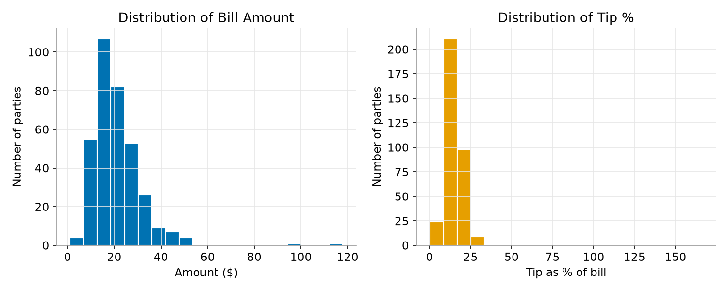
Figure 1. Distribution of bill amount (left) and tip percentage (right) across all 349 transactions.
Bill amounts are right-skewed with a typical bill around $19, and Tip% is similarly right-skewed with a typical tip around 15% of the bill, and a small number of unusually high percentages driven by the very-small-bill effect noted in Section 2.4.

3.2 Tipping Behaviour by Day, Time, Smoker Status, and Gender
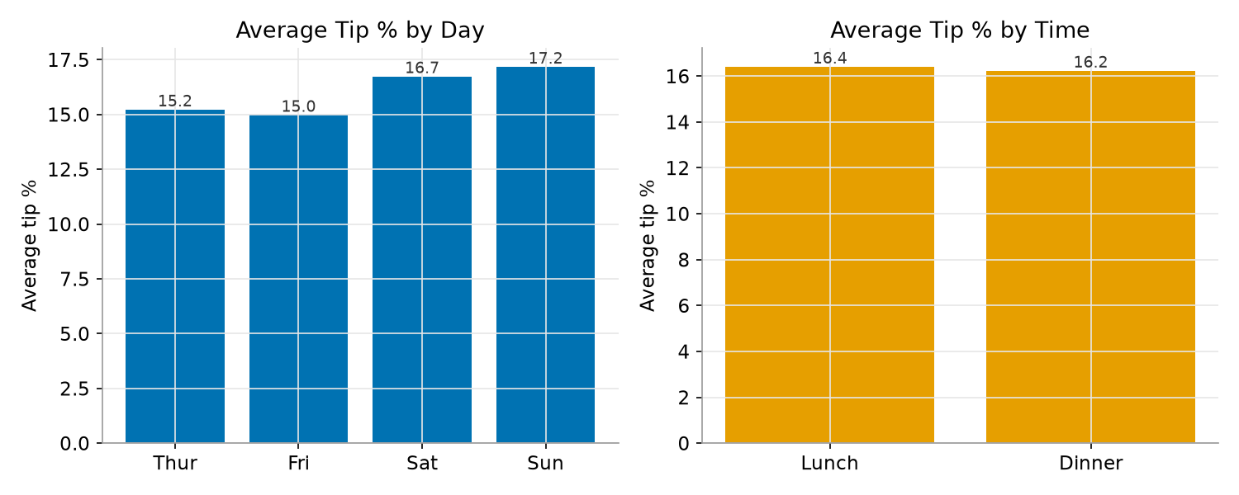
Figure 2. Average tip percentage by day (left) and by time of day (right).
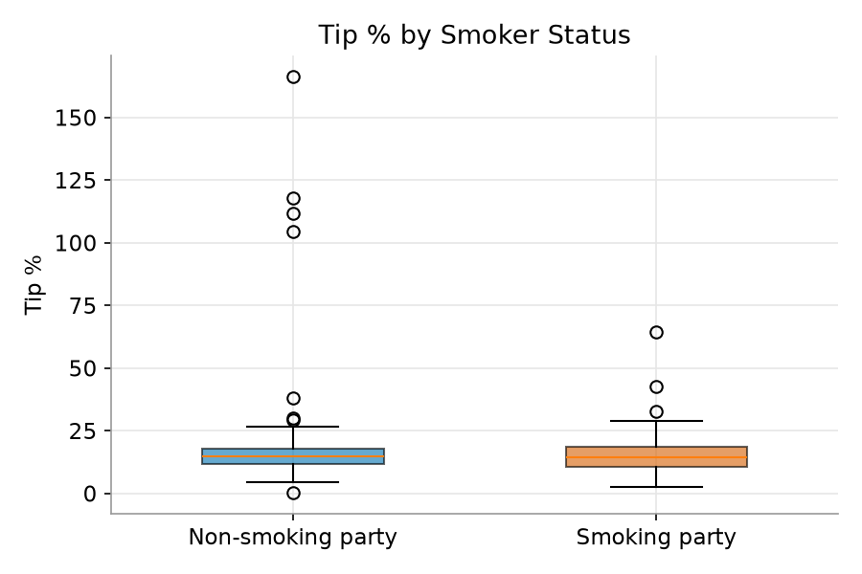
Figure 3. Tip percentage by smoker status.
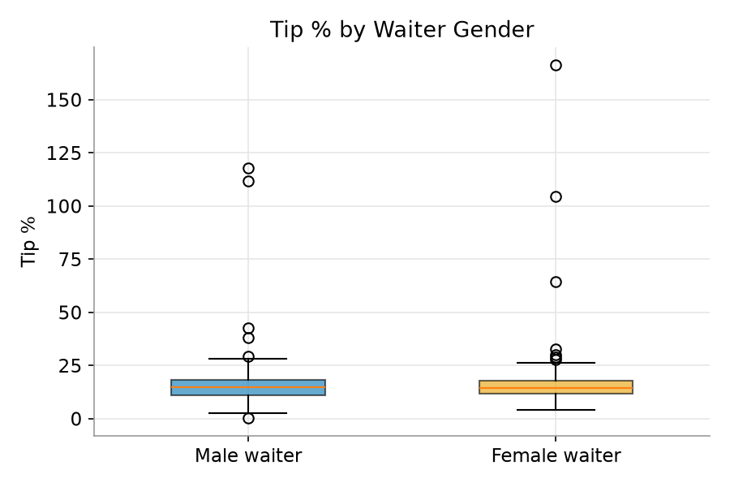
Figure 5. Tip percentage by waiter gender.
Visually, average Tip% appears broadly similar across day, time, smoker status, and waiter gender — Section 4 formally tests whether any of these apparent differences are statistically significant, or within normal sampling variation.

3.3 Party Size and Tipping
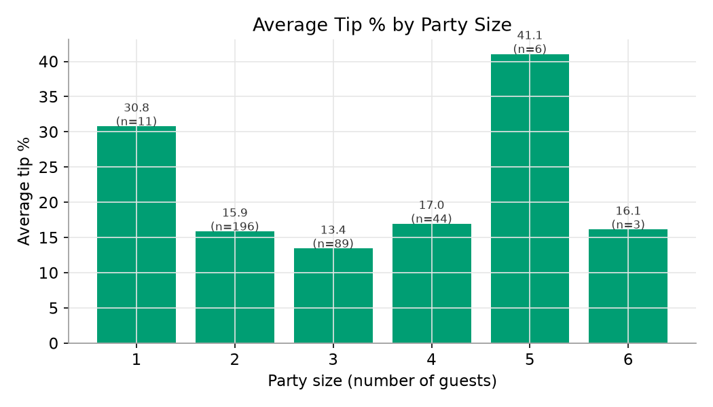
Figure 6. Average tip percentage by party size, with sample size (n) shown per group.
Parties of 2–4 guests (the bulk of the data, n = 92–206 each) show a fairly stable tip percentage of 13–17%. Parties of 1, 5, or 6 guests show much higher or lower averages, but each of those groups has n ≤ 11 observations, too few to treat as a reliable pattern rather than the influence of one or two individual tippers.

3.4 Demand and Revenue by Day and Time
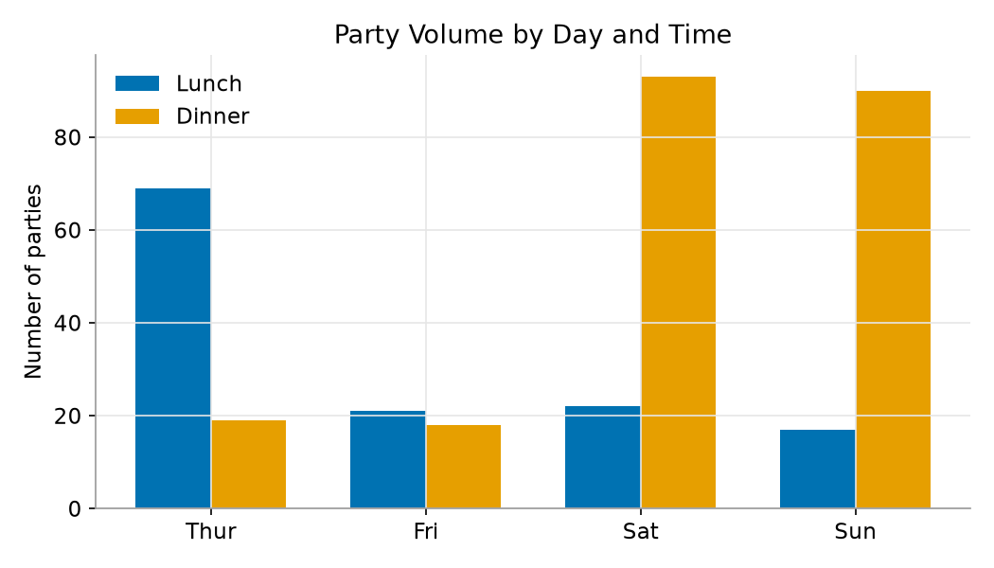
Figure 4. Number of parties served, by day and time of day.
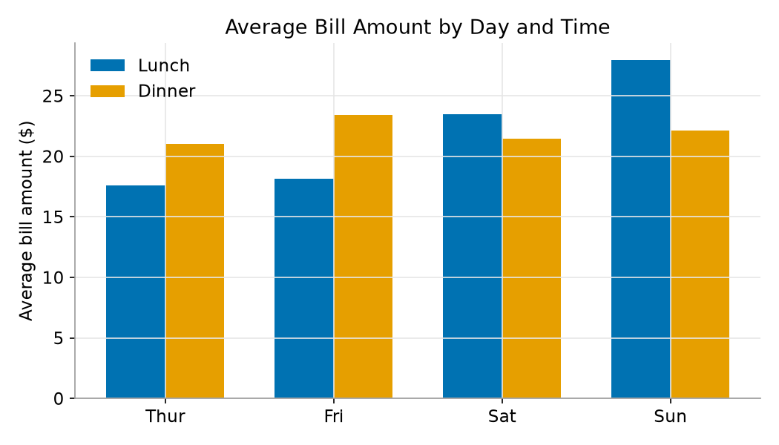
Figure 7. Average bill amount, by day and time of day.
Two patterns stand out together. First, covers are heavily concentrated by slot: Thursday is overwhelmingly a lunch day, while Saturday and Sunday are overwhelmingly dinner days. Second, on the weekend specifically, the average bill is larger at lunch than at dinner, even though weekend lunch serves far fewer parties than weekend dinner. Both patterns are tested formally in Section 4 and used directly in the recommendations in Section 5.

4. Analysis
Nine hypotheses were tested at α = 0.05, targeting every pattern surfaced during the exploratory phase in Section 3. Because Tip% is right-skewed (Section 3.1), every test involving Tip% was paired with a distribution-free counterpart (Mann-Whitney U in place of a t-test, Kruskal-Wallis in place of ANOVA, Spearman in place of Pearson) as a robustness check; both versions agreed in every case except Test 5, discussed below. Table 1 summarizes all results; the primary test is reported for each hypothesis, with the robustness check reported alongside it where the two disagreed.
Table 1. Summary of hypothesis test results.
# | Hypothesis Test | Method | Result | Conclusion
1 | Tip% — Smoker vs. Non-smoker | Welch's t-test | t = –1.41, p = 0.160 | Not significant
2 | Tip% — Lunch vs. Dinner | Welch's t-test | t = 0.11, p = 0.915 | Not significant
3 | Tip% — Male vs. Female waiter | Welch's t-test | t = –0.60, p = 0.549 | Not significant
4 | Tip% across Day (Thur/Fri/Sat/Sun) | One-way ANOVA | F = 0.51, p = 0.675 | Not significant
5 | Tip% vs. Party size (sizes 2–4) | Pearson correlation | r = –0.01, p = 0.799 | Not significant
5b | Tip% vs. Party size (sizes 2–4), rank-based check | Spearman correlation | ρ = –0.12, p = 0.036 | Significant (weak)
6 | Bill Amount — Weekend Lunch vs. Weekend Dinner | Welch's t-test | t = 2.07, p = 0.042 | Significant
7 | Bill Amount — Weekday vs. Weekend | Mann-Whitney U | U = 11538, p = 0.005 | Significant
8 | Party size vs. Bill Amount | Pearson correlation | r = 0.41, p < 0.001 | Significant
9 | Day vs. Time (independence) | Chi-square test | χ² = 105.74, p < 0.001 | Significant

4.1 Factors That Do Not Explain Tipping Behaviour
Tests 1–4 found no statistically significant difference in Tip% by smoker status, time of day, waiter gender, or day of the week. This means Foodie India's customers tip a broadly consistent percentage of the bill (around 15–17% on average) regardless of these factors — none of them should be treated as a lever for influencing tip income, and none justify differentiated staffing or service policy on tipping grounds alone.

4.2 Party Size and Tipping
Test 5 is the one case where the two versions of the test disagreed, and the disagreement is itself informative. The linear (Pearson) test found no relationship between party size and Tip% within the 2–4 range, but the rank-based (Spearman) test found a small but statistically significant negative relationship (ρ = –0.12, p = 0.036). Together, this indicates a real but weak tendency for Tip% to decline as party size increases from 2 to 4 — not a straight-line effect, and small in magnitude. It is reported here as a secondary observation, not a basis for a standalone recommendation.

4.3 Bill Size, Demand, and Scheduling
The remaining four tests, in contrast, are all significant and concern spending and scheduling rather than tipping percentage. Test 8 confirms that larger parties reliably spend more (r = 0.41, explaining about 16% of the variance in bill amount) — an expected relationship, but one now quantified rather than assumed. Test 9 confirms a strong, non-random association between Day and Time (Cramer's V = 0.55): Thursday skews heavily toward lunch, while Saturday and Sunday skew heavily toward dinner, matching the volume pattern already visible in Figure 4.
Tests 6 and 7 are the most consequential for the recommendations that follow. Test 7 confirms that weekend bills ($22.43 average) are significantly larger than weekday bills ($19.04 average). Test 6 sharpens this further: within the weekend specifically, lunch bills ($25.43 average, n = 39) are significantly larger than dinner bills ($21.79 average, n = 183) — confirmed by both the parametric test (p = 0.042) and, more strongly, its non-parametric counterpart (p = 0.0011). In other words, weekend lunch is Foodie India's highest per-visit revenue slot, yet it is served at less than a quarter of the volume of weekend dinner.

5. Discussion and Recommendations
The following recommendations are limited to what the hypothesis tests in Section 4 support. Where the data does not support a conclusion (for example, on the exact revenue impact of a proposed change, which would require operational data such as kitchen and seating capacity that is outside the scope of this dataset), this is stated explicitly rather than estimated.

5.1 Grow Weekend Lunch Service
This is the strongest, best-supported recommendation in this report. Weekend lunch already produces a significantly higher average bill than weekend dinner (Test 6), yet draws substantially fewer parties (39 vs. 183 in this dataset — Figure 4). This combination — higher value, lower volume, on the same two days the restaurant is already open — makes weekend lunch the most efficient candidate for a targeted growth initiative: a promotional weekend lunch menu, a reservation push, or targeted marketing aimed specifically at the Saturday/Sunday lunch slot. Because this dataset does not include cost, staffing-cost, or seating-capacity data, we do not project a specific revenue figure; the recommendation is to pilot a weekend-lunch-focused promotion and measure the resulting change in covers directly.

5.2 Align Staffing to the Day×Time Demand Pattern
Test 9 confirms a strong, statistically significant association between Day and Time: demand is concentrated in specific slots (Thursday lunch; Saturday and Sunday dinner) rather than spread evenly across the week. We recommend staffing levels be set to track this pattern directly (heavier lunch staffing on Thursday, heavier dinner staffing on the weekend) rather than a uniform schedule, to avoid overstaffing lighter slots and understaffing peak ones.

5.3 Encourage Larger Party Bookings
Test 8 confirms that party size is a reliable, statistically significant predictor of bill size. This supports actively encouraging group bookings — for example, a group or private-party reservation option, or modest incentives for parties of 4 or more — as a direct, low-risk lever for increasing average revenue per booking.

5.4 Do Not Base Policy on Smoker Status, Waiter Gender, Day, or Time-of-Day for Tipping
Tests 1–4 found no evidence that smoker status, waiter gender, day of week, or time of day affect the percentage customers tip. We recommend against any staffing, scheduling, or incentive policy that assumes otherwise (for example, assigning staff by gender in the belief that it affects tip income) — the data does not support such an assumption, and policies built on it would not be grounded in evidence.

5.5 Secondary Observation: Party Size and Tip Percentage
Test 5 found a weak but statistically real tendency for parties of 4 to tip a slightly lower percentage than parties of 2. Given the effect is small, we do not recommend a firm policy change on this basis alone, but Foodie India may wish to pilot an auto-gratuity or suggested-tip line for parties of 4 or more — a common industry practice — and monitor whether it maintains tip income for larger parties without materially affecting customer satisfaction.

5.6 Summary
Of the nine hypotheses tested, four returned statistically significant results, and all four concern spending patterns and scheduling rather than tipping behaviour: party size predicts bill size, weekday/weekend and lunch/dinner define distinct revenue and demand regimes, and weekend lunch specifically stands out as an under-served, higher-value slot. These four results form the basis of the recommendations above; every other factor tested (smoker status, gender, day, time-of-day, each on Tip% specifically) was found not to matter, which is itself a useful, evidence-based conclusion for ruling out ineffective policy levers.

6. References
- Course assignment brief: DOM207-DOM3007-DOM6401: MP1 (project specification and dataset field definitions provided by course instructor).
- Virtanen, P., Gommers, R., Oliphant, T.E. et al. (2020). SciPy 1.0: Fundamental Algorithms for Scientific Computing in Python. Nature Methods, 17, 261–272. (scipy.stats module used for all hypothesis tests: Welch's t-test, one-way ANOVA, Pearson and Spearman correlation, Mann-Whitney U test, Kruskal-Wallis test, and the chi-square test of independence.)
- McKinney, W. (2010). Data Structures for Statistical Computing in Python. Proceedings of the 9th Python in Science Conference. (pandas library used for all data cleaning, transformation, and aggregation.)
- Hunter, J. D. (2007). Matplotlib: A 2D Graphics Environment. Computing in Science & Engineering, 9(3), 90–95. (matplotlib library used for all charts in Section 3.)

