IBM SkillsBuild Data Analytics with AI Internship 2026
BharatCares in association with AICTE
PROJECT REPORT
ShelfSense
Dead-Stock, Expiry & Reorder Analyzer for Small Shops
An interactive data analytics and machine learning application
Submitted by | Vanshika Solanki
Course | Bachelor of Computer Applications (BCA)
College | Sri Balaji University, Pune
Internship ID | IBMUEDA3540
Internship | 6-week Virtual IBM SkillsBuild Data Analytics with AI Internship 2026
Duration | 17 August 2026 to 30 September 2026
Offered by | BharatCares in collaboration with AICTE and IBM SkillsBuild
Project domain | Retail analytics, inventory optimisation, machine learning
UN SDG alignment | SDG 12: Responsible Consumption and Production

Declaration
I hereby declare that the project report titled “ShelfSense: Dead-Stock, Expiry & Reorder Analyzer for Small Shops” is a record of work carried out by me, a BCA student of Sri Balaji University, Pune, during the IBM SkillsBuild Data Analytics with AI Internship 2026 (Internship ID IBMUEDA3540), offered by BharatCares in association with AICTE. The results presented in this report were produced by the project code on the publicly available dataset cited in the references.
Vanshika Solanki
Date: ____________

Acknowledgement
I am grateful to IBM SkillsBuild, BharatCares and AICTE for the opportunity to take part in this internship and for the learning resources, masterclasses and mentorship provided during the programme. I also thank the UCI Machine Learning Repository and the creator of the Online Retail II dataset for making real retail data publicly available, and the open-source communities behind Python, pandas, scikit-learn, Plotly and Streamlit.

Table of Contents
Section | Page
Declaration | 2
Acknowledgement | 2
Abstract | 4
1. Introduction | 4
2. Objectives and Scope | 5
3. Dataset | 5
4. Tools and Technologies | 6
5. System Design and Methodology | 7
6. Data Understanding and Quality Assessment | 7
7. Data Cleaning | 8
8. Exploratory and Descriptive Analysis | 10
9. ABC-XYZ Analysis | 11
10. Machine Learning | 12
11. Inventory Optimisation | 16
12. The ShelfSense Application | 18
13. Results and Key Insights | 19
14. Recommendations for a Shop Owner | 20
15. Testing and Validation | 20
16. Limitations | 21
17. Future Scope | 21
18. Conclusion | 21
References | 22
Appendix A: How to Run | 22

Abstract
Small shops such as kirana stores, pharmacies and gift shops often lose money on stock that stops selling, stock that expires, and stock-outs of their best products, because reordering is done by guesswork. ShelfSense is an interactive web application that turns a shop's ordinary sales file into clear inventory decisions. A user uploads a CSV or Excel file; the application maps the columns automatically, checks data quality, cleans the data with a documented log, analyses sales with ABC-XYZ classification, and applies machine learning to predict dead stock, forecast demand and segment products. It then calculates safety stock and reorder points and, when a stock sheet is supplied, produces reorder, overstock, dead-stock and expiry action lists, a what-if simulator and downloadable reports.
The system was developed and evaluated on the real UCI Online Retail II dataset (1,067,371 transactions, December 2009 to December 2011). Cleaning produced 996,940 valid sales lines. Only 831 of 3,755 active products (22%) generated 80% of revenue. A Random Forest model predicted which products would sell nothing in the next 60 days with an ROC-AUC of 0.96 on an unseen period (a simple recency rule scored 0.954). For next-4-week demand, a Gradient Boosting model matched the accuracy of the best simple method (WAPE 42.3% vs 42.2%) while cutting forecast bias from −9.5% to −0.8%, which matters for avoiding stock-outs. The project shows how practical data analytics and AI can support responsible consumption (UN SDG 12) in small businesses.

1. Introduction

1.1 Background
Inventory is usually the largest investment of a small retail business. Money spent on products that do not sell (dead stock) is locked up, occupies shelf space and, for items with a shelf life, turns into waste when it expires. At the same time, running out of fast-selling products loses sales and customers. Large retailers use analytics teams and specialised software to balance these risks; small shops rarely can, even though they already record every sale in billing software or registers.

1.2 Problem statement
Using only the sales records a shop already has, can we (1) clean and understand the data automatically, (2) identify which products matter most and which are predictable, (3) predict which products are likely to become dead stock, (4) forecast near-term demand, and (5) convert these results into concrete, explainable actions: what to reorder, what to discount, and what to stop stocking?

1.3 Motivation and SDG alignment
Reducing unsold and expired stock directly supports UN Sustainable Development Goal 12 (Responsible Consumption and Production), in particular target 12.3 on reducing waste along supply chains, and improves the financial health of small enterprises (SDG 8). ShelfSense runs entirely on a normal laptop with free, open-source tools, so it is accessible to small businesses.

2. Objectives and Scope
- Accept any shop's sales file (CSV/Excel) and map its columns automatically.
- Assess data quality and clean the data with a transparent, documented log.
- Describe sales patterns: trends, timing, top products, returns.
- Classify products with ABC (value) and XYZ (demand variability) analysis.
- Predict dead-stock risk with machine learning, validated on an unseen period.
- Forecast next-4-week demand per product and compare against simple baselines.
- Segment products by sales behaviour using clustering.
- Calculate safety stock, reorder points and order quantities; flag overstock and expiry risk.
- Provide a what-if simulator and downloadable HTML/Excel reports.
Scope: the application analyses historical sales and an optional current-stock sheet. It does not connect to billing systems or suppliers, and its recommendations are decision support, not automatic ordering.

3. Dataset

3.1 Source
- Name: Online Retail II
- Publisher: UCI Machine Learning Repository (Chen, 2012), DOI 10.24432/C5CG6D
- URL: https://archive.ics.uci.edu/dataset/502/online+retail+ii
- Licence: Creative Commons Attribution 4.0 (CC BY 4.0)
- File: online_retail_II.xlsx (two sheets: 2009-2010 and 2010-2011)
The dataset contains all transactions of a UK-based online retailer that sells giftware, mainly to wholesale customers. It was chosen because it is real (not synthetic), large, and messy in the same ways shop data is messy: returns, cancellations, duplicates, missing values, fee lines and inconsistent product names. It has sales but no stock or expiry information (see Section 11.3).

3.2 Description
Property | Value
Rows (transaction lines) | 1,067,371
Columns | 8
Period | 2009-12-01 to 2011-12-09
Unique products (after cleaning) | 4,709
Unique invoices (after cleaning) | 39,251
Customers / countries | 5,839 / 43
Currency | Pound sterling (£)

3.3 Data dictionary
Column | Type | Meaning | Mapped to
Invoice | Text | Invoice number; starts with 'C' if cancelled | Invoice / bill number
StockCode | Text | Product code | Product code / SKU
Description | Text | Product name | Product name
Quantity | Integer | Units per line (negative = return) | Quantity sold
InvoiceDate | Date-time | Date and time of the sale | Date of sale
Price | Decimal | Unit price (£) | Unit selling price
Customer ID | Number | Customer identifier (often missing) | Customer ID
Country | Text | Customer country | Country / branch / store

Note: the column names in the actual file (Invoice, Price, Customer ID) differ from those on the UCI web page (InvoiceNo, UnitPrice, CustomerID). ShelfSense therefore detects columns by name patterns and lets the user confirm them, rather than relying on fixed names.

4. Tools and Technologies
Tool | Use in the project
Python 3 | Programming language
pandas, NumPy | Loading, cleaning, reshaping and aggregating data
scikit-learn | Random Forest, Logistic Regression, Gradient Boosting, K-Means, metrics, and permutation importance
Plotly | Interactive charts inside the app
Streamlit | Interactive web interface (runs locally in the browser)
openpyxl | Excel report export
statistics.NormalDist (Python) | z-value for the chosen service level

All tools are free and open source. No paid API or cloud service is used, and no data leaves the user's computer.

5. System Design and Methodology
The project follows a complete analytics workflow. Each stage is a function in the single code file VanshikaSolanki_ShelfSense.py, so the same pipeline powers the web app and a command-line mode.
Stage | Function(s) | Output
1. Load & map | read_table(), auto_map() | DataFrame + suggested column mapping
2. Quality check | quality_report() | Issues found before cleaning
3. Cleaning | clean_data() | Clean sales, returns table, cleaning log
4. Descriptive analytics | product_table(), charts | KPIs, trends, ABC-XYZ classes
5. Segmentation | segment_products() | 4 behaviour segments (K-Means)
6. Dead-stock AI | dead_stock_snapshot(), train_dead_stock_model() | Risk score per product
7. Demand forecast | build_weekly_grid(), train_forecaster() | Next-4-week demand per product
8. Inventory plan | build_plan() | Safety stock, reorder point, actions
9. Insights & reports | generate_insights(), build_html_report(), build_excel() | Text insights, HTML/Excel
10. Interface | app() (Streamlit), cli() | 8-tab web app / command-line run

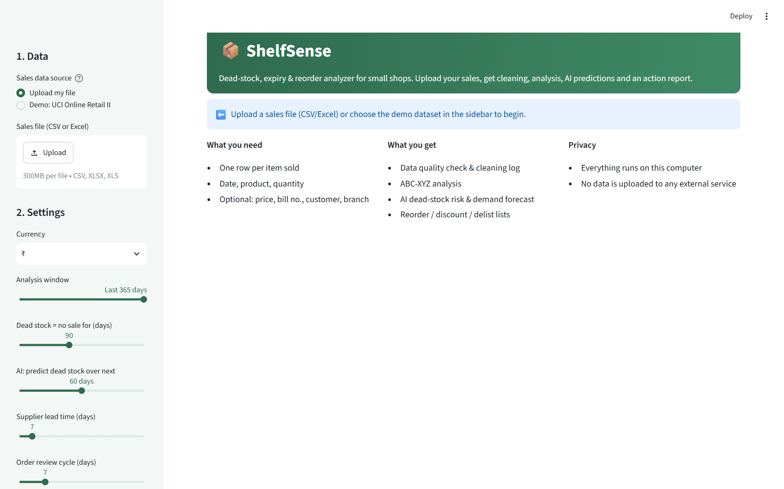
Figure 1: ShelfSense start screen: data source and settings in the sidebar

6. Data Understanding and Quality Assessment
Before any change is made, ShelfSense reports the problems it finds. On the demo dataset:
Issue | Column | Rows | % of rows
Missing values | Product name ('Description') | 4,382 | 0.41
Missing values | Customer ID ('Customer ID') | 243,007 | 22.77
Exact duplicate rows | All mapped columns | 34,335 | 3.22
Negative quantity (returns) | Quantity | 22,950 | 2.15
Zero or negative price | Price | 6,207 | 0.58
Cancelled invoices (start with 'C') | Invoice | 19,494 | 1.83
Non-product lines (postage, fees, adjustments) | Product code / name | 6,181 | 0.58

The largest issue is missing Customer IDs (22.8% of rows). These are kept, because a sale without a customer ID is still a sale; customer counts are simply calculated from the rows that have one.
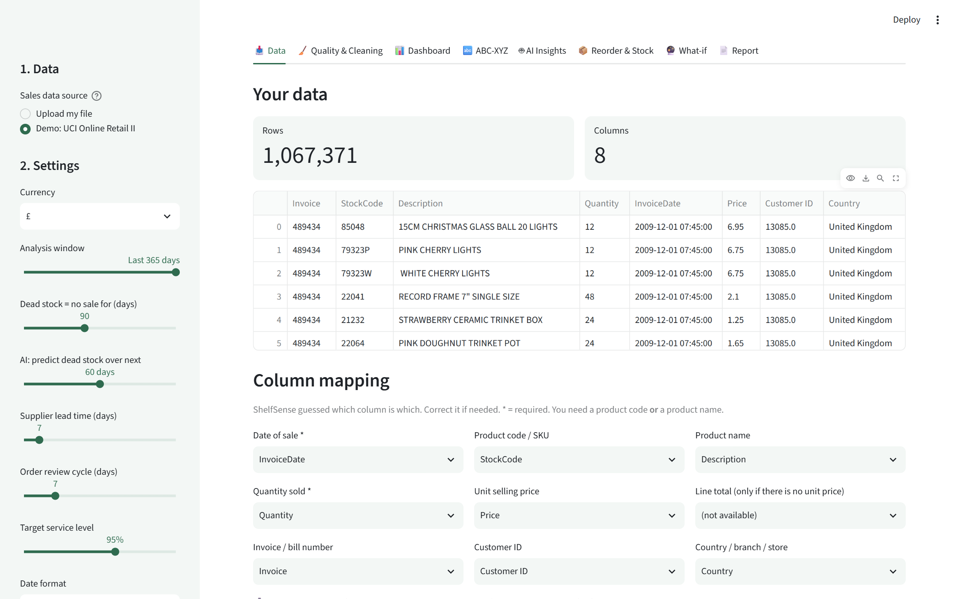
Figure 2: Data tab: preview of the uploaded file and automatic column mapping

7. Data Cleaning
Every cleaning step is logged with the number of rows affected and the reason. The log below is produced by the application itself:
Step | Issue | Rows | Action
1. Dates | Date missing or unreadable | 0 | Removed
2. Quantity | Quantity missing / not a number | 0 | Removed
3. Products | Product code missing | 0 | Filled from product name where possible, otherwise removed
3. Products | Product name missing | 4,382 | Filled with the most common name used for that product code
3. Products | Same code recorded with different names | 1,190 | Standardized to the most frequent name per code
4. Duplicates | Exact duplicate lines | 34,337 | Removed
5. Returns | Cancelled invoices / negative quantities | 22,497 | Moved to a separate returns table
5. Returns | Orders cancelled in full (sale matched to its cancellation: same customer, product and quantity) | 6,335 | Both lines removed
5. Returns | Zero quantity | 0 | Removed
6. Prices | Price missing, zero or negative | 2,625 | Removed
7. Non-products | Postage, fees, manual adjustments, samples | 4,637 | Removed
8. Outliers | Exceptional bulk orders (above max(Q3 + 3 × IQR, 10 × Q3) for that product) | 9,950 | Kept for revenue; capped at the product's upper fence for demand planning

Result: 1,067,371 raw rows became 996,940 clean sales lines, with 15,121 return lines kept separately for return-rate analysis.

Important cleaning decisions
- Returns are separated, not deleted. Cancelled invoices and negative quantities are moved to a returns table so return rates can still be analysed.
- Fully cancelled orders are removed. 6,335 sales were matched to a later cancellation with the same customer, product and quantity. Without this step, one cancelled order of 80,995 units would have appeared as the best-selling product.
- Exceptional bulk orders are capped only for planning. 9,950 lines above max(Q3 + 3 × IQR, 10 × Q3) for their product are kept for revenue but capped for demand forecasting and reorder levels. A plain Q3 + 3 × IQR rule was tested and rejected: in this wholesale data it would have altered about 44% of all units sold, because orders of hundreds of units are normal.
- Non-product lines are removed. Postage, bank charges, manual adjustments and marketplace fees are not stock items and must never appear on a reorder list.
- Names are standardised. 1,190 product codes had several spellings; the most frequent name is used. 36 names that appear under more than one code are listed for manual review instead of being merged automatically.
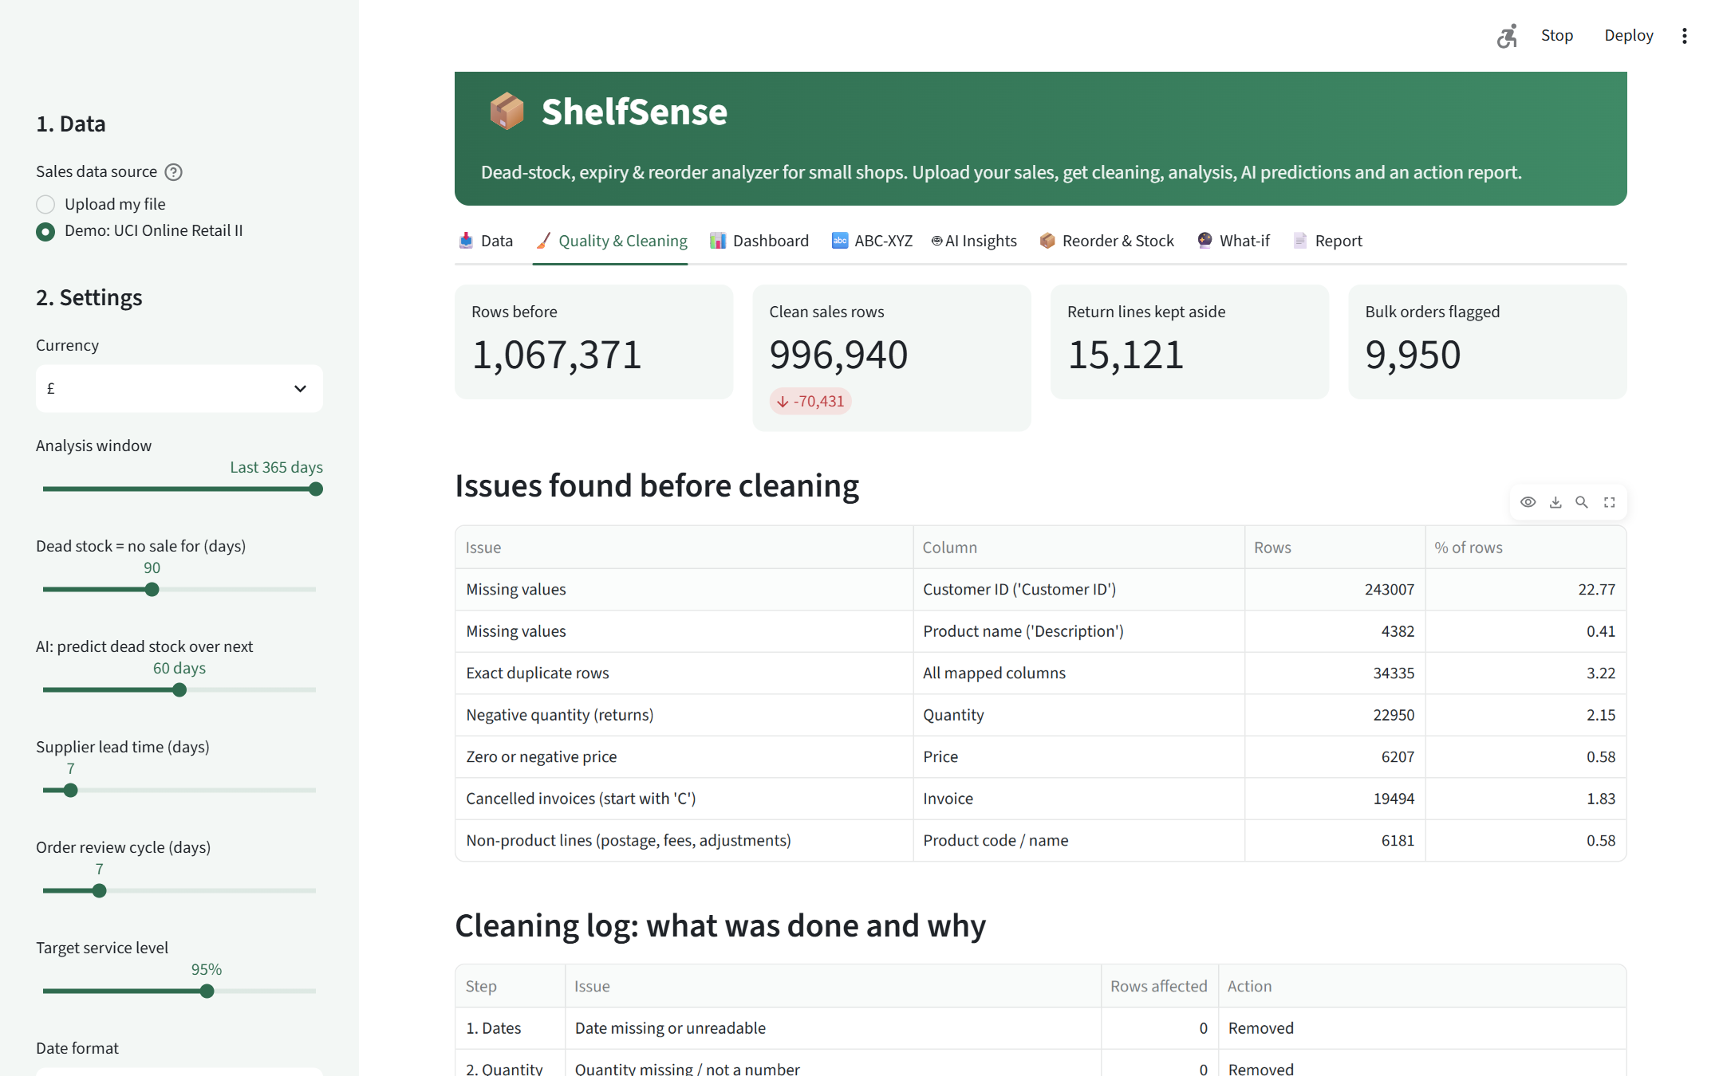
Figure 3: Quality & Cleaning tab: before/after counts and issues found

8. Exploratory and Descriptive Analysis
In the last 365 days of data, the business earned £9.44 million from 5,168,527 units across 18,884 orders and 3,755 products. The United Kingdom accounts for 85% of all revenue. Returned units equal 5.9% of units sold.
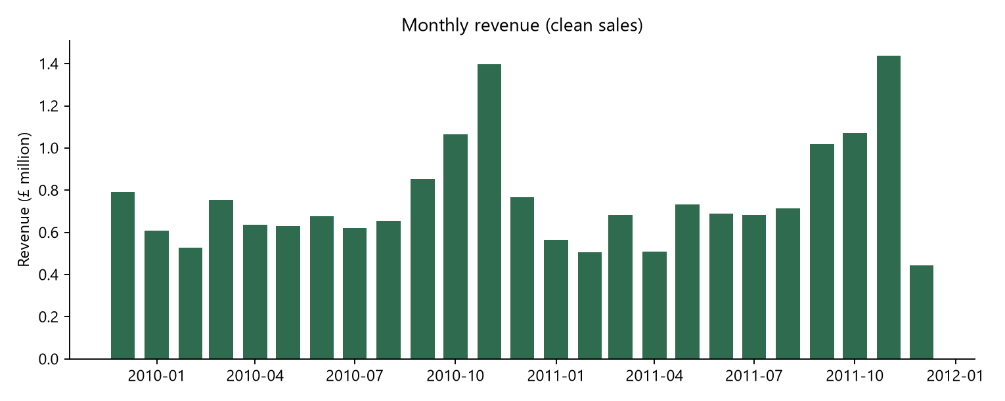
Figure 4: Monthly revenue shows a strong autumn peak every year
Sales are strongly seasonal: revenue rises from September and peaks in November 2011 (£1.44 million), which fits a giftware business supplying Christmas stock. For inventory, this means A-class items must be stocked 4-6 weeks before the peak, and seasonal items that are not sold by December are likely to become dead stock.
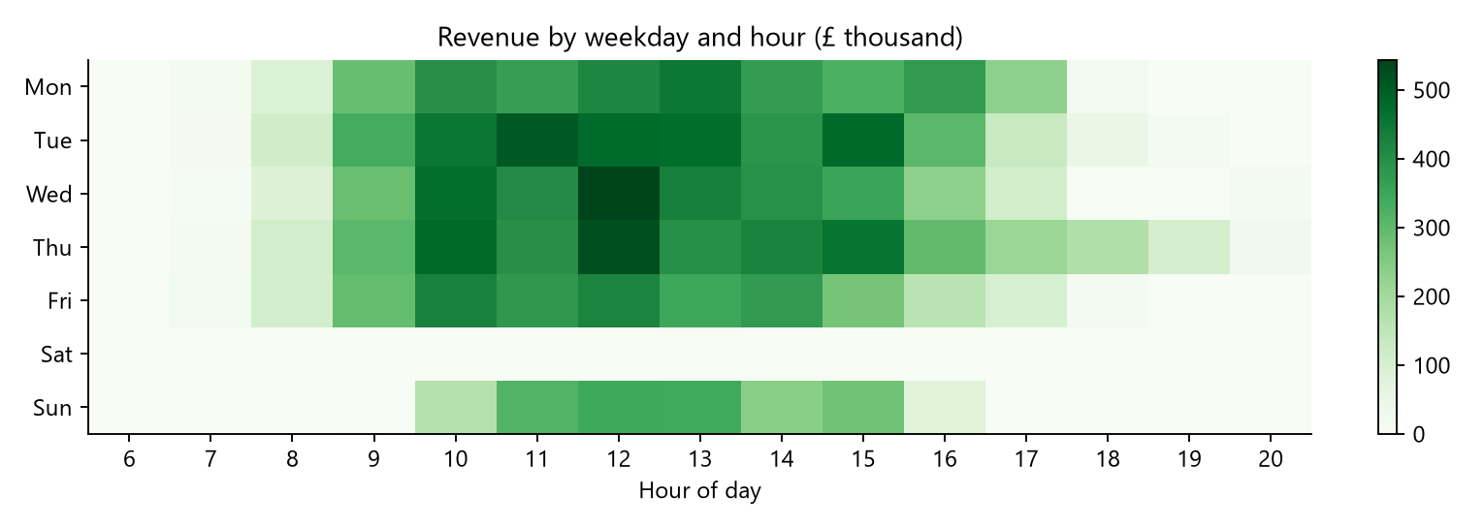
Figure 5: Revenue by weekday and hour
Most revenue is earned on weekday mornings and around midday; there is almost no trade on Saturdays. This helps plan when to receive deliveries and restock shelves.
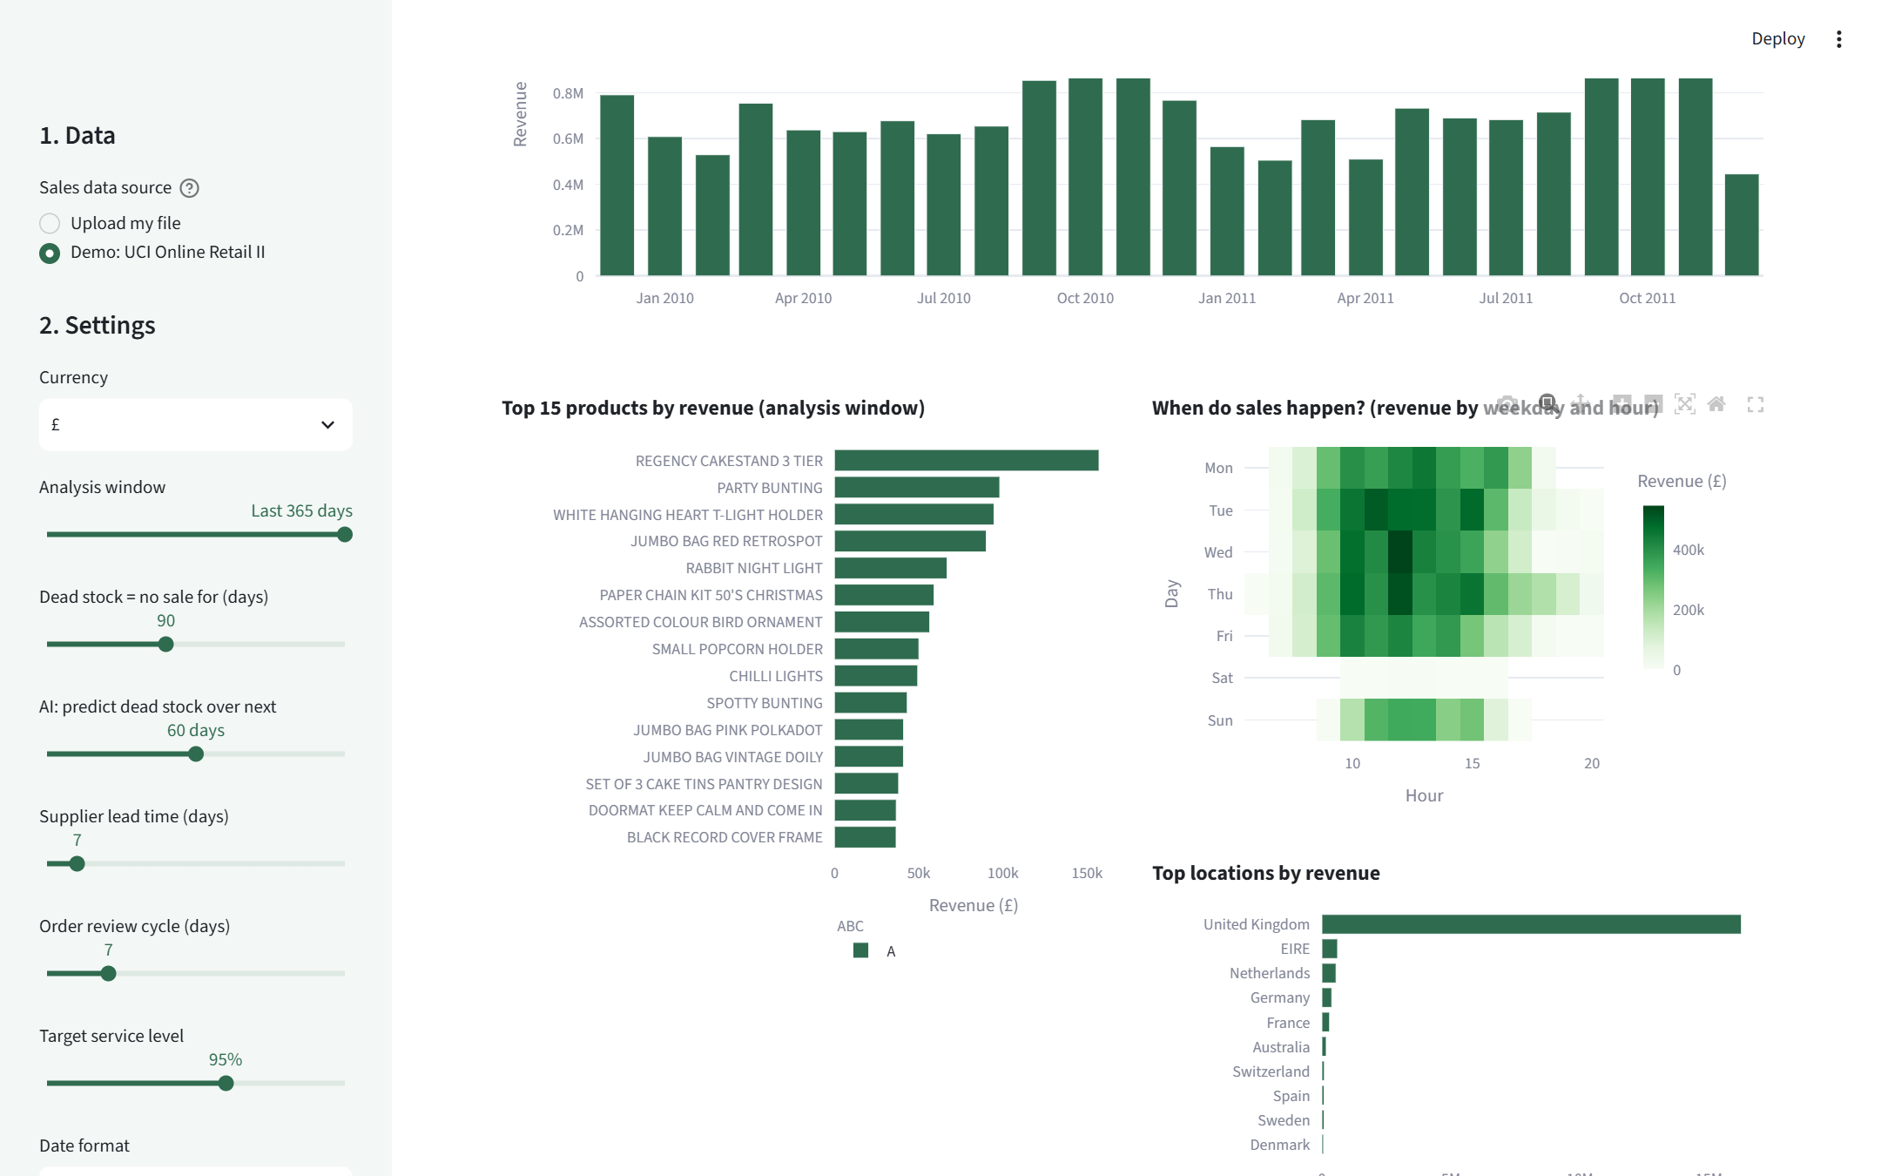
Figure 6: Dashboard tab: top products, sales timing and top countries

9. ABC-XYZ Analysis
ABC analysis ranks products by revenue: A items together earn the first 80% of revenue, B the next 15% and C the last 5%. XYZ analysis measures how predictable weekly demand is using the coefficient of variation (CV = standard deviation ÷ mean of weekly units): X < 0.5 (steady), Y 0.5-1.0 (variable), Z > 1.0 (erratic). Combining both gives nine classes, each with a different stocking strategy.
Class | Products | % of products | % of revenue
A | 831 | 22.1% | 80.0%
B | 956 | 25.5% | 15.0%
C | 1,968 | 52.4% | 5.0%

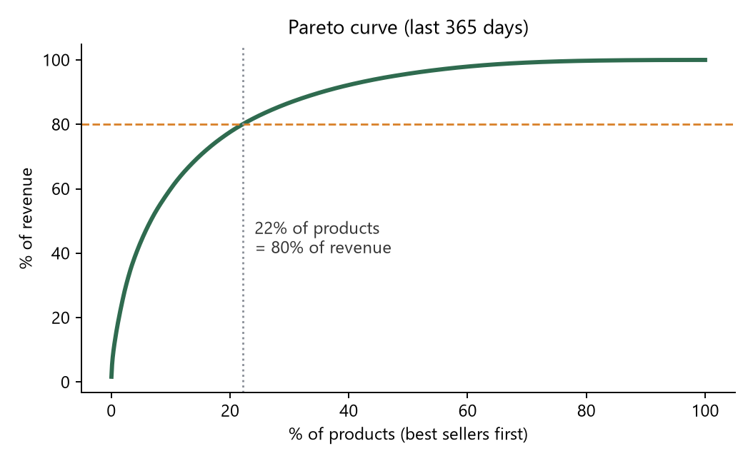 | 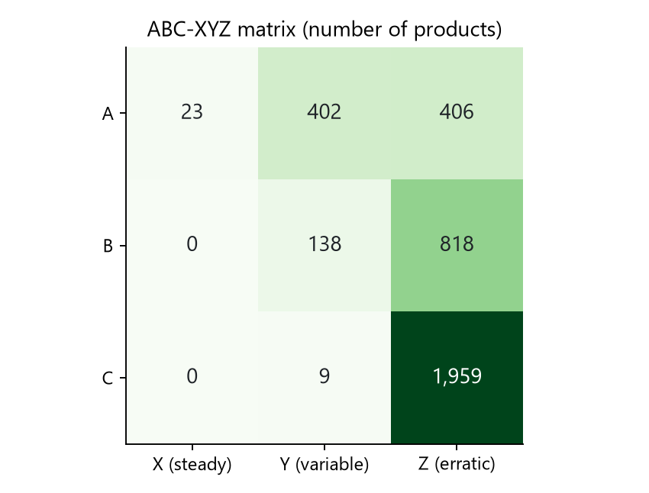
Figure 7: Pareto curve and ABC-XYZ matrix
Class | Products | % of revenue | Suggested strategy
AX | 23 | 8.3% | Top earner, steady demand: never run out. Tight reorder, low safety stock.
AY | 402 | 42.8% | Top earner, variable demand: review weekly, keep moderate safety stock.
AZ | 406 | 28.9% | Top earner, erratic demand: order in smaller batches, watch closely.
BY | 138 | 2.5% | Mid earner, variable: standard reorder with safety stock.
BZ | 818 | 12.5% | Mid earner, erratic: order on demand, avoid bulk buying.
CY | 9 | 0.1% | Low earner, variable: reduce range or order only when needed.
CZ | 1,959 | 4.9% | Low earner, erratic: prime dead-stock candidates. Consider delisting.

Key finding: 1,959 products are CZ (low value, erratic demand) and together earn only 4.9% of revenue. They are the main source of slow-moving stock and the first candidates to reduce or delist, while the A items must never run out.

10. Machine Learning
Three machine-learning components are used. Each is compared with simple baselines and evaluated on data the model has never seen, so the reported results are honest.

10.1 Dead-stock risk prediction (classification)
Question: will a product that is currently active sell nothing at all in the next 60 days? To avoid data leakage, the model is trained on historical snapshots. For a snapshot date, features are computed only from sales up to that date, and the label records what happened in the following 60 days.
- Training snapshots: 2011-08-11, 2011-07-14, 2011-06-16, 2011-05-19, 2011-04-21, 2011-03-24 (22,479 product-snapshot examples).
- Validation snapshot: 2011-10-10 (3,755 products). Its 60-day outcome period comes after all training outcome periods, so the test is a true look into the future.
- Features (11): days since last sale, product age, units in the last 30/90/365 days, orders in the last 90 days, customers in the last year, active weeks and demand variability in the last 52 weeks, 90-day trend, average price.
- Models: a recency rule (no sale in the last 60 days), Logistic Regression and Random Forest, both with balanced class weights. Selection criterion: highest ROC-AUC on the validation snapshot.
Model | ROC-AUC | Precision | Recall | F1
Rule: no sale in last 60 days | 0.954 | 0.785 | 0.831 | 0.807
Logistic Regression | 0.950 | 0.655 | 0.922 | 0.766
Random Forest | 0.960 | 0.722 | 0.913 | 0.806

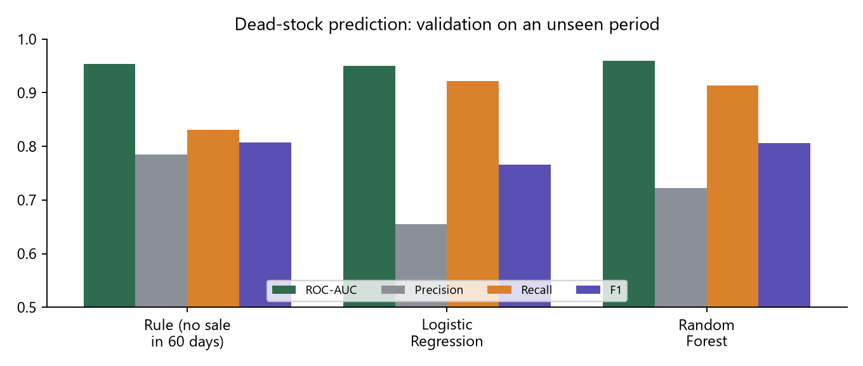
Figure 8: Dead-stock models on the unseen validation period
In the validation period, 24% of active products went dead. The Random Forest achieved the highest ROC-AUC (0.960) and the highest recall among models with good precision: it catches 91% of products that really stopped selling, compared with 83% for the simple rule. The rule, however, is more precise (0.79 vs 0.72), so its F1 score is almost identical. This is an honest and useful finding: recency alone is a strong signal, and the model's main added value is catching more at-risk products earlier, which is what a shopkeeper needs before placing a reorder.
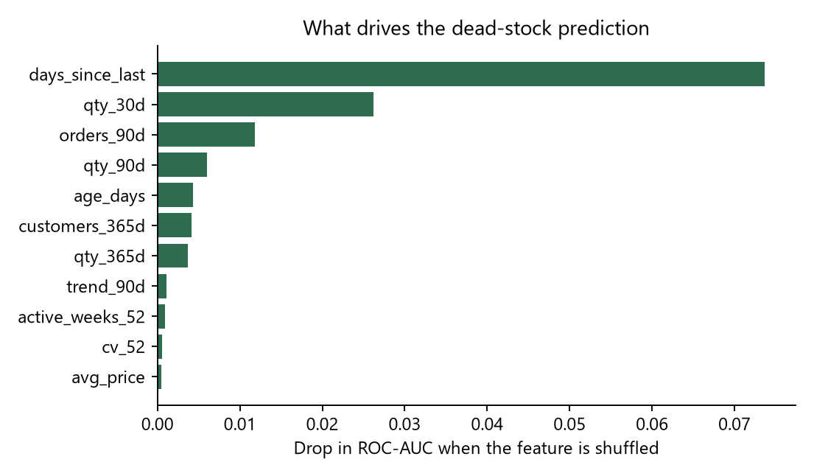
Figure 9: Permutation importance of the Random Forest features
Days since the last sale is by far the most important feature, followed by units sold in the last 30 days and the number of recent orders. Price and demand variability contribute little. As of the end of the data, the model rates 755 active products as high risk, 256 as medium and 2,722 as low.
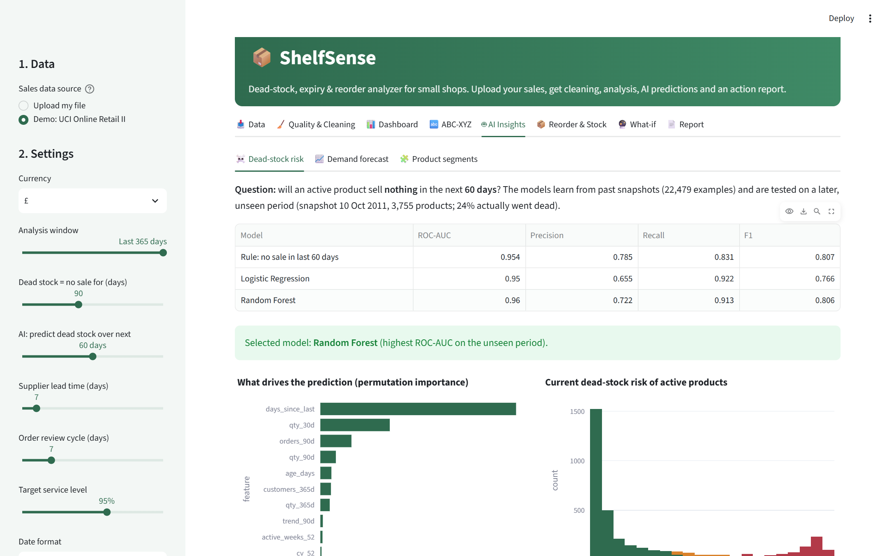
Figure 10: AI Insights tab: dead-stock model comparison in the app

10.2 Demand forecasting (regression)
The quantity that matters for reordering is demand over the next few weeks. For the 3,021 products that sold in at least 8 of the last 52 weeks, weekly sales were arranged in a complete product × week grid (weeks without sales = 0). For each week, the model predicts total units for the following 4 weeks, using lags of recent weeks, rolling means and standard deviations, the same period last year, product age and calendar features.
Four methods were compared on the last 8 weeks of data (forecast origins 2011-10-31, 2011-10-03), which none of the models saw during training (220,980 training rows). The Gradient Boosting model uses a Poisson loss, which suits count data. Metrics: MAE (units per product per 4 weeks), WAPE (total absolute error ÷ total actual demand) and Bias (over- or under-forecasting).
Method | MAE | WAPE % | Bias %
Naive: last 4 weeks | 75.91 | 42.17 | −9.51
Moving average (12 weeks) | 85.11 | 47.27 | −18.55
Seasonal naive: same weeks last year | 114.67 | 63.69 | +19.52
Gradient Boosting (AI) | 76.14 | 42.29 | −0.79

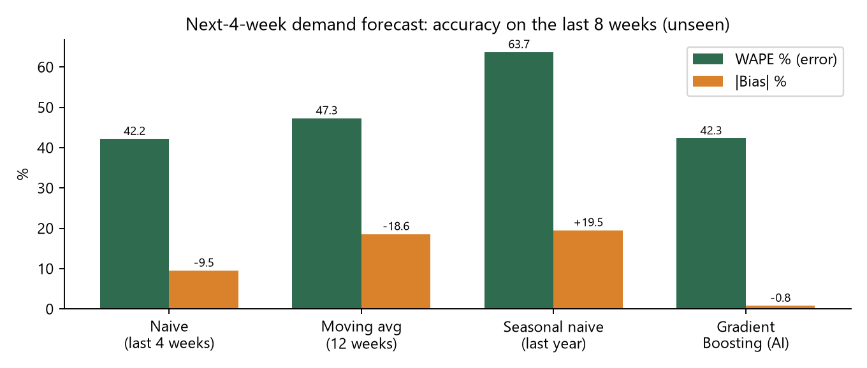
Figure 11: Forecast accuracy (WAPE) and bias of the four methods
Gradient Boosting and the naive method (repeat the last 4 weeks) were practically tied on accuracy (WAPE 42.29% vs 42.17%). The difference is in bias: the naive method under-forecast total demand by 9.5%, while Gradient Boosting was almost unbiased (−0.8%). Consistent under-forecasting causes stock-outs, so the selection rule used by the application is: methods within 1 percentage point of the best WAPE are treated as equally accurate and the least biased one is chosen. Last year's same weeks performed worst: in the test period (October-November 2011) many products sold very differently from the same weeks of 2010. Product-level weekly demand is naturally noisy, so errors of this size are expected, and this is why the reorder calculation adds safety stock.
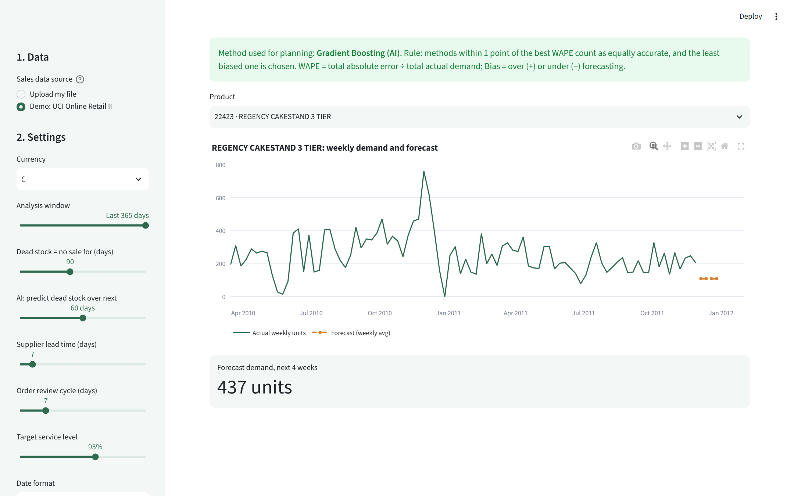
Figure 12: Weekly demand history and 4-week forecast for a selected product

10.3 Product segmentation (clustering)
K-Means clustering (k = 4) grouped active products by six standardised behaviour features: revenue (log), share of weeks with a sale, demand variability, 13-week trend, days since last sale and the share of annual sales in the peak month. Clusters were named automatically from their average behaviour. The silhouette score was 0.364, indicating reasonably separated groups.
Segment | Products | Active weeks | Days since sale | Peak-month share | % revenue
Dormant / fading | 446 | 0.07 | 219 | 0.80 | 0.5%
Occasional / slow movers | 1,102 | 0.28 | 43 | 0.39 | 3.6%
Seasonal / peaky | 387 | 0.25 | 5 | 0.56 | 6.7%
Steady sellers | 1,820 | 0.77 | 4 | 0.24 | 89.2%

Steady sellers (1,820 products) earn 89% of revenue and sell in most weeks: these should be on automatic reorder. Dormant/fading products earn almost nothing and are the main dead-stock pool.

11. Inventory Optimisation

11.1 Safety stock and reorder point
For every product with recent demand, ShelfSense uses the forecast daily demand d, the variability of daily demand σ (derived from the last 12 weeks), the supplier lead time L (days), the review cycle R (days) and a target service level with its z-value:
Safety stock SS = z × σ × √L
Reorder point ROP = d × L + SS
Order-up-to level S = d × (L + R) + SS
With the default settings (L = 7 days, R = 7 days, 95% service level, z ≈ 1.645) the plan covers 3,133 products. All three parameters can be changed with sliders, and the tables update immediately.

11.2 Stock-based actions
When a current-stock sheet (product, stock, optional cost and expiry date) is uploaded, each product receives a status:
- Reorder now: stock ≤ reorder point; suggested order quantity = S − stock.
- Dead / slow stock: stock on hand and either no sale for 90 days or HIGH AI dead-stock risk.
- Overstocked: more than 120 days of cover at forecast demand.
- Expiry risk: units that will not sell before the expiry date at the forecast rate (stock − d × days to expiry), with a suggested action such as a discount, bundle or return to supplier.

11.3 Transparency about stock data
The UCI dataset contains no stock or expiry information. To demonstrate the stock features, the application offers a clearly labelled simulated stock sheet for the demo dataset only. Every screen and report that uses it displays a warning. Simulated figures are therefore not reported as project results; with a real shop's stock sheet, the same calculations use real values.
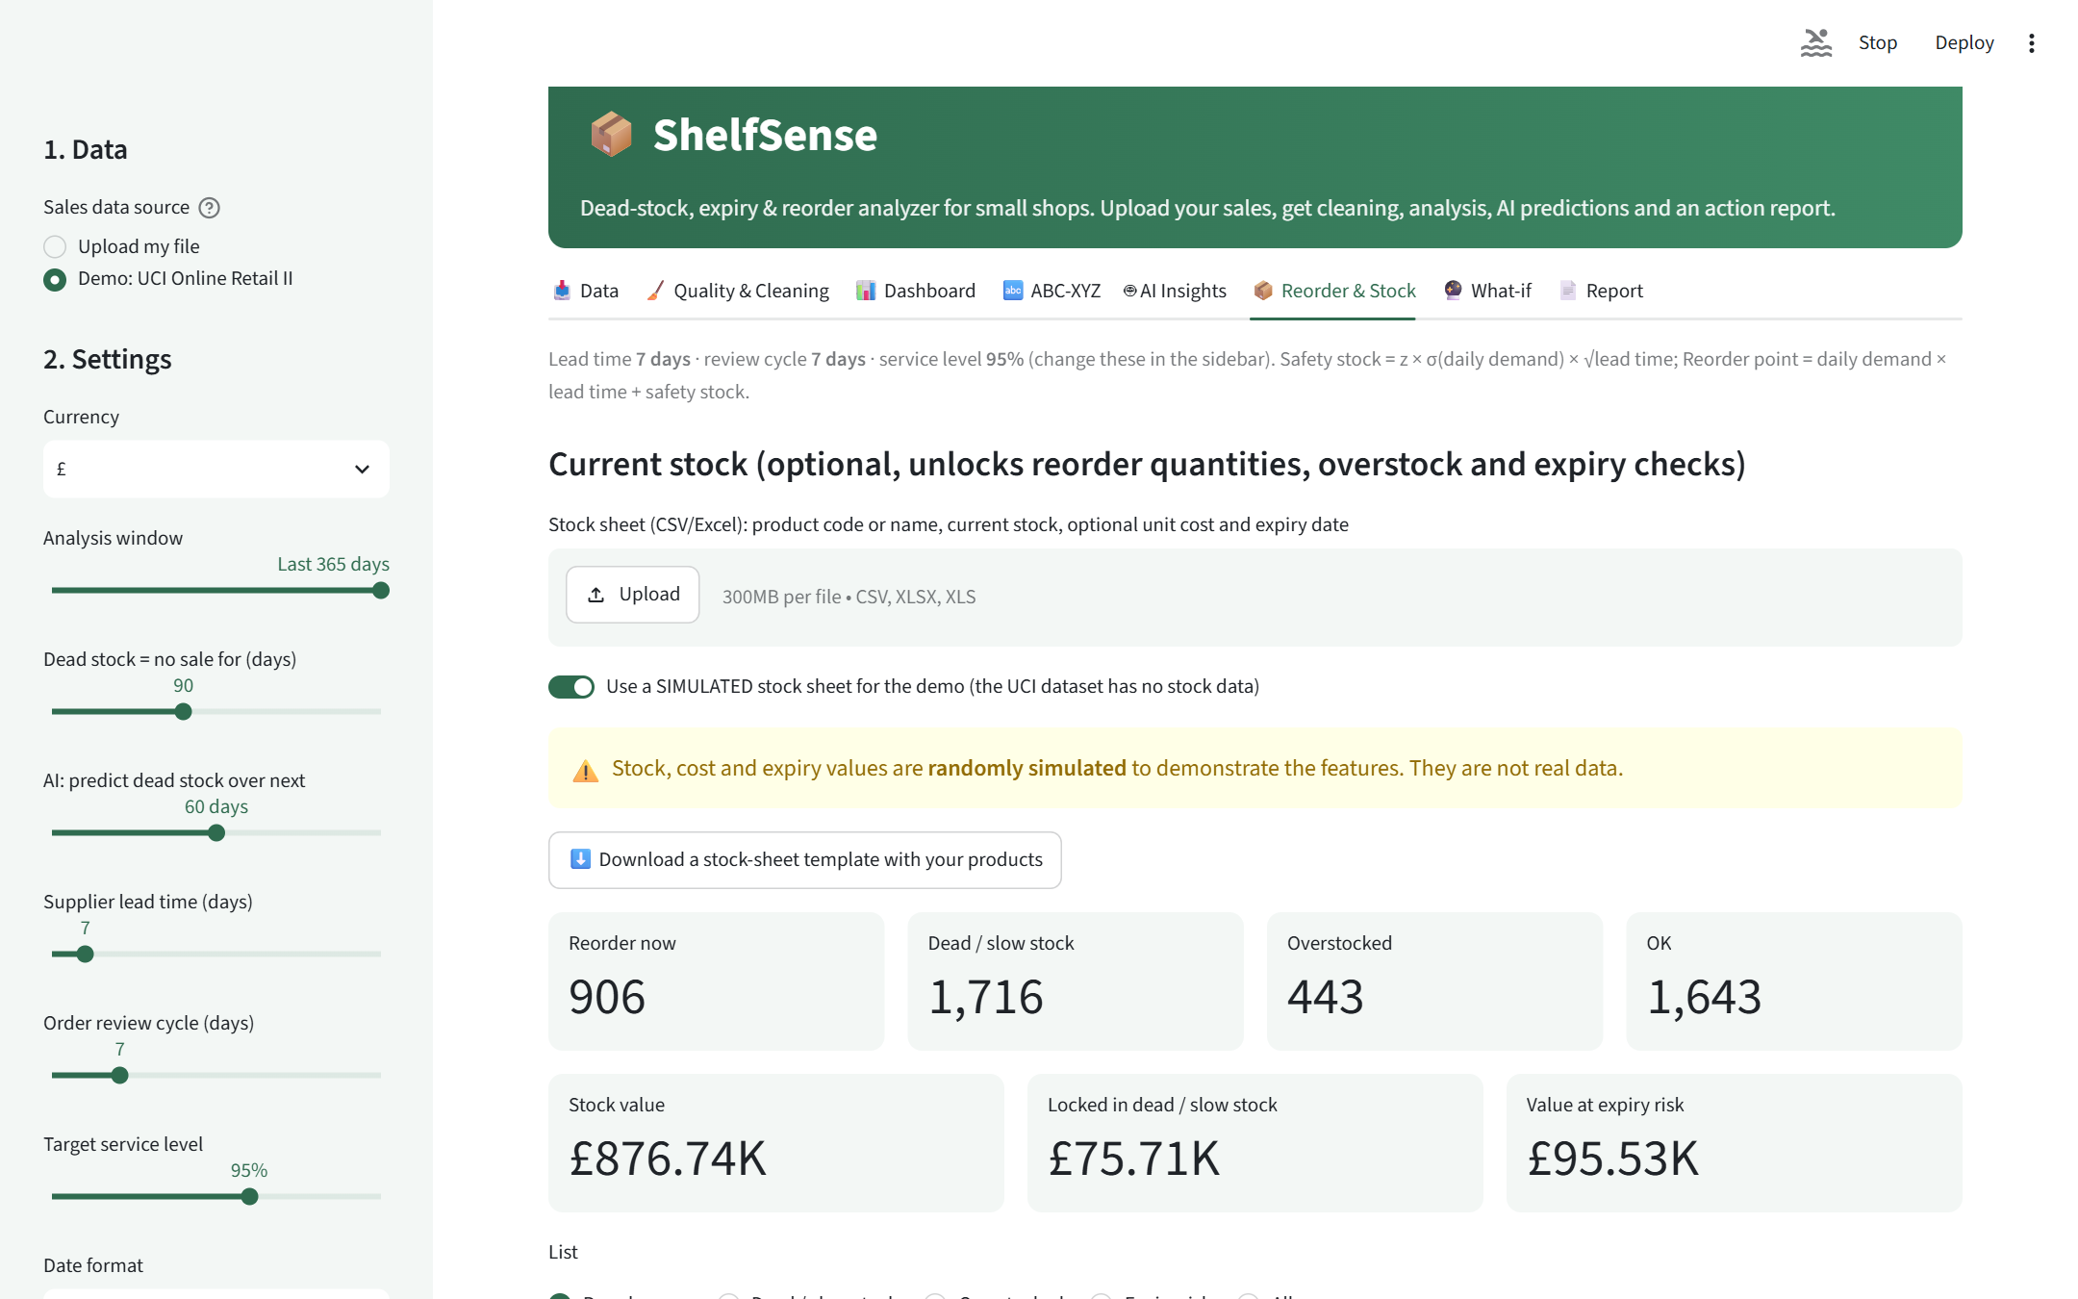
Figure 13: Reorder & Stock tab with the clearly labelled simulated stock sheet

12. The ShelfSense Application
The web interface is built with Streamlit and runs locally in the browser. It has eight tabs:
Tab | What the user can do
Data | Upload CSV/Excel (or load the demo), preview rows, confirm the column mapping, run the analysis
Quality & Cleaning | See issues found, the full cleaning log, possible duplicate products; download clean data
Dashboard | KPIs, monthly revenue, top products, weekday-hour heatmap, top countries, most-returned products; filter by country
ABC-XYZ | Pareto curve, ABC-XYZ matrix, class strategies, product lists per class
AI Insights | Dead-stock model results and risk lists; demand forecast per product; product segments
Reorder & Stock | Reorder levels; upload stock sheet; reorder / dead / overstock / expiry lists; template download
What-if | Change demand, lead time and service level for a product; clearance-sale cash calculator
Report | Key insights and recommendations; download HTML report, Excel workbook, cleaned CSV

Settings in the sidebar (currency, analysis window, dead-stock definition, AI horizon, lead time, review cycle, service level, date format and cleaning options) make the tool usable for different shops, including Indian shops with ₹ prices and DD/MM/YYYY dates.
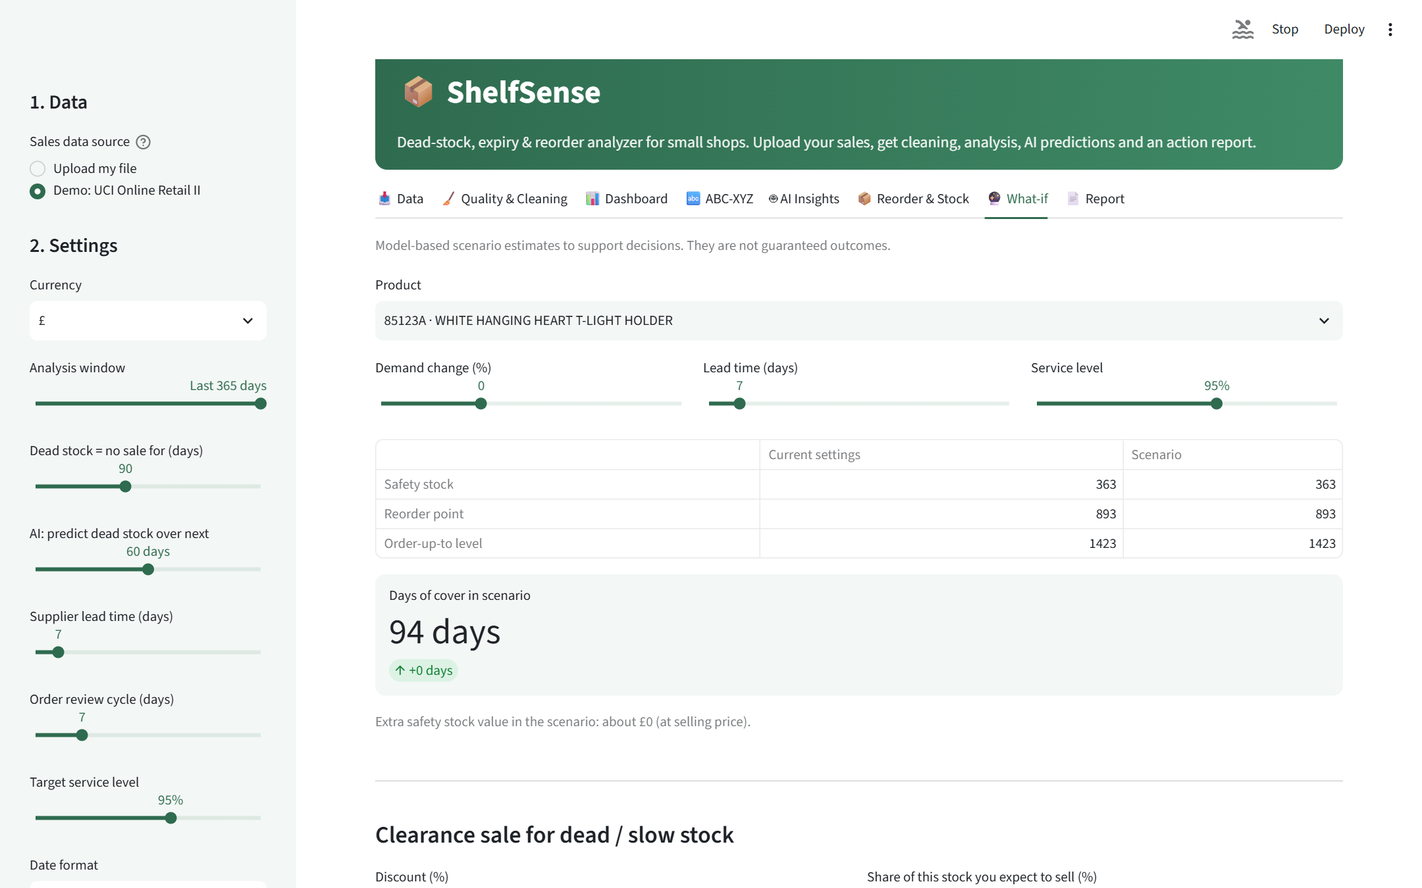
Figure 14: What-if tab: scenario simulation for a product and a clearance sale
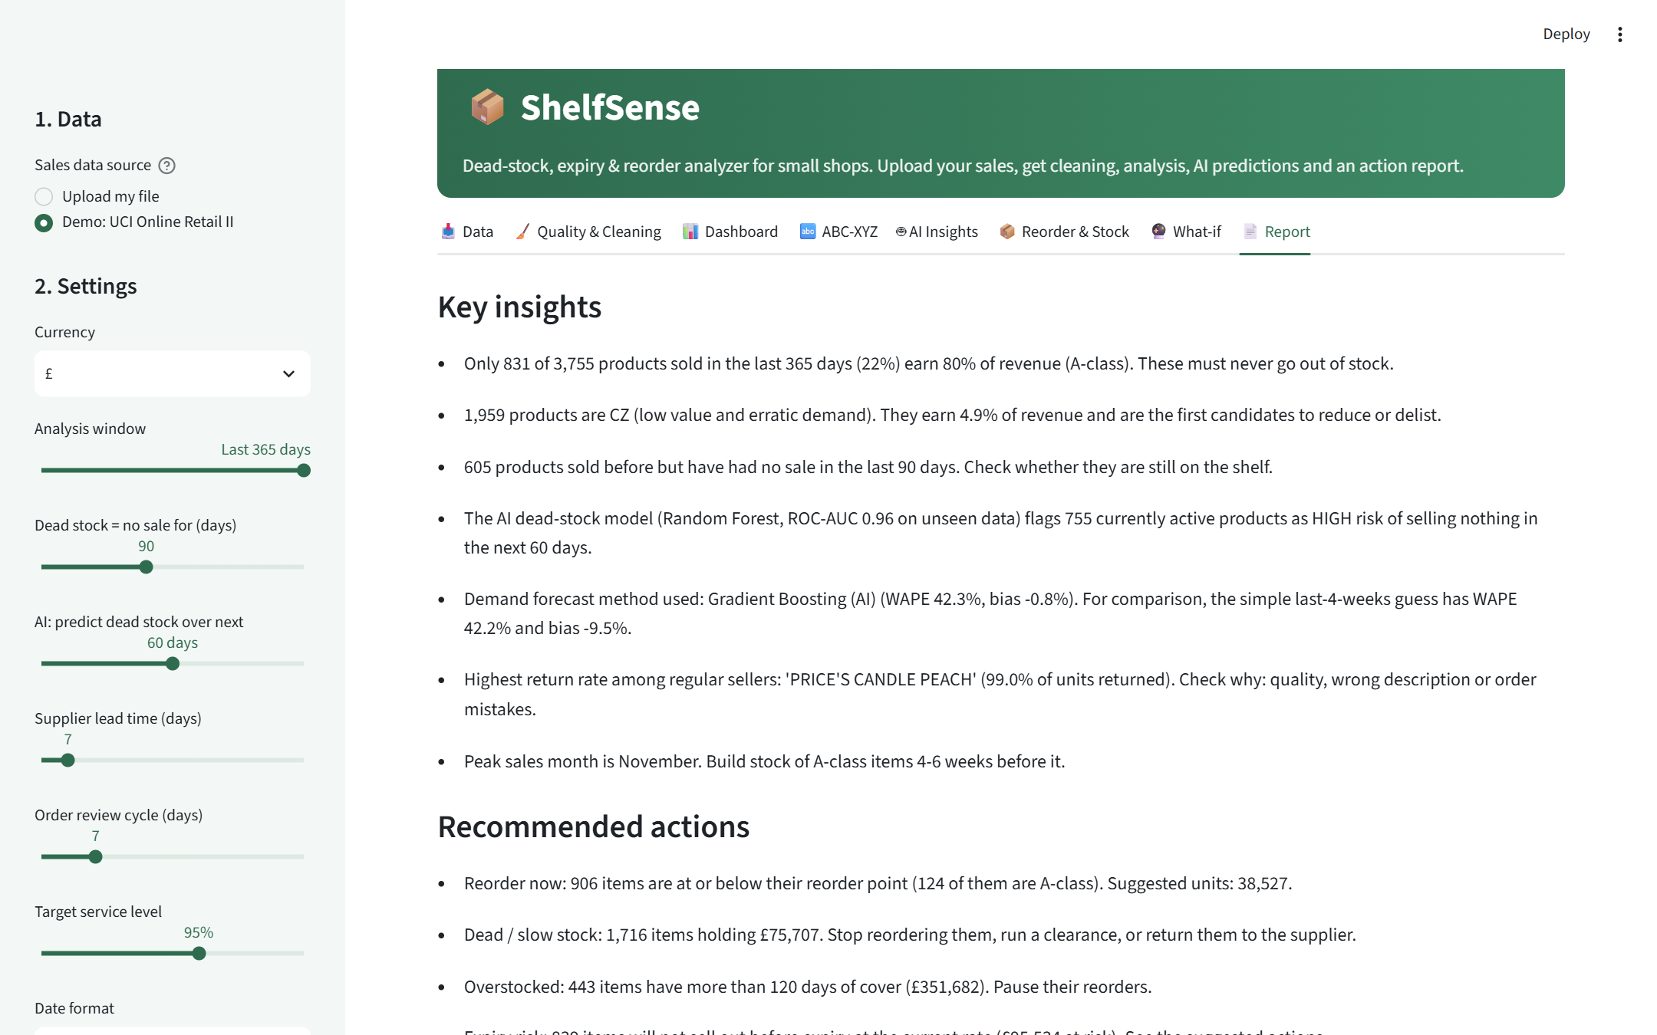
Figure 15: Report tab: automatically generated insights and download buttons

13. Results and Key Insights
The following insights were generated automatically by the application from the demo data:
- Only 831 of 3,755 products sold in the last 365 days (22%) earn 80% of revenue (A-class). These must never go out of stock.
- 1,959 products are CZ (low value and erratic demand). They earn 4.9% of revenue and are the first candidates to reduce or delist.
- 605 products sold before but have had no sale in the last 90 days. Check whether they are still on the shelf.
- The AI dead-stock model (Random Forest, ROC-AUC 0.96 on unseen data) flags 755 currently active products as HIGH risk of selling nothing in the next 60 days.
- Demand forecast method used: Gradient Boosting (AI), with WAPE 42.3% and bias −0.8%. For comparison, the simple last-4-weeks guess has WAPE 42.2% and bias −9.5%.
- Highest return rate among regular sellers: 'PRICE'S CANDLE PEACH' (99.0% of units returned). Check why: quality, wrong description or order mistakes.
- Peak sales month is November. Build stock of A-class items 4-6 weeks before it.

14. Recommendations for a Shop Owner
- Protect A-class items: review them weekly and never let them fall below the reorder point.
- Stop automatic reordering of CZ items and of products rated HIGH dead-stock risk; clear existing stock with discounts or bundles.
- Build seasonal stock 4-6 weeks before the peak month and plan clearance of seasonal leftovers straight after it.
- Investigate products with unusually high return rates (quality, description or order errors).
- Record stock and expiry dates regularly so that the stock-based actions can be used every week.
These are data-driven suggestions based on past sales; they support, but do not replace, the shopkeeper's judgement.

15. Testing and Validation
- Full-dataset run: the complete pipeline processes all 1,067,371 rows (about 1.5-3 minutes on an 8 GB laptop, then cached for the session).
- Automated interface test: Streamlit's AppTest framework loaded the demo, ran the analysis, enabled the stock sheet and switched every list; no errors occurred.
- Browser test: every tab was opened and checked in a real browser.
- Different file format: a kirana-style file with columns 'Bill No', 'Item Name', 'Qty', 'Rate' (values like ₹1,250.00), DD/MM/YYYY dates and spelling variants was mapped and cleaned correctly; with too little history, the AI modules skip themselves with an explanation instead of failing.
- Leakage checks: all features use only data before the snapshot or forecast date; models are evaluated on later, unseen periods.

16. Limitations
- The demo dataset is from a UK giftware wholesaler; retail kirana data will have different patterns.
- The demo dataset has no stock, cost or expiry data, so stock features were demonstrated with simulated values only.
- Product-level weekly demand is noisy (WAPE about 42%); forecasts should be used with safety stock.
- Safety stock assumes roughly normal demand and a fixed lead time.
- The app analyses files; it is not connected live to billing or supplier systems.

17. Future Scope
- Connect directly to billing software (e.g. Tally, Vyapar) or Google Sheets for automatic updates.
- Add supplier lead-time tracking and purchase-order generation.
- Use promotions and festival calendars (Diwali, Eid, Christmas) as forecast features.
- Add multi-branch support with stock transfers between branches.
- Send WhatsApp or SMS alerts for reorder and expiry actions.
- Deploy on Streamlit Community Cloud for access from a phone.

18. Conclusion
ShelfSense shows how a small shop's existing sales records can be turned into practical inventory decisions with data analytics and machine learning. Applied to more than one million real transactions, it cleaned the data transparently, showed that about a fifth of products earn 80% of revenue, predicted dead stock with an ROC-AUC of 0.96 on an unseen period, and produced demand forecasts that are as accurate as the best simple method but far less biased. The honest comparison with baselines is itself a result: simple rules are strong, and the AI adds value by catching more at-risk products and removing systematic under-forecasting. Delivered as an interactive, local and free web application, the project supports responsible consumption and reduced waste in line with UN SDG 12.

References
[1] Chen, D. (2012). Online Retail II [Dataset]. UCI Machine Learning Repository. https://doi.org/10.24432/C5CG6D
[2] Pedregosa, F. et al. (2011). Scikit-learn: Machine Learning in Python. Journal of Machine Learning Research, 12, 2825-2830.
[3] McKinney, W. (2010). Data Structures for Statistical Computing in Python. Proceedings of the 9th Python in Science Conference.
[4] Breiman, L. (2001). Random Forests. Machine Learning, 45(1), 5-32.
[5] Friedman, J. H. (2001). Greedy Function Approximation: A Gradient Boosting Machine. Annals of Statistics, 29(5), 1189-1232.
[6] Silver, E. A., Pyke, D. F. & Thomas, D. J. (2017). Inventory and Production Management in Supply Chains (4th ed.). CRC Press.
[7] Hyndman, R. J. & Athanasopoulos, G. (2021). Forecasting: Principles and Practice (3rd ed.). OTexts. https://otexts.com/fpp3/
[8] Streamlit documentation. https://docs.streamlit.io
[9] Plotly Python documentation. https://plotly.com/python/
[10] United Nations. Sustainable Development Goal 12. https://sdgs.un.org/goals/goal12

Appendix A: How to Run
pip install -r requirements.txt
streamlit run VanshikaSolanki_ShelfSense.py
python VanshikaSolanki_ShelfSense.py (command-line mode)

