LAB 1–2: COMMAND-LINE FILE MANAGEMENT

Name: _Vanshika Khanna_

Roll Number: _2610997586____

Course: BCA AI & ML

Subject: BCPS

1. Aim

To learn basic file and directory management using Windows Command Prompt (CMD).

2. Commands Used

1. "mkdir" — Creates a directory.
2. "cd" — Changes the current directory.
3. "dir" — Displays files and directories.
4. "type" — Displays the contents of a text file.
5. "copy" — Copies a file.
6. "ren" — Renames a file.
7. "move" — Moves a file.
8. "rmdir" — Removes an empty directory.

3. Procedure

1. Opened Windows Command Prompt.
2. Created the practice directory and subdirectories.
3. Created a text file and displayed its contents.
4. Copied the file and renamed the copy.
5. Moved the renamed file into the Archive directory.
6. Removed the empty directory.
7. Checked the final files and directory contents.

4. Result

The file and directory management commands were practised successfully using Windows CMD.

5. Conclusion

This practical helped me understand basic command-line operations for creating, viewing, copying, renaming, moving, and deleting files and directories.

6. Screenshots

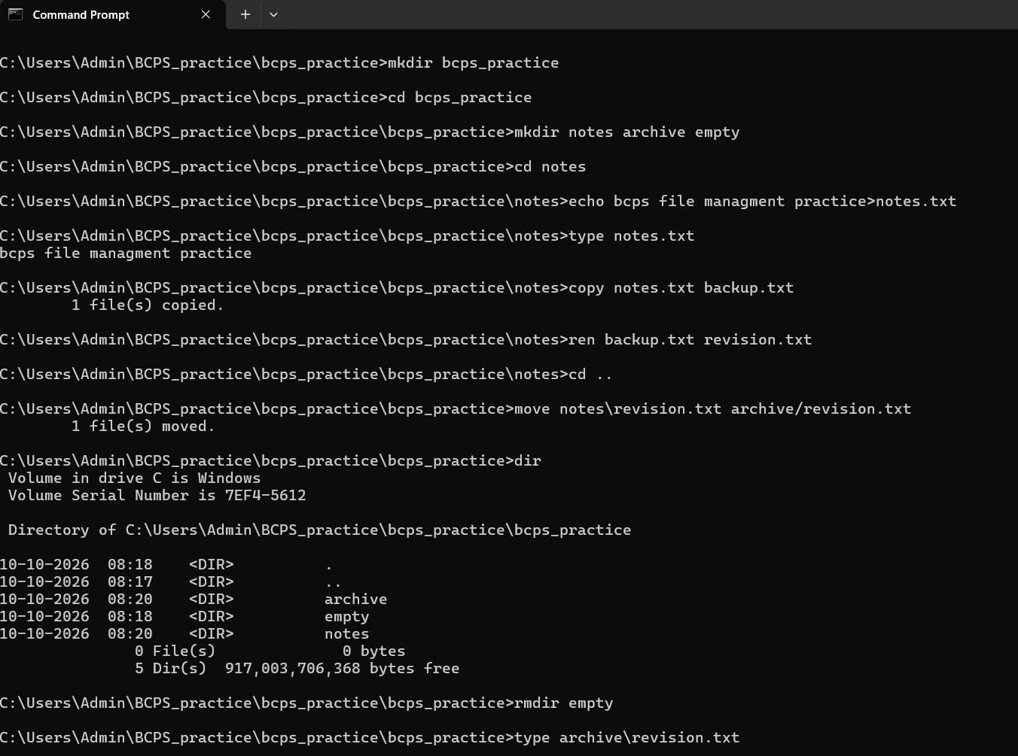
CMD practical screenshots are attached as evidence of the commands executed and their outputs.

