# TIC TAC TOE REPORT

Tic Tac Toe

Game Implementation

**Prepared by**: Vanshika Aggarwal

**Roll No.** : 202401100400207

**Algorithm used** : Minimax Algorithm

**Purpose**: This report details the implementation of a Tic Tac Toe game using Python and AI algorithms.

## Introduction

Tic-Tac-Toe is a two-player game where players take turns marking a **3x3 grid** with their respective symbols ('O' for the human and 'X' for the AI). The objective is to get **three marks in a row, column, or diagonal** before the opponent. If all cells are filled without a winner, the game ends in a draw.

This project is a **terminal-based Tic-Tac-Toe game**, where the **AI plays optimally using the Minimax algorithm**. The AI always selects the best possible move, ensuring that it **never loses**. By simulating all potential moves and evaluating their outcomes, the AI strategically plays to **win or force a draw** if winning is impossible.

This game is an excellent demonstration of **game theory, decision-making algorithms, and artificial intelligence** in a simple, interactive format. It provides an engaging way to understand how AI can **think ahead, anticipate moves, and make optimal choices** in competitive settings. Whether you're looking to challenge yourself against a **perfect AI opponent** or explore the logic behind Minimax, this project serves as a great introduction to AI-powered decision-making in games!

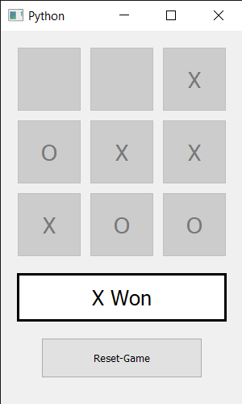

## Methodology

### ****Step 1: Understanding the Game Rules****

* The game is played on a **3x3 grid**.
* Two players take turns marking the board with 'O' (human) and 'X' (AI).
* A player wins by placing three of their marks in a row, column, or diagonal.
* If all cells are filled and no one wins, the game ends in a **draw**.

### ****Step 2: Designing the Game Structure****

To implement the game, the following core components were identified:

1. **Board Representation** → A 3x3 list to store player moves.
2. **Game Display** → A function to print the board in a readable format.
3. **Move Handling** → Functions to allow user input and AI decision-making.
4. **Win Checking** → A function to determine if a player has won.
5. **AI Decision Making** → Implementation of the **Minimax algorithm**.

### ****Step 3: Implementing the Game Logic****

* **Initializing the board** → A 3x3 grid initialized with empty spaces.
* **User input handling** → Validates the user’s move and ensures it is within range and not occupied.
* **Win condition checking** → Iterates through rows, columns, and diagonals to determine if a player has won.

### ****Step 4: Implementing the Minimax Algorithm for AI****

To create an **unbeatable AI**, the Minimax algorithm was implemented:

1. **Base cases:**
   * If AI wins, return a **positive score**.
   * If the player wins, return a **negative score**.
   * If the board is full, return **zero** (draw).
2. **Recursive exploration:**
   * The AI simulates all possible moves and evaluates their outcomes.
   * It assigns scores based on the **best possible future state**.
   * AI **maximizes** its score, while the human **minimizes** AI’s score.

## Code Typed

import math #math module for infinty value

# Players

user = 'O'

ai = 'X'

empty = ' '

# Print the Tic-Tac-Toe board

def print_board(board):

    for row in board:

        print(" | ".join(row))

    print("\n")

# Check for a win

def check_winner(board, player):

    # Check rows

    for i in range(3):

        if board[i][0] == player and board[i][1] == player and board[i][2] == player:

            return True

    # Check columns

    for i in range(3):

        if board[0][i] == player and board[1][i] == player and board[2][i] == player:

            return True

    # Check main diagonal

    if board[0][0] == player and board[1][1] == player and board[2][2] == player:

        return True

    # Check secondary diagonal

    if board[0][2] == player and board[1][1] == player and board[2][0] == player:

        return True

    return False #if no condition becomes true, return false

# Minimax Algorithm

def minimax(board, depth, is_max):

    if check_winner(board, ai):

      return 10 - depth  # AI wins

    if check_winner(board, user):

      return depth - 10  # Human wins

    draw = True

    for row in board:

        for cell in row:

            if cell == empty:

                draw = False  # Still empty spaces left, game is not a draw

    if draw:

        return 0  # It's a draw

    best_score = -math.inf if is_max else math.inf #if is_max=true then ai turn else user turn

    for i in range(3):

        for j in range(3):

            if board[i][j] == empty:

                board[i][j] = ai if is_max else user

                score = minimax(board, depth + 1, not is_max)

                board[i][j] = empty

                best_score = max(best_score, score) if is_max else min(best_score, score)

    return best_score

# Find the best move for AI

def best_move(board):

    best_score, move = -math.inf, (-1, -1)

    for i in range(3):

        for j in range(3):

            if board[i][j] == empty:

                board[i][j] = ai

                score = minimax(board, 0, False)

                board[i][j] = empty

                if score > best_score:

                    best_score, move = score, (i, j)

    return move

# Game loop

def play_game():

    board = [[empty] * 3 for _ in range(3)]

    print("Tic-Tac-Toe! You are 'O', AI is 'X'\n")

    print_board(board)

    for turn in range(9):

        if turn % 2 == 0:  # Human move

            while True:

                try:

                    row, col = map(int, input("Enter row and column (0-2): ").split())

                    if board[row][col] == empty:

                        board[row][col] = user

                        break

                    print("Cell occupied! Try again.")

                except:

                    print("Invalid input! Enter numbers between 0 and 2.")

        else:  # AI move

            print("AI is thinking...")

            row, col = best_move(board) #minimax algo for optimal solution

            board[row][col] = ai

        print_board(board)

        if check_winner(board, user): return print("You win! ")

        if check_winner(board, ai): return print("AI wins! ")

    print("It's a draw!")

if __name__ == "__main__":

    play_game()

## Output Screenshots

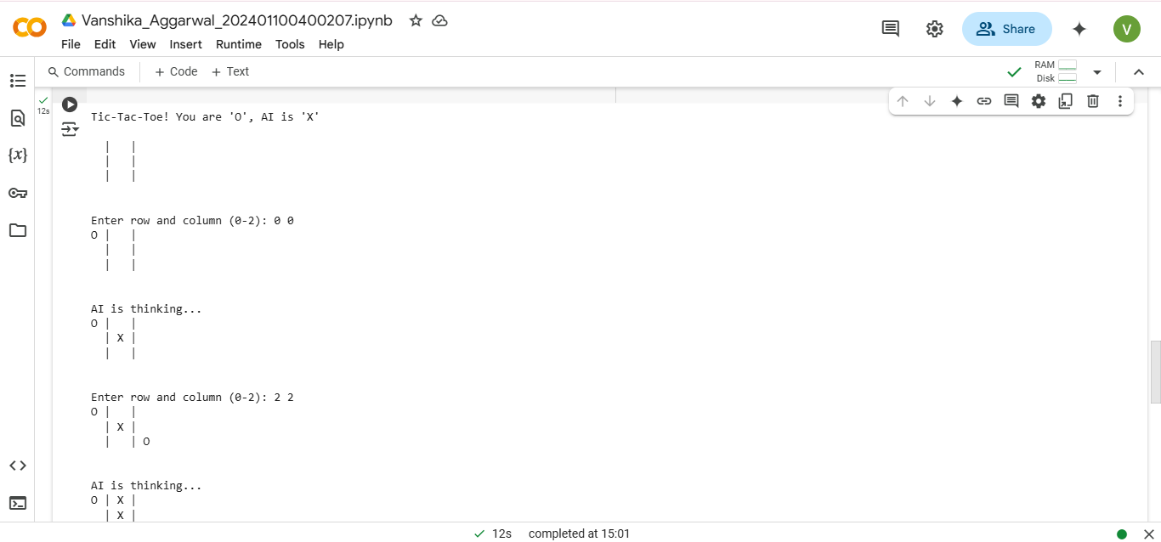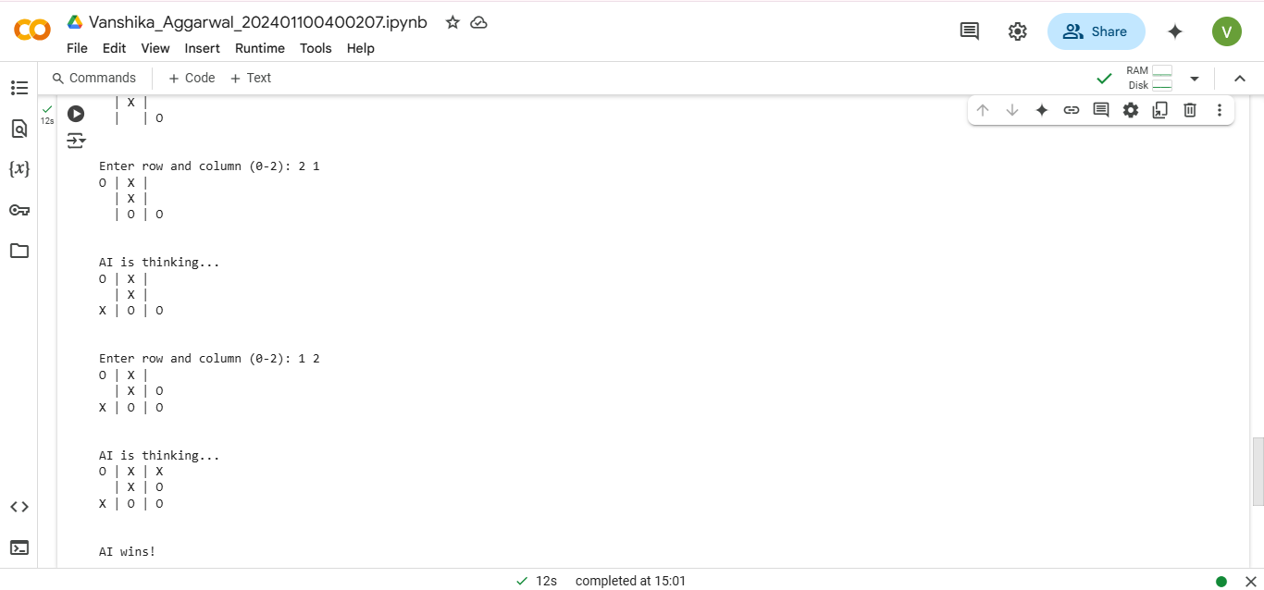

## ****COnclusion****

The developmental approach followed an iterative cycle of **design, implementation, and testing** to create a fully functional **Tic-Tac-Toe AI**. By using the Minimax algorithm, the AI is **unbeatable** and always makes the best possible move. This project successfully demonstrates **AI-driven decision-making, game theory, and strategic planning** in a simple yet effective manner.

### ****Future Improvements****

* Implement **Alpha-Beta Pruning** to optimize Minimax and improve execution speed.
* Add a **Graphical User Interface (GUI)** using **Tkinter or Pygame**.
* Extend the game to **larger grids** (4x4, 5x5) with modified rules.

## ****References****

1. **Game Theory and Minimax Algorithm:**

* Russell, S., & Norvig, P. (2021). Artificial Intelligence: A Modern Approach (4th Edition). Pearson.

1. **Minimax Algorithm in AI:**

* Michie, D. (1966). *Game-Playing and Artificial Intelligence*. Elsevier.

1. **Online Resources and Documentation:**

* Python Official Documentation: <https://docs.python.org/>
* Stack Overflow: Discussions on optimizing Minimax in Tic-Tac-Toe.