LAB-2: Use Case Diagram – Library Management System
Submitted by: Vanshika Mudgal Reg. No: 202401100200340 Subject: Software Engineering Lab

Aim
To draw the use case diagram of a Library Management System and to specify the role of each actor. Also to state the precondition, post condition and function of each use case.

Theory
A use case diagram is a behavioural UML diagram that shows what a system does from the point of view of its users. It consists of the following elements:
- Actor: a person or an external system that interacts with the system (shown as a stick figure).
- Use case: a function or service provided by the system to an actor (shown as an oval).
- System boundary: a rectangle that separates the system from the actors.
- Relationships: association (actor to use case), include (mandatory reused behaviour) and extend (optional behaviour).

Problem Statement
The Library Management System (LMS) automates the day-to-day work of a college library. Members can search, reserve, borrow and return books. The librarian manages the book catalogue, issues and receives books and collects fines. The administrator manages user accounts and generates reports.

Actors and Their Roles
Actor | Role
Member (Student / Faculty) | The primary user of the library. Registers, logs in, searches for books, reserves books, views issued books and pays fines.
Librarian | Manages the book catalogue. Issues books to members, accepts returned books, calculates and collects fines and handles reservations.
Administrator | Controls the system as a whole. Manages member and librarian accounts, assigns access rights and generates reports.

Use Case Diagram
The use case diagram of the Library Management System is shown below. The Member, Librarian and Administrator interact with the use cases inside the system boundary. Login is included by every use case that needs an authenticated user, and Calculate Fine is included in Return Book.
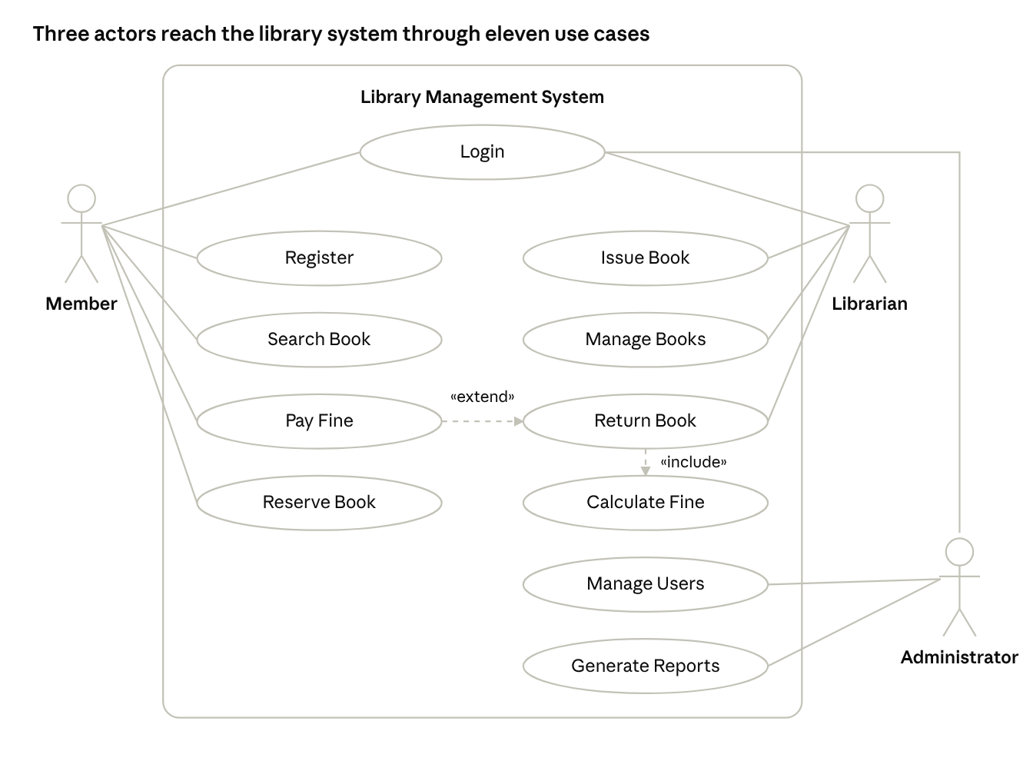
use case diagram · 3 actors, 11 use cases
Figure 1: Use case diagram of the Library Management System. Dashed arrows show the «include» and «extend» relationships.

Use Case Specification
No. | Use Case | Actor | Function | Precondition | Post Condition
1 | Register | Member | Allows a new student or faculty member to create an account by entering personal details. | The member is not already registered and has valid details such as ID and email. | A new member account is created and a membership ID is generated.
2 | Login | Member, Librarian, Administrator | Verifies the user's credentials and gives access to the features allowed for that role. | The user has a registered and active account. | The user is authenticated and the role-specific dashboard is displayed.
3 | Search Book | Member, Librarian | Searches the catalogue by title, author, subject or ISBN and shows availability. | The user is logged in and the catalogue is available. | The list of matching books with their availability status is displayed.
4 | Reserve Book | Member | Allows a member to reserve a book that is currently issued to someone else. | The member is logged in, the book is currently unavailable and the member has not crossed the reservation limit. | The reservation is recorded and the member is notified when the book becomes available.
5 | Issue Book | Librarian | Issues an available book to a member and records the issue date and due date. | The member is registered with no pending fine, has not crossed the issue limit and the book copy is available. | The book status changes to issued, the transaction is recorded and the due date is set.
6 | Return Book | Librarian | Accepts a returned book and updates the records of the member and the book. | The book is issued to the member and the member is present with the book. | The book status changes to available and the member's issued list is updated.
7 | Calculate Fine | Librarian | Calculates the fine for late return based on the number of days after the due date. | A book is being returned after its due date. | The fine amount is calculated and added to the member's account.
8 | Pay Fine | Member | Allows the member to clear the pending fine amount. | The member has an outstanding fine. | The fine is marked as paid, a receipt is generated and the member can borrow again.
9 | Manage Books | Librarian | Adds, updates or deletes book records in the catalogue. | The librarian is logged in. | The catalogue is updated with the latest book information.
10 | Manage Users | Administrator | Creates, updates, blocks or deletes member and librarian accounts and assigns roles. | The administrator is logged in. | The user records and access rights are updated in the database.
11 | Generate Reports | Administrator | Produces reports such as issued books, overdue books, fines collected and popular books. | The administrator is logged in and transaction data exists. | The requested report is generated and displayed or exported.

Relationships Used in the Diagram
- Include: Issue Book, Return Book, Reserve Book, Pay Fine, Manage Books, Manage Users and Generate Reports include Login, because the user must be authenticated first.
- Include: Return Book includes Calculate Fine, because the fine is always checked when a book is returned.
- Extend: Pay Fine extends Return Book, because it happens only when a fine is generated.

Conclusion
The use case diagram of the Library Management System was drawn and the three actors, Member, Librarian and Administrator, were identified along with their roles. The function, precondition and post condition of each use case were specified. This diagram gives a clear view of the system requirements and helps in the later design and development stages.

