LAB 3: UML Class Diagram – Library Management System
Submitted by: Vanshika Mudgal
Registration No: 202401100200340
Subject: Software Engineering Lab

Aim
To identify the classes, attributes, methods and relationships from the requirements of the selected project (Library Management System) and to prepare the UML Class Diagram.

Theory
A class diagram is a structural UML diagram that shows the classes of a system, their attributes and methods, and the relationships between them. It is the main building block of object-oriented modelling.
Each class is drawn as a rectangle with three compartments:
- Top compartment: the name of the class.
- Middle compartment: the attributes (data) of the class.
- Bottom compartment: the methods (operations) of the class.
Visibility symbols used in the diagram: + means public and - means private.
The relationships used are:
- Association: a simple link between two classes, for example a Member borrows a Book.
- Generalization (inheritance): a child class inherits the attributes and methods of a parent class (is-a relationship). It is drawn with a hollow triangle at the parent end.
- Multiplicity: shows how many objects of one class can be linked to an object of the other class, for example 1, 0..1 or 0..*.

Project Requirements
The Library Management System should satisfy the following requirements:
- A member (student or faculty) can register, log in, search for books, reserve a book and pay fines.
- A librarian can add, update and delete books, issue books to members and accept returned books.
- An administrator can manage user accounts and generate reports.
- The system records every issue and return of a book along with the issue date, due date and return date.
- A fine is generated when a book is returned after the due date.
- A member can reserve a book that is currently issued to someone else.

Identification of Classes
The classes are identified by picking the nouns from the requirements. The verbs become the methods of the classes.
Class | Description
User | Parent class that holds the common data and login operations of all users of the system.
Member | A student or faculty member who borrows books from the library.
Librarian | Staff member who manages books and handles issue and return.
Administrator | Person who controls user accounts and reports of the system.
Book | A book of the library catalogue with its details and available copies.
BookIssue | A record of a book issued to a member, with issue date, due date and return date.
Reservation | A request made by a member to hold a book that is currently not available.
Fine | The penalty generated when a book is returned late.

Attributes and Methods
Class | Attributes | Methods
User | userId, name, email, password | login(), logout()
Member | membershipId, memberType, issuedCount | searchBook(), reserveBook(), payFine()
Librarian | employeeId, shift | issueBook(), returnBook(), manageBooks()
Administrator | adminId | manageUsers(), generateReport()
Book | isbn, title, author, category, availableCopies | getDetails(), updateStock()
BookIssue | issueId, issueDate, dueDate, returnDate | calculateFine()
Reservation | reservationId, reserveDate, status | confirm(), cancel()
Fine | fineId, amount, status | markPaid()

Relationships between Classes
Class A | Relationship | Class B | Multiplicity | Meaning
Member, Librarian, Administrator | Generalization | User | – | Each of them is a User and inherits userId, name, email, password, login() and logout().
Member | Association | BookIssue | 1 to 0..* | A member borrows many books over time.
Librarian | Association | BookIssue | 1 to 0..* | A librarian issues and receives many books.
Librarian | Association | Book | 1 to 0..* | A librarian manages (adds, updates, deletes) many books.
Member | Association | Reservation | 1 to 0..* | A member can make many reservations.
Book | Association | BookIssue | 1 to 0..* | A book can be issued many times.
Book | Association | Reservation | 1 to 0..* | A book can be reserved many times.
BookIssue | Association | Fine | 1 to 0..1 | A late return generates at most one fine.

Class Diagram
The class diagram of the Library Management System is shown below. Member, Librarian and Administrator inherit from User, and the borrowing process is recorded through the BookIssue class.
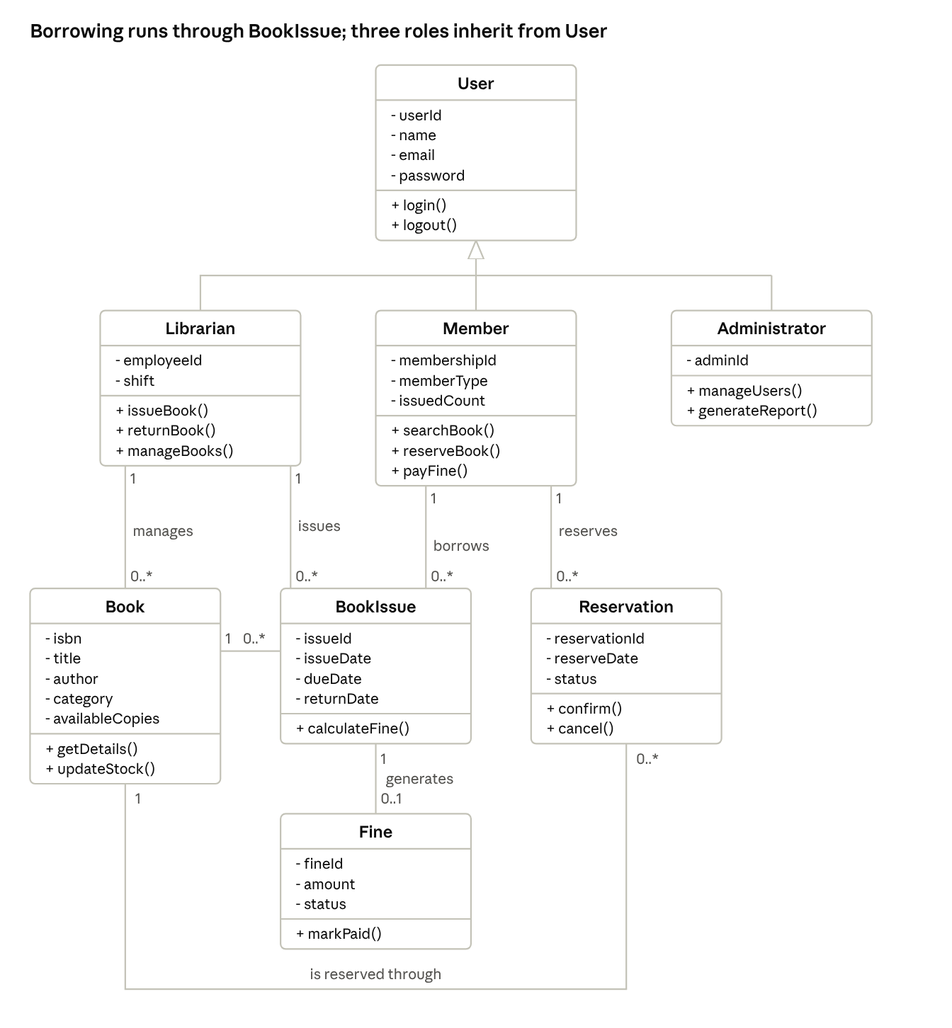
class diagram · 8 classes, inheritance and associations
Figure 1: UML class diagram of the Library Management System. + means public, - means private.

Conclusion
The classes, attributes, methods and relationships of the Library Management System were identified from the project requirements and the UML class diagram was prepared. The diagram gives a clear structure of the system and works as a base for the coding and database design.

