LAB 4: Activity Diagram – Library Management System
Submitted by: Vanshika Mudgal Reg no: 202401100200340 Subject: Software Engineering Lab

Aim
To draw the activity diagram of the Library Management System showing the flow of activities for borrowing and returning a book.

Theory
An activity diagram is a behavioural UML diagram that shows the flow of control from one activity to another. It is similar to a flowchart but it can also show parallel work and the person or system responsible for each activity (using swimlanes).
The elements used in the diagram are:
- Initial node: a filled circle that shows where the process starts.
- Activity (action): a rounded rectangle that shows a task performed in the process.
- Decision node: a diamond with one incoming flow and two or more outgoing flows, each marked with a condition such as Yes or No.
- Control flow: an arrow that connects one node to the next.
- Swimlane (partition): a vertical lane that shows who performs the activities placed inside it.
- Final node: a circle with a filled centre that shows where the process ends.

Process Description
The process drawn is borrowing and returning a book in the Library Management System. It involves three swimlanes: Member, Librarian and System.
- The member logs in and the system verifies the credentials. If the login is invalid, the member has to log in again.
- The member searches for a book. If the book is not available, the member reserves it and the process ends.
- If the book is available, the librarian checks whether the member is eligible (no pending fine and the issue limit is not crossed). If the member is not eligible, the request is rejected and the process ends.
- If the member is eligible, the librarian issues the book and the system updates the records.
- When the member returns the book, the librarian accepts it and checks whether it is late. For a late return the fine is calculated and the member pays it.
- Finally the librarian updates the availability of the book and the process ends.

Activities and Responsible Actors
Step | Activity | Performed by
1 | Login | Member
2 | Verify credentials (decision: valid login?) | System
3 | Search Book | Member
4 | Check availability (decision: book available?) | System
5 | Reserve Book (when the book is not available) | Member
6 | Check eligibility (decision: eligible?) | Librarian
7 | Issue Book | Librarian
8 | Update Records | System
9 | Return Book | Member
10 | Accept Book (decision: returned late?) | Librarian
11 | Calculate Fine (for a late return) | Librarian
12 | Pay Fine | Member
13 | Update Availability | Librarian

Activity Diagram
The activity diagram of borrowing and returning a book is shown below.
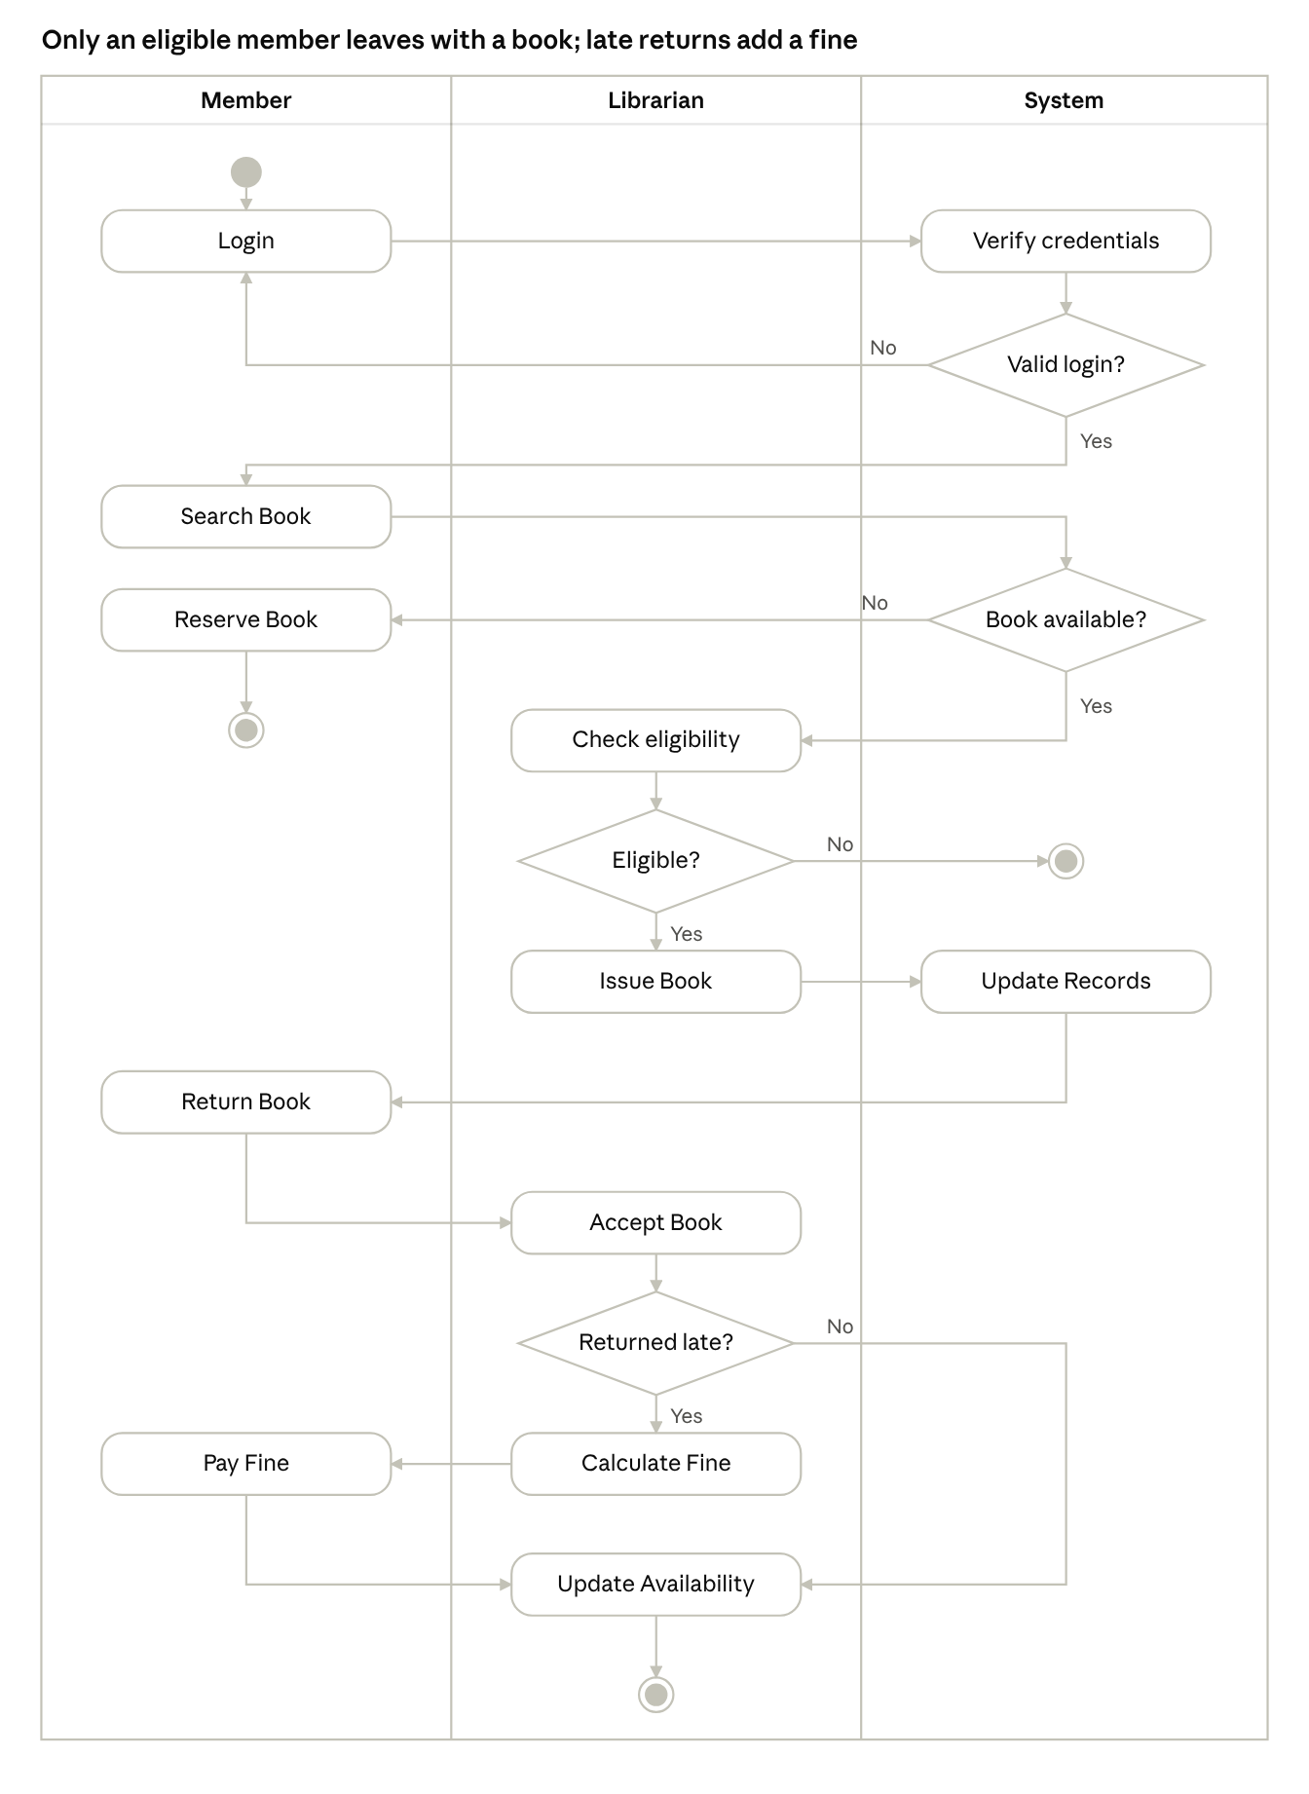
activity diagram · 3 swimlanes, 4 decisions
Figure 1: Activity diagram for borrowing and returning a book in the Library Management System.

Conclusion
The activity diagram of the Library Management System was drawn using swimlanes for the Member, Librarian and System. It shows the complete flow from login to return of the book, including the decisions for valid login, book availability, member eligibility and late return.

